Dissertation proposal
By Emily Jayne Botting p147425

Introduction

For my dissertation, I am planning to look into how an illustration style can change the narrative of a children’s book, primarily looking into forest painting and how lighting and textures can have a dramatic emotional impact on the book. I will analyze and compare two children’s books, which have completely different narratives and look at how the books would be perceived if the illustration styles in the two were swapped. I will first look at ‘where the wild things are’ as the darker of the two books and compare with the softer book ‘wind and the willow’. I have chosen these two books as the illustration styles are very opposite and will be good examples to compare.

First keyword: Narrative

The first word I will be looking in to will be narrative. As I am basing my dissertation on children's book narratives, this will naturally play an important role.
There are perceived two be two types of narratives in a children’s book which primarily work together but can also cross wires if not done right. These are the ‘narrative in text’ and then ‘narrative in illustration’.
I will first begin researching into textual narratives in children’s books as they are most commonly used in the beginning processes and is what holds the whole production together. This is because without a strong engaging narrative it would become extremely difficult for the illustrator to create a visual narrative around the story given. The illustrator has only what the writer has given them to create the visual narrative so without a strong narrative or with lack of communication between the two party’s it would become easy for the narrative to be changed and manipulated by the illustrator if they were to interpret the text in a different way to the writer. Most often in younger children’s books, the illustrative narrative is commonly what they would pick up on first, as it is much easier for them to follow when they are learning in comparison to textual narrative. It is commonly heard of that a child learning to read will originally take in a book by using the illustrative narrative given and then once they have their head around the basic storyline go back and read through the textual narrative, as it then becomes a lot easier to follow. So one narrative is not more important then the other but they are something that needs to link well with one another so story lines are not crossed.
Narratives in children’s books are most commonly formed in a simplistic way so that they are easier to be followed by young children. However I will be looking into two slightly more complex children’s book for the reason that the illustrations in them have more narrative to them because of the fact there are more storylines to illustrate from. The first narrative is ‘where the wild things are’ this will play as the slightly more darker narrative out of the two. Then the later ‘wind in the willow' playing as the lighter-hearted narrative. I have chosen these two narratives as they are seen to be very opposite children’s books but both hold very detailed interesting visual illustrative narratives. Their storylines also work around forests and woods and this is the illustration science that I want to focus on in my dissertation as I feel they hold a lot to them and can be analyzed in greater depth. The main focus of my dissertation will be comparing the two illustrative narratives. Primarily focusing on the forest paintings, and analyzing the change in narrative, both visual and textual if the two illustration styles were swapped. My hopes in exploring this topic are to sufficiently evident that the narratives in both of these books would completely change and have new meaning to them if the styles were swapped. I will lastly research the visual and textual narratives of both books to help evidence this. I will also be researching into the illustrators of the books: Maurice Sendak ‘where the wild things are’ and Arthur Rackham ‘wind in the willow, 1940’ so I closely analyze there illustration styles and the importance they created on the narratives.

Second keyword: Lighting

The next word I will be looking into will be lighting as it will become very important and hold a lot of meaning in my dissertation subject.
One of the main focuses in my dissertation subject is going to be looking into moods in narratives and how they can be easily manipulated when changing small aspects of the illustration style and in result changing the original narrative given. So lighting plays a massive part in this process because it has the ability to completely change the mood in an illustrative piece when used correctly.
For example the first book I plan to analyze when writing my dissertation will be ‘where the wild things are’. Originally this books narrative is known for having a fairly dark and jumpy storyline and illustrative style to in children’s eyes, and my aim is too evident how this narrative can be changed with a few small changes within the illustration.

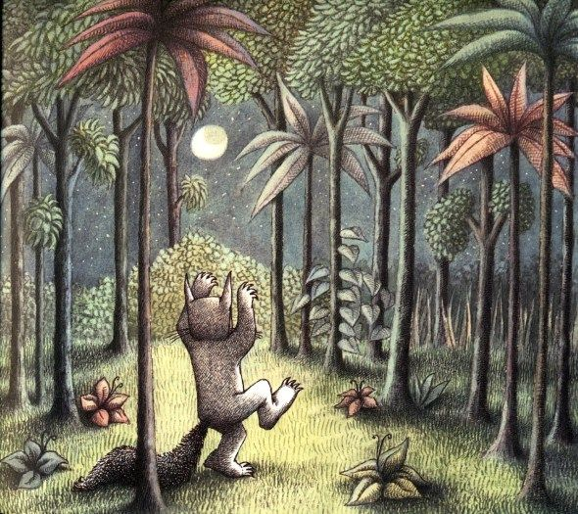

(Where the wild things are, Maurice Sendak 9.4.1963)

Looking at the illustration I have chosen from the book ‘where the wild things are’ It is evident that the lighting used in the forest is done in a very dark and monotone style creating an atmosphere of the unknown and the imminent feeling of what is happening in the forest beyond the tree line. These feelings are directly created from how the illustrator ‘Maurice Sendak’ has cleverly balanced lighting in the work by focusing on using dark shadows and eliminating strong usage of light within the depths of the forest to therefore create the feeling of uneasy and liveliness of the forest to the reader. The lightning here is used with high sophistication as not to make the darkness of the illustration so overpowering that the book becomes unenjoyable to the reader whereas to create the atmosphere of fear and terror but also still holding onto the fun and excitement in the narrative. Sendak has archived this by keeping the character in the illustration full of light and liveliness, this is done by the only source of light in the illustration being found in the moon between the trees. Instead of reflection this light all over the forest it is focused primarily on the child but also on a few surrounding trees and patches of grass. Overall this is resulting in an illustration of a lively child playing in unknowing surroundings creating the subtle balance of light and heavy feel to it.
I would then plan to analyze how this overall feel of the chosen illustrative piece could be flipped around with a change of lighting in the illustration style to have an overall different feel to it. This would then be compared to my other chosen children’s book.
The lighting using in the other children’s book ‘wind and the willow’ that I will be analyzing is used in a very different way to create an entirely different narrative and feel to the storyline. From looking at the illustration by E. H Shepard the lighting he has chosen to use in his style is very soft and calming. He has used little darkness and shadows in his work focusing primarily on using bright light filed colors there for creating an atmosphere of safety and comfort in the forest. By doing this he is sticking well to the joying narrative the storyline enhancing the element of joy and peacefulness also given in the text.
I will then also analyze this and how the lighting can once again be manipulated evidencing that the forest could become the opposite and be sinister with different lighting even when surrounded by the joyful text.

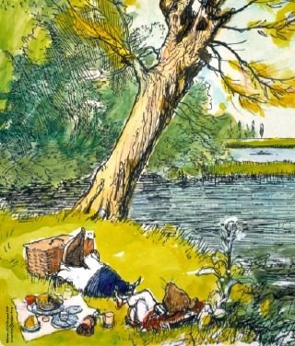

(Wind and the willow, E. H Shepard, 1981)

Third keyword: Texture

The last keyword that I will be focusing on in my dissertation will be texture.
The word texture links to my chosen subject for similar reasons to that of my previous keyword ‘lighting' as it helps control mood and narrative in illustration, however it archives this in a subtler way than that of lighting.
When you first look at an illustration lighting can be an initial key indication of the mood of a piece as it can show various indications of the narrative of the illustration quite obviously, such as day from night or joy to fear etc. However texture works in a much more advanced way and may not be the first thing a reader would pick up on and might be something noticed after analyzing the image for a longer period of time.
Looking back at the illustration I analyzed in lighting ‘where the wild things it is evident that the illustrator Maurice Sendak has used a lot of different textures in the illustration to create the atmosphere. Sendak has used very harsh textured lines especially within the depths of the forest to indicate the unknown and therefore creating tension in the narrative. The harsh lines represent these emotions because of the heaviness it puts on the illustration, whereas if the lights were soft and clean it would act the same way as the words sound, creating more of an innocent atmosphere. As well as this there are also lots of hard straight lines used in the illustration. This method also gives off the same effect as the harsh heavy lines as it holds no looseness to it. Straight textured lines create unease in illustrations as it extracts any softness from the work given it the opposite impact. Whereas looser lines are seen to be more free and lively. This texture can be seen a lot around the majority of the illustration with exception of the boy as it is seen that the intent was to still keep softness to the character, which only enhances the harshness of his surroundings.
I would then plan to again explore how the narrative would change in this piece if the textures were changed alongside the lighting.
For the other image I looked at with lighting ‘wind in the willow’ it is evident that the textures used in this illustration by E. H Shepard are very different in comparison. The textures Shepard used in his illustration are a lot lighter with softer tones to them, and as a result of this the atmosphere it has created is very calm and peaceful one with more of a safe tone to it. Whereas if the textures used were a lot harsher and dark the illustration would soon become a lot heavier therefore straying away from the original textual narrative of the book. Another noticeable place where a lot of texture has been used is in the trees. Even though the forest has a lot of depth to it Shepard has steered clear from dark textures, which is what would most commonly create depth and has replaced it with vibrant colours and loose cross-hatching. This texture creates a welcoming soft vibe to the illustration and illuminating any fear in the forest.

Question preparation

Looking into the three keywords that I had chosen has helped lead me to a question for my dissertation next year as it has pushed me to research each element individually instead of looking at the subject as a whole. This has given me a much greater understanding of what the primary aspects of my subject will be and has highlighted what areas are going to need more attention than others throughout the assignment. By now understanding this I will be able to create a fully formed question that I will answer next year for my dissertation.

Research question

A study into the relationship between illustrative and textual narratives in children's books, and how these narrative illustrations can be manipulated with a change of illustrative style and how this would then affect the original narrative of the books storyline

Bibliography

Books

Where the wild things are, by Maurice Sendak, published 09.04.1963 Harper & Row

Wind and the willow, by Kenneth Grahame (illustrator E. H Shepard)
27.08.1981 Methuen young books

