DS 1 Template

My Screenshots/Photos
- Please add 4–6 screenshots or photos of your digital life.
- You can use your phone or laptop.
- For each screenshot, write one or two sentences explaining what it shows.

Screenshot/Photo 1
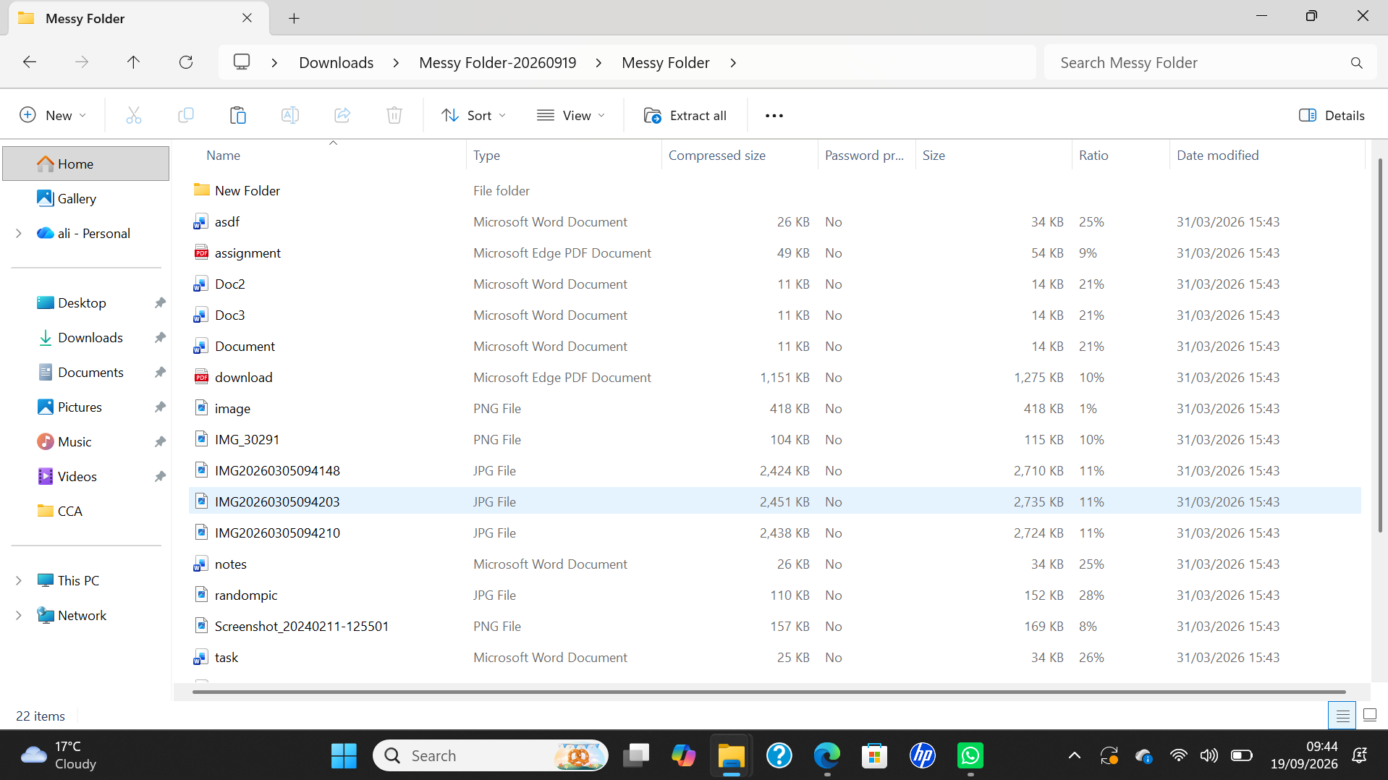
This screenshot shows my laptop files and where I keep my school assignments and other work right now. As you can see, it’s a bit messy, but I can use my digital skills to organise it and make it look tidier.

Screenshot/Photo 2
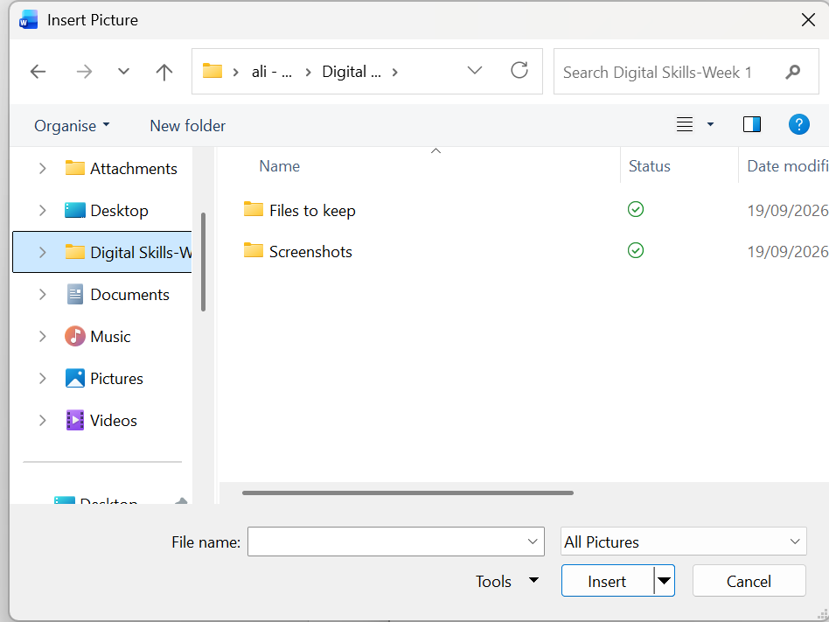
This is a screenshot of my tidy files, so every time I go on it to check or save my work, it's easier to find and store because of the folders and how they separate everything.

Screenshot/Photo 3
[Insert Photo/Screenshot below]
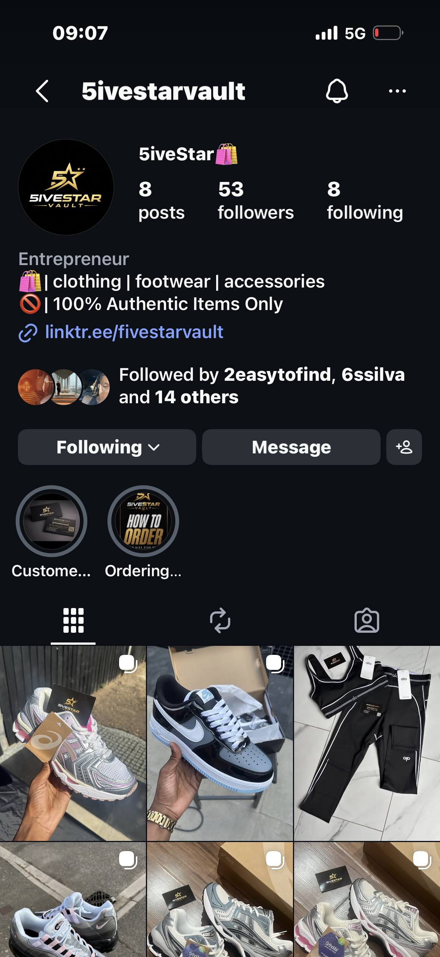
This screenshot shows my Instagram business page: 5ivetsarvault, where I sell multiple things like shoes, clothes, and many more stuff. It also shows how I use social media to promote my products, find new customers and share pictures of items I sell.

Screenshot/Photo 4
[Insert Photo/Screenshot below]
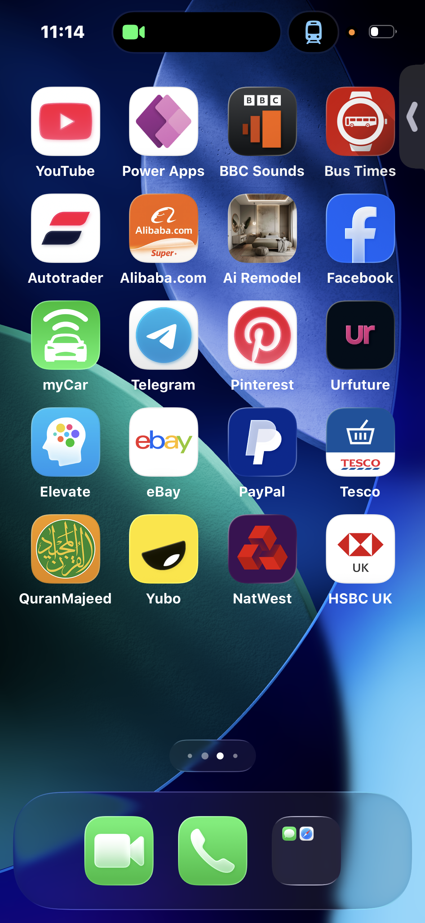
This screenshot shows multiple apps that I use for entertainment, communication and everyday use. It shows how my phone helps me stay connected to friends and do many other things, like checking my bank account to see my balance.

Screenshot/Photo 5
[Insert Photo/Screenshot below]
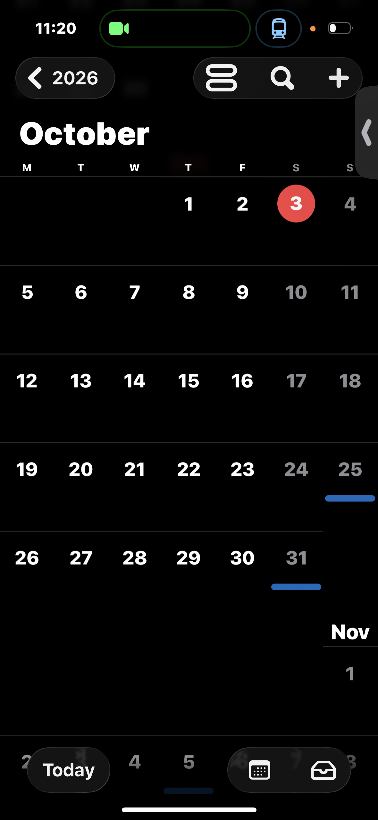
This screen shows my calendar, which I use to keep me on track with assignments and also activities, and it even tells me the date and day it is, which is very useful and shows me how I use digital tools to keep me on track.

Screenshot/Photo 6
[Insert Photo/Screenshot below]
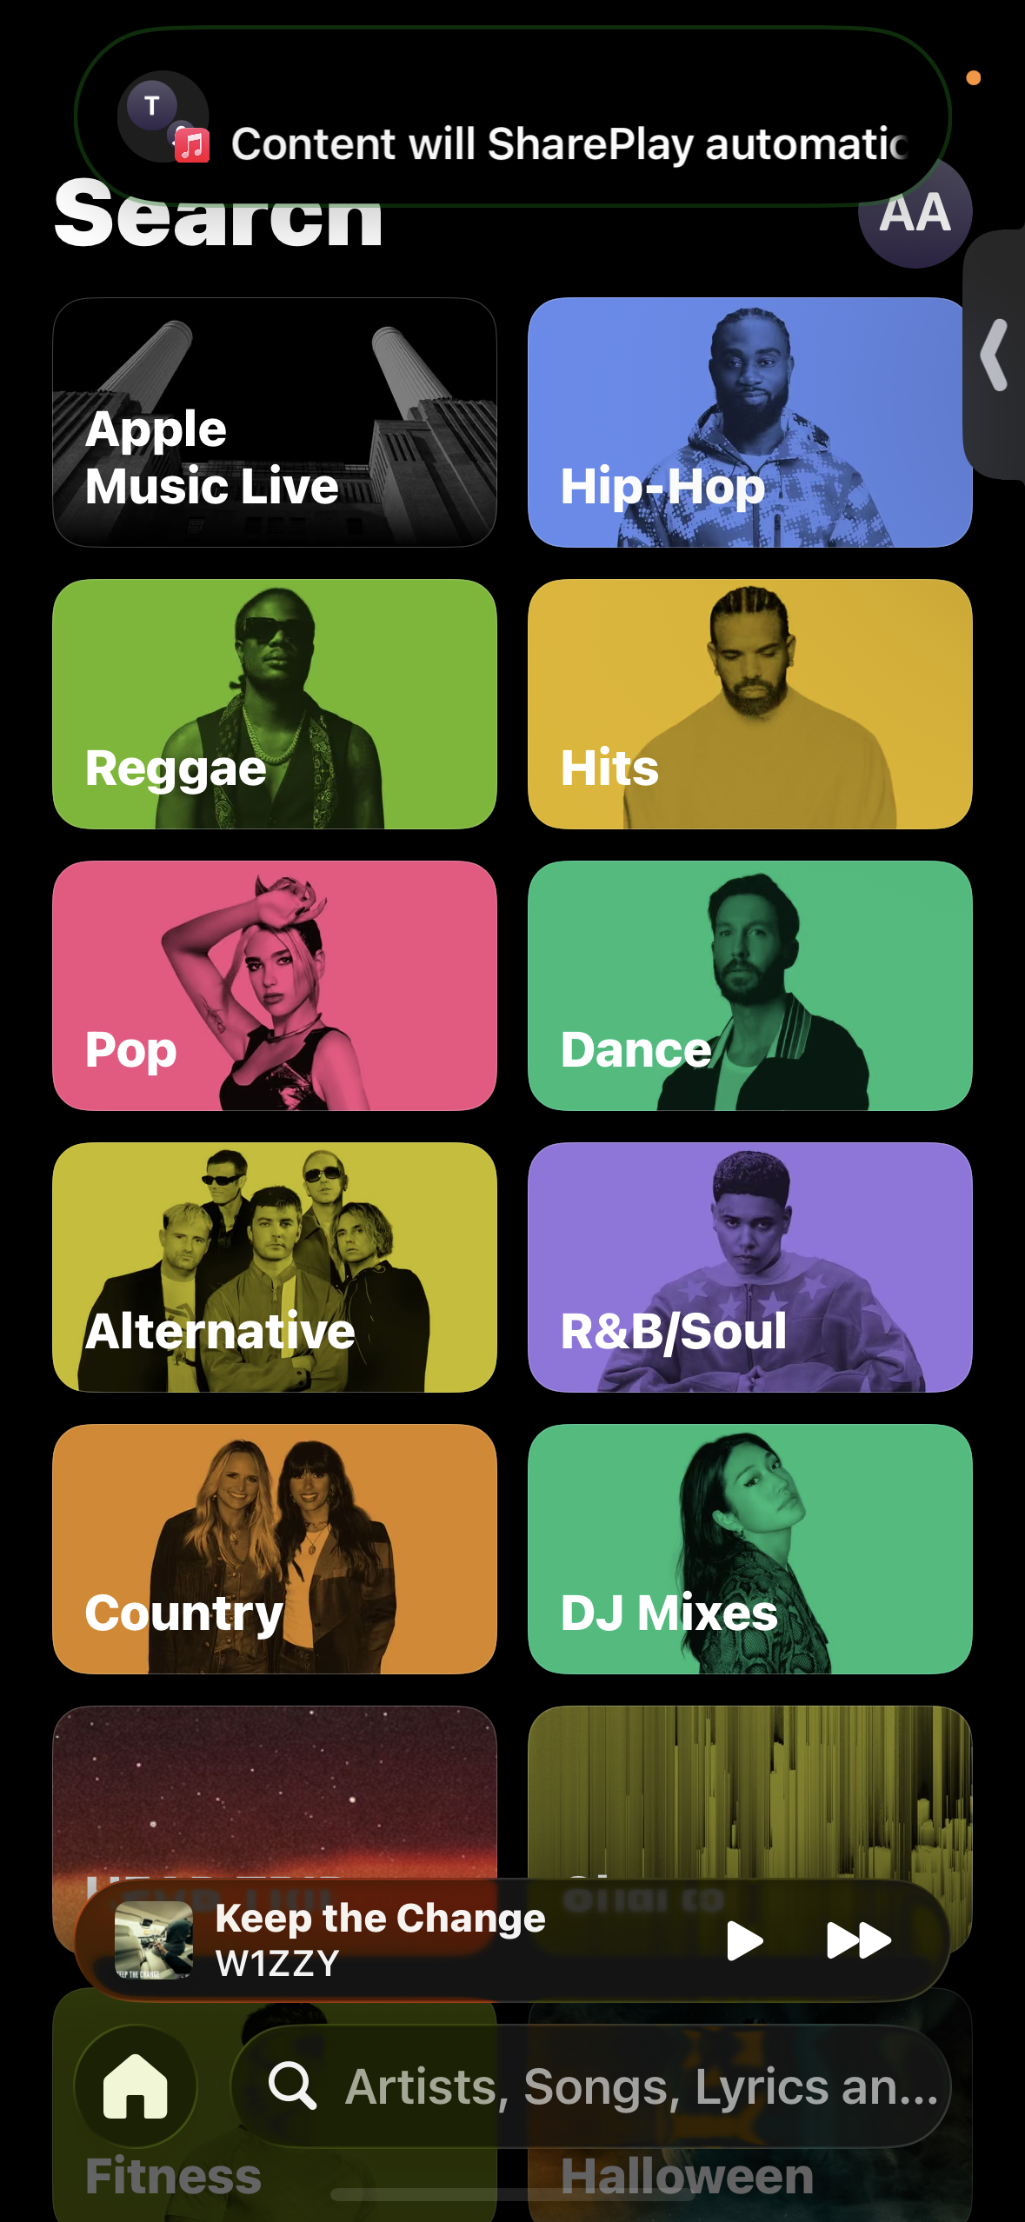
This screenshot shows my Apple Music app where I listen to a variety of music, including hip-hop, reggae and pop music. It shows how I use digital technology for my free time and entertainment , and I enjoy music when I want in my own free time.

My Short Reflection
- Write 5–8 simple sentences about your digital life.
- You can use the sentence starters below if helpful.
I use digital skills every day for reminders, communication and entertainment. I feel confident when I use my phone to use multiple and different apps.I often use tools like Gmail, Instagram and Apple Music. I also use digital technology to manage my online business and to talk to clients. I want to improve my digital skills so I can use technology much better. Sometimes I feel nervous about making multiple mistakes when I'm introduced to new technology. Digital skills are very important to me because I need them for my everyday use.

Sentence starters
- I use digital tools to …
- I feel confident when I …
- I want to improve …
- I often use these tools: …
- I sometimes feel nervous about …
- I hope this module will help me …
- Digital skills are important for me because …
You can write more if you want.
I use

I Submission Checklist
Before you submit, please check:
​​​ ☒ I added 4–6 screenshots
☒ I wrote short sentences for each screenshot
☒ I wrote my short reflection
☒ My work is my own
☒ My file opens correctly
​​☒ My file opens correctly

