
Programme: Certificate of Higher Education skills for the workplace
Module: Problem Solving and Innovation
Module Code: BMSW4014
Title: The Decline of the retailer WILKO

Student Name : Liljana Reci
Student ID : 2309831
Word Count : 1495

Table of Contents
Introduction 3
Nature, Impact and Problems faced by the Wilko. 4
SWOT Analysis 5
Strengths 5
Weaknesses: 5
Opportunities: 5
Threats: 5
Identification of the Problem 6
Potential solutions 6
PESTLE Analysis 7
Political Factors 7
Economic Factors: 7
Social Factors: 7
Technological Factors: 7
Legal Factors: 8
Environmental factors: 8
Conclusion 8
References 10

Introduction
In order to adapt to the demands of evolving consumer preferences, economic conditions, and intensifying market rivalry, retail establishments are perpetually transformed. Certain establishments, including those that have been operational for an extended period, are currently encountering challenges that could potentially compel them to cease operations. This research looks closely at the incident involving the well-known shop Wilko to identify and describe the problems that led to its closing. This full study includes a SWOT analysis, a PESTLE analysis, and a conclusion. Our goal is to shed light on what went wrong with Wilko and suggest how things might have been different.

Nature, Impact and Problems faced by the Wilko.
The Wilko store was maintaining a remarkable level of operation prior to its closure. The government has chosen to take over this problem because it is so hard to solve. One of the primary challenges confronting the retail industry is transformation, which is sparked by shifting consumer preferences, increased competition, and the growing popularity of e-commerce. Stores like Wilko had a hard time getting used to the changes, which hurt their sales and market share a lot. Competing with large online retailers and traditional retailers was more difficult for Wal-Mart. Customers have found it easier to do many things since online shopping has grown (Hallak et al., 2018). This has made traditional shops like Wilko rethink how they run their businesses. They also had issues with how they managed their supply chain, their old technology, and missed chances to capitalise on new market trends. These issues made people not want to come in as much, which meant that less money came in.
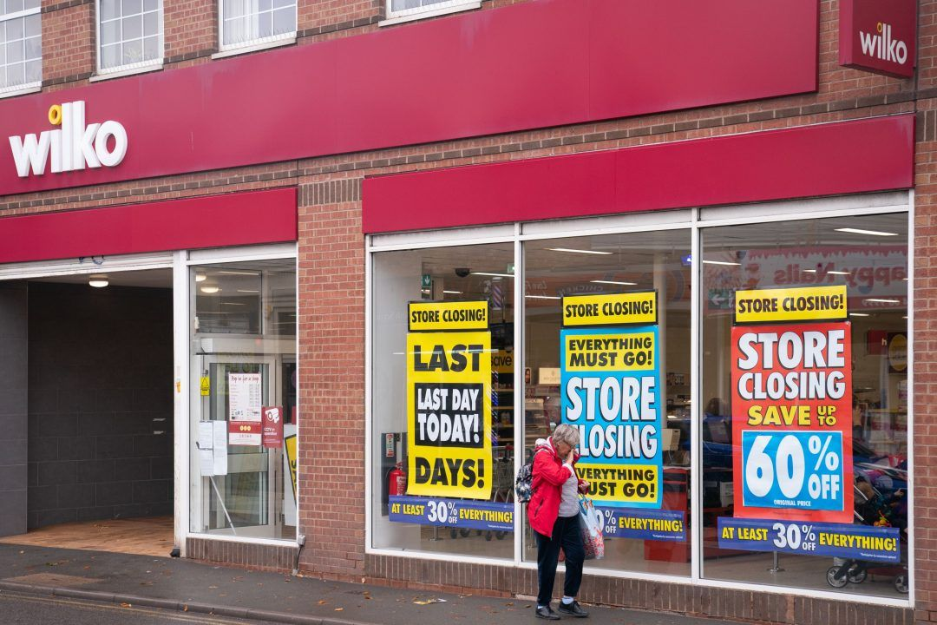
Image: Wilko Stores During Closing Period.
Source: Internet.

SWOT Analysis

Strengths
During its infancy, Wilko experienced a surge in popularity due to a multitude of successful factors. One of the best things about it was that it had a lot of home goods, items for DIY projects, and tools for farming (Wanzenböck et al., 2022). People in the UK knew the name because many of the shops were in great spots. Wilko's reputation for carrying inexpensive merchandise attracted a large number of customers.

Weaknesses:
Even though Wilko had many advantages the company had some weaknesses too. Often, Businesses faces troubles in keeping track of their goods because their computer system was old and their supply chain didn't work well. Stock-outs and overstocks happened sometimes because of this, which was generally bad for buyers (Tang, 2019). It was also bad for Wilko that it didn't have a strong web presence in a retail market that was changing quickly.

Opportunities:
Wilko had chances to make money in the fast-growing retail sector that they hadn't yet taken advantage of. The business could have reached more people and kept up with the times if it had made its online presence better (Nordin, and Osman, 2018). Wilko's market reception might have been enhanced had it partnered with renowned brands and industry leaders. Wilko could have also gotten more customers by adding new varieties of items and smart new services.

Threats:
External factors posed numerous challenges for Wilko, impeding their ability to maintain operations. Prices dropped because there was a lot of tough competition from stores both online and off. This presented Wilko with a greater challenge in maintaining its commitment to values. According to Van Aken and Berends (2018), During economic downturns, like the global recession, people became more price aware, which caused them to spend less. Also, customer habits changed, like more people shopping online, which made Wilko's plan for a local business less likely.

Identification of the Problem
Wilko's closed down because of bad management and threats from outside the company. Due to not being online and using old technology, the company was unable to change to the changing times. People using the system had an even harder time figuring out how to track goods and move through the supply chain (Treffinger, Isaksen, and Stead-Dorval, 2023). Wilko lost all of his money because he didn't know enough about the market. There was intense competition among businesses vying for consumers, whose preferences were constantly evolving.

Potential solutions
Wilko was compelled to devise brilliant strategies to avert the coming disaster. In the beginning, the technical core had to be completely re-evaluated. Pressman (2018) stated that to better handle sales, customers, and goods, it would have been helpful to get high-tech tools. Wilko should have been more concerned with their online appearance. By making it easier to shop online, the brand could adapt to new shopping habits and reach people who don't live nearby. Wilko could have made itself more visible online by using digital marketing and social media. Nordin and Osman (2018), agrees that it would have been advantageous for the establishment to offer a greater variety of products and streamline the in-store and online shopping experiences.
Through increasing sales, introducing new product lines, and incorporating customer feedback into product development, Wilko might have been able to enhance its reputation and attract more clients. It would be smart for small businesses that have to deal with markets that change quickly to learn from Wilko's exit (Tan, 2021). By implementing a comprehensive SWOT analysis, organisations can effectively address challenges and ensure their sustainability. They can focus on the most important issues and quickly come up with good answers with this skill. Wilko closed because it didn't adapt to new technology or changes in the times. This shows how important it is for the shopping business to keep things open and planned ahead.

PESTLE Analysis

Political Factors
One of the main political reasons why Wilko went out of business was because the rules for stores changed. The company had to deal with more money problems because of new laws and rules, such as higher taxes and changes to the minimum wage laws. According to Çitilci and Akbalık (2020), the unpredictability of Brexit and its potential repercussions on supply chain management and trade further impeded Wilko's operations. When politicians are unstable, it can be hard for businesses to do well, which can make it hard for shops to handle issues.

Economic Factors:
There were issues with the market that made it hard for Wilko to do well. People spent less because the COVID-19 spread made the economic downturn worse. More people were being careful with their money, which hurt shops like Wilko that didn't sell basics. Business costs went up because of changes in the economy, mostly because of issues in the supply chain and higher prices.

Social Factors:
Customer views and habits changed, which was the main reason Wilko closed. Because of changes in demographics and the rise of online shopping, traditional shops have been hit hard. Wilko encountered challenges in effectively adapting to evolving consumer preferences, particularly in the realms of technology and personalised purchasing experiences (Römgens, Scoupe, and Beausaert, 2020). With the growing consumer interest in ethically produced and healthful commodities, Wilko encountered challenges in aligning its products with these emerging standards.

Technological Factors:
The old way that Wilko did business was having a hard time with how quickly technology was changing, especially in e-commerce. Inadequate investment in online sites and difficulty keeping up with technological advancements plagued the company (Van Aken, and Berends, 2018). In the absence of innovative technologies, Wilko was unable to compete with large online retailers or reach as many customers. People stopped buying from them because their business plan didn't include internet strategies.

Legal Factors:
Concerns regarding health and safety regulations, labour laws, and product quality standards were among the legal obstacles that Wilko encountered, which hindered the efficiency of its operations. It became harder for the company to pay its bills when the costs of following the law went up. People didn't trust and buy from the store as much because of the lawsuits and legal fights that were going on.

Environmental factors:
As people learned more about sustainability and environmental issues, Wilko changed the things they sold and how they got their supplies (Çitilci, and Akbalık, 2020). It was hard for the store to start eco-friendly programmes, and its business methods didn't match the growing demand for eco-friendly goods. Environmentally conscious customers who didn't think they could help quit shopping there.

Conclusion
Unfortunately, Wilko had to close because of issues inside and outside the business that weren't treated properly. Because nothing new or different could be added to or changed about the store, it had to close. They didn’t have enough cash, too many rivals, and the ability to prepare for or respond to outside influences was lacking. Wilko might have been able to stop this decline by doing smart things like offering more goods online, forming smart partnerships with other companies to get access to more products, and affirming its commitment to being more eco-friendly. Long-term success for retail companies depends on having a business plan that can be adjusted to fit changing needs and situations. For stores to stay open and do well in today's tough retail market, they need to be alert, always look at both internal and external factors, and be able to change.

References
Çitilci, T. and Akbalık, M. (2020). The importance of PESTEL analysis for environmental scanning process. In Handbook of Research on Decision-Making Techniques in Financial Marketing (pp. 336-357). IGI Global.
Hallak, R., Assaker, G., O’Connor, P. and Lee, C. (2018). Firm performance in the upscale restaurant sector: The effects of resilience, creative self-efficacy, innovation and industry experience. Journal of Retailing and Consumer Services, 40, pp.229-240.
Nordin, N.M. and Osman, K. (2018). Students’ generated animation: An innovative approach to inculcate collaborative problem solving (CPS) skills in learning physics. Journal of Education in Science Environment and Health, 4(2), pp.206-226.
Pressman, A. (2018). Design thinking: A guide to creative problem solving for everyone. Routledge.
Römgens, I., Scoupe, R. and Beausaert, S. (2020). Unraveling the concept of employability, bringing together research on employability in higher education and the workplace. Studies in Higher Education, 45(12), pp.2588-2603.
Tan, O.S. (2021). Problem-based learning innovation: Using problems to power learning in the 21st century. Gale Cengage Learning.
Tang, K.N. (2019). Beyond Employability: Embedding Soft Skills in Higher Education. Turkish Online Journal of Educational Technology-TOJET, 18(2), pp.1-9.
Treffinger, D.J., Isaksen, S.G. and Stead-Dorval, K.B. (2023). Creative problem solving: An introduction. Routledge.
Van Aken, J.E. and Berends, H. (2018). Problem solving in organizations. Cambridge university press.
Wanzenböck, I., Wesseling, J.H., Frenken, K., Hekkert, M.P. and Weber, K.M. (2022). A framework for mission-oriented innovation policy: Alternative pathways through the problem–solution space. Science and public policy, 47(4), pp.474-489.

