Materials - ACBA4016

Construction Materials
Jac Roberts

Word Count - 2014

Contents

- Introduction

- Concrete Building – The Barbican Estate, London
  - Method of Construction
  - Building Specifications
  - Ease of assembly
  - Adaption
  - Impacts

- Steel Frame – Willis Tower
  - Method of Construction
  - Building Specifications
  - Ease of assembly
  - Adaption
  - Impacts

- Comparison of Steel and Reinforced Concrete Framing

- Conclusion

- Bibliography

1 Introduction

This case study investigates two habitable buildings: the Barbican Estate in London, a concrete frame building, and the Willis Tower in Chicago, a steel frame building.
The author reports on the original design of the chosen buildings and the process of construction. This report undertakes a comparative study of these iconic structures, focusing on their construction methods. The Barbican Estate, a large residential complex, shows an example of reinforced concrete frame construction.
On the other hand, the Willis Tower, a commercial and residential skyscraper, shows the use of a "bundled tube" steel frame system, enabling its record height. By studying the methods taken in these projects, this case study aims to highlight the contrasting strengths and limitations of concrete and steel frame construction, mostly in relation to strength, durability, climatic challenges, and the environmental conditions of London and Chicago. Furthermore, it will explore how these material choices shaped the architectural expression and urban impact of each building.

2 Concrete Building – The Barbican Estate, London

The Barbican Estate, located within the City of London, stands as a significant example of Brutalist architecture.
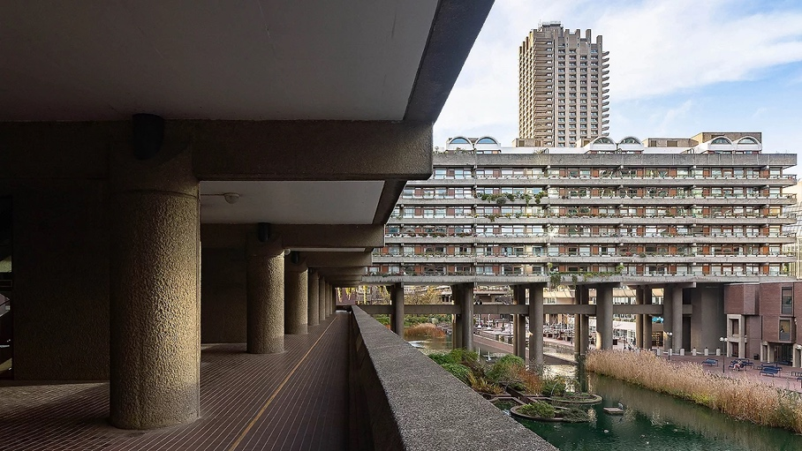
Construction of the Barbican Estate began in 1965, 11 years later it was complete. It is now home to more than 4,000 residents (City of London Corporation, 2023).
Image 1 (Williams, 2023)
2.1 Method of Construction
The construction of the Barbican Estate in London is recognised for its wide use of reinforced concrete. Here is a summary of the key construction methods:

The estate is mostly constructed from in-situ reinforced concrete (RC), which allowed for the buildings unique design including different shapes and textures.
The concrete mix included Pen Lee crushed granite and was later textured using a method called “pick hammering” (Barbican Living, 2015).

Wooden shuttering was used to create moulds for the concrete pours. Allowing for unique designs to be achieved compared to using other materials.
The tower blocks used pre-cast reinforced concrete units for their structural framework.
The designers had to consider the existing ground conditions, including existing sewers and services. This resulted in the use of piles, and reinforced concrete pillars, to ensure that existing sewers were not damaged during construction and the buildings life span.

2.2 Building Specifications

Two grades of structural concrete were used with 28-day cube strengths of 34 N/mm2 and 42 N/mm2. For the most part, all batching and mixing of concrete was carried out on site.
The concrete walls were thicker at the bottom of a building where they would carry most weight. There the slabs might be 2 feet or 18 inches deep. Higher up the building, with less weight to carry, the walls might be reduced to 12-inch slabs. (Barbican Living, 2015).
The mix characteristics throughout the building are believed to be incredibly dense allowing the structure to have good water resistance, fire resistance properties and be able to withstand the weight of the building above.
The use of tensile steel reinforcement was used throughout for strength purposes especially in the areas like balconies and bridges. The Barbican is characterised by the monumental use of reinforced concrete – cheap and widely available in the 1960s and 1970s. (Historic England, 2022)

2.3 Ease of Assembly
- On-site Construction:
  - Formwork (molds/shuttering) is erected first, reinforcement steel bars placed, then the desired concrete mix is poured and left to set and cure. This process can be time-consuming however this eliminates precast construct ion costs and transport issues.
- Precast Concrete:
  - The use of precast concrete improves ease of assembly. Precast components (beams, slabs, columns, walls) are manufactured off-site and then transported to be assembled on-site by a team of qualified individuals.
  - Precast speeds up construction, allows for better quality control, and reduces on-site time and labour.
  - In the case of the barbican estate, precast concrete would have been a far less feasible decision due to transport throughout the busy city of London and due to the need for heavy plant and machinery when lifting such large concrete structures.
- Complexity:
  - The complexity of the design can impact ease of assembly. Complex shapes can increase construction time and labour with both in-suite concrete and precast concrete construction.
2.4 Adaption
- Structural Limitations:
  - Reinforced concrete structures are fundamentally less adaptable than steel structures. When the concrete has set in its desired shape and size this will take great amounts of effort and money to adapt.
  - Due to most concrete elements of a reinforced concrete framed building being load bearing it is important that they accounted for whilst making changes to the building.
- Modifications:
  - Creating adaptations and altering an existing reinforced concrete structure takes immense labour and time. this is mostly down to its strength and scale in comparison to other framing methods.
  - However, non-structural concrete elements, like partitions and other no load bearing areas can be adapted with less thought and design time.
2.5 Impacts
Positive Impacts | Negative Impacts
Strength and Durability | Environmental
Fire Resistance | Adaptability Limitations
Thermal Mass | Construction (Labour intensive and H+S)
Sound resistance | Cracking
Versatility | “Urban Heat Island” Effect
3 Steel Frame Building – Willis Tower, Chicago
Formerly known as the Sears Tower, Willis Tower has been an iconic part of the Chicago skyline since 1973. At 110 stories high, Willis Tower is also one of the largest skyscrapers in the world. At 110 stories high (www.willistower.com, n.d.) was built using steel frame construction.


Image 2 (Midwestern Career College, n.d.)

3.1 Method of Construction
The Willis Tower, Chicago, stands as an architectural and engineering marvel. A bundled-tube system introduced by lead structural engineer Fazlur Khan (Aisc.org, 2023) allowed the building to reach its height despite the outdated technology of the time.
The tower sits on a reinforced concrete foundation (caissons) that extends down to bedrock. The steel frame then extends off the caissons in a “bundled tube” formation which is tubular interlocking system that accommodated for a sturdy, efficient frame design. This comprised of nine interconnected “tubes” that would form a stepped profile as it rose the height of the building.
Being that the frame is entirely made of steel cladding and protecting is an important part of the buildings longevity. The choice of the time involved using black aluminium sheeting and bronze tinted glass.
3.2 Building Specifications
A high-grade steel was used for the main base of the tower and all the supporting elements of the building having to cope with immense compressive and tensile loads. Due to the tower reaching a height of 441.2m (www.skyscrapercenter.com, n.d.) not only compressive strength was considered, but wind also adds massive tensile stress to the faces. The steel was mostly prefabricated in sections and later transported to site for the ease of assembly and costs of the time. The frame components were supplied by the U.S Steel industry and checked by ASTM standards which was a big industry located in Chicago at the time, this cut costs and aloud the contractors to import from local foundries.

3.3 Ease of Assembly
- Prefabrication of Steel Components:
  - A major quantity of the steel frame was fabricated off-site.
  - Pre-fabrication allowed for superior accuracy and quality control, decreasing on-site fabrication time and the risk of potential errors.
- Bolted Connections:
  - The steel sections were mainly fixed using bolted connections. This process is quicker and more effective than welding, particularly for a structure of this size.
  - Bolting rather then welding also allows the building to have some movement in areas that is needed sue to high winds and stress.
- Crane Technology:
  - The usage of advanced crane equipment allowed for the effective lifting and positioning of the heavy steel modules.
  - The cranes had to be competent to lift very heavy steel sections, to great heights.
  - Adaption

- Structural limitations
The bundled tube design of the Willis tower would restrict anyone wishing to make drastic changes to floor plans due to it being the main element of support holding up the tower. On the other hand steel framed buildings are usually very adaptable as it can be cut and re fixed with ease. In order to make adaptions an engineer with knowledge of the building would have to be present in order to avoid weakening the structural properties of the building.

- Modifications
Modifications to a steel frame building can be straight forward depending on the circumstance. Benefits include flexibility of mounting/fixing the steel. This can be done by welding or bolting new additions to the primary or existing structure. Steel frames are usually open plan leaving lots of room for new additions like partitions and features.
3.5 Impacts
Positive Impacts | Negative Impacts
Strength and Durability | Corrosion
Speed of Construction | Thermal conduction
Design Flexibility | Fire Susceptibility
Recyclability | Environmental impact during production
Ductility | Cost

- Comparison of Steel and Reinforced Concrete Framing

Feature | Steel Frame | Reinforced Concrete Frame (RC)
Cost | Material costs vairy however steel is more expensive per kg then concrete. Labour costs are kept to a minimum due to its fast-erecting time. | Material costs can vairy due to the scale of the project. Labour costs are usually much higher than steel as there is a longer process until completion.
Durability | Steel Frames can be extremely durable if they are kept enclosed and away from natural elements (moisture). | Concrete is highly durable, fire and weather resistant. However poor mixes can result in cracking (Freeze thaw).
Fire Resistance | Although steel is not flammable it can bend/warp under extreme high temperatures. This risk can be reduced if the frame is protected using fire insulation materials. | RC frames are renowned for their fire-resistant properties. Concrete is not a flammable material and in most cases the steel reinforcement is encased deep within the outer layer of mix.
Climatic resistance | If Steel frames are not protected, they can be susceptible to corrosion. | RC frames have great thermal properties and perform under varied temperatures. Concrete can be vulnerable to chemical damage.
Strength | Steel has a remarkable strength to weight ratio. It performs well under tensile and compressive loads. | RC has a good strength to volume ratio. It performs well under compressive load however underachieves under tensile load.
Ease of assembly | Steel is fast to assemble due to being relatively easy to cut and install using welding or hardware. | RC is a slow method of framing due to time making formwork, poring the concrete and allowing it to cure over the 28-day period.
Environmental impact | Steel is recyclable and can be made into a new product. Waste is also considerably less then concrete framing. | Concrete is difficult to recycle and is a huge contributor to Co2 emissions.
Sound Insulation | Steel is a dense material allowing sound to reverberate off therefore making it not very sound efficient. | Concrete, like steel is dense and allows sound to reverberate however it has better sound insulation properties.
Ascetics | Steel frames allow buildings to be more flexible with their ascetics for example less frame required, and open plan designs can be achieved. | RC frames need more support therefore leaving less space for open areas. Concrete does allow you to have form any shape and add a desired texture.
Foundation Requirements | Steel is counted as light weight in comparison to RC therefore foundations can be smaller and less extensive. | Concrete is heavy and more brittle thus needing a more substantial foundation.

- Conclusion
In conclusion, this study compared the Barbican Estate's concrete frame with the Willis Tower's steel frame, contrasting strengths and restraints. The Barbican shows. concrete's resilience and fire resistance, while the Willis Tower highlighted steel's adaptability and quick build time. Material choices suggestively influenced each building's design and urban impact. Steel helped with the Willis Tower's height and adaptability, where concrete offered the Barbican estate’s strength and thermal mass. Both materials, show environmental challenges. Ultimately, build requirements dictate material selection, balancing strength, adaptability, and sustainability in construction, especially of this scale.

6 Bibliography

- Aisc.org. (2023). Modern Steel Construction. [online] Available at: https://www.aisc.org/modernsteel/news/2023/may/a-pioneer-in-bundled-tube-design-iconic-willis-tower-turns-50/
- Barbican Living. (2015). Structure of buildings in the Barbican Estate. [online] Available at: https://www.barbicanliving.co.uk/barbican-story/construction/structure/.
- City of London (2022). Barbican Estate history. [online] City of London. Available at: https://www.cityoflondon.gov.uk/services/barbican-estate/barbican-estate-history.
- Historic England (2022). Brutal and Beautiful: The Story of London’s Barbican. [online] The Historic England Blog. Available at: https://heritagecalling.com/2022/02/28/brutal-and-beautiful-the-story-of-londons-barbican/.
- Jacobsson, M. and Wilson, T.L. (2018). Revisiting the construction of the Empire State Building: Have we forgotten something? Business Horizons, 61(1), pp.47–57. doi:https://doi.org/10.1016/j.bushor.2017.09.004.
- Midwestern Career College. (n.d.). Exploring the Willis Tower: A Must-Visit for International Students in Chicago. [online] Available at: https://mccollege.edu/blog/exploring-the-willis-tower-a-must-visit-for-international-students-in-chicago/.
- Williams, M. (2023). Brutal or beautiful? The Barbican Estate. [online] ww3.rics.org. Available at: https://ww3.rics.org/uk/en/modus/built-environment/homes-and-communities/barbican-estate.html.
- www.skyscrapercenter.com. (n.d.). Willis Tower - The Skyscraper Center. [online] Available at: https://www.skyscrapercenter.com/building/willis-tower/169.
- www.willistower.com. (n.d.). About Willis Tower. [online] Available at: https://www.willistower.com/about.

