

Marketing Fundamental
Analysis and evaulution
Borislava Borisova
Student number ID02114506
Date of submission 10.01.2022

Module Lecture Tushara Balendran

Executive Summary
Debenhams has positioned itself as excellent consumer goods brand among customers. The report indicates brief understanding of Debenhams along with its competitiveness in marketplace. It also evaluates that Debenhams has focused upon House of Brand strategy to maintain emotional connection with customers. The report has identified that current COVID 19 pandemic has enforced Debenhams to shift towards zero-emission policies, disruptive technologies and product innovation. The report has evaluated that Debenhams biggest strength lies in its strong product portfolio, technological innovations and R&D facilities. However, intense competition and campaign criticism may lead to potential downfall of Debenhams operations.

Table of Contents
Introduction 4
Company Background (Debenhams) 4
Process and Stages of Marketing Debenhams 5
Internal and External Analysis of Debenhams 7
Segmentation, Targeting, and Positioning 10
Marketing Mix of Debenhams 11
Conclusion 14
Reference List 15

Introduction
Marketing mainly involves engaging people towards company’s product or service. It is all about creating strong value network for customers (Ediss, 2022). The ultimate objective of report is to provide concise information about Debenhams which is the multinational consumer goods brand among customers. The report has applied strategic frameworks such as PESTEL, SWOT, marketing mix and STP model on chosen organization. It also highlights that how COVID 19 has adverse effect upon business performance. The report indicates different processes and stages of marketing that creates additional value for customers.

Company Background (Debenhams)
Debenhams is a multinational retailer mainly operates under a department store with franchise across the world. The Company mainly sells wide range of products or service to fulfill the demand of customer (The Economic Times, 2022). It include men, women, children clothing’s, and household item to grab the customer attention. In 1778, Debenhams is operated as independent store when it’s demerged with Burton group. The Company has employed more than 26,000 people for smooth running of business operations. The Company has over 26 Debenhams stores across the Middle East including Saudi Arabia and UAE. Debenhams has maintained close relationship with online retailer to improve the customer experience.
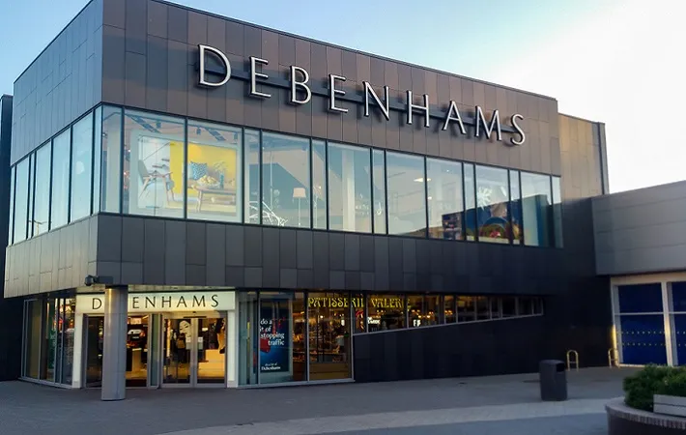
Source: (Ediss, 2022)

Process and Stages of Marketing Debenhams
According to Philip Kotler “Marketing is the administrative process whereby marketers exchange their products among others”. Marketing mainly help businesses to create cohesive value among customers through attractive packaging, innovative product design and other distinctive features (Annualreport, 2022). Through marketing, Firms mainly focus upon three fundamental concepts involving production capacities, managing quality standards and monitor campaign development. During this pandemic, Digital marketing has set new era of flexible and convenient shopping among customers. During COVID 19 recession, Firms has adopted different digital marketing strategies such as Zoom Classes, Facebook Live and Instacart shopping sessions to interact with customers (Xu et al., 2022). Thus, Marketing is completely changing the entire market scenario through insightful educational materials, conducting Q&A sessions, massive online shopping and limited time promotions to attract large customers. Thus, Marketing is quite essential to strengthen audience connections and listen to other’s perspectives (The Economic Times, 2022). The marketing process is broadly classified into different aspects. Some of the major stages are as follows:
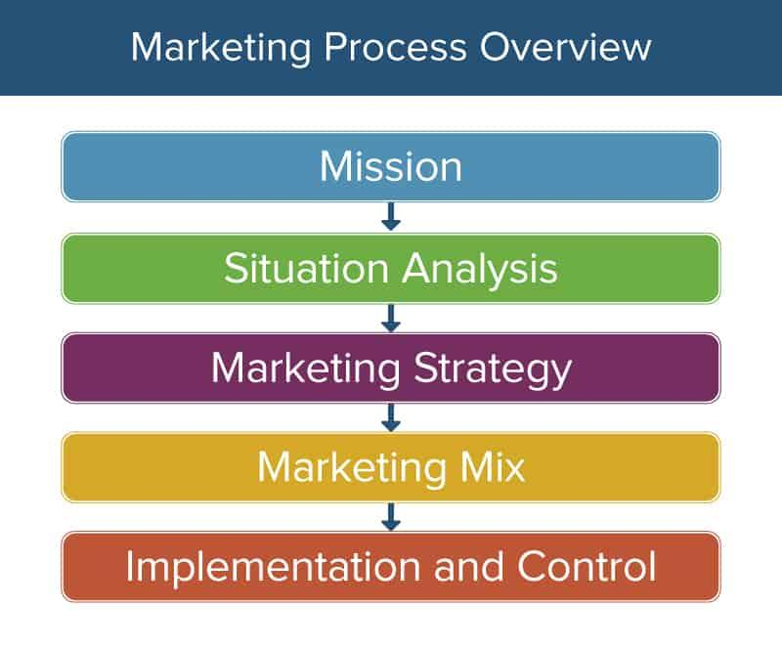
Source: (Ediss, 2022)
Mission: Strategic marketing mainly involves setting realistic goals and parameters to retain customer confidence. For example, Debenhams is committed towards creating best lifestyle-oriented and household brands for customers such as Fizz, Principles, Monsoon, TTK Confectionary, and Tog 24 (Xu et al., 2022). Thus, a clear mission statement inspires staff members to work harder towards better customer service. It truly indicates that how business have executed their marketing strategy to achieve long-term returns.
Situational Analysis: It completely evaluates the internal and external environment within business operations. Situational analysis mainly determines the overall financial and social position of business. It pays towards current customer perspectives, marketing needs and company’s positioning (The Economic Times, 2022). For example, the competitive advantage of Debenhams ultimately lies in its differentiation. The company always focuses upon new product categories such as personal care and room refreshments to gain immense superiority over customer proposition.
Marketing Strategy: Here, Firms mainly focus upon target audience, price sensitivity and commitment. The company often set simple and precise goals to attract customers (Michael et al., 2022). The marketing team mainly considers several parameters for the successful execution of marketing plan such as public relations, staffing costs and branding to prioritize customer needs. For example, Debenhams may focus upon warranty packages, quality standards and positioning to attract customers.
Marketing Mix: This feature mainly determines the product, promotional and placement strategy for customers (Ediss, 2022). For example, Debenhams has established its own global research & development facilities to customers. For example, Debenhams has mainly committee sponsorship programme where customers can get complete information about shipping delivery status and delivery charges.
Implementation and Control: At this stage, Debenhams often persuades customers to purchase their products and services (Annualreport, 2022). Under evaluation plan, the company mainly concentrates upon weekly action steps, marketing appointments and monthly benchmarks to track customer satisfaction.

Internal and External Analysis of Debenhams
SWOT Analysis of Debenhams
It is a systematic planning process that determines suitable strategies and capabilities acquired by business for long-term success (Xu et al., 2022). Firms often use SWOT Analysis to revamp their internal procedures and alternate their plan as per changing scenarios. This ultimately allows organizations to pursue new direction and overcome challenges. Some of the major aspects are as follows:
Strengths: Debenhams mainly focus on develop diversified income stream to improve the shopping experience of customer. The Company has high brand equity in fashion and brand recall among customer mind. Debenhams has operated more than 150 stores in 20 countries across the world (The Economic Times, 2022). The Company focuses on high-quality fashionable clothes for excellent customer experience. In 2020, Debenhams has employed more than 30,000 people for smooth working in the competitive market. In Denmark, the Company has introduced over 75 new brands. The Company continues focus on review of international market presence to grab the customer attention (GURL, 2017). In 2018, Debenhams have over 475 suppliers to fulfill the increased demand of customer. With the help of partnership, Debenhams develop a channel to maintain strong presence in global market.
Weaknesses: In pandemic, the Company analyzes the dip in store sales and profit margin. Competitors often duplicate Debenhams products in order to gain customer attention. This makes challenging for Debenhams to secure their trademark and logo (Ediss, 2022). The Company does not focus on marketing strategy to target different types of customer segments. In global outbreak, the Company makes a huge investment in R&D especially to grab customer attention for future success (Michael et al., 2022). Debenhams mainly focus on inflexible organizational structure that direct impact on the decision making power and administrative of the firm.
Opportunities: In epidemic, the Company adopts latest technologies and innovations to improve the customer service. With perspective partnership, Debenhams has increased its market share and customer base for future development (Xu et al., 2022). In pandemic, the Company mainly focuses on restricting policies and regulations to improve the shopping experience of customer. With marketing strategy, the Company understands the latest opportunities in new segment and geographic (Paruchuri, 2019). In pandemic, Debenhams mainly focus on expansion of new store in local and international market to become successful. With the help of technology, Debenhams main aim is to build a new franchise service model for future development (Reichstein and Brusch, 2019). The Company mainly focus on understand the customer preference and choice at fashion industry to become successful in the global marketplace.
Threats: In the fashion industry, the Company has faced tough competition from domestic player, and it also affects the profit margin of the firm. The main competitor of Debenhams is Next, M&S, and River Island (Michael et al., 2022). During the global outbreak, the raw material prices are increased that increase the input cost. The company has also faced legal controversy over consumer fraud class action lawsuit which may lead to customer dissatisfaction.
PESTLE Analysis of Debenhams
It mainly refers to in-depth study that examines certain external factors such as political, technological and social trends which affects business performance (Perera, 2017). This model helps organizations to develop effective strategies to deal with economic recession and mitigate possibilities of market failure. PESTEL analysis is summarized into different environmental factors which are as follows:
Political Factors: During this pandemic, Debenhams is deeply affected by new high in saturated fat, sugar and salt (HFSS) guidelines to manage their business operations. Thus, frequent changes in HFSS guidelines have negative impact upon consumer goods operations (Annualreport, 2022). Apart from this, the government is also providing greater support to retailers who want to expand their business into overseas markets. This government support acts as profitable opportunity for Debenhams to set up its own online shop in Asian and European market. With political stability, Debenhams is highly committed to create fair and sustainable environment for customers. The company has also established its own political action committee that supports new candidates at the federal and state level (Reichstein and Brusch, 2019). On the other side, strict self-quarantine measures have enforced Debenhams to shut down retail stores.
Economic Factors: Higher disposable income is the most important economic indicator for financial growth of Debenhams (Ediss, 2022). The company often generates higher disposable income through North America and Europe which may boost sales collections. This may ultimately allows P&G to increase their penetration in developing countries. However, COVID 19 has brought greater downfall in customer spending around 50% which may affect business operations. During COVID 19, Debenhams has mainly recorded £500 million loss due to strict social distancing norms (GURL, 2017). The pandemic has enforced Debenhams to cut more than 12,000 job cuts and redundancies which may weaken profit margins.
Social Factors: The current global outbreak has increased the demand for healthy & nutritious products among customers. This is a greater opportunity for Debenhams to introduce more nutritious and affordable protein smoothies for customers (Annualreport, 2022). During this pandemic, the company has introduced new digital initiative is to provide financial support to families which are deeply affected by current economic recession and natural disasters. During COVID 19 recession, the company has established marketing campaign to offer greater education and healthcare services to local communities (Vega, 2022).
Technological Factors: Debenhams is constantly focusing upon latest technological trends to strive innovation within fashion and clothing segment (Teoli et al., 2019). During this pandemic, the company has launched its new companion website with new brands where customers can easily take virtual tour of Debenhams innovative lab and explore live product demonstrations (The Economic Times, 2022). In this way, the consumer goods retailer often encourages customers to purchase products from live show. On the other side, the company has taken advantage of artificial intelligence to boost the confidence of employee and improve customer experience.
Environmental Factors: Over the past few years, Debenhams is trying to make valuable contribution towards the sustainable development of countries. The company has also set new benchmark for UK department’s stores retail in 2020s (Perera, 2017). The consumer goods retailer has established its own sustainability goals named Ambition 2030 to promote water conservation, renewable electricity and reduce carbon emissions. The company has also implemented sustainable practice leading to reduce the CO2 emission to protect the environment. These initiatives mainly help Debenhams to support vulnerable species and achieve 100% sustainable certification to gain customer satisfaction.
Legal Factors: Increasing health & safety regulations mainly helps Debenhams to deliver superior quality products to customers (Paruchuri, 2019). With such higher standards, the company can easily claim that their products are much better as compared to other rivals. On the other side, the consumer goods retailer has faced several accusations over patents and other copyright issues which may disrupt business reputation. In pandemic, Debenhams mainly focus on health and safety regulations to engage the employee at the workplace (Rapo, 2019). These accusations will make company vulnerable towards market losses which may tarnish brand image.

Segmentation, Targeting, and Positioning
Market Segmentation: Debenhams mainly consider demographic segmentation to target customers based on social class, personality, age and household consumption. For example, Debenhams often target market based on gender. With this strategy, the Company mainly focuses on diversified target audience in different market segment (Teoli et al., 2019). Through latest marketing, Debenhams redesigned their products or service to improve the customer service and maintain brand loyalty. The Company mainly focuses on online marketing to continue rapid growth in mobile demand of 20% in 2018 for future development. Through strategic partnership, the Company mainly focuses on satisfaction of increased customer and demand (Perera, 2017). On the other side, Low income families can easily fashionable products or service. Moreover, Debenhams completely responds towards the needs of each and every age group from small infants to middle aged adults.
Target Audience: Debenhams mainly target 18-49 aged customers who are quite smart, open-minded and attracted towards high quality standards. The target audience of Debenhams ultimately belongs to young mothers, highly educated professionals, upper and middle class shoppers (Vega, 2022). The company always focuses upon differentiated marketing to create remarkable value among customers. Moreover, Debenhams has introduced several brands under particular product category. For example, the Company mainly focuses on fashionable design and quality to grab the customer attractiveness. Through offering products, and marketing variation to segment, Debenhams may get a higher profit margin to maintain strong position in the global marketplace (Weinstein, 2013). With the help of social media marketing, the Company mainly focuses on latest news, analysis, and opinion of target markets for future development.
Positioning: Debenhams always positioned itself as distinctive brand among customers. The company often tries to create distinctive brands to make customer loyal towards company’s goals and services (Shtal et al., 2018). For example, Debenhams has maintained powerful position as family-oriented fashionable clothes brand among customers. The Company mainly focus on stores is continues to be downsized to keep up with local competition. With the help of latest technology, Debenhams mainly focus on necessary changes to maintain brand positioning at global level.

Marketing Mix of Debenhams
It is a strategic tool that helps businesses to select right promotional & distribution strategy to endorse their products among customers (Pandya, 2013). The marketing mix mainly outlines the services, procedures and brand positioning of business for the long-term survival. It often involves several aspects which are as follows:
Products: Debenhams is a leading British multinational retailer in the UK and Ireland. The Company mainly deals with variety of products like clothing, households, furniture and other to fulfill the increase demand of customer (Weinstein, 2013). Debenhams mainly focus on clothing item of men and women to maintain strong position. In pandemic, the Company focuses on designed branded products with exclusive designers such as Laura Oaks, Andrew Fionda and other to grab the customer attention. The Company also develops an online website or digital channel to improve experience of online customers. On the contrary side, the company is constantly working towards all-paper packaging to make their products more effective and appealing among customers.
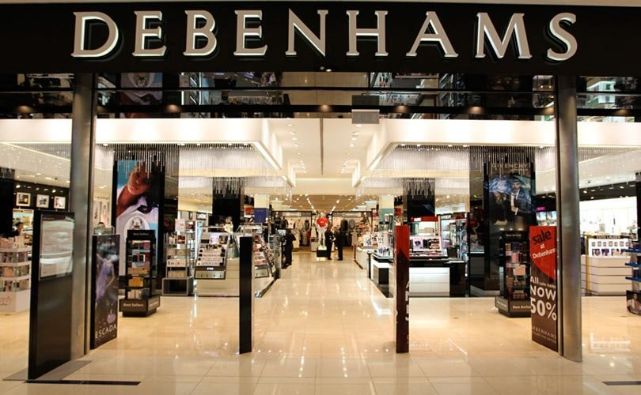
Source: (Shtal et al., 2018)
Price: Debenhams mainly considers three different pricing strategies such as penetration, competitive and premium pricing strategy to generate higher revenue. The company usually sets its products based on competitors (Pandya, 2013). With marketing strategies, Debenhams focuses on online sites and social media platform to fulfill the increased demand of customer. In pandemic, the Company also offering long duration discounts for clearance of unsold stock to reduce the negative impact on firm. The Company focuses on direct channel to extend the sales margin and profit margin. For fresh fashion, Debenhams mainly charges premium market base price to improve the customer demand.
Place: Debenhams often try to distribute their products through retail outlets, supermarkets and chemist shops. Apart from this, large number of authorized dealers and hospitality brands use Debenhams brands for international expansion (Weinstein, 2013). Moreover, the company utilizes several distribution channels such as e-commerce platforms, membership club stores, wholesalers and pharmacies to sell vast quantity of products among customers. The Company managed more than 240 departmental stores around 27 nations. Debenhams international channel over 67 stores in 22 countries to grab the customer attention (Rapo, 2019). The Company also develops mobile app and online website to improve the customer experience.
Promotion: Debenhams focuses upon both traditional and digital marketing techniques such as TVC, trade shows and print advertising to promote their products among customers. Additionally, Debenhams mainly conducts several marketing campaigns to create incredible impressions among customers (Shtal et al., 2018). With social media platform, the Company reached more than 6 million customers across the world. In global outbreak, Debenhams mainly focus on creative concept, filming, and it implementation to capture the heart of customer. The Company conducts CSR activities to improve the community relationship for future development.
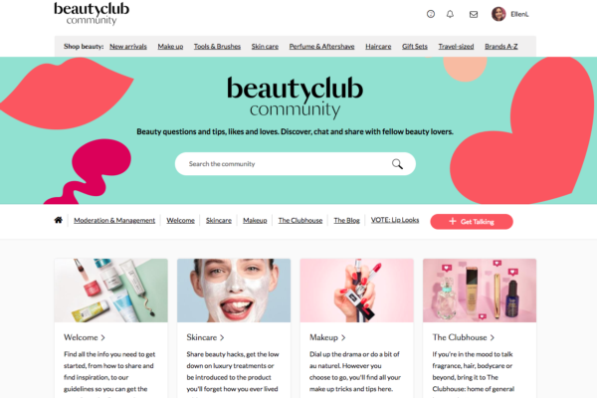
Source: (Pandya, 2013)
People: Debenhams has mainly employed highly dedicated workforce to deliver excellent customer service. The company has 30,000 employees that provide innovative suggestions towards excellent customer service. The company conducts wide range of health & wellness programs for employees to ensure their wellbeing (Weinstein, 2013). Debenhams offer several benefits to employees such as private medical insurance, health plan and other competitive salary packages to customers.
Process: Debenhams has mainly adopted efficient integrated working systems to improve manufacturing processes and reduce operational costs (Pandya, 2013). This system mainly helps Debenhams to overcome distribution challenges and achieve operational excellence.
Physical Evidence: Debenhams mainly focus upon recyclable packaging and colorful logo to present itself as unique and innovative consumer goods brand among customers (Rapo, 2019). The company mainly emphasize upon differentiation concepts and sustainability aspects to maintain long-term relationship with customers.

Conclusion
The report concluded that Debenhams has achieved remarkable position in global consumer goods segment due to its diverse portfolio and innovations. It has been evaluated that Debenhams mainly consider House of Brand to offer distinctive clothing, furniture and household items to customers. It also evaluate that Debenhams often try to distribute their products through supermarkets, whole sale distributors and R&D centre. The report has evaluated that current COVID 19 pandemic has enforced Debenhams to become more sustainable and innovative leader in global marketplace. The report has indicated that Debenhams mainly consider competitive pricing strategy to gain customer satisfaction.

Reference List
Annualreports.com. 2022. [online] Available at: <https://www.annualreports.com/HostedData/AnnualReports/PDF/LSE_DEB_2018.pdf> [Accessed 3 January 2022].
Ediss, S., 2022. Helping Debenhams to win 'Best Social Media Campaign' at the World Retail Summit.. [online] Thegatefilms.com. Available at: <https://www.thegatefilms.com/blog/helping-debenhams-to-win-best-social-media-campaign-at-the-world-retail-summit> [Accessed 3 January 2022].
GURL, E., 2017. SWOT analysis: A theoretical review.
Michael, C., Ronkainen Illka, A., Kotler, P., Keller, K., Manceau, D. and Dubois, B., 2022. Marketing Approach (An). ESCE CURRICULUM, 2, p.84.
Pandya, K.V., 2013. 4 Managing marketing information for value. Principles of Marketing: A Value-Based Approach, p.103.
Paruchuri, H., 2019. Market segmentation, targeting, and positioning using machine learning. Asian Journal of Applied Science and Engineering, 8, pp.7-14.
Perera, R., 2017. The PESTLE analysis. Nerdynaut.
Rapo, N., 2019. Marketing the high street: a solution to the British retail crisis?.
Reichstein, T. and Brusch, I., 2019. The decision‐making process in viral marketing—A review and suggestions for further research. Psychology & Marketing, 36(11), pp.1062-1081.
Shtal, T.V., Buriak, M., Ukubassova, G., Amirbekuly, Y., Toiboldinova, Z. and Tlegen, T., 2018. Methods of analysis of the external environment of business activities.
Teoli, D., Sanvictores, T. and An, J., 2019. SWOT analysis.
The Economic Times. 2022. Debenhams shuts all stores, around 12,000 jobs lost. [online] Available at: <https://economictimes.indiatimes.com/news/international/business/debenhams-shuts-all-stores-around-12000-jobs-lost/articleshow/80449459.cms?from=mdr> [Accessed 3 January 2022].
Vega-Rosado, L.L., 2022. The 3D IFB SWOT Analysis as a Strategic Tool to Develop Entrepreneurial Plans for Family Businesses. In Research Anthology on Strategies for Maintaining Successful Family Firms (pp. 268-294). IGI Global.
Weinstein, A., 2013. Handbook of market segmentation: Strategic targeting for business and technology firms. Routledge.
Xu, Z., Zhu, G., Metawa, N. and Zhou, Q., 2022. Machine learning based customer meta-combination brand equity analysis for marketing behavior evaluation. Information Processing & Management, 59(1), p.102800.

Internal and External Analysis of

