Name: Sharon Cuthbert
Student No: 2409782
Word Count: 4288
Evidence Based Practice
CIPD_5CO02_24_01
Part One
(AC 1.1)
Evidence based practise [EBP] is a process where evidence from reliable sources is used to develop knowledge and understanding to inform sound decision making. According to Barends, Rousseau and Briner (2014, cited in Peoples Practice A Complete Guide CIPD pp.47-48) it involves the use of multiple sources of evidence and empirical results as a means of attaining knowledge, and also provides for the opportunity to support current and future HR practice and achieve better decision-making.
Robust decision-making can be quite challenging. People professionals are often confronted with a range of people and business-related issues during their typical workday that require decisions of some kind to be made, some of which can be complex.
We would use the EBP when gathering evidence from sources to give a better outcome during investigations in the workplace. There are quite a few methods HR would use to assist with the investigation, ranging from internal investigations to external sources.
When investigating, it is critical we gather as much relevant information relating to the investigation because the implications of getting it wrong can be immense in HR.
The workshop illustrated how 4 sources come into practice, and how we would use them as evidence to gather information:
4 sources
- Practitioner expertise:
- Look at the evidence and ask, why is there a problem, have we seen this problem before, how serious is this problem, are we facing a big or small problem. Are there possible solutions?
- Organisation data:
- E.g. you could focus on women in the workplace by analysing data of their progression.
- Scientific evidence:
- E.g. what do we know about interventions to increase the number of women in senior management.
- Stake holder perspectives:
- E.g. talk to managers, the women themselves, shareholder- what do they think about this problem, what kind of problem is it? If a problem, what do they think about possible solution(s).
A robust process would include, where feasible, elements of all of the above then evaluate them to ensure biases are removed from the evidence using a critical mindset.
According to Nigel Cassidy podcast 169 CIPD (2024), Evidence-based L&D - ‘Why does evidence matter?’ | Podcast | CIPDwe use EBP when fiercely focusing doing things which have a direct impact on effective learning and how it’s going to affect the organisation positively, and how we use evidence to improve, disprove and approve.
There are many different ways to which we can apply EBP to our decision making, and where you start gathering information from and how you start applying it.
The steps to Evidence-Based decision-making can be illustrated as the table below, as per the information from the textbook (People practice a complete guide. p.49) As illustrated in People Practice: A Complete Guide P. 49. Briner (2019) provides valuable insight into evidence-based decision-making.

6 STEPS

1 | Asking  Gather as much information.  HR data, employees, managers and external sources, like shareholders, employment law etc.
2 | Acquiring  Retrieve and gather all evidence from statements, for example.
3 | Appraising  Judge that the evidence gathered is relevant and trustworthy- this is a critical stage.
4 | Aggregating  Ensure you have gathered enough evidence.
5 | Applying  Combine all the evidence ready to start your decision-making process.
6 | Assessing  When a decision has been made, evaluate the outcome to ensure it’s a fair decision.
The steps above will increase the potential of a robust outcome.
(taken from the assignment brief EBP (AC 1.1) and input some of my own knowledge to give an explanation) – (Cuthbert.S.2409782)

Below are some example scenarios based from on my own knowledge combined with the podcast from YouTube from where Rob Briner (2022) discusses where how EBP can be applied and lead to improved outcomes:
rob briner evidence based practice - YouTube
1, Disciplinary Investigations and hearing:
To ensure we know the full facets of an issue with an employee, we need to gather and appraise all of the relevant information which will include witness/manager statements, performance reports, time/attendance records, etc. We can identify potential biases in the information, e.g. by looking at the relationships with the manager. In aggregating we would ascertain whether we have secured enough robust information to enable the decision formulation. The outcome can be assessed to ensure it is fair and reasonable for the employee as well as having the appropriate effect for the business.
2, Production quality issue:
In this case, applying the 6 steps can provide a route cause of the defect and what needs to be focused on to remedy it. We would collate and appraise all of the relevant information including supervisor/technician reports, quality check data, operator statements, etc. We can then appraise if the information is susceptible to bias and, if so, will need to be scrutinised and evaluated against factual data – e.g. were the machine parameters changed by the operator that caused the defect? If so, the operator statement may be skewed, but the machine logs will have documented the changes made.
We can assert that using EBP will inevitably lead to a clearer understanding of the issue(s) which will lead to a better quality of decision on the resolution.
When considering the effectiveness of EBP, we can see from the examples above:
- The absence of this process could lead to the wrong decisions being made due to incorrect identification of the problem. E.g. based on a perception that is incorrect.
- Further to point a., could lead to an incorrect/less effective solution.
- Setting out the steps in a logical way ensures simplicity and is repeatable.
- Coupling the 4 sources and the 6 steps should ensure a robust outcome/decision.
- We have defensible justification/under pinning of any decision that is made to aid in communication to relevant stakeholders or if challenged.
- Meticulous record keeping is essential to aid in the integrity of the outcome.

Briner, R, (2022) Evidence-based practice [ You Tube ]. Available at: https://www.bing.com/videos/riverview/relatedvideo?q=rob%20briner%20evidence%20based%20practice%20-%20YouTube&mid=8C0379CAA450E64BD79D8C0379CAA450E64BD79D&ajaxhist=0. (Accessed 25 Jan 2025).
Waite, K, Beevers, K, Small, N, Tomlinson, K, Hussain, S, and Briner, R, 2019. People Practice: A Complete Guide. P. 49.
Cassidy, N, 2024. Evidence-based L&D: Why does evidence matter? ( No 169) [Audio podcast]. CIPD. Avallabile at: https://www.cipd.org/uk/knowledge/podcasts/ld-why-does-evidence-matter/

(AC 1.2)
There are many analysis tools to aid an organisation in understanding its current performance and potential sources of change, or challenge, in the future. We consider SWOT to be a good example of this.
SWOT:
Represented in a grid table form, a SWOT analysis illustrates what the business is doing well, not so well, and what positive/negative influences may affect the business in the future. The consideration of the outputs of the SWOT analysis can inform future strategies.
Strengths  Comprehensive and Robust procedures | Weaknesses  Poor Business Culture
Opportunities  Recognising the poor company culture with the opportunity to introduce team building days. | Threats  A new rival business has opened up a facility in close proximity to our facility
[CIPD Factsheet, online] Tile: Learning Outcome 3 | Evidence-Based Practice (BMPD5017) | Home
Taken from the CIPD Factsheet According to CIPD, 2023. People analytics (EPB BMPD5017), people analytics is a method of analysing data about people to solve business problems. By integrating people analytics into the swot analysis, we gain actionable insights that allow for data-driven decision-making. This approach not only highlights internal and external factors but also ensures a proactive stance in addressing challenges and leverage opportunities.
See below, the SWOT tool with People Analytics integration examples:
1, Strengths
- Robust procedures are a key organisational strength. Sets out clear expectations relating to how the business conducts its activities. Clear roles and responsibilities allow employees to understand how they should perform their jobs. Removing ambiguity enhances employee well-being as well as more consistent and desired outcomes from operations.
2, Opportunities
- The business has identified that the introduction of a 4-day working week will lead to greater employee morale and, therefore, retention.
3, Weakness
- Employee competence is not commensurate with industry standards. A training needs analysis will need to be undertaken to fully understand this, and remedial action taken.
4, Threats
- The emergence of a competitor nearby poses a threat to employee retention. We can forecast potential attrition risks, particularly among employees who may be tempted by opportunities at the rival company – we need to implement competitive retention strategies.
Some of the advantages of using these tools are:
- Visual summary of factors that can impact the performance of the business.
- It is succinct, therefore useful in stakeholder engagement.
- Gives insight at the micro and macro levels:
  - Strengths and weaknesses - Micro as looking inwards at what we are doing well and not so well.
  - Opportunities and Threats - Macro as looking outwards at what could impact the business positively or negatively, albeit at a high level.
- Ease of use and understanding.
- Due to the potential broad range of application within the business environment, is considered flexible.
- Can be used to form future strategies and prioritisation.
Disadvantages or limitations using SWOT:
- May not fully describe potential sources of external influence on the business. We could use PESTLE for a more comprehensive understanding of external factors.
- We would need to understand the detail to lead to a more robust strategy/decision making.
CIPD, 2023. People analytics. [Factsheet] Available at: https://www.cipd.org/uk/knowledge/factsheets/analytics-factsheet/
(AC 1.3)
According to the textbook (Studying Human Resources Management A guide to the study, Context and Practice of HR pp.199-200) According to Howlett (CIPD, 2019, cited in Studying Human Resources Management, 3rd ed, pp. 200-201) critical thinking builds upon the principles of EBP in the sense that it seeks to ask good questions. Whereby an uncritical thinker may display egocentric and sociocentric tendencies, a critical thinker tests claims and assumptions in order to explore the bigger picture. A critical thinker will reflect on ideas rather than just positively accepting them, thus leaving them able to solve problems more effectively and creatively.
CIPD website Critical thinking | Podcast | CIPD with Pippa Lamb, Warren Howlett and Tim Coburn discusses why they think critical thinking is a key skill for HR:
They assert that critical thinking is the ability to think well and to critically reflect on the ideas, opinions and arguments of others, as well as problem solving and decision making.
There are three key parts to critical thinking for people professionals.
1, Critiquing the ideas, opinions and arguments of others.
Listening to other’s input and ascertaining is it correct, does it contain personal/organisational bias, assessing the usefulness of their input.
2, Construct arguments and opinions themselves that they are communicating to others.
Understand the subject matter yourself and form an opinion, based on EBP outputs. We must then consider how we communicate this to others considering the message to be conveyed and the method of conveying. Consideration needs to be given on our level of influence in the forum.
3, Identify when others are using critical thinking techniques that impact how that people professional is making a case or building an argument/making a business case.
If we consider other are using these techniques, will aid in our understanding and justifications of their assertions/viewpoint.
They also suggested that good preparatory work prior to discussions/meetings, should lead to relevant aspects being discussed – opposed to the discussions running off topic to something unrelated to the subject matter.
As an example, we have a solicitor attending the meeting that you need critical advice from. This, in itself, is a good indication that you have gathered all the critical information you need during the meeting because these meetings could be sporadic and only happen maybe once a month, and you may need to gather important information relating to your case. If we haven’t, then we may not get the results you were looking for.
We can apply these principles in almost every aspect of business life. In almost every interaction between two or multiple people, there exists the potential for differing viewpoints. It will be essential that we understand the integrity of others’ ideas and viewpoints to gauge whether there is a misalignment with our own. Understanding this will allow us to evolve our own thinking and formulate a more rounded response.
Taylor, S. and Woodhams, C., 2022. Studying Human Resources Management: A guide to the study, context and practice of HR. 3rd ed. London, United Kingdom; New York, NY: CIPD: KoganPage.
(AC 1.4)
Making effective decisions, you will need to apply your skills to select the most appropriate approach for the context you are operating in and the kind of decision you need to make. Good decision-making skills will enable you to understand what information you will require and how best to use it to inform your decision, as well as helping you to avoid unhelpful or biased assumptions, and recognising the degrees of uncertainty and risk involved and whether these are acceptable in the circumstances. Understanding the implications of your decision, including the impact on departmental and organisational objectives, will help you to avoid costly mistakes and make decisions that add value to your business. (Decision making – CMI (managers.org.uk)
HR practitioners are central to decision making in organisations due to their involvement with employees and their experience in organisations. There are many models and techniques that outline ways that decisions are made and can be improved through systematic evaluations. One such example is the Edward De Bono `Six hats` technique. (Muler,2019). This technique encourages decision-makers to consider many ways of thinking about a problem and decisions based on different colour hats. Furthermore, CIPD (2015a) cited in Studying Human Resource Management, 3rd ed, p.201, highlights that there is no straightforward solution for addressing ethical dilemmas in the workplace, however, the eight lenses provide people practitioners with various perspectives to help them gain a deontological understanding of what is right and wrong.(Studying Human Resources Management 3rd Edition, p200). Each colour hat represents a different emotion/perspective, allowing the individual to compare and evaluate options, critically. Whilst it is possible for one person to take on multiple hats, the method can work successfully in teams, such as a project team making decisions on the implementation of a new people system.
Blue Hat – Organisation and Planning
The blue hats’ purpose is to ensure that the six hats method is implemented to enable enhanced effectiveness. To ensure the group stay focused on the objective – E.g. When meeting participants veer off the subject of the meeting to pursue their own agenda, the blue hat [E.g. HR Manager] needs to reaffirm the objective and topic.
Green Hat – Creative Thinking
The green hat are the creative thinkers, thinking of alternative or new ideas – E.g. we need to explore ideas to enhance employee retention- the green hat can develop ideas not thought of by others, like implementing a 4-day week, which isn’t considered by others due to not thinking of it or due to bias.
Red Hat – Feelings and intuition
The red hats are tuned into the human side – E.g. we have an intuition that Bob, who is constantly late, is moonlighting in Tesco at nights.
Black Hat – Risk Management Hat
The black hat, one of the most powerful of the 6, identifies risk, problems or challenges. They also strive to provide solutions or mitigations – E.g. If a manager wishes to terminate an employee’s contract due to performance, yet the employee has not been through any performance appraisal meeting, then the black hat would raise the issue but may suggest they conduct a performance review with the employee and put in place a performance improvement plan.
White Hat – Information gathering
Gathering information and analysing objectively – E.g. In the case of a disciplinary issue with an employee, the white hat would be focused on gathering data free from bias and ensure it is recorded factually.
Yellow Hat – Positives/Optimism
The yellow hat focuses on positives and seeks value and benefit– E.g. An employee wishes to go part time, it could give the opportunity for another employee to get some valuable experience in performing this role.
Another example of a decision-making process would be Best Fit– this is contrary to Best Practise in respect of best fit aligns to the premise that there are no universally applicable solutions. To explain this further, it is built upon an understanding that a vast majority of employers or employees will have different needs. Best fit allows the versatility of adapting to these varying needs.
The best fit approach still demonstrates a link between HR practises and business performance by modelling the approach to suit the individual business needs, arguably, making it more efficient and effective.
Taylor, S. and Woodhams, C., 2022. Studying Human Resources Management: A guide to the study, context and practice of HR. 3rd ed. London, United Kingdom; New York, NY: CIPD: KoganPage.

(AC 1.5)
Ethics is a set of principles often defined as a code that acts as a guide of conduct for employees that can be used to promote ethical behaviours.
An organisations visons and values that align with Ethical Principles, produces a positive mindset and working environment. Below I will mention two ethical perspectives we can consider:
- Deontology – doing the right thing based on justice, fairness and equality, based on the assumption that there are fundamental rights and wrongs.
Example: A business recognises that disabled access into the office building is inadequate and causes unfair challenges to customers or employees that are not fully able-bodied. To correct this, they install ramps and lifts to make it easier for access / egress. This is fair and promotes equality but not necessarily benefits a large proportion of people.
Impact: A useful perspective in that it is not focused on the greatest level of impact for the majority but instead, considers any areas of injustice/unfairness. The impact for the people/organisations involved will mean they feel more valued.
- Utilitarianism – aim for the greater good for the greater number. It is the theory of morality and considers decisions/actions that result in happiness as doing the right thing.
Example: Trade union negotiations for better pay and conditions illustrates driving for a better position for a majority of the work force.
Impact: This has a greater impact due to the needs of the many being considered as a higher priority – this leads to greater levels of satisfaction throughout the organisation. However, arguably, the impact per individual may not be as great.
The above perspectives describe two differing motivational desired outcomes – for decisions, do we focus on only what is fundamentally correct or do we aim for the best available outcome for the majority. It is feasible that these two perspectives can be used in parallel – e.g. focusing on what is right is in the best interests of the majority.
Recognising the CIPD eight lenses gives us varied perspectives, as a subset of the Deontology approach described above, from which to approach a decision that ensures a more considered and justifiable response. There is effort to be expended on getting to a point that the decision or resolution is the optimal outcome. However, there is a perspective that may suggest that the status quo is optimal and requires no resolution – this would mean nothing improves. Please see below the eight lenses:
- Fairness
- Everyone in an organisation should be able to agree to it, whatever their place in it.
- Merit
- Jobs and their rewards should track talent and hard work.
- Markets
- Jobs and their rewards should follow from voluntary market exchanges.
- Democracy
- No one should be subject to a regime in which they have no say.
- Well-being
- Work should be good for us.
- Rights and Duties
- Everyone has rights to do some things and to be free of some things, and everyone has duties not to violate others’ rights.
- Character
- Each of us should work to develop the best ethical character for our roles.
- Handing Down
- We can’t reinvent or master the world and are instead responsible for conserving and maintaining the small part of it over which we currently have stewardship, and for passing it on undamaged to our descendant.
CIPD RESEARCH REPORT AUG 2015 https://www.cipd.co.uk/knowledge/study-guides/critical-review-writing
Clark, S 2015, Ethical decision – making: Eight perspectives on workplace dilemmas.[Review] Lancaster University, Chartered Institute of Personnel and Development. Available at: https://www.cipd.org/globalassets/media/knowledge/knowledge-hub/reports/ethical-decision-making-2015-eight-perspectives-on-workplace-dilemmas_tcm18-9564.pdf
(AC 3.1)
It is important for organisations to measure performance on a perpetual basis. They give a high-level quantum on the status of the business at that given point. There are several aspects of performance that a business can measure, of which I will describe and assess two examples as follows:
- Financial – Gross Profit.
Gross profit is measured to understand the current financial performance of the business. It considers what the business revenue is versus what the costs are. To be considered in profit, the revenue should be larger than the costs. If revenue is less than costs, then the business is making a loss.
Advantages:
- Easily understandable metric on the financial health of the business.
- Assumptions can be made that things are going well without delving into masses of detail/data.
Limitations:
- Does not provide insight into the general health of the business – e.g. employee well-being, talent retention, etc.
- We cannot ascertain the sustainability of the business – Doesn’t give us order book strength for future work.
Analysing the under-pinning and peripheral information will alleviate the limitations but requires an understanding to correctly appraise the performance.
- Non-Financial – Employee Well-being
Employee Well-being can offer insight in to how the business is conducting its activities and to understand the overall perception of the business from the employees. A happy work force is productive and more likely to stay with the company.
Advantages:
- A simple metric to gauge the status at a point in time on employee satisfaction. We can also look at trends over time if this offers further benefits.
- Can indicate if there are problems as well as identifying where those issues lie – e.g. a specific department has low well-being scores when the rest are high. Therefore, we can concentrate our efforts there first.
Limitations:
- Can be subjective, so individual or group perception bias could skew the outputs.
- Does not demonstrate what aspects are being done well in the business and what are not.
According to Tim Stobierski (2020), understanding how organizations measure financial and non-financial performance enables professionals to make more informed decisions and add value to their business. Although finance may seem intimidating, learning key financial metrics is crucial for managers to contribute to strategic objectives and align their teams with the company’s goals.
The same process applies to the private sector, where businesses use both financial and non-financial performance indicators to assess their health and success. Key Performance Indicators (KPIs) help evaluate various aspects of performance, such as profitability, revenue growth, customer satisfaction, and employee engagement. KPIs provide measurable data, enabling businesses to track progress, identify areas for improvement, and ensure alignment with long-term goals.
Measuring performance continually is essential for businesses, as it offers valuable insights into their current status.
Financial metrics, such as Gross Profit, are often used to assess financial health. Gross profit compares revenue to costs, with profitability occurring when revenue exceeds costs. Advantages of measuring gross profit provides a clear, easily understandable view of a company’s financial health, allowing stakeholders to quickly gauge performance without extensive data analysis. However, gross profit does have limitations as it only offers a high-level view, potentially overlooking deeper issues like inefficiencies or long-term sustainability challenges.
Considering a non-financial metric, we can use the example of employee well-being as a key indicator of organizational health. Happy employees tend to be more productive and stay with the company longer. An advantage of tracking employee satisfaction over time provides insights into trends and highlights problem areas, for example, like departments with low well-being scores could be targeted for interventions. However, these metrics can be subjective and do not pinpoint specific strengths or weaknesses within the organization, requiring further analysis.
In conclusion, using both financial and non-financial metrics helps businesses understand where they currently are at a point in time as well as allowing them to make informed, strategic decisions.

Stobierski,T. (2020, May 5). Financial performance measures. Harvard Business School Online. Retrieved from https://online.hbs.edu/blog/post/financial-performance-measures

(AC 3.2)
I believe from my previous experience in the HR department, people practises are an integral part of the organisation as it deals with the majority of the aspects of human resources. Below are a few examples of typical activities:
- Design organisational structures.
- Recruit new staff.
- Payroll – ensure people are paid correctly and on time.
- Competency and training.
- Succession planning – business continuity.
- Personnel Performance monitoring.
- Etc.
From the list above we can see that no matter what the business purpose is, it cannot achieve this without people practise involvement. All aspects of an organisation will require people and as such will require some or all of the facets described above. We can assert that some of the activities are day-to-day operations, however, some are considered to be strategic in nature – e.g. Succession planning is essential for business continuity as well as personnel development.
We can see that these practises add value in a qualitative way with some being quantitative. Capturing quantitative and qualitive evidence and analysing evidence through a critical lens helps to improve decision-making.
If we focus on two elements from the list above, we can consider methods that are used to measure the impacts:
- Payroll – We can use quantitative data on things such as:
  - Numbers of people paid on time.
  - Numbers of people paid accurately.
This can result in a percentage being formulated to tell us the accuracy of payroll.
Using a qualitative approach, we can assess employee satisfaction, with payroll satisfaction being a part of that appraisal.
- People retention – Quantitative:
    - We can measure the attrition rates of our staff using data gathering.
Qualitative:
- E.g. We can gain further insight into reasons for people leaving the organisation.
I believe from my previous experience in the HR department, people practises are an integral part of the organisation as they impact key areas such as recruitment, employee development and performance management. By promoting a positive work environment, these practices help align individual goals with the organisational objectives, driving both employee satisfaction and business success, and according to Bryman et al (2018) cited in Studying Human Resource Management CIPD pp.121-122, qualitive data is usually based around words and meanings, rather than the collection and analysis of numbers. Quantitative data usually contains numbers and can be analysed through statistical analysis software and can help create a picture of what is happening in organisations.
Some typical HRM activities are:
- Design organisational structures.
- Recruit new staff.
- Payroll – ensure people are paid correctly and on time.
- Competency and training.
- Succession planning – business continuity.
- Personnel Performance monitoring.
From the list above we can see that no matter what the business purpose is, it cannot achieve this without people practise involvement. All aspects of an organisation will require people and as such will require some or all of the facets described above. We can assert that some of the activities are day-to-day operations, however, some are considered to be strategic in nature – e.g. Succession planning is essential for business continuity as well as personnel development.
We can see that these practises add value in a qualitative way with some being quantitative. Capturing quantitative and qualitive evidence and analysing evidence through a critical lens helps to improve decision-making.
If we focus on two elements from the list above, we can consider methods that are used to measure the impacts:
Payroll – Quantitative:
Payroll can be measured quantitatively by tracking the payroll accuracy rate, which indicates the number of errors over a given period, and monitoring the timeliness of payment. This will equate to a percentage of employees paid correctly and on time. The data will inform areas requiring addressing and improvement, for example.
Payroll – Qualitative:
Payroll can be assessed qualitatively by gathering employee feedback through surveys or focus groups to evaluate their satisfaction with payroll accuracy, payment timeliness, and the clarity of payroll-related communication. Again, this feedback will allow targeted areas of improvement as well as appraising the effectiveness of initiatives previously implemented.

Personnel Performance Monitoring – Quantitative:
Personnel performance can be quantitatively measured by tracking the distribution of performance ratings across the organization to identify trends and by measuring the percentage of individual and team goals achieved as part of the performance management system. This intelligence will aid in strategising requirements for the future to maintain and improve the performance.
Personnel Performance Monitoring – Qualitative:
Performance monitoring can be assessed qualitatively by using surveys or interviews to gather employee feedback on their satisfaction with the performance review process, including their perceptions of fairness, transparency, and constructiveness. Similar to the quantitative example above, we can use this insight to formulate initiatives for future improvements.
Taylor, S. and Woodhams, C., 2022. Studying Human Resources Management: A guide to the study, context and practice of HR. 3rd ed. London, United Kingdom; New York, NY: CIPD: KoganPage.

Part Two
Table 1 - Q1:
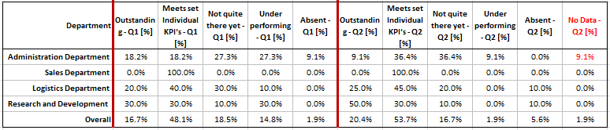
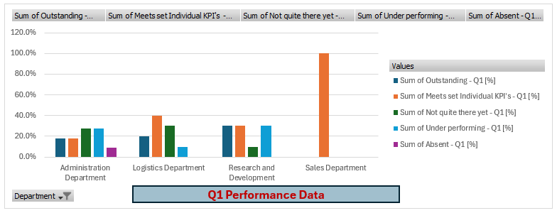
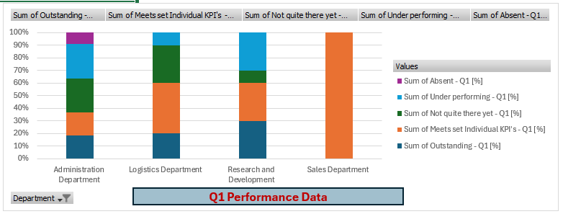
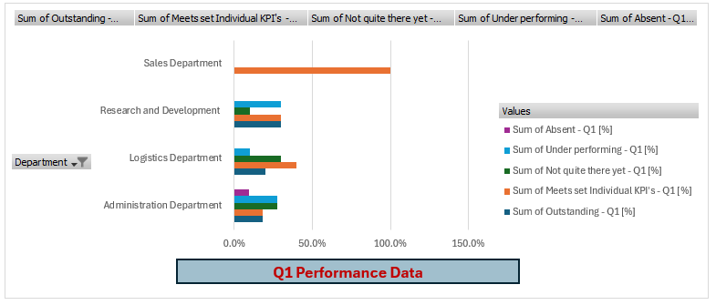
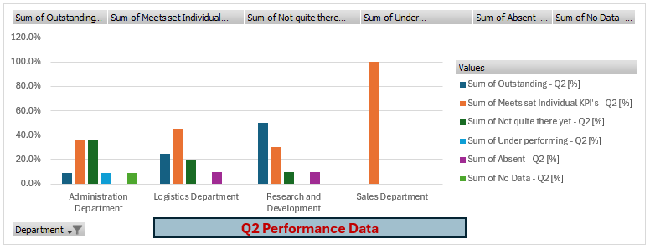
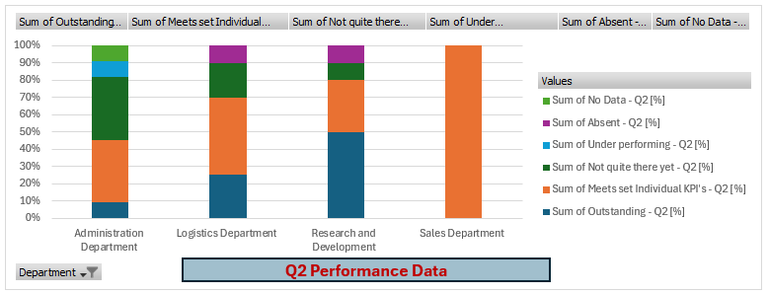

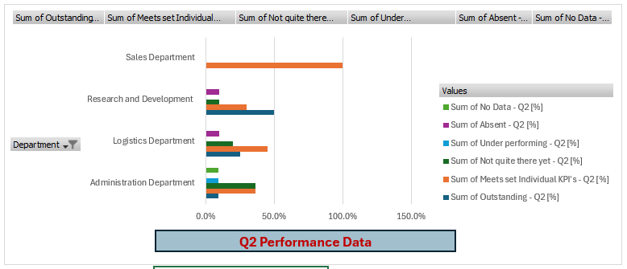

From an appraisal of the data provided, we can provide the following analysis:
- Q2 data is missing for Administration dept – We need to secure the missing data to ensure the data is complete.
- There are a few evaluations for team members missing in each quarter due to absences – Are they absent for the full quarter? What are the reasons for the persistent absences? Is the HR department aware of these? We need to delve in to this deeper to understand the issues to support the employees and managers.
- Overall, we can see a positive trend with the number of “outstandings” increasing from 16.7% to 20.4%. However, administration is bucking that trend with a decrease in this number. We need to investigate this further to see what the cause is and take action to help improve performance and increase the number of high performers.
- The administration department is also seeing an upward trend for team members moving from “Underperforming” to higher categories.
- There is an overall positive trend with team members moving from “underperforming” to higher categories. Although this is an upward trend, we must analyse to understand the cause of the improvements so lessons can be understood and assimilated.
- The Sales departments results seem curious and further investigation is required due to the consistent nature of the results across team members and quarters. Are the targets and objectives challenging enough? Is the manager appraising appropriately? Understanding the answers to these questions and subsequent correction, if required, will result in a more robust dataset and a more appropriate analysis.

Cost/Benefit Analysis:
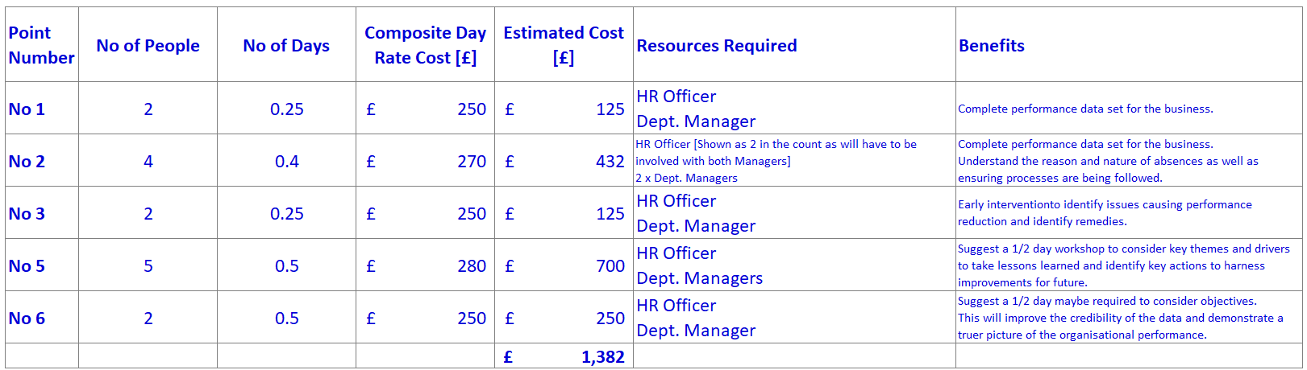

Table 1 - Q2:
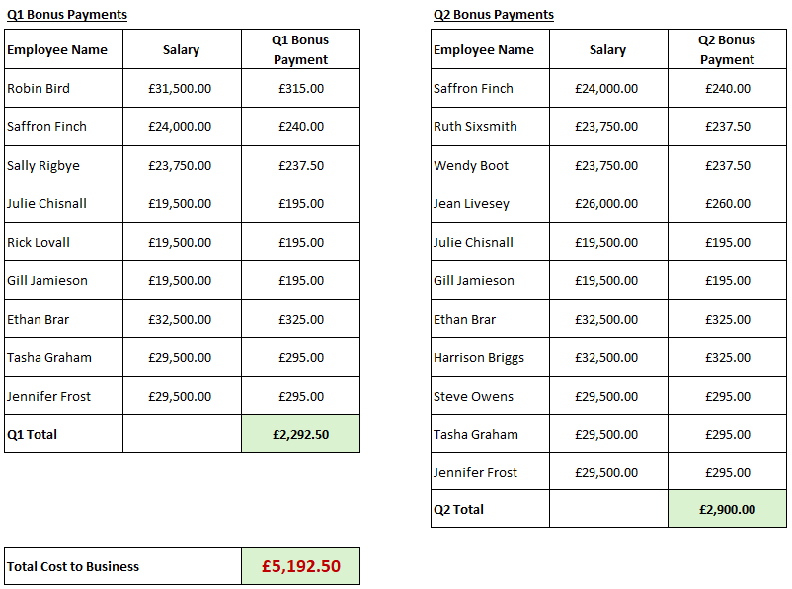


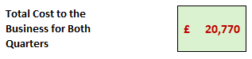
Table 2 –
The feedback tables offer insight into many aspects of the emotional intelligence as well as the operational performance of the business. There are a few stand out data points that we will consider useful:

Manager Feedback – All 50 have identified they have not had appropriate training to conduct appraisals. We would organise training for managers to conduct Performance Appraisals. This will have the added benefit in improving managers’ confidence in conducting appraisals. Taking this step will result in a better quality of appraisals being conducted and reduce the risk of challenge from the employees as well as improving the employees feeling more valued.

In the managers feedback, 82% suggest they are not comfortable in challenging underperforming team members. When we consider 63% of employees suggest they receive positive feedback, we have to consider “are these figures skewed due to a high proportion of managers struggling to deal with difficult topic areas?” Further analysis will be required and potential for additional training or mentoring for managers to better equip them to deal with challenges such as this. Unfortunately, this is a required element of the manager role to be able to proactively address underperforming individuals. If left, it is likely that underperforming individuals will continue to underperform and affect the performance of the business as well as upsetting other employees who are performing well.

58% of managers believe they conduct reviews fairly which correlates with 61% of employees believing they receive a balanced response from managers. – This tells us a consistent message but also confirms that managers need consistent and robust training when appraising employees.

The employee feedback overall suggests only 54% view the appraisals as positive taking all the questions asked as part of the feedback gathering – this percentage is considered very low. The low overall scores can be largely represented by the following issues:

- Managers providing clear and direct guidance – We need to better equip our managers to be able to lead departments. Confidence and communication abilities can be improved by various methods, including high performing teams’ workshops as described in CIPD (2023), training courses, etc. This will inevitably lead to efficiency and effectiveness improvements in the operations of the business.
- Managers not listening to employees’ ideas – this needs to be addressed as employees can be a great source of innovation and performance improvement, as cited in CIPD (2024). The risks of not addressing this could result in employees feeling undervalued, becoming disengaged and possibly even leaving the business.
CIPD, 2024. People-powered innovation. [Report] Available at:https://www.cipd.org/globalassets/media/knowledge/knowledge-hub/reports/2024-pdfs/8674-people-powered-innovation-report-web.pdf
CIPD, 2023. High-performing teams: An evidence review. [Report] Available at: https://www.cipd.org/globalassets/media/knowledge/knowledge-hub/evidence-reviews/2023-pdfs/8388-high-performing-teams-practice-summary.pdf

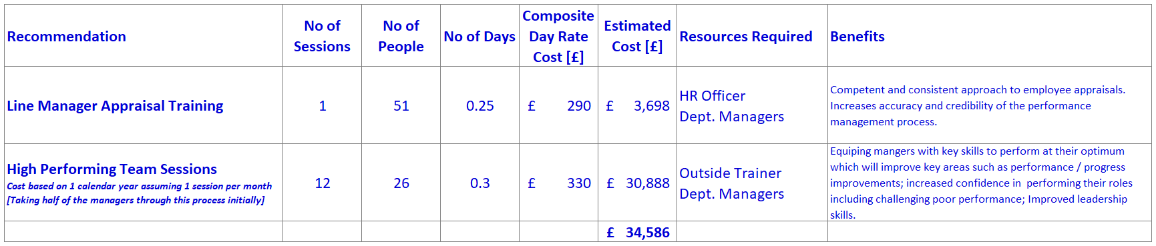

Financial implications of implementing such an approach equates to a number of people engaging in regular workshops / training courses and then time to cascade to their teams. The implications of not adopting such an approach can be considered in recruitment costs due to higher than necessary attrition rates, reduced organisation performance leading to inefficiencies that can be ascertained through KPI metrics for example to be quantified.

We can re-run the survey after appraisal training to assess effectiveness, looking for positive feedback trends from managers and employees. This will improve process outputs, providing better insights into individual performance and allowing focus on areas for improvement. We hope to see an improvement in individual and departmental KPIs. Positive outcomes from high-performing team sessions will emerge in the mid-to-long term, with near-term benefits as managers feel valued and reinvigorated. We’ll evaluate effectiveness quarterly through targeted surveys and KPI metrics. If improvements aren’t evident by quarters 2 or 3, adjustments will be made. Expected improvement is 1%, yielding £170k from £35k investment, assuming a £17M operational budget.

Stobierski,T. (2020, May 5). Financial performance measures. Harvard Business School Online. Available at: https://online.hbs.edu/blog/post/financial-performance-measures
CIPD , 2015. Critical review writing, (online) Available at: https://www.cipd.co.uk/knowledge/study-guides/critical-review-writing (Accessed 25 Jan 2025).
CIPD, 2023. People analytics. [Factsheet] Available at: https://www.cipd.org/uk/knowledge/factsheets/analytics-factsheet/ (Accessed 25 Jan 2025).
Briner, R, 2022. Evidence-based practice [ You Tube ]. Available at: https://www.bing.com/videos/riverview/relatedvideo?q=rob%20briner%20evidence%20based%20practice%20-%20YouTube&mid=8C0379CAA450E64BD79D8C0379CAA450E64BD79D&ajaxhist=0. (Accessed 25 Jan 2025).
Waite, K, Beevers, K, Small, N, Tomlinson, K, Hussain, S, and Briner, R, 2019. People Practice: A Complete Guide. P. 49.
Cassidy, N, 2024. Evidence-based L&D: Why does evidence matter? ( No 169) [Audio podcast]. CIPD. Avallabile at: https://www.cipd.org/uk/knowledge/podcasts/ld-why-does-evidence-matter/
Taylor, S. Woodhams, C., ( 2022 ). Studying human resources management: A guide to the study, context and practice of HR. 3rd ed. London, United Kingdom; New York, NY: CIPD: KoganPage.
Clark, S 2015. Ethical decision – making: Eight perspectives on workplace dilemmas.[Review] Lancaster University, Chartered Institute of Personnel and Development. Available at: https://www.cipd.org/globalassets/media/knowledge/knowledge-hub/reports/ethical-decision-making-2015-eight-perspectives-on-workplace-dilemmas_tcm18-9564.pdf
CIPD, 2024. People-powered innovation. [Report] Available at:https://www.cipd.org/globalassets/media/knowledge/knowledge-hub/reports/2024-pdfs/8674-people-powered-innovation-report-web.pdf (Accessed 25 Jan 2025).
CIPD, 2023. High-performing teams: An evidence review. [Report] Available at: https://www.cipd.org/globalassets/media/knowledge/knowledge-hub/evidence-reviews/2023-pdfs/8388-high-performing-teams-practice-summary.pdf (Accessed 25 Jan 2025).
Briner, R. (2022). Evidence-based practice [YouTube]. Available at: https://www.bing.com/videos/riverview/relatedvideo?q=rob%20briner%20evidence%20based%20practice%20-%20YouTube&mid=8C0379CAA450E64BD79D8C0379CAA450E64BD79D&ajaxhist=0. (Accessed 25 Jan 2025).
Cassidy, N. (2024). Evidence-based L&D: Why does evidence matter? (No. 169) [Audio podcast]. CIPD. Available at: https://www.cipd.org/uk/knowledge/podcasts/ld-why-does-evidence-matter/.
CIPD. (2015). Critical review writing. Available at: https://www.cipd.co.uk/knowledge/study-guides/critical-review-writing. (Accessed 25 Jan 2025).
CIPD. (2023). High-performing teams: An evidence review. [Report] Available at: https://www.cipd.org/globalassets/media/knowledge/knowledge-hub/evidence-reviews/2023-pdfs/8388-high-performing-teams-practice-summary.pdf. (Accessed 25 Jan 2025).
CIPD. (2023). People analytics. [Factsheet] Available at: https://www.cipd.org/uk/knowledge/factsheets/analytics-factsheet/. (Accessed 25 Jan 2025).
CIPD. (2024). People-powered innovation. [Report] Available at: https://www.cipd.org/globalassets/media/knowledge/knowledge-hub/reports/2024-pdfs/8674-people-powered-innovation-report-web.pdf. (Accessed 25 Jan 2025).
Clark, S. (2015). Ethical decision-making: Eight perspectives on workplace dilemmas. [Review] Lancaster University, Chartered Institute of Personnel and Development. Available at: https://www.cipd.org/globalassets/media/knowledge/knowledge-hub/reports/ethical-decision-making-2015-eight-perspectives-on-workplace-dilemmas_tcm18-9564.pdf.
Stobierski, T. (2020, May 5). Financial performance measures. Harvard Business School Online. Available at: https://online.hbs.edu/blog/post/financial-performance-measures.
Taylor, S., & Woodhams, C. (2022). Studying human resources management: A guide to the study, context and practice of HR. 3rd ed. London, United Kingdom; New York, NY: CIPD (2023) Kogan Page.
Waite, K., Beevers, K., Small, N., Tomlinson, K., Hussain, S., & Briner, R. (2019). People Practice: A Complete Guide. p. 49.

