University of Wales Trinity Saint David

Course Title



Assignment Application of Computer Aided Engineering Processes
CAE (ACDB5007)

Max Fisher

2113637

April 2023

Lecturer: Andrew Noble

Contents
1.0 Introduction 3
1.1 Aims & Objectives 3
2.0 Background Information 4
3.0 Methodology 7
4.0 Validation 17
5.0 Results & Analysis 22
6.0 Conclusion 31
7.0 Reference List 33
References 33

Introduction
This report will describe the utility and application along with the limitations of Computer Aided Engineering within an organisation, and how the modelling can be used to assist real world delivery through a case study. Specifically, this report focuses on how a complex dynamic event can be modelled in Ansys software and where potential error can be introduced and or mitigated.

Aims & Objectives
The report will detail the process of simulating a dynamic event, specifically a large projectile colliding with and perforating a steel plate. This will consider the effect of mesh structure and generation. How the shape of objects can affect mesh growth. Also discussed will be the disparity between the physical features of real-world objects and the ‘perfection’ of simulated object bodies will be discussed in detail.

2.0 Background Information
Before starting this report, the author had conceptual awareness of Computed Aided Engineering and limited experience with Computer Aided Design, as such much of the information presented here should be considered a guide as opposed to a comprehensive method statement.

The use of computers in design was first developed in the United States by Douglass Ross during his tenure at the Massachusetts institute of technology, where he coined the term Computer Aided Design, and pioneered the use of Automatically programmed tooling [1], and early predecessor of the now ubiquitous CNC manufacturing technique.
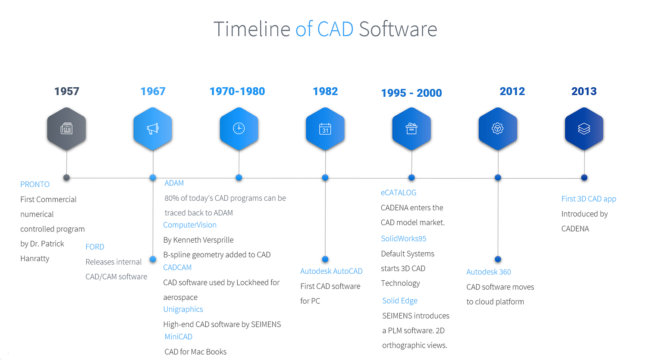
This initial research was improved upon significantly by Patrick Hanratty whilst at General Motors research laboratory where he developed the first commercial CAD software ‘Pronto’ involving interactive graphics in 1957. [2] At this point CAD developed rapidly as an alternative to the traditional draughtsmen, as it began to reduce the lead time of designs, while increasing their accuracy, reproducibility. As such significant investment was made resulting in a rapid development of the technology as presented in the below graphic [3]
Figure 1 History of Cad

The software that is used within the report is Ansys Workbench, which while first introduced in 2010 [4] , has been regularly updated and improved upon, the most recent version available to the author was Ansys workbench R1 2022. Ansys is reported used by around 3500 companies, with many different higher education institutions also using the software. This gives Ansys a market share of around 0.5% of the total CAD industry [5] Ansys workbench has the capability to carry out full simulations, from initial design within the geometry function, to over 20 different analysis systems, to fully interrogate a design. It also has access to a wide-ranging material library, which is fully referenced and sourced.
As discussed, while possible to build objects for testing within the Ansys Workbench package, on the advice of the module lecturer Andrew Noble, it was suggested that other CAD tools could be used to create the objects for testing. The software used for this was Dassault Systems Solidworks, first introduced in 1995, as is described as ‘the first fully capable 3D modelling program for Windows’ [6]. This package allows the user to draw outlines in 2d before exporting them in a third dimension along with fully 3d drawing. The package allows both individual parts to be generated within the space, and for multiple parts to be ‘mated’ to form an assembly. Both parts and assemblies can be exported in a variety of forms, including .part, .stl, .step etc. This means that Solidworks can be used interchangeably with many other CAD/CAE packages.
The projectile that was chosen to simulate was a 30mm jacketed round. This was loosely based up the 30mm RARDEN tungsten core penetrator [7]. As seen in Figure 3 30mm RARDEN penetrator, the projectile contains a tungsten core with a PEI glass reinforced plastic jacket, this aids in penetration of a target as the denser core material is accelerate more and protected from extreme shock unlike unjacketed ammunition. [8]This also aids in the process of barrel wear, reducing deposition of material in the rifling and its subsequent erosion.
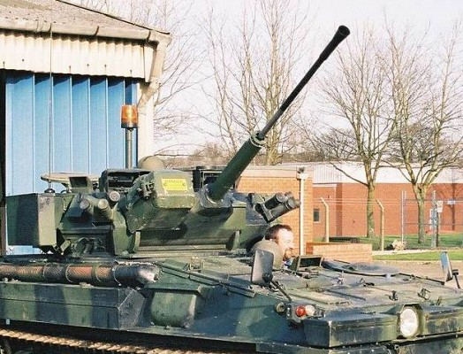
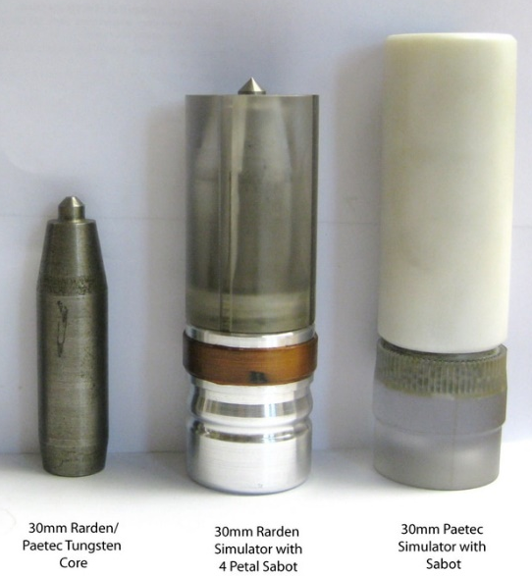

Figure 3 Warrior AFV armed with 30mm RARDEN autocannon.
Figure 2 30mm RARDEN penetrator
The RARDEN gun system has been in use since 1970 and has been used in a variety of vehicles such as:
- FV721 Fox armoured car
- FV107 Scimitar tracked reconnaissance vehicle.
- FV101 Scorpion (Sabre)
- FV510 Warrior infantry fighting vehicle.
However, the RARDEN is now being phased out in favour of 40mm Case-telescoping weapon system, which will first be seen on the AFV ‘AJAX’ after having initially been planned to be refitted to the Warrior [9]

3.0 Methodology
As discussed within the Background information section, the projectile that was to be simulated was a 30mm RARDEN, tungsten jacket penetrator. In order to aid the authors understanding of CAD software, they decided to model it within Solidworks.

This was first achieved by modelling the inner ‘core’, using the 2d plane feature, a cross section of it was drawn. This was a 5mm x 40mm rectangle, with an angled front edge, set at a 20⁰ slope. Using the revolve feature and selecting what was to become the central axis, the 2d drawing was extruded 360⁰. This created a cylinder with a taped front edge, 10x40mm. This was then saved as a .prt file and set aside for later.

Next the jacket was designed, again, a section drawing was created in a 2d plane. This was initially a 10x54mm rectangle similar to the core. However, a relief had to be created to allow the core to be positioned inside the jacket. This relief matched the dimensions of the cores 2d plan drawing, including the 20⁰ angles on the front section. A 4mm wide section was left at the back of the jacket ensuring that enough material would remain to withstand a hypothetical setback force (propulsion force) that the real projectile would experience. This was not based directly upon a set figure but rather a ‘ballpark’ estimation. The remaining 10mm of jacket was drawn in front of where the core would sit. Again, similar to the core, the revolve tool was used to extrude the 2d drawing into the 3d space, 360⁰. This was also saved as a .prt file.

Two versions of the target plates were also drawn in Solidworks. Firstly, using the 2d plane, a circle of diameter 100mm was drawn. This was then extruded into 3d 50mm and saved as a .prt file. The other target plate was drawn as a 100x100mm square in the 2d plane. This was also extruded 50mm in the Z plane and saved as a .prt file.

Two versions of the final assemblies were to be created, one with a square target and one with the round. Within Solidworks assembly panel, the three constituent parts were imported, the core, jacket, and corresponding target plate. Using the wireframe tool, the jacket’s faces were made transparent, this allowed the cores face to be mated to the inner void of the jacket. The core’s outer face and the jackets inner face was selected, and surface/coincident mate was confirmed this moved the core within the jacket and ensured it was concentric due to the tapered nature of the core’s faces. Wire frame was disabled, and the core/jacket assembly was complete. At temporary mate was then used to align the projectile with the centre of the target plate. Using the normal feature of the mate, the projectile was made perpendicular to the surface of the target. The projectile was then moved to the centre of the target before adding approximately 20mm as a standoff. At this point the mate between the projectile and target was deleted. Checking through all the mates within the design tree, only the mate between the jacket and core remained. This was then saved as an. ass and as a .step file. The .step file then allows the assembly to be imported into Ansys as a geometry.

To begin the simulation, an explicit dynamics module was imported into Ansys workbench, this the allows the importation of geometry into the software, using the import geometry tool and selecting the assembly made earlier. Due to processing limitations and to expedite the learning process it was decided to simulate a set of different setups these were as follows:
- Round target non-jacket
- Round target jacketed.
- Round target jacket medium mesh
- Round target jacket fine mesh
- Square target non-jacket
- Square target jacket
- Square target jacket medium mesh
- Square target jacket fine mesh

In order to setup the non-jacket simulations, a modification was made within the geometry, as Ansys identifies that the core and jacket at two objects that are mated, and that individual objects can be ‘supressed’. This means that the jacket can be removed from the simulation without having to redraw/re-assemble the geometry, reducing the risk of error is design/setup.
At this stage materials were assigned and imported. The steel selected as the target plate ‘High strength low alloy steel, YS460 hot rolled’ was found within the explicit library of Ansys workbench, which meant that the material could simply be dragged into the material selection window. Unlike the Steel, the PEI plastic of the Jacket and the Tungsten core had to be imported from another source, these were taken from another Ansys product ‘Granta’, the material had to be exported from Granta and then re-imported into workbench. Several other materials were imported into the model workspace see Figure 4 Engineering Material Data. This was done to provide a sanity check at a later stage (replacing the projectile assigned materials with much ‘Softer’ materials). These were also assigned at this stage using the materials tool under the model tab.
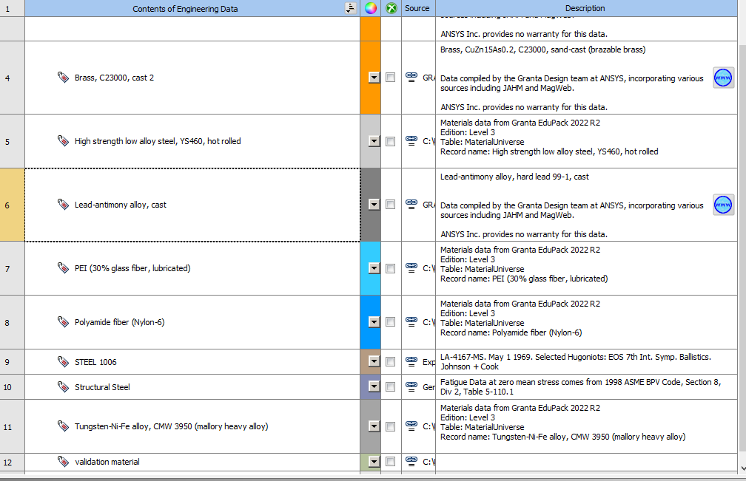
Figure 4 Engineering Material Data

The next step was to generate a mesh for each of the simulations following simulations:
- Round target non-jacket
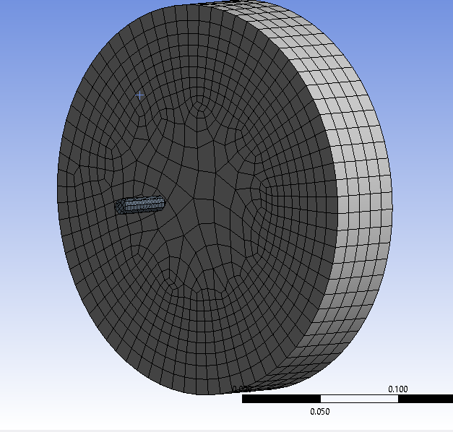
This utilised the default mesh features. The created relatively fine mesh on the core, while the mesh of the target plate was extremely coarse, this was especially the case for the centre of the target, Figure 5 Round target non-jacketed default mesh shows this bias towards the external features of the target. This is likely due to the quadrilateral nature of this mesh, although it was decided not to switch to tetrahedral mesh in order keep it in common with the square targets.

Figure 5 Round target non-jacketed default mesh
- Square target non-jacket
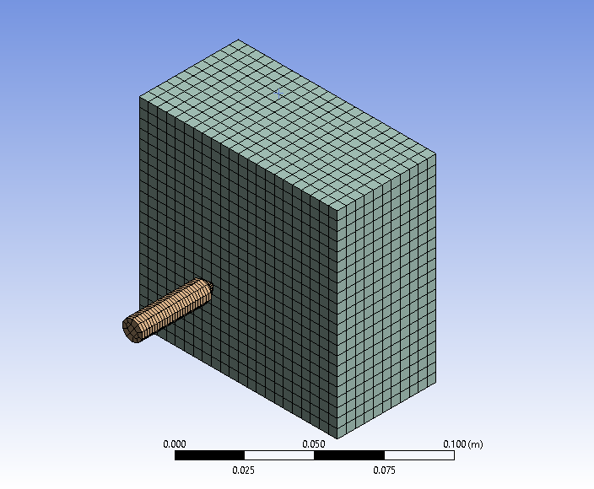
This again was achieved using the default mesh settings, this meant that the core remained with the same mesh, but the software process the square target in a much more accurate way ,Figure 6 Square Non-jacket default mesh show that the mesh in not bias towards the outer edges, but is more consistent throughout, this will be discussed in the results and analysis section.

Figure 6 Square Non-jacket default mesh
- Round target jacketed.
This was achieved in the same way as the non-jacketed projectile, but the jacket was first ‘unsuppressed’ in the geometry section of the simulation. This generated the mesh seen in Figure 7 Round Jacketed Default mesh, this generated a particularly fine mesh for the jacket, this will be discussed in the later in the methodology.
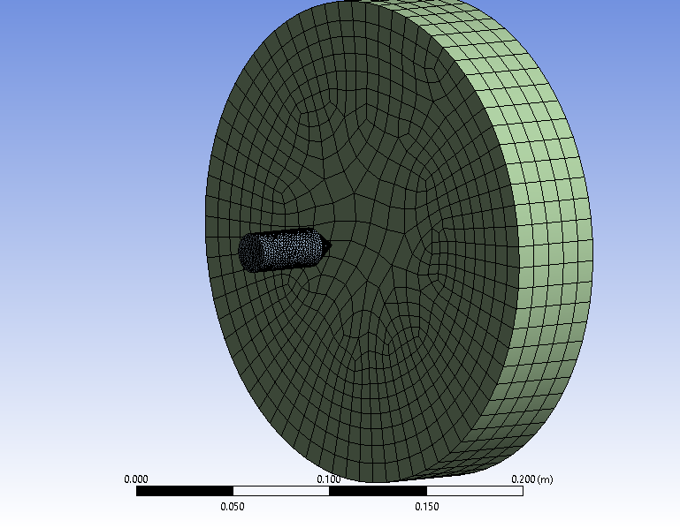
Figure 7 Round Jacketed Default mesh

- Round target jacket medium mesh
For reasons that will become apparent within the analysis it was decided to discontinue with the round target simulations as such, both the medium and fine jacketed mesh of the round target were not completed.
- Round target jacket fine mesh
See above.

- Square target jacket
Again, in order to achieve this mesh, the jacket object had to be unsuppressed, before again using the default mesh settings to generate. The jacket mesh was extremely fine once more, with both the core and target remaining the same as the unjacketed mesh. This can be seen in Figure 8 Square jacket default mesh

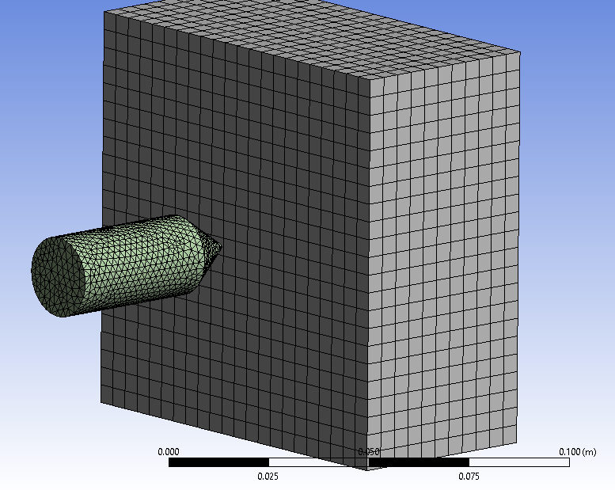
Figure 8 Square jacket default mesh

- Square target jacket medium mesh
In order to vary the mesh size across the bodies within the simulation individual sizing settings had to be generated, this was done by selecting the appropriate body (core, jacket, target) and applying a mesh size. For the medium mesh, the following settings were used; Core default, Jacket, 0.005m, Target 0.003m the values here correspond to the distance between nodes, by reducing this distance more nodes are generated for a give volume, corresponding to a finer mesh. There mesh generated can be seen in Figure 9 Square target Jacket medium mesh
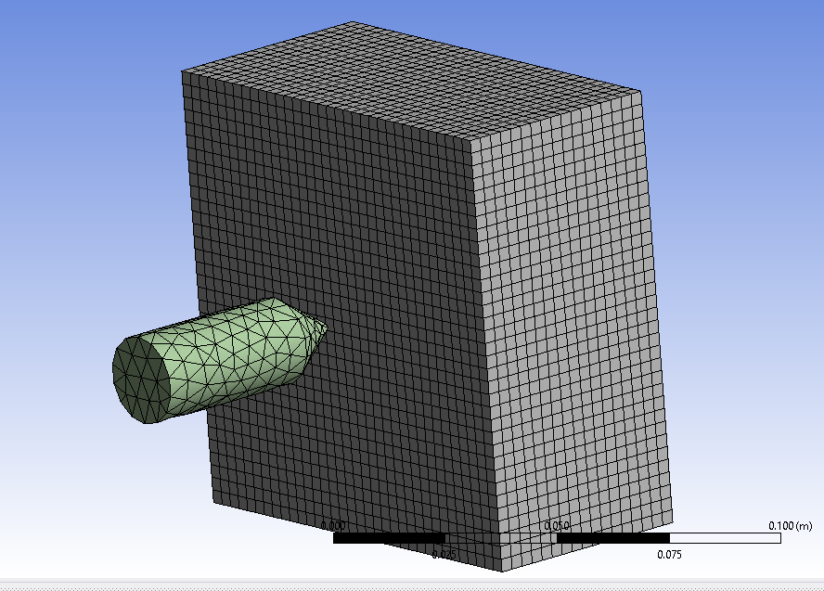
Figure 9 Square target Jacket medium mesh

- Square target jacket fine mesh
Again, the individual bodies were selected, and individual mesh sizes set. In this case it was as follows: Core 0.001m, Jacket 0.003m Target 0.002m This was the finest mesh used although the software can generate significantly finer meshes, this would affect processing time, something that will be discussed later. This can be seen in Figure 10 Square Jacket Fine Mesh
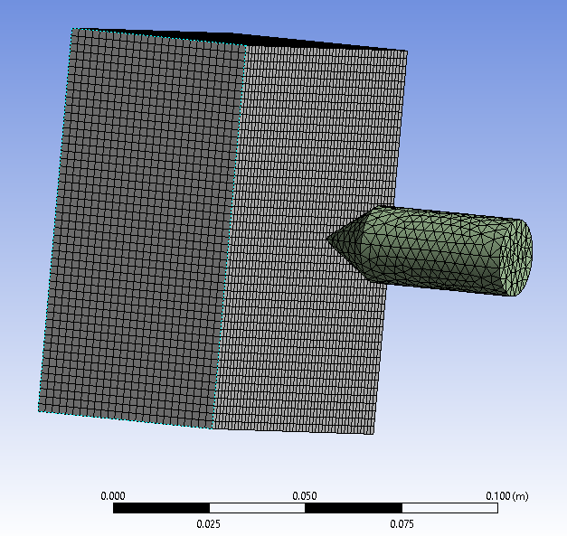
Figure 10 Square Jacket Fine Mesh

The next step was to assign velocities and fixed points to allow the model to simulate. This was done by selecting the ‘side’ of the target, in the case of the circular target, this was broken into two surfaces, while the square target had 4 ‘edge’ faces. Now these were considered an immovable object for the sake of the simulation. A velocity was now applied to the core by selecting the entire object. This was set at 700ms⁻¹. Due to the mates made earlier in Solidworks, Ansys also carried this forward, as such that the jacket did not require the velocity to be applied separately to the jacket.

Two things remained before the simulations could be conducted. Firstly, the timestep had to be calculated. This in effect was how long the simulation would be run for. A crude calculation was conducted. By assuming that the projectile was travelling at 1000ms⁻¹ and knowing that the target was only 50mm thick, only a small-time window was required to view the perforation of the plate. Using the simple equation Speed = Distance/Time the time required could be estimated.
1000ms⁻¹=50x10⁻³/T T= 50x10⁻³/1000=5x10⁻⁵S.

Finally, the software allows the results data to be displayed in a range of different ways. For this application Deformation was required. This window allowed different options for the deformation: Total, planar and by object. Total and Object deformation were chosen, mainly to show the ‘whole picture’ and to give a detailed look at each object (total deformation will be biased by the projectiles traveling as Ansys interprets the projectile moving as ‘deformation’).

The final Workbench Workspace showed the workflow process seen described in the above methodology. Figure 11 Workbench Workspace shows how each of the simulations were linked and what by, for instance, the square jacket shares both its engineering data (material data) and its geometry with the square jacket medium mesh. This creates a network of simulations which allows the user to adjust a ‘root’ simulation before carrying that out across the network. This speeds up working time and allows other users to understand at a glance how the simulations have been done and in which order.

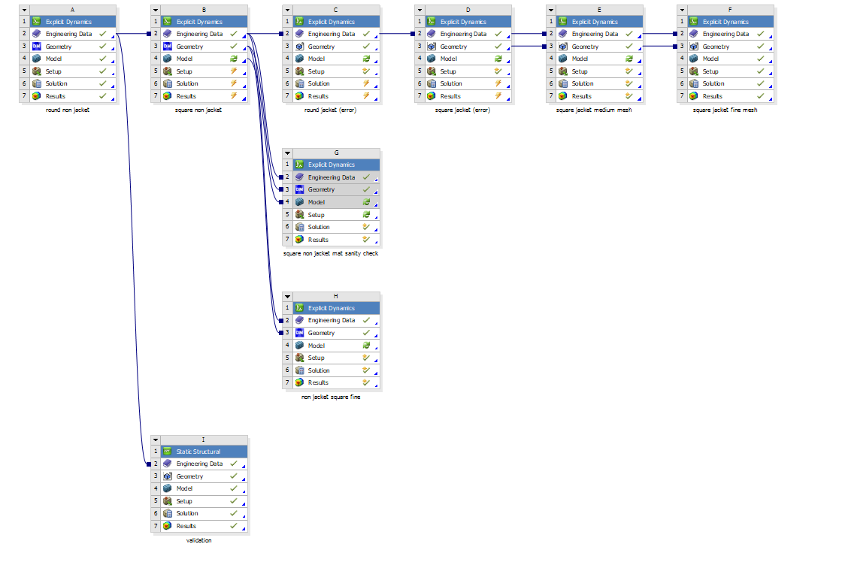
Figure 11 Workbench Workspace

4.0 Validation

Validation is an essential part of CAE analysis; this is because it provides the evidence that a model is grounded in reality. Software can cause a wide ranger of errors and issues that can drastically affect the finished simulation. Validation raises the confidence of the model and provides assurances that a model will performs in a similar way to a real-life test.

It was initial decided to trial an explicit dynamic validation, this would provide a good basis to conduct the explicit dynamic analysis required by this simulation. Via online software company Dlubal the ‘Lee’s Buckling Frame’ [10]. This was intended to show a deformation of an ‘L’ shaped frame when a large force was applied as shown by Figure 12 Lee's buckling frame.
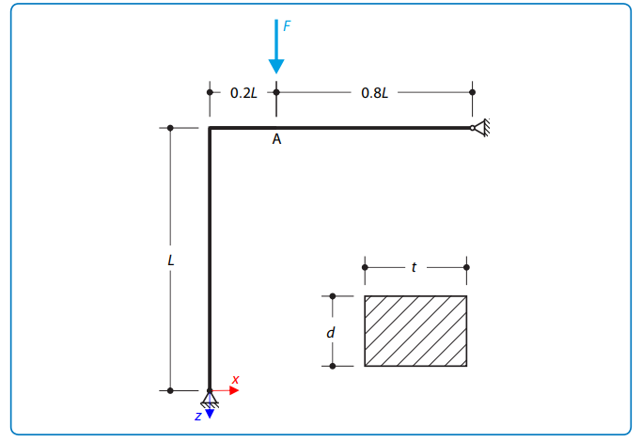
Figure 12 Lee's buckling frame

This was intended to have the following deformation, Figure 13 Lees Frame Deformation. This details what the deformation should look like if the model is working correctly, with a maximum deflection of 0 .012 m and 3.557478 m respectively.
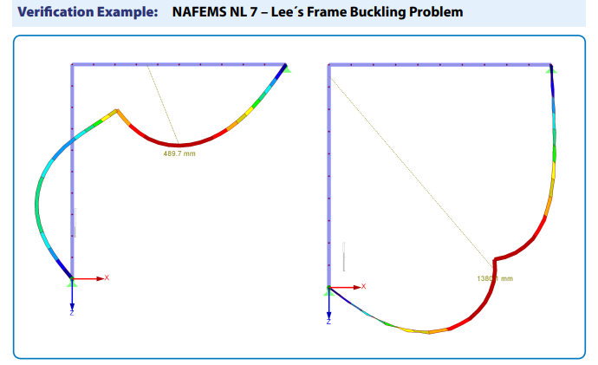
Figure 13 Lees Frame Deformation
Unfortunately, at this stage an issue was found with this validation. This was primarily due to the lack of a key data point regarding material properties. Without the complete set of material data, the validation could not be simulated as such it was decided to change the validation for a static structural analysis.

It was decided to use another of Dlubal’s validation examples, this time the Bending Cantilever with axial force [11]. This is a beam fixed at one end with a load applied along the opposing face as demonstrated by Figure 14 Axial Beam diagram
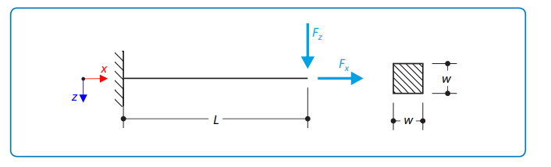
Figure 14 Axial Beam diagram
This object was then drawn within Solidworks with the dimensions: 10x0.08x0.08m, this was then imported into Ansys using the geometry tool, before being meshed. The mesh sizing was set to 0.02m to provide a fine mesh for the validation simulation. The material properties of the beam were clearly defined in the validation file along with the forces that were to be applied across the beam. All of this information can be seen in Figure 15 Validation numerical values.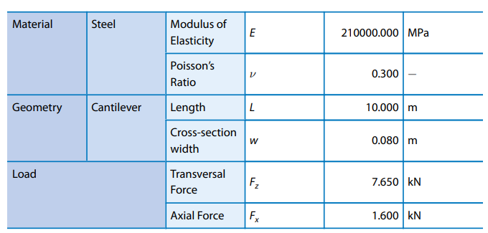
Figure 15 Validation numerical values
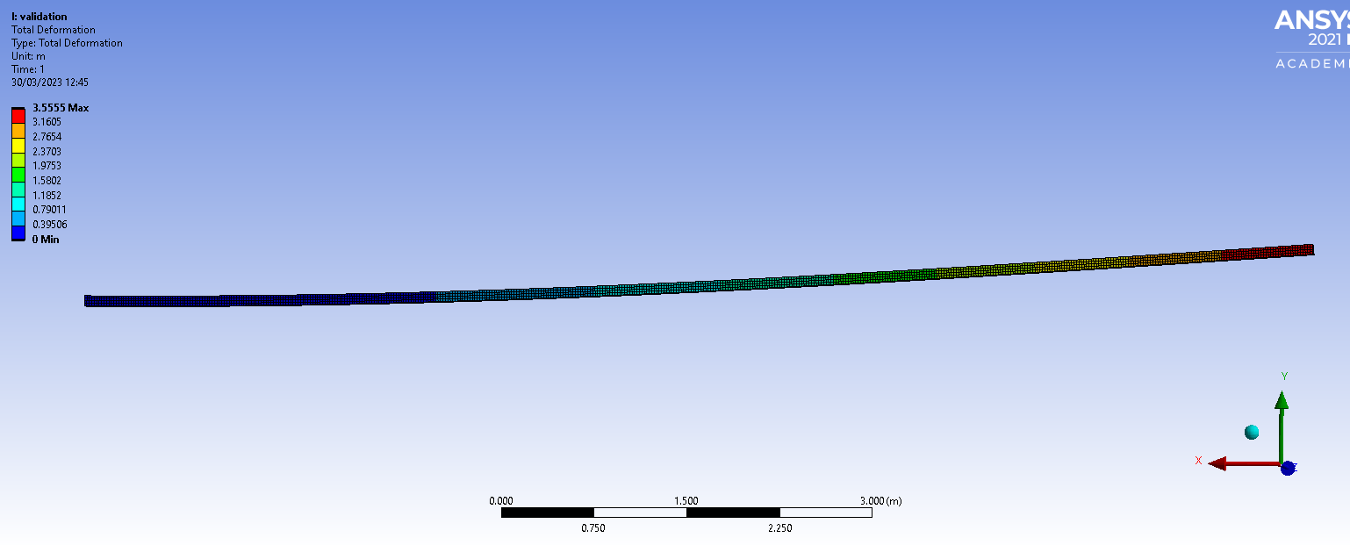
When the simulation was run it returned the following deformations:
Figure 16 Validation Total Deformation
Figure 17 Validation total deformation
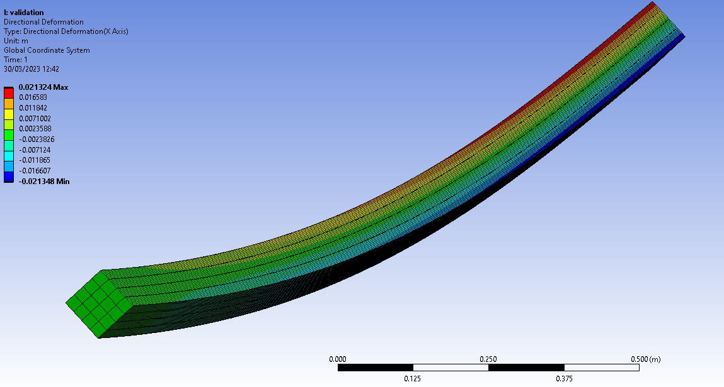
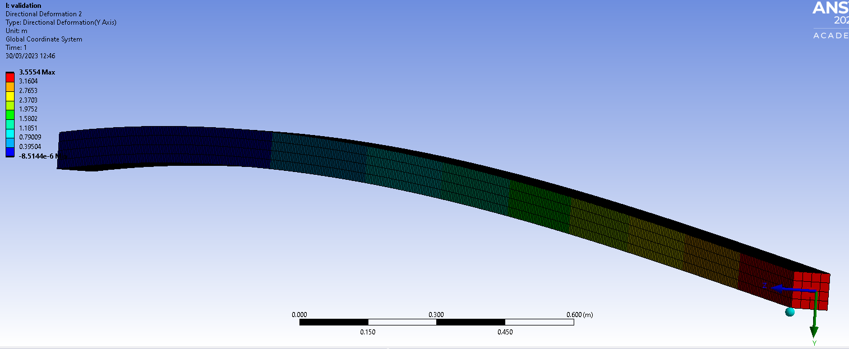
The above figures demonstrate that the actual deformation was 0.02m and 3.554m. that is compared with a predicted deformation of 0 .012 m and 3.557478 m despite the slight differences as they values fall close to the expected, the validation can be shown as successful.

Figure 18 Validation X axis Deformation
Figure 18 Validation X axis Deformation
Figure 19 Validation Y axis deformation

As the validation is successful the model can be taken as representative of a real event. However as previously highlighted, this validation while valid is not perfect, ideally an explicit dynamic validation would be used. This is because although both operate via the Ansys workbench package, they utilise different solvers, this may introduce error later, and as such a significant safety margin should be taken when considering results from the following simulation.

5.0 Results & Analysis
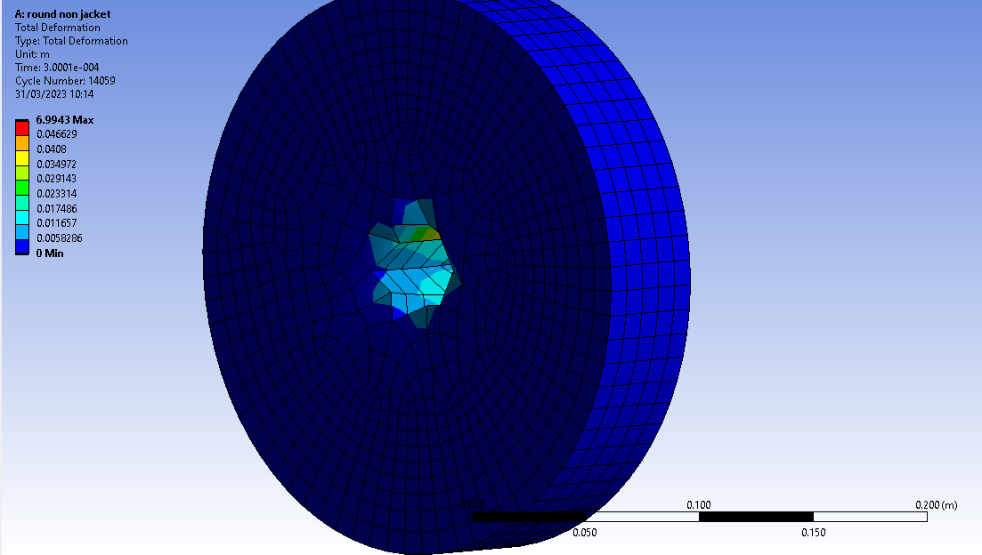
In this section the author will first present the results of the simulation analysing each one in turn. All final comments about causation will be found within the conclusion.
Round Target non-jacketed:
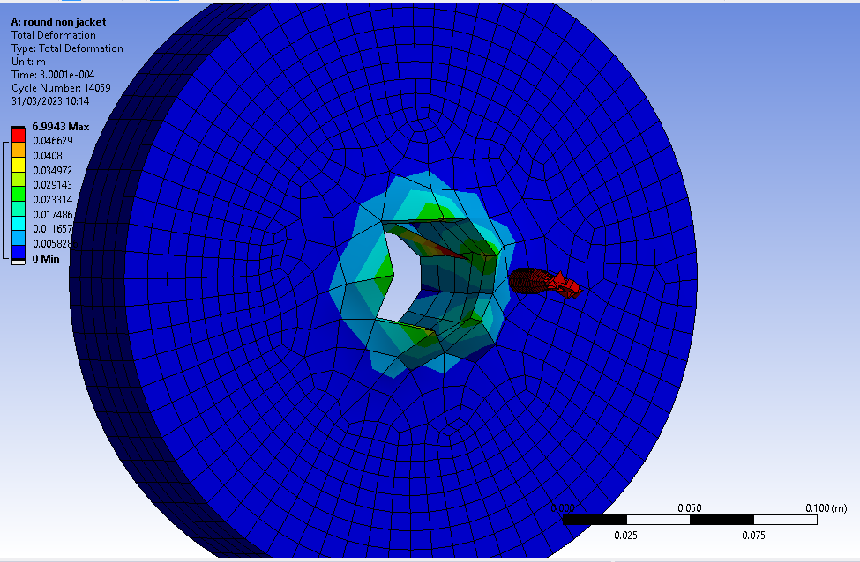
Figure 20 round non-jacket front view
Figure 21 round non-jacket rear view
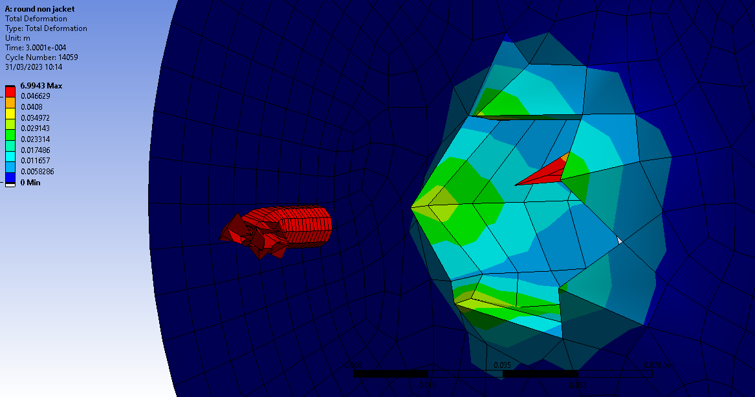
Figure 22 round non-jacket core

Figures Figure 20,Figure 21, Figure 22 demonstrate the core penetrates the steel target, causing significant damage to the surrounding area of the plate. There is significant ‘tear out’ the steel material as well as significant deformation to the front of the core. This damage does not appear to be symmetrical as one may expect. Within the perforation, there is an errant node, this appears to have deformed excessively, representing itself almost as a shard, separate from the surrounding materials. This shards deformation approaches the maximum band displayed on the left scale. This scale is biased by the cores travel, as Ansys considers its movement a deformation. As such the deformation seen on the tip of the core cannot be evaluated using this scale. The mesh surrounding the impact site is exceedingly large this creates a significant ‘ridging’ effect.
Square Target Non-jacketed:
Figure 23 shows the effect of the impact on the core and target when using the default mesh of a square target. The affected area is relatively small, with large deformations seen around the edge of the perforation. The projectile tip appears to have ‘squared off’ but still remains symmetrical. The deformation scale shows that there is significant movement of the surface of the target plate, with ‘ridging’ seen around the remaining hole.

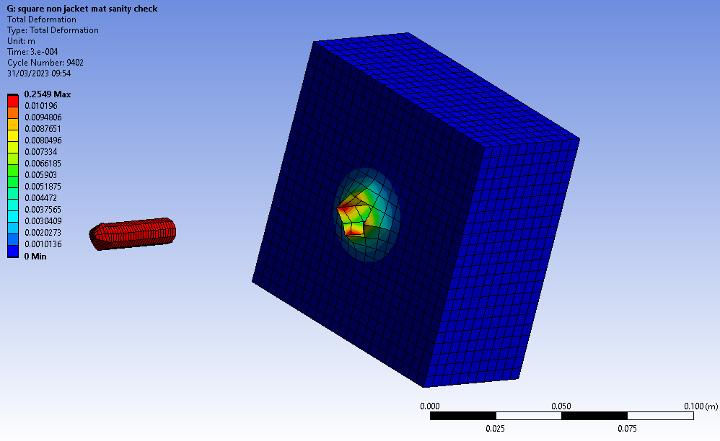
Figure 23 Square target non-jacketed perforation

Square Target Non-jacketed ‘sanity check’:
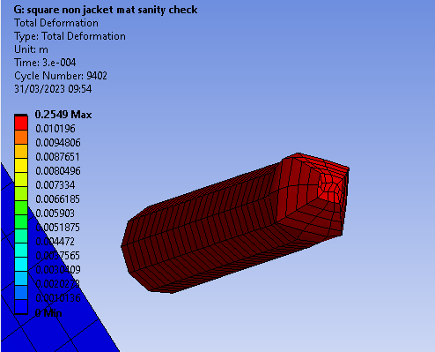
Figure 24 Square non jacketed core 'sanity check'
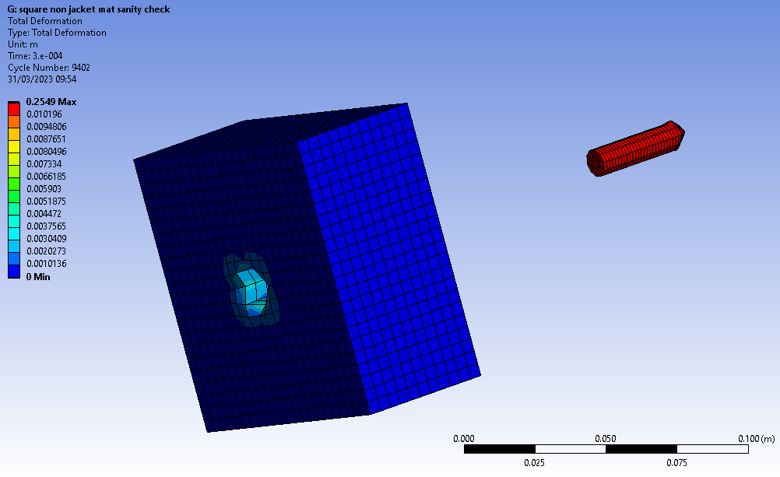
Figure 25 square non jacketed overview sanity check
The ‘sanity check’ test was to ensure that the steel target block was preforming as expected. Instead of the high strength low alloy steel, Steel 1006 was used, having been selected from within Ansys’ own material library. This was done to ensure that the target steel was not failing in an unusual way and as a reassurance to the author that they had used the correct materials within the simulation process.

Round Target Jacketed:
Figure 26 and Figure 27 show the results of the round target when used with the jacketed projectile. In this case the simulation would not complete. This is likely due to the high mesh density at the tip of the jacket, where many small meshes interact with the low mesh density of the target plate. This meant that the projectile collided with the target, but stopped almost instantly when the mesh geometry began to deform. This can be seen especially clearly in Figure 27 which shows that the simulation was only an estimated 12% through the simulation before completing with the error ‘problem terminated timestep too small’.
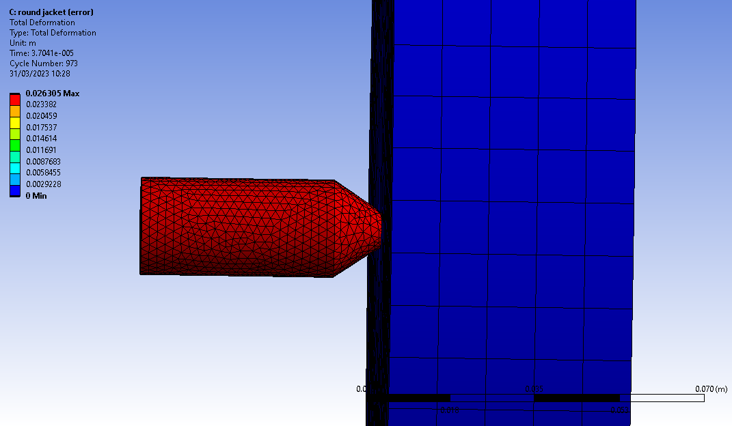
Figure 26 Round Jacketed Mesh failure 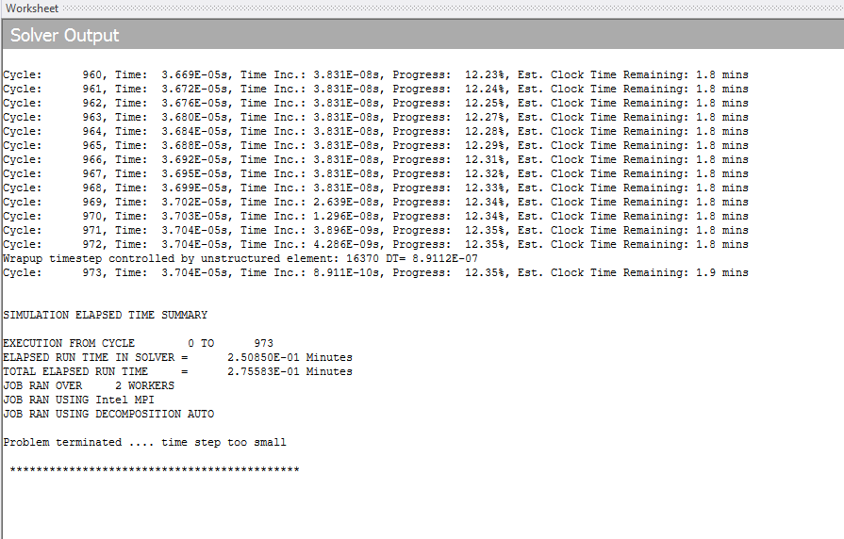
Figure 27 Round Jacket Mesh Failure log

Square Target Jacketed:
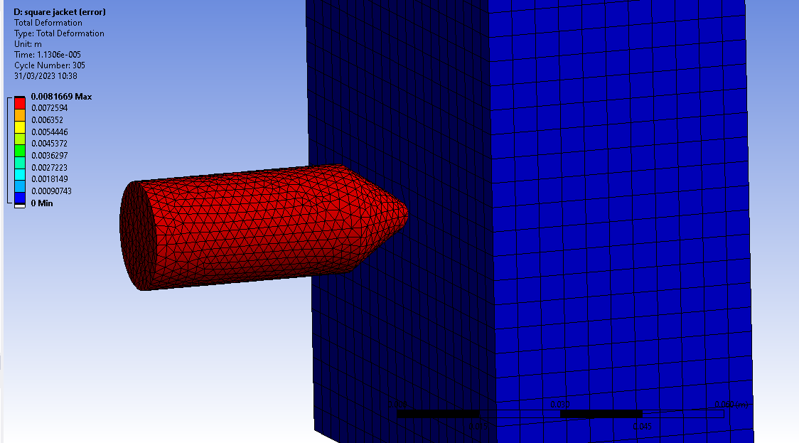
Figure 28 Square Jacketed Mesh failure
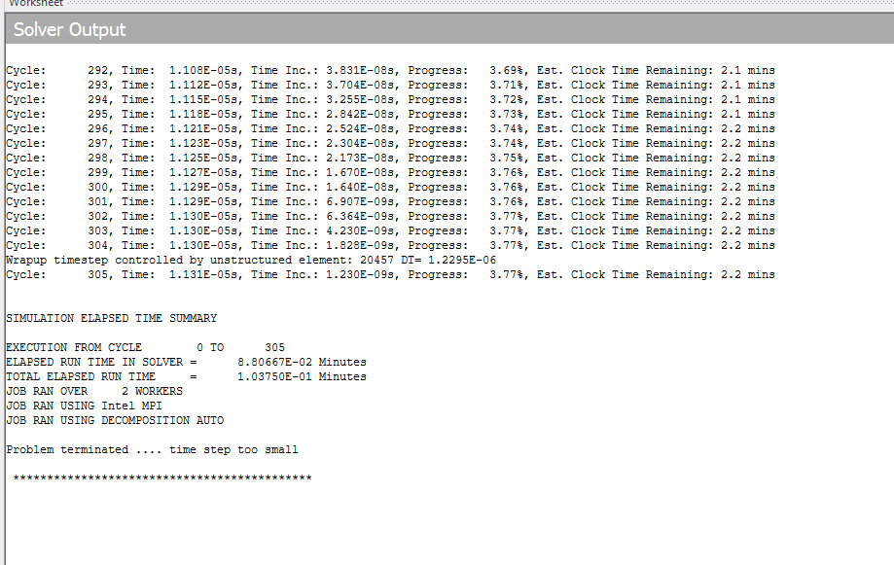
Figure 29 Square Jacketed Mesh failure log
Similar to the round target, the square target also ran into an error, see Figure 28. It is believed this is again due to the fine mesh of the jacket ‘over compressing’ whilst in contact with the relatively coarse mesh of the target plate. This attempt only managed to make it to 3.77% before again terminating as can be seen in Figure 29 with the error ‘problem terminated time step too small’.
Square Target Jacketed Medium mesh:
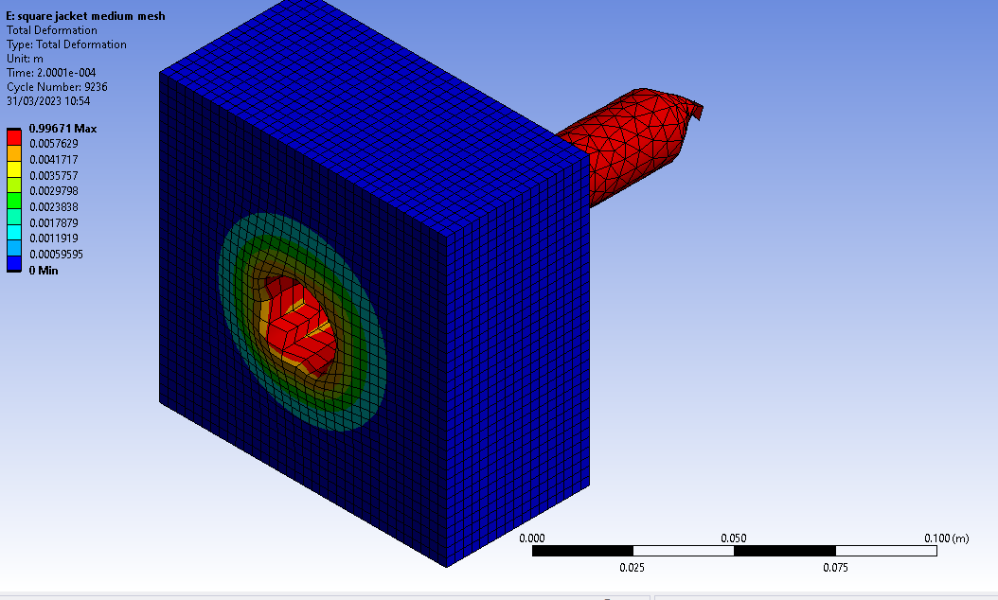
Figure 30 Square Jacketed Medium mesh front.
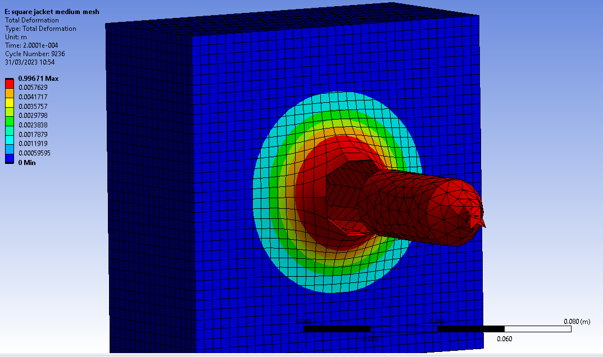
Figure 31 Square Jacketed Medium mesh rear
The medium mesh was able to run through the entire simulation. The mesh density of the targe was increased, and the jacket decreased, this enabled the simulation to run to completion. The tip of the jacket has been ‘squashed’ somewhat and some of the nodes appear to be overstretched and only one node thick. However, the target plate appears to have a much more graduated deformation, while a significant hole is left by the projectile, deformation appears to spread out from the centre in rings, with the effects lessening as its progresses. The ridging effect is still seen but to a lesser extent.

Square target jacketed fine mesh:
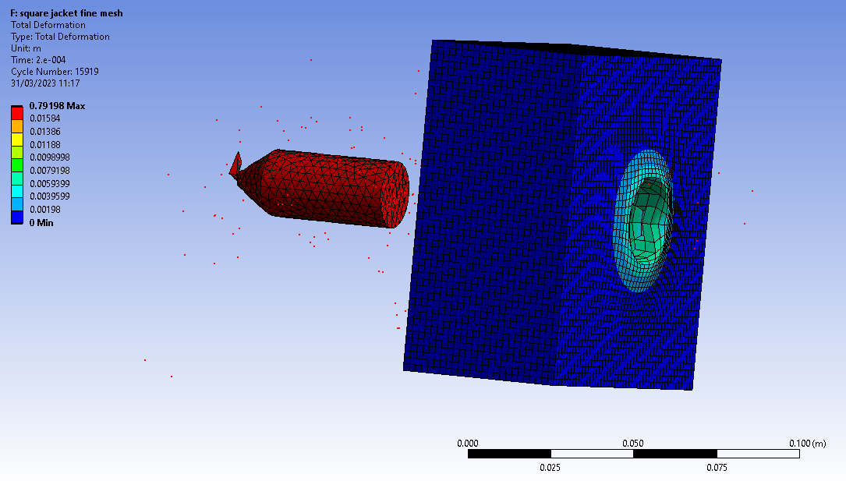
Figure 32 Square Target Jacketed fine mesh isometric view.
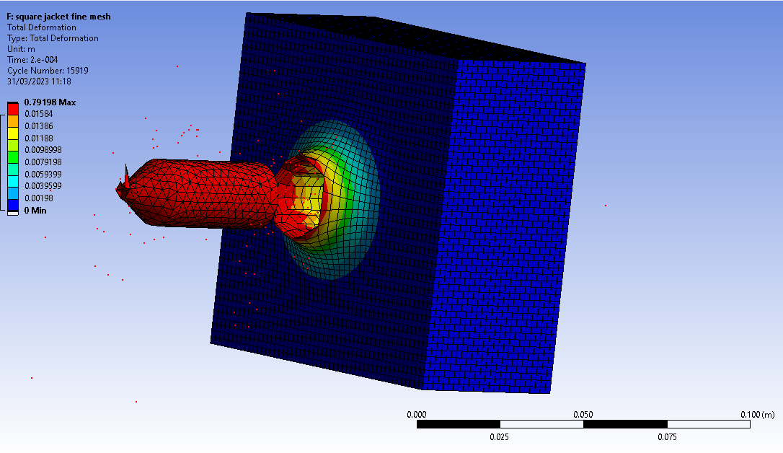
Figure 33 square target jacketed fine mesh rear.
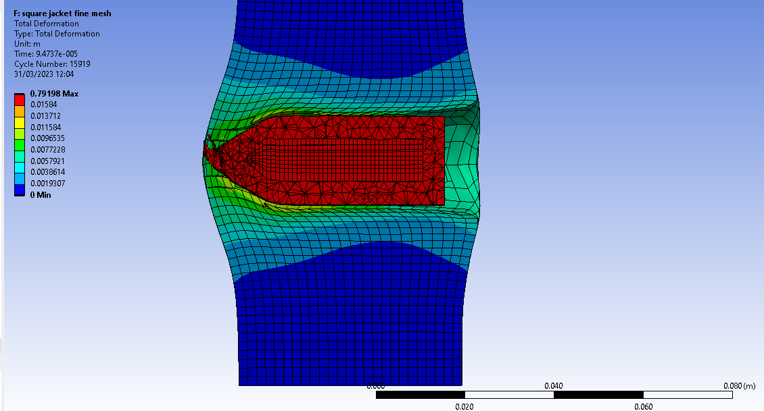
Figure 34 square target jacketed fine mesh cutaway.
Figure 32 shows the perforation of the target plate, it also shows a number of small red dots across the screen, moving in the same direction of the projectile. This is likely to bed nodes of target material, broken away from the main body, and travelling as Behind armour effect fragmentation. Only this mesh demonstrates this form of energetic effect. Similar to the medium mesh analysis, the jacket deforms only slightly, with some nodes over stretching creating a ‘shard’ like effect. Figure 33 clearly demonstrates the cylindrical nature of the exit hole, with a smooth ‘ridge’ is generated. This appears consistent around the perimeter of the perforation with deformation radiating outwards. Figure 34 shows a sectioned view of the projectile mid-way through the target. It clearly shows the extent of deformation during the penetration, with the rearwards portion of the target plate being pushed and pulled as the projectile moves through. It also shows how the target pushes back on the projectile, with the jacket being deformed. This view especially shows the depth of the features seen on the front and back of the target plates; the targe material is extensively warped.

6.0 Conclusion
The simulations carried out clearly demonstrate that CAE can be used to carry out studies and aid research into materials and ballistics, however throughout this testing it became evident that there is a number of potential issues with the process this will be listed in the following section.
Perfection of the Simulation:
Firstly, there is a key detail that is nearly impossible to accurately model within a simulation software package such as this. It is extremely unlikely that the geometry created will match exactly with a real plate. This can range from minor variations in tolerances in the parts manufacture to surface finishes and differences in material properties. An example of this is variation of properties within the target plate. In reality this plate, having been hot rolled would exhibit differing properties across a section of material. This processing makes the plate not truly uniform, while the simulation applies the same material properties across the whole object, this difference can cause issues when trying to directly compare trials data with simulation data.
Mesh Bias:
Seen especially within the Circular targets, the mesh-geometry generator can struggle with simple shapes. This meant that the mesh was not evenly distributed, this is a fundamental difference from reality; the circular mesh resulted in large sections of target plate being represented as a single node, when this failed, a significantly larger hole was made than expected. Whilst most clear on the circular features, it cannot be assumed that the cuboid meshes are unaffected by this. Coarse meshes are especially vulnerable, while finer meshes can seemingly alleviate this issue. Regardless, is something that must be considered when evaluating results.

Mesh Sizing:
Mesh sizing appears to have a significant impact on the results of a simulation. This effect can be seen most visually in the ‘ridging’ seen across all targets. Coarse mesh targets retain an irregular, ‘ring’ around the perforation; whilst the finer meshes are significantly more symmetrical and smoother. The finer the mesh the more datapoints can be analysed, this is especially seen when looking at deformation, often coarser meshes will simply remove a node that has been overstretched. This is true for finer meshes too, but as the nodes are much closer together, the individual displacement of a node is significantly reduced. In physical trial, this problem would be greatly reduced as matter cannot simply cease to exist. As described in the Law of Conservation of mass ‘Matter can change form through physical and chemical changes, but through any of these changes matter is conserved. The same amount of matter exists before and after the change—none is created or destroyed.’ [12] This again will cause significant issues. Mesh sizing is also a significant factor in processing time. As models get more complex, more calculations must be done to simulate the results. This can cause issues especially when working with older devices and in limited timeframes. While simple simulations may have only taken a few minutes, an ultra-fine mesh may take a number of hours or even days. As such a decision must be taken to trade off these two key factors.

Temperature Changes:
At the level of understanding of the author, it is extremely difficult to accurately model the temperature changes generated during this high energy impact. As the materials used within this simulation are temperature sensitive, it can be assumed that significant error is introduced by not simulating this part of the interaction. This likely can be achieved with further work, however it also highlights the level of experience required by individuals involved in simulation studies.

However, it is important to remember that simulation is a guiding tool, its main utility it to aid a project that would otherwise be extremely costly or those of which there is only one attempt at doing. It can help to improve the experiments by allowing refinement of ideas and processes at an early stage, allowing redesigns and revisions without having to physically machine or manufacture objects. This utility cannot be undervalued and will continue to be developed to improve its results.

In conclusion CAE, whilst CAE contains a number of significant issues, many of these can be overcome. CAE’s proliferation is testament toits ability to help workflow in projects, although physical trials must still be conducted to ensure confidence in the modelling and to provide accurate outcomes.

7.0 Reference List

References

[1] | D. Geddes, Technical foam services, 2020 5 5. [Online]. Available: https://technicalfoamservices.co.uk/blog/blog-history-of-cad-cam/#:~:text=Initially%20used%20by%20Douglas%20T,technology%20and%20computer%20display%20systems.. [Accessed 18 4 23].
[2] | A. Beck, “60 Years of CAD Infographic: The History of CAD since 1957,” Part solutions, 2019. [Online]. Available: https://partsolutions.com/60-years-of-cad-infographic-the-history-of-cad-since-1957/. [Accessed 18 4 2023].
[3] | M. Kolla, “The Role of CAD modeling in 3D printing,” fab heads, [Online]. Available: https://fabheads.com/blogs/the-role-of-cad-modeling-in-3d-printing/. [Accessed 18 4 2023].
[4] | A. S. T. Michail E. Smirnov, “History of Development and Application of the Capabilities of Modern CAE Systems in Designing Innovative Rolling Stock,” Ural design bureau of railway.
[5] | enlyft, [Online]. Available: https://enlyft.com/tech/products/ansys-workbench. [Accessed 18 4 2023].
[6] | L. Fuentes, “SolidWorks vs Inventor: The Differences,” All3DP, 3 6 2022. [Online]. Available: https://all3dp.com/2/solidworks-vs-inventor-cad-software-compared/#i-16-final-thoughts. [Accessed 18 4 2023].
[7] | “PROJECTILES,” New Lenox Ordinance, [Online]. Available: https://www.newlenoxordnance.com/projectiles.html. [Accessed 18 4 2023].
[8] | D. Lesmana, “On the importance of the bullet jacket during the penetration process: Reversed-ballistic experimental and numerical study,” Journal of Mechanical science and tecnology, vol. 34, pp. 1871-1877, 2020.
[9] | BAE Systems, “CTA International Secures New Contract From UK MOD,” 16 6 2004. [Online]. Available: https://web.archive.org/web/20100401064911/http://www.baesystems.de/Newsroom/NewsReleases/2004/press_16062004.html. [Accessed 18 4 2023].
[10] | “Lee´s Frame Buckling Problem,” Dlubal, 13 5 22. [Online]. Available: https://www.dlubal.com/en/downloads-and-information/examples-and-tutorials/verification-examples/002207. [Accessed 19 4 2023].
[11] | “Bending Cantilever with Axial Force,” dlubal, [Online]. Available: https://www.dlubal.com/en/downloads-and-information/examples-and-tutorials/verification-examples/000042. [Accessed 19 4 2023].
[12] | National Geographic, “The Conservation of Matter During Physical and Chemical Changes,” 2 6 2022. [Online]. Available: https://education.nationalgeographic.org/resource/conservation-matter-during-physical-and-chemical-changes/. [Accessed 21 4 23].

