How Important is the Concept of Authenticity in the Presentation of Heritage?
Authenticity has become a significant factor in the discussion of heritage in the past few decades. Heritage acts as a tool to preserve the past in a commercial setting where people travel to locations to see or experience historical and cultural materiality and practices (Chhabra, 2021; 1). While heritage can be seen as a positive influence due to its protective nature, the desire to tell or re-tell a specific cultural narrative can cause institutions to compromise authenticity in favour of more commercial business goals (Chhabra, 2021; 1). The problem of authenticity in heritage arises when various groups have different ideas on what makes a building, artefact or cultural practice “authentic” and, therefore, different preservation ideas that maintain both the narrative and the consumerist potential (Chhabra, 2021; 20). As both “authenticity” and “heritage” are flexible, human constructs, it will be necessary to define these concepts before reflecting on the importance of authenticity in a specific example of heritage presentation (Chhabra, 2021; 2). This essay will first set out the model of authenticity for this work, then apply these parameters to the presentation of heritage and finally use the framework established to look at the importance of authenticity in the heritage presentation of Glanffrwd Mill, Cellan.

Authenticity is a flexible construct, impossible to pin down in a single, all-encompassing definition. Many things can affect how “authentic” an object is seen to be. Authenticity can be lost, gained or even transferred! The concept of authenticity is subjective. The viewer defines authenticity through a set of parameters created by the individual and the authority through which the object is viewed.
This essay will use a model of authenticity based on three main layers; the object, the interpreter and the subject. “Object authenticity” relates directly to the artefact, building or practice being viewed. “Interpreter authenticity” is provided by the objects association with a recognised academic or heritage institution such as a museum. “Subject authenticity” is the most difficult as it is an individual’s idea of authenticity. (Casey, no dateb, paragraph 5)
Object.

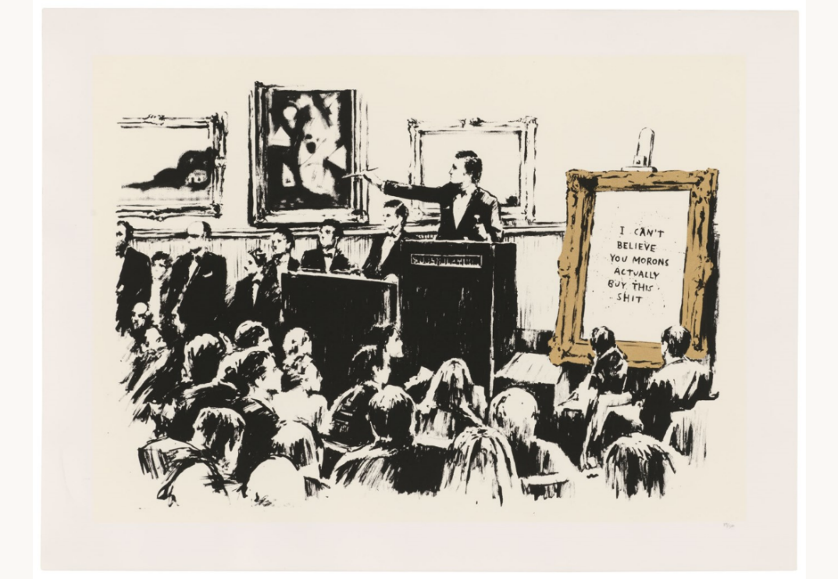
The first layer of authenticity is within the object itself. According to Walter Benjamin, authenticity is composed of an objects “substantive duration” and its “testimony to the history which it has experienced” (Benjamin, 2007; 221). An object’s unique location in time and space is attributed to the “aura”, an essential aspect of its authenticity (Shanks & Tilley, 1992; 75). Benjamin argues that a reproduction of a piece of art or an artefact can not reveal the object’s history through scientific analysis or historical legacy as it holds none of those original aspects, such as chemical composition and history (Benjamin, 2007; 220). In the art world, graffiti is distinctly anti-capitalist and location-specific, and yet in the 1970s, it became heavily commercialised and moved into galleries and popular culture. The objectification of graffiti as “art” changes its aura as it becomes depoliticised (Akin & Kipçak, 2016; 155). The commodification of graffiti is most clearly seen in the works of Banksy. In their original settings, Banksy’s art works as a political statement (Figure 1); however, when they are moved to a gallery for display, no matter how much attention is paid to replicating the original environment, the aura is eradicated (Akin & Kipçak, 2016; 157). Banksy is known for mocking those who operate in the art world (Figure 2), yet this attitude can increase the authenticity of his work. In 2018, Sotheby’s auctioned a print of Banksy’s famous “Girl with Balloon” work. When the gavel came down, a shredder hidden in the ornate frame started to destroy the work. This act gave that particular print an “aura”; it had been “Banksy’d” (Romano, 2018). Benjamin’s premise of the aura of a piece of art being reliant on its unique position in space and time can also be applied to the authenticity of a historical object, building or practice. For a material historian to establish legitimacy in their claims of fact, they must be sure that the object they are dealing with “…[entirely], actually and irrevocably “belongs to history”” (Benjamin, 2002; 363 [J76a, 4]).
Figure 1: “Unwelcome Intervention” by Banksy (https://www.theartstory.org/artist/banksy/ Accessed on 17/10/2021)
Figure 2: "I Can't Believe You People Actually Buy This Sh*t" by Banksy (https://onlineonly.christies.com/s/banksy-i-cant-believe-you-morons-actually-buy-sh-t/banksy-b-1974-4/99334?ldp_breadcrumb=back Accessed on 17/10/2021).
Interpreter.
The interpreter acts on both the object and the subject. An interpreter puts a “screen” of information between the object and the subject in the form of text labels, display design and audio narration, through which the object must be viewed (Casey, no datea, paragraph 3). The aim of the “screen” is to provide context; however, it also creates distance between the subject and object (Casey, no datea, paragraph 3). As museums have developed their display processes, the prime focus of museum and heritage centres has shifted towards the performance aspect of the “screen”. They no longer rely on the object’s authenticity but apply their own as an “institution” that holds, protects and categorises cultural objects and practices (Casey, no datea; paragraph 16). Museums and heritage institutes attribute authenticity through interpretation and structuring displays and exhibitions in an easily identifiable context (Casey, no datea, paragraph 9). Museums glorify selected objects to imbue them with “aura” and create authenticity as symbols of specific moments in history (Casey, no dateb, paragraph 6). At St Fagans Museum of History, there is a reconstruction of an Iron Age roundhouse (Figure 3). 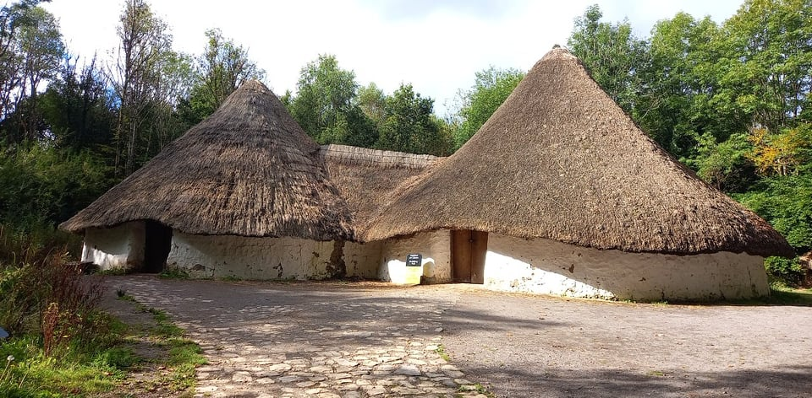
Figure 3: Bryn Eryr Iron Age Roundhouse at St Fagans (Mercer, 2021).
The roundhouse is given authenticity because it is based on “actual” archaeological remains (National Museum Wales, no date). Under the authenticity of St Fagans, Bryn Eryr has become representational of the entire Iron Age in Wales. While museums can be seen as dusty repositories of historical things, they must be adaptable to cultural identity and heritage changes to continue to function both socially and politically (Casey, no dateb, Paragraph 7). Museums often display items to depoliticise them and instead invoke a sentimental nostalgia of the past (Bennet, 1996; 112), enabling them to present a socially acceptable and “authentic” history. The development of the museum has caused the already fragile relationship between the object and subject to dissolve through the authority of thematic displays (Casey, no datea; paragraph 3). However, some artefacts exhibit such a strong “aura” that they do not need interpretation for authenticity. The Rosetta Stone (Figure 4) is displayed with little context yet remains relevant due to its aura. 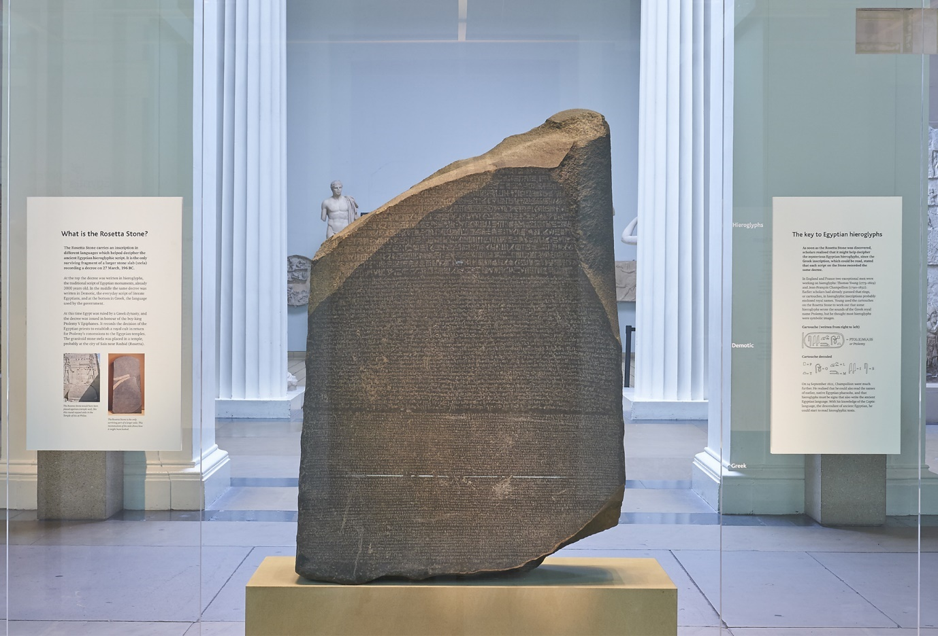
Figure 4: The Rosetta Stone in Room 4 at the British Museum (https://blog.britishmuseum.org/everything-you-ever-wanted-to-know-about-the-rosetta-stone/ Accessed on 17/10/2021).
Subject.
The most challenging aspect of authenticity to account for is that of the subject. The rise in interest in one’s cultural history has caused society to remember and document the past (Casey, no datea; paragraph 13). Every individual has their concept of what makes an object or experience “authentic”. An item’s authenticity is decided based on the person’s parameters developed throughout their life with exposure to knowledge and those put in place by the situation or institution that houses the object. Individual parameters can include an objects originality, its material content, the quality or pedigree of craftsmanship and its historical basis (Casey, no dateb; paragraph 3). The existence of museums and heritage sites helps influence a person’s specifications of authenticity by creating a division between those who produce and verify knowledge and those who consume it (Bennet, 1996; 89). People assume museums display an accurate interpretation of the past based on current academic ideas. Visiting these institutions help to solidify ideas of history and what is authentic. Popular culture can also have a significant effect on “subject authenticity”. Films and TV shows can influence ideas of authenticity through a “state of distraction” that has become the norm for the modern society of “absent-minded examiners” (Schwartz, 2001; 1735). A biopic “based on true events” can re-write the history of a person or town; a historical TV series can change societies ideas of ancient clothing and culture because films show the individual a representation of themselves as a collective (Schwarts, 2001; 1736).

Heritage is the collective memory of both tangible and non-tangible aspects of the past. Nick Merriman (2000; 1) suggests that the past belongs to everyone, so they should be able to access it, whether they choose to or not. People have always had an interest in history, but the use of the term “heritage” to describe a specific “national history” is relatively recent (Lowenthal, 1998; 6). The Office of Works began protecting buildings in 1882, and as more and more locations were added to the portfolio, the protecting body was remade “English Heritage” (English Heritage, no date). By the 1970s, heritage had become a broad term encompassing artefacts, natural phenomena, and practices (Benton, 2010; 1). Heritage conservation began with protecting the landscape, the first being Areas of Outstanding Natural Beauty (Benton, 2010; 2). The driving force of modern heritage is that of protection, preservation and in many instances, restoration and reproduction. In order to discuss the importance of authenticity in heritage, each of the layers, “object”, “interpreter”, and “subject”, will be discussed individually.

Object.
The heritage sector uses objects to tell national and community narratives; however, this creates a frozen history that is romanticised by sentimentality (Bennet, 1996; 111). Change is the fate of the landscape, and even an attempt to preserve it changes it (Benton, 2010; 2). When restoring a building that has existed for hundreds of years, the project manager/heritage specialist must decide what aspects from which period in the buildings life should be restored to give it authenticity to maintain the narrative while also protecting and replicating “aura”. Any “display” of heritage requires some degree of restoration or reproduction, which in itself lacks authenticity as it does not have the ‘aura’ of its spatial and temporal position (Benjamin, 2007, 220). Walter Benjamin (2007; 222) claims that the traditional values of cultural heritage are lost in reproduction as the sphere of authenticity is beyond technical reproducibility. In terms of heritage, the authenticity and “aura” of an object is practically extraneous. The irrelevancy of “object authenticity” is two-fold. Firstly, the archaeological record holds just a fraction of the material culture of the past; therefore, an accurate representation of the past requires restoration, reproduction, and interpretation. Secondly, the same heritage narratives are told in many different locations and so require the replication of objects. For example, the headstones of the Welsh Princes (Figure 5) were moved from Strata Florida to St Fagans and replaced with replicas to protect them, but the replicas facilitate the narrative to be told in both locations. 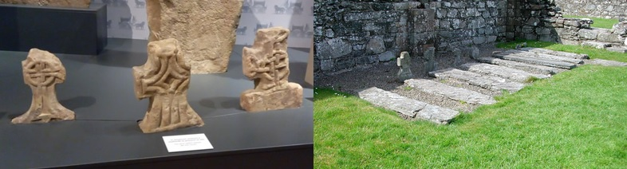
Figure 5: The Headstones of the Princes Graves at (Left) St Fagans (Mercer, 2021) and (Right) Strata Florida (http://www.castlewales.com/strata.html accessed on 17/10/2021). Interestingly, this exchange is noted in the museum at St Fagans but not on the information boards at Strata Florida.
Interpreter.
Museums act as “guardians of heritage” (Merriman, 2000;1). There would be significant gaps if we only used the “authentic” to display and understand our heritage. A reproduction does not hold the narrative of the original object. It has not experienced what we might wish to learn; however, heritage can be shown through reproduction, which preserves our knowledge. The heritage sector has also increased the timescale appropriate for conservation to include the recent past (Benton, 2010; 2). It has become a challenge to discern what should not be included in heritage presentation as it has become an integral part of the tourist industry and is heavily commodified (Benton, 2010; 2). Heritage has become increasingly politicised, and presentation control has moved away from historians and archaeologists to governments (Benton, 2010; 1). It is no longer a systematic presentation of evidence that supports a theory but is a dialogue between society and the government in the form of montage, interpretation and juxtaposition (Schwarts, 2001; 1723). The authenticity embedded in the institution’s authority is the most important aspect of the presentation of heritage. Because heritage is a narrative unburdened by evidence and fact, reproduction, restoration and interpretation are necessary to promote the “national identity” part of the collective memory. Moving the discussion of heritage from the value of artefacts to memory changes the debate (Benton, 2010; 2).
Subject.
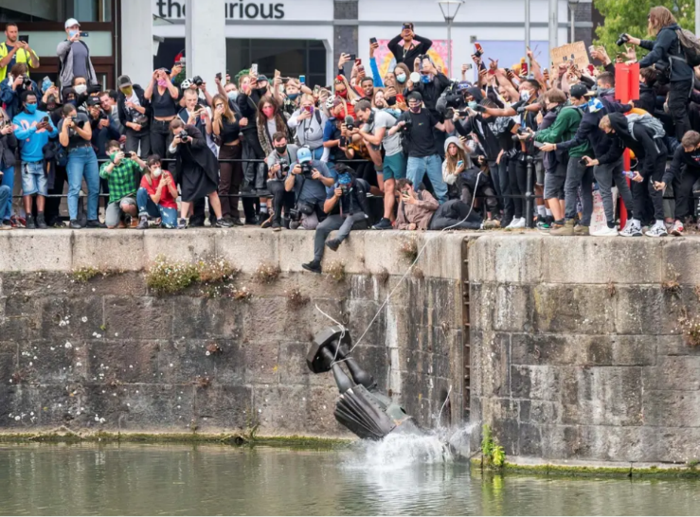
It is now agreed across many fields that heritage not only belongs to the public and communities but, most crucially, is defined by them (Benton, 2010; 1). An object’s authenticity is experienced and negotiated differently for individuals, depending on their perception of the heritage narrative (Chhabra, 2021; 17). Memory is an essential part of the non-tangible heritage; it shows the shared idea of what happened in the past and why it is important. This creates tourism and other demands that can be met by the heritage sector in many different ways, including visitor centres and monuments (Benton, 2010; 1). The very act of heritage conservation and the public money invested in numerous places and objects has created new expectations of experience in the sector (Benton, 2021; 1). The importance of a heritage narrative does not rely on the age, rarity or value of a cultural object, but the sentimental feelings projected onto the objects (Benton, 2010; 2). There is a reliance on society having faith in academia and museum institutions to portray the narrative rather than seeking out absolute proof in historical fact (Lowenthal, 1998; 7). The non-tangible aspects of heritage act as the motivational drive behind many conservation projects (Benton, 2010; 1). As individuals and groups of people remember things differently, it creates problems in managing heritage resources. The discussion is not only about which artefacts should be preserved, but which version of past events should be remembered and how? (Benton, 2010; 2). Heritage is not fixed and is directly related to national identity and worth (Lowenthall, 1998; 8). The “falsified legacies” parroted at various sites as a “national heritage” are vital to the feelings of identity and uniqueness with a community or society (Lowenthal, 1998; 11). The fact that museums and heritage institutions influence the ideas of “authentic history” means the “subject authenticity” has very little importance to the presentation of heritage. In a multi-cultural society, events spur minorities to voice their heritage narratives, even if they are contrary to the current ideals, and can change the national heritage. The recent “Black Lives Matter” movement has led to discussions and protests over aspects of how the United Kingdom commemorates its colonial heritage, including the removal of a statue of Edward Colston in Bristol (Wood, 2020 & Figure 6)
Figure 6: Colston thrown in Bristol river by protesters (https://www.independent.co.uk/news/uk/home-news/colston-statue-bristol-museum-river-avon-history-a9559771.html accessed on 17/10/2021).

Heritage is not celebrated because it is factually, provably authentic and true, but because it is what society as a collective wants to be the “true” national narrative (Lowenthal, 1998; 8). David Lowenthal (1998; 7) argues that the fabrication that dominates heritage is not harmful; heritage does not require authenticity as it has more flexibility than history. History may change through continued research, but it must conform to the rules of evidence and academia, whereas heritage can transgress without explanation or justification (Lowenthal, 1998; 7). The use of reproductions in the presentation of heritage is not a bad thing. Despite the loss of aura, reproduction and restoration enable larger audiences to experience national heritage (Akin & Kipcak, 2016; 153). If only a handful of “authentic” artefacts remain, reproductions can aid in education in a wide variety of sites and situations (Benjamin, 2007; 262).
Glanffrwd mill draws on object, interpreter and subject authenticity to create a snapshot of the early woollen industry in the Teifi Valley while at the same time continuing to be a practical working site. The main point to remember about Glanffrwd Mill is that it is a heritage site and a working woollen mill. It seeks to preserve the tangible and non-tangible aspects of the Welsh woollen industry of the early 20th century.
During the mill’s restoration in the early 1990s by Margaret, considerable attention was paid to certain aspects of authenticity (Bide, 2005). However, significant changes were made for it to be a working mill and preserve Welsh heritage. This is distinct from such sites as the National Woollen Museum, Dre-Fach Felindre and Esgair Moel, St Fagans Museum of National History, as they are both museums with a functional aspect for demonstrative purposes.
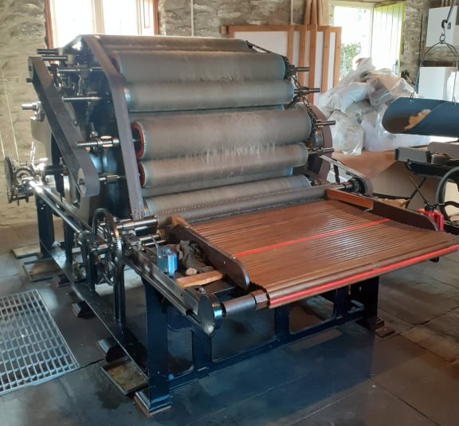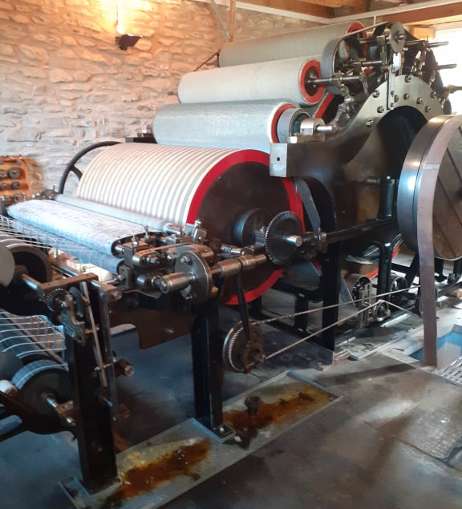
Figure 7: Scribber (Left) and Condenser (Right) carding machine at Glanffrwd Mill (Mercer, 2021).
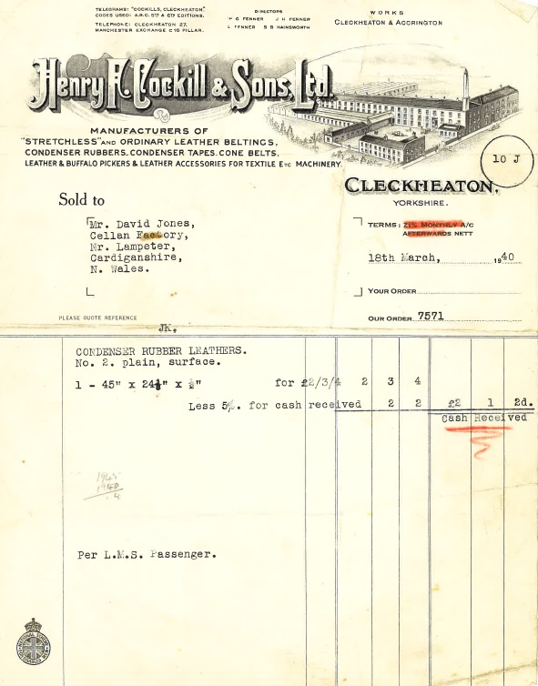
The most obvious “authentic” object in the mill is the carding machinery. The scribber and condenser (Figure 7) have been used on this site since it was made into a vertical woollen mill in 1884 (Bide, 2005; 04:41). Even during the conservation process, Miss Bide deliberately set about finding a restorer in Cleckheaton, Yorkshire, as this was where the original mill owners had received parts from when they were working the mill (Figure 8 & Malaws, H, 2021; Personal Communication, 9 October).
One of the main factors in “interpreter authenticity” was maintaining the operational aspect of the mill. This included changing the location of the main drive shaft from an overhead to an underfloor system to increase the safety of those working in the mill (Bide, 2005; 16:37). While this is not the traditional layout, it continues the heritage narrative into the modern day with health and safety considerations. Moving the driveshaft was only possible because the floor was excavated to install underfloor heating. Some heritage institutions believed the addition of modern technology compromised the authenticity of the restoration (Malaws, H, 2021; Personal Communication, 9 October); however, this was to prolong the life of the machinery even if the mill became idle (Bide, M, 2018, Personal Communication 21 November). The use of modern technology adds to the heritage management, the restoration by Margaret Bide has become an integral part of the story of Glanffrwd Mill.
Figure 8: Invoice for Condenser leathers from 1940 (Mercer, 2021).
The issue of subject authenticity is more difficult to apply to Glanffrwd as it is not open to the public as a museum but a privately-owned site. However, there are expectations of a historic woollen mill: a water wheel to power the machinery for one. By 1943, Glanffrwd was using a diesel engine to power the machinery and had stopped using the water wheel altogether, but the restoration returned the mill to a purely water-powered system. The addition of a diesel engine at the site would be more “authentic” to the factual history of the mill while also taking away from the heritage narrative.
No matter the lack of authenticity in some areas, the site itself remains authentic to an industrial site’s adaptable and ever-changing nature. The Welsh woollen industry was adaptive to the season, with many being run alongside smallholdings and repurposing machinery for other purposes during harvest time (Jenkins, 1969: 282). The “authenticity” of any working site is always dubious as machinery is constantly being repaired and upgraded. Much like the Ship of Theseus, which iteration of the machinery and set-up is the “authentic” one?

Conclusion
Authenticity and heritage are human constructs that are affected by politics and the morals of society. Presentations of heritage reflect the non-tangible memories of a group or community, often in a tangible way (Benton, 2010; 4). There is no doubt that a degree of authenticity is necessary for the presentation of heritage; however, this does not need to be ‘authentic authenticity’ in the way of evidence-based facts, merely ‘perceived authenticity’ for the sake of the narrative. By applying the model laid out in this essay, it is possible to analyse the authenticity of different aspects of a heritage site to different degrees while acknowledging the importance of each layer in the overall presentation. “Authenticity” can take many forms and change over time (Chhabra, 2021; 2). For example, the replica gravestones at Strata Florida do not detract from the authenticity but shift it from the object to the interpreter. Applying the model to a site such as Glanffrwd Mill helps identify areas of change that are authentic to the continuous heritage narrative of a working site. Despite alterations made to the building and layout of the machinery, the Welsh Mill Society recognises Glanffrwd Mill as a sympathetic restoration and authentic representation of the woollen industry in Wales from the early 20th century to now (Malaws, H, 2021; Personal Communication, 9 October). This is corroborated by the Garde II listed status of the mill building and machinery received in 2021 (British Listed Buildings, 2021).

Reference List
Akin, C and Sezin Kipçak, N. 2016. Art in the Age of Digital Reproduction: Reconsidering Benjamin’s Aura in “Art of Banksy”. In Journal of Communication and Computer 13. Pp 153-158. Accessed on http://www.davidpublisher.com/Public/uploads/Contribute/57a1b26d39e3d.pdf 07/10/2021.
Benjamin, W. 2002. The Arcades Project. Translated by Eiland, H & McLaughlin, K. Harvard University Press, Cambridge, MA.
Benjamin, W. 2007. Illuminations: Essays and Reflections. Translated by Zohn, H. Random House, Inc, New York.
Bennet, T. 1996. The Birth of the Museum: History, Theory, Politics. Routledge, London.
Benton, T (ed). 2010. Understanding Heritage and Memory. Manchester University Press (in association with The Open University), Manchester.
Bide, M. 2005. The Restoration of a Welsh Woollen Mill. Presentation at University of Wales Trinity Saint David, 15/03/2005.
British Listed Buildings. 2021. Glanffrwd Mill. Accessed on https://britishlistedbuildings.co.uk/300087822-glanffrwd-mill-llanfair-clydogau#.YWw9cxzTVPY 17/10/2021.
Casey, V. No Datea. The Museum Effect Accessed on http://valcasey.com/yale_effect.html 17/10/2021.
Casey, V. No Dateb. The Technocratic Museum. Accessed on http://valcasey.com/yale_technocratic.html 17/10/2021.
Chhabra, D. 2021. Resilience, Authenticity and Digital Heritage Tourism. Routledge, London.
English Heritage. No Date. Our History. Accessed on https://www.english-heritage.org.uk/about-us/our-history/ 17/10/2021.
Jenkins, J. G. (1969) The Welsh Woollen Industry. National Museum of Wales, Welsh folk Museum, Cardiff.
Lowenthal, D. 1998. Fabricating Heritage. In History and Memory; Vol 10, No 1. Indiana University Press, Bloomington, IN. Pp 5-24.
Merriman, N. 2000. Beyond the Glass Case: The Past, the Heritage, the Public. University College London Institute of Archaeology, London.
National Museum Wales. No Date. Bryn Eryr Iron Age Roundhouses. Accessed on https://museum.wales/stfagans/buildings/bryneryr/ 17/10/2021.
Romano, A. 2018. Banksy’s shredded Sotheby’s art was a rebuke of empty consumerism from a master. Accessed on https://www.vox.com/2018/10/8/17941350/banksy-trolls-sothebys-shredded-art-balloon-girl 07/10/2021.
Schwartz, V. R. 2001. Walter Benjamin for Historians. In The American History Review; Vol 106, No 5. Oxford University Press (on behalf of the American History Association), Oxford. Pp 1721-1743.
Shanks, M and Tilley, C. 1992. Re-Constructing Archaeology: Theory and Practice. Routledge, London.
Wood, V. 2020. Bristol Says it will retrieve slave trader statue from river and put it in a museum. The Independent. Accessed on https://www.independent.co.uk/news/uk/home-news/colston-statue-bristol-museum-river-avon-history-a9559771.html 17/10/2021.

