Recycling and the environment

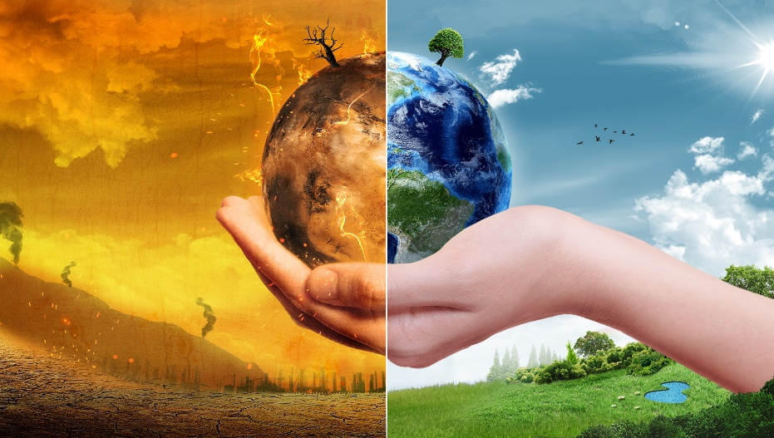
The ongoing issue of litter polluting oceans has been a major topic for many years. Many organisations are making it their mission to educate people about pollution around the globe, with many not quite understanding the serious impact litter is having on the environment. The most prominent piece of litter that has significantly negatively impacted our seas is plastic. Mainly effecting our coral reefs which are crucial to the environment because they act as a natural filtration system.

Effects on us
It goes without saying, if fish or other species are consumed by humans, there is a likely hood of us consuming micro plastics as our waters are contaminated causing serious harm to our bodies. Micro plastics absorb and produce very harmful pollutants which has a negative effect on our health.
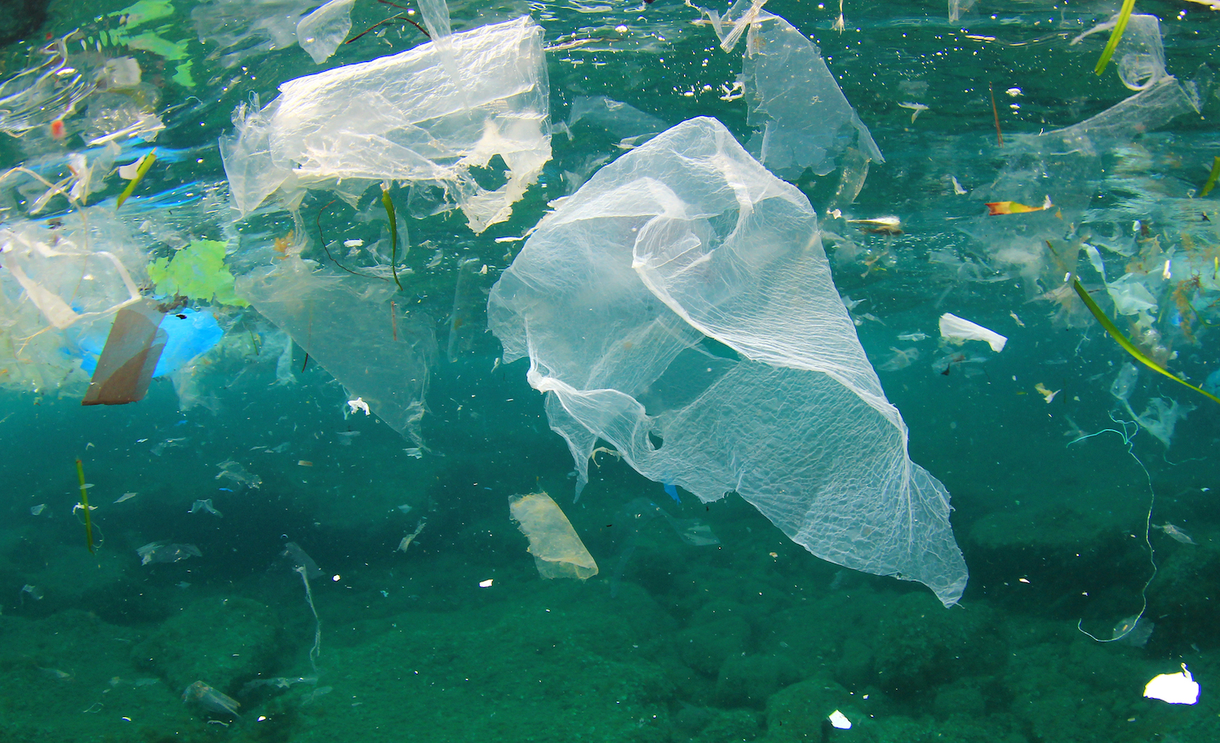

Ways to help reduce plastics in our seas
- Recycle properly
- Reduce your use of single use plastics
- Educating the youth
- Participate in beach\river clean ups
- Fill reusable bottles instead of buying new ones
Reference

Davies, A. (2021, November 30). The Impact of Ocean Litter. Adopt a Beach. https://adoptabeach.com/the-impact-of-ocean-litter/
Hutchinson, B. (2022, October 6). 7 Solutions To Ocean Plastic Pollution. Oceanic Society. https://www.oceanicsociety.org/resources/7-ways-to-reduce-ocean-plastic-pollution-today/
Plastic-Free to Save our Sea: Conservation at. (2019, April 29). Point Defiance Zoo & Aquarium. https://www.pdza.org/care/plastic-free/

