

University of Wales Trinity Saint David
School of Engineering

Can FEA Replace Physical Testing

Michael Anderson
P151178

31/03/20

Advanced Stress Analysis & FEA
M6X00420

Kelvin Lake
Contents

1) Introduction 1
2) FEA vs Physical Testing 2
2.1. Why Companies Typically Carryout FEA Alongside Physical Testing. 2
2.2. How A Physical Test May Be Correlated To An FE Model. 4
2.3. Can (Or Should) FEA Ever Replace Physical Testing. 7
3) References 9

Figure 1 – Physical Testing vs FEA Model Comparison Under Buckling (Quan, et al., 2015) 4
Figure 2 – Loading Of 'I' Beams (Quan, et al., 2015) 5
Figure 3 – Measurements From The 'I' Beams Used For Physical Testing (Quan, et al., 2015) 6
Figure 4 – Comparisons Between FEA & Real-World Results On Four Different Sections Of An ‘I’ Beam (Quan, et al., 2015) 6

Introduction

This report will cover the basic principles of FEA and how it relates to physical testing within the real world.
Research was conducted into both FEA and physical testing to determine how effective each method is at displaying any deformations that would occur on a component under load. This led into uncovering why companies use FEA software alongside physical testing during the design process.
An important aspect of any virtual simulation is the ability to replicate results that would be seen within real life. If this correlation does not occur, the results predicted by the FEA software package could not be trusted as their validity would be in question.
Although the advantages of FEA programs are substantial, there are just as many negatives, or at least potentially, as there are positives. These will be discussed and compared to each other to answer the question if FEA could completely replace physical testing experiments, to ascertain the quality, strengths and weaknesses of a component.

FEA vs Physical Testing

Why Companies Typically Carryout FEA Alongside Physical Testing.

Physical testing has been conducted since the beginning of invention. Every time a product is created, it has always been necessary to test its operation within real-world conditions, before selling the product to a customer. This allows the designer to ensure their product works as intended, whether due to structural requirements, safety concerns or determining if new materials or methods of assembly/manufacturing have adversely affected the overall quality and performance of the finalised product.
Although the results of physical testing can be accurate, it is hard to maintain an environment in which testing can occur without negative impacts to avoid adverse influences and untrustworthy results. For example, if during the products real world operation, it is only subjected to high ambient temperatures (~45°C) and dry conditions, then it would be highly impractical to test the durability of that product in an environment that does not reflect those conditions, e.g. where during testing the temperature is 0°C and it is submerged in water. The results would not reflect real-life values, trends or deterioration through wear, and would therefore be considered inaccurate, impractical and useless.
It can be expensive to create the correct environment for testing, whether due to replicating real-world conditions, such as wind speeds, temperature and pressure. The size of the facility would also drastically affect costing. Testing the yield strength of a bolt requires significantly less space and resources than applying the same testing method onto a fully assembled aeroplane wing, and should that test be conducted incorrectly, the bolt, and associated shrapnel, would be easier to contain than if the plane’s wing collapsed due to inappropriate/inadequate joining methods (bolts/welds).
Since physical testing can be costly, Finite Element Analysis (FEA) computer software has been developed by numerous companies to mathematically simulate physical phenomenon, such as; compression, tension, instantaneous impacts or loading, on any object or shape, within a virtual environment using the numerical Finite Element Method (FEM) technique. Designers and Engineers alike, use FEA to reduce the number of physical prototypes created and experiments required to optimize components while being designed, to enhance the development of products quicker in comparison and more cost effective. (Simscale, 2020)

Mathematics are necessary to comprehensively understand and validate any physical phenomena that would occur within the component or assembly, during its lifetime. Most FEM processes split the geometric shape down into smaller pieces called elements, a parameter value defined by the user. Partial differential equations are applied to each individual element within the structure to determine the stress, strain, temperature or any other required data at any given time. Numerical techniques have been developed for use within this process to aid with the reduction in computational calculation time and processing power usage. (Caliber Design, 2015)
The advantages of using an FEA process are numerous (Pre Technologies, 2020):
- Generation of the physical response of the system, usually colour mapped to display stress concentrations or weak/break points for easier visualisation.
- Safe simulation of potentially hazardous, destructive or impractical loading conditions, reducing the need for a secure environment that would potentially need decontamination.
- Accessibility of running several physical events applied to the same model that would otherwise require a complicated ‘jig’ to secure the part or method of force application to simulate.
- The simultaneous calculation and visual representation of physical parameters and material characteristics, enabling the designer to analyse performance and apply modifications to compensate for unusual results or unexpected failures.
- Relatively low initial investment and calculation time compared to creating the environment to adequately test a physical prototype.
By using both FEA and physical testing on a product, both results can either validate or dispute one another. Should both set of results be within tolerance, they can confirm that the adverse effects that were observed in the virtual environment, would be replicated within real-life, Figure 1. They can just as easily oppose one another, in which case, it may be best to reconduct either one or both experiments.
The computational FEA result may be producing the expected outcome, but within the physical component, the materials used may have an undetected deformity, such as; rust, air pockets, microfractures or a slight change in alloy grade/composition of the material that cannot be seen without specialist procedures. On the other hand, the physical results could be correct, the FEA model may have been using an incorrect solver model, too small/large element size, incorrect material, density and mass applied to the component, which all would drastically change the results and their validity.

How A Physical Test May Be Correlated To An FE Model.

It is an indisputable fact that for FEA results to be comparable predictions to those of real-life, they must have some form of correlation, either in trends or values. It boils down to the fact that it is hard for FEA programs to predict exact real-life environments and situations, depending on the settings and solvers used. It generally predicts a static ‘best case’ scenario for the components at any one time.
Although software exists to create a simulation in motion, it is difficult to replicate a dynamically changing environment, subjecting the component to changes of temperature, pressure, lubrication, wind speed, rain and the sun. If the part is used outside in all weathers, it may be difficult to account for material degradation and deformation over time, including whether maintenance is not performed by the user at its allocated scheduling as stated by the manufacturer.
Designers use FEA primarily to test whether the component would withstand certain loadings, temperatures or pressures as if product was brand new, this allows them to determine whether the shaping or design was adequate for use at the point of sale, or needed revisiting. (Donald, 2007)
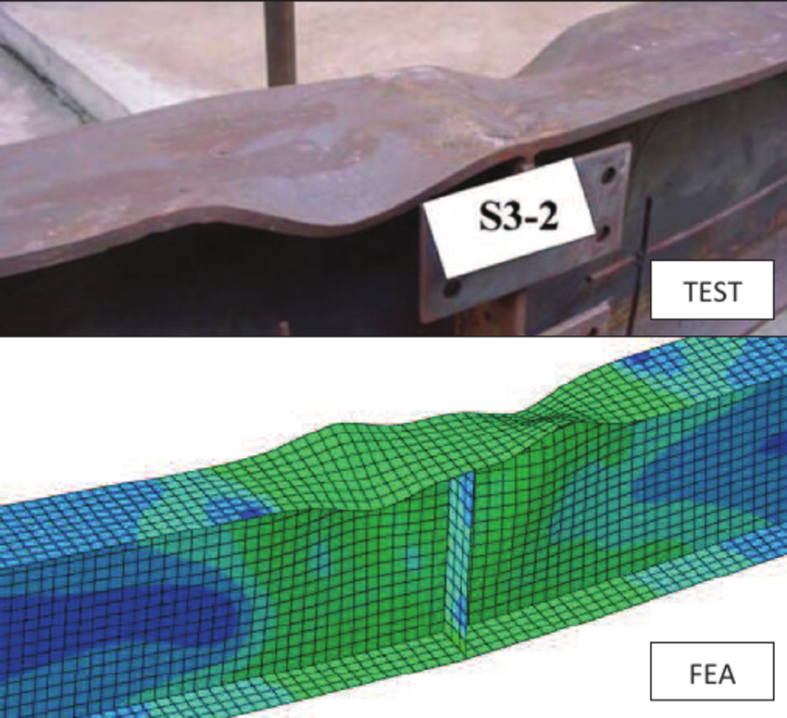
Figure 1 shows the different resultant outcomes from performing a buckling test upon an ‘I’ beam in the both the real world and using a FEA software package (Quan, et al., 2015). Overall there are similarities between the two, the highlighted red points show the similarities and the blue points show the differences.
Figure 1 – Physical Testing vs FEA Model Comparison Under Buckling (Quan, et al., 2015)

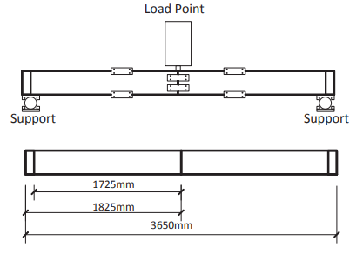
It is then customary to provide every component with some form of guarantee or warranty period, ensuring the product will last a suitable lifetime, entirely dependent of the components use. E.g. a large ‘I’ beam for structural use within a building, should be designed to last a lot longer than a motorcycle brake lever, due to both the magnitude of the forces applied through the component, but also to a lack of accessibility, the cost of replacement parts or the ability for repairs to take place. (Vermaas & Vial, 2018)
Figure 2 – Loading Of 'I' Beams (Quan, et al., 2015)
Both ‘I’ beams were laid horizontally while supported at both ends, then loaded in the centre and tested up to failure, Figure 2. This method was used to determine the strength of the beam-to-column connections trying different web thicknesses at different temperatures 415°C- 615°C.
“This may be because the accuracy of the assumption of flange buckling length from Eq. (1) may differ at different temperatures; this would have a significant effect on the beam post-buckling behaviour.” (Quan, et al., 2015)
For this study, the ABAQUS software was used with an element size of 15mm by 15mm was used as an optimum balance between accuracy and computing efficiency.
It is clear to see they acknowledge that within the steel beam assembly, the ‘I’ beams are not the weak point, it is what joins the numerous beams together which is the weak link that would cause structural failure. Which, could result in criminal liability, should someone become injured after the component was installed, while being within its warranty period.

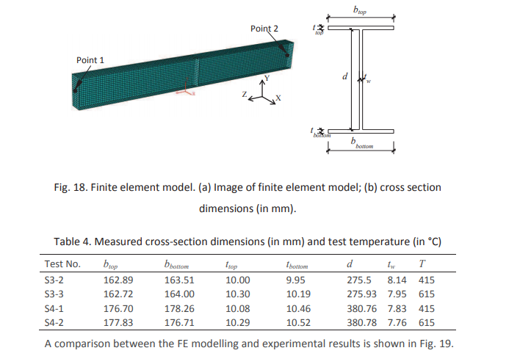
Figure 3 are the measurements from the experiments conducted on the physical ‘I’ beam sections, taken from the top and bottom flange breadths and thicknesses. “Table 4 presents the details of cross-section dimensions and test temperatures. All dimensions are the average values of measurements by Dharma [26] from different locations.” (Quan, et al., 2015)
Figure 3 – Measurements From The 'I' Beams Used For Physical Testing (Quan, et al., 2015)
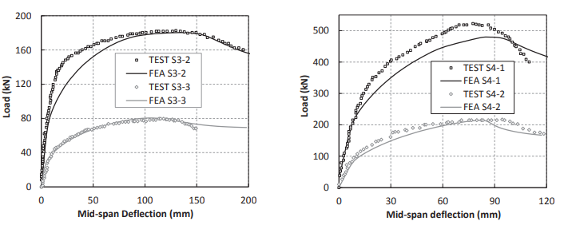
During this study, they discovered that the FEA models can also predict the buckling shape very well compared with the physical test results; shown in Figure 1. Hence, the numerical model is considered reliable and was used within the study.
Figure 4 – Comparisons Between FEA & Real-World Results On Four Different Sections Of An ‘I’ Beam (Quan, et al., 2015)

Can (Or Should) FEA Ever Replace Physical Testing.

This question poses a difficult and unclear response. Physical testing should always take place and can never be ruled out completely. Because there’s no better guarantee that a component will handle the stress and strains or be durable enough to last its designated lifetime, unless it is tested in the real world. This would allow extra tests to be conducted on the components afterwards, if the part becomes distorted, NDT processes would allow designers to understand how far away the part was from failing and where that failure would occur. If the part had failed, data could be collected to analyse the design and acknowledge areas where it can be improved upon. (Mayes, 2008)
FEA will always improve results and reduce the number of physical experiments required to take place by accurately predicting the results that would be expected, but nothing quite compares to the real thing. It has always been in a company’s best interest to keep research and development costs low, making it easier to reclaim that cost back through sales. Depending on the size of the end product, it may be cheaper to run a multitude of FEA simulations compared to one physical test, but without that physical test taking place, how can you correlate the FEA results and predictions to those that would actually occur, even over time. (Ostergaard, 2018)
“[Digital] simulation has definitely come a long way from its initial applications in linear, structural analysis. Today, complex nonlinear structural analysis is commonplace ... the other area where it has grown is in fluid dynamics.” (Wong, 2010)
By using FEA, we get an approximate solution based on numerous mathematical models that are available by using computer simulations. But relying totally on FEM is not the correct approach. As experimental techniques related to the study take place, it may be noticed that parameters used within the mathematical model are not accurate, bringing the validity of all previous studies using the old parameters into question. (Jamaludin, 2012)
In this case, it is necessary to modify the mathematical model and rerun the simulations and assess the impact those modification had on the data. By doing a series of experimental work, it is possible to modify the model and be able to predict the behaviour more accurately and closer to values exhibited in real-life. This can be highly advantageous as opposed to testing the component in a physical environment, due to its significant cost and impracticality. (ATA Engineering, 2020)

An experienced designer should not blindly follow a prediction of responses by the mathematical model. Should an FEA model be as accurate as real life, it can be a very powerful tool in optimising the component further to improve upon the results. If a company can guarantee their product will withstand a higher loading or last 10 years longer than their competitor, then they will be the first choice to any sensible customer, so long as the components are competitively priced.

References

ATA Engineering, 2020. Validate Predictions with Test-Analysis Correlation. [Online]
Available at: http://www.ata-e.com/services/test/test-analysis-correlation/
[Accessed 01 04 2020].
Caliber Design, 2015. Why Use FEA?: An introduction to Finite Element Analysis. [Online]
Available at: https://www.caliberdesign.co.nz/wp-content/uploads/2015/05/Caliber-Design-HowToGuide-Intro-to-FEA.pdf
[Accessed 03 2020].
Donald, B. J. M., 2007. Practical Stress Analysis with Finite Elements. Dublin: Glasnevin Publishing.
Jamaludin, A. S., 2012. How reliable is FEM analysis or simulation in a test, for example, machining simulation? How can we judge that our simulation is correct?. [Online]
Available at: https://www.researchgate.net/post/How_reliable_is_FEM_analysis_or_simulation_in_a_test_for_example_machining_simulation_How_can_we_judge_that_our_simulation_is_correct
Karpat, F., 2018. Finite Element Analyses and Correlation with Physical Tests of a Rollover Protective Structure (ROPS) Performance, Bursa: International Research Journal of Advanced Engineering and Science.
Mayes, R. L., 2008. Model Correlation and Calibration , Albuquerque: Experimental Mechanics, NDE and Model Validation Department.
Ostergaard, E., 2018. Correlating Experimental Test Data and FE Results. s.l.:s.n.
Pre Technologies, 2020. Advantages of finite element analysis (FEA). [Online]
Available at: http://www.pretechnologies.com/services/finite-element-analysis/advantages
[Accessed 01 04 2020].
Quan, G., Huang, S.-S. & Burgess, I., 2015. Component-Based Model of Buckling Panels of Steel Beams at Elevated, Sheffield: University of Sheffield.
Simscale, 2020. What is FEA | Finite Element Analysis?. [Online]
Available at: https://www.simscale.com/docs/content/simwiki/fea/whatisfea.html
[Accessed 01 04 2020].
Tiossi R1, V. M. L. L. C. H. B. O. R. R. F. A., 2013. Validation of finite element models for strain analysis of implant-supported prostheses using digital image correlation., São Paulo: Department of Dental Materials and Prosthodontics.
Vermaas, P. E. & Vial, S., 2018. Advancements in the Philosophy of Design. Cham: Springer Interanational Publishing.
Wong, K., 2010. Is Digital Simulation Good Enough to Replace Physical Tests?. [Online]
Available at: https://www.digitalengineering247.com/article/is-digital-simulation-good-enough-to-replace-physical-tests

