

BMIH6004 Managing Hotel Administration
Student Learning Log
Student Name: Silvia Daniela Grecu
Student ID: 2245642

Table of Contents
1. Introduction 1
2. Main Body: Department Reflection 1
2.1 Scenario 1 - Administrative Challenges and Level 4 Links 1
2.2 Scenario 2 - Financial and Revenue Administration 2
2.3 Interdepartmental Coordination and Level 4 Comparison 3
3. Conclusion and Development Plan 4
References 5

1. Introduction
This reflective log will talk about my Level 6 placement in the department of Reception and Front Office in the Best Western Abbots Barton Hotel. The Front Office is the administrative centre of the hotel and it is where guests check-in, reserve, make bills and general enquiries. It is their initial and final impression to the guests, and therefore it is a very crucial aspect to create a favourable impression.
According to Bardi (2010), the front office is the nerve centre of a hotel where all the information regarding the administration is collected and sent to other departments. The proper management of hotel operations completely depends on the credibility of the work carried out at the front desk (Vallen and Valen, 2014). My placement duties included working with the hotel's property management software, guest data, and daily arrival arrangement. Gibbs (1988)'s Reflective Cycle will be used to assess my professional development in this log. In administrative circumstances, I will apply my theoretical study to my real-life experience and compare my current competencies to those from my Level 4 placement.

2. Main Body: Department Reflection

2.1 Scenario 1 - Administrative Challenges and Level 4 Links
A particular administrative situation that I encountered was in working with a complicated reservation error. One of the visitors came with the expectation of a family suite but a glitch in a system had made him be assigned a standard two-person room. To finalise this, I had to remain composed, apologetic, and use the booking software manually to find a possible upgrade, in addition to keeping the annoyed guest composed. This circumstance is directly associated with the theories I have learned during my Level 4 Customer Service course, as we were taught about service recovery and conflict resolution.
According to ASET (2017), good practice in work-based learning means that students should be put in circumstances where they have to resolve unexpected issues without supervision. This angry customer also made me use my academic knowledge of service recovery in a real stressful situation. Hagg (2013) observes that the idea of internship is created exactly with this goal in mind: transferring students between theoretical and practical knowledge. According to Brotherton and Wood (2008), the ability of staff to recuperate service failures within a very short duration is a core aspect of hospitality management that helps to avoid long term harm to the reputation of the hotel.
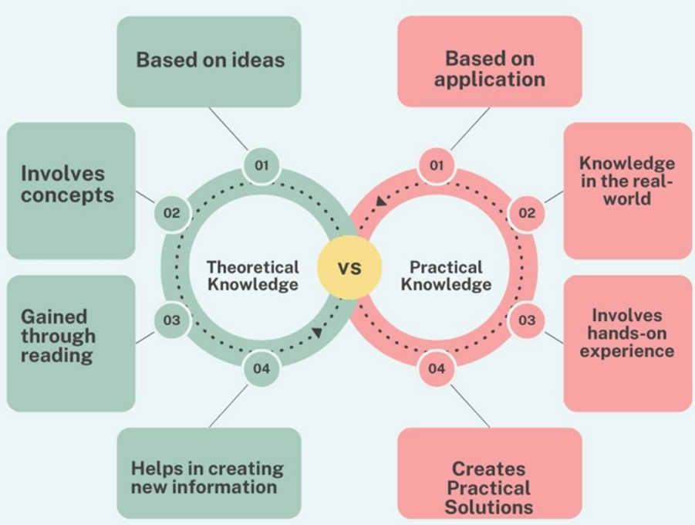
Figure 1 Theoretical vs Practical Knowledge (ASET, 2017)
I actively used my Level 4 training in customer service by effectively upgrading the guest and providing them with free breakfast as an apology. I ensured that I contacted the guest the following morning to ensure that they were not experiencing any problems in the new room. This additional measure was a sign of proactive customer service and served to restore the confidence that the customers had on the overall standards of service offered by the hotel. In the case of the guest, the guest left positive reviews on the day of departure, and this indicates that problem-solving by the administration is important in saving the experience of the guest.

2.2 Scenario 2 - Financial and Revenue Administration
The second important situation was when I got exposed to the financial administration of the hotel. I was assigned to do the daily billing reports processing and a review of the room rates in the upcoming week. This necessitated me to ensure that corporate clients were charged their negotiated agreed rates and not the normal public price. This is a very administrative task that is closely associated with my Level 4 Hospitality Finance course where I initially got acquainted with the concept of pricing and revenue generation.
Martin (2020) emphasises accuracy and rates of billing and control at the front desk as a significant aspect of comprehending and increasing the hotel profitability. In the case of a receptionist not using the proper corporate discount, the hotel will risk losing a great long term business customer. I thoroughly traced the accounts and found a booking in which the incorrect rate had been charged and rectified it before the customer walked out.
I was also taught how to come up with financial summaries at the end of the day, cross-reference card payments to the property management system to identify the slightest of differences. This day having audit made me realise that proper data input is the key to the financial well being of the business. According to Fallon and Rutherford (2010), hotel management and operations rely on front office employees who perform the role of the main financial controllers of the guest accounts. The financial theories that I used during my Level 4 studies made me realise the broader commercial effect of my daily administrative activities. It opened my eyes to the fact that the work of front desk is not merely arranging room keys in the hands of the customers; it is also safeguarding the economic stability of the company.

2.3 Interdepartmental Coordination and Level 4 Comparison
By reflecting on such situations, I will be able to contrast my present administrative skills with the skills that I possessed at Level 4 during my placement. My perception of hotel administration was very shallow in the past, and I was usually confused by the booking software. I tended to follow other people but not to act alone. But in Level 6, I was in charge of complex matters of billing and communicated with other departments.
One of the spheres of improvement was my skills in dealing with interdepartmental communication. According to Johnston et al. (2012), to enhance service delivery, the departments need to exchange information in an accurate and fast way. I used to communicate with the Housekeeping team frequently to update the statuses of the rooms on the system so that guests could check into the rooms early. Both Casado and Rughubalan (2012) emphasise that housekeeping operations are impossible to operate without proper, real-time data delivered by administration of the front office. Through this flow of information, I proactively enhanced the rate of operations of the hotel.
According to Wood (2013), these are the main concepts that one must master in the hospitality management to become not just a simple employee but the one who can perform the duties of a supervisor. Felce (2019) goes in line with this by stating that any form of higher education apprenticeship and placement is effective when it results in the creation of independent professionals who are confident. On comparing my two experiences at the placement, it is possible to identify a clear flow. I am no longer in a situation when I have to deal with simple things, now I see how my administrative choice influences the financial results of the hotel and its working tempo.

3. Conclusion and Development Plan
To sum it up, my administrative and supervisory skills were greatly developed during the period of my placement in the Front Office of the Best Western Abbots Barton Hotel. I was able to use the theories learned in my Level 4 modules of customer service and finance by contemplating on certain situations, e.g. fixing booking mistakes and preparing financial statements. This would have illustrated my development as a professional as it was a clear indication that I was not only an observer who at Level 4 only had basic observation skills but was an independent problem solver at Level 6. In the future, my professional development project will be developed on the increased awareness of revenue management software and the investigation of the intersection of digital marketing and front office sales. Enhancing my technical skills in these aspects will further solidify my administrative base that I have developed during this placement and make me prepared to work in the hotel management in the future.

References
ASET (2017) Good Practice Guide for Workbased and Placement Learning in Higher Education. Sheffield: ASET.
Bardi, J. (2010) Hotel Front Office Management. London: Wiley.
Brotherton, B. & Wood, R.C. (2008) The SAGE handbook of hospitality management. 1st edition. London: Sage. doi:10.4135/9781849200417.
Casado, M. (2012) Housekeeping Management. London: Wiley.
Fallon, M. & Rutherford, D. (2010) Hotel Management and Operations. London: Wiley.
Felce, A. (2019) 'Managing the quality of higher education in apprenticeships', Higher education, skills and work-based learning, 9(2), pp. 141-148.
Hagg, E. (2013) Internship Guide: Work Placements Step by Step. 5th Ed. The Hague: Eleven International Publishing.
Johnston, R., Clark, G. & Shulver, M. (2012) Service Operations Management: Improving Service Delivery. 5th Ed. London: Pearson.
Martin, A. (2020) The Practical Guide to Understanding and Raising Hotel Profitability. Abingdon: Routledge.
Rughubalan, G. (2009) Hotel Housekeeping: Operations and Management. Oxford: Higher Education Press.
Vallen, G.K. & Valen, Jerome J. (2014) Check-In Check-Out: Managing Hotel Operations. 9th Ed. Harlow: Pearson Education Limited.
Wood, R.C. (2013) Key Concepts in Hospitality Management. London: SAGE Publications Ltd.

