Student Name: Aida Lamer
Student ID Number: 1706552
Module: Smart and Connected Devices
Module Code: ACDA5005
In the following report is considering how and why the programming techniques have been selected as a solution used for the creation of the website.
The image below shows the rainfall text files being successfully transferred into a database using php script. Once the php was saved and phpMyAdmin was refreshed, the text files transferred onto the database.
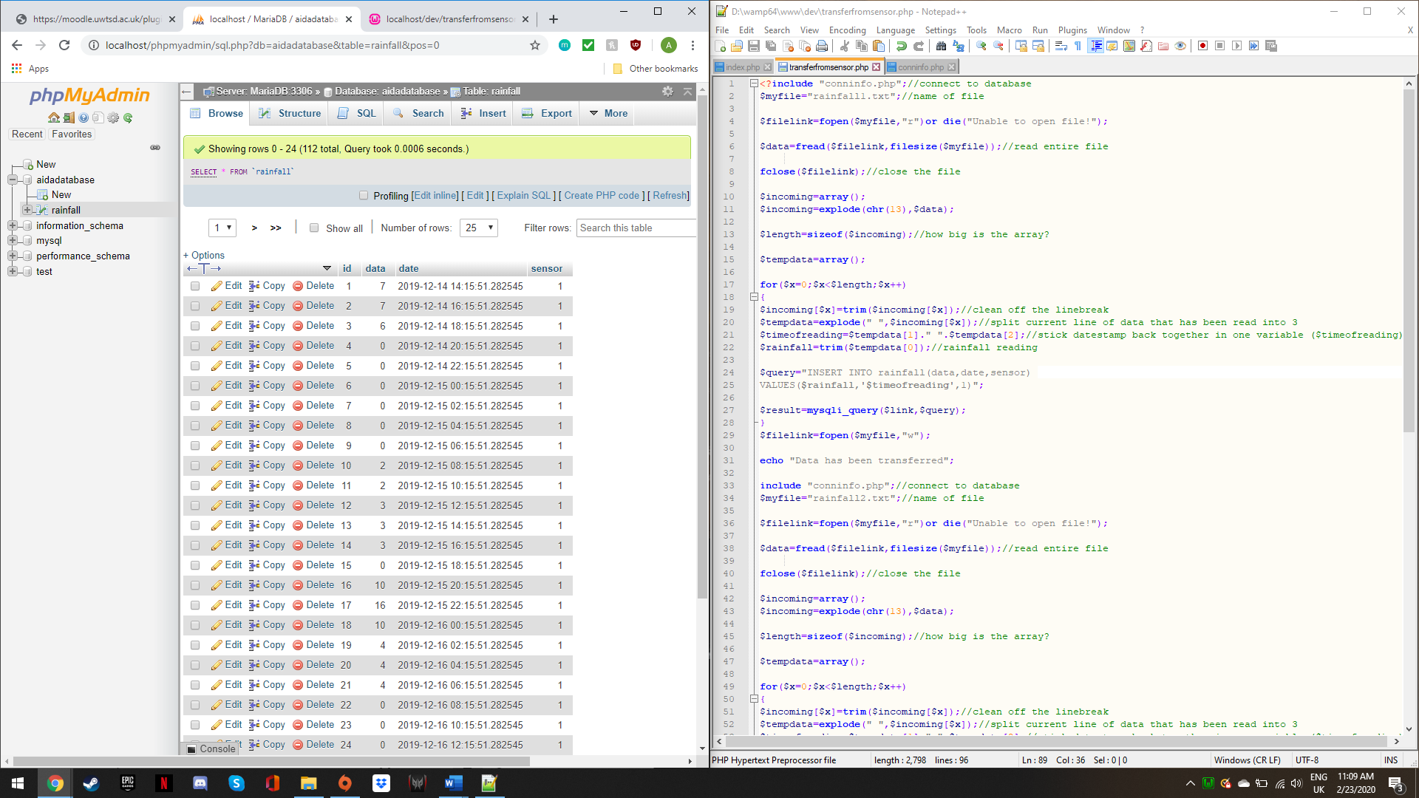
The following code stops the data from being read again in order to avoid showing up in the database multiple times.
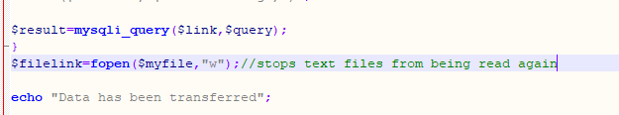

The message “Data has been transferred” confirms that the data has been transferred onto the database. This message only shows once. If the website was refreshed at this point, an error message would appear as the text files are now empty and there is no data in them to transfer.
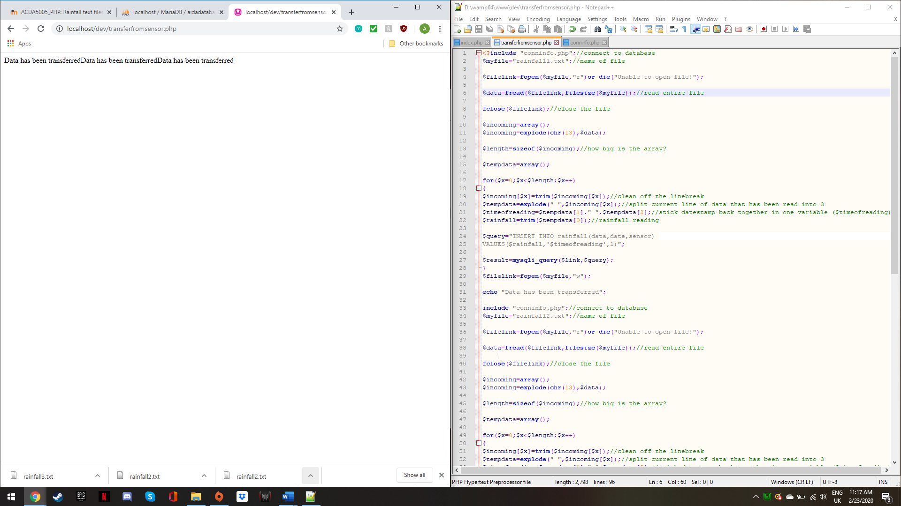
The data from the text files is displayed on website. The code below is the code that executes the query.
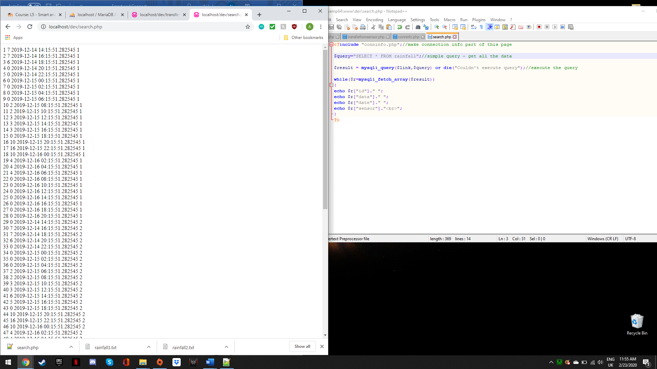
The data from the text files is organised into a simple table with borders to make the data easily readable for the user. The code below shows the use of html to create the table.
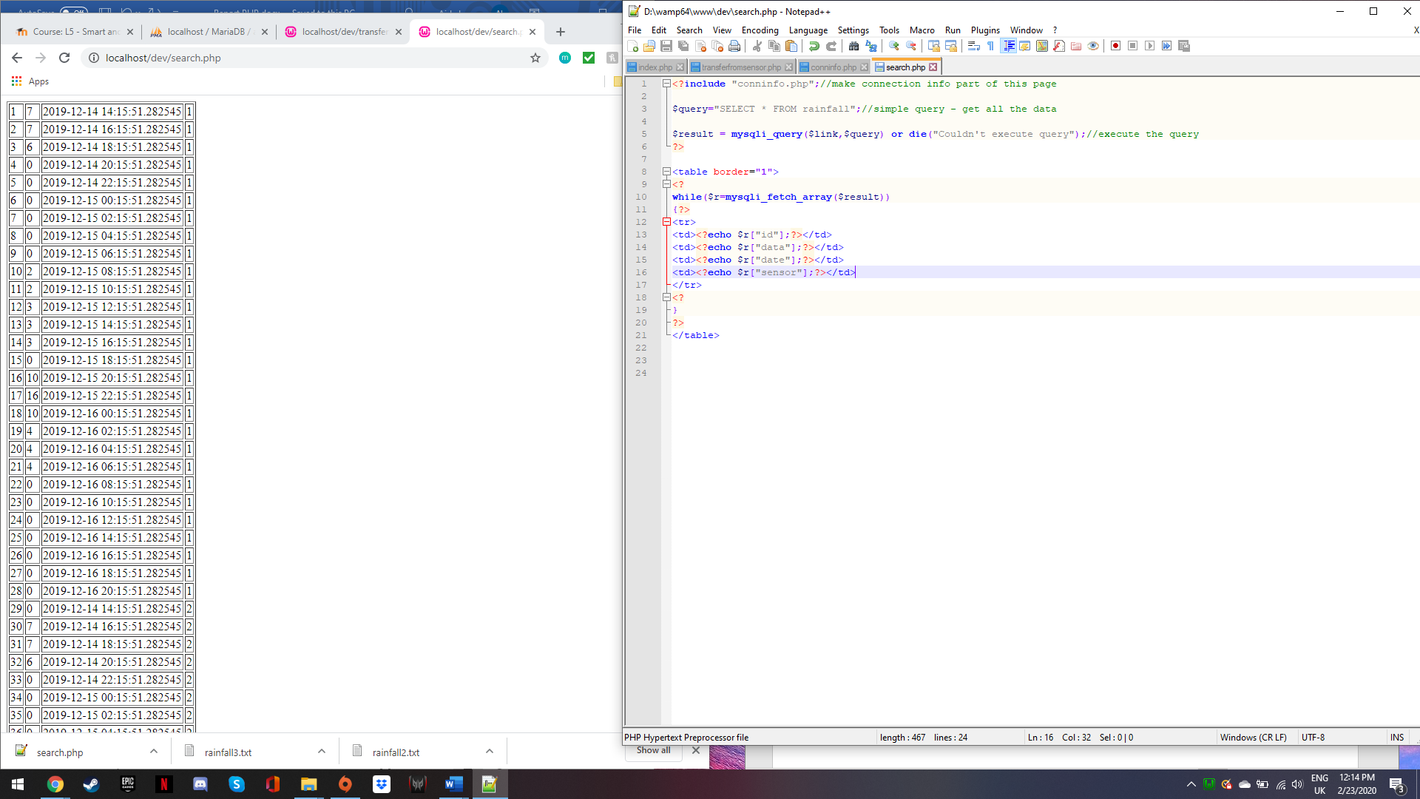
The data from the text files can be filtered by date by inputting a date into “Data to search” field. At this stage the filter appears to work but is not actually functioning. This took some time correcting and identifying the error. Html form was used for the filter function. The reason why the code was not working was due to using $results instead of $search_result in the query.
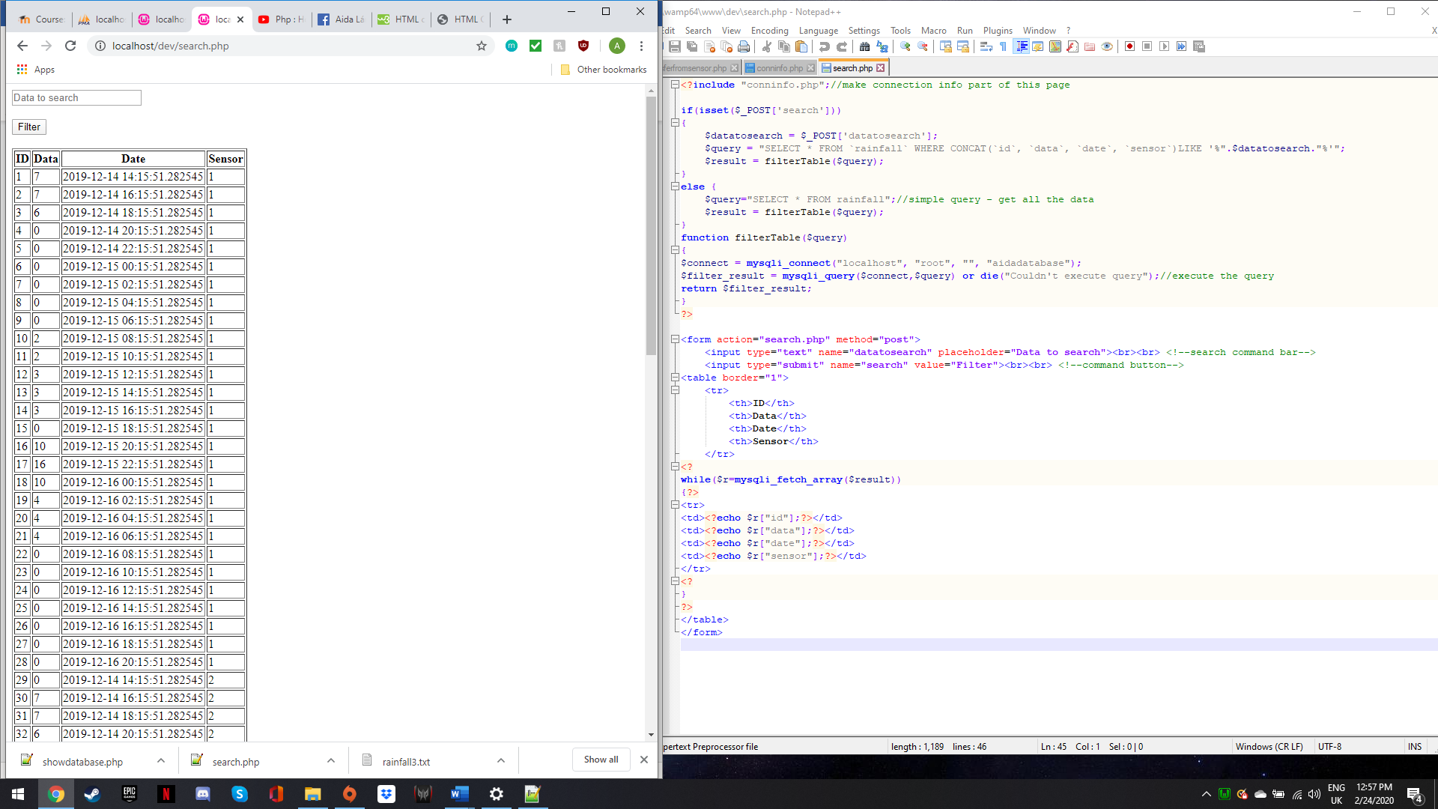
The photo below shows the filter function working. The website is showing the recorded rainfall data from 2019-12-14. All data can be displayed by clearing the “Data to search” field and searching again. The code below shows how the filter function was created.
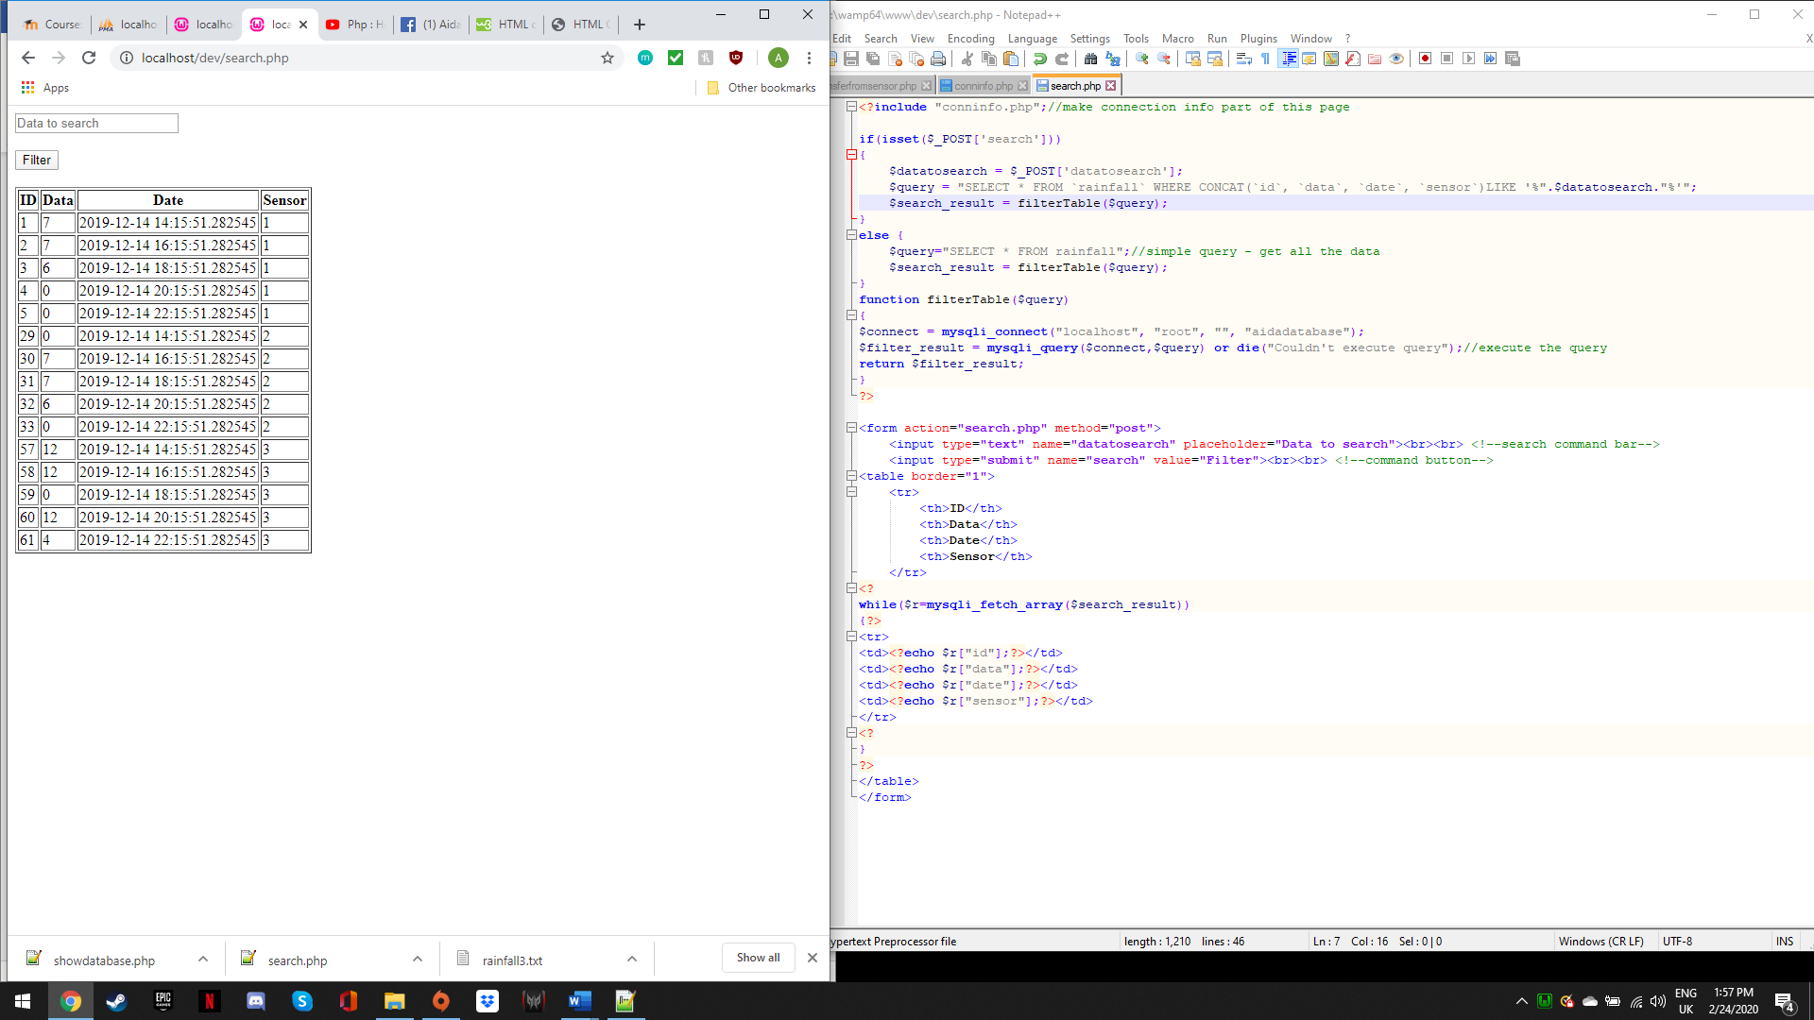
The drop-down box allows the user to understand the data they are viewing. The options are “Show all”, “Highest rainfall” and “Lowest rainfall” which allow the user to interpret the data.
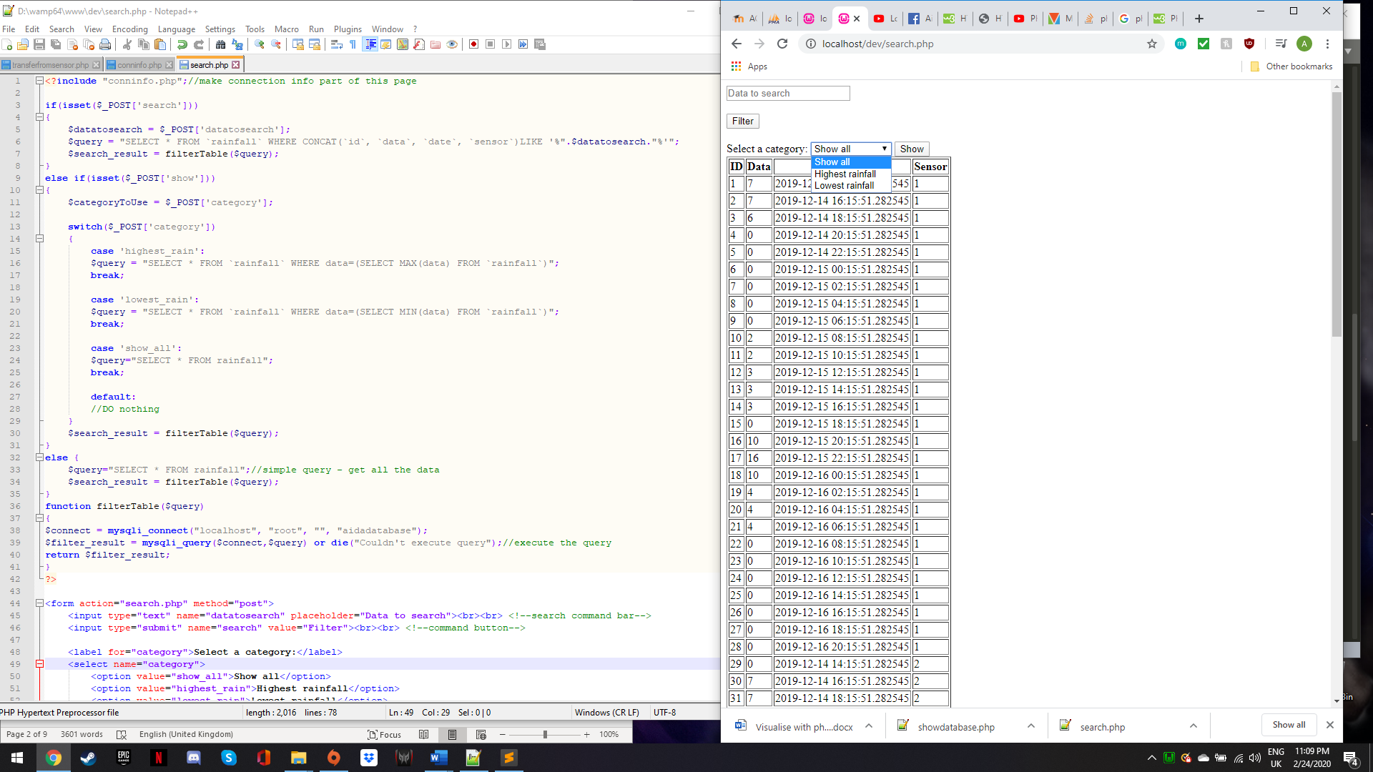
The photo below shows the website showing the “Highest rainfall” which will allow the user to interpret the correct data from the wettest day. The code below used switch instead of if statements due to the number of values.
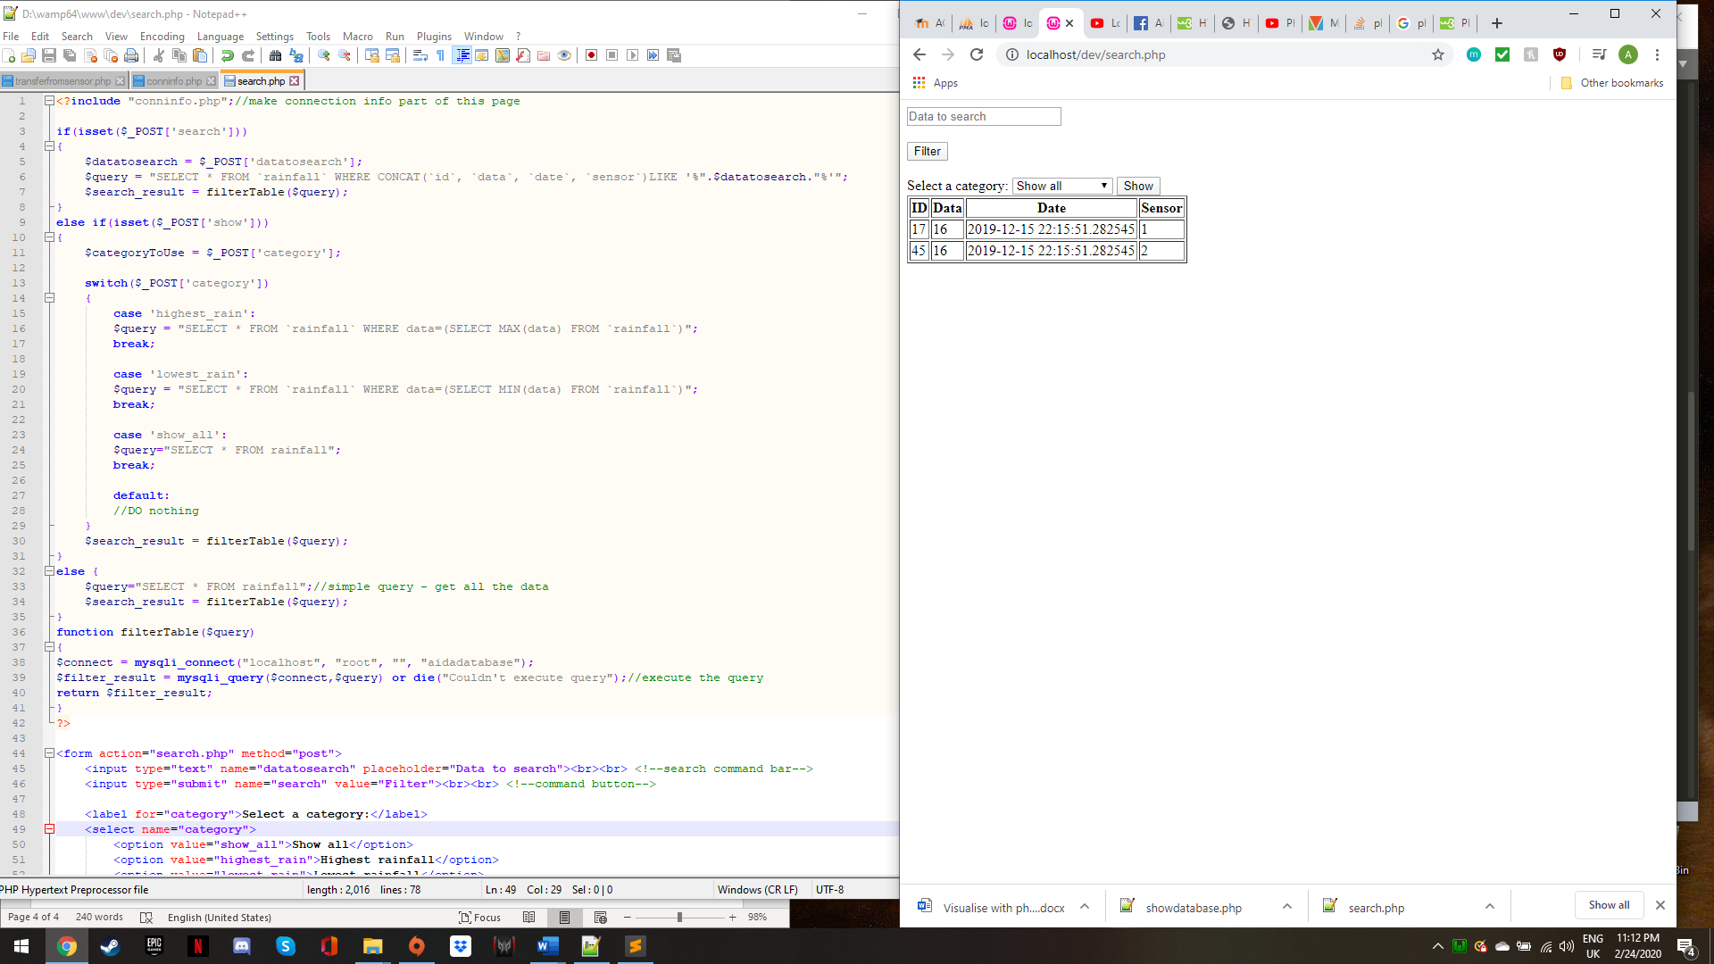
Log in page and code allowing users from the database to access the data.
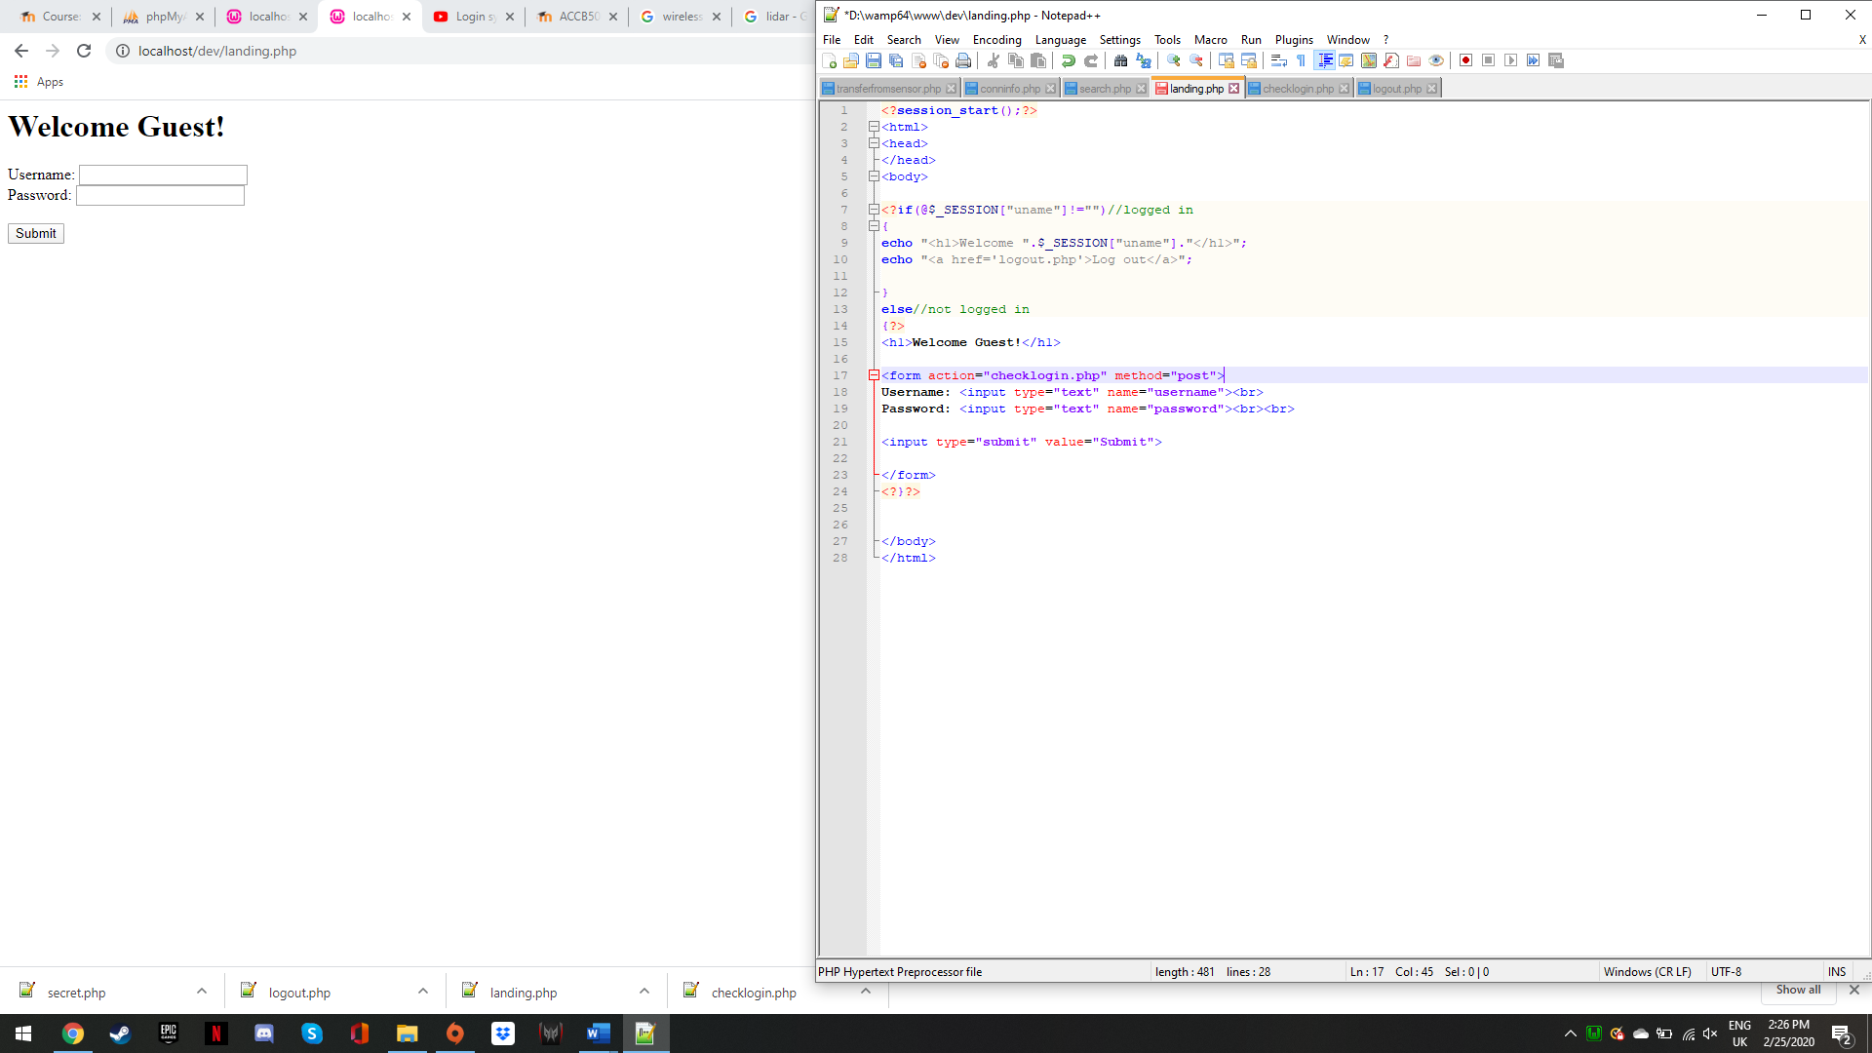
Website confirming use details are correct. The option “Go to my secret page” will allow users to view data.
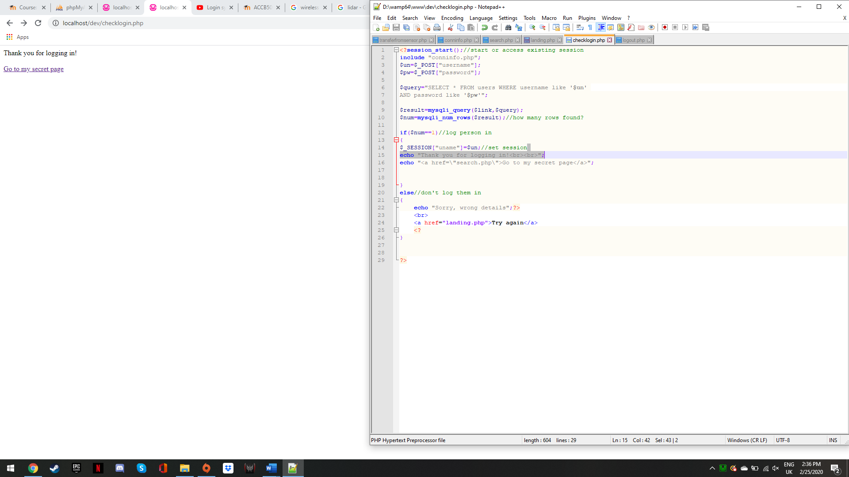

Data loading on the website allowing users to view and interact with it. At the bottom of the page the user can log out using the “Log Out” button, which will take them back to the “landing” page.
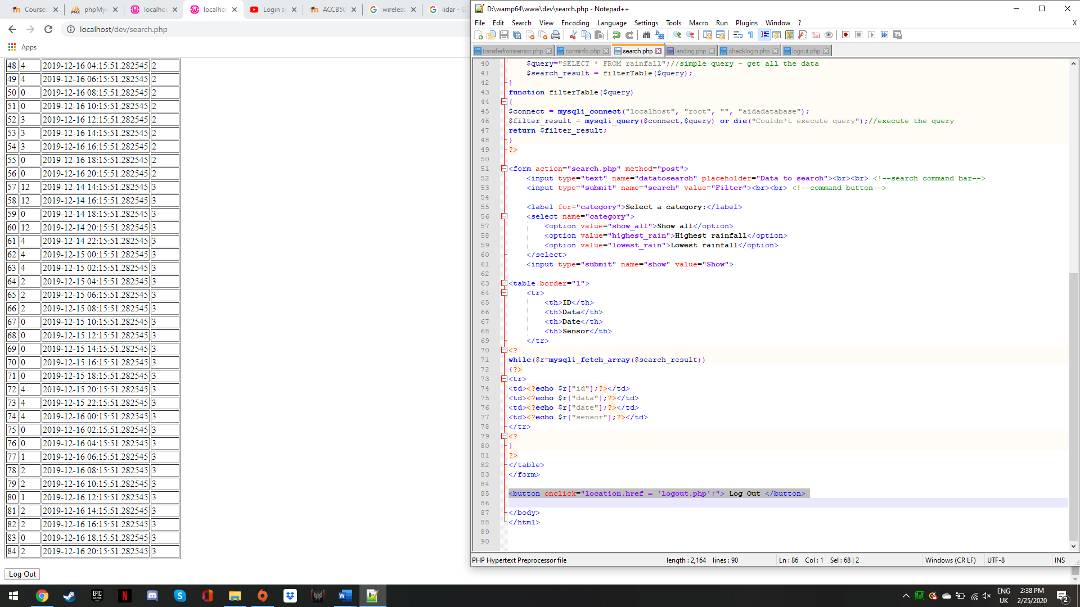
The image below is the landing page of the website with the code used to create it. This code simply takes the user from the landing page to the checklogin page. The website used the color #83B9C3 which is a light blue/grey color to fit the rainfall theme. The password field is hashed out for basic security measures.
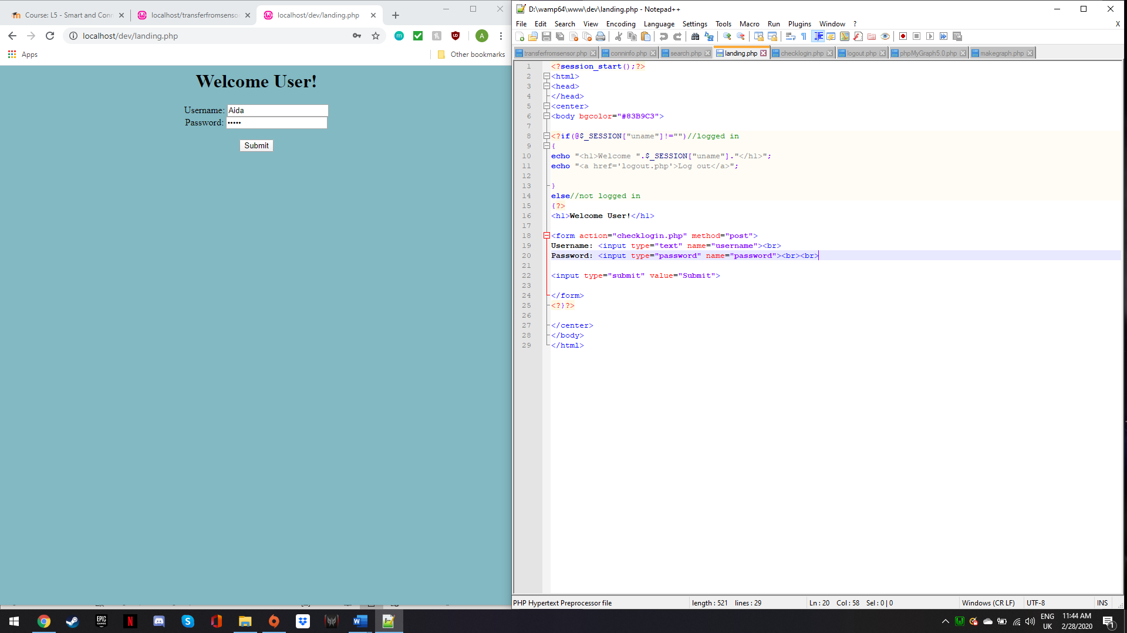
On the landing page, if the login is successful, the user can proceed to “Go to my secret page” which will connect to the search page. If the login fails, the user is directed back to the landing page.
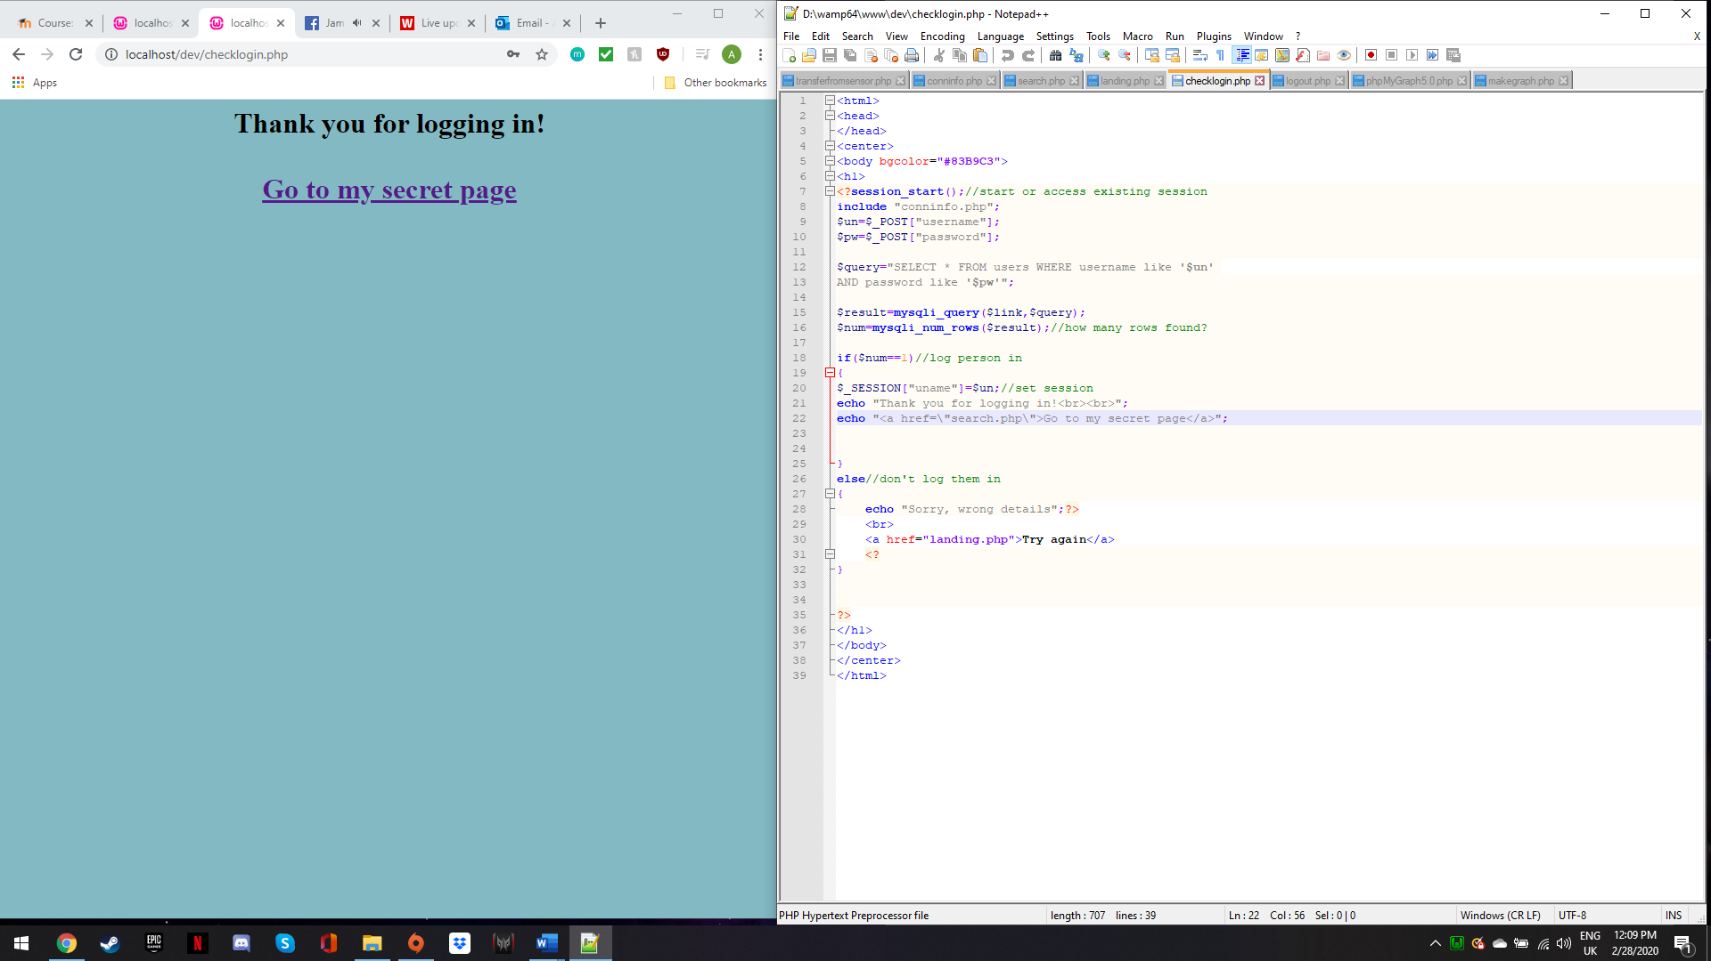
The search page loads all the data from the database. The table used to display the data is centered to allow the user to easily locate the information and make it look pleasing. The colour code for the table was #CAEAF0 which is a light blue to bring out the imputed data and make it more readable. The column for “Sensor” is centered to make the date more appealing to view and to avoid it from being too close to the data showing the “Date”. An improvement on this would be to widen the table and allow the data to be more spread out. Another improvement would be to create a highlight column to allow the user to read specific data highlighted.
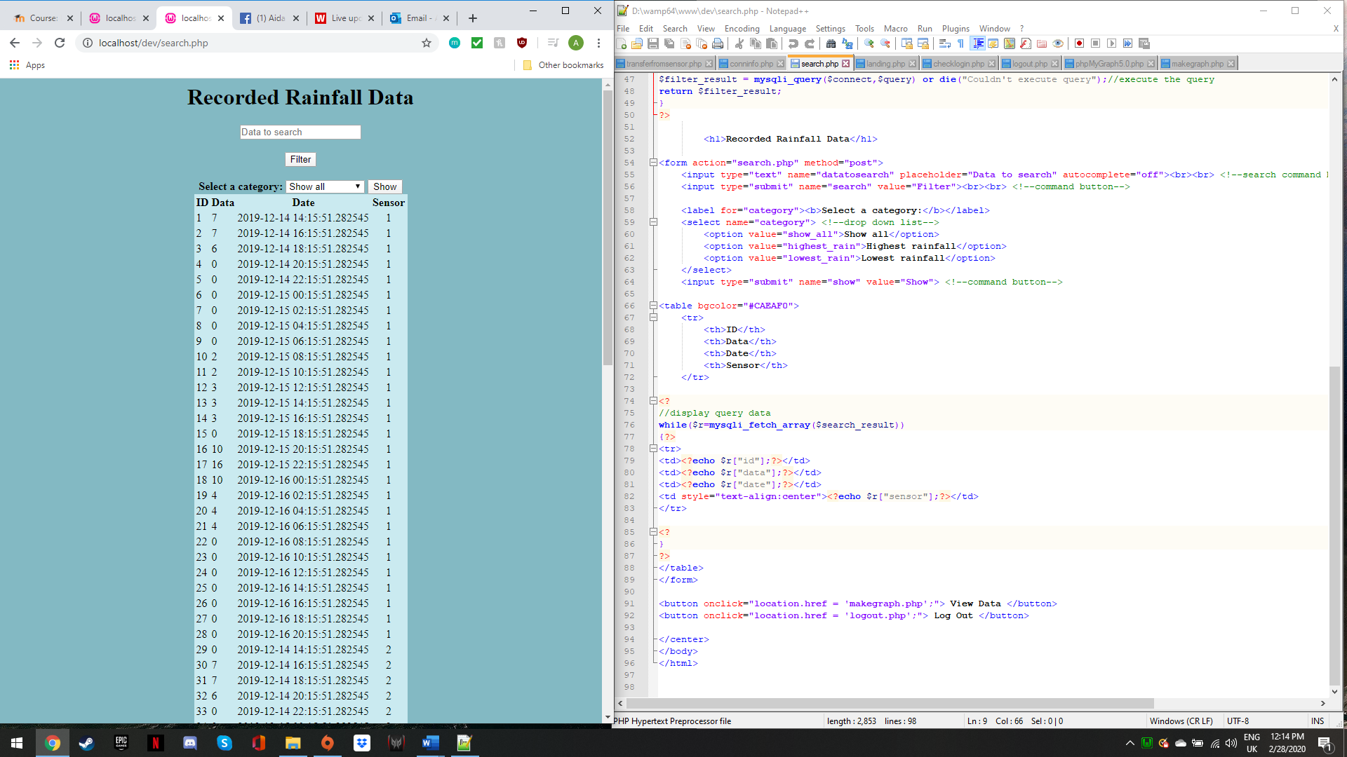
As mentioned above, the search bar allows the user to search the data by date. This makes it quick and easy to find data by date. Autocomplete is turned off to avoid the search bar from showing previously input searches. If this was turned on the field would store private data the user searched previously and anyone with access to the user’s computer would be able to see their previous search history which would be a huge privacy concern.
The code used to help the user interpret the data. The user can select “Highest rainfall” and “Lower rainfall” to show the most and least amount of rainfall. The option “Show all” allows the user to iew all the data from the database. Another search option would have been to search the data by sensor to allow the user better understanding.
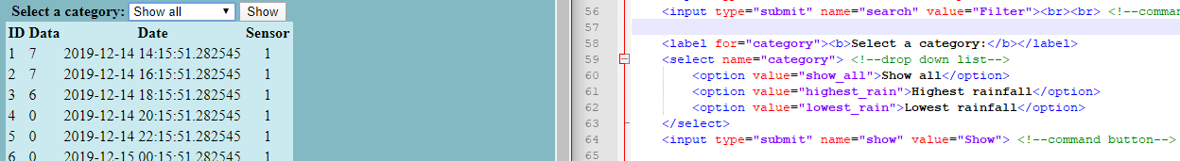
The image below shows the highest recorded rainfall data. The user can select “Show all” to load all the data. The user can select the option “View Data” which sends them to makegraph page.
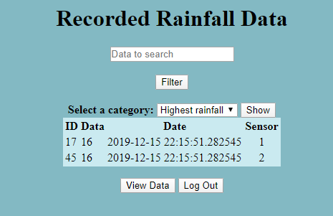
Button used to direct user to makegraph page.
The makegraph includes ‘phpMyGraph5.0.php’ to create the graph. The width and height of the graph was set to acceptable measures that would make it easy to read and understand. Conninfo connects to the database allowing to fetch the data from rainfall. The graph shows the recorded rainfall data along with the data ID. The type of graph used is a vertical column graph. This allows the user to easily notice the data with most recorded rainfall.
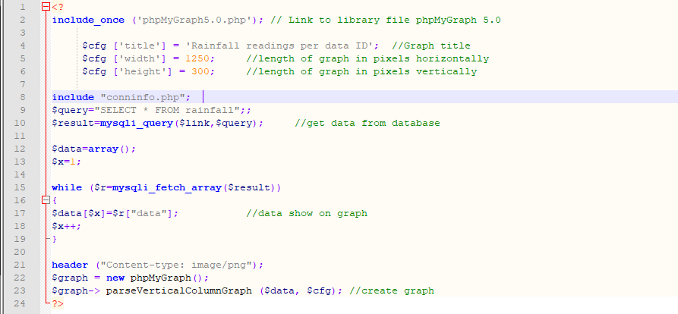

The image below shows the data from the database displayed in a graph. Both least and most amount of recorded rainfall can be easily located in the graph. A disadvantage would be that it is unclear what sensor the data the graph represents belongs to. The data could have been displayed on three individual graphs based each sensor. This would have allowed he user to view least and most amount of rainfall data recorder per sensor.
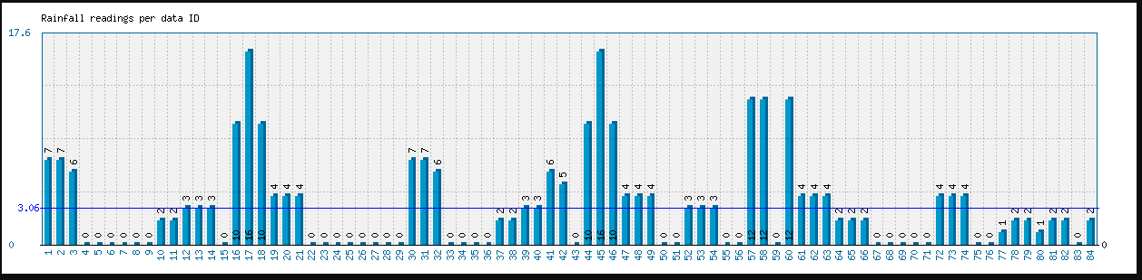
The log out button allows the user to safely exit the information. This button directs the user to the log out page.
The image below shows the code used to direct the user back to the landing page. Another security measure would be to secure the website so no one unauthorised can gain access to it by changing the url to “search”.
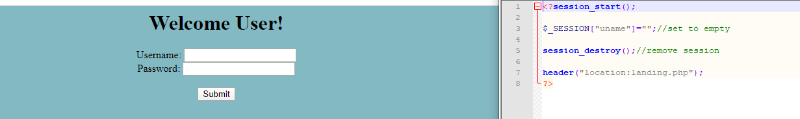
Overall, the website stores the information from the database in an organised table that can be filtered to help the user understand the data and also search the data by date to have a better understanding of the events by date. The data can also be viewed on a working graph and the user can safely log out once done with their session. In the future it would be recommended to add another function to allow the users to input their own data onto the website.

