

BSc (Hons) Health and Social Care

Changemakers: Building your Personal Brand for Sustainable Employment

Module code – BMHP5015 - BIRM

Component 1 – Portfolio
Lecturer – Parese Ahmed

Student: Claudia Gomes
Student No - 2326791
Task 1 – Personal Brand
Write about your own person brand and how you could develop this to enable you to reach your employment goals (200 words- 2 referenced sources)

Personal branding is the process of shaping how others see your strengths, values, and character, while emphasising what makes you unique. It is important because it builds trust, attracts opportunities, and helps others clearly recognise the value you contribute (Appelbaum, 2022).
As an aspiring social worker, my personal brand is rooted in compassion, empathy, and a deep commitment to advocacy. I bring valuable strengths including active listening, cultural sensitivity, and the ability to build trusting relationships with individuals from diverse backgrounds. These skills have been strengthened through my professional experience, where I consistently demonstrate reliability, professionalism, and a strong dedication to empowering others. My passion lies in creating meaningful, positive change in the lives of those I serve.
I also acknowledge areas where I aim to grow, including leadership development, public speaking, and enhancing my communication skills, particularly in engaging with vulnerable families, which is essential in the role of a social worker. To strengthen my personal brand, I plan to seek mentorship, pursue ongoing professional development such as a master’s degree, and actively participate in community outreach (Kaputa, 2012). These actions will enhance my confidence, visibility, and expertise
By refining my personal brand, I will be able to make a greater impact in the lives of those I serve, create meaningful changes, and position myself for leadership opportunities. Developing my brand will open doors, expand my network, and help me achieve long-term career success (Fine, 2010).
.

Task 2 - Network Map and Rationale
Create a map of your own network considering career, support, social and community dimensions. Additionally, you should provide a supporting rationale explaining and critically assessing this (200 words- 2 referenced sources).

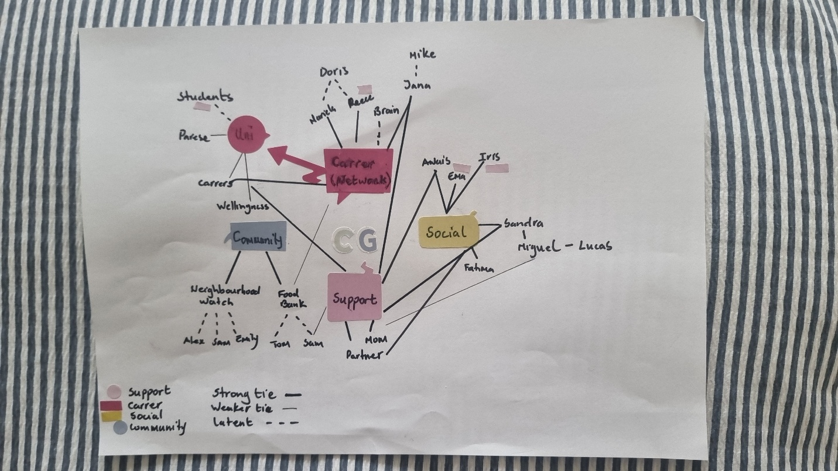

I consider myself a Hybrid networked individual, drawing strength from relationships across personal, professional, and community spheres (Dubos, 2017). My social capital resources, knowledge, and support arising from these networks are vital for both personal growth and career development.
I categorize my connections as Bonding, Bridging, and Linking. Bonding ties include my daughters, sister, close friends, and a few work colleagues who provide emotional support, guidance, and resilience during challenges. For instance, my daughters and team leader offer advice and encouragement that help me navigate professional uncertainties. Bridging connections extend beyond my immediate circle, such as workmates, university peers, and acquaintances from volunteering. These relationships expose me to new perspectives, opportunities, and career pathways I might not encounter otherwise. Linking ties connect me with people in positions of authority, including leaders in my neighbourhood watch and the local food bank. These relationships grant access to resources and opportunities beyond my direct reach, supporting both community engagement and personal development (Jaspers, 2024). Balancing bonding, bridging, and linking relationships enables my network to support me socially, professionally, and emotionally.

As Gino, Kouchaki, and Casciaro (2016), emphasize by intentionally nurturing these connections, I strengthen my resilience, broaden my knowledge, and enhance my ability to contribute meaningfully across multiple dimensions of life.

Task 3- Blog
Write a blog exploring a current topic or issue of your choice within the health and social care sector in the UK. The purpose of this is to inform a specific target audience of your choosing (300 words)
The UK Social Care Workforce Crisis
Why Action Can’t Wait !

Shortages of staff in H&SC is a crisis that demands urgent attention from policymakers and social care leaders, who can drive reform through fair pay, sustainable funding, and stronger workforce planning. It also concerns advocacy groups, researchers, and the wider public, all of whom rely on the UK’s vital care services.
The social care system stands at a critical crossroads, with staff shortages, high turnover, and chronic underfunding placing severe strain on care providers. As Britnell (2019) warns, without decisive reform, the stability of the entire health and social care system is at risk. What’s at stake is not just a service, but the wellbeing of care workers and the dignity of millions who depend on consistent, compassionate care.
The scale of the crises
Across England, there are an estimated 152,000 vacancies in adult social care, one in ten roles remain unfilled (The King’s Fund, 2023). Recruitment and retention are faltering due to low pay, heavy workloads, and limited career progression (Care Quality Commission, 2023). These challenges ripple through the entire healthcare system. Hospital discharges are delayed, ambulance services struggle, and vulnerable people go without essential support. Meanwhile, overstretched staff face mounting stress and burnout, deepening the cycle of workforce instability.
Way Forward
The crisis is embedded in systemic neglect, low wages, poor working conditions, and a lack of training or career progression (Health Business, 2023). Restrictive immigration policies have degraded the problem by limiting access to overseas talent. Addressing these demands requires immediate action, such as improving pay and conditions, investing in professional development, creating leadership opportunities, supporting ethical overseas recruitment, and ensuring long-term government funding for workforce planning (NHS Confederation, 2023).
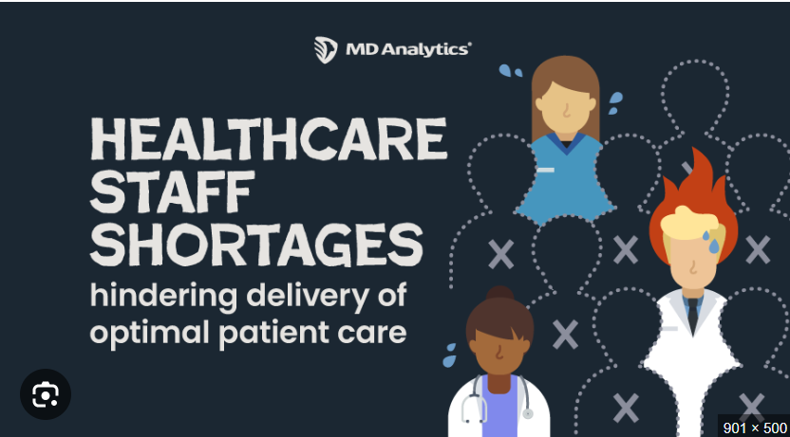

Conclusion
The UK social care workforce crisis is not an isolated issue. It is a national emergency affecting every layer of society. It jeopardizes patient safety, community wellbeing, and the resilience of the entire health system. Through coordinated reform and genuine investment in people, the UK can rebuild a stronger, fairer, and more sustainable care sector. One that values those who care for others.

Task 4- NHS Equality, Diversity and Inclusion Quiz (250 words equivalent)
- What is the primary goal of the NHS Equality, Diversity, and Inclusion Improvement Plan?
The main goal of the NHS Equality, Diversity, and Inclusion Improvement Plan is to make the NHS fairer and more inclusive for staff, patients, and communities (NHS England, 2023)

- How does the NHS EDI Improvement Plan propose to tackle the gender pay gap?
The NHS EDI Improvement Plan aims to close the gender pay gap by sharing pay information openly, removing career barriers, and promoting fair hiring and promotion for everyone (England, 2024).

- What is meant by the term ‘intersectionality’ as used in the NHS EDI Improvement Plan?
In the NHS EDI Improvement Plan, intersectionality’ means that different parts of a person’s identity, like race, gender, or disability, can overlap and lead to unique challenges or discrimination.

- Why is it important for the NHS to create a psychologically safe work environment?
Creating a psychologically safe work environment in the NHS is important because it helps staff feel supported, encourages them to speak up without fear, and enhances their well-being, teamwork, and quality of patient care.

- How does the NHS EDI Improvement Plan suggest improving the experience of internationally recruited staff?
The NHS EDI Improvement Plan aims to support internationally recruited staff by treating them fairly, offering help, and giving chances to grow, so they feel valued and included.

- What role does leadership play in advancing EDI objectives according to the NHS Improvement Plan?
According to the NHS Improvement Plan, leaders help advance EDI by encouraging inclusivity, setting a positive example, and making sure the organization stays accountable for fairness and equality.

- Identify one way the NHS EDI Improvement Plan aims to reduce health inequalities within the workforce.
One way the NHS EDI Improvement Plan aims to reduce health inequalities within the workforce is by promoting fair recruitment and career development opportunities, ensuring all staff have equal access to roles, training, and progression.

- Why does the NHS EDI Improvement Plan emphasise the importance of collecting and analysing data on protected characteristics?
The NHS EDI Improvement Plan stresses collecting and studying data on protected characteristics to spot inequalities, track progress, and ensure fairness and inclusion for all staff.

- Explain how flexible working policies can contribute to equality and inclusion in the NHS workforce.
Accordingly, to Home Berkshire Healthcare NHS Foundation Trust, 2022 flexible working policies help NHS staff balance work with personal responsibilities, giving everyone, regardless of their background, a fair chance to work, stay, and advance in their careers.

- What is one strategy mentioned in the NHS EDI Improvement Plan to combat bullying and harassment in the workplace?
One strategy mentioned in the NHS EDI Improvement Plan to combat bullying and harassment is implementing clear policies and reporting systems, ensuring staff can safely raise concerns and that issues are address ed promptly and fairly.

Task 5- A Letter to Yourself
Think of a time in the past when you may have been experiencing issues or difficulties, and after considering what you have learned in this module about emotional intelligence and resilience write a letter to your younger self explaining how these attributes were important at that time and perhaps how developing these areas could have been useful (250 words)

Dear Younger Me,
I know you’re feeling overwhelmed right now trying to handle everything alone and believing that showing emotion is a sign of weakness. You often hide your stress and push through challenges without asking for help. Looking back, I realise that what you truly needed was emotional intelligence and resilience (Dann & Dann, 2015). These qualities, the ability to understand and manage your emotions while adapting positively to change, would have made all the difference.
Emotional intelligence would have helped me recognise and express my feelings instead of suppressing them. By becoming more aware of my emotions, you could have communicated your needs clearly and built deeper, more supportive relationships. Empathy, too, would have shown you that others were struggling in similar ways, helping you feel less isolated and more connected. Resilience would have reminded you that setbacks aren’t failures but opportunities for growth and learning (Luna et al., 2021).
Instead of viewing challenges as proof that you were not good enough, you could have seen them as stepping stones toward strength and self-awareness. If you had nurtured these traits earlier, you might have approached stress with greater balance, made more confident decisions, and shown yourself greater kindness in difficult moments.
Still, every struggle has shaped who I am today, someone who values emotional intelligence, self-compassion, and perseverance. Keep learning, keep feeling, and remember strength isn’t about never falling, but about rising every time you do.
With care,
Your Older Self

Task 6- GANTT Chart (200 words equivalent)
Compile a Gantt chart which illustrates the tasks you have to complete to achieve your future employment goals

Research Career Requirements (Jan-Mar 2026)
Exploring what qualifications, skills, and experience are required to work as a Substance Misuse Worker. This includes looking into NHS and charity job descriptions, as well as entry level roles (Team, 2023).
Gain Relevant Qualifications (Jan 2026–Nov 2027)
Gain the knowledge and credentials needed for employment. Finish my Level 6 at BS (Hons) Health and Social Care in the University of Wales. Enrol in a relevant qualification such as Counselling Skills, or Substance Misuse Awareness.
Volunteer / Work Placement (Jun–Dec 2026)
Gain hands-on experience, by volunteering completing a placement in a rehabilitation centre, charity, or support service. This helps understand real life client support and develop professional confidence.
Develop Key Skills (Jun–Dec 2026)
Volunteering, focus on improving essential skills like communication, empathy, report writing, and safeguarding awareness, all crucial for the role
Create Professional CV and Cover Letter (Jan–Feb 2027)
After building qualifications and experience, create a CV and cover letter that showcase skills and training in substance misuse support.

Apply for Substance Misuse Roles (Feb–Apr 2027)
Applying for roles within NHS Trusts, charities such as (Turning Point or Change Grow Live), and local rehabilitation programs.
Interview Preparation (Feb–Apr 2027)
Prepare interviews by reviewing harm reduction strategies, safeguarding procedures, and professional ethics (APM, 2025).
Secure Employment (May 2027)
By this stage, aim to secure employment as a Substance Misuse Worker.

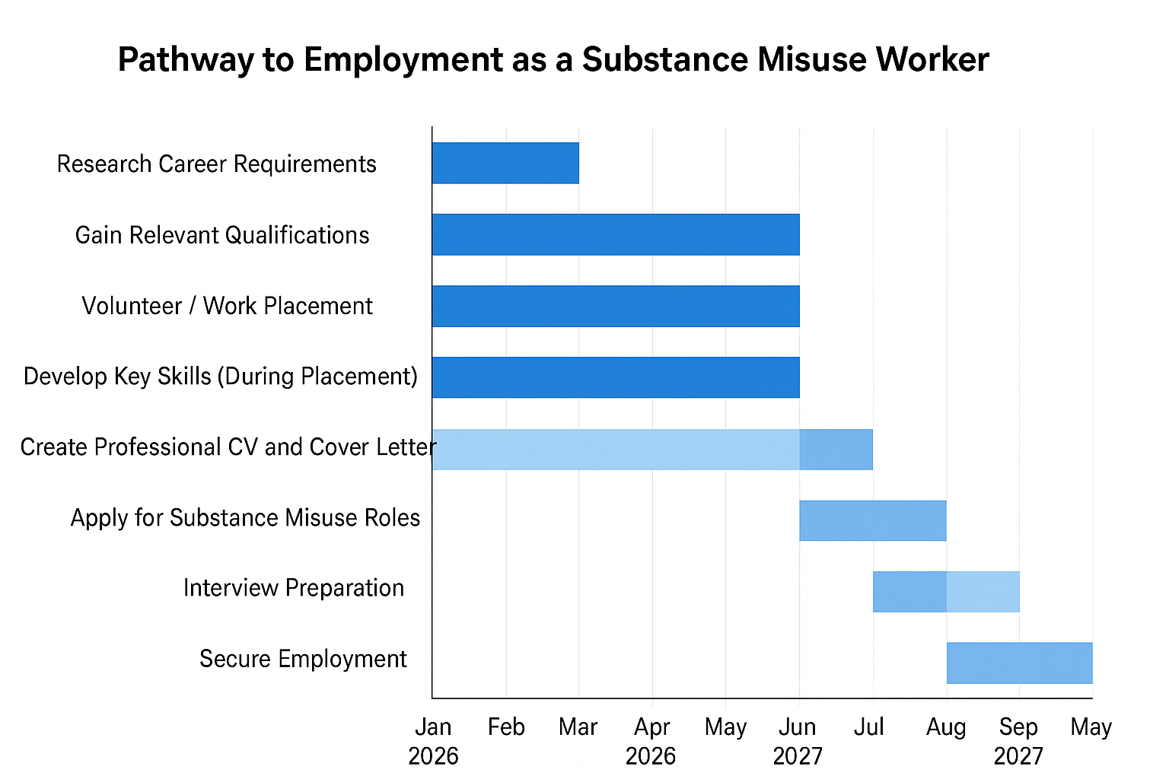

Task 7- Making Changes- Report
You are the manager of a care home and want to make changes your workplace. Identify one specific change that you want to implement and write a brief report on how this is going to be achieved considering the necessary skills needed and addressing possible barriers to success. Relevant change models can be highlighted (250 words- 2 referenced sources).

Staff wellbeing programme
As the manager of a care home, I intend to introduce a staff wellbeing programme aimed at improving employee morale, reducing burnout, and enhancing the quality of care provided to residents. High staff turnover and stress levels can negatively impact both service delivery and workplace culture, so creating a supportive environment is essential.
To guide this change, I will apply Kotter’s 8-Step Change Model (1996). The process will begin by establishing a sense of urgency, using staff surveys and feedback to highlight wellbeing concerns. A guiding combination of senior carers and team leaders will be formed to champion the initiative. The next steps involve creating and communicating a clear vision for change, example, promoting a culture that values work-life balance and emotional support.
The wellbeing programme will include access to mental health resources, regular supervision sessions, and wellbeing workshops on stress management and mindfulness. Managers will need strong communication, leadership, and emotional intelligence skills to implement these changes successfully.
Potential barriers include staff scepticism, time constraints, and limited funding. These can be addressed through open dialogue, flexible scheduling, and demonstrating management commitment to staff welfare (Pooja Vishwanathan, 2024).
By establishing wellbeing into everyday practice and celebrating small successes, the change will become part of the organisation’s culture. This approach will promote a healthier, more motivated workforce and lead to better resident outcomes.

Task 8- Self-Reflection
Using one of the highlighted models of reflection, reflect on what you have learned about yourself during this module ,as well as the knowledge you have gained, and explain how this has developed your skills and informed your future practice (250 words- you must reference the model you use)
Using Gibbs’ Reflective Cycle (1988), in this reflection, I explored a learning experience from Building my Personal Brand module . During the module, I developed my professional portfolio and identified my unique value plan. Initially, I struggled with how to present myself authentically while maintaining a professional image.
At first, I felt anxious and self-critical because I found it difficult to recognise and articulate my strengths and achievements. However, as the module progressed, I became more confident and motivated through reflective exercises and constructive peer feedback.
A positive aspect of this experience was successfully identifying my core values and professional goals, which allowed me to create a clear and consistent message across my CV, LinkedIn profile, and personal statement. On the other hand, I could have improved my work by seeking more external feedback to enhance the quality of my online presence.
This experience highlighted the importance of self-awareness and strategic communication in personal branding. I realised that building a personal brand is not about self-promotion, but about authentically aligning my skills, values, and goals with professional opportunities. It also emphasised the need to stay adaptable and continuously update my skills in a changing job market (Gorbatov, Khapova and Lysova, 2019).
Looking back, I could have spent more time gathering feedback from mentors and professionals to further refine my brand and online identity.
In the future, I will continue developing my personal brand by networking, seeking mentorship, and maintaining a strong online presence. I will also regularly review my goals to ensure my brand reflects my evolving professional ambitions.

Reference List

- APM (2025) What Is a Gantt chart? | APM, Apm.org.uk. Association for Project Management. Available at: https://www.apm.org.uk/resources/find-a-resource/gantt-chart/.

- Appelbaum, U. (2022) The Brand Positioning Workbook.

- Britnell, M. (2019) Human: Solving the global workforce crisis in healthcare. Oxford University Press.

- Care Quality Commission (2023) The state of health care and adult social care in England 2022/23. Available at: https://www.cqc.org.uk (Accessed: 30 September 2025).

- Dubos, R. (2017) Social Capital. Routledge.

- England, N. (2024) NHS England» NHS Workforce Race Equality Standard 2024 data analysis report for NHS trusts, England.nhs.uk. Available at: https://www.england.nhs.uk/long-read/nhs-workforce-race-equality-sta (Accessed: 14 September 2025).

- Fine, L.G. (2010) The SWOT analysis : using your strength to overcome weaknesses, using opportunities to overcome threats. Kick It.

- Gibbs, G. (1988) Learning by Doing: A Guide to Teaching and Learning Methods. Oxford: Oxford Polytechnic.
- Gino, F., Kouchaki, M. and Casciaro, T. (2016). Learn to Love Networking. [online] Harvard Business Review. Available at: https://hbr.org/2016/05/learn-to-love-networking.

- Gorbatov, S., Khapova, S.N. and Lysova, E.I. (2019) ‘Get Noticed to Get Ahead: The Impact of Personal Branding on Career Success’, Frontiers in Psychology, 10(2662). Available at: https://www.frontiersin.org/articles/10.3389/fpsyg.2019.02662/full.

- Health Business (2023) Workforce challenges in health and social care. Available at: https://healthbusinessuk.net (Accessed: 29 September 2025).

- Home | Berkshire Healthcare NHS Foundation Trust (2022) Berkshire Healthcare NHS Foundation Trust. Available at: https://www.berkshirehealthcare.nhs.uk (Accessed: 26 September 2025).

- Jaspers, E. (2024) The power of networking: Building relationships for success, WeAreBrain. Available at: https://wearebrain.com/blog/the-power-of-networking/.

- Kaputa, C. (2012) You Are a Brand! Nicholas Brealey.

- Kotter, J.P. (1996) Leading Change. Harvard Business School Press.

- NHS Confederation (2023) NHS leaders warn social care workforce crisis risks patient safety. Available at: https://www.nhsconfed.org (Accessed: 29 September 2025).

- NHS England (2023) NHS England» NHS equality, diversity and inclusion (EDI) improvement plan, www.england.nhs.uk. Available at: https://www.england.nhs.uk/publication/nhs-edi-improvement-plan/.

- Pooja Vishwanathan (2024) Employee Wellbeing. Taylor & Francis.

- Skills for Care. (2021). Wellbeing of the Adult Social Care Workforce. Skills for Care

- Team, C. (2023) Gantt Chart: A Complete Guide (Definition & Examples) | Canva, Canva. Available at: https://www.canva.com/online-whiteboard/gantt-chart/.

- The King’s Fund (2023) Making a career in health and social care more attractive. Available at: https://www.kingsfund.org.uk (Accessed: 01 October 2025).

