Assignment

Zhihao Xiao
2200466
(of Affiliation)
Artificial Intelligence
2200466@student.uwtsd.ac.uk

Abstract--As human society enters the information age, machine learning has been widely used in many fields and achieved important results[1]. For example, in the field of pattern recognition, the recognition of handwritten digits can be well realized by using some algorithms of machine learning. Many algorithms of machine learning have their own advantages and disadvantages, and choosing the appropriate algorithm and parameter configuration will help to get a better model[2]. This paper will use KNN algorithm and decision tree algorithm to study the problem of handwritten digit recognition, and verify it on the data set MNIST. Firstly, the MNIST related files are preprocessed, and then the KNN algorithm and the decision tree algorithm are implemented using the Python language and based on the Sklearn library, and then the KNN and decision tree models are trained on the training set. Finally, the results of the two models on the test set are compared and analyzed.

Keywords-- KNN, Decision tree, MNIST, Python, Sklearn, handwritten digit

- Introduction
With the development of the economy, the financial market has also accelerated. However, there are still a large number of handwritten digital reports and remittance lists that require computers for identification and management. If a computer can be used for handwriting digital identification, it will save a lot of manpower and financial resources[1]. Therefore, the development of handwritten digital identification system plays an important role in production and life. Today's social science and technology has developed rapidly, and the Internet has gradually become popular. In order to be able to make more efficient use of information and people invented a lot of methods. Among them, machine learning belonging to the type of artificial intelligence's new category has developed rapidly. When using machine learning, learners do not need any reasoning or understanding other knowledge. They only need to collect a lot of information directly and use the constructed program to achieve it. There are many machine learning algorithms. Although the same problem can be solved through different algorithms, the final result may be different. Because each algorithm has its limitations and advantages, it is not practical to talk about the quality of an algorithm. This article will discuss the identification of handwriting numbers with two algorithms of KNN and decision tree, and study the advantages and disadvantages of the two algorithms for their respective identification.

- MNIST data set

- The source of the data set
The data used in this article is derived from MNIST (The Mnist DataBase of Handwritten Digits). Its data comes from NIST (The National Standard Institute of Standards and Technology). The hand -writing numbers can comprehensively reflect the style of various handwriting fonts, and it is also a model data source that is currently internationally written digital recognition. The download of the data set is provided on the official website, mainly including four files as shown in Figure 1:

Fig.1

In the above file, the training set contains a total of 60,000 images and labels, and the test set contains a total of 10,000 images and labels. The first 5,000 test sets from the initial NIST project, and the last 5,000 test sets from the original NIST project. The first 5,000 are more regular than the last 5,000. This is because the first 5,000 data comes from the employees of the American Census Bureau, and the latter 5,000 comes from college students. Since 1998, this data set has been widely used in the field of machine learning and deep learning to test the effects of the algorithm.

- Interpretation of data sets
After downloading the above four files, you will find that you will not get a series of pictures, but the files of the .idx1-UBYTE and .idx3-UBYTE format. This is an IDX data format, and its basic format is shown in Figure 2:
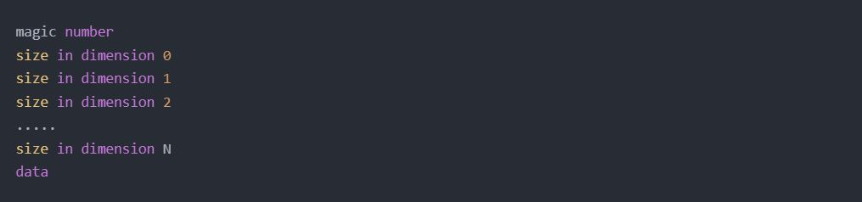
Fig.2
Among them, Magic Number is 4 bytes, and the first 2 bytes are always 0. The 3rd byte represents the format of data. The meaning of the fourth byte represents the number of dimensions: 1 represents one dimension (such as vectors), 2 represents two -dimensional (such as Matrices), and 3 represents three -dimensional (such as the image represented by Numpy, high, wide, channel number). The format of the label file of the training set and test set are the Train-Labels-Idx1-Ubyte and T10K-Labels-Idx1-Ubyte. The data format of IDX1-Ubtype is shown in Figure 3:

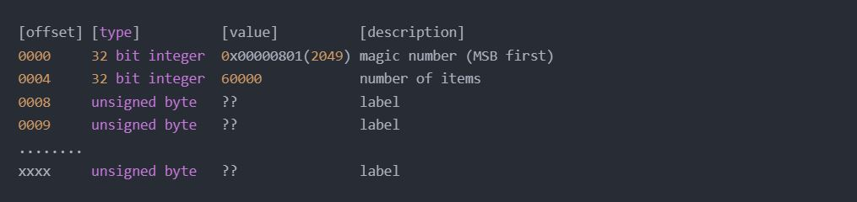
Fig.3

The 0 ~ 3 bytes are 32 -bit integer data, with a value of 0x00000801 (2049), which uses the fantasy 2049 record file data format. The format here is the text format.

The 4 ~ 7 bytes are 32 -bit integer data, with a value of 60,000 (at the time of training) or 10000 (test set), which is used to record the number of label data.

(The 8th byte ~) is a non -symbolic number. The value is the tag number between the corresponding 0 ~ 9, which is used to record the label of the sample.

The format of the image file of the training set and test set is (Train-IMAGES-Idx3-UBYTE and T10K-IMAGES-IDX3-Ubyte). IDX3-Ubtype's file data format is shown in Figure 4:

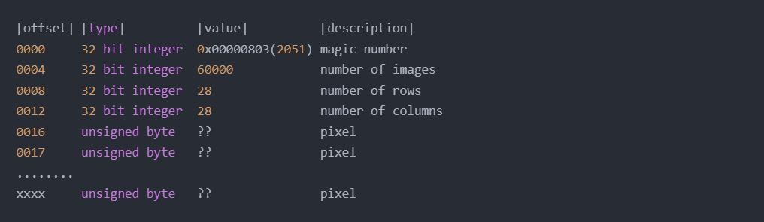
Fig.4

The 0 ~ 3 bytes are 32 -bit integer data, with a value of 0x00000803 (2051), which uses the fantasy 2051 record file data format. The format here is the picture format.

The 4 ~ 7 bytes are 32 -bit integer data, with a value of 60,000 (at the time of the training set) or 10000 (test set) to record the number of picture data.
The 8 to 11 bytes are 32 -bit integer data, with a value of 28, which is used to record the height of the picture data.

The 12 to 15 bytes are 32 -bit integer data, with a value of 28, which is used to record the width of the picture data.

The 16th byte ~) is a non -symbolic number, with the grayscale value between 0 and 255, which is used to record the gray value data obtained after the picture is expanded. ), 255 indicates the prospect (black).

- Data reading
Because the format of the MNIST data set is a special binary file, the rules are as described above. To read the appeal data, we need to interpret it according to the file data structure. This article uses the Stuck library in Python to read the files of different formats. First of all, we decompress the file from the official website, and place the Train-Labels.idx1-UBYTE and Train-IMAGES.idx3-UBYTE files under the same path, and create a new Python file and import the stuck library. The code is shown in Figure 5:
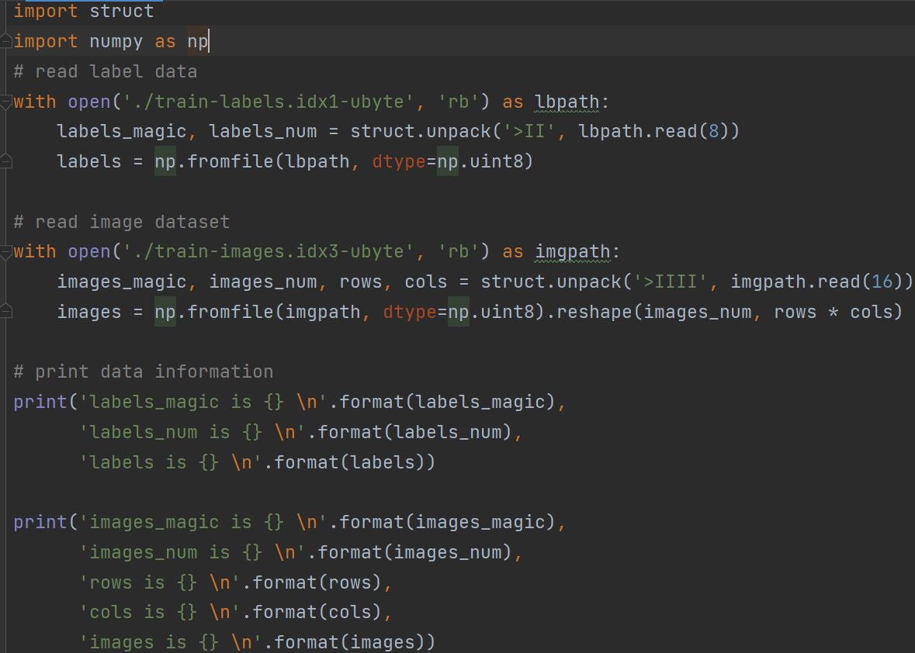
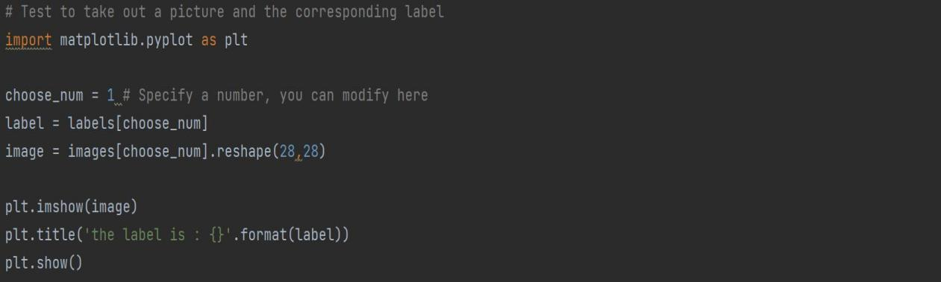
Fig.5
Run results are shown in Figure 6
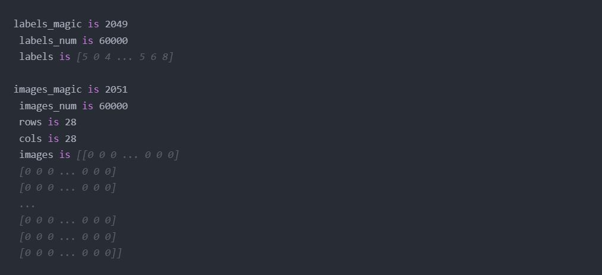
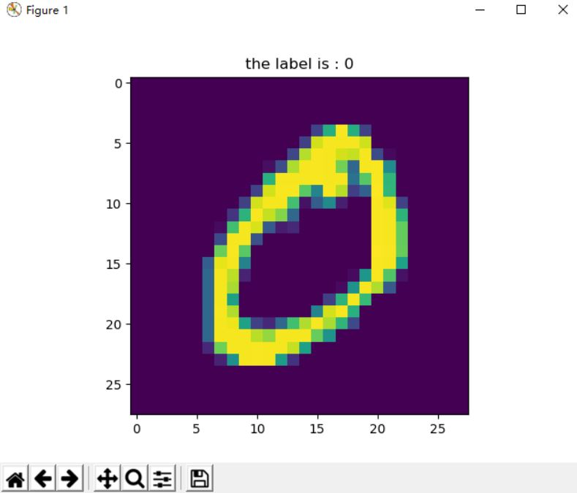
Fig.6

- KNN Algorithm

- The theory of KNN
A classification and logical regression approach is called KNN (K Nearest Neighboring). It is a straightforward and efficient machine learning algorithm. It is a machine learning classification method, and it operates in a rather straightforward manner. Knowing the correspondence between the data in the sample data set and its category and providing a sample set, also known as the sample training set[3]. After inputting a new unclassified data, the computer extracts the features of the data and compares them with the features in the data set to find K data with similar characteristics, and the classification with the highest classification frequency among the K data is used as classification of the new data.
It may be assumed that there is a data sample set X, which contains N samples, that is, X={X₁ ,X₂ ,…X_{i} ..X_{N}}, where X_{i} is the i-th sample, and each sample contains M features, that is, Xi = {t_{i1}, t_{i2},...t_{iM}; 1≤ i ≤ N}, each sample corresponds to a label Y_{i}, and the label Y_{i} indicates the category to which the sample Xi belongs. The data sample set X is referred to here as training data. The KNN algorithm takes new data with the same characteristics as the training samples, that is, the prediction samples, as input parameters. Here, it may be assumed that the new samples are P_{j} ={t_{j1},t_{j2},…t_{jM}}. The key point of the algorithm is to calculate the distance Distance_{ij} between each sample X_{i} and P_{j} of the training data X. Since the number of samples of training data X is N, N distances will be obtained through the above steps, that is, Distance={Distance_{1j},Distance_{2j},….Distance_{Nj}}. Among the above distances, sorting them in ascending order to get the first k samples with the smallest distance (generally speaking, k ≤ 20), and counting the categories of labels corresponding to the first k samples.
It may be assumed that the first k samples have L categories, and each The number of samples contained in each category is num₁, num₂, .... num_{L}. The final algorithm will select the category containing the largest number of samples as the predicted category of the predicted sample, that is to say, the final algorithm predicts that the final category of the new data is L_{α}, where num_{α}=max(num₁,num₂,….num_{L}). In the above algorithm, the distance Distance_{ij} between samples X_{i} and P_{j} is calculated using the Euler distance, and the calculation formula is as follows:

${Distance}_{ij}=\sqrt{\sum_{l=1}^{M}{{(t_{il}−t_{jl})}^{2}}}$ (1)
In the above formula, til represents the l-th feature of the sample X_{i}, t_{jl} represents the l-th feature of the predicted sample P_{j}, and M represents the number of features of the sample.

- Implementation of KNN in MNIST data set
The implementation of this algorithm is all encapsulated in the KNNClassifier class under the Sklearn framework. The constructor of this class determines the value of k, where the fit function passes in the training samples and the labels of the training samples, and the predict function uses the prediction samples as parameters to calculate respectively. The distance between the predicted sample and the training sample is obtained to obtain the category of the predicted sample. Before this, we have preprocessed the MNIST data set, where the number of training sets is 60,000 and the number of test sets is 10,000. Next, you only need to execute the KNN algorithm by calling the functions in the KNNClassifier class respectively. The code is as shown in Figure 7:

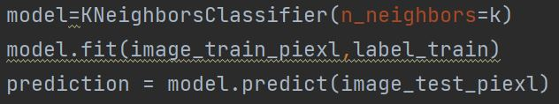
Fig.7
After the prediction result is obtained, it is necessary to compare the prediction result with the real category of the test sample to obtain various indicators of the evaluation model (confusion matrix, f1-socre, Precision, Recall).

- Experimental results
This article uses the implementation code mentioned in the previous section to set k to a value between [1, 30], and predict 10,000 test sample data with different k values. The test results take the k value and the corresponding accuracy rate as shown in the figure 8 (obviously K should be equal to 3). Accuracy is the fraction of test samples that agree with the true class of handwritten digits across all predicted classes.
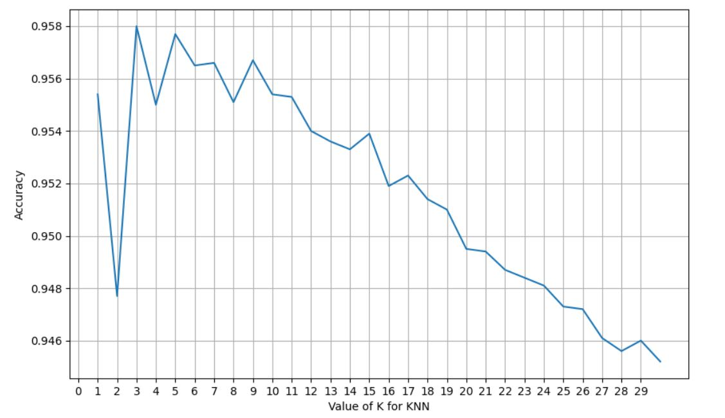

Fig.8
The various indexes of the classifier when K is equal to 3 are shown in Figures 9 and 10
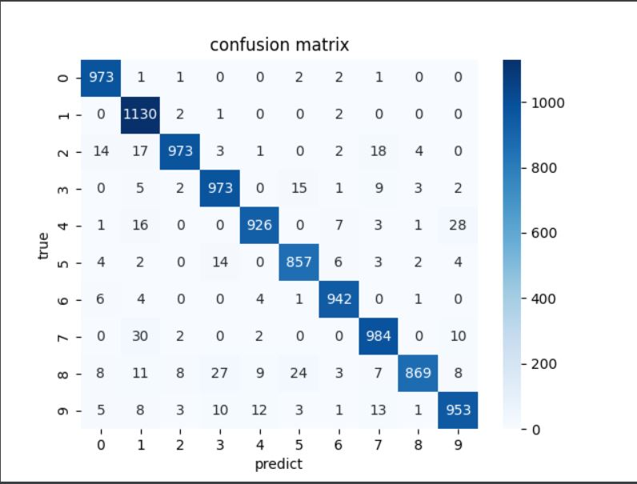
Fig.9
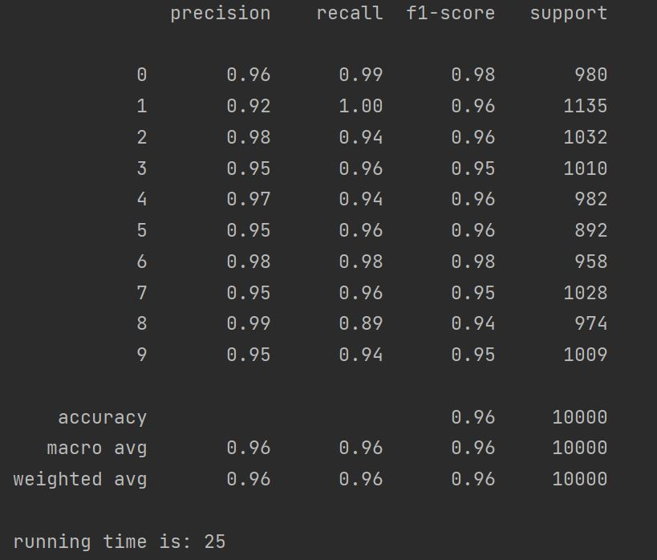
Fig.10

The prediction results of the KNN method used in this research on the MNIST test set are shown in Figure 10. The average accuracy, recall, and f1-score of the KNN algorithm used in this study on the MINIST test set are all 0.96, as shown in Figure 10. In regards to accuracy, the accuracy performance of numbers 2, 4, 6, and 8 is greater than the average, and the accuracy rate has risen over 0.97; whereas the accuracy rate of numbers 1, 3, 5, 7, and 9 is lower, and the accuracy rate is less than 0.96. In respect of remember rate, recall rates 2, 4, 8, and 9 are lower than the average memory rate, while the others are greater. In terms of f1-score, 0 and 6 have the highest value (0.98), whereas 8 has the minimum number (0.94).

- Analysis of advantages and disadvantages of KNN algorithm
The KNN method is a classification technique that is both straightforward and efficient. Without retraining, the new data set may be directly computed. It is simpler to develop, more accurate, less sensitive to outliers, and more tolerable than other algorithms. However, there are flaws in several areas as well. First off, the K-nearest neighbor method will struggle to precisely extract features from images with high-dimensional characteristics. Second, there will be some mistake if there are enough verification numbers. This experiment requires the algorithm to carry out up to 2,000 distance operations on the test vector, each of which includes 210-dimensional operations, resulting in an unreasonably large computational complexity and decreased operational efficiency.

- Decision Tree Algorithms

- The theory of decision tree algorithm
A fundamental classification and regression technique is the decision tree. It is organized like a tree. For a data point on a given feature space, it is always possible to assign it to child nodes incrementally along the decision tree's root node until it reaches the leaf node, which then displays the category to which the data point belongs[4]. Each assignment to a child node may be thought of as an if-then decision on the value of the data point's distinctive feature property. A decision tree may also be thought of as a conditional probability distribution that is specified on feature space and class space, or as a set of if-then rules. The training data will be used by the decision tree as it begins to learn to create a decision tree model based on the idea of minimizing the loss function. The trained decision tree model will categorize and forecast fresh data while doing prediction. The oldest decision tree algorithm model ID3 method was proposed by machine learning researcher J.Ross Quinlan in the 1970s[5]. Following that, the science of machine learning substantially advanced decision trees, from which several new models emerged, including C4.5 and the CART model. In this study, the experimental outcomes of two models—ID3 and CART—are compared in order to achieve the recognition of handwritten digits on the MNIST data set.

- CART Algorithm
Breiman created the classification regression tree model in 1984, and it is a popular decision tree learning technique. Feature selection, tree formation, and pruning are further components of CART that may be applied to both classification and regression[5]. The GINI value is utilized as the foundation for dividing nodes when CART is a classification tree. The smallest variance of samples is utilized to separate nodes when CART is employed as a regression tree. Given that there are K classes in the classification issue and that Pk is the chance that the sample point belongs to one of the K classes, the Gini index of the probability distribution is defined as:
$Gini(p)=\sum_{k=1}^{K}{p_{k}(1−p_{k})}$ (2)

If the chance that the sample points belong to the first category is p for the binary classification issue, then the Gini index of the probability distribution is:

$Gini(p)=2p(1−p)$ (3)

For a given sample set D, its Gini index is:
$Gini(D)=1−\sum_{k=1}^{K}{\frac{{C_{k}}^{2}}{D}}$ (4)

C_{k} is the sample subset in D that belongs to the kth class, and K is the total number of classes. The number of subsets and samples are represented by |C_{k}| and D, respectively. If the sample set D is split into the two groups D₁ and D₂ based on whether the feature A accepts a potential value, then:
D₁={(x,y)∈D|A(x)=a}, D₂=D−D₁ (5)

So under the condition of feature A, the Gini index of set D is:

$Gini(D,A)=\frac{D_{1}Gini(D_{1})}{D}+\frac{D_{2}Gini(D_{2})}{D}$ (6)

The Gini index G(D,A) indicates the uncertainty of the set following the A=a decomposition, whereas the Gini index Gini(D) represents the uncertainty of the set. The sample set's level of uncertainty increases with increasing Gini index values.

- CART Algorithm Flow
The decision tree T is the result of the CART algorithm, which takes the training set D, the Gini coefficient threshold, and the number of samples threshold as inputs.
- For the training sample set D, calculating all Gini impurity scores.

- Comparing the Gini impurity scores, and selecting the feature with the lowest impurity score to separate the current sample set.

- Repeating the above steps until the decision tree reaches the leaf node, or reaches the pruning threshold, or the current sample set no longer needs to be divided (no impurities).

The test code is as shown in Figure 11
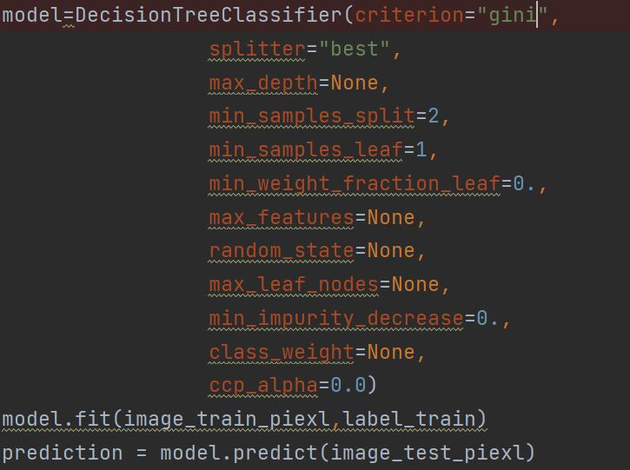
Fig.11
- Experimental results
The indicators of the classifier are shown in Figures 12 and 13 below
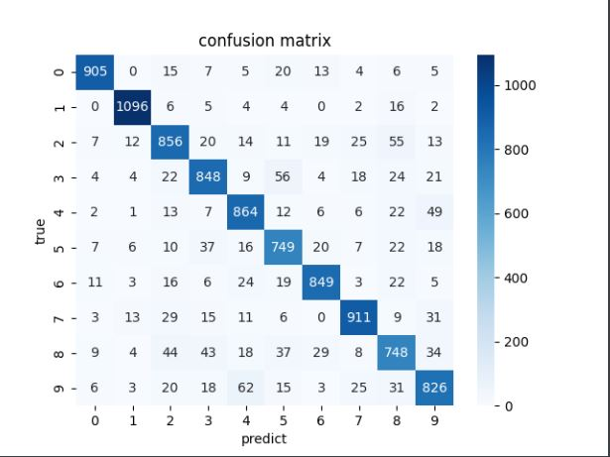
Fig.12

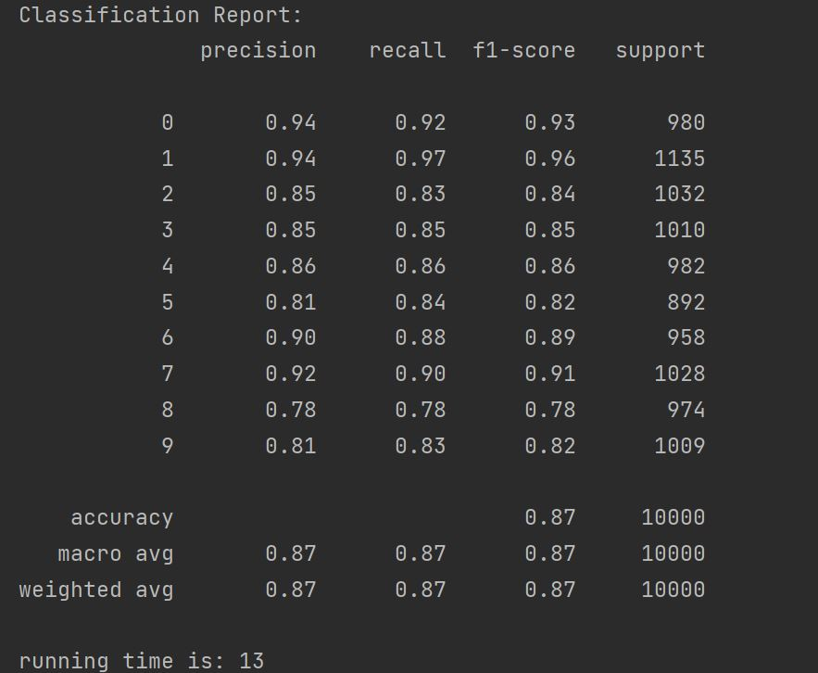
Fig.13
It can be seen from Figure 13 that the average accuracy, recall and f1-score of the CART algorithm implemented in this paper are all 0.87 on the MINIST test set. The digits 0, 1, 6, and 7 were recognized with an accuracy of over 0.90, while the digits 0, 3, 4, 5, 8, and 9 were recognized with an accuracy of less than 0.87. In terms of recall, the recall rates of 0, 1, 4, 6, and 7 are higher than the value of the average recall rate, while the others are all lower than the average value. In terms of f1-score, 1 has the highest value (0.96), while 8 has the lowest value (0.78).

- ID3 Algorithm
Information gain is the ID3 algorithm decision tree's distinguishing criteria. The information gain measures the extent to which having the knowledge about the characteristic XX reduces the uncertainty of the information of the class YY[6]. Entropy must be understood before knowledge gain is introduced. Entropy, which is the anticipated value of information, is the most often used metric to assess the purity of a sample collection. If the transaction to be categorised is capable of being separated into more than one category, the following information pertains to the symbol (feature) K:
$l(k)=−\log_{2}{p(k)}$ (7)

Where P(K) is the probability of selecting the category.
The formula for entropy, which determines the anticipated value of information contained in every conceivable value for every category, is as follows:
$Ent(D)=−\sum_{k=1}^{N}{p(k)\log_{2}{p(k)}}$ (8)

where N is the number of categories.
Information gain is defined as: the information gain The difference between the empirical entropy of the training data set D and the empirical conditional entropy Ent(D|a) of feature an is called the Gain(D,a) of the feature to the training data set D.
$Gain(D,a)=Ent(D)−Ent(D|a)$ (9)
Among them, the feature a divides the data set into: D₁, D₂, ......, D_{v}, and the empirical conditional entropy is:
$Ent(D|a)=\sum_{i=1}^{v}{\frac{D_{i}}{D}Ent(D_{i})}$ (10)

- ID3 algorithm steps
- The construction of the root node, traversing all the features, finding the feature that maximizes the classification information gain, setting it as the root node, and deleting this feature.

- Since the root node has bifurcated the data, recursively finding the optimal feature of each branch.

- id3 uses information gain to select the optimal split feature.

The test code is as shown in Figure 14:

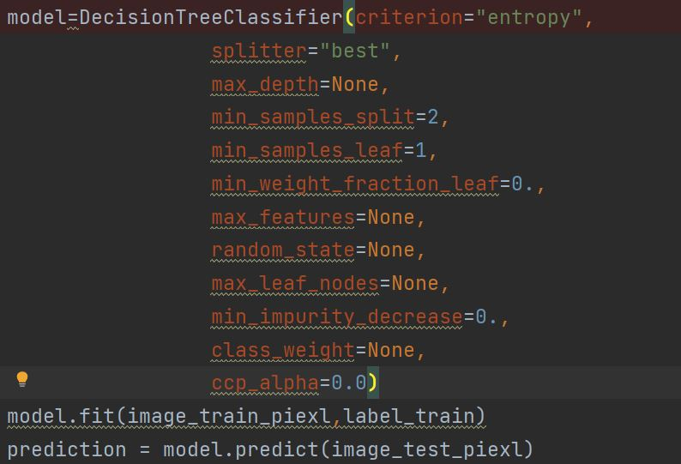Fig.14
- Experimental results
The indicators of the classifier are shown in Figures 15 and 16 below

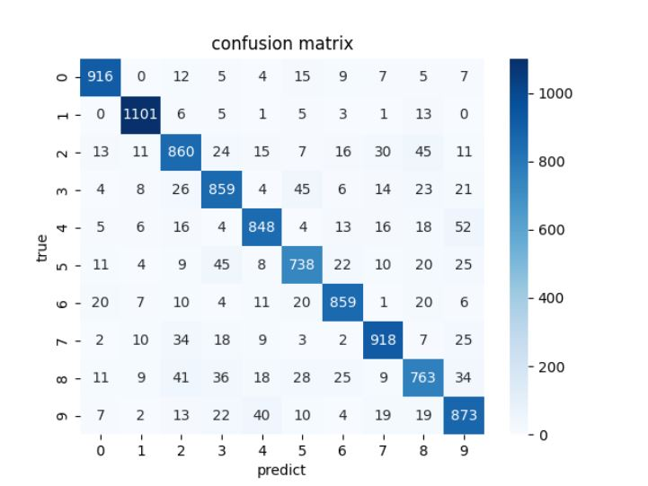
Fig.15
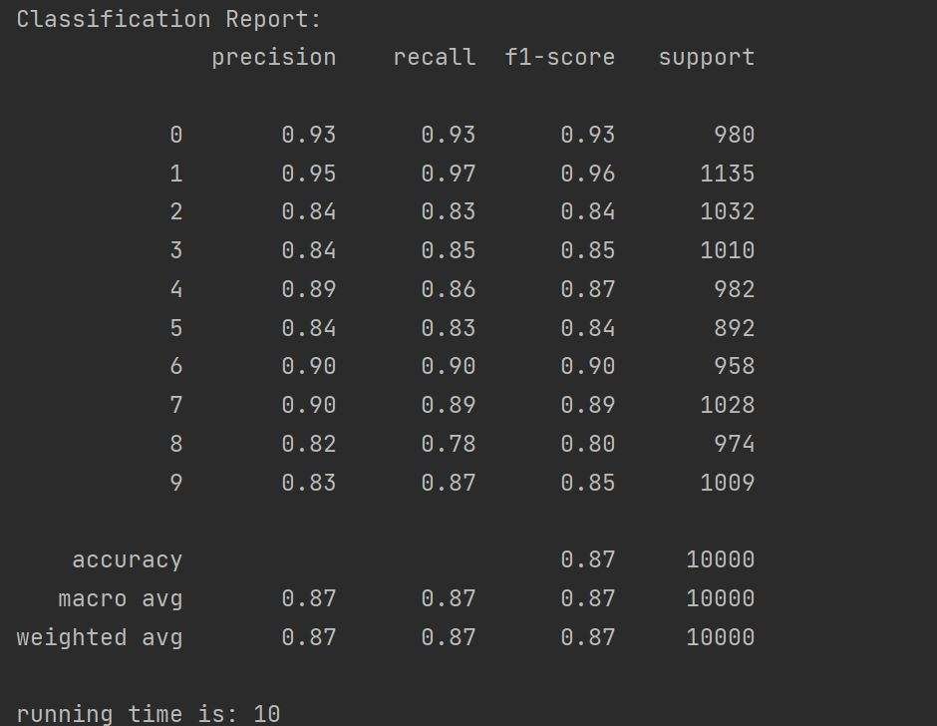
Fig.16

The average accuracy, recall, and f1-score of the ID3 algorithm used in this study on the MINIST test set are also all 0.87, as can be shown in Figure 16. However, in regards to accuracy, 5 digits (2, 3, 5, 8, 9) were successfully identified in the ID3 model while 6 digits (2, 3, 4, 5, 8, 9) were correctly identified in the CART model. The memory rates for six numbers (2, 3, 4, 5, 8, and 9) in the CART model are lower than the average recall rate. Five integers (2, 3, 4, 5, 8) in the ID3 model have recall values that are below average. The f1-score values of 6 numbers (2, 3, 4, 5, 8, 9) in the CART model are below average in terms of f1-score. Five integers (2, 3, 5, 8, and 9) in the ID3 model have f1-score values that are below average. In the predicted image, ID3 uses 10s and CART uses 13s.

- Conclusion

This paper mainly uses Python to design two handwritten digit recognition algorithms based on KNN or decision tree. The training samples are finally processed into a one-dimensional array of 784 feature values, and the classification accuracy, recall rate and f1-score of the two algorithms are obtained in the test samples. In general, the KNN algorithm is much higher than the decision tree in terms of accuracy, recall and f1-score, but the disadvantage is that it takes a long time to predict the category of the picture.

References
- dos Santos Freitas Maurício Madson,Barbosa Jhonatas Rodrigues,dos Santos Martins Emilly Marry,da Silva Martins Luiza Helena,de Souza Farias Fabricio,de Fátima Henriques Lourenço Lúcia,da Silva e Silva Natácia. KNN algorithm and multivariate analysis to select and classify starch films[J]. Food Packaging and Shelf Life,2022,34.
- Reddy O. Yugeswar,Chatterjee Soumesh,Chakraborty Ajoy Kumar. Bilayered fault detection and classification scheme for low-voltage DC microgrid with weighted KNN and decision tree[J]. International Journal of Green Energy,2022,19(11).
- Ghouchan Nezhad Noor Nia Raheleh,Jalali Mehrdad,Houshmand Mahboobeh. A Graph-Based k-Nearest Neighbor (KNN) Approach for Predicting Phases in High-Entropy Alloys[J]. Applied Sciences,2022,12(16).
- Speiser Jaime Lynn,Wolf Bethany J,Chung Dongjun,Karvellas Constantine J,Koch David G,Durkalski Valerie L. BiMM tree: A decision tree method for modeling clustered and longitudinal binary outcomes.[J]. Communications in statistics: Simulation and computation,2020,49(4).
- Bo Xiang,Chunfen Zeng,Xinning Dong,Jiayue Wang. The Application of a Decision Tree and Stochastic Forest Model in Summer Precipitation Prediction in Chongqing[J]. Atmosphere,2020,11(5).
- Machine Learning; Findings from National University of Defense Technology Broaden Understanding of Machine Learning (Towards Practical Privacy-preserving Decision Tree Training and Evaluation In the Cloud)[J]. Information Technology Newsweekly,2020.

