
CERTIFICATE OF HIGHER EDUCATION FOR WORKPLACE

MODULE: MANAGING ENTERPRISE IN THE 21st CENTURY
MODULE ID: BMSK4006
STUDENT NAME: SONIA WELBECK
STUENDT ID: 1714747
LEVEL: 4
TUTOR : DR ISAIAH OINO

DEADLINE FOR SUBMISSION: 14 JANUARY 2019.

UNIVERSITY OF WALES TRINITY St. DAVID LONDON

Table of Contents
INTRODUCTION 3
Main Body 4
The Aims of TSD Health Group 5
Objectives of TSD Health Group 6
Importance of Market Research 6
Source of Capital 7
Conclusion 8
Bibliography 9

INTRODUCTION
This reflective study will be use to analyse the lesson learned from the group presentation in the last semester, which will also include mistakes and improvement on the presentation till date. The group name is called TSD Health Group which consists of four group members that discussed on the plan to establish health care services in the city of London to provide high quality health care professional services for the residents of the communities around and beyond.
The study will explain what TSD Health Group achieved as well as the challenges confronted during the process and means of improving in the later future, most importantly the aims and objectives of the business. However, during the last presentation the group were unable to agree on who should be the group leader, which is the beginning of the challenges that almost made the group to crumble from the onset.
Specific responsibilities were given to the group members of my team from the beginning. However, the roles given were not seen as evenly hard members of the team. There were crisis in the group due to the insight of unfairness in the sharing of the roles that were given to individuals. Thus, social interdependence theory recognises a type of group interaction called ‘positive mutually dependent’, meaning collaboration among the group were difficult and various researches revealed that “cooperative learning experiences encourage higher achievement” (Maughan, 2001). Despite all what the group went through during the preparation stage we eventually achieved a successful outcome. In other to improve the process in the future, the group perhaps needed a competent person with the zeal that can give confidence and cooperation among the team when roles were given to them. In the future team tasks, I would probably propose better idea and lesson learned from the previous group presentation.
The most significant purpose the reflective is to improve from the past mistakes and avoid such from happening in the later future. According to Maughan (2001) ''Reflection offers you the opportunity to consider how your personal experiences and observations shape your thinking and your acceptance of new ideas''. Reflective writing entails looking back on the past actions and assess the outcome, in reference to the significant of this topic with a view of improving in the future practice, task and analysis.
Time management is another vital point to be discussed as well as team player and communication skills including problem solving skills, culture and adaptability. But, with group total commitment the TSD Health Group were able to accomplished their aim, which later provide a fair result hence, that result is far below the expected performance. Having learned and developed interrelationship skills from the last group work, the group can now provide more better and understanding presentation in the future should such task been given. All the above mentioned challenges will be fully analysed and provide means of improvement in the main body.

Main Body
When we talk of leadership skills, the researcher was able to provide leadership skills from the initial stage of the group presentation, according to McPheat (2010), leadership skills is the apparatus, performance and capabilities that individuals required to possess in other to cope, inspire and motivates group of people and organisation to achieve the desired goal. Thus, appropriate leadership require more than all the above attributes; the quality to support people to develop in their own abilities is significant in leadership skill. Most successful people are those that can influence people to achieve their desire success from what they enjoy doing most. From the beginning of the group presentation, the group was formed while the researcher took a bold step to lead the group, initiated leadership skills and guidance on how to commence the presentation process. Some member of the group consented to it while other rejected it. Which was envisaged by the researcher from the onset, but with the leadership skills employed it was all resolved, by influencing the group that I process the qualities to lead the team to achieve the best result, which contributed to the successful results of the group.
However, as a group member, the issue of leadership should not have resulted to argument or crisis that took many weeks to resolved from the start, if appropriate approach has been employed by requesting the group approval before taken the mantle of leadership. Should incase such issue arise in the future the researcher will definitely take another approach of ballot or asking the group opinion before assuming everyone will accepted the leadership position that was taken.
Initially when some group member rejected the researcher opinion of been the group leader, it was like a gang up, but after series of consideration it was concluded that not only individual opinion that matters but collective ideas to achieve desire success is very paramount. Having learnt the importance of group contribution along the process when some member was adamant not to get involved unless we select the group leader buy means of voting and as at then, the researcher was lost of ideas.
With the problem solving skills that the researcher possess, the group was able to find lasting solution to the issue of leadership. In reference to Abazov (2016) says problem solving skills is the crucial ambition and ability of individual person used in solving any obstruction, and finding a way out to the problem that determine the matter in the best possible way. In order to find an effective solution to the leadership issue, the researcher was able to employed some other important skills which includes:
- Creativity. Problems are usually solved either intuitively or systematically.
- Researching Skills
- Team Working
- Emotional Intelligence
- Risk Management
- Decision Making
Below are other skills used in finding solution to the leadership crisis in the group.
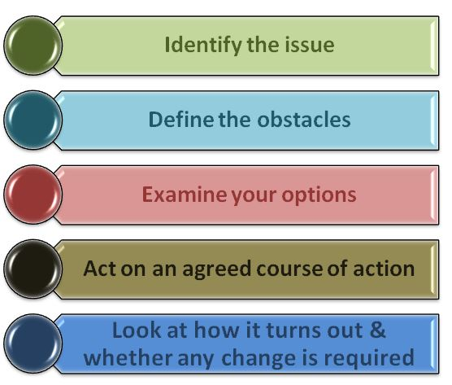Source: (Abazov, 2016)

The Aims of TSD Health Group
The primary goal of the group was to ensure that all services provided by the organisation comply with the rules and regulations in the industry in accordance with the recruitment law and comply with the UK boarder agency EEA standards of trade, which includes the provision of adequate training for the employees, well-being of both the clients (service users) and workers, as well as working hour, pay rates and health & safety of employees & services users and to quality health care services provided. More so, to ensure that TSD Health Group continue monitoring the impacts of services provided through the quality monitoring system by electronics and modern technology. The team also plan to deliver a reliable service that can encourage other service users to continue patronising the company. The group also planned to establish a new branch in Manchester soon.
On reflecting on the aims of the group, the researcher concluded that all the aims are not achievable within that short period of time. Hence, this is most common approach in professional systems, similar to business, forensics, education and health care services like this. It is very important part of reflecting on previous activities conducted and seeking alternatives means of improving by building connections between theory and practice. On evaluating the circumstances surrounding the aims of the group based on ideas from lectures in the class. However, after adequate research I later realised that the opportunity to take time to think about available options, the achievement and disappointments of the group need to be carryout within a specific framework, like this particular group presentation.
Now I know there are other means of approaching the aims rather than the initial approach employed by the group. The group should have engaged professionals to take charge of the process in other to provide realistic plan that can produce desired results. If such task is given in a real life scenario, different approach would have be more beneficial to the success of TSD Health Group.

Objectives of TSD Health Group
Every new businesses begin with an idea of becoming business owner. Making use of the these initiatives into practicable business plans is definitely a big challenge. The plan to put appropriate machinery in place to understand how to create a strategy to identify and find require skills that will deliver needed knowledge to achieve the aims and objectives of the proposed business to be materialised.
The group objectives at the end of our the first year in operation was to have customer base of up to 50 to 100 including both privates and public organisations such as government parastatal (NHS). TSD Health Group also expecting to achieve circa 2 million pounds turnover with the same year in service with the aid of advertising our services to the local clients and beyond.
Setting up unrealistic goal is a very bad foundation without appropriate market search, which will eventually leads to total failure. The group were unable to conduct market research to know both pro and coin of the operational system of the health care industry, all the steps that was taken was based on assumption without element of fact and figure to actualise the dream of TSD Health Group.

Importance of Market Research
The importance of market research should never be underrated. The most successful new companies and businesses remain competitive in their various industries due to the fact that their owners always carryout regular market research to know their target market, know their customers problems and their locations as well as identify realistic competitors. Market research is the easiest means for entrepreneurs to remain in any industry development and continue to have a competitive advantage over its competitors by measuring up business opportunity in the industry (Sprott, 2009).
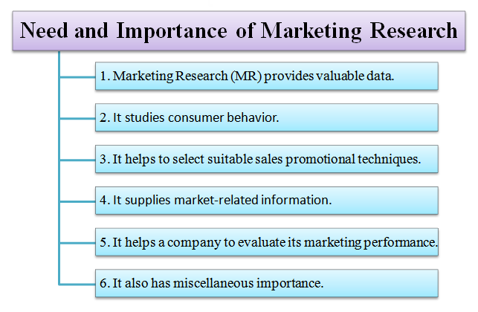
Source: Gaurav Akrani
The TSD Health Group however, did not follow the appropriate channel when planning their business proposal. The objectives of the market research was not defined which should take control of the business objectives and how the lesson learnt from the market operations can be use to influence the goals of the TSD Health Group.
There was no monitoring system in place to compliment the effectiveness of services users but only to assume 2 million pounds turn over within a single year in operation. We planned to provide quality services to our clients without prior knowledge of how other companies provides their services for us to improve on their system of operations. No adequate communication channels conducted to influence the quality of services we intended to provide for our potential clients. We only want to access the industry without prior knowledge of how active the competition within the market are.

Source of Capital
Another important issue that was totally ignored during the group presentation was the source of raising capital, since none of the group member are financial buoyant to finance such business proposal. There are numerous sources of raising funds when new establishment is about to commence depending on the sizes, aims and the nature of businesses that are involved, each business have their financial obligation and investment goals. They fall into two categories:
- Debt financing, which is basically the means how individuals or group of people raise capital from financial institutions with the plans to repay it with certain percentage of interest either in lump sum or on instalment;
- Equity financing is the another means of raising funds to promotes newly establish business. It is a process where capital invested into a business is used as partly own or have share of the business known as exchange for part ownership. The business owner we have certain percentage of the business while the financial institution have other percentage of the business (Sherman, 2015).

Conclusion
This reflective writing has given the researcher an eye opener on the process and means of establishing business and how to be an effective team player for future group or business endeavour. The researcher get to know it is difficult to manage group of people from various background, believe, culture and orientation. It is very crucial for anyone or group to have full knowledge about and skills required before venturing into business at any point in time. Hence, professional and financial support should not be ignore in other to actualise the desire goal of the business.

Bibliography
Abazov, R. (2016). Problem Solving Skills, a requisite of Independent Employees. Researchgate , 22-29.
Maughan, C. &. (2001). Small group learning and assessment. Higher Education Academy , 1-12.
McPheat, S. (2010). Leadership Skills. London: MTD Training & Ventus.
Sherman, A. J. (2015, June 08). American Express. Retrieved November 26, 2018, from www.americanexpress.com/en: https://www.americanexpress.com/en-us/business/trends-and-insights/articles/small-business-guide-sources-of-capital/
Sprott, D. (2009). The Importance of a General Measure of Brand Engagement on Market Behavior: Development and Validation of a Scale. Washington: Washington State University.

