Name: Joao Paulo Borges Straioto
Student ID: 2430803
Module: Network Evidence Portfolio
Module code: ACCA5023
Student Name: Joao Paulo Straioto
Student ID: 2430803
Lecturer: Dr. Nitheesh Kaliyamurthy
Date: 01/05/2026
Table of Contents
Introduction 1
1. Server1 — Static IP Address 1
2. DebianServer — IP Forwarding 2
3. Active Directory — Domain and Users 3
4. DNS — Reverse Lookup Zones 3
5. RRAS — LondonVPN Interface 3
6. DHCP — Birmingham Network Scope 4
7. DHCP Client — IP Assigned to Client1 4
8. Connectivity — Ping Test 5
9. E:\BirminghamFiles — Second Disk 5
10. IIS — Windows Authentication 6
Conclusion 6

Introduction

This document provides evidence of the network infrastructure I configured for the ACCA5023 assessment. It covers ten key tasks completed across a virtualised two-site environment — Birmingham running Windows Server 2019, and London running Debian Linux.

1. Server1 — Static IP Address
Server1 was assigned the static IP 192.168.100.10, required for DNS and DHCP to work reliably.
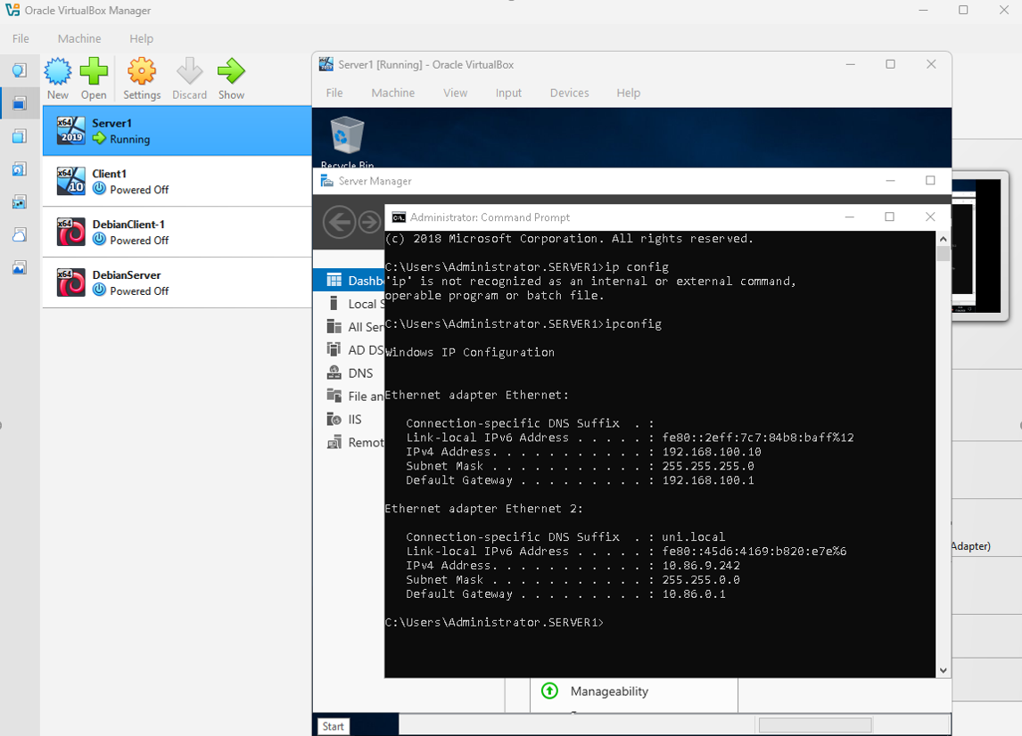
Figure 1 ipconfig confirming static IP 192.168.100.10 on Server1

2. DebianServer — IP Forwarding
IP forwarding was enabled by setting net.ipv4.ip_forward=1 in /etc/sysctl.conf, allowing the Debian server to route traffic between subnets.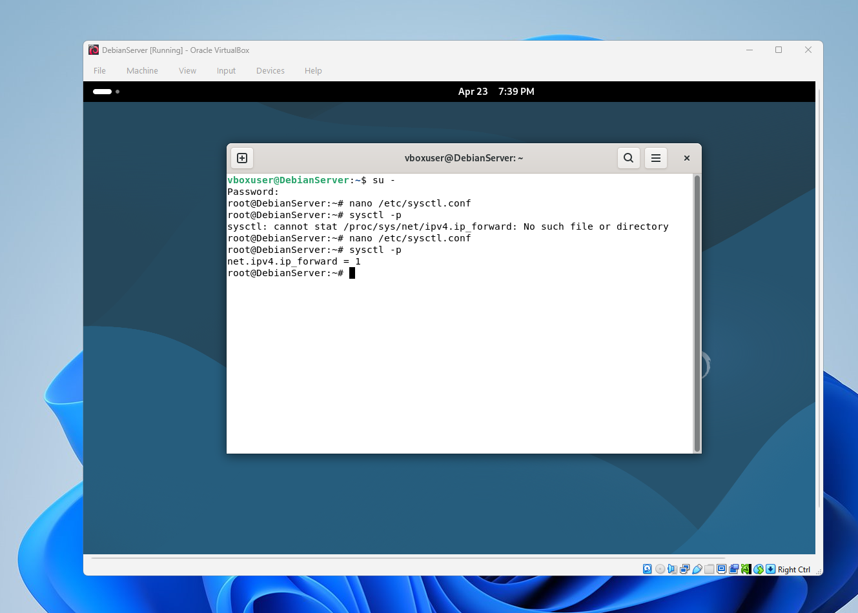
Figure 2 IP forwarding enabled persistently on DebianServer

3. Active Directory — Domain and Users
The domain birmingham.acca was created and user accounts were configured in Active Directory, enabling centralised management of the network.
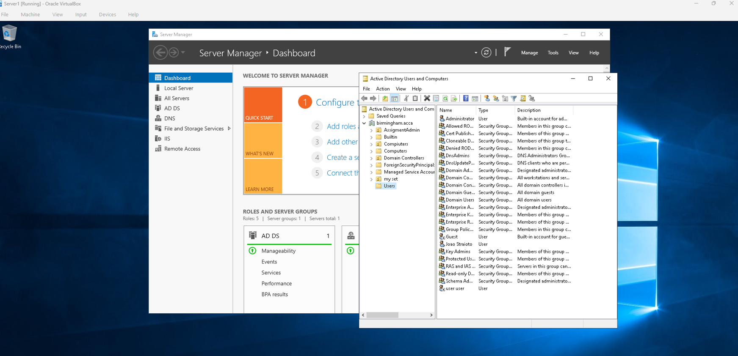
Figure 3 Active Directory Users and Computers showing birmingham.acca

4. DNS — Reverse Lookup Zones
Reverse lookup zones were created for both subnets with PTR records, allowing IP addresses to be resolved back to hostnames.
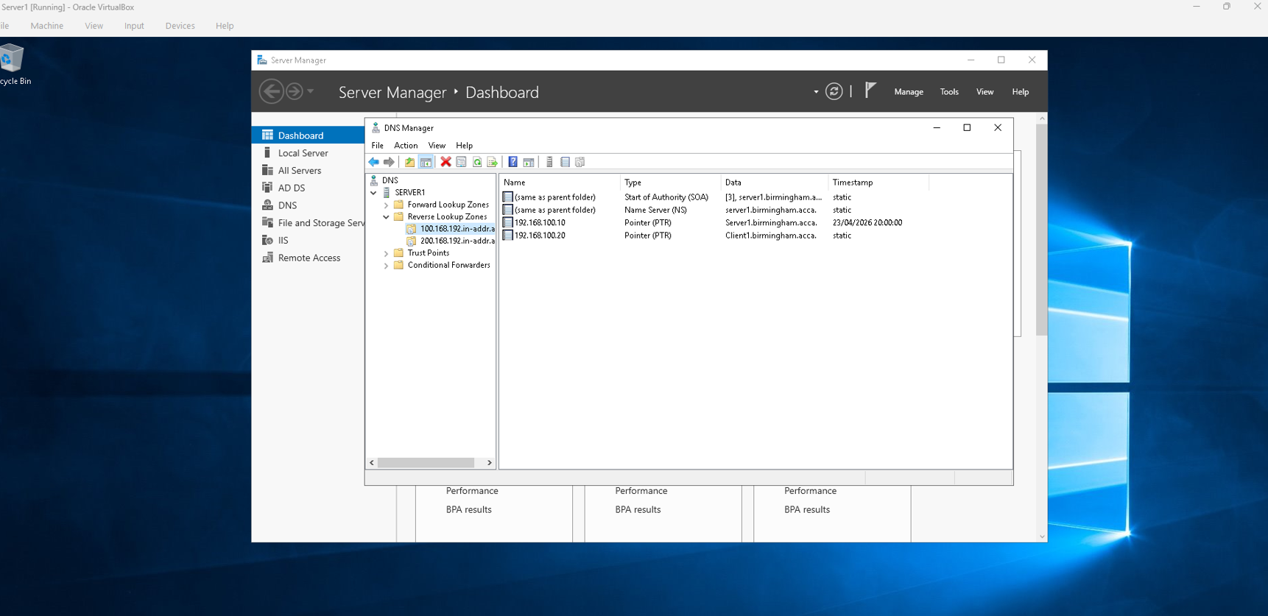
Figure 4 DNS reverse lookup zones with PTR records configured

5. RRAS — LondonVPN Interface
A site-to-site VPN interface named LondonVPN was configured in RRAS using IKEv2. The tunnel could not be fully established due to the Debian environment having no internet access.
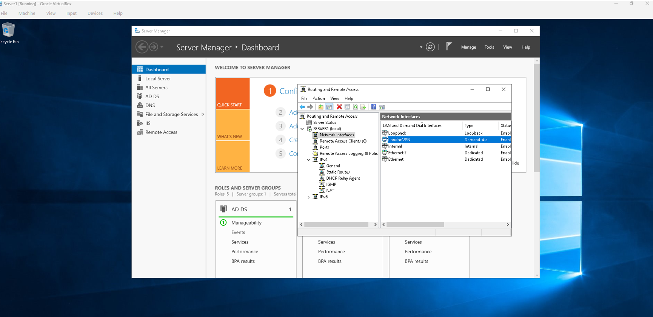
Figure 5 RRAS showing the LondonVPN demand-dial interface

6. DHCP — Birmingham Network Scope
A DHCP scope was created on Server1 covering 192.168.100.0/24, automatically assigning IP addresses to clients with the correct gateway and DNS settings.
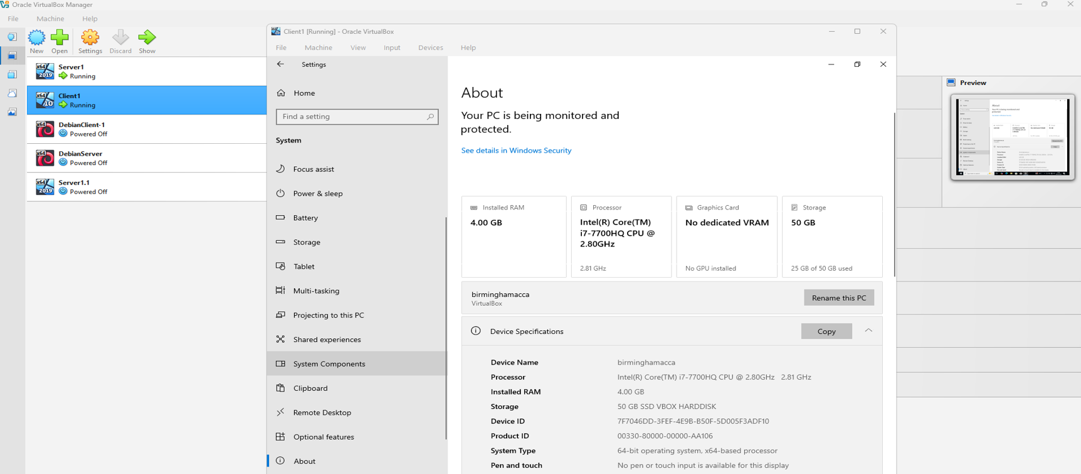
Figure 6 DHCP scope active on server1.birmingham.acca

7. DHCP Client — IP Assigned to Client1
After running ipconfig /renew, Client1 received the address 192.168.100.11 from the DHCP server, with the DNS suffix set to birmingham.acca.
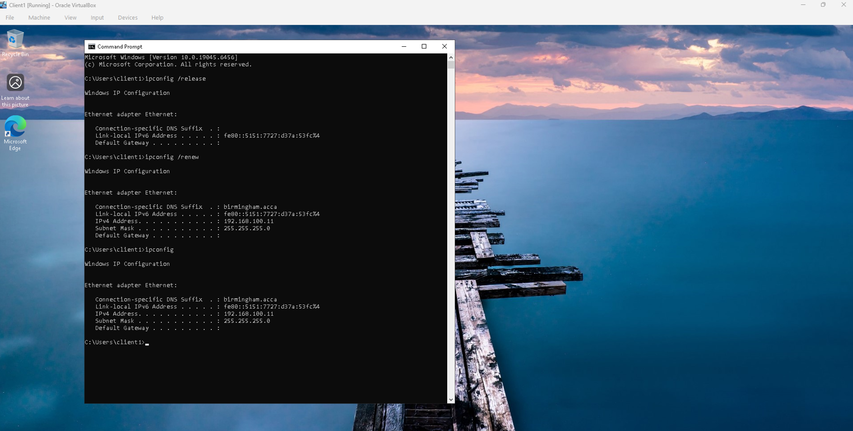
Figure 7 Client1 assigned IP 192.168.100.11 via DHCP

8. Connectivity — Ping Test
A ping from Server1 to Client1 returned 4 out of 4 packets with 0% loss, confirming full connectivity within the Birmingham network.
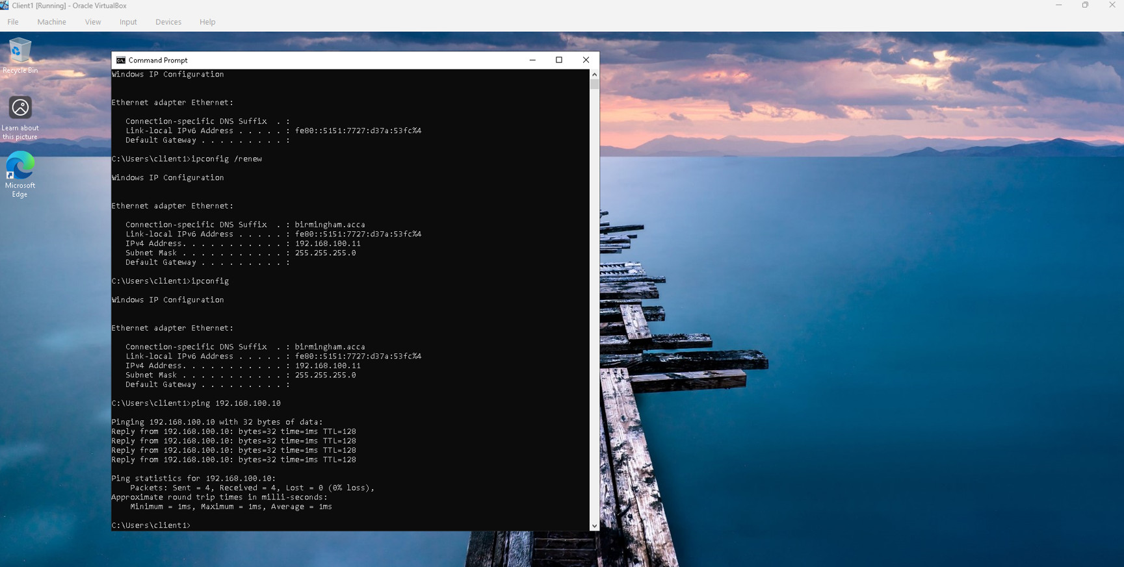
Figure 8 Ping from Server1 to Client1 with 0% packet loss

9. E:\BirminghamFiles — Second Disk
A 10GB virtual disk was added to Server1, formatted as NTFS and labelled BirminghamFiles. Permissions were set to give Administrators full control and domain Users standard access.
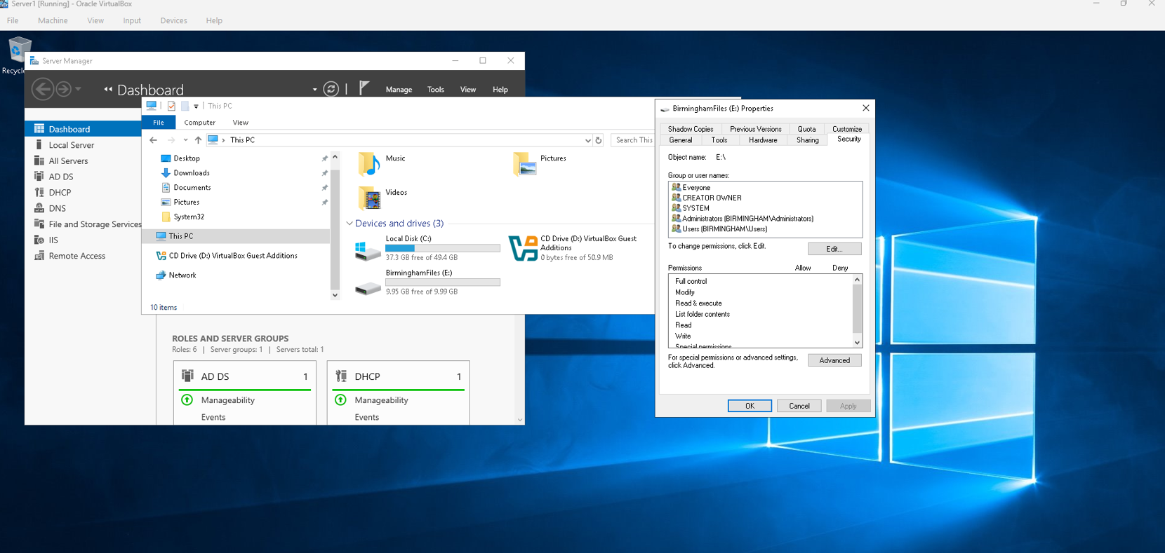
Figure 9 BirminghamFiles drive with NTFS permissions configured

10. IIS — Windows Authentication
The website webs.joao.acca was created in IIS with Windows Authentication enabled and Anonymous Authentication disabled, restricting access to domain users only.
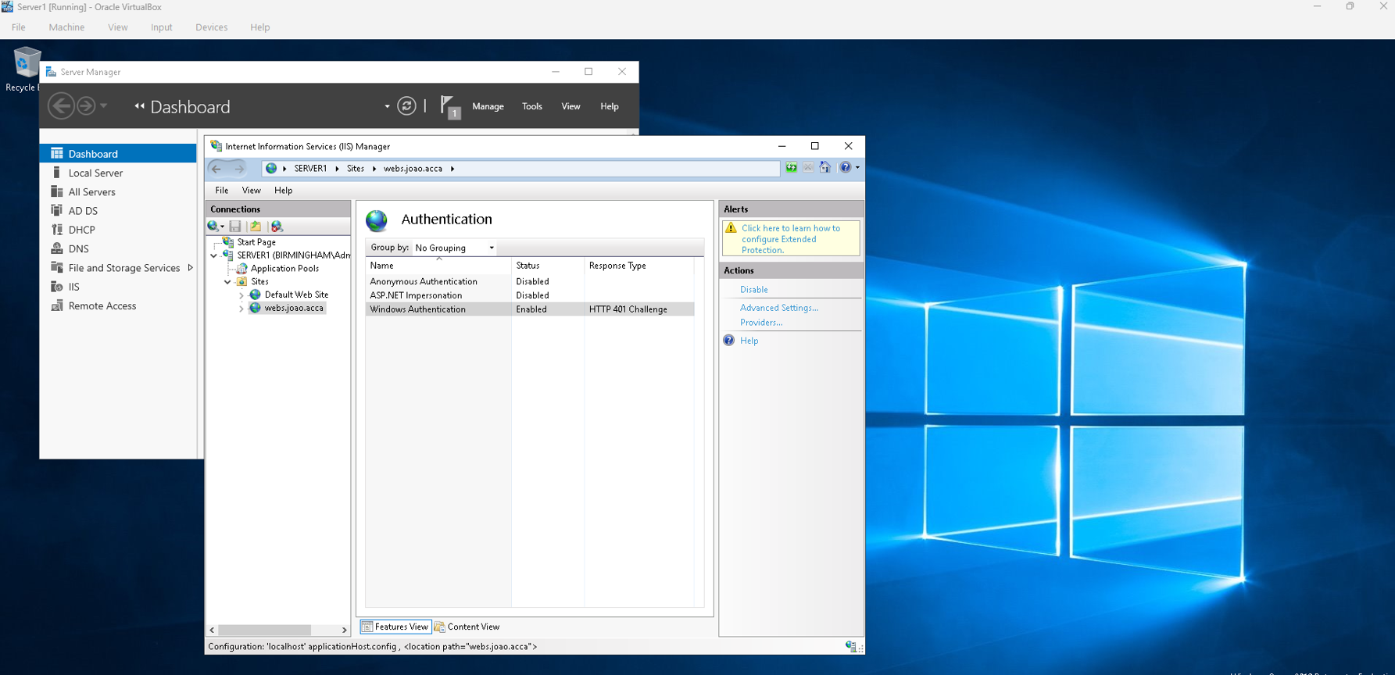
Figure 10 IIS showing Windows Authentication enabled for webs.joao.acca

Conclusion
The evidence above demonstrates the successful configuration of core enterprise network services across a virtualised environment. Each task was completed and tested methodically. Where limitations arose — such as the VPN tunnel and DHCP relay — these were caused by the isolated lab setup and are clearly documented throughout the report.

