UNDERSTANDING AND ENGAGING IN THE CUSTOMER EXPERIENCE
Student Name: Rabia Miah
Student Number: 1605763
Module Number: BMSK5003

Module Title: Understanding and engaging in the customer experience
Lecturers Name: Yajesh Kumar

Table of Contents
Introduction: - 1
1. Critically analysing the factors that impact Debenhams’s ability to maximize customer value: - 2
1.2 Value chain analysis: - 2
1.2 Strengths of the company: - 5
1.4 Resources and Capabilities of the company: - 5
1.5 PESTLE Analysis: - 6
1.5 Porter Five Forces: - 9
2. Critical understanding of Debenhams’s quality processes and its effectiveness in meeting customer requirements: - 11
2.1 Indemnification of the customers need: - 11
2.2 Leadership theories: - 11
2.3 Operational theories: - 15
Conclusions: - 22
References: - 23

Introduction: -

Every company tries to provide better products and services to the customers then its competitors to achieve competitive advantages in the marketplace. Customers are the key factors based on which all the business activities are designed, renovated and developed (Worthington et al., 2018). Nowadays, companies have become more and more concerned about customer satisfaction and customer engagement in business activities. Research shows that the more the customer engagement in business activities, the higher level of customer satisfaction (Barney, 2018). Debenhams is a multinational retailing company which has been continuing its business activities in UK, Iceland, Denmark and some other European countries in 178 locations through its diversified supply chain. Debenhams mainly deals with groceries, cosmetics, clothing, electronic products, toys, fashion elements, and home accessories to satisfy the customers through its unique and diversified product design. Such fashion materials, home accessories, electronic items trend changes over time (Marmol et al., 2015). So, Debenhams needs to be very aware of the customer preferences, choices, likes, dislikes and convenience to ensure the highest level of customer satisfaction. In this report, we will discuss that how Debenhams engage and manage the customers to build up a better and strong customer relationship to increase the level of customer satisfaction.

1. Critically analyzing the factors that impact Debenhams’s ability to maximize customer value: -

There are lots of internal and external factors that actually led Debenhams to adjust to the customer's demand. The internal factors include its powerful human resource management, brand value, diversified product range, quality product, strong management etc. (Hesterly, 2014). On the contrary, the external factors include the suitable business environment of Debenhams. All these factors affect Debenhams directly or indirectly to maximize its customer's value.

1.2 Value chain analysis: -

Michael Porter developed the value chain model to analyze the overall activities of a company. Value chain analysis explains all the business activities of a company including production, marketing, storing, delivering and managing human resources (Blythe, 2017). Debenhams identifies the primary and support activities and also assumes the cost drivers related to all these factors to develop a strong value chain system to maximize the customer value.
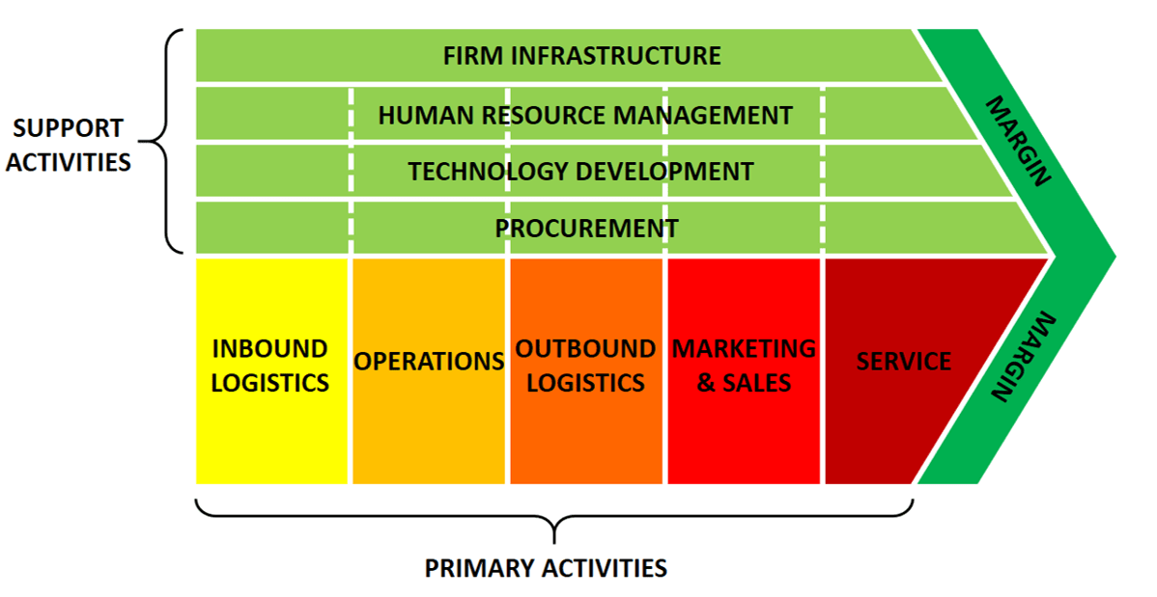
Figure 1: - Value Chain Analysis
Source: - (Hesterly, 2014)
Firm infrastructure: -
To develop a strong value chain system, Debenhams has developed a strong infrastructure to support the primary activities. For example, Debenhams has an investment a huge amount of money and also has financed a lot of amount from the external sources to raise the capital. Again, a strong management system, good planning, legal support of a company also develop the firm's infrastructure (Nilsson, 2015).
Human resource management: -
Debenhams initiates the long-term planning of the professional developments to develop the employee relations with the upper management to develop the value chain. For example, Debenhams does performance appraisals, sophisticated recruitment system and organizes training sessions to develop the human resource department. Again, companies set competitive wages for the employees to retain the workers (Blythe, 2017).
Technology development: -
Debenhams has embraced all the technological changes to develop its value chain and to support its primary activities. For example, Debenhams has developed an integrated supply chain system and retail time sales information to foster the firm business activities.
Procurement: -
Debenhams manufactures the grocery items, clothing, home accessories and also the electronic equipment etc. and for these activities, Debenhams maintains a high-quality procurement system. For example, Debenhams uses JIT for proper inventory management. Again, real-time inventory system, communication with suppliers, purchasing supplies of good quality at a reasonable price also support the primary value chain activities (Hesterly, 2014).
Inbound logistics: -
To develop a strong value chain system to maximize customer value, Debenhams uses real-time inbound data for proper inventory management and production process. Again, Debenhams has 178 diversified location of the distribution channel to bring the necessary raw materials and supplies for the manufacturing process. Again, a sufficient number of delivery trucks, efficient material handling, and developed warehouse system helps an organization to ensure a well developed inbound logistics system (Nilsson, 2015).
Operations: -
To deliver quality products to the customers to maximize customer value, companies try to develop standardized operation model (Steiner, 2014). Debenhams does the same thing too. Again to ensure optimum level of production and to reduce the operation cost, Debenhams uses proper cross-department communication systems. For example, Debenhams uses real-time sales and inventory information especially the Kaizen method, the JIT method to ensure production efficiency.
Outbound logistics: -
Debenhams ensures the highest customer service and so it provides door to door customer service to deliver its products and services. According to the order processing, Debenhams delivers all of its products to the customers through its delivery trucks to its different outlets. Again, for online sales, Debenhams also ensures quick delivery facilities.
Marketing and sales: -
Debenhams uses an integrated marketing system to mobilize the promotional and branding strategy of the firm. Debenhams does competitive pricing strategy compared with Walmart, Unilever, Marks, and Spencer etc. big market rivals. Companies conduct both online and offline promotional activities to foster sales (Blythe, 2017). Again, Debenhams ensures product based on community needs for better customer value. Debenhams sets the price low so that the consumers can easily grab the products.
Services: -
For online purchase system, Debenhams ensures quick home delivery system to ensure better customer service. Again, Debenhams also provides free installation, repair service, and post-purchase services to the customers. Again, discount cards, cash back offer, Debenhams’s own credit card, greeting cards, and price cut offer for the customers are the most famous strategies of the multinational retailers to ensure greater customer value.

1.2 Strengths of the company: -

The biggest strength of Debenhams is that it delivers good quality products at a reasonable price range with delivering high customer service. Debenhams is quite renowned for its diversified supply chain and retailing locations in the UK, Iceland, Denmark, and other European countries. Another strength of Debenhams is that it uses dynamic manufacturing and marketing strategies based on the preferences of the customers. The trends of the clothing, home accessories, footwear, electronic equipment change over time so the companies try to diversify its products to adapt to the change (Ansoff, 2016).
Again, the strong infrastructural position, good brand value, developed value chain and skilled human resource department have enabled Debenhams to ensure the highest level of customer value. Again, Debenhams uses a divisional organizational structure to meet the different needs of different customers. Moreover, Debenhams has initiated the total quality management, six sigma strategy, management by objective, JIT, Kaizen system, motivational strategies, integrated marketing system which has strengthened its business activities too. Proper employee motivation helps a firm to develop a skilled and loyal workforce (Nilsson, 2015).

1.4 Resources and Capabilities of the company: -

Resources are the key forces which make an organization strong, efficient, capable and broaden its business activities (Steiner, 2014). Debenhams has the following resources which have increased the capacity of production as well as the distribution of goods.
Strong infrastructure: -
Debenhams has a strong infrastructure which helps Debenhams to deliver a better quality product and massive production. Debenhams has the financial ability to take over al the new technological advancements in the production and distribution process which ultimately lead towards economies of scale. Economic scale reduced the per unit production cost (Nilsson, 2015).

Skilled workforce: -
Debenhams has developed a sophisticated employee recruitment process and recruit the employees after a scrutiny test too. Again, proper training facilities, monitoring facilities, coaching facilities as well as the counseling sessions are organized to flourish the employee skills (Steiner, 2014). Again, Debenhams provides proper motivational facilities to the employees to build up unity among the workers for better use of human resource.
Competitive advantages: -
Debenhams is a renowned company and also has its distribution channels in different locations which help Debenhams to gain competitive advantages. Again, the low prices of the commodities and the greater customer services have made Debenhams more popular in the market. Again, the low production cost, online purchase facilities, online apps, strong PR group also helps a firm to gain competitive advantages (Nilsson, 2015).
Marketing strategy and promotional activities: -
Debenhams has initiated an integrated marketing strategy which includes both online and offline promotional activities. Again, Debenhams has been also providing discounts, gift vouchers, discount cards, premium card facilities, sales offer, personal selling facilities and bundle offer to the customers which have been creating a buzz for Debenhams in the marketplace.

1.5 PESTLE Analysis: -

The business performances of Debenhams gets affected by the external environment and so to analyze the effects of those external factors on Debenhams’s value proposition, we have to conduct this PESTLE analysis. PESTLE analysis describes the impacts of the political, social, economic, technological, legal and environmental issues on business activities (Ansoff, 2016).
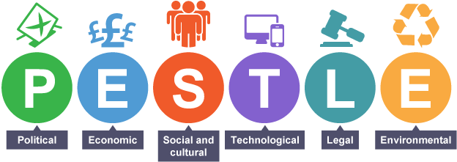
Figure 2: - PESTLE Analysis
Source: - (Sefue and Mkapa, 2014)
Political issue: -
The political stability, government tax policy, the government supports, country codes, positive view of the rival parties and the business-friendly policy of the government helps a company to expand its business activities (Michaux et al., 2015). In this case, the favorable and business-friendly policy of the UK government has been helping Debenhams to conduct its business smoothly. The political stability also encourages Debenhams to expand its supply chain without any interruption in the supply chain. Despite these, the strict tax regulation policy of the UK government and the bureaucratic complexity often frustrate the business activities of Debenhams.
Economic issues: -
After the great recession of 2008 and the Brexit issue in 2015, Debenhams business activities got negatively affected and the sales were declined too. But now the UK has overcome those issues. So, now, the strong economy of the UK, economic stability, low rate of unemployment, strong capital market help Debenhams to establish more retailing stores in more locations because the current economy supports business expansion.

Social and cultural issues: -
Debenhams is a multinational retailing company and it has its retailing stores in different countries. The social cultures, norms, and values of the customers of different geographical areas are different (Marmol et al., 2015). So, Debenhams designs its fashion materials, cosmetics, home accessories based on the culture and tradition of that particular areas. For example, the fashion materials of the UK are not the same as that of Iceland.
Technological issues: -
Debenhams uses all the modern technologies and equipment in its manufacturing and distribution process. Debenhams uses artificial intelligence (AI) in the manufacturing process to enhance the quality of goods. Again, in the distribution process it uses modern trucks, cargo, sophisticated storage facilities, automatic inventory management systems too (Marmol et al., 2015). Again, as a part of the technological revolution, companies have been focusing more on online sales, online PR groups, online customers services, and online websites developments too. Debenhams is not an exception in this case.
Legal issues: -
The good relationship and strong diplomatic relation of the UK government with the other European counties as well as the Asian countries help Debenhams to expand its retailing business in different regions. Sometimes, the high tax rate, tariff complexity, lack of government support of the other countries discourage Debenhams to expand its business in that particular country.
Environmental issues: -
As a part of sustainable development, Debenhams has been using an environment-friendly machine, pollution resistant materials, green technologies, solar power, and developed a recycling process in the manufacturing process. Moreover, different social awareness programs and CSR activities are conducted to protect the environment as well as to develop the brand image of that particular company in front of the public (Sefue and Mkapa, 2014).

1.5 Porter Five Forces: -

To provide better customer value, Debenhams must have a better understanding of the retailing industry so that Debenhams can differentiate its business activities and can take precautionary steps to tackle all the possible threats. Porter’s five forces analysis helps an organization to have a better understanding of the power of the competitors, suppliers, customers, market entrants and substitute goods (Michaux et al., 2015).
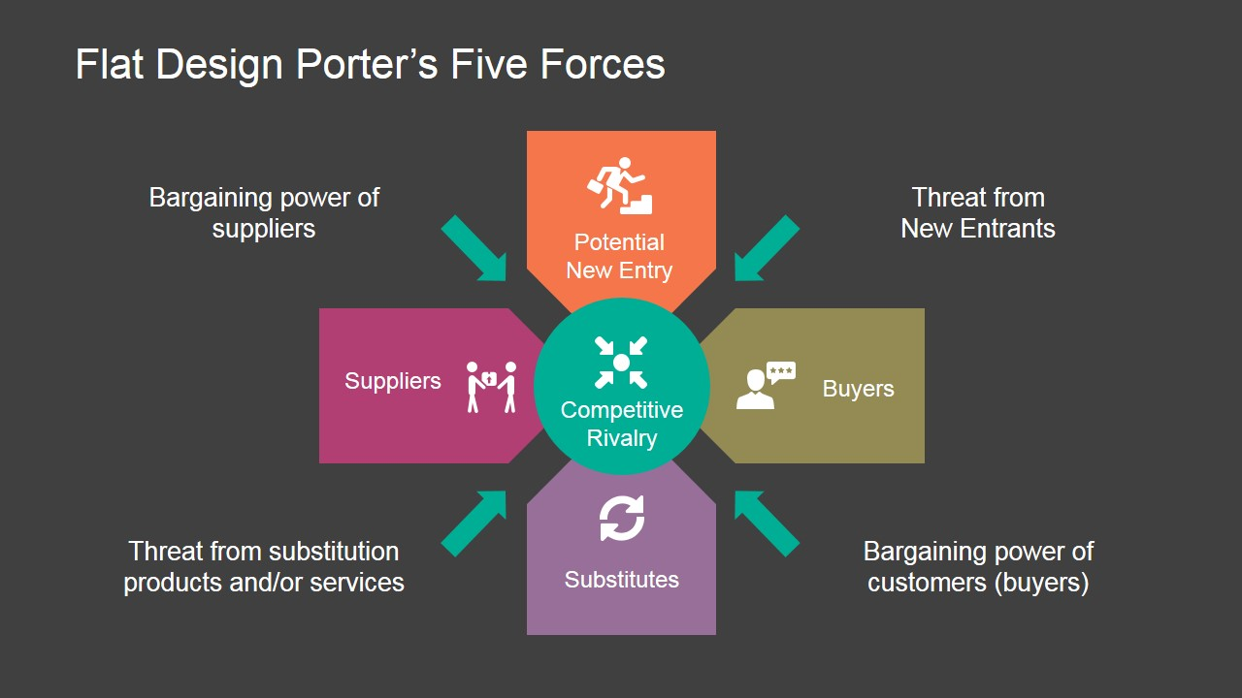
Figure 3: - Porter Five Forces Analysis
Sources: - (Michaux et al., 2015)
The threat of new market entrants: -
Due to the open market of the UK and the other European countries, new companies are getting interested to enter into the retailing industry due to the massive growth of this industry. Big companies like Coca-Cola, Starbucks etc. have been thinking about entering into this market too. Again, there are lots of small companies who are frequently joining this marketplace (Ansoff, 2016). So, the threat of new market entrants is very high here.
The threat of the competitors: -
The big market leaders like Unilever, Walmart, Mark, and Spencer have been playing the major role in the retail industry (Sefue and Mkapa, 2014). Debenhams finds it very difficult to compete with such market giants because their distribution channel is very strong than Debenhams’s. So, the threats of the competitors in the retail market are very high too.
The threat of substitutions: -
There are lots of substitute goods and services of the competitors available in the market (Michaux et al., 2015). So, consumers have different options to buy their goods. So, Debenhams always try to provide the best quality goods at an affordable price range because a little defect of the goods may lead the consumers to go for the substitute goods.
Bargaining power of suppliers: -
Debenhams doesn’t rely on the single supplier and it maintains good relations with different suppliers. Again, there is a huge number of suppliers available to supply the raw materials and other supplies of the retail industry (Ansoff, 2016). So, the bargaining power of the suppliers is moderate.
Bargaining power of customers: -
Customers play a key role in the retailing industry (Worthington et al., 2018). All the companies including Debenhams bring necessary changes in their product, distribution activities and in marketing activities based on the customer preferences, choices and lokes or dislikes. So, the bargaining power of the customers is very high here.

2. Critical understanding of Debenhams’s quality processes and its effectiveness in meeting customer requirements: -

Debenhams uses sophisticated management process and strict controlling and monitoring process to ensure the better quality goods and services for the customers. In this case, the effective leadership theories and operational management theories contribute to a higher level to quality control to meet the customer’s requirements (Sefue and Mkapa, 2014).

2.1 Indemnification of the customers need: -

At first, Debenhams conducts marketing research to understand the needs and demands as well as the preferences of the customers. In this case, consumers choice, thoughts, views, affordability, preferences are considered and based on that the products are designed. Debenhams also designs its distribution channels and marketing strategies based on customer needs. In this case, Debenhams initiates consumer awareness, consumer hypothesis analysis, and product testing and customers feedbacks to enrich the quality process to meet the customers’ requirements.

2.2 Leadership theories: -

The leadership theories describe the appropriate methods or process through which the management can ensure the best use of the human resources to achieve its organizational goals in the given time limit (McDonald and Meldrum, 2017). So, Debenhams uses different leadership strategies to lead its employees to attain the organizational goals to meet the customers’ requirements. In this case, Debenhams uses the situational leadership style most of the time.
Situational leadership model: -
This leadership model suggests that there is nothing called as the best leadership style because the leadership style depends on the behaviors of the group of workers and on the patterns of the task (Worthington et al., 2018). So, Debenhams encourages its leaders to change the leadership styles based on the nature of the tasks and behavior patterns of the workers to adapt to the situational change.
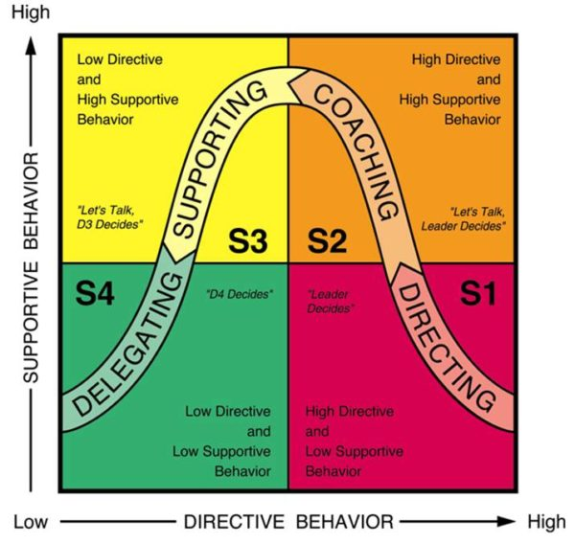
Figure 4: - Situational leadership model
Source: - (Hesterly, 2014)
Directing (S1): -
In this scenario, the group of workers is lack of technical skills and other professional skills to accomplish a particular task in the organization but they are highly motivated and enthusiastic to accomplish the task (Sefue and Mkapa, 2014). In such a scenario, Debenhams provides all the necessary directing, monitoring, and training facilities to the employees to make them efficient to meet the customer requirements.
Coaching (S2): -
In this particular situation, the employees are more able, skilled, proficient and professional in their work but somehow they get demotivated or discouraged to attain the organizational goals and objectives (Leech, 2014). In such a scenario, Debenhams suggests its management leaders organize necessary motivational seminars, monetary benefits as well as the other complementary benefits to the employees to ensure better quality and control and high customer services.
Supporting (S3): -
In this case, the workers are fully skilled, professional and experienced at their work but sometimes they feel lack of confidence or lack of self-esteem or demotivation while accomplishing the tasks (McDonald and Meldrum, 2017). So, in such a scenario, the HR manager of Debenhams provides high supporting facilities, personal counseling facilities and ensure the job security to encourage them to meet the customer service requirements.
Delegating (S4): -
In this scenario, the employees are more professionals, experienced and they contain a clear goal in their mind. In this situation, employees not only accomplish the entire assigned task but also they take proper responsibility and accountability of the tasks (Worthington et al., 2018). In this case, the HR leader of Debenhams provides acknowledgment of the employees and also provides promotions, bonus, and recognition to develop the employee engagement to deliver better customer value by maintaining quality control.
System leader: -
To ensure better quality control and to meet the customer requirements at the highest level, Debenhams assigns the system leaders to monitor, control and guide the employees of the organization. A system leader maintains a leadership framework to direct all the employees towards the organizational goals (Leech, 2014).
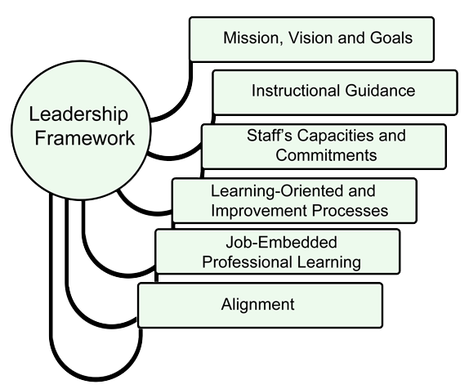
Figure 5: - System leader
Source: - (Marmol et al., 2015)
A system leader at first clarifies all the mission, vision and goals of the organization to the employees to have a better understanding of the employees on the organizations' objectives (Worthington et al., 2018). Then the system leaders provide instructional guidance to the employees so that they can maintain the quality of the product and services. In this case, the system leaders of Debenhams understands the capabilities and capacities of the employees and based on that he assigns the tasks. In this case, to develop the quality process, the system leaders of Debenhams impart necessary professional learning facilities and training facilities to the employees. So, the employees get the chance to go through the learning oriented improvement process which also motivates them a lot. Most importantly, the system leader coordinates all the tasks of all the employees of various departments and aligns all the task in a strategic line so that all the employees can work together with uniformity to achieve the common goals and objectives of the company (McDonald and Meldrum, 2017). Thus, Debenhams ensures its quality process and build up a skilled workforce who are committed to meet the customer requirements.

2.3 Operational theories: -

The operational theories suggest the best way to implement the business strategy of an organization (Hesterly, 2014). Debenhams uses different types of operational theories to ensure the attainment of the customers' needs and demands through maintaining quality control.
Operation management: -
The operation management includes the controlling, monitoring, executing and implementing the management processes through will all the organizational resources will convert into desired goods and services which will meet the needs of the target group of customers (Worthington et al., 2018). Debenhams conducts the following activities as a part of the operational management.
Total Quality Management (TQM): -
Debenhams initiates the total quality management as a part of the management process through which the quality of the output goods and services are developed through the continual development process.
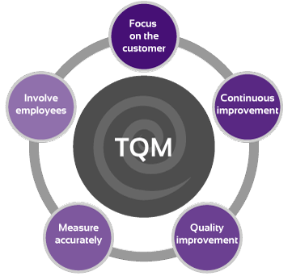
Figure 6: - Total Quality Management (TQM)
Source: - (Aaker et al., 2016)
Through TQM, Debenhams puts the main focus on the customer especially the customer's needs, preferences and dislikes on the goods and services. Based on that, Debenhams engages all the employees to meet the customer demands. For the quality goods, Debenhams measures the level of accuracy with matching the executed tasks with the standard one. If there is any deviation, necessary quality control, and quality improvement initiatives are undertaken by the organizations (McDonald and Meldrum, 2017). Most importantly, Debenhams ensures continuous improvement with the operational activities for better customer satisfaction.
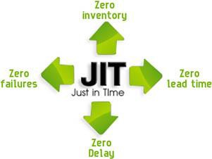
Figure 7: - Just in Time (JIT)
Sources: - (Marmol et al., 2015)
Just in Time (JIT): -
Debenhams uses Just in time (JIT) system in its operational management and inventory management activities. Through JIT system Debenhams directly call the all the necessary raw materials to the manufacturing center with no lead time and delay. Through the JIT system, management reduces the inventory loss, wastages and loss of unsold products (Aaker et al., 2016). So, Debenhams justifies the consumer needs a manufactures all of the products as the order placed. JIT helps Debenhams to reduce its operational costs.
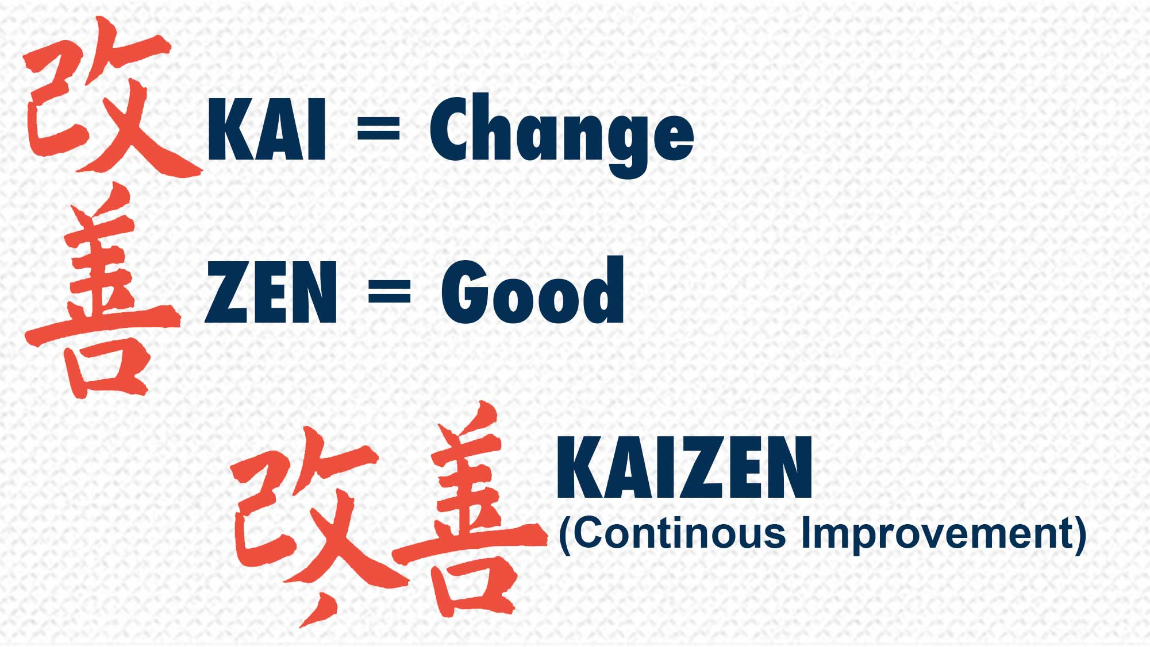
Figure 8: - Kaizen (continuous improvement)
Source: - (Worthington et al., 2018)
Kaizen: -
It’s a Japanese term which is a combination of two words. Here, Kai means ‘change’ and Zen means ‘goods’. So, Kaizen means continuous improvement of goods and services(McDonald and Meldrum, 2017). Debenhams uses this operational management strategy to ensure continuous improvement of goods and services. So, Debenhams regularly checks its operational procedures and ask all the employees to get the feedbacks. Debenhams collects the feedbacks of the respective employees of a particular task who has skilled on that task and suggest the employee give some suggestions to develop the operational process. This is how Debenhams ensures the continuous improvement to ensure better quality goods for meeting the customer requirements.
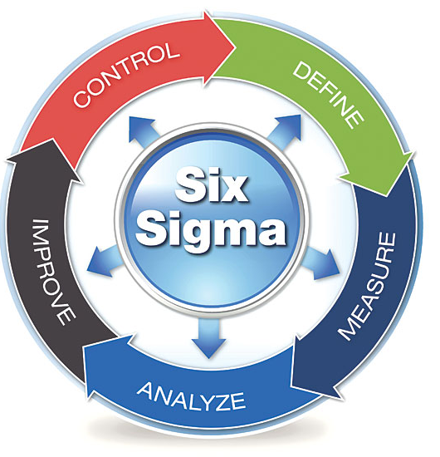
Figure 9: - Six Sigma techniques
Source: - (Barney, 2018)
Six Sigma techniques: -
Debenhams uses Six Sigma techniques when it starts its new distribution and production process for a new product. Debenhams uses Six Sigma techniques to ensure continuous improvement through eradicating the number of errors or reducing the likelihood of occurring an error in the production system. In this technique, all the management procedures are defined to the employees and the employee performances are measured and any sized through comparing with the established standards (Hesterly, 2014). After that, Debenhams takes necessary improvement initiatives and controls all the operational activities for a better quality of customer service management.
Lean theory: -
Debenhams uses the lean theory to minimize the wastage in the production, packaging, distribution and in the inventory phase. Lean strategy helps to identify the unnecessary business activities or the overloaded products which may incur a cost to the production (Leech, 2014). Lean theory helps Debenhams to align all the business activities strict to the ultimate consumers. Again lean theory also encourages no to accomplish the repeated task through proper mapping systems. The lean strategy also allows the customers to go for the pull strategy for meeting their needs. Most importantly, lean strategy removes the wastage and unnecessary business activities from the business process and allows Debenhams to reduce its cost.
Queuing theory: -
Debenhams uses this theory to maintain a sequence and order of the inventoried goods as well as the finished goods so that the lead time can be reduced. This theory suggests that all the queues will be connected by a common channel for swift distribution. Queue theory is used to understand the queue length of the product line and to know the lead time of the raw materials distribution to the production spot (Aaker et al., 2016). It helps Debenhams to bring efficiency in production activities by arranging all the goods systematically and reducing the lead time.
Process design: -
Debenhams sets the organizational goals and objectives and based on that Debenhams goes for process designs. While designing a business process, several paths and steps are developed for quality control and to check the products. Based on the product feature the business process is designed and several controlling points are developed (Barney, 2018). If any defect is found in the control point, that particular product starts its journey again. To ensure the business process development all the critical paths of the business objectives are identified and analyzed. After that, Debenhams justifies all the probabilities and chooses the most efficient business process model to ensure greater customer value maintaining high quality. Most importantly, Debenhams conducts regular improvement and development activities through constant inspection to develop the business process.
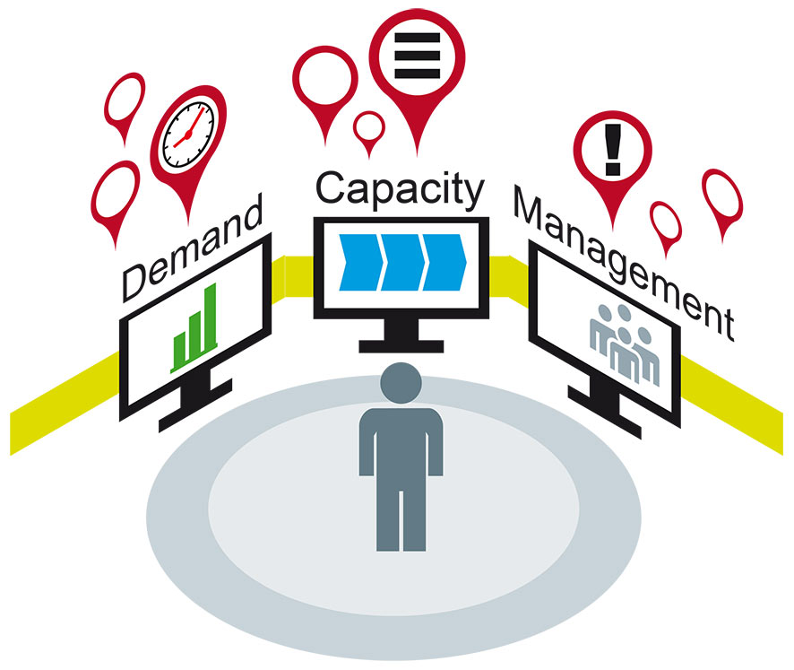
Figure 10: - Capacity management
Source: - (Aaker et al., 2016)
Capacity management: -
Capacity management ensures the efficient use of all the business information system through IT development and strong and developed IT infrastructure. Debenhams analyze all the business information and predicts and forecasts the demand of the customers and based on that the management conducts its operational activities. In this case, Debenhams conducts business capacity management, component management, and service capacity management to ensure efficient use of information systems. In this case, online websites, online support services, and online PR group and IT department play a major role (Barney, 2018).

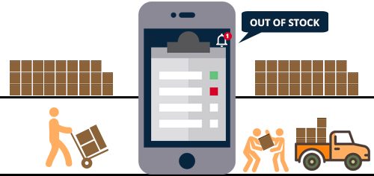
Figure 11: - Stock & Logistics Management
Source: - (McDonald and Meldrum, 2017)
Stock & Logistics Management: -
Debenhams conducts the stock and logistics management activities to reduce the inventory cost as well as to ensure proper distribution of goods from stock to production spot and distribution spot. In the case of stock management, proper controlling, inventory inspection and good storage facilities should be ensured to provide a better quality of products to the customers (Barney, 2018). Again, in the case of logistics management, Debenhams uses efficient delivery, inventory apps, forward flow and reverse flow of the inventoried goods to maintain the optimum level of production to reduce the production cost. Again, Debenhams aligns all the goods systematically in the storage and distribute them through well-developed vehicles.

Conclusions: -

The retailing industry is a very competitive marketplace. So to grow market share in such a competitive marketplace, Debenhams will have to provide better quality unique products at an affordable price range. Again, Debenhams will have to analyze the external and internal factors and the impacts of these factors to bring necessary changes in the products features and service management to retain the customers. Again, Debenhams will have to use the modern operational management techniques and dynamic leadership theories to ensure the best use of the organizational resources to provide high-quality customer value which will fulfill the customers’ needs and demands.

References: -

Aaker, D., Kumar, V. and Day, G. (2016). Marketing research. New York: Wiley.
Ansoff, H. (2016). Business strategy. 1st ed. Harmondsworth [u.a.]: Penguin.
Barney, J. (2018). Strategic management and competitive advantage. [s.l.]: Pearson.
Blythe, J. (2017). Consumer behavior. London: SAGE.
Hesterly, W. (2014). Strategic Management and Competitive Advantage Concepts and Cases. Pearson Education Limited.
Leech, C. (2014). Improving competitive advantage. Amsterdam: Elsevier.
Marmol, T., Feys, B., and Probert, C. (2015). PESTLE analysis. 1st ed.
McDonald, M. and Meldrum, M. (2017). Marketing in a nutshell. Oxford: Butterworth-Heinemann.
Michaux, S., Cadiat, A. and Probert, C. (2015). Porter's Five Forces. Namur: 50Minutes.com.
Nilsson, J. (2015). Consumer decision making in a complex environment. Umeå: Umeå School of Business, Umeå University.
Sefue, O. and Mkapa, B. (2014). The external environment. Dar es Salaam: Mkuki na Nyota.
Steiner, G. (2014). Strategic planning. 1st ed. [Place of publication not identified]: Free Press.
Worthington, I., Britton, C. and Thompson, E. (2018). The Business Environment. Harlow, United Kingdom: Pearson Education Limited.

