
DIGITAL SKILLS AND RESEARCH METHODS
IMPACT OF VIRTUAL LEARNING ENVIRONMENT
MIRELA MIHAELA URZICA | 12/15/20 | CERTHE IN SKILLS FOR WORKPLACE

DIGITAL SKILLS AND RESEARCH METHODS

IMPACT 0F VIRTUAL LEARNING ENVIRONMENT
UNIVERSITY OF WELSH TRINITY SAINT DAVID
MIRELA MIHAELA URZICA- 1922003
LECTURER NAME: RICHARD ASHAYE

TABLE OF CONTENTS
Introduction 1
Literature review 1
Define virtual learning environment and its components: 1
Components of virtual learning environment 2
The impact of virtual learning environment due to COVID 19 3
Discussion 4
Analysis 5
Conclusion 10
References 11
Appendix 12

Introduction
A virtual learning environment offers digital solutions to the students and helps them to enhance their learning skill, it is an online based field. The report will assist the impact of virtual learning environment on the students from UWTSD due to the COVID 19. The report will consist of two main parts, it will analyse the primary data which has been collected through survey method. The assignment will demonstrate the uses of virtual learning environment in the time of pandemic situation. Virtual learning environment helps the students to deal with the pandemic situation in a digital way and helps them to learn new skills through online.

Literature review

Define virtual learning environment and its components:
Virtual learning environment is an online based platform which helps the students and teachers to communicate well through the internet and explore the digital world. It makes easy for the distance learner; in any corner of the world the student can connect with the research. The VLE helps the students to enhance their learning skills and, also adds value to their knowledge improvement. Due to the pandemic all the school, universities are closed, VLE helps the students to deal with this pandemic in a smart and digital way. It makes the people connected, it helps to create an active learning environment and, also makes the interaction easier (Hassanet al. 2019). VLE helps the professor to teach the students various courses and, also helps them to continue the digital communication. Pandemic has increased the value of the VLE which makes the students life easy and access to learn. It helps the student to make a self-paced format, it encourages students to try new different things which makes them responsible for their own learning. It involves all the online courses such as programming, lecture notes which adds material to the learning abilities. Students must have an email address to connect to the VLE and lead them to involve in this digital world.
The virtual learning environment generally allows the main components such as content management which involves in creating and, also to store the learning resources. Curriculum mapping helps in planning lesson, assessment, and all other learning experience, it gives ways to engage the learners and, also lead to manage the learner information. The main component of the VLE is communication and collaboration, it allows the people to communicate with various topic and also lead them to collaborate with such research. It also has video conferencing option which helps the people to communicate in the virtual world, video conferencing helps the people to understand the topic well. It includes various course syllabus which gives opportunities to the students to learn the topics. The courses help them to improve the knowledge and to be more skillful and advanced about the digital world (Mosquera, 2017). It allows basic information about each topic which helps the student to choose the courses wisely and gives them chance to know more about the specific topic. It makes easy for the students and professor to make payment and, also to register through the VLE. It allows live performance of the professor which gives the student opportunities to clear all the doubts regarding any topic.

Components of virtual learning environment
Virtual learning environment helps the student to connect with professors, it helps the professor to make lesson and manage the administrative. It makes the education system better, easy, and faster for the distance learner and also helps the student to deal with this pandemic.
Flexibility: the virtual learning environment makes the education process flexible as with the time, with the presence of materials it helps the students to make plan for further studies and for other activities. It makes easy for the students to continue the studies without even joining the classroom, it makes simpler to continue the process of learning in this pandemic (Perervaet al. 2020) It helps the students to make notes and, also to watch videos as much as they want, it makes more understanding.
Accessibility: Since in this digital world and to this pandemic the students do not have to attend the classroom as they can join the classes through online, VLE helps the students to maintain the social distancing and makes the people safe in this pandemic (Odrekhivskyyet al. 2019). It makes easy for the disable people to make high quality education as it does not require to go outside for attending the virtual class.
Affordability: It helps the poor and talented students to make the payment through online and also at the cheapest rate, the online courses provide various sides of the top universities which helps the student’s life easy to enhance their learning skill. It does not require for the students to make campus fees as the students are joined the classes through virtual learning.
Simple management: it makes easy for the teachers to make lessons for the students at home and, also at the comfort place. The professors can track the performance of the students through online which helps to be active at this pandemic. VLE helps the teachers to manage the administrative works at any place, video conferencing makes the communication easy and more comfortable (Vuopala, Hyvönen, and Järvelä, 2016). It becomes easy and simple for the students to clear all doubts regarding any topic while attending online courses.
Engagement: VLE helps to explore new ideas and makes the students to experiment new advanced technology which makes the learning process easy. As the virtual learning adds quizzes and videos, it helps the people to enhance their knowledge and also to become advanced with this digital world. Different activities help the students to engage and it increases the ability to learn new approaches.

The impact of virtual learning environment due to COVID 19
Positive impacts of VLE:
Independence and time management: The VLE makes the students life easy and simple in this pandemic as due to the pandemic many school and universities are still being closed. As students are participated in the online courses, it makes them to sharpen their ability to work independently. It also helps the student to expand the various courses with the use of efficient time which improves the time management factor. It makes them more stable and confident while attending online classes as compare to traditional classes.
Advanced and specialized classes: As there are many areas which are still in the phase of developing and may not able to arrange the specialized classes for the students. The VLE helps the people to arrange a suitable online platform to enhance their knowledge and, also to take part in this advanced classes (Larmuseauet al. 2018). It helps the people to gain experience about the digital education process and, also helps them to explore new approaches, it gives them wing to fly in this digital world.
Emphasis on the written work: the virtual learning environment helps the student to enhance their writing skill, as writing skill has to be improved in the education process. VLE provides many ways to explore new approaches which lead the students to improve the writing skills while receiving the online notes through attending the video conferencing (Gunawan, Prisca Kalensun, and NurulFajar, 2018). The video and audio conferencing makes faster the skill of writing, it makes the communication easy and efficient in between the teachers and students.
Negative impact of VLE:
Lack of face-to-face interaction: as in many cases it is required the face-to-face contact between the student and the teacher and also amongst the students for making improvement in the skills. As in online classes these components are missing, it makes little complex for the students to take part in education process and to improve the experience. Pandemic affects the student’s education process as due to the situation peoples are mostly having to attend the classes through the virtual learning environment.
Need to self-start online classes has been benefited for those students who are smart enough to deal with the issue digitally, but the students who are mostly like to attend the classes through traditional way, it becomes difficult for them to start a self –motivation (Liew and Tan, 2016). VLE brings the independency amongst the students, the student who have hard time with self-encouragement, it becomes disadvantages for those people. The people may need to start work on self-motivation, the pandemic reflects the education process through the VLE.

Discussion
The analysis is made on the research through the survey method, the data has been collected through the primary approach. There are twenty people in a group which has been take part to this analysis. The survey consists of ten suitable questions which are related to the impact of virtual learning environment due to the COVID 19. The questions have been asked to the twenty people who act as a group as for the collection of data. The analysis will help to identify the references of the people as per the questions, it will help to know the actual impact of virtual learning environment.

Analysis
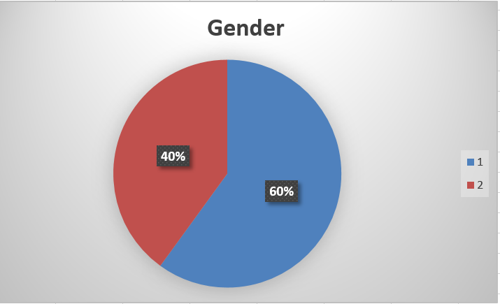
As per the data collected, there are 12 male and 8 female which has been take part to survey. The people has gone through ten suitable questions which is related through the impact of VLE due to COVID 19 and it has been shown that the male gender has the more interested to the learning technique.
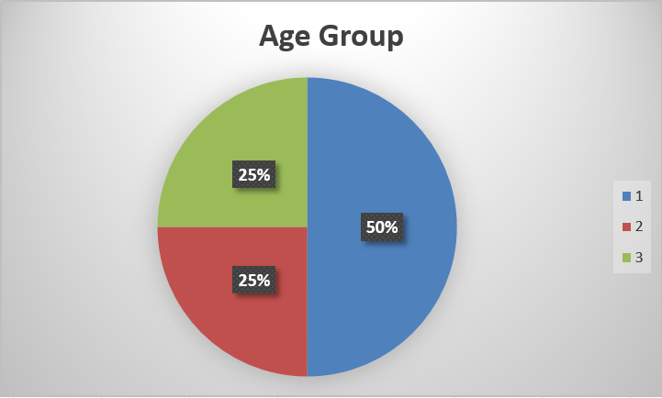
There are different age group people in the set of twenty people who has been participated in the survey method. These age group are more likely to involve in the virtual learning environment as per the survey report. Out of 20 participants 10 respondents belongs to 15-25, 5 participants belong to 25-35 age group and remaining are above 35.
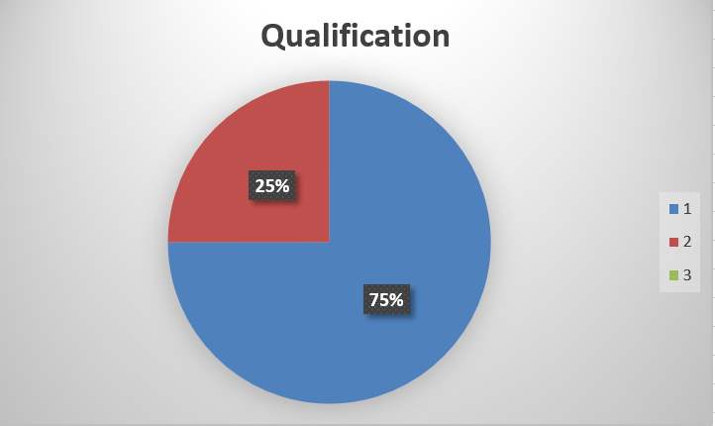
As per the data collected, the responded 15 people are doing masters as it is more involved in their daily schedule and remaining 5 belongs to Graduation. The VLE is affected most in the master’s level people as the peoples are more interested to enhance their skill, the report has been shown that.
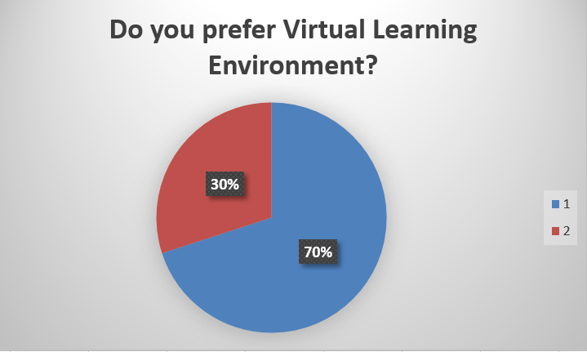
As for the responded, there are 14 people who prefer the virtual learning environment in this pandemic situation and remaining 6 said that they did not prefer Virtual learning environment. As VLE helps the education process easier and simpler, it helps to continue the education also in this pandemic. The VLE makes people self-motivated, it provides various courses to expand knowledge.
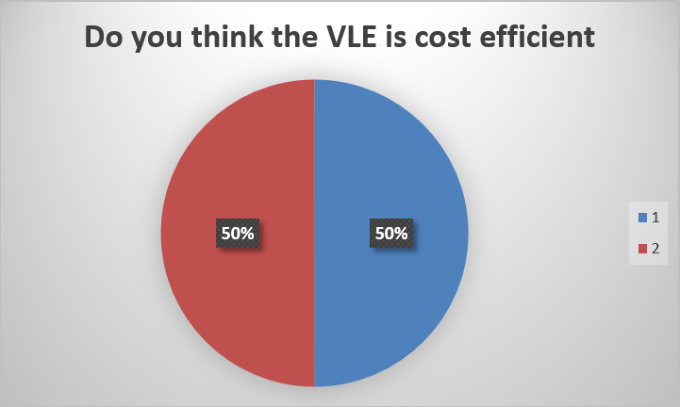
As per the respondent, it has been shown that there are maximum people who says no to this cost statement as virtual learning environment makes the students life easy by providing a specialized and advanced classes at cheapest rate. As per the data collected it has been evaluated that 10 people said that VLE is cost efficient and remaining 10 said that VLE is not cost efficient. It also helps them to connect with the top universities, it provides online transaction which makes easy payment.
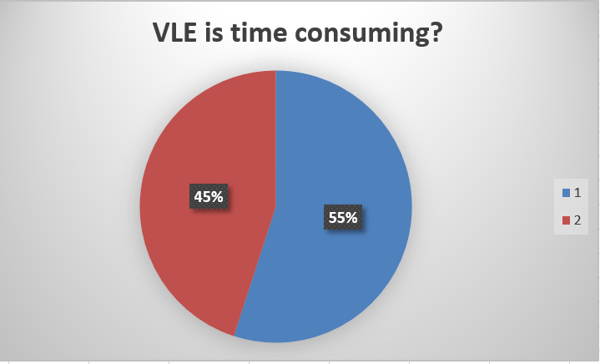
As per the data collected, it has been identified that there is minimum person who speaks about time consuming. 11 Out of 20 people said that virtual learning environment is time consuming and 9 people said that VLE is not time consuming. It requires more time to enhance skills and to connect with various courses.
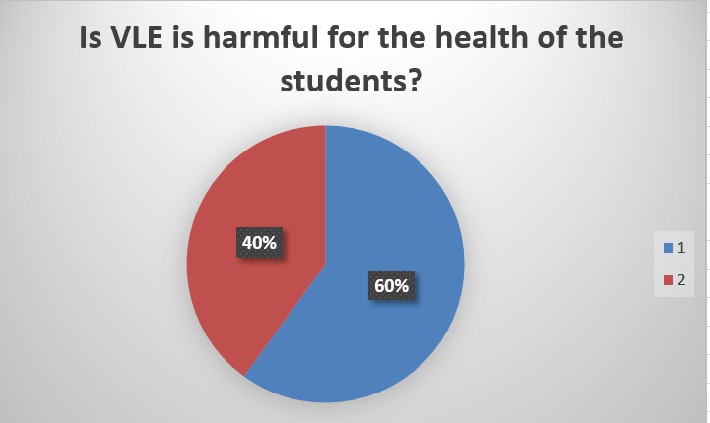
As per the data collected 12 people said that VLE is harmful for the user and 8 people said that virtual learning environment is not harmful for the health. As for the responded, the more involvement with the people and courses with the digital learning, it makes them lazy to walk outside which affects their physical and mental health.
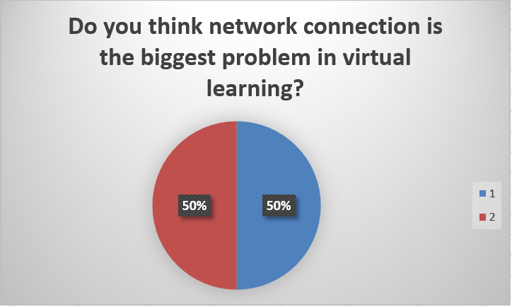
According to the data collected it has been identified that 10 people said that network is the biggest issue for VLE on the other hand 10 people said that network is not a big problem. As per the responded network connection becomes the biggest issue while attending the online classes, due to the poor connection sometimes it needs to shut down the system. The people has faced problem to continue the learning process as due to the poor network connection.
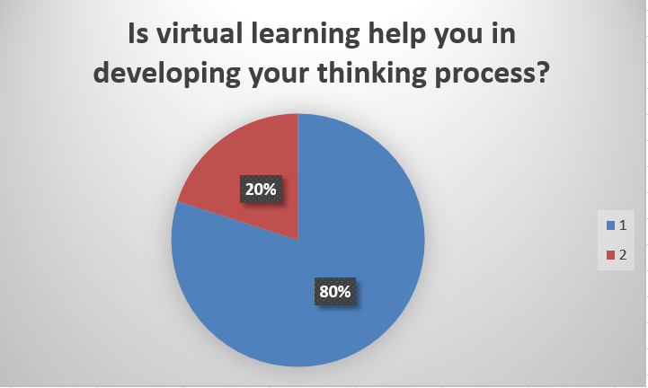
As per the respondent 16 people said that VLE help in developing the thinking process on the other hand 4 people said that VLE does not improve the thinking process. Maximum people say yes to the learning ability of the virtual learning environment. According to the people VLE helps them to connect with professors and helps to attend the classes. It provides various components to ensure the better learning experience which helps the people to enhance the thinking capacity.
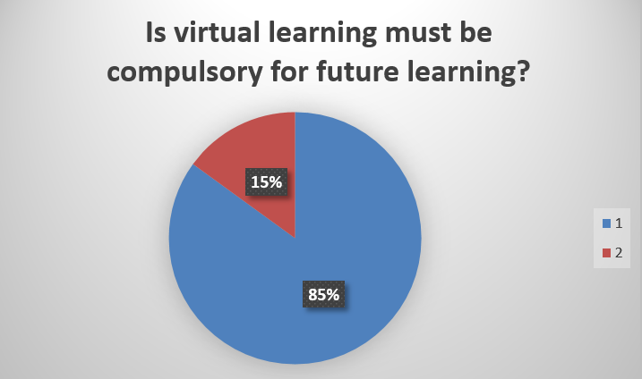
As per the data collected it has been concluded that virtual learning must has to be compulsory for future learning as it helps the student to learn in a specialized class. 17 out of 20 respondents said that virtual learning must be compulsory for future learning process on the other hand 3 respondents said that virtual learning must not there for future learning. It provides various online courses which helps them to enhance their learning skills and makes them advanced with this digital world, VLE helps the student to be self-motivated.

Conclusion
After going through the above section, it may conclude that the virtual learning environment is an online based field which helps the student to connect with the professors and keep continuing the education process. The VLE makes the system flexible and it helps the student to explore new approaches and ideas to become more skillful. It helps the people to be advanced in this digital world and helps to enhance their learning ability. VLE makes easy for the teacher to make notes and to manage the administrative works, the survey shows that there are maximum people who involves in virtual learning environment.

References
Gunawan, W., Prisca Kalensun, E. and NurulFajar, A., 2018, September. E-Learning through social media in the virtual learning environment. In Materials Science and Engineering Conference Series (Vol. 420, No. 1, p. 012110).
Hassan, S.U., Waheed, H., Aljohani, N.R., Ali, M., Ventura, S. and Herrera, F., 2019. Virtual learning environment to predict withdrawal by leveraging deep learning. International Journal of Intelligent Systems, 34(8), pp.1935-1952.
Larmuseau, C., Evens, M., Elen, J., Van Den Noortgate, W., Desmet, P. and Depaepe, F., 2018. The relationship between acceptance, actual Use of a virtual learning environment and performance: An ecological approach. Journal of Computers in Education, 5(1), pp.95-111.
Liew, T.W. and Tan, S.M., 2016, September. Virtual agents with personality: Adaptation of learner-agent personality in a virtual learning environment. In 2016 Eleventh International Conference on Digital Information Management (ICDIM) (pp. 157-162). IEEE.
Mosquera, L.H., 2017. IMPACT OF IMPLEMENTING A VIRTUAL LEARNING ENVIRONMENT (VLE) IN THE EFL CLASSROOM. Íkala: Revista de Lenguaje y Cultura, 22(3).
Odrekhivskyy, M., Pasichnyk, V., Rzheuskyi, A., Andrunyk, V., Nazaruk, M., Kunanets, O. and Tabachyshyn, D., 2019. Problems of the Intelligent Virtual Learning Environment Development. In MoMLeT (pp. 359-369).
Pererva, V., Lavrentieva, O., Lakomova, O., Zavalniuk, O. and Tolmachev, S., 2020. The technique of the use of Virtual Learning Environment in the process of organizing the future teachers' terminological work by specialty.
Vuopala, E., Hyvönen, P. and Järvelä, S., 2016. Interaction forms in successful collaborative learning in virtual learning environments. Active Learning in Higher Education, 17(1), pp.25-38.

Appendix
SURVEY QUESTIONS
Please tick the answer:
- What is your Gender?
- Male( )
- Female ( )
- Age group
- 15-25( )
- 25-35( )
- 35 above( )
- What is your qualification?
- Graduation
- Masters
- Do you prefer VLE?
- Yes ( )
- No ( )
5 Do you think the VLE is cost efficient?
- Yes ( )
- No ( )
6 VLE is time consuming?
- Yes ( )
- No ( )
7 Is VLE is harmful for the health of the students?
- Yes ( )
- No ( )
8 Do you think network connection is the biggest problem in virtual learning?
- Yes ( )
- No ( )
9 Is virtual learning help you in developing your thinking process?
- Yes ( )
- No ( )
10 Is virtual learning must be compulsory for future learning?
- Yes ( )
- No ( )

