Cultural Awareness
Student Name: Sufia Islam Munni
Student ID: 2015036
Module Title: Foreign Languages & Cultural Awareness
Module Code: BMIH5003
Lecturer: Rodrigo Fernandes Aguilera

Executive Summary
The hospitality industry is one of the fastest-growing industries at this time. The fast growth of this industry is because of the intellectual competency of the employees of these businesses. The industry serves consumers from different cultures, with different norms, and values. And intellectual competencies of employees help them to offer excellent services as they understand the necessity of learning different languages, norms, and values to communicate better.

This report analyses the variations between the cultures of France and America. The chosen hotel for this assignment is the Hilton hotel. Hofstede’s Cultural Dimension frame in the research analysis to understand the culture of both countries. This report analyses how Hilton Hotel employees in America can make their performance better in themselves and in France by finding the cultural differences. Different instances were given to know the cultural differences, sensitivity, proficiency, etc between France and America. Finally, a summary sheet is provided to help the hotel staff in both countries can enhance their capability.

Contents
Executive Summary 2
Introduction 4
Country A 4
Analysis of American culture 4
Country B 5
Analysis of French culture 6
Critical Analysis 7
Handbook 8
Conclusion 9
Reference 10
Appendices 12

Introduction
In the hospitality industry, intellectual competency is known as the capability of interacting with people from multicultural dimensions productively and adaptability according to different cultural contexts (Urbanek, 2017). This study uses Hofstede’s Cultural dimension framework to analyse the differences in the culture of the US and France. It investigates how hotel employees in the USA can balance the cultural balances of France. It also provides a summary sheet of cultural competencies to know the Do’s and Don’ts of each culture.

Country A
For this study, country A is the USA. And the chosen hotel is the Hilton hotel- Houston, 1600 Lamar St, Houston, TX 77010, United States (Hilton, 2022). This study will investigate American culture using the cultural dimension framework of Hofstede.

Analysis of American culture
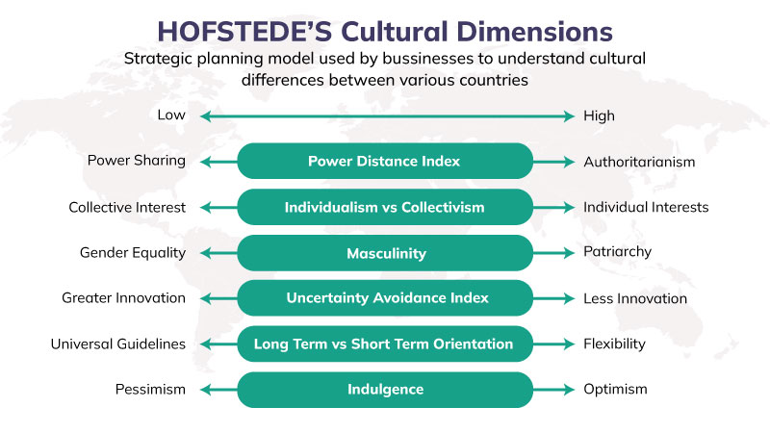
Figure: Hofstede’s Cultural Dimension Source: (S Tamer Cavusgil, Knight and Riesenberger, 2013)

Power distance- The power distance in the USA is low. So people of this country think everyone should be treated equally and their social economic status shouldn’t come in between, that’s why hotel personnel in the USA may serve all of its employees equally.
Individualism- America has a culture of believing in individualism. Thus, every employee focuses on their job and feels responsible for their part only. They don’t feel the necessity of building a relationship with the guests (Ruhet Genc, 2014).
Masculine- The country's culture is assumed to be masculine so the employees are highly competitive and they are focused on success.
Uncertainty Avoidance- The culture has strict guidelines to maintain the work and avoid uncertainty. They are less flexible in serving the guests.
Long term/short term orientation- America is a short-term-oriented country. They like to check new possibilities and are prone to change when they see new opportunities. Thus, hotel employees always make short-term goals to achieve (Halder, 2021).
Indulgence- This culture is indulgent. So, hotel guests want to spend their leisure time enjoying and the hotel services need to be adjusted for better entertainment.
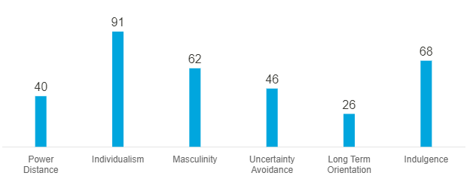
Figure: America’s cultural analysis Source: (Nain, 2018)

Country B
For this study, country B is France. The culture of the country will be analysed with Hofstede’s cultural dimension framework.

Analysis of French culture
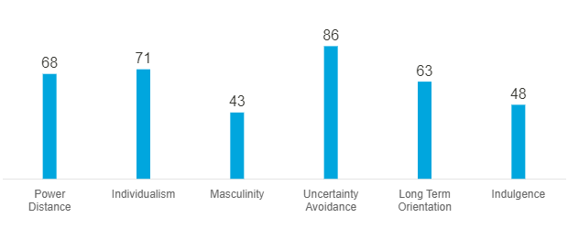
Figure: France’s cultural analysis Source: (Hofstede Insights, 2017)
Power distance- The power distance in France is very high, so socioeconomic status is very important there and people are treated according to their social status. Hotels treat people from different classes differently.
Collectivism- France is less individualist than America. So, guests may want the hotel employees to treat all the members of their group with proper care.
Masculinity- France is assumed to have a feminine culture. They would expect the hotel employees to be caring, understanding, and helpful (Kashyap, 2014).
Uncertainty avoidance- The uncertainty avoidance ratio of France is very high, which means the people of this country don’t like surprises. They need everything planned and structured, thus hotels should provide structured services.
Long-term orientation- France is a long-term-oriented country. They make plans for the future so they may want to have planned programs. And traditional services.
Indulgence- France is less-indulgent than America. They have a more flexible culture and want flexibility in work and leisure. Thus, hotels need to prepare their services according to the choice of the consumers (Weaver and Lawton, 2014).

Critical Analysis
From the analysis of the cultural dimensions of France and America, it can be seen that there are huge differences in both countries cultures. The power distance is very high in France compared to America. So, the guests appreciate when they are treated especially according to their social status. Thus, Holton hotel which focuses on treating all consumers equally may need to adjust themselves while treating French guests (Fan, 2021).
France and America both are individualist countries, thus Hilton needs to ensure that people are getting services according to their preferences and individual choices are needed to be respected.
Also, French people are more sensitive to their social and traditional norms and rituals. So, Hilton hotel management needs to pay close attention to the norms and rituals of their guest and be respectful toward them.
Moreover, as the French people don’t like anything sudden and want long-term plans, Hilton hotel needs to make plans for how to serve consumers in advance to avoid uncertainties.
The indulgence level is mid for French people, which shows they enjoy a less relaxed life and enjoy life less. So, the hotel may need to add appropriate hospitality training to its employees to ensure efficient services to the guest during their stay in America (Mensah, 2019).

Handbook
To ensure appropriate etiquette the hotel personnel of both countries needs an illustrated guideline:

Etiquettes |  | Do’s and Don’ts
Greetings | USA | - Offer firm handshake  - Use last names to address guests  - Avoid prolonged eye contact
Greetings | France | - Offer a handshake and say “Bonjour’’ to the guests  - Avoid overusing the Monsieur and madame.
Nonverbal-communication | USA | - Stand at least two feet apart during a conversation  - Avoid speaking too softly or too loudly
Nonverbal-communication | France | - Direct eye contact is a form of respect  - Avoid smiling too often
Attire | USA | - Wear formal clothes and a proper dress code  - Avoid having messy hair and being unhygienic (Savage, 2021).
Attire | France | - Wear formal clothes, suits, and ties for men  - Avoid wearing clothes that seem unsmart
Dining | USA | - Have foods that is left to yours and drinks that is right to yours.  - Avoid talking with a full mouth of food
Dining | France | - Meals should be planned prolonged  - Avoid serving slowly as they like to start eating together (The Guardian, 2014).
Others | USA | - Avoid staring too much  - Avoid making physical contact
Others | France | - Expect to hear ‘’No”  - Avoid having a quick and hasty conversation.

Conclusion
This study has analysed the differences in cultures between France and America. Hilton hotel was chosen to show the importance of intellectual competencies in the context of these countries. It has showed the differences in cultures of France and America in detail with Hofstede’s cultural dimension framework. It analysed how Hilton hotel America, can recognize the cultural differences between the two countries. Finally, a summary sheet was given for the hotel employees to understand the Do’s and Don’ts of both countries to help them increase their intellectual competency.

Reference
Fan, Q. (2021). An Analysis of Hofstede’s 5 Cultural Dimensions Functioning in Ren Zhengfei’s Intercultural Communication With BBC Reporter. [online] www.atlantis-press.com. doi:10.2991/assehr.k.210121.027.
Halder, S. (2021). THE MAJOR CHALLENGES THAT FACE THE HOSPITALITY AND TOURISM SECTORS AMIDST THE EXISTING PANDEMIC. [online] The Daily Guardian. Available at: https://thedailyguardian.com/the-major-challenges-that-face-the-hospitality-and-tourism-sectors-amidst-the-existing-pandemic/.
Hilton (2022). Hilton Americas-Houston Hotel - Downtown Houston. [online] Hilton. Available at: https://www.hilton.com/en/hotels/houcvhh-hilton-americas-houston/ [Accessed 8 Nov. 2022].
Hofstede Insights (2017). France - Hofstede Insights. [online] Hofstede Insights. Available at: https://www.hofstede-insights.com/country/france/.
Kashyap, G. (2014). Challenges faced by the Hotel Industry: a review of Indian Scenario. IOSR Journal of Business and Management, [online] 16(9), pp.69–73. doi:10.9790/487x-16916973.
Mensah, I. (2019). Environmental management concepts and practices for the hospitality industry. Newcastle-upon-Tyne: Cambridge Scholars Publisher.
Nain, A. (2018). (PDF) A Study on Major Challenges Faced by Hotel Industry Globally. [online] ResearchGate. Available at: https://www.researchgate.net/publication/327282314_A_Study_on_Major_Challenges_Faced_by_Hotel_Industry_Globally.
Ruhet Genc (2014). International Hotel and Restaurant Management. CreateSpace.
S Tamer Cavusgil, Knight, G.A. and Riesenberger, J.R. (2013). Framework for international business. Upper Saddle River, Nj: Prentice Hall.
Savage, M. (2021). Is cultural knowledge more important than language skills? [online] www.bbc.com. Available at: https://www.bbc.com/worklife/article/20180518-is-cultural-knowledge-more-important-than-language-skills.
The Guardian (2014). Cultural complexity: the etiquette of doing business abroad. [online] the Guardian. Available at: https://www.theguardian.com/small-business-network/2014/oct/27/cultural-etiquette-doing-business-abroad.
Urbanek, G. (2017). The Identification of a Company’s Competitive and Market Competency Gaps. Kidmore End: Academic Conferences International Limited.
Weaver, D.B. and Lawton, L. (2014). Tourism management. 5th ed. Milton, Qld.: Wiley.

Appendices
Figure: Hofstede’s Cultural Dimension
Figure: America’s cultural analysis
Figure: France’s cultural analysis

