3C003 Core Behaviours for People Professionals

Task 1 (AC 1.1)– Ethical practice paper

What are ethics and professional values?
“At its simplest, ethics is a system of moral principles. They affect how people make decisions and lead their lives. Ethics is concerned with what is good for individuals and society and is also described as moral philosophy”. (BBC 2014)
“Your professional values are the core ethics and values you uphold and demonstrate in the workplace. They can include actions, skills, and behaviours that many companies actively seek out and want to see in an employee”. (Kirova 2023)

Referring to the two definitions above I can see there is a great difference between what it ethical and what are professional values. The difference between valued and unvalued is straight forward and clear: is it important. The difference between ethical and unethical can be easily blurred, this is because it maybe an opinion or belief.
Depending on your own or the company values may have an influence on your ethical behaviour. The underlining rule here is trust……
Who remember the P&O staff redundancies, very poorly handled and highlighted loopholes within legislation resulted is a public outcry but was it illegal, no just unethical and unprofessional resulting in the public refusing to use their service.

I believe that 3 of the most important ethical behaviour includes “honesty, integrity, fairness” (Peek 2023) I must agree with Peek that these three behaviours reflect a People Professional’s role and need to consider them when faced with making unpopular decisions. This leads us nicely to the CIPD Profession Map, as people Practices, we focus on work, people, and professionalism.

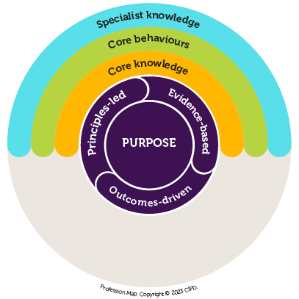
(CIPD 2023)
A professional map is a useful tool and may help when planning a task. A policy we wish to implement may look like the following:

Purpose: GDPR compliant (Policy under review)
Core knowledge: current legislation, (What we know)
Core behaviour: unified approach with policies (Our aim)
Specialist Knowledge: Compliant with any advice or updates our legal team advise. (what we gain)
If we can answer these then we know we are fair with our process.

(AC 1.2)
I have identified the Date protection Act (2018) along with the CIPD -Code of Conducts and Ethics 2023, the act ensures that we safeguard the personal information we collected and that we store the date following the Act’s requirement. The Code of conducts and ethics ensure that a person professional has at our heart:
Five key virtues:
Positive and active impact on working lives
Civic virtue and stewardship
Good character
Professional service and competence
Personal responsibility (Cheese2023)

The five virtues above will help us with our values and by following the act and valuing the code we should be compliant with both. This should result in there never being a breach and should we have an audit/inspection or a request of subject access then we would be honest, transparent and compliant.

(AC 2.1)

To ensure we demonstrate respect and an inclusive working environment we should when contributing views and opinions remain professional, calm and confident. Know who our audience is and adapting the information for relevance, providing latest facts and their sources and be prepared for different or conflicting or challenging opinions.
By doing this we can clarify problems or issues by reflecting on the facts/figures presented and their legitimacy, remembering we all have different values means that there may be different viewpoints leading to frustrations and voices completing. Again, remaining calm ensure you are in control redirect and rephrase to ensure the situation is being communicated effectively and reflect to ensure you fully understand the responses. This should ensure we are working effectively as part of a team, demonstrating values or empathy in each other’s characteristics, respect in learning styles and leadership qualities.

If we consider Tuckman’s 1965 theory on team building, he identified 5 stages:
Forming
Storming
Norming
Preforming
Adjourning

By recognising these stages, it can help us identify where our team is at or heading, we can identify strengths and weakness and the group can find or identify roles for individuals but referring to Bellan and Business cycle model we must identify that change is inevitable and should be prepared for.

We also need to identify the style of leadership we are under or presenting, are we getting the best from our group, can we adapt, change or compromise?
Tannenbaum and Schmidt identified a continuum model that help explain what kind of leader you maybe and where you focus may lie.
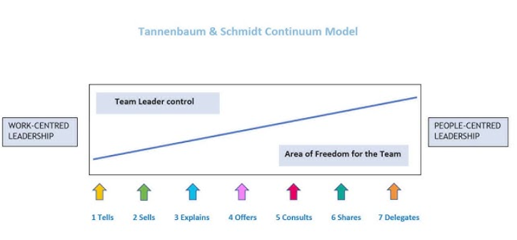
https://www.youtube.com/watch?app=desktop&v=gpe84HWFgFQ
Using the above theories and understanding what type of leader each member is may have a positive effect on the relationships, teaming up the members of Pioneers, Guardians, Drivers and Integrators may get the best out of the team.

(AC 2.2)
So, how do we know what legislation or values are the latest for us to comply to?
Having our CIPD membership provides me with access to the latest materials, via journals, website, newsletters training workshops and e-mails.
Using Linked in you can follow other businesses and HR professional who may share latest topics/updates. You Tube, Facebook, Twitter Ticktock are ways social media can share updates but with all public forums always check the reliability of the posts. ACAS Webinars
I have recently joined a South Wales HR Ninja group, we meet by monthly in various areas sharing experiences, systems information, practices and knowledge while using a Facebook message group where updates are posted and the groups are linked to other national HR Regional groups.
ACAS – using these forums, website, newsfeeds, they also provide workshops for training and networking, I have used these webinars due to their accessibility, reliability and follow up recordings.
Contracted legal team, they should be contacting you informing you of any new/change in legislation and recommending updates in policies.
Government websites, news, The Budget – this will give you an insight into proposed government /political changes, they usual provide a date you need to compliant with allowing companies time to prepare of changes.
All of these are no good if you don’t have a team who are driven to be ethical and value their profession. You must have a level of self-driven and a hunger to learn.

Task 2 – Professional Development Record (2.3)

Development record

NAME: | Clair George | MEMBERSHIP NUMBER: | 2116803
COVERING THE PERIOD FROM: | Feb 2022 | TO: | Sep 2023

Key dates | What did you do? | Why? | What did you learn from this? | How have/will you use this?  Any further action?
10/02/2022 | UTSD – CIPD Level 3 | To gain a recognised qualification in my field of work | How to prepare and present accurate information to stakeholders and peers, the importance of personal development | To maintain my CIPD membership and further my knowledge and skills
01/03/022 | Ceredigion County Council -  Lone Working | To enable me to be prepared when conducting home visits or off-site meetings. We work in a predominantly male environment and felt it would give me confidence in one-to-one situations. | Tips on safe practices, triggers, and disengaging techniques. How to read body language and to negotiate a safe exit should the need arise | The reading of body language is very useful, and I have used this in other situations. The tips are valuable by ensuring I never place myself at risk
02/11//2022 | ACAS - Investigations and Disciplinaries | A reputable company who will ensure a fair and unbiased process is in place | To keep an open mind, communication and recordings are accurate. We all have a level of  biased impressions and how not to act on them. | Essential and transferable skills, used often for all interview technique and record keeping.
10/01/2023 | Morgan LaRoche –  Managing Absence Webinar | To ensure our policies and compliant this the latest legislation, to see if the company can reduce sickness levels, to ensure we are referring people to the correct Occ Health system | Our sickness policy is compliant, and it is the most cost effective we can produce, The importance of how sickness is recording, sickness related accidents – RIDDOR reports timelines. How to identify fake fit for work notes. | We ensure the managers are keeping accurate recordings, completing RTW’s and ensuring staff complete their self certs. Linking sickness absence reasons into categories.
22/03/2023 | First Aid -Wales  Refresh Mental Health First Aid | To provide support of the unseen First Aid, to support staff returning to the office post Covid, to address stress and sickness levels to identify individuals how may be at risk. | Take the time to really talk and listen to people, not to take “I fine” for an answer, to ask direct questions and be prepared for uncomfortable answers or rejection. To admit when you’re out of your depth. | We offer “HR Surgeries” where staff can drop-in and request support, we identify if it work or personal related and what can be done to reduce the feelings, it is a service that is being monitored to ensure the support staff are also supported and not overwhelmed.
19/9/2023 | Alpha Academy - Online HR &Payroll Diploma | Part of my new duties evolve using a HR System to run payroll, and I wanted to ensure I have the necessary skills. | Legislation regarding Salery sacrifice, NI deductions, submitting P11d’s – Part time staff and Bank holiday calculations. | This has spiked my interest in payroll which has led me to look at further college courses regarding Payroll.

Reflection
I have never been what I would describe has a scholar, I rarely completed homework in school and find it very hard to just sit and produce work, so to choose to study is not something I feel compelled to do, saying that I have several qualifications and I have never failed at an exam or qualification. When I signed up to the CIPD qualification I thought it would be verifying my day-to-day work activities, I had several health setbacks, and it became a very difficult year leaving me to prioritise my family meaning I have found it hard to focus on the “wordy” assignments and reading materials. I write better from the heart rather than citing facts or figures. I recognise the importance of the qualification, but I avoid anything that takes my time from my family or leaves me along with my thoughts. I choose to develop myself during work time, so I enjoy webinars or training days where there are usually an exchange of ideas and instant feedback, and I am not left to second guess the work I produce.
This is why I feel I excelled at role play exercises, I really enjoyed the Mental Health First Aid, training and I found the lone working techniques were transferable skills which are also useful with disciplinary and investigations. They offered an insight into my own mental health requirements, and I can identify with the Imposter Syndrome thinking my shortcomings are going to be discovered any moment. This is part of the reason I signed up to the Alpha course, I have self-funded the course and I have not informed anyone that I have signed up, so I don’t feel the same pressure to succeed. This allows me to complete my CIPD and dip in and out the payroll course in a short space of time.
I have notice that our role needs to be continually updated due to changes in legislations and policies, it is difficult to prioritise our workload, each requested is delivered with urgency and I must decide what take priority, I decide this by the required outcome and possible consequences of a delay. When I receive a request, I always advise on a time scale so there is clarity, here our team is essential, our department has a good working relationship and support each other with our workload.
We use a Trello board so we can see each other’s tasks and expected time scale, our aim is to ensure our department is reliable thus we offer support when we can see deadlines approaching. This ensures that we are accountable for our tasks and regular department meetings allow us time to express any difficulties we may face and reflect on the pros or cons of each task. We have several KPI we are responsible for but as a team we offer support to ensure they are meet. We are actively encourage to undertake training and that is why I was determined to complete this qualification, I wanted to be able to relay that all our team have a CIPD qualification and are member of CIPD.

Reference

BBC - Ethics - Introduction to ethics: Ethics: a general introduction
(Cheese2023)
Code of Conduct and Ethics | CIPD
(CIPD2023)
https://www.cipd.org/en/the-people-profession/the-profession-map/explore-the-profession-map/

(KIROVA 2023)
Values. Institute - Last modified on February 26, 2023 Filed Under: Values, Workplace

(Sean Peek2023)
https://www.businessnewsdaily.com/9424-business-ethical-behavior.html

Reading List
People Management Magazine
Pioneers, Drivers, Integrators and Guardians
Harvard Business Review March-April 2017

Ethical practice and the role of people professionals (April 2022) Ethics at work; an employer’s guide

CIPD Continuing Professional Development CIPD – Reflective Practice
People Management – Life isn’t fair – but your workplace can be

People Practice: A Complete Guide. Waite,. et al (2021).

Martin, M and Whiting, F (2020) Human resource practice, 8th ed. London: CIPD Kogan Page

CIPD.(n.d) My CPD map. London Chartered Institute of Personnel and Development. Available at www.cipd.co.uk/learning/cpd/map

www.cipd.co.uk
www.gov.co.uk
www.lbsbm.co.uk

