
University Of Wales Trinity Saint David

Effective Teamworking for
Business Success



Module: Effective Team Working and Communication
Module Code: BMSW 4002
Studente: Keila Costa (2127935)
Contents
1. Introduction................................................................................................................... 3
2.Team/ Group.................................................................................................................. 4
2.1 Group benefits and disadvantages...........................................................................5
2.2 Team benefits and disadvantage..............................................................................5
3. Means to achieve effective teamwork.............................................................................5
4. Team development models…………………………………………………………............. 6
4.1. Tuckman………………………………………………………………………………….....6
4.1.1 Forming………………………………………………………………………………….…6
4.1.2 Storming…………………………………………………………………………………...6
4.1.3 Norming …………………………………………………………………………………...7
4.1.4 Performing………………………………………………………………………………….7
4.1.5 Adjourning…………………………………………………………………………………..7
5. Roles to create a cohesive and effective team................................................................. 8
5.1 Thinking Roles …………………………………………………………………………….…8
5.2 Action Roles…………………………………………………………………………………..9
5.3 People Roles ………………………………………………………………………………...9
Discussion………………………………………………………………………………….……….10
Advantages of effective teamworking………………………………………………………….…11
Barriers to effective teamworking………………………………………………………………....11
Conclusion………………………………………………………………………………………...…12
Reference List…………………………………………………………………………………….…13

Introduction

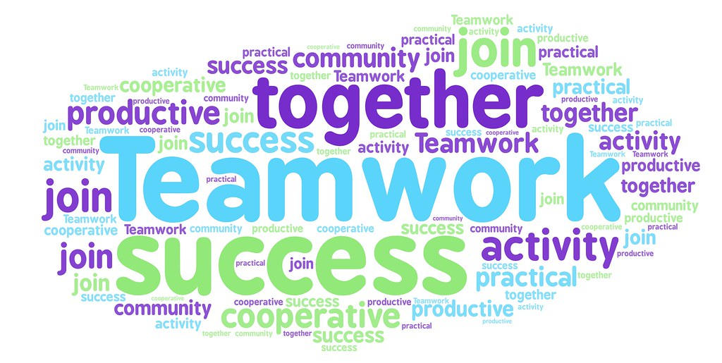

In this report we will discuss how effective teamwork can be for business, having as a starting point a group from Amazon company whose one of the managers is responsible for preparing a project to open three stores, however, the group is not work as a team. I will also explain what models we can use to achieve an effective work team and what are the advantages and barriers.
In this example we can see that there are team problems that make the work not progress. However, this type of problems can be solved using models that require effective teamwork. The use of these models is very important to improve teamwork and thus help them reach their final goal, which is a common goal.

2. Team/ Group



In the work environment, it is essential to create a pleasant work environment where they use a transparent communication so first of all it is important to define what is a group and what is a team, since both can be easily confused. Starting with what is a group, between a lot of definition, a group is a number of people with individual goals in which each professional is expected to deliver what is asked of him so in a group, members are independent and have individual responsibilities.
About a team we can say that a team is a number of people who work together to achieve the same goal like Morgan said “A team is a number of individuals working as one to achieve a particular goal to which they are mutually committed” (Morgan, 2017, p204). So we can say that each team is the sum of its parts, which means that team members depend on each other to achieve the result.

2.1 Group benefits and disadvantages :

One of the benefits of being part of a group is that groups are good at achieving individual efficiency because while teams seek to be efficient for the greater good, groups focus on individual efficiency. This can improve effectiveness in relation to individual work and larger group goals. And of course been part of a group can have some disadvantages like the fact that individuals tend to isolate themselves because they work separately, there is not much time left for the development of team spirit and that cause communication problems.

2.2 Team benefits and disadvantages:
Teams drive group productivity: While groups help with efficiency, teams have the edge in terms of productivity. That's because team members help each other at work and solve the overall problem, which makes the work itself more productive. However, there are also disadvantages in being part of a team, for example in a team they do not always pay attention to individual growth, there are exceptions, but some teams have difficulty promoting individual growth.

3. Means to achieve effective teamwork:
- Decisions must be made through dialogue between all team members.

- There must be trust so that everyone can express their ideas.

- Each individual must be special for the qualities that make him/her unique and this must be valued by the team.

- Each team member should know what their responsibilities are.

- There must be a team support.

- The team should do activities outside the work environment so that they can get to know each other better.

4. Team development models
For the Amazon team to be effective, its components (Mihaela and Spencer) must be able to work in harmony, collectively contributing to the results, which unfortunately is not happening because this energy may not happen automatically, but it develops as the team works together.
And in order to explain and better understand the team development process, we can use several models, such as Bruce Tuckman's team development model and the Wheelan Model.
4.1. Tuckman
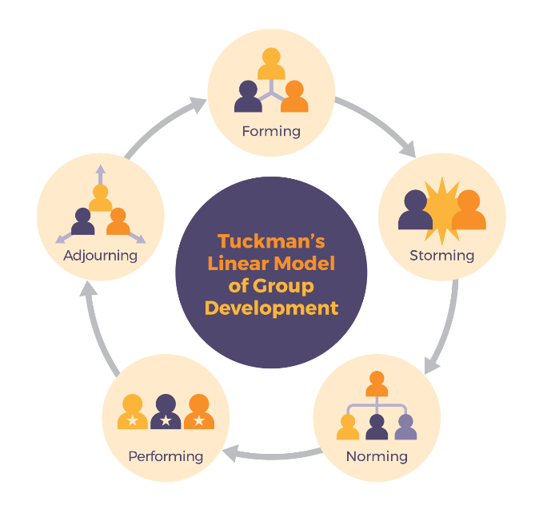

In 1965, educational psychologist Bruce Tuckman published a study describing the four-stage process of team development and behaviour: Forming, Storming, Norming, Performing and Adjourning.
4.1.1 Forming: This stage describes a period of mentoring and familiarization where uncertainty is high, and people look for leadership and authority.

4.1.2 Storming: This stage is marked by confrontation and competition as each member's personalities begin to emerge. Team members at this stage will try to establish themselves and secure their position in relation to their peers and the leader. In this way we can say that our Amazon team is at this stage.
4.1.3 Norming: If the Storming phase is successfully passed, the conflict between the members will be transformed into cohesion, which will give rise to a work environment in which each individual is aware of their role within the team. In this phase, the team starts to prioritize the collective objectives, leaving aside fights and private interests.

4.1.4 Performing: In this phase, we usually see a considerable increase in the performance of the team, since the trust of the team members has improved considerably and the number of conflicts is reduced. The workers feel comfortable in their role and the feeling that they belong to the group and the company also grows, that is, the stage of high performance has been reached.

4.1.5 Adjourning: In this phase, we usually see a considerable increase in the performance of the team, since the trust of the team members has improved considerably and the number of conflicts is reduced. The team members feel they comfortable in their role and begin to feel that they belong to the group and the company also grows, that is, the high performance stage has been reached.

4.2 Wheelan model

Another model that can also be used is the Wheelan model developed in 2016

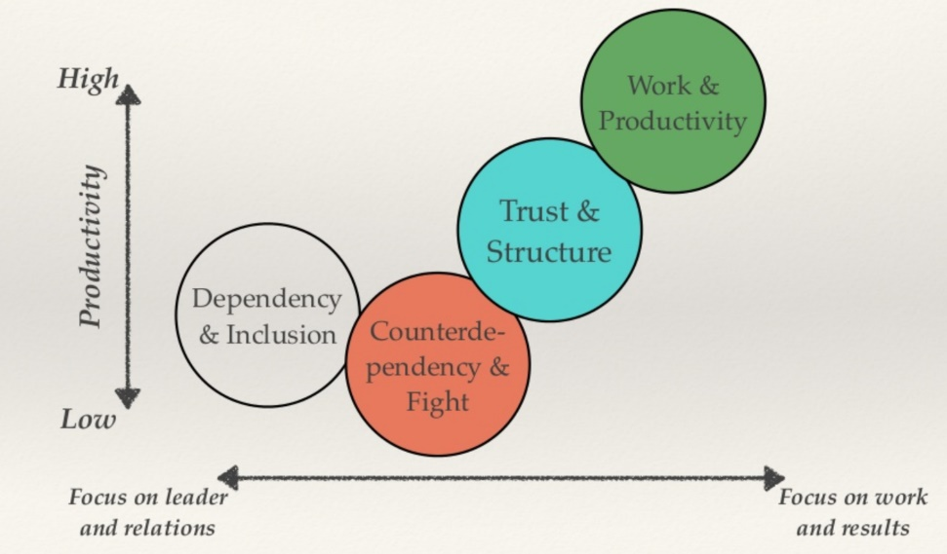

In my opinion, the Tuckman model is the most suitable to be used in our situation, as it is the one that most clearly presents all stages of the development of a team. Thus, the Amazon team is in the storming stage.
5. Roles to create a cohesive and effective team

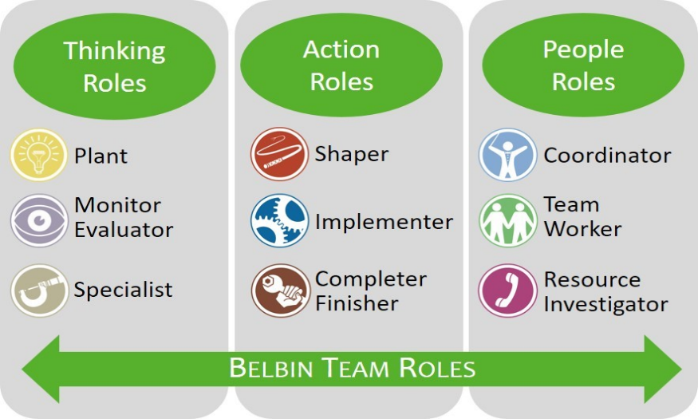

In order to create a successful team, it is important to take into account the characteristics of each individual on the team, such as their personality, motivations, mental abilities, experiences, but it is also important to take into account the work environment and role learning.
This is where we come in with Belbin's theory (1981), which argues that for the team to be successful needs a balance between characteristics/personalities and rules. There are 9 rules divided into 3 categories that will be presented below.
5.1 Thinking Roles
Plant is a very imaginative and intelligent person and is the one who finds it easier within the team to look for new approaches to the team's problems. This team member can sometimes be offensive in the way he criticizes the ideas of others and exposes his own ideas.
Monitor Evaluator is a person with a strong sense of analysis and is able to separate good ideas from bad ideas. He doesn't have much creative ability but he is an excellent critic.
Specialist this person is the team's expert. They are usually hired as consultants, that is, he is not part of the team permanently, which sometimes leads to conflicts with other team members.

5.2 Action Roles
Shapers are people who challenge the team to improve. They are dynamic and usually extroverted people who like to stimulate others and question norms.
Implementer is a practical and organized person he makes decisions manageable and defined tasks so that people can continue
Completer finisher is the somewhat pessimistic person who worries a lot about what could go wrong, checking every detail as a form of obsession and anxiety.

5.3 People Roles
Coordinator They are people who have a natural character to be leaders. These people are intelligent rather than brilliant, and according to each one's abilities they manage to create work roles in a way that focuses each one according to their best characteristics.
Team worker is a person who is aware of their needs and emotions within the team. He is a person who has the gift of communicating with others, he is a friendly person who is popular among everyone and who establishes a connection between all the elements of the team.
Resource Investigator He is an enthusiastic, friendly person who socializes with everyone. He brings information from the outside to the inside of the group and works very well on pressure helping the team not to lose contact with reality.

Discussion


We will unveil the secrets of successful groups according to Coyle's theory (2018),

Build Safety: According to Coley, in this first stage, we must use body language and eye contact in order to demonstrate that we are attentive to what is being said.
We must highlight our fallibility from the start and receiving bad news or feedback in a responsive manner.
Share Vulnerability: It is important to see that the leader is also someone who is vulnerable like others and who also has doubts. Negative news or negative feedback should be done privately so as not to embarrass the team member and create a safe environment.
Team members must feel that they are heard and respected.
Establish Purpose: It is important to know how to classify priorities so that the final objective can be successfully achieved. Priorities must be presented clearly with no room for doubt and must be presented in such a way that everyone has access to them in case they forget.

Advantages of effective teamworking:
Having an effective work team helps to reach the final objective within a friendly environment, without conflicts in which team members respect each other and are open to dialogue.
It is important to have a healthy work environment so that people work willingly, do not constantly feel that they want to leave the project and feel motivated to do more and more for the common good. In this case, the amazon team leader must promote dialogue between his team, he must listen to the members who cause conflict, try to understand their problems and thus find solutions so that they feel part of the team, however if that doesn't work, the manager you can always take those two team members and better choose the new members taking into account the emotions of the team and the emotions and character of the new members.

Barriers to effective teamworking:
As with everything in life, not everything is perfect and of course in this case it is no different. There are some barriers in creating an effective work group, as people are different, each with their own personality, which is sometimes difficult to reconcile.
Among other things, people have personal problems that can disrupt their performance at work and the way they interact with the team, which can lead to conflicts. In this way, the work of a manager is very difficult and may sometimes have to create new teams.
As I mentioned earlier, our Amazon boss will likely have to replace the two contentious members of his team.
An example of a unsuccessful team is when we have a work team where they don't agree with each other and thus never reach a conclusion which leads to them not reaching the end goal. If team members do not empathize with each other it will lead to conflict. A team that has a relationship that is beyond professional and that have bonds of friendship will more easily create a healthy work environment and will more easily reach their final goal.

Conclusion



In conclusion, for a group of people to be able to work as a team and achieve their common goal, it is very important that this group of people is very well chosen, taking into account the individual differences of each member, as this will influence the entire group. A group can be more effective when it has a greater variety of personalities, each member must be special for the qualities that set him apart from the others, and these qualities must add the team. The manager has an important role in bringing this team together and it is important that he knows how to create a safe environment for team members. The work of creating a team is not easy because there are several barriers such as the difference in personalities and the fact that each individual can be affected by problems outside the work and thus become a toxic member for the whole team, that's why models should be used to help create a team. In the example where the Amazon boss has two conflicting members we can see that this team was not well chosen and how toxic two members can become and destabilize an entire team. In this case I would recommend the manager to use Tuckman's model and discard these two disruptive members, thus making the team move out of the storm stage and progress towards success.

Reference List

Lee, G.V., 2009. From group to team. The Learning Professional, 30(5), p.44.
Miles, S.J. and Mangold, G., 2002. The impact of team leader performance on team member satisfaction: The subordinate’s perspective. Team Performance Management: An International Journal.
Cohen, P.R. and Levesque, H.J., 1991. Teamwork. Nous, 25(4), pp.487-512.
West, M.A., 2012. Effective teamwork: Practical lessons from organizational research. John Wiley & Sons.
Wagner, E.H., 2004. Effective teamwork and quality of care. Medical care, 42(11), pp.1037-1039.
Clements, D., Dault, M. and Priest, A., 2007. Effective teamwork in healthcare: research and reality. HealthcarePapers, 7, pp.26-34.
Bakheit, A.M.O., 1996. Effective teamwork in rehabilitation. International Journal of Rehabilitation Research, 19(4), pp.301-306.
Fisher, S.G., Hunter, T.A. and Macrosson, W.D.K., 1998. The structure of Belbin's team roles. Journal of occupational and organizational psychology, 71(3), pp.283-288.
Aritzeta, A., Swailes, S. and Senior, B., 2007. Belbin's team role model: Development, validity and applications for team building. Journal of Management Studies, 44(1), pp.96-118.
Orjonikidze, N. and Gogidze, M., 2015. The Advantages of “Teamwork” Approach during Personnel Management. Journal of Business, 4(1), pp.17-19.
Baybakova, I. and Hasko, O., 2019. The advantages of teamwork methodology in the esp discourse classroom. Наукові записки [Центральноукраїнського державного педагогічного університету імені Володимира Винниченка]. Серія: Філологічні науки, (175), pp.795-798.

