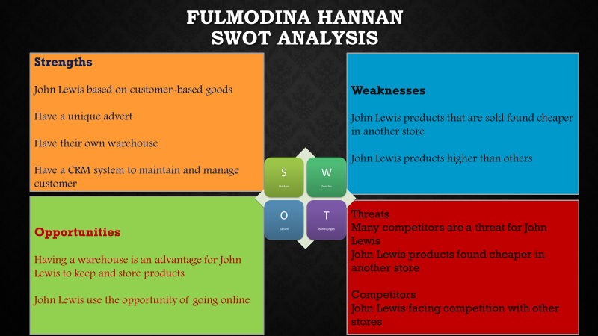

Customer Relationship Management System Team Presentation
Presentation speaker notes Task 6
SWOT Analysis of John Lewis
- Strengths
- John Lewis first strength is that it is based on its reputation for high-quality, customer-based goods. (Eley, 2019).
- John Lewis have a unique advert during Christmas time, which their competitors do not have, and this attract a lot more customers. (John Lewis Partnership. 2019)
- John Lewis have their own warehouse. (Adhikari, 2019)
- John Lewis has a CRM system which enables them to keep customers loyal and maintains customer engagement. (John Lewis Partnership Plc. 2016)

- Weaknesses
- Products that are sold in John Lewis are found cheaper elsewhere. (Rodionova, 2017 and Lewis, 2017)
- Products prices are higher than supermarkets and grocery stores which could restrict the target audiences. This is suggested by MBA Skool. (2019)

- Opportunities
- John Lewis Partnership. (2019) states that as John Lewis have their own warehouse, they can take advantage of this by buying the items now, storing them and then selling them at a higher price when the market options are up. As for the for customers john Lewis can offer discount to their loyal customers which customers can benefit from it too.
- John Lewis also use the opportunity of going online which will expand their business opportunities as it would cost less while also allowing the customer to shop whenever they want at their ease. As well as this, discounts could be offered a lot more. This is suggested by Hammett 2019, Riley 2016 and Rigby 2016.

- Threats
- Mustoe (2019) and MBA Skool. (2019) suggests that the several competitors are a threat for John Lewis as many are offering similar services and products and so customers will be more inclined to go to them. As well as this, other competitors may offer a John Lewis service but at a lower price.
- Clark (2018) states that cheaper products can be found elsewhere which means that John Lewis will price match their product in order to keep customers loyal. This means John Lewis loses out on profits.

- Competitors
According to MBA Skool. (2019) John Lewis is facing intense competition, with Tesco, Asda, Sainsbury's, Morrisons and Marks and Spencer dominating the industry as their primary rivals.

Conclusion
To conclude, the customer relationship management method is useful in managing and controlling the organization in order to enhance the business. According to John Lewis Partnership PLC. (2019) it helps John Lewis to stay connected with its customers and makes it easier to understand the target audiences. The CRM method also allowing John Lewis to track and keep record of individual customer data which can help improve market research and customer satisfaction. Through this, john Lewis is able to apply personalized discounts and promotions for customer loyalty.
As well as this through the CRM method, John Lewis are using online platforms to target a wider audience which is also adapted to suit the customer’s needs. According to John Lewis Partnership Plc. (2016) and Riley (2016) this is benefitting John Lewis as customers feel more inclined to stay with the organization as they are working with their needs. By adapting the CRM system John Lewis has been very successful in business as they have improved their awareness of customer needs and have understood the needs of customer commitment which is increasing the number of loyal customers as well as profits.
John Lewis Partnership plc (2016) noted that throughout the CRM method, John Lewis have been using the McKinsey 7-S framework which is a model that helps John Lewis to identify the skills needed to be seen in the organization. It focuses on the plan of the business and how to maintain a competitive advantage over its competitors. It is benefitting the company, as it is allowing employees to work better as a team and understand the needs of the business and customers.
Finally, we have conducted a swot analysis on the CRM method and have found the strengths, weaknesses, opportunities and threats on this method.

Reference
Adhikari, S. S. (2019), ‘John Lewis SWOT and PESTEL Analysis’, [Online] https://www.swotandpestle.com, Accessed Date 30th May 2019.
Blakeley, G. (2019), ‘The British high street crisis is due to debt, not Brexit’, [Online] https://www.newstatesman.com, Accessed Date 6th June 2019.
Clark, P. (2018), ‘How to bag a bargain from one of Britain's biggest high street retailers’, [Online] https://www.expertreviews.co.uk, Accessed Date 6th June 2019.
Eley, J. (2019), ‘John Lewis looks to play to its strengths’, [Online] https://www.ft.com, Accessed Date 30th May 2019.
Hammett, E. (2018), ‘At John Lewis, smartphones are now the most popular way to shop online’, [Online] https://www.marketingweek.com, Accessed Date 6th June 2019.
John Lewis Partnership Plc. (2016), ‘John Lewis Partnership plc Annual Report and Accounts 2016’, [Online] https://www.johnlewispartnership.co.uk, Accessed Date 6th June 2019.
John Lewis Partnership Plc. (2019), ‘Jobs in the Partnership’, [Online] https://www.johnlewispartnership.co.uk, Accessed Date 6th June 2019.
Lewis, M. (2017), ‘MSE investigation reveals John Lewis IS 'knowingly undersold', [Online] https://www.moneysavingexpert.com, Accessed Date 6th June 2019.
MBA Skool. (2019), ‘John Lewis SWOT Analysis, Competitors & USP’, [Online] https://www.mbaskool.com, Accessed Date 30th May 2019.
Mustoe, B. (2019), ‘Four reasons John Lewis is under pressure’, [Online] https://www.bbc.co.uk, Accessed Date 6th June 2019.
Rigby, C. (2016), ‘John Lewis sees fast growth online and via mobile – but Waitrose ecommerce sales are down’, [Online] https://internetretailing.net, Accessed Date 6th June 2019.
Riley, J. (2016), ‘John Lewis Reaps a High Return on Investment in E-commerce’, [Online] https://www.tutor2u.net, Accessed Date 6th June 2019.
Rodionova, Z. (2017), ‘John Lewis' 'Never Knowingly Undersold' policy criticised as it fails to drop prices’, [online] https://www.independent.co.uk, Accessed Date 6th June 2019.

