PLANNING AND DELIVERING AN INTERNATIONAL MEETING/EVENT
MODULE CODE: INTERNATIONAL MEETINGS MANAGEMENT
MODULE TITLE: BMIH6007
STUDENT NAME: Alina Neagu
STUDENT ID: 2121368

Introduction
This study navigates the preparation of a justifiable concentrated event named “Sustainable Haven” in cooperation with the hospitality sector. It draws attention to embodying “Green principles” as it turned out. The analysis describes the “operational aspects”, like place selection and event concern. Market factors assemble by identifying the principal prey audience and evaluating the competition. Conversely, financial factors judge the costs and income of arranging the MICE event. The study focuses on planning a “sustainable event” in hospitality, which is mentioned as “Sustainable Heaven”. It includes key areas, such as selecting Venus and gathering requirements. Market investigation describes the actual audience and competition. Financial considerations evaluate the “cost and revenues” of planning the events. The introduction also focuses on sustainability and hospitality, which is linked to hosting the MICE event. It additions different essential analyses, which are conducted to divulge internal and external elements that affect the event, on condition that a “comprehensive understanding of its dynamics.

The event cycle
The event cycle can be defined as the systematic method associated with planning, assembling, executing as well as assessing different events beginning from the area of inception to the final completion. There are different stages such as “pre-event planning, event execution, and finally evaluation” to understand the success and effectiveness of the entire event (Cerra et al. 2023). This provides a structured framework for better event organisation and developing areas of improvement and innovation.
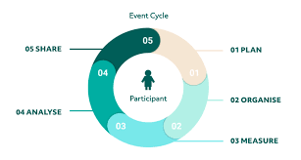
Figure 1: Event Cycle
(Source: Cerra et al. 2023)
“Sustainable Haven” is drawn plans of various aspects about making things eco-friendly in hotels and stuff. The purpose of them is that they want people to care more about the environment, at the time when they plan the hotel activities. The great idea is to build such a place where hotels are guided by the idea of being green. The event gives an idea, discusses, and works to give people a lesson to do things better.
The pre-event planning for this event includes understanding the objectives, audience, and theme while utilising the most required resources. For the event, trends must be viewed and sponsorships must be gained (Mair and Smith, 2022). In the domain of execution of the event, the preparations are made as determined in the planning phase and the execution of the same is done. Furthermore, the setting up of the venue and innovative presentations are done with the aid of the trained and experienced staff.
Finally, the post-event evaluation includes the evaluation of the success through gaining feedback from the participants. Based on the same, the factors, both internal and external in adding to the success are identified and assessed (Skeete et al. 2020). It also includes understanding attendee satisfaction levels by measuring the environmental footprints and analysing the initiatives implemented during the entire event.

Event concept
The event in question, “Sustainable Haven” is done to bring together the different stakeholders based in the hospitality sector to provide innovative solutions so that sustainability can be ensured. On arriving, delegates and guests were greeted with a reception with locally sourced refreshments and networking scopes (Cooper et al. 2021). The event will begin with an inspiring keynote with a renowned sustainability expert who conducted discussions and interactive sessions. Attendees will also be provided with the scope of engaging in workshops and panel discussions to develop different areas of sustainability in hospitality.
The different areas to be addressed include energy effectiveness, waste administration eco-friendly procurement, and recycling with the use of “green products”. Through the same, valuable insights and practical knowledge are provided so that sustainable operations can be brought about. After lunch again, the event with continue with attendees and guests coming up on stage to share and interchange ideas and develop partnerships. The event is to be concluded through celebrating achievements of commitments developed towards sustainability followed by a networking reception for developing contacts (Chersulich Tomino et al. 2020). Therefore, the event is one to develop and share dynamic and informative experiences that can aid attendees to become more successful in the area of hospitality domain to be more impactful.

Aim and objectives of the event
The event has been conducted keeping in mind different aims and objectives that are to be fulfilled effectively. These include different areas associated with the dynamic hospitality industry. Promotion of sustainability: one of the major aims associated with this event is to promote sustainability within the domain of hospitality through the depiction of innovative practices, to develop better collaboration as well as inspire actionable alterations among different industrial officials (Mzembe et al. 2020). The promotion and facilitation of knowledge exchange and learning scopes is another main objective associated with the main event. Through the different types of formats such as keynote presentations, panel discussions, and further workshops based on sustainability, better insights can be gathered on the same and proper strategies can be effectively developed for the integration of sustainability into daily hospitality activities. The SMART objectives are elucidated below:
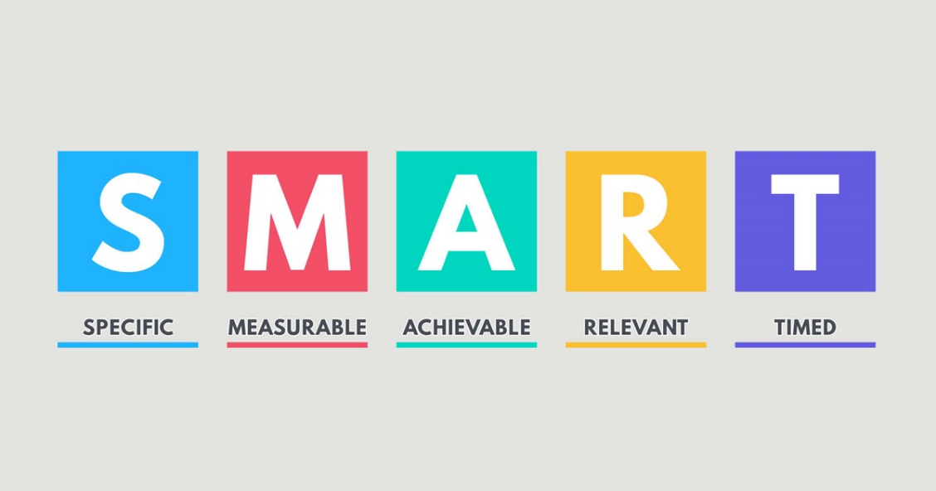
Figure 2: SMART objectives
(Source: Pereira et al. 2021)
Chances for better networking and collaboration with others: The event also functions with the aim of providing a platform where effective collaboration as well as networking can be conducted with others so that sustainable ideas can be promoted effectively among all. The people to be included here are event planners, NGOs, hoteliers, and other people. The event aims to provide better partnerships and alliances to achieve common sustainable goals (Pereira et al. 2021). It is specific as it targets event planners and NGOs to promote sustainability among all. It can be measured through the rate of success and number of developed partnerships. It is achieved through interactive workshops and sessions (Gutkevych and Haba, 2020). It is relevant as it aligns with the goals of developing sustainability. Finally, it can be achieved within 2 months.
Innovation Showcase: Another major aim associated with this event is to showcase and bring innovative solutions and technologies as well as initiatives that bring in better environmental sustainability within the mentioned sector. Through the event named “Sustainability Haven”, the aim is to provide sponsors with the scope to showcase different “Green” products and services so that brewer trends can be brought about and better benefits can be inculcated among everyone (Allen et al. 2022). It is specific as these are directed towards enhancing sustainability in the hospitality domain. It can be measured through the number of sponsorships gathered and can be stated as successful with obtaining at least 8 sponsorships. It can be achieved through discussions and presentations. It is relevant as it supports sustainability practices and brings innovation. Finally, it can be achieved within 2 months.

Event operations
To ensure that proper planning as well as execution of the event Sustainable Haven can be conducted effectively, different types of skills and resources will be needed to effectively include sustainability principles and develop a proper and effective event for everyone (Nani and Ali, 2020). These can be categorised into two different parts, namely the skills required for the staff to be more impactful and productive as well as the resources to be employed so that the event can be made a roaring success (Wang, 2022). These can be elucidated below as follows:
Skills for staff
Expertise in sustainable measures: the staff to be present at the mentioned event must possess a proper understanding of sustainable policies. These include proper knowledge in the areas of waste minimisation, energy protection, and responsible sourcing. These people must also be trained in the proper handling and care of green products and innovative technologies (Sönnichsen and Clement, 2020). Furthermore, these personnel must also be well aware of industry standards, and the best measures through which better sustainability can be brought about.
Competence in the administration of waste: Waste administration, as well as recycling, are other essential skills that must be possessed by such trained staff. These activities are considered crucial for the development of a circular economy. Through this, the development of waste can be mitigated and better optimisation of resources can be undertaken in the mentioned event (Aksoy et al. 2022). Therefore, the associated staff must be proficient in understanding the areas associated with waste generation and composting methods so that responsible disposal can be undertaken for resource reuse and recovery.
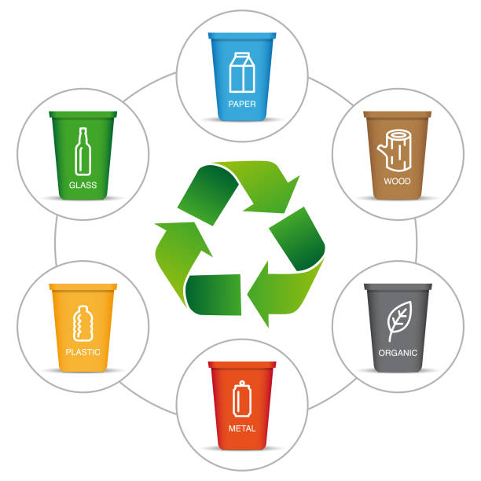
Figure 3: waste management
(Source: Aksoy et al. 2022)
Problem resolution: The event staff must also have an idea of problem-solving skills along with adaptability so that the uncertainty and other issues cropping up during the event can be eradicated. The ability of these people to think innovatively and according to the situation can ensure a better and consistent event movement from the beginning till the very end.
Resources required
Sustainable catering: Since the event is about sustainability, therefore, for the attendees, the catering must be locally sourced with ethically sourced and seasonal ingredients so that the food provisions can be aligned with sustainability and environmental footprints can be reduced.
Energy-effective lighting: The lighting fixtures and other such systems must also be used throughout the event so that greenhouse gases can be kept under control. It provides better sustainability and enhances the ambiance (Kumar et al. 2021).
Eco-friendly seating and parking facilities: Proper parking methods and provisions of bicycle areas and charging stations must be promoted while separate parking for carpoolers and other sustainable car users must be provided (TULSI and JI, 2020). In addition, eco-friendly seating methods and recyclable materials must also be effectively provided.
Waste management and biodegradable water provisions: There must also be proper waste management and disposal arrangements for different guests attending the event like recycling bins, composting areas, and signage. These will also provide resource recovery facilities and depict a better commitment to sustainability (Morgana-Orellana et al. 2023). Besides, having access to refillable and biodegradable water stations can ensure proper hydration in an eco-friendly manner.

Event budget
The event budget for the mentioned event depicts a comprehensive breakdown of income and expenditures, thereby stating the dynamics of the event. The main sources of income include registration fees for 500 attendees, with an association of gold, silver, and finally bronze sponsorships. Another essential source of the same includes exhibitor fees. Therefore, the total income gained through the event is about $135,000. These revenues are necessary since these cover the major expenses undertaken for arranging the mentioned event and ensuring financial viability. These provide the main funds to support logistics, along with programming and arranging sustainability initiatives as well.
On the other side, there are different areas of expenditures incurred for assembling and arranging the event and ensuring the smooth execution of the same. The venue itself has taken up a significant area of expense. It cost about $25000. The next huge expense is met in the sphere of sustainable catering to gain sustainable food options that are locally sourced and made available to all. It cost $20,000. Furthermore, additional expenses have been incurred in the sphere of hiring staff and attendants along with logistics. The inclusion of logistics, marketing, and miscellaneous expenses must also be included. All expenses together amount to $80,000. [Refer to appendix 1]
Based on the conducted budget, it has been viewed that the net income gained from subtracting the total expenses from the entire revenue obtained, the net income amounts to $55000. This is a surplus present and highlights the success gained in arranging and conducting the entire event. The positive income shows financial sustainability and also provides scope for future investments in similar initiatives so that better and more effective sustainability can be ensured among all (Seyitoğlu et al. 2023). Therefore, the event Sustainable Haven can promote better growth in the hospitality sector through the provision of positive change.

Industry trends and impacts
The recent trends in the event meeting associated with the hospitality industry reflect a developed emphasis on sustainability, the use of effective and innovative technology as well as experiential involvement (Salama and Abdelsalam, 2021). It is viewed that sustainable practices including eco-friendly venues and carbon-less events are gaining momentum in different sectors and that the hospitality sector is no different (Malheiro et al. 2020). These trends resonate with the objectives of “Sustainable Haven” which also is conducted so that innovative solutions and partnerships can be promoted so that the best practices and networking can be undertaken effectively.
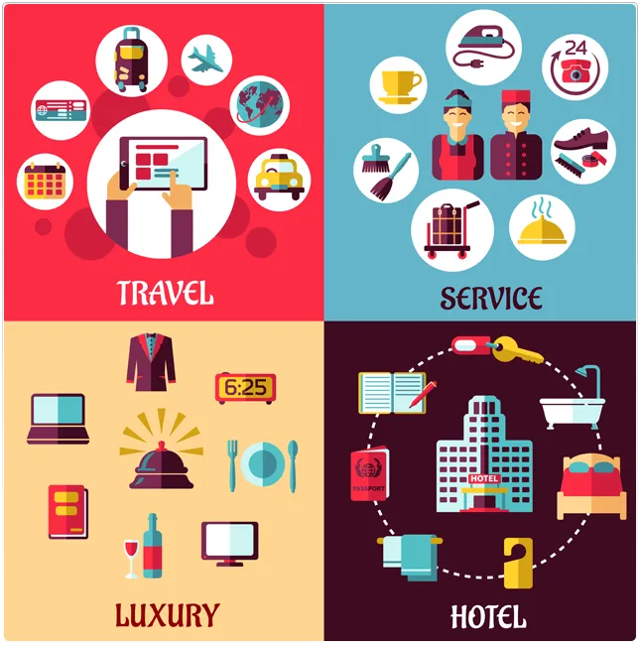
Figure 4: Hospitality Trends
(source: Floričić, 2020)
In addition, technology also plays an essential role in the development of experiences through the event. The interactive digital platform and the adoption of virtual and hybrid formats also state the development of interactive digital areas and data analytic tools (Bux and Amicarelli, 2023). The event itself leverages technology for the development of real and virtual networking opportunities and educational content to promote better trends.
Another essential trend explored through this event is experiential involvement and it focuses on the development of immersive and memorable experiences for different attendees. Experiments like workshops and interactive exhibits are explored to develop better connections among all.

Cultural and Situational Considerations
There are different cultural and situational considerations that play an essential role in the determination of the context and the impact of the event in discussion. Cultural diversity within the mentioned sector includes different norms, measures, and practices. These also influence the implementation of sustainable initiatives in a more impactful manner (Sharma et al. 2020). The consideration of such differences is crucial so that sustainable efforts can be made more inclusive and relevant across different parties (Gürlek and Koseoglu, 2021). In addition, situational factors including geographical locations, socioeconomic variants, and regulatory spheres also determine the success and effectiveness of sustainability events.
The main area of the venue in the heart of the city has better access to renewable sources and administration infrastructures. The availability of sustainable transportation options also depends on the same. The sustainable procurement of the same through locally sourced materials and others also promotes better sustainable initiatives and ensures better efforts directed towards that initiative (Ben Youssef and Ziqiri, 2022). These enable tailoring sustainability strategies to specific contexts to optimise impacts and decrease barriers to rising challenges. Through the addressing of all wider cultural and situational aspects, the event in question can highlight the relevance, involvement as well as effectiveness of the different communities and geographical areas (Osti and Goffi, 2021). Through this better inclusivity and cultural sensitivity can be upheld.

Conclusion
Based on the study, evidence has been gathered on the fact that Sustainable Haven is one of the major events that took place with the aim of catalysing positive alterations within the hospitality domain through the championing of sustainable principles and collaborations with all. Through a proper approach, innovative inclusion of solutions, strategic partnerships, and experimental engagement are viewed as the major domains to be discussed and understood to develop a new standard for eco-conscious event planning and execution.
It also aligns with industry trends and develops sustainability with technological integration and commitment to developing meaningful impacts for all. In addition, functional and situational considerations must be taken into question so that inclusivity, relevance, and effectiveness can be ensured across different communities and geographic locations. Furthermore, the study also delves into understanding the event cycle, concepts, objectives, and operations are studied. The budgets and trends gathered are also promoted effectively to gain a comprehensive understanding of the entire study.

References
Aksoy, L., Choi, S., Dogru, T., Keiningham, T., Lorenz, M., Rubin, D. and Tracey, J.B., 2022. Global trends in hospitality. Journal of Business Research, 142, pp.957-973.
Allen, J., Harris, R., Jago, L., Tantrai, A., Jonson, P. and D'Arcy, E., 2022. Festival and special event management. John Wiley & Sons.
Ben Youssef, A. and Zeqiri, A., 2022. Hospitality industry 4.0 and climate change. Circular Economy and Sustainability, 2(3), pp.1043-1063.
Bux, C. and Amicarelli, V., 2023. Circular economy and sustainable strategies in the hospitality industry: Current trends and empirical implications. Tourism and Hospitality Research, 23(4), pp.624-636.
Cerra, V., Fatás, A. and Saxena, S.C., 2023. Hysteresis and business cycles. Journal of Economic Literature, 61(1), pp.181-225.
Chersulich Tomino, A., Perić, M. and Wise, N., 2020. Assessing and considering the wider impacts of sport-tourism events: A research agenda review of sustainability and strategic planning elements. Sustainability, 12(11), p.4473.
Cooper, J.A. and Alderman, D.H., 2021. Cancelling March Madness exposes opportunities for a more sustainable sports tourism economy. In Global Tourism and COVID-19 (pp. 71-81). Routledge.
Floričić, T., 2020. Sustainable solutions in the hospitality industry and competitiveness context of “green hotels”. Civil Engineering Journal, 6(6), pp.1104-1113.
Gürlek, M. and Koseoglu, M.A., 2021. Green innovation research in the field of hospitality and tourism: The construct, antecedents, consequences, and future outlook. The Service Industries Journal, 41(11-12), pp.734-766.
Gutkevych, S. and Haba, M., 2020. Rural green tourism: Current trends and development prospects. Information & Media, 89, pp.116-133.
Kumar, S., Kumar, V. and Attri, K., 2021. Impact of artificial intelligence and service robots in tourism and hospitality sector: current use & future trends. Administrative Development: A Journal of HIPA, Shimla, 8, pp.59-83.
Mair, J. and Smith, A., 2022. Events and sustainability: Why making events more sustainable is not enough. In Events and sustainability (pp. 1-17). Routledge.
Malheiro, A., Sousa, B.B., Liberato, D. and Liberato, P., 2020, April. Sustainability in tourism and hospitality: Trends and challenges. In 35th IBIMA conference education excellence and innovation management: A 2025 vision to sustain economic development during global challenges (pp. 15545-15555). IBIMA.
Morgana-Orellana, M.Y., Picazo-Peral, P. and Moreno-Gil, S., 2023. Future Trends in Tourism and Hospitality Research.
Mzembe, A.N., Lindgreen, A., Idemudia, U. and Melissen, F., 2020. A club perspective of sustainability certification schemes in the tourism and hospitality industry. Journal of Sustainable Tourism, 28(9), pp.1332-1350.
Nani, D.A. and Ali, S., 2020. Determinants of Effective E-Procurement System: Empirical Evidence from Indonesian Local Governments. Jurnal Dinamika Akuntansi Dan Bisnis, 7(1), pp.33-50.
Osti, L. and Goffi, G., 2021. Lifestyle of health & sustainability: The hospitality sector's response to a new market segment. Journal of Hospitality and Tourism Management, 46, pp.360-363.
Pereira, V., Silva, G.M. and Dias, Á., 2021. Sustainability practices in hospitality: Case study of a luxury hotel in Arrábida Natural Park. Sustainability, 13(6), p.3164.
Salama, W. and Abdelsalam, E., 2021. Impact of hotel guests’ trends to recycle food waste to obtain bioenergy. Sustainability, 13(6), p.3094.
Seyitoğlu, F., Costa, C., Martins, M. and Malta, A.M., 2023. The future of tourism and hospitality labour: challenges, requirements, trends, skills and the impact of technology. Current Issues in Tourism, pp.1-15.
Sharma, T., Chen, J. and Liu, W.Y., 2020. Eco-innovation in hospitality research (1998-2018): a systematic review. International Journal of Contemporary Hospitality Management, 32(2), pp.913-933.
Skeete, J.P., Wells, P., Dong, X., Heidrich, O. and Harper, G., 2020. Beyond the EVent horizon: Battery waste, recycling, and sustainability in the United Kingdom electric vehicle transition. Energy Research & Social Science, 69, p.101581.
Sönnichsen, S.D. and Clement, J., 2020. Review of green and sustainable public procurement: Towards circular public procurement. Journal of cleaner production, 245, p.118901.
TULSI, P. and JI, Y., 2020. A conceptual approach to green human resource management and corporate environmental responsibility in the hospitality industry. Journal of Asian Finance, Economics and Business, 7(1), pp.195-203.
Wang, J., 2022. Building competitive advantage for hospitality companies: The roles of green innovation strategic orientation and green intellectual capital. International Journal of Hospitality Management, 102, p.103161.

