

BA Business Management

LCBB5004: Managing People

Name: Iulia Ramona Florescu
Student ID: 2233853

Table of Contents
Introduction 3
The role of technology in appraising the performance of remote workers 3
Performance measurement techniques for remote workers 6
Performance appraisal tools for remote workers 9
Conclusion 12

Introduction
Technology has facilitated improvement in all sectors, and in the wake of the recent Covid-19 pandemic, it has allowed workers to work remotely with convenience. As stated by Shirish, Chandra and Srivastava (2021), the role of technology in keeping things going when the whole world came to a standstill cannot be denied. An in-depth discussion regarding the same reveals that technology has been crucial in performance management of remote workers in various ways. One of the things that technology has facilitated seamlessly in a remote manner is by providing feedback. It gets hard for managers to track the efficiency of employees that are working remotely. The essay will mainly analyse the role of technology to appraise performance of remote workers, and it will define different performance measurement techniques for remote workers. Along this, it will also evaluate four different performance appraisal tools for remote workers.

The role of technology in appraising the performance of remote workers
Tools like Reflektive allow managers to provide feedback, manage and recognize employees and their efforts, while also assisting managers with guiding workforce development (Clement, 2020).
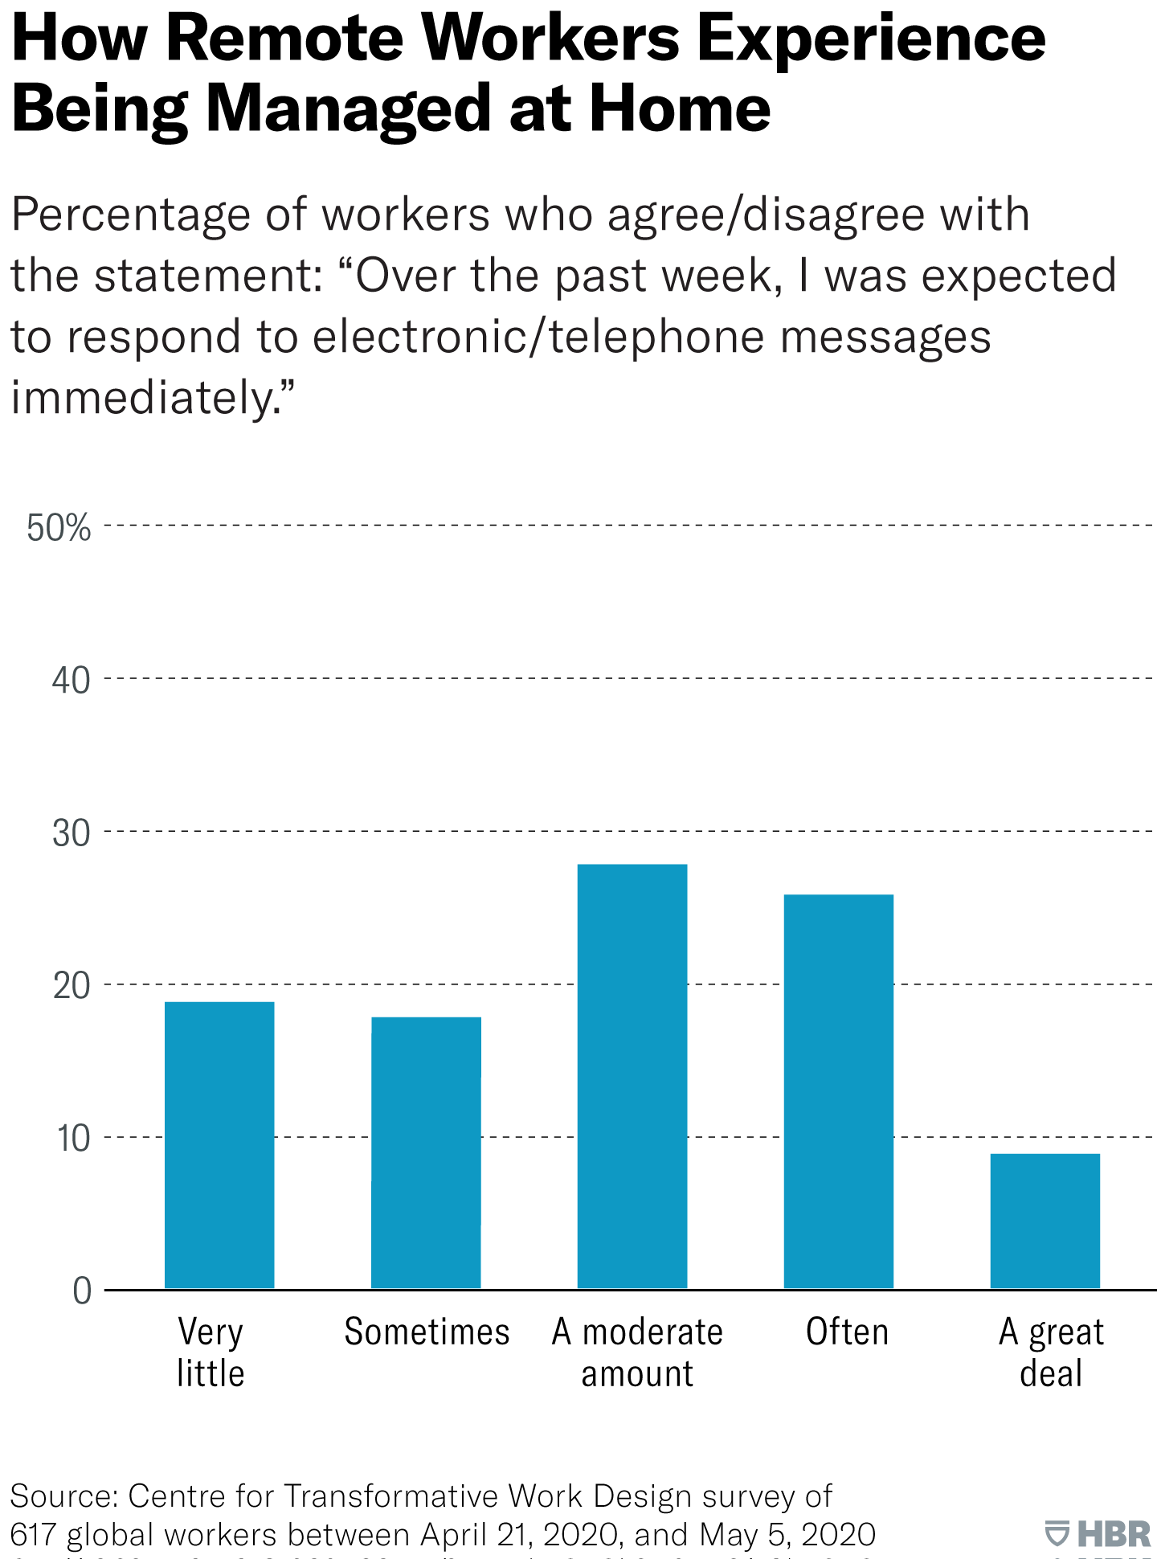
Figure 1: Percentage of employees that were expected to respond promptly throughout the day
(Source: Amico, 2021)
Technological advancements have fostered tools like AI and trainable models into existence, which can be involved in day-to-day work. The automation of processes with the help of such tools makes processes easier to execute, and more interactive. Adisa, Ogbonnaya and Adekoya (2023) have stated that technology allows managers to access data related to the performance of workers, which foster quantification of their efficiency, which in turn helps managers make data-driven decisions. Data-driven decisions are more accurate than the ones taken instinctively. Further, technological advancements allow remote and hybrid teams to collaborate with each other in a seamless fashion, which ensures better functional efficiency within organisations. Several technologies have the capacity of helping businesses deliver better, and constantly improving employee experience. In the opinion of Diab-Bahman and Al-Enzi (2020), technological tools aimed at improving employee experiences and organisational efficiency end up making a positive impact on the workplace culture, purpose, and mission within organisations, which helps improve the performance of remote workers. However, some threats that are related to cybersecurity, virtual desktop infrastructure limitations, and compliance make things more complicated, and must be accounted for by organisations.
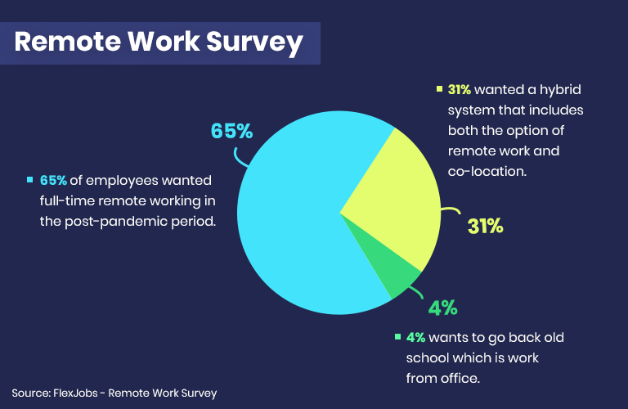
Figure 2: Benefits of Remote Work
(Source: Globalvincitore, 2021)
Moreover, technologies like Instant messaging applications, video chat applications, and cloud computing have also led to improved organisational functioning. Processes and communication of organisational data has been made easier with communication tools that allow employees to connect with others in a seamless fashion. From the article of Alam (2020), Cloud computing has allowed employees to collaborate, and facilitate instantaneous file sharing, which in turn affects the efficiency of employees positively. Technology has also been observed to encourage inclusivity and diversity in organisations, as it limits the chances of discrimination, and standardises operating procedures. Thus, an innovative use of technology allows streamlining of processes, and allows employees to carry out their tasks with relative ease, while enhancing the quantifiable nature of efforts. Further, Jiang, Siponen and Tsohou (2023) have suggested that higher involvement of technology directly translates to lower chances of error being made by individuals working for an organisation.

Performance measurement techniques for remote workers
Employee performance management such as KPIs and OKRs are not just mere terms to be touted in reports, but they can be used to track the productivity of employees as well. KPIs, a short form for Key Performance Indicators, while OKR is a short form of Objectives & Key Results help employers gauge the productivity of employees, and make sure that they are reaching their targets, and making decisions that align with the goals that have been set for them (Aslan et al., 2022). KPIs refers to metrics that are related to a job role, that act as signposts for an employee’s performance, and showcase how well they’re meeting performance expectations. Further, it can be stated that KPIs are quantifiable factors related to a job role and responsibilities that can be gauged on a scale to comprehend whether an employee is performing well, or not. The case of a telemarketer calling potential clients can be considered to gain an accurate understanding of KPIs. In this case, Aslan et al., (2022) opined that some of the KPIs that can act as signposts for the performance of this telemarketer can include the number of people contacted, the number of clients that have been converted, and average call duration. Whether the telemarketer is meeting the OKR’s set by the organisation, it can also help measure their performance.
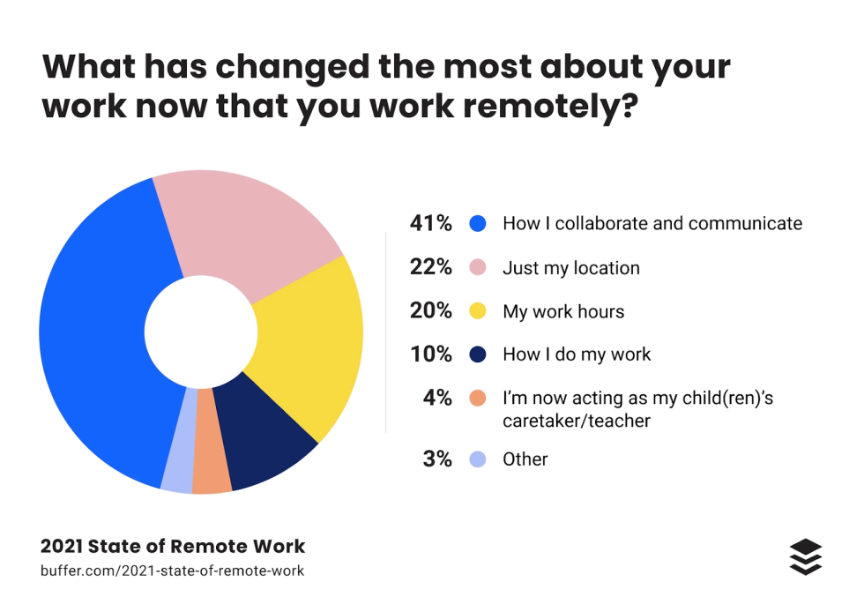
Figure 3: Changes in employees’ lives after working remotely
(Source: Norris, 2022)
Project management software has allowed the management professionals to handle different aspects of projects through platforms that bring together all business operations under a single umbrella. There are project management software of different kinds, and different strengths on the market. According to Puška et al. (2020), these tools allow management employees to facilitate the quantification of productivity without being too intrusive, while making it easier to track the progress on projects, and individual tasks as a whole. These tools allow managers to set goals for the employees that report them, and measure progress in real-time, while providing useful analytics that can help improve overall team efficiency.
In order to further enhance the productivity of employees, managers can set up internal feedback channels to obtain information regarding the performance of employees, and understand how remote employees utilise their day. Tools such as chat bots and AI can provide feedback to employees regarding their goals, skills, and general behaviours, while pointing out ways for them to improve the same. As opined by Puška et al. (2020), technological advancements can allow managers to gather data and analyse it to identify patterns of performance, and make data-driven decisions regarding allocation of tasks to employees, and appraising their efforts during appraisal cycles. Technical advancements, when used for the sourcing and analysis of feedback, can help identify the strong and weak points of employees as well, which can lead to more optimized use of workforce. Availability of the in-depth feedback regarding the performance of employees can also help the management decide which employees are suited for leadership roles, and how they can affect achievement of organisational goals.
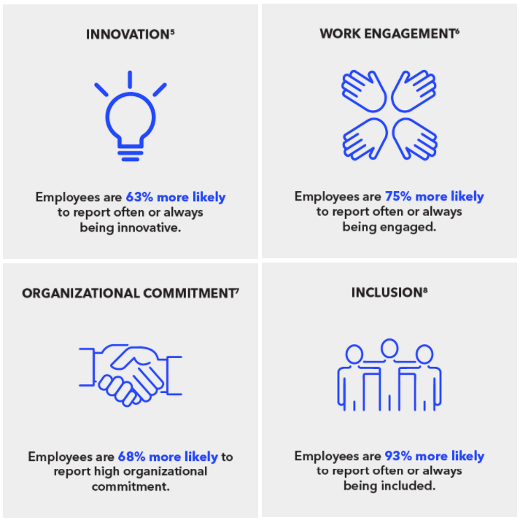
Figure 4: Statistics related to employees working remotely
(Source: Norris, 2022)
In order to keep track of the progress made by employees related to the tasks that have been assigned to them, managers tend to organise check-in meetings on a regular basis. These check-in meetings are not only exclusive to hybrid workers, or only employees working from office. It also allows employees that are working remotely to be included. Video calling platforms such as Zoom, Cisco Web Meetings, WebEx, and others allow managers and employees to connect virtually, discuss goals and progresses made by employees related to these goals. It has further been mentioned by Abiddin, Ibrahim and Abdul Aziz (2022) that these daily-stands in meetings facilitate better collaboration within teams, and improves communication within the organisation, which ends up enhancing organisational performance of employees. Moreover, sourcing regular updates from employees regarding their goals through instant messaging applications further increases the visibility among different members of the team. This, in turn fosters better organisational communication as well, leading to better measurement of employee performance.

Performance appraisal tools for remote workers
Several performance appraisal tools work for remote workers, and can help the management keep an account of the performance of employees. Some of the tools that can prove to come in handy to track remote workers include HR Automation tools, Self-assessment tools, performance metrics, recognition and rewards.
Tools such as Jira, SuccessFactors HR Tool, and other Employee Monitoring software can help track employee productivity and performance by keeping a track of their attendance, and time spent on projects. Self-service portals that are facilitated by HR Automation tools can help employees manoeuvre through processes such as on-boarding, evaluation of performance, and other services offered by the company to benefit employees can help improve employee performance as well. In the opinion of Mahdi et al. (2022), these tools also provide HR analytics that can help make informed decisions to facilitate efficient workforce management. Moreover, Core HR Systems allows the department to handle employee data, ensure accurate provision of payroll and benefits. HR Automation tools also ensure that all employees are compliant with organisational policies, as well as project requirements.
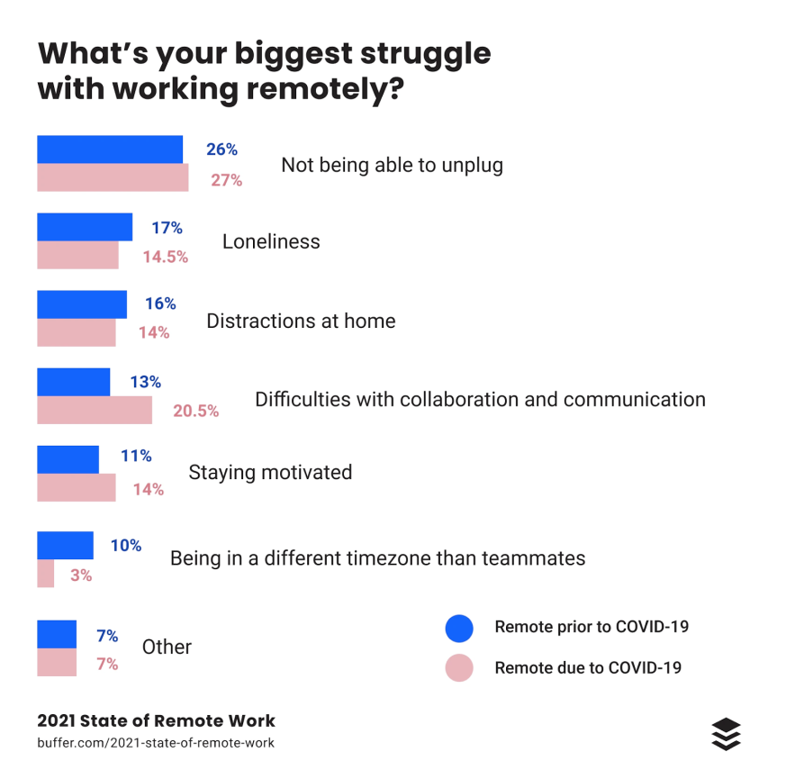
Figure 5: Struggles faced while working remotely
(Source: Norris, 2022)
Several self-assessment tools on the market can be used to help remote workers overcome blockers such as imposter syndrome, isolation, and unavailability of feedback. Remote working has changed organisational dynamics throughout the world, and it is only through execution of several innovative techniques that employees receive proper feedback regarding their performance, allowing them to make improvements. As opined by Aulicino et al. (2020), these self-assessment tools also allow employees to identify their weak points that can be targeted for improvement. Further, career development and progress can be facilitated, as these tools allow employees to understand how they have developed knowledge and certain skills in the workplace. Documentation of achievements and progress is also made feasible, as it makes it easier to rate employee during appraisal cycles for promotions, and appraisals in general. Some career-assessment tools that can be accessed by employees are the Myers-Briggs Type Indicator (MBTI), Short Interest Inventory (SII), Career Value Scales (CVS), and CliftonStrengths Assessment (Aulicino et al., 2020). Some skill tests that can be taken regularly, in order to comprehend improvements made by an employee are Cognitive ability tests, behavioural tests, sales skills tests, and marketing skills tests. It is important for the employees to be aware of their proficiency in all domains, so that they can identify weak links that need improvement.
Performance management tools such as Trakstar, BambooHR, Primalogik, and Lattice can help employees attain accurate and ample feedback regarding their performance instantaneously. Puška et al. (2020) has further suggested that these tools facilitate integrated HR management, connect different stages of an employee lifecycle and collect 360-degree feedback, and analyse it later. It is thus important for organisations to enable performance management tools for employees to be aware of their contributions to the project, and keep a track of their progress over the period of their employment. As per Shirish, Chandra and Srivastava (2021), these tools need to be easy to comprehend, and must provide information that is easy to understand as well. In other words, performance management tools allow managers to keep track of the KPIs of different individuals, which lead to better Human Resource management. Several tools keep an accurate track of the activities of remote employees, while making notes of the time spent by the employee on different tools. This leads to better monitoring of employee activity, and identification of tools that are frequently used by employees. Identification of these tools can lead to subsequent enhancements, or introduction of better alternatives that lead to better overall organisational efficiency.
ERPs also tie-in difference aspects of a business under a single umbrella, as they are capable of brining data related to diverse business domains such as sales, production, and marketing. This data gathered by the platform allows management professionals to quantify the improvement within employee efficiency, while pointing out areas that need improvement. In the opinion of Adisa, Ogbonnaya and Adekoya (2023), ERPs can lead to the recognition of departments and individuals performing exceptionally. The recognition of such employees and provision of benefits to employees that have been performing exceptionally can lead to better motivation and drive within employees to meet organisational goals. Thus, ERP tools can be used for performance appraisal of remote workers.

Conclusion
It can therefore be concluded from this essay that the remote working situation has changed how work is done in organisations. It is vital for the performance of remote workers to be appraised properly, in order to provide them with enough motivation and drive to perform well. However, it has also been observed that with changing organisational dynamics, new techniques and tools have emerged that can help managers appraise the performance of remote employees. Organisations must explore these possibilities so that they can be utilised in order to improve employee and overall organisational efficiency.

References
Abiddin, N.Z., Ibrahim, I. and Abdul Aziz, S.A., (2022). A literature review of work from home phenomenon during COVID-19 toward employees’ performance and quality of life in Malaysia and Indonesia. Frontiers in psychology, 13, p.819860. Available at: https://www.frontiersin.org/articles/10.3389/fpsyg.2022.819860/pdf
Adisa, T.A., Ogbonnaya, C. and Adekoya, O.D., (2023). Remote working and employee engagement: a qualitative study of British workers during the pandemic. Information Technology & People, 36(5), pp.1835-1850. Available at: https://repository.uel.ac.uk/download/f8f474e0eca42c17d9f43a8381175b6a3f629ab261f2d5b7812076b2d38a3d2f/291476/ITP-Accepted%20Version.pdf
Alam, T., (2020). Cloud Computing and its role in the Information Technology. IAIC Transactions on Sustainable Digital Innovation (ITSDI), 1(2), pp.108-115. Available at: https://aptikom-journal.id/index.php/itsdi/article/download/103/70
Amico, L. (2021). The Realities of Remote Work. [online] Harvard Business Review. Available at: https://hbr.org/2021/10/the-realities-of-remote-work.
Aslan, M., Yaman, F., Aksu, A. and Güngör, H., (2022). Task performance and job satisfaction under the effect of remote working: Call center evidence. Economics & Sociology. Available at: https://acikerisim.gelisim.edu.tr/xmlui/bitstream/handle/11363/5724/18I_1239_Aslan%20et%20al.pdf?sequence=1&isAllowed=y
Clement, M. (2020). 5 Remote Work Project Management Challenges and How to Fix Them. [online] Thrive Global. Available at: https://community.thriveglobal.com/5-remote-work-project-management-challenges-and-how-to-fix-them/#:~:text=In%20all%20remote%20work%20undertakings%2C%20technology%20plays[Accessed 16 Apr. 2024].
Diab-Bahman, R. and Al-Enzi, A., (2020). The impact of COVID-19 pandemic on conventional work settings. International Journal of Sociology and Social Policy, 40(9/10), pp.909-927. Available at:
Globalvincitore (2021). Remote vs Office Work: The Impact of Workspace on Performance. [online] Global Vincitore. Available at: https://www.globalvincitore.com/remote-vs-the-office-the-impact-of-workspace-on-performance/.
Jiang, H., Siponen, M. and Tsohou, A., (2023). Personal use of technology at work: a literature review and a theoretical model for understanding how it affects employee job performance. European Journal of Information Systems, 32(2), pp.331-345. Available at: https://www.tandfonline.com/doi/pdf/10.1080/0960085X.2021.1963193
Mohamed, S.A., Mahmoud, M.A., Mahdi, M.N. and Mostafa, S.A., (2022). Improving efficiency and effectiveness of robotic process automation in human resource management. Sustainability, 14(7), p.3920. Available at: https://www.mdpi.com/2071-1050/14/7/3920/pdf
Moretti, A., Menna, F., Aulicino, M., Paoletta, M., Liguori, S. and Iolascon, G., (2020). Characterization of home working population during COVID-19 emergency: a cross-sectional analysis. International journal of environmental research and public health, 17(17), p.6284. Available at: https://www.mdpi.com/1660-4601/17/17/6284/pdf
Norris, P. (2022). 5 KPIs to boost your team’s work from home productivity | Together Mentoring Software. [online] www.togetherplatform.com. Available at: https://www.togetherplatform.com/blog/5-kpis-to-boost-your-teams-work-from-home-productivity[Accessed 16 Apr. 2024].
Puška, A., Stojanović, I., Maksimović, A. and Osmanović, N., (2020). Project management software evaluation by using the measurement of alternatives and ranking according to compromise solution (MARCOS) method. Operational Research in Engineering Sciences: Theory and Applications, 3(1), pp.89-102. Available at: https://d1wqtxts1xzle7.cloudfront.net/101676256/38-libre.pdf?1682896408=&response-content-disposition=inline%3B+filename%3DProject_Management_Software_Evaluation_b.pdf&Expires=1713269231&Signature=bKUpYD3IMBplQx7I9N~rhUmZqXIUP6Rn5uyoVwoA1nYtN6jUeuYvgXmy3AUwbgeUt4gxSbFIGOABQtfXJfKjpnNTgypj~ibtae-LTuaxa4FLg7gVr5RPeHaOI8PFQk5I2gPKMEfh8iAC1eVpsNiQuE-iimfQ01~PMHAXa4vIId~nz29fM3oZBhHXPnrMyQXIgdGm1l3XH2EvKESHHgmXk4H05jGXn6eL1DJ5OXwy-N62DOuAYx4BxBTJiM9U8pQy615fhh6VQltdgxIF4jXqvw-t0tPDc89uVSs4dfFVROQO0fzdw9uKNosTEqv8ckfRr9Z8qQ9-YhDmS2WZneaFFQ__&Key-Pair-Id=APKAJLOHF5GGSLRBV4ZA
Shirish, A., Chandra, S. and Srivastava, S.C., (2021). Switching to online learning during COVID-19: Theorizing the role of IT mindfulness and techno eustress for facilitating productivity and creativity in student learning. International Journal of Information Management, 61, p.102394. Available at: https://www.sciencedirect.com/science/article/abs/pii/S0268401221000876

