Everyday Life in Athens and Rome (HPHP4020)
Political and social values in Roman portraiture

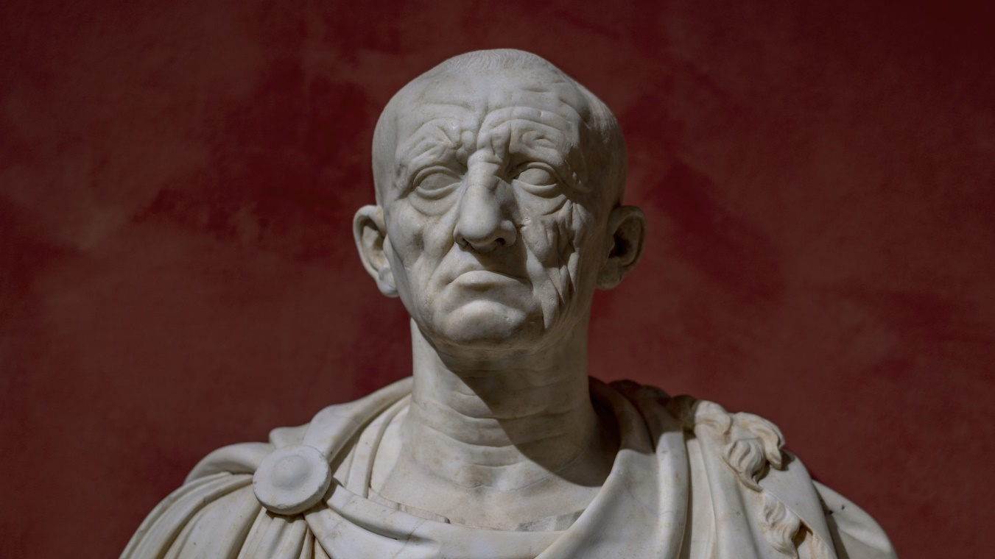

In this workshop we will examine Roman portrait statues and busts. These images were often used to convey ideals and qualities that were not necessarily based on a youthful aesthetic ideal but reflected important political and social values. In particular, we will look at some veristic style portraits which become popular in the late second century BC and continued into the Imperial period, as well as the classicising style adopted by Augustus. Have a look at the images set out on the following pages, and while doing so, think about the questions set below. For anyone who wish to follow this topic up at a later point, I have suggested some modern scholarship.

Questions:
- What would you want yourself to look like in a painting or portrait that was being produced for you?
  - Would you want it to be realistic?
  - Would you want it to put yourself in the best possible light?
  - Would you want anything to be exaggerated?
  - How much would the context or purposes of the image affect your choices?
- What is your reaction to the veristic style Roman portraits?
  - Do you find the images particularly appealing?
  - Would you personally wish for yourself to be represented in this way?
  - Why do you think many elite Romans chose to be represented in this way – what qualities may they have been trying to emphasis?
  - If you do happen to have some familiarity with the political context of the mid-late Republic, how do you think these portraits feed / or were influenced by this context?
- What might Pompey have been trying to achieve (if this image is in fact of him) on the Glyptotek bust?
  - Do you find it artistically coherent?
  - Can the image still be seen as versitic?
- Why do you think Augustus chose to move away from verism and adopt the Augustan “Classicising” style?
  - What underlying social and political context may have influenced this change?
  - What practical and propagandist purposes may have been served by adopting a consistent Classicising style?
  - Who is Augustus accompanied by on the Prima Porta statue, what is the significance?
  - What is the importance of the symbolism of Augustus armour on the Prima Porta statue?
- Does the bust of Livia look distinct to you in any particular way?
  - How might the social and political position of women in Rome have affected the style of portraits that were produced?
- What is your reaction to the statue of Claudius and do you find anything particularly odd?
  - Might different parts of the statue be conveying different qualities?
  - What reason may Claudius have had from moving away from the Classicising style?

Modern Scholarship (optional):
Smith, R. R. R. 1981: ‘Greeks, Foreigners and Roman Republican Portraits’, JRS 71: 24-38.
Richter, G. M. A. 1955: ‘The Origins of Verism in Roman Portraits’, JRS 45: 39-56.

Roman Veristic Art
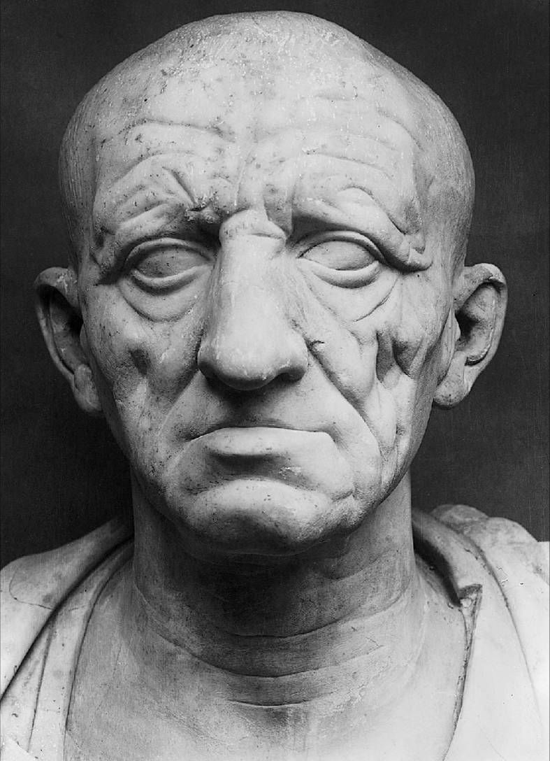

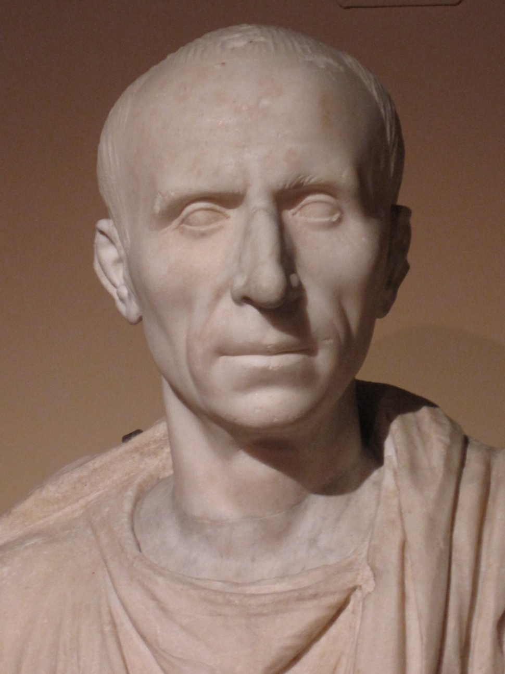
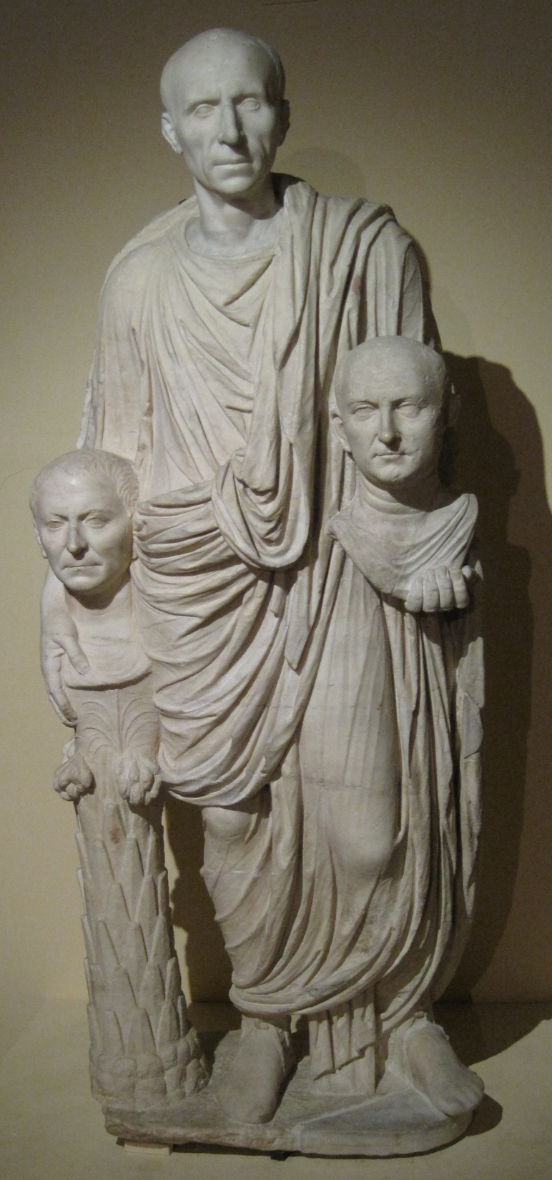

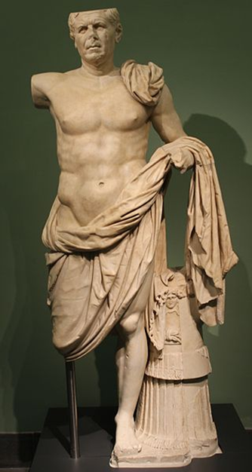
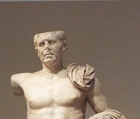

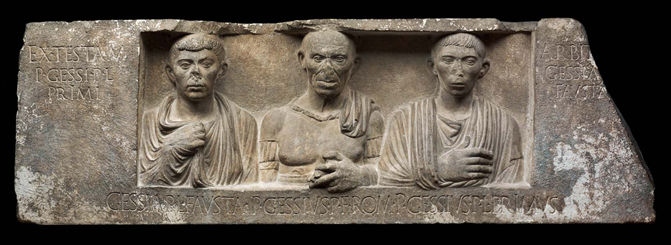
Veristic style among liberti
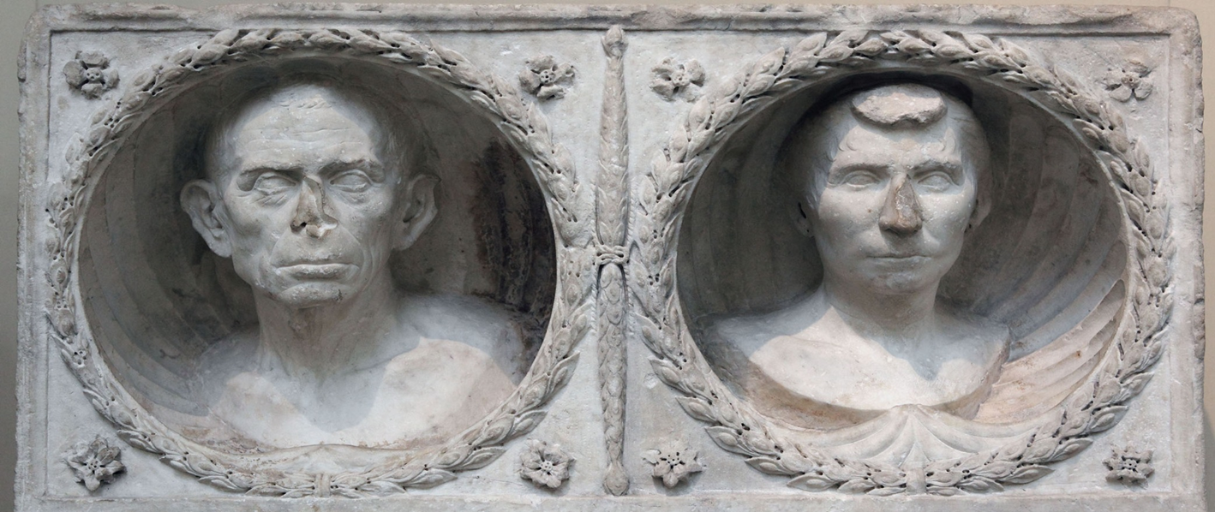
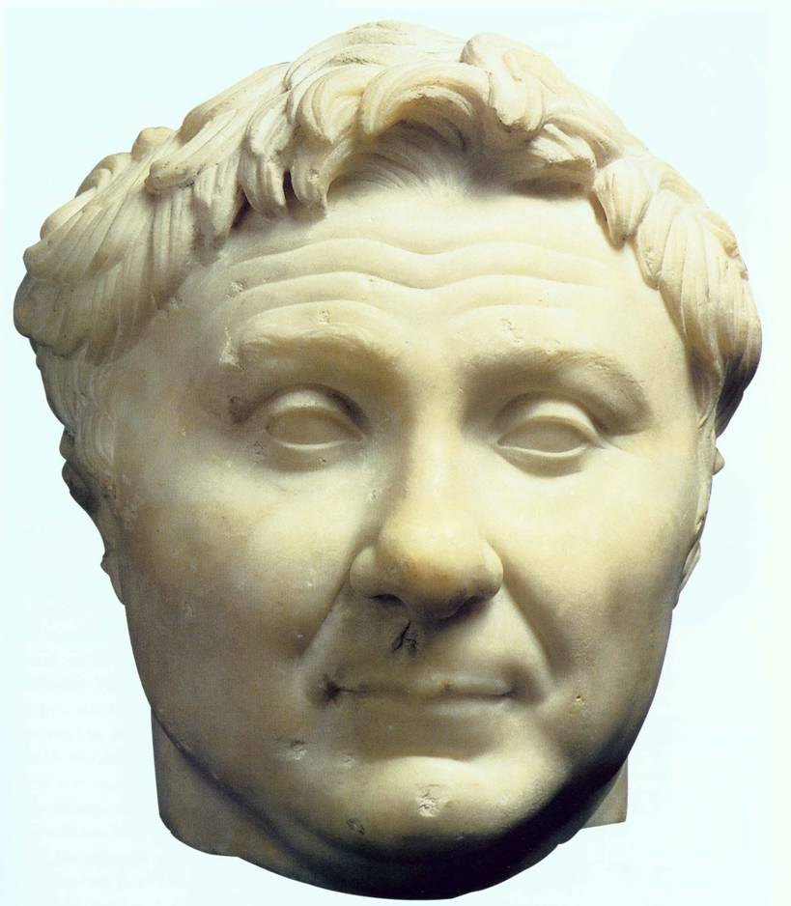

Augustan Classicizing portraiture

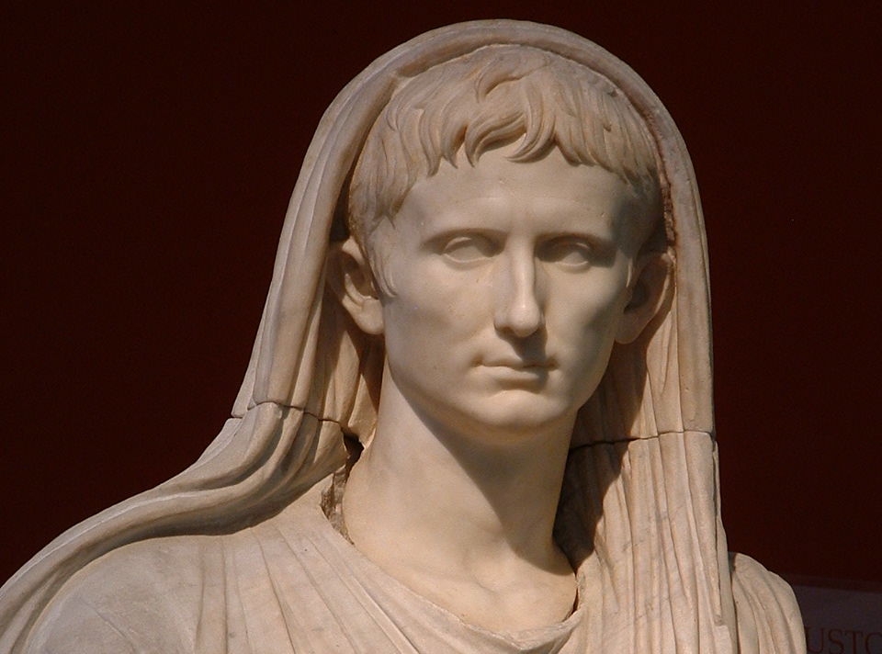
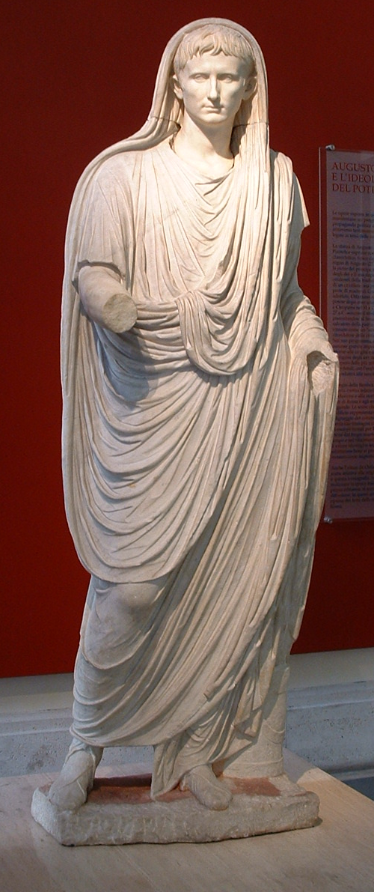

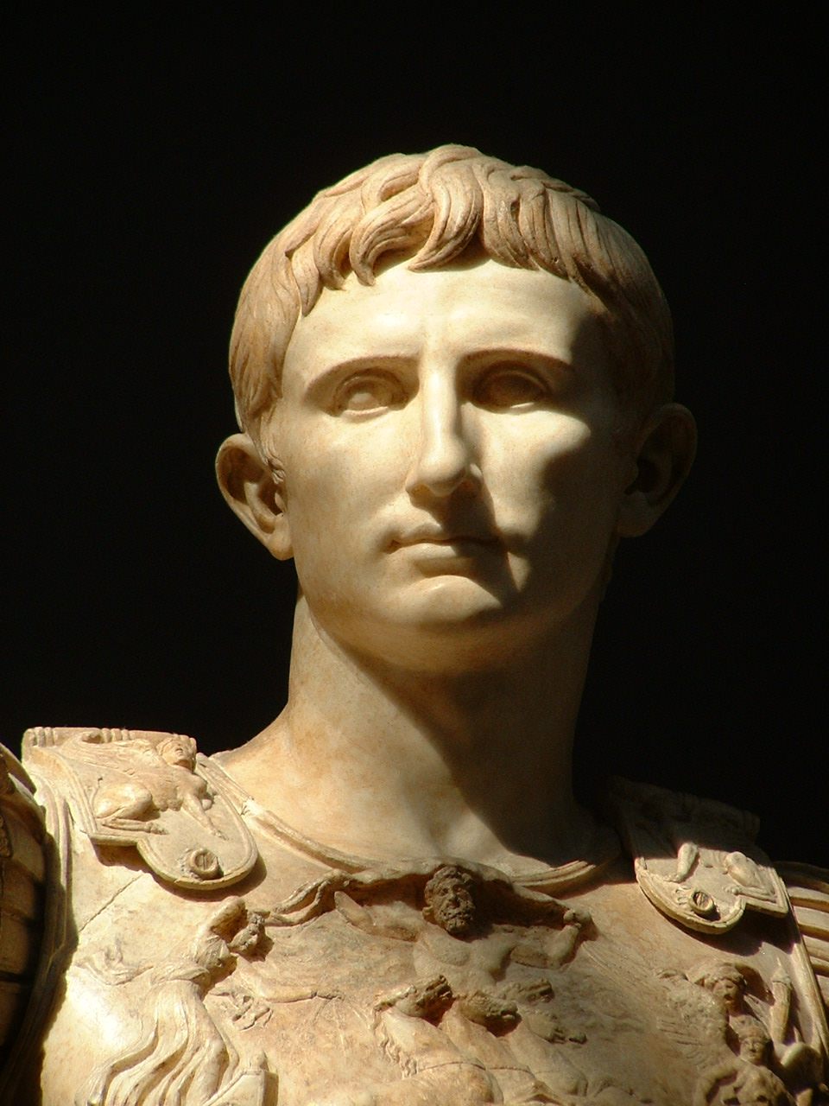
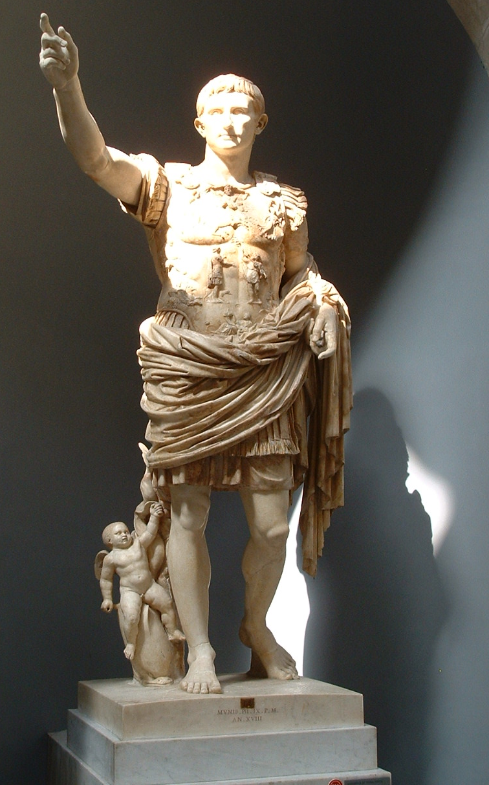

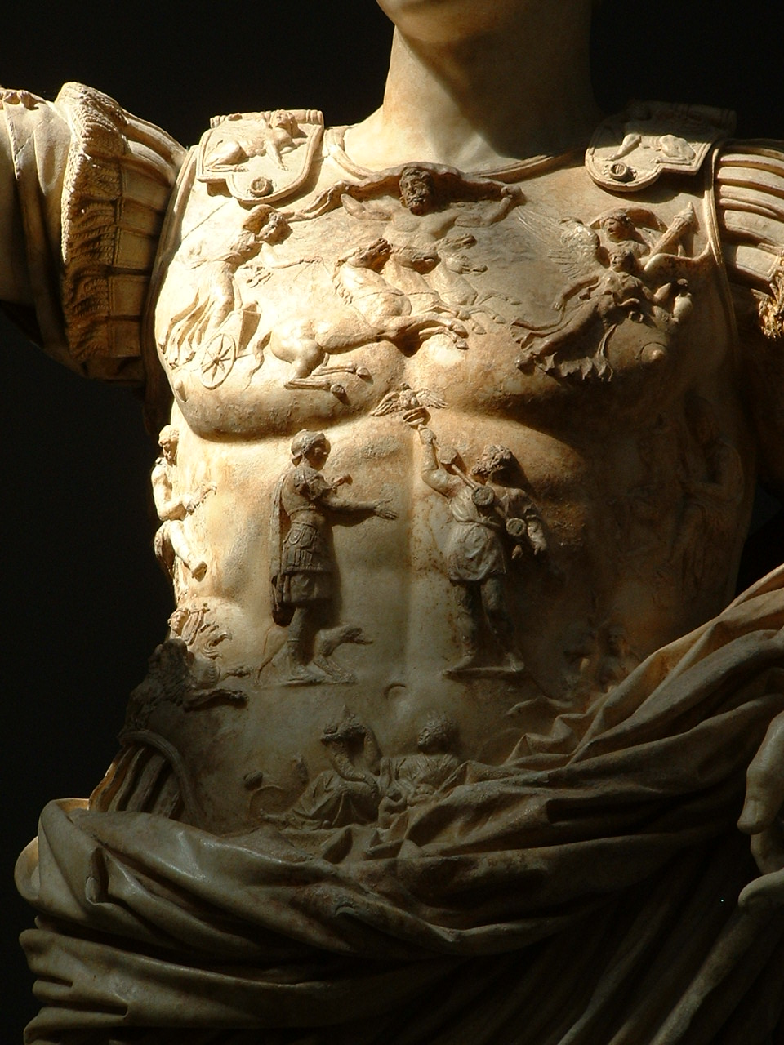
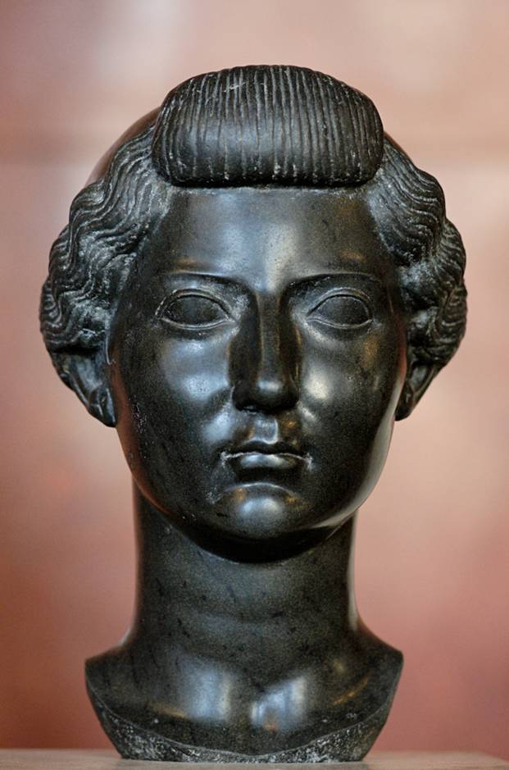

Later Julio-Claudian and Flavian emperors
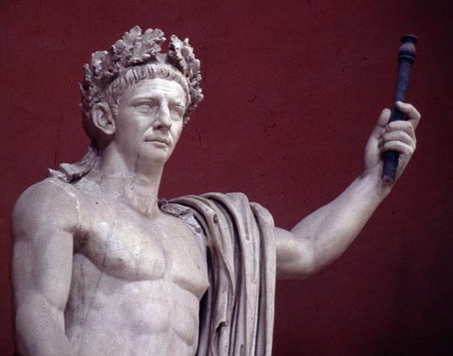
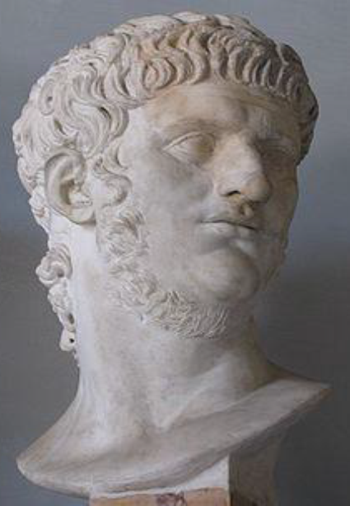
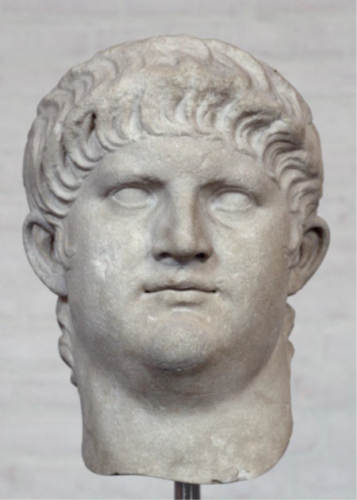
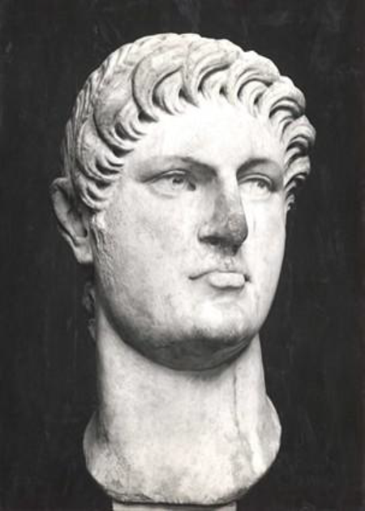

A bust of the emperor Vespasian (first of the Flavian dynasty)


