Portfolio on Personal Career Development
By
Student: Tuty Jallow Sarr - student number: 2027118
Module: Professional Career Development
Module Code: BMSW 4005_BIRM
Lecturer: Farah Islam

Table of Contents
i Introduction 3
Section One: Self-awareness Analytical Theories (SAT) 4
1. Description 4
1.1 Tuty’s Johari Window 4
1.2 Personality Test Analytical Theory (PTAT) 4
Section Two: Learning Needs Assessment for Individual Care Services Staff 5
2 Training, Learning and Development Needs (TLDNs) Description 5
2.1 Training and Development Manager for Individual Carer Services (ICS) 5
2. 2 Analysis of TLDN tools for Employees 6
Section Three: Reflection on Learning Outcome 8
3 Reflective Models (RM) 8
3.1 Gibbs Model for the Open Book Assessment 8
3,2 Gibbs Model on Mock Interview 9
3.3 Gibbs Model on UK Employment Legislation Learnt 10
4 Conclusion 12
Reference List 13
Appendixes 14

i Introduction
This paper sets out to address three key topics studied under Professional Career Development Module.
Section one will focus on assessing and evaluating my personality, using ‘Self-awareness Theories - ‘Johari’s Window’ and ‘Personality Test’. Section two will stimulate being a manager at the Individual Care Services (ICS) assessing the Training, Learning, and Development Needs theories for both new and existing staff to enable linking learning style and personality to that of ICS strategy for quality standard and productive services. Section three will use ‘Gibbs reflective model to evaluate learning outcomes on the open book assessment, mock interview and UK employment legislation. Section four will be the conclusion followed by the appendixes, reference list of materials used within this report.

Section One: Self-awareness Analytical Theories (SAT)

1. Description
SAT as described by Carden, Jones, and Passmore, (2021), are the several methods for analysing and assessing one’s hidden personality such as having knowledge of ones ‘Real Self (skills, personalities, and competencies). This will enable me to link my personality with the best Career choice for effective and efficient work-life.
Based on the various SAT learnt, Johari’s Window and Personality Test are the theories that I consider best suited to evaluate my own skills and competencies

1.1 Tuty’s Johari Window
Johari Window is a SAT developed by Joseph Luft and Harry Ingham to aid understanding of both ‘Real and ‘Ideal Self’ to build trust within team as well as own personal career development. The window is in four parts representing information about the me as illustrated below (Cottrell, 2015; MetaPeople development, 2015).
The Open Area  The information known to both me and my colleagues such as I am a dedicated and compassionate worker and can drive teamwork. I love singing and dancing | The Blind Area  The information my colleagues know about that I do not know such as too much stress to do the right think and not delegating most of the team assignment
The Hidden Are.a  The information I know about myself that my colleagues do not know such as my personal relationship/medical information | Unknow Area  Information unknown to both me and my colleagues such as my characteristics/personality which is revealed through test as being ‘Consul’, ‘Helper’ and ‘Pleasing’ (see appendix 1 and 2)
Table 1 Self Joharu Window (MetaPeople development – the Johari window, 2015).

1.2 Personality Test Analytical Theory (PTAT)
PTAT, is a valuable tool designed for individuals to understand, measure and ‘uncover their personality across broad range of situations to enabling one to link it with personal career aspiration (Cottrell, 2021, p.7).
My personality traits from three different tests revealed Protagonists and ‘Consul’ (see appendix 1 and 2) which means that I have a charisma and potential of leadership and can positively inspire others. I also discover that I am a helper and good communicator which are required skills for ‘Social care worker. It never down to me that I possess these characteristics. PTAT also indicated that, I place a lot of pressure on myself and colleagues in achieving results, thus putting a lot of pressure on my colleagues, and affecting my health (16Personlalities, 2021).
Self-awareness tools enables me to change the awareness I held about my Real-self from constructive feedback. This will facilitate building trust and interpersonal relationship with colleagues as well as building own PCDP. Also work on closing any skills/competency gaps to link personality and ‘Learning Style’ to that of ‘Individual Care Services for efficient and effect work-life (Cottrell, 2015; 16Personlalities, 2021). These personalities qualifies me to be the manager at the ICS.

Section Two: Learning Needs Assessment for Individual Care Services Staff

2 Training, Learning and Development Needs (TLDNs) Description
TLDNs are those skills and competencies an individual possesses to enhance work-life effectiveness and efficiency. Having knowledge of both the Real-self and that of the Ideal-self from previous section, it is important to assess the Learning Style (LS). LS are SAT brings out our personalities with the way we learn. As human being we are all different in nature therefore differently in the way we learn. It is therefore important to assess the TLDNs of staff to fit in with ICS work-life (Neugebauer and Evans-Brain, 2016)

2.1 Training and Development Manager for Individual Carer Services (ICS)
The Health and Social Care disciple operates in a rapidly changing environment both in terms of policies, procedures, and equipment. This being the case as the manager for ICS, I have to update with changes and technologies in the field. My responsibilities are to ensure that employees (both new and existing) are also all fit with these changes; conduct regular staff review for training needs. Plan and conduct the appropriate training sand development to fill the existing gaps for effective and efficient workforce (CIPD, 2013). As a manager, it is important to understand that LS has an impact on Training and Career Development as it will reveal the individual’s personality and LS for proper linking with their ICS strategy. Let’s take a look at Honey and Munford, (2012) LS.
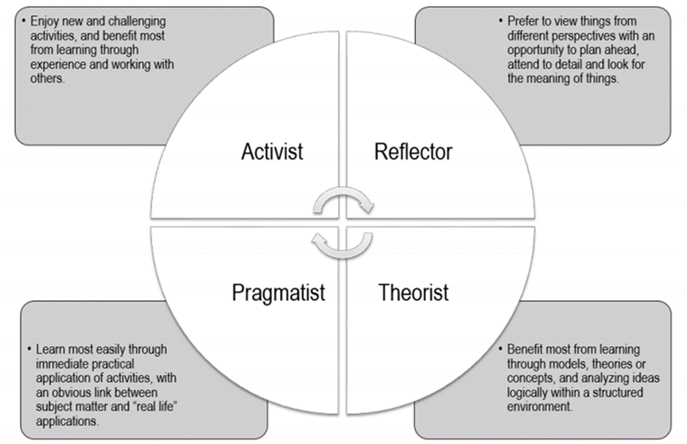
Fig 2 .1 Honey and Mumford, (2012) LS from

With LS theory an individuals may possess more than one LS as in my case I am a Pragmatist in general but have some elements of the other three. With the background knowledge of personality assessment for balancing staff selection, the next step is to assess the TLDN for quality services, productive workforce and personal career development (Cottrell, 2015).

2. 2 Analysis of TLDN tools for Employees
Out of the many TLDN models such as: Best Value Learning and Development; Mmentoring; Continuing Professional Development (CPD); Reflective and Active Learning (RAL) and Performance Reviews I believed that RAL will best suit for new employees and CPD for existing employees.

Employee status | New Employees | Existing Employees
LS DESCRIPTION | Reflective and Action Learning (RAL) as described by Neugebauer and Evans-Brain, (2016) on-the-job learning originated from ‘the works of Professor Reg Revans. Revans who believed that “real learning only took place when supported by real-world experiences and not formal courses’ which I agreed upon. | Continuing Professional Development (CPD) is a model of ensuring that staff personal skills and competencies are relevant and appropriate with that of the organisation and kept up-to-date at all times using action plan (see appendix 3) (Neugebauer and Evans-Brain, 2016, p. 8-9).
Benefits | learning to learn for fresh knowledge and expertise, support and challenge each other for positive results (Neugebauer and Evans-Brain, 2016, pp.5; ). . | Widely used by individual for employability. Help monitor and maintain PCD and enhance transferable skills. CPD will help organisation to easily match skills and competence with work (Neugebauer and Evans-Brain, 2016, p. 8-9). .
Shortcomings | it can be time consuming and stressful particularly having to coach staff on a busy period. (Neugebauer and Evans-Brain, 2016, pp.5; ). | If an organisation does not support learning, CPD will be useless to the staff.
Reason for Selection | It will be the best choice for new staff to have the first-hand practical experience and the chance to blend with existing staff for constructive feedback for continuous PCD (Neugebauer and Evans-Brain, 2016, pp.5). | Good for existing staff to easily monitor, help and support any skills gap for effectiveness and efficiency of work-life (Neugebauer and Evans-Brain, 2016, p. 8-9).
 | Table 2: TLDNs Assessment

With the required TLDN for staff, mapping skills and competencies to ICS strategy for productive work-life will be easy. And will facilitate transferable skills to any organisation for short to medium term as well as longer-term career development and employability chances (Marquaradt and Banks, 2010 pp.159–160).

Section Three: Reflection on Learning Outcome

3 Reflective Models (RM)
RM are there to help us understand the work and or life experiences we have gone through to enable turning weaknesses and threats to strengths and opportunities. This will improve continuous work performance as well as personal career development. From the many ‘Reflective models’, I prefer the Gibbs model, (1998). Though it is an old model it is easy to understand and can still fit on modern time (see fig 3.1).
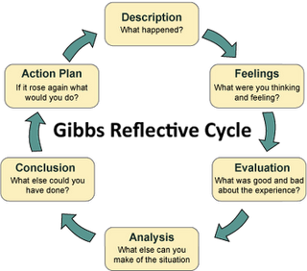

Fig 3 reflective model from lifelong learning website

3.1 Gibbs Model for the Open Book Assessment
Description: Open Book Assessment on Mental Health issues affecting the workforce, the organisation as well as the society
Feeling: I initially felt under pressure and agitated of not being able to finish on time. Frustrated on having to do research, analyse it and type within 2 hours considering struggling with my vision issuesime.
Evaluation: The good thing about the assessment is that it opens a new view about mental health and how it is affecting work health environment. Though I struggle with reading and typing, I learnt to work towards target. I’ve learnt powerful and useful information on mental health. The down side of it is the pressure of being under exam condition and having to manage my time which was very hard even with my extra time allocation.
Analysis: is part of a learning circle. I have developed both the theoretical and practical application of techniques learnt. I now know how to work to target from the general feedback of the lecturer.
Conclusion: If I were to be in the situation again, will seek help by using the ‘Dictate’ menu button available on work for faster typing in effect manage my time well..
.
Action Plan: revise well before the day and constantly updating my knowledge and skills on IT. I will use the facilities available for editing the work and faster typing (use dictate menu). Seek for more training on finding information and research

3,2 Gibbs Model on Mock Interview
Description - mock interview for the preparation of real-world job selection and application, and selection , cv and cover letter creation for the right career pathway
Feeling - under pressure and helpless as unclear about the best health and social care pathway. Was initially struggling on the suitable health and social care disciple to choose from before receiving clear and precise explanation of CPCD with lecturer, coupled with my vision issues. .
Evaluation The exciting and interesting thing about the whole process of mock interview is that it opens a wide range of both practical and theoretical experiences on job searching, utilising provided application for cv and cover letter creation. Also giving the opportunity for real-time mock interviews practice with instant feedback for improvement. A guidance and template for cv creation with grading and instant feedback.
The career development tool available for students boost my mock interview performance (see appendix 3 marks and feedback). It also helps in working towards targeted timeframe for future interviews. I’ve learnt powerful and useful information for continuous career development. The downside was my over-confidence and did not check on plan of action for the mock interview and in answering question to the point.

Analysis is a learning circle. I have developed both the theoretical and practical approach on job selection, application, and interviews. I am confidence on my career pathway and have the know-how for improvement from constructive feedback of the lecturer.

Conclusion If I were to be in the situation again, will engage more on questions and answer techniques eek help on basic IT skills as a lot of my time was spent trying to figure out how to use the application, and spend more time on the literature review to gain more knowledge experience.
.
Action Plan constantly updating the knowledge and skills learnt for future employment acquisition and retention. I will also seek help on editing the work by more than three people as what one cannot pick up on at least the others can pick. Seek for more training on finding information and research. Re-organise my personal development plan even though I finished all my activities on time

3.3 Gibbs Model on UK Employment Legislation Learnt
Description As part of career development, it is important to be knowledgeable on the UK employment legislation. The employment legislation is a formation of laws set put to regulate the relationship between employers and employees (CIPD, 20--).
Feeling - Pleased and happy to discover in detail the Key legal issues posing risk to both employees and employer.
Evaluation The legality governing important policies and regulations between employers and employees are now clear. The contents is in simple English and easy to understand. It is good to know what is required of you as an employee as well as that of your employer to avoid any gross misconduct that might lead one to heavy fines or imprisonment.

Most organisation back themselves more than they back their employees by using clause that are hard to understand as no proper training is mostly received. I now know where and how to get the legal information that concerned me

Analysis it is a very important session of this module as it gives legal framework on all aspect of employing and the relationship between employers and employees. I have developed knowledge employment legal aspect to guide throughout my work-life career.

Conclusion Built connection with legal advisers and join workers union for continuous guidance.
.
Action Plan constantly updating the knowledge and skills learnt for future career development.
Reflective models helps in evaluating skills and knowledge for personal career develop both within and outside your. organisation and

4 Conclusion
Self-awareness tools enables me to change the awareness I held about my Real-self from constructive feedback. This will allow me to you work on closing any skills and competency gap and link my personality and LS to get the required training and development needs . Also monitor and evaluate progress and gaps for future improvement. In this gain transferable skills and competencies to any organisation for productive work-life in the short to medium term as well as longer-term career development and employability chances

Reference List

16Personalities (2021). Community / 16Personalities. [online] 16personalities.com. available at: https://www.16personalities.com/enfj-personality. (Accessed 3rd February 2022).
Carden, J., Jones, R.J. and Passmore, J (2021). ‘Defining self-awareness in the context of adult development: a systematic literature review’. Journal of management education, 46(1), pp.142-145. Available at: https://journals.sagepub.com/doi/pdf/10.1177/1052562921990065 [Accessed 23rd March 2022].
CIPD. (2012). CIPD Megatrends: the trends shaping work lives. YouTube (Video). Available at: https://www.youtube.com/watch?v=d6oXfMilLe8 [Accessed 12th March 2022].
Cottrell, S. (2015) Skills for success: personal development and employability. 3rd ed. Basingstoke: Palgrave Macmillan.
Cottrell, S. (2021) Skills for success: personal development and employability. [online] 4th edition. London: Red Globe Press (Accessed 29th March 2022).
Marquardt, M.J. et.al., 2018. Optimizing the power of action learning: Real-time strategies for developing leaders, building teams and transforming organizations. 3rd edition Hachette UK.
MetaPeople . (n.d.). ‘MetaPeople development’. The JoHari window. (Youtube Video). Available at: https://www.youtube.com/watch?v=nC3U_4OtNJs [Accessed 12th March 2022].
Neugebauer, J. and Evans-Brain, J. 2016. Workplace Learning and Development. In: 2016. Employability: Making the Most of Your Career Development, 55 City Road, London: SAGE Publications Ltd. pp. 94-112 Available at: https://dx.doi.org/10.4135/9781473996694.n5 [Accessed 20 Mar 2022].

Appendixes
Appendix 1 : Personality Test Result

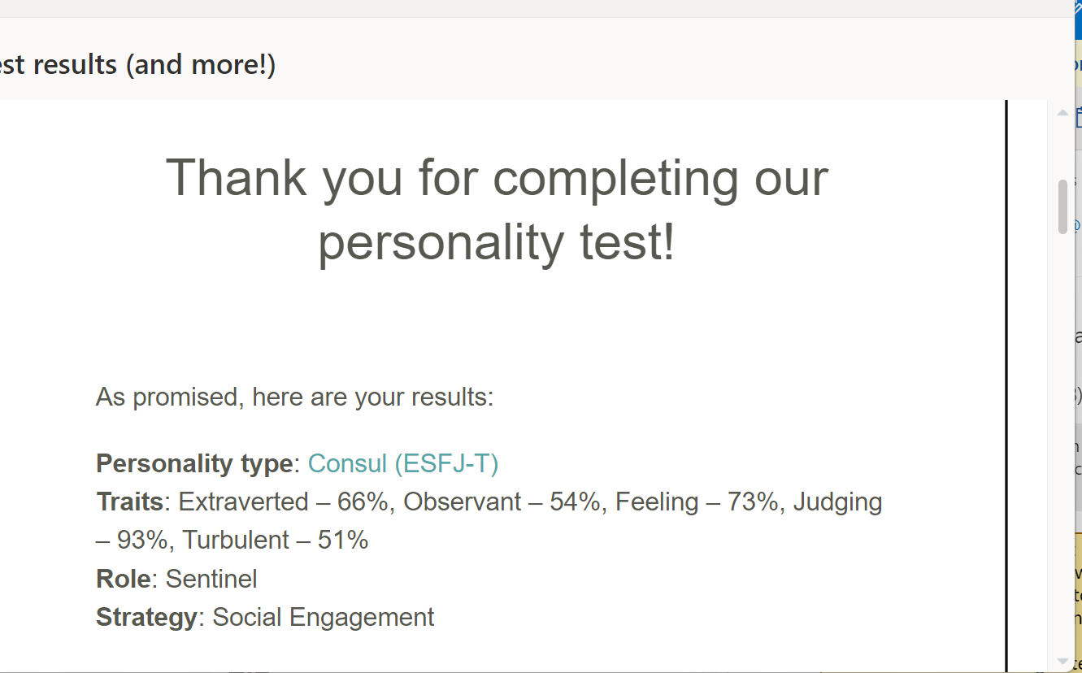

Appendix 2 Personality 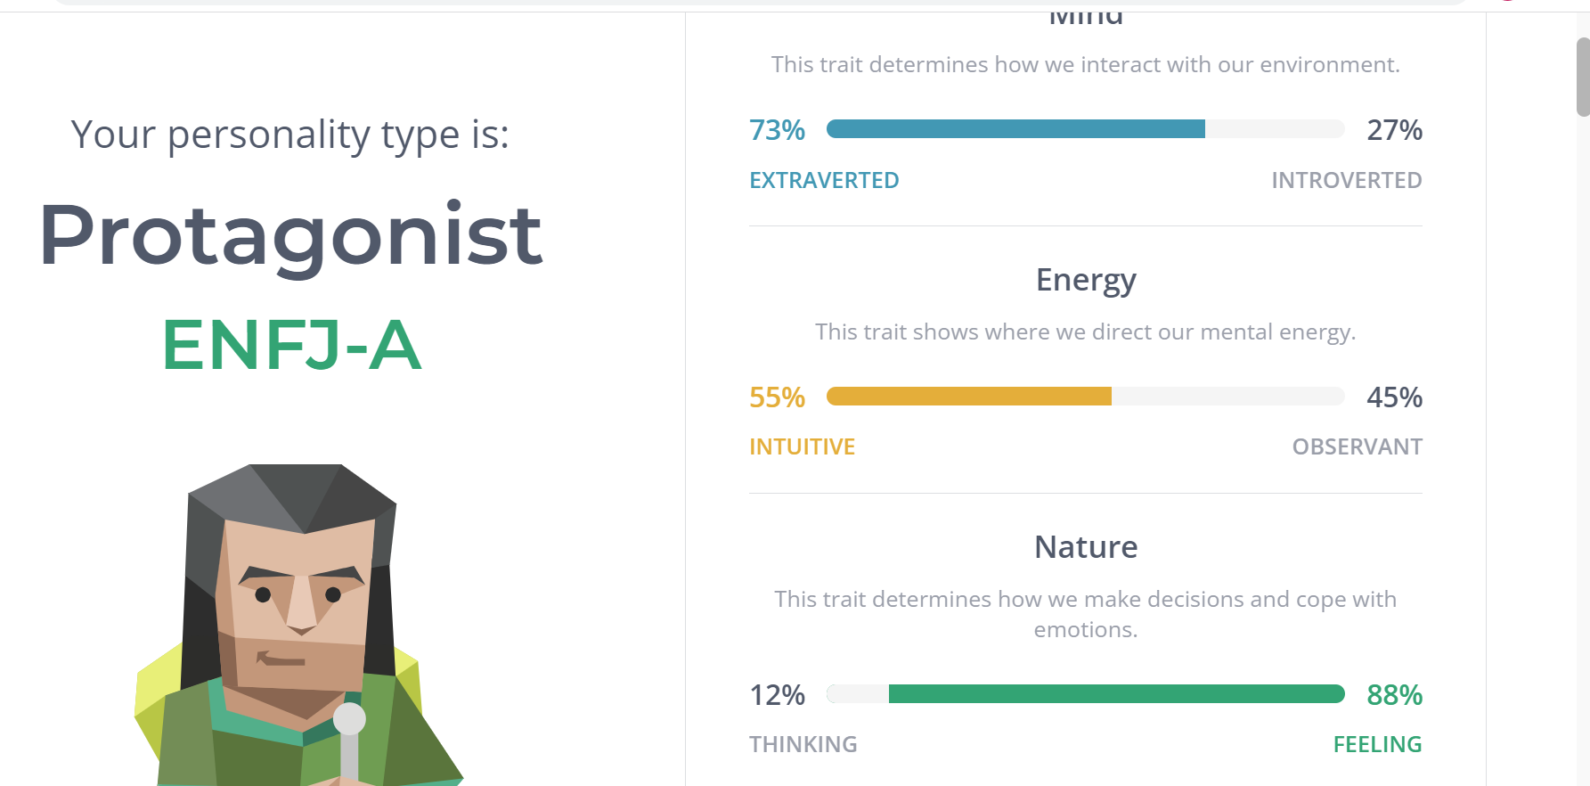

Appendix 3: Learning Style
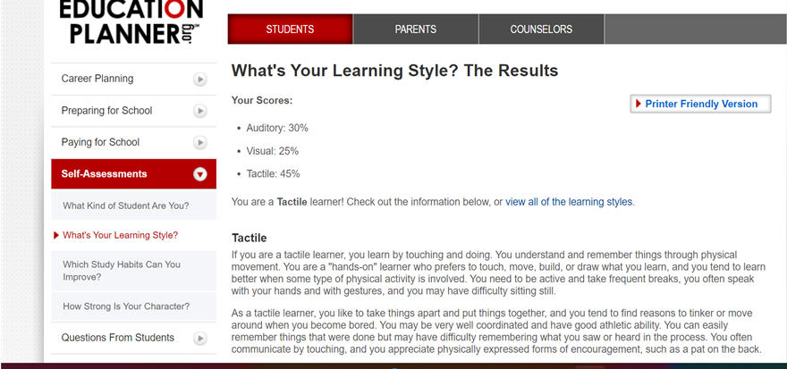

Appendix 4 Personal Development Plan for Health and Social care Qualifications
Objective | Timeframe | Activities | Success Criteria | Resources
Short Term | Jan 22; to May 22 | Research work
 |  | Assessments/assignments
Medium Term | May 21 – April 22
Long Term | In three years

Appendix 4: Mock Interview Feedback

