

Case Study Analysis Report
Leadership, Governance and Systems Thinking in Health and Social Care:
The Lewis Blackman Case (2000)

Submitted By: Krupa Patni
Student ID: 2525352

Programme: MSc Public Health and Social Care in Practice
Module: Health Care System Organisation and Leadership
Module code: LCHS7002
Case study selected: Case Study 1, The Lewis Blackman Story
Word count: 5030
Lecturer: Dr Pascal Navelle

Table of Contents
INTRODUCTION 4
MAIN BODY 5
a. Identifying the Problem and Setting the System Context 5
The central problem 5
Global and national statistical context 5
Systemic weaknesses and level of governance 8
Underlying challenges 8
The rich picture 9
b. Centralisation or Decentralisation within the Case Study 11
Centralised elements of the case 11
Decentralised elements and what was missing 11
Critical analysis 12
c. Leadership Theories and Application to the Case Study 13
Relevant leadership theories 13
Application to the case 13
Was the leadership style appropriate, and what could have been done differently 14
d. Improvement, and Lessons Learned 15
How leadership and governance interacted 15
Missed opportunities and evidence based solutions 16
Linking the findings 17
RECOMMENDATION 17
CONCLUSION 19
REFERENCES 20

LIST OF FIGURES AND TABLES
Figure 1. Key global patient safety statistics.
Figure 2. NHS England Never Events reported per year, 2018/19 to 2024/25.
Figure 3. NHS Never Events by category, 2018-2024, England.
Figure 4. Nurse staffing ratio and relative increase in 30-day surgical mortality.
Figure 5. Rich picture of the Lewis Blackman case.
Table 1. Global, national and organisational statistics relevant to the Blackman case.
Table 2. Centralised versus decentralised systems, applied to the case.
Table 3. Leadership theories applied to the case.
Table 4. Problem, evidence and improvement summary.

INTRODUCTION
In November of 2000, the case of the similarly fit and healthy fifteen-year-old boy, Lewis Blackman, occurred when he died four days after having undergone a routine surgery to correct a chest wall deformity in a South Carolina hospital. His operation alone was not the cause of his death. His mother reported the signs of a serious problem his stomach just didn't feel right and nurses reported that, but the medical staff didn't follow up in time and he died from the perforated ulcer that resulted from taking a common pain medication (Acquaviva, Haskell and Johnson, 2013). His mother, Helen Haskell, went on to become one of the biggest voices calling for patient safety reform, and the case continues to be one of the most often studied instances of the interaction of communication, hierarchy, and inadequate systems oversight resulting in preventable harm (Patient Safety Movement Foundation, 2014).
The aim of this report is to bring the issue of leadership and governance in health and social care organisations into focus illustrated through the Lewis Blackman case. Leadership, as it relates here, is the capacity to influence others toward reaching a common objective, which in this case, is for patient safety (West et al., 2015). Health systems operate within a continuum with variations in the level of centralisation, which range from a small group of senior staff or managers who have the authority to make decisions, to the decentralisation of authority and responsibility to teams working at the frontline (Abimbola, Baatiema and Bigdeli, 2019). Leadership style is not a singular thing, either. Transformational leaders are leaders who spark commitment in their staff, leaders who motivate them to go the extra mile, transactional leaders are leaders who rely on active job descriptions, rewards and correction, situation leaders adjust their leadership style depending on the maturity level of the group and the situation of the moment (Ystaas et al., 2023; Galvão et al., 1997).
You have options when it comes to leadership styles, but it isn't a choice you can pick based on your tastes. The inappropriate style, such as a rigidly command oriented approach to a situation that requires open listening and quick escalation, in crisis could be fatal, but the appropriate style could save a patient whose condition is worsening (Cosby and Croskerry, 2004). The Lewis Blackman case will be presented in the context of the system using systems thinking and a rich picture. It will then examine if the structure would be centralised or decentralised and the implications on accountability for the hospital. It will assess their leadership response, identify what was learnt from their response and the improvement that was made using leadership theory. Another feature of the report is a set of recommendations and a summary conclusion.

MAIN BODY

a. Identifying the Problem and Setting the System Context

The central problem
On 30 October 2000, Lewis Blackman had a pectus excavatum corrective procedure for which he opted. He developed a progressively increasing heart rate over the next 4 days, a decrease in urine output, and distention/pain in the abdomen. His mother remained at his bed-side and continued to say to nurses "something is wrong with him. Concerns were raised by the nurses, but the resident over duty who was cross covering for the primary surgical team and did not escalate to the attending surgeon. The boy had also been given a strong anti inflammatory painkiller called toradol for more than recommended, before going to the doctor and not telling them he had stomach pain, how it was masking his symptoms and how this caused him to have a perforated ulcer. When his condition was identified as a surgical emergency he was in cardiovascular collapse and died 2 November 2000 (Acquaviva, Haskell and Johnson, 2013).

Global and national statistical context
Blackman's case is not the only one. It represents trends seen in global patient safety information. Communication failure and BD delay are a leading preventable cause of death in acute care, as highlighted by WHO (2024). As illustrated in Figure 1, WHO estimates that approximately one in ten patients in a high income country suffers harm while receiving care in hospital care settings, and that up to four in ten harms are suffered by patients in primary and outpatient care settings, with one half being preventable, and unsafe care responsible for more than three million deaths globally on an annual basis (World Health Organization, 2023). Both poor team working and unclear escalation are identified as system level drivers of harm—these are candidates for leadership by all levels in the Global Patient Safety Action Plan.(World Health Organization, 2021).
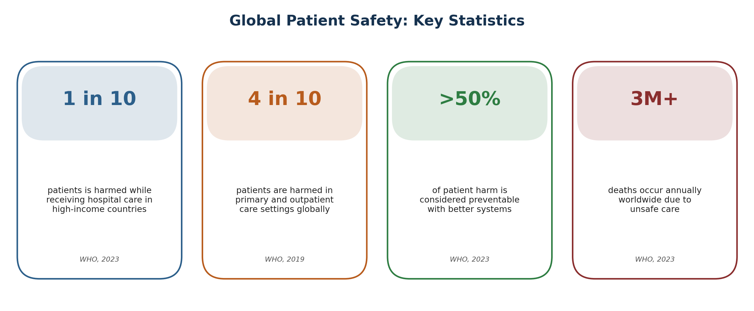
Figure 1. Key global patient safety statistics (World Health Organization, 2023; World Health Organization, 2019).
NHS data at National level shows similar patterns. Each year NHS England has reported so-called 'never events' as part of its own monitoring, where incidents should not have occurred even if existing safety advice is followed, and these have included incidents involving poor communication. A consistently improving picture would show a decline to 421 NE in 2024/25 following a 2020/21 low of 364 NE, but this is not what Figure 2 indicates for England.If it was a consistently improving picture, you would expect England to be at 421 NE in 2024/25, having seen its lowest point in 2020/21 at 364 NE.. A six year thematic analysis further reveals the focus of the risk as seen in figure 3, most recorded never events are attributable to wrong site surgery and retained foreign objects, while in addition, another 198 events are directly attributed to medication errors the cause of Lewis Blackman's death (Abosheisha, Hafez and Omar, 2025).
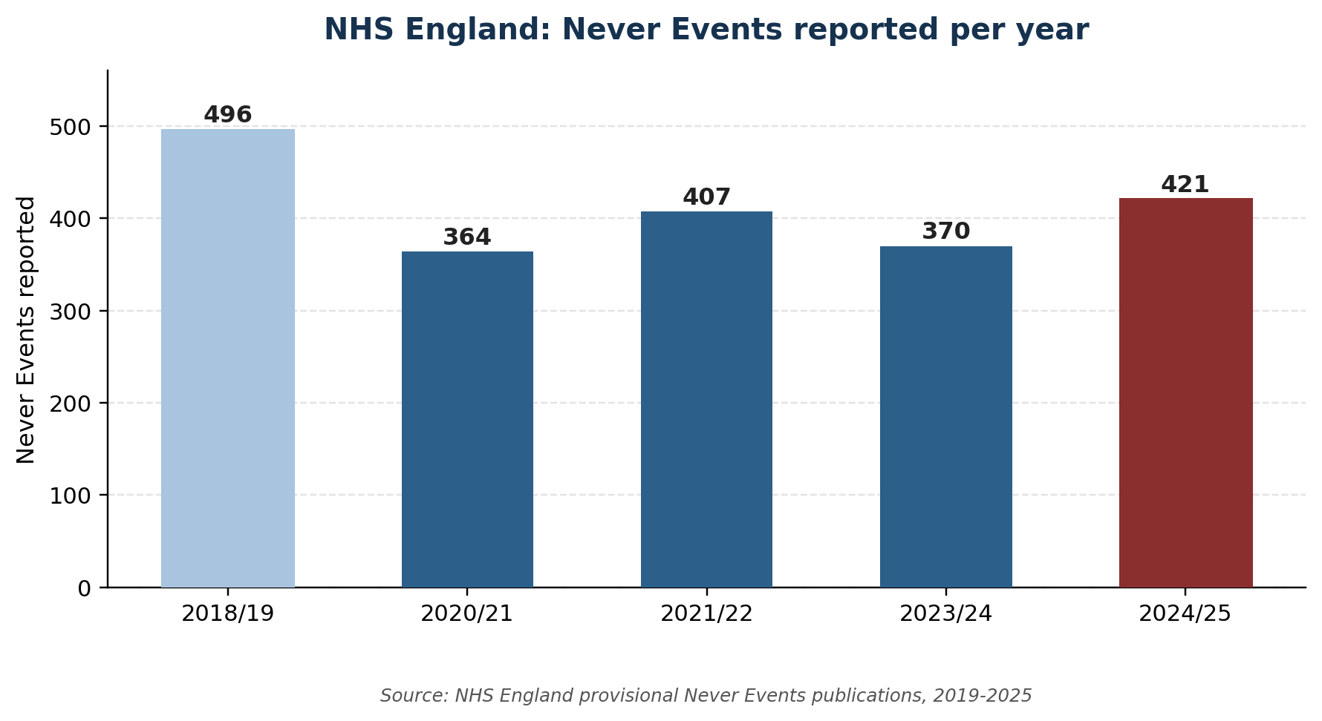
Figure 2. NHS England Never Events reported per year, 2018/19 to 2024/25 (NHS England, 2025).
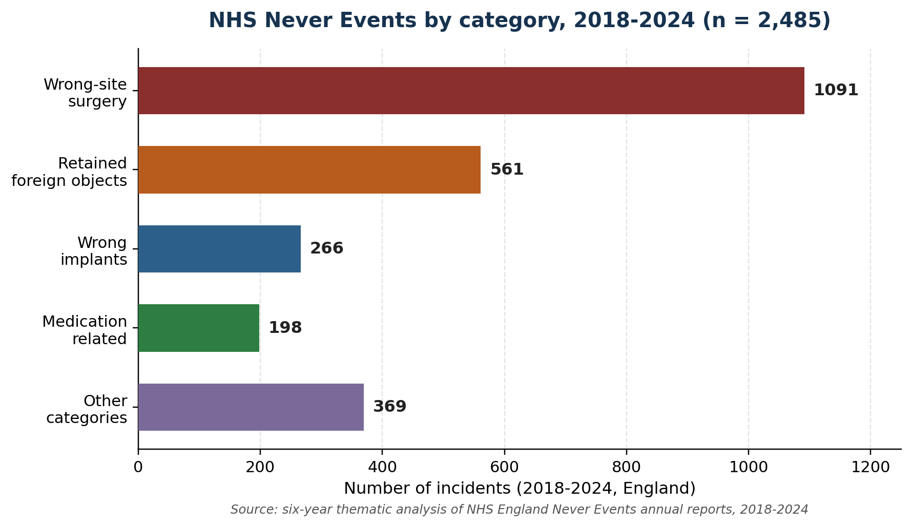
Figure 3. NHS Never Events by category, 2018-2024, England (Abosheisha, Hafez and Omar, 2025).
In its landmark report, To Err is Human, the United States estimated that tens of thousands of hospital deaths a year were due to medical errors, that they were not always the result of one wrong person, but in nearly every case to a wrong system (Kohn, Corrigan and Donaldson, 2000). The Institute for Healthcare Improvement builds directly on this evidence, and contends that the successful culture of safe and reliable care relies on the ability of any member of staff, no matter their status, to speak up (Frankel et al., 2017). This relates directly to the Blackman case, as there were nurses who did raise their concerns but these were not converted in a timely fashion into actions for senior review because of the culture and structure of the hospital. In the United Kingdom, the Mid Staffordshire inquiry reveals a culture of being target driven and centralised which allowed appalling standards of care to persist for years without escalation of concerns from ward level to trust level (Francis, 2013).

Systemic weaknesses and level of governance
The 'Blackman' case highlights systemic areas of weakness on multiple fronts. There was a gradient of authority, a perceived differential of status and power between the junior nurses and senior physicians which made it difficult for the covering resident and nurses to advocate for urgent assessment (Cosby and Croskerry, 2004; Sekar et al., 2022). In terms of organisational factors, like in many other hospitals with a functional organisation, the doctor on shift did not know the patient well outside of regular work hours, and was not keen to do everything the primary team decided. The hospital followed an escalation policy (also known as a chain of command policy) on the governance level but it was unclear to staff or the family how to invoke the escalation plan, and it had not been used during the four days Lewis was deteriorating (Acquaviva, Haskell and Johnson, 2013).

Underlying challenges
Such failure is more likely to happen when there are pressures on the underlying workforce, as is evidenced in the data below. Using huge hospital data from all over the US and Europe, Aiken and colleagues revealed a reliable statistical association between low nurse staffing levels and increased mortality, and they associated poor nurse staffing with burnout and with nurses' overall capacity to advocate for their patients (Aiken et al., 2002; Aiken et al., 2014). The dose response relationship illustrated on figure 4 suggests that the number of patients per nurse is not just a background issue but it's a measurable source of harm (Aiken et al., 2002). Subsequent research found that mandated staffing ratios were correlated with a reduction in deaths (McHugh et al., 2021) and that the more nurses a hospital unit had, the higher the survival rates following an in hospital cardiac arrest, the very type of event that killed Lewis Blackman (McHugh et al., 2016).
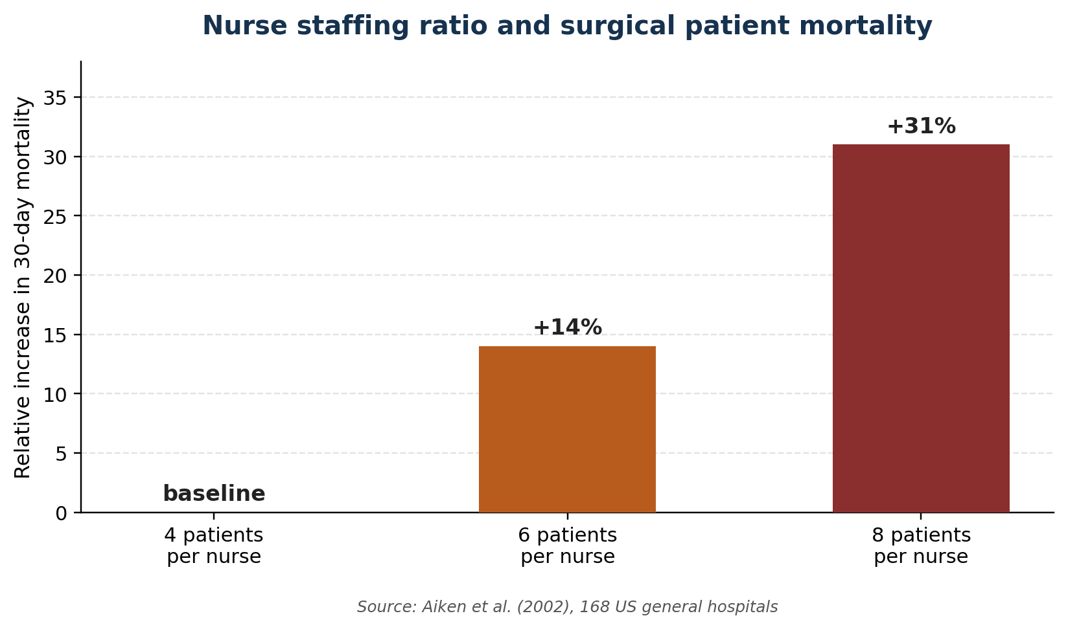
Figure 4. Relationship between nurse staffing ratio and relative increase in 30-day surgical mortality (Aiken et al., 2002).

The rich picture
Figure 5 is an example of a rich picture in the Blackman case study, generated using a soft systems technique to try to map out the actors, relationships and communication in a poorly-structured problem, prior to defining it formally (Checkland and Poulter, 2010; Checkland, 1981). In the picture, the patient and his mother raise escalating concern on the left side; the clinical signals, worsening vital signs, don't bother me, toradol dose and unused chain of command policy are on the middle left side; and the available structure and culture – absence of attending surgeon, authority gradient and a fractured hospital system – are on the middle right side. Note how the feedback loop (green) brings the disaster back into a redesign of the system, precisely the type of double loop learning systems thinking advocates, until the Lewis Blackman Hospital Patient Safety Act of South Carolina was enacted in 2005.
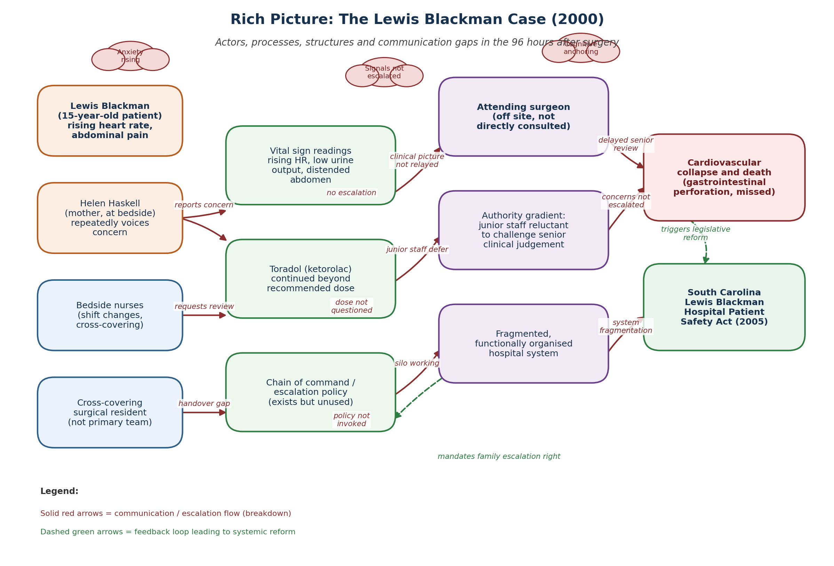
Figure 5. Rich picture of the Lewis Blackman case, showing actors, communication flows and the feedback loop to systemic reform (author's own construction, based on Acquaviva, Haskell and Johnson, 2013; Checkland and Poulter, 2010).
Table 1. Global, national and organisational statistics relevant to the Blackman case.
Level | Source and headline figure | Relevance to this case
Global | WHO Global Patient Safety Report (2024): unsafe care remains a leading cause of avoidable harm in hospitals worldwide, with communication failure and diagnostic delay repeatedly identified as major contributors. | Frames the Blackman case as part of a recognised worldwide pattern, not an isolated local failure.
National (UK) | NHS England (2025): never events, incidents that should not occur if existing national safety guidance is followed, continue to be reported annually, many linked to breakdowns in communication or failure to follow agreed procedure. | Shows the same communication and escalation weaknesses recur within a well resourced, centrally regulated system.
Organisational / IHI | Institute for Healthcare Improvement (Frankel et al., 2017): safe, reliable care requires a culture in which any staff member, of any seniority, is expected and supported to speak up. | Identifies the precise cultural gap present in the Blackman case, where concerns were raised but not acted upon.
Underlying workforce data | Aiken et al. (2014): lower nurse staffing ratios are statistically associated with higher inpatient mortality across nine European health systems. | Explains a structural pressure, thin senior cover and cross-covering, that made timely escalation less likely.

b. Centralisation or Decentralisation within the Case Study

Centralised elements of the case
The case of the Blackman hospital had very strong centralised characteristics associated with the clinical decision making structure. A surgeon working off site held authority over the plans of care, and although the regional (off-site) surgeons were notified at the time, their call sign was not "compassionate touch" and their expertise was not sought at the critical hours when plans of care needed to be altered. This is an example of a centralised model of clinical governance, where the decision rights are centralized within a professional hierarchical structure, as opposed to those at the bottom of the hierarchy with closest access to the patient (Shishkin et al., 2025).
Such centralisation has some of its known benefits. It facilitates consistency of care standards, can establish lines of accountability in writing and may facilitate effective use of limited specialist skills (Scarffe et al., 2022) where every decision does not always have to be made by most senior staff member as a well designed structure raises issues in a timely manner to the appropriate specialist. The downsides of course came into the Blackman situation. Centralisation studies in health care systems reveal that consolidation of control from the point of care can hinder decision making at the very moment it is needed, while harming front staff's sense of responsibility for patient outcomes (Shishkin et al, 2025). The evidence from OECD shows that highly centralised systems can lead to bottlenecks in which local staff have to wait for approval instead of acting on what is in front of them.

Decentralised elements and what was missing
A true decentralised system is one in which the bedside nurse and the "covering" resident would have had clear and protected authority to require a senior to come and review the situation urgently when an agreed set of warning criteria was met without asking permission of a doctor not immediately present or a "calling" doctor. This is similar to the principle behind contemporary fast response and early warning systems that put the authority to escalate at the lowest staff member to spot the danger sign (Frankel et al., 2017). Research on decentralisation found evidence that a certain extent of devolution of authority and resources to frontline teams can enhance responsiveness as well as accountability, as this tends to increase the staff who have real decision making power to also feel more responsible for the results (Abimbola, Baatiema and Bigdeli, 2019). But, as the same research makes clear, decentralisation is not necessarily safer. It requires training, confidence and formally sanctioned authority for frontline workers to do so, all of which were lacking with the nurses involved with Lewis Blackman. Other studies find mixed, non linear impacts on system performance based on how the system is supported for decentralisation (Abimbola, Baatiema and Bigdeli, 2019).

Critical analysis
Blackman case straddled a dismal "no man's land. It did not have the formally protected escalation rights which made the decentralisation work safely at the same time. The difference argument is backed by numeracy evidence. Poorly staffed, hierarchical hospital settings found by Aiken et al. (2002) were associated with significantly higher nurse burnout rates and less confidence in raising concernsa previous sign of burnout among staff caring for Lewis. That this is not just a local failure, data on never events within NHS services shows that a significant proportion of incidents recorded in NHS hospitals every year are due to communication breakdowns or relevant deviations from an agreed safety procedure (NHS England, 2025).
This decisive comparison is also relevant for Companies' crisis management in general. Information can be gathered and reacted to quickly if the information reaches the centre, because the resources may be mobilized by one person and decision-maker in the centre, without having to wait for a number of local teams. The time and trust they need to pass information up through a hierarchy is the first example of their weakness, as seen in the Blackman case. Similarly, when it comes to accountability, it is easier to assign, in theory, particular accountability to individuals when things are more centralised, but the flipside of that is that if things are decentralised, people closer to the action are more likely to feel more accountable provided they are trained and empowered to be. The key point is that which side of this continuum centralisation-decentralisation one chooses is less important than whether a system of clear rules, training and a culture allows the right person to do the right thing, at the right time (Scarffe et al., 2022.
Table 2. Centralised versus decentralised systems, applied to the case.
Feature | Centralised systems | Decentralised systems
Decision authority | Concentrated with senior staff, e.g. the attending surgeon, often physically distant from the bedside. | Distributed to frontline staff closest to the patient, e.g. bedside nurses and covering clinicians.
Advantage in this case | Consistent clinical standards; clear formal line of accountability (Scarffe et al., 2022). | Faster recognition and response to deterioration; greater frontline ownership of outcomes (Abimbola, Baatiema and Bigdeli, 2019).
Disadvantage in this case | Slower escalation when the decision maker is unavailable; bottlenecks under pressure (Shishkin et al., 2025). | Risk of inconsistency between teams if training, protocols and confidence are not equally strong (Abimbola, Baatiema and Bigdeli, 2019).
Evidence of the gap | Attending surgeon not directly consulted for four days despite worsening vital signs (Acquaviva, Haskell and Johnson, 2013). | No protected, trained escalation right existed for nurses or family to bypass the hierarchy.

c. Leadership Theories and Application to the Case Study

Relevant leadership theories
This article uses three leadership theories, transformational, situational, and psychological safety in teams, to analyze the Blackman case. Transformational leadership refers to leaders who allow and elicit decisions at lower levels to be challenged when something does not seem to be right, which are characterized by successful communication and establishing a trusting relationship with employees (Bass and Avolio, 1994; Burns, 1978). According to situational leadership, times call for different types of leadership behaviour, that is, sometimes leaders need to be very directive and supportive with their followers and other times step back and delegate (Hersey and Blanchard, 1969; Galvão et al., 1997). Psychological safety is one of the best predictors of action for frontline employees to report safety concerns and is the sense employees will not be punished or humiliated for raising concerns, questions or mistakes (Edmondson, 1999).

Application to the case
No one of these is present in the Blackman case to any extent complete. Although the attending surgeon was clinically responsible, he was not physically here and he didn't establish a relationship with the covering team – relationship is key in transformational leadership. Leadership within the unit seems to have been mostly command driven and reactive rather than proactive and purpose driven as they waited for the mother's concern to escalate and the vital signs to deteriorate prior to taking action (Acquaviva, Haskell and Johnson, 2013). This is consistent with the findings that command emphasis lacking in true-2-way communication is associated with lower patient safety culture scores in several health systems (Althobaiti, 2026). Using a situational leadership approach there was clearly a need for increased active support from the senior clinician and a more readily accepted action for review, and yet there was an exact opposite demand of that same clinician, namely the ability to work independently, in order to accommodate the needs of the less knowledgeable cross covering person on the health care team (Galvão et al., 1997).
The evidence from most systematic reviews has consistently associated the behaviours of transformational leadership; visible presence; coaching; and encouraging challenge with enhanced nursing work environment and better patient outcomes, whereas more distant, authoritarian leadership styles have associated with poorer safety culture and higher missed care (Ystaas et al., 2023; Rawas and Abou Hashish, 2023). When we are psychologically safe, we are also more likely to make more errors, as staff feel safe to present them, not to cover up (Edmondson, 1999). If that's the case for Blackman, this means you can assume the mother and nurses spotted the red flags, but that the wider culture and leadership did not make it easy to come to the conclusion that that warranted urgent action.

Was the leadership style appropriate, and what could have been done differently
Based on these theories, Blackman's leadership style was not a good fit for the circumstances. Situational leadership theory suggests that low familiar situations (Hersey and Blanchard, 1969), by definition a cross covering scenario is a low familiarity, high uncertainty scenario. Rather, it represented the request of the least informed clinician present to make more and more important judgements largely on his or her own. Leadership was reactive, or reliance on a member being sufficiently "alarmed" to prompt a contact with the operating surgeon - it failed to rely on a proactive system of checks, such as regular check in by senior members or automatic activation of reviews, etc., leading to greater senior input at the bedside more early on (Frankel et al., 2017).
There were some other things that might conceivably have made the difference to the outcome: a more distributed leadership model with the covering staff; the attending surgeon proactively building trust relations with the covering staff; the attending surgeon checking in rather than waiting to be called; the surgeon making it clear to the family and nursing staff that escalation was always welcome (Goleman, 1998; The King's Fund, 2014). The ability of a leader to detect and "read" the interpersonal and emotional cues, including a worrier parent's persistence, in the team has been associated in leadership research to staff and parent communication climate and greater overall open communication (Goleman, 1998). Structured communication methods like SBAR provide an assertive framework for staff, regardless of their seniority, for raising a concern, and their omission from the Blackman case is significant; such approaches have been shown in controlled studies to have a positive impact in reducing adverse events during handover (Li, Zhao and Fu, 2022).
Table 3. Leadership theories applied to the case.
Theory | Core idea | Application to the Blackman case
Transformational leadership (Burns, 1978; Bass and Avolio, 1994) | Leaders build trust and a shared safety vision, and actively invite challenge from staff at every level. | Absent: the attending surgeon had no visible, trust-based relationship with the covering team; challenge was not actively invited.
Situational leadership (Hersey and Blanchard, 1969) | Leadership behaviour should match the readiness of the people being led, more direction for less prepared teams. | Mismatched: a covering resident unfamiliar with the patient needed more senior direction, but received less.
Psychological safety (Edmondson, 1999) | Teams that feel safe to speak up about concerns and mistakes catch problems earlier. | Weak: nurses raised concerns but the surrounding culture did not convert these into urgent senior action.

d. Improvement, and Lessons Learned

How leadership and governance interacted
A centralised governance model coupled with a leadership culture which did not actively encourage junior people to question senior people's views resulted in the Blackman case. Although the hospital had a chain of command policy, clinical governance, understood as a mechanism that provides the framework for the institution to be held accountable for continually improving the quality of care and protecting high standards (Scally and Donaldson, 1998), was not working and the family were never informed of its presence. In effect, a governance structure was created that has formal accountability in place but lacked practical, day-to-day, accountability – exactly what was pointed out in the national review of patient safety failures in England conducted by Berwick (2013), where he described the situation of a written policy that tolerated weak support as a culture of openness, and in his own experience as an orthopedic consultant surgeon, “a policy recorded in writing which is executed in practice without being acted upon and acted out” as a governance “facet”.

Missed opportunities and evidence based solutions
Three missed opportunities (with matching evidence-based solutions) emerge, summarised in Table 4. One was that nurse and family raised concern again and again, but it has never been brought to the attention of a higher decision maker. Since that time, similar investigations in the United Kingdom, including Mid Staffordshire, have revealed that when concerns were made about safety they were not necessarily acted on for long periods of time due to staff or workers potentially lacking the authority to raise the issue beyond the boundaries of their usual job roles (Francis, 2013).
The second being that a covering resident, who was not previously aware of the patient, was left to decide matters themselves with no direct help from a senior. The literature on staffing and staff mix in nursing and health service generally demonstrate a consistent association between insufficient staffing support and both adverse patient outcomes and reduced recognition of deterioration by nursing and junior doctors (Aiken et al, 2014; McHugh et al, 2016). To replace the improvement with obligation to involve senior staff as per structured senior review triggers based on objective vital signs parameters similar to Early Warning scores system, no matter whether or not the junior member of staff feels confident to ask for it.
Third, pain medication extending a poor condition of the abdomen was maintained, without reassessment. Time and again, patient safety investigations of cases of similar medication related harm reveal a lack of positive action to examine medicines based on a patient's evolving condition, with the continuation of medicines instead occurring by default (Kohn, Corrigan and Donaldson, 2000). This change is required Medication Review checkpoints based on specified time and dosage have been added, and continued to be reviewed after that time/dose will not occur automatically without active senior signoff.

Linking the findings
The Blackman case is a good example of how the way a system is structured, leadership style and feedback loops combine to reveal certain outcomes. Nothing decentralised and unassisted by which serious issues could be circumvented a hierarchy that at that time was too slow. A facially reactive leadership culture meant that staff waited for an obvious crisis not acting on the whisps of crisis. It was only after Lewis's death and as a direct result of Helen Haskell's advocacy that this feedback loop closed in 2005 with the enactment of the South Carolina Lewis Blackman Hospital Patient Safety Act, which established a statutory duty for immediate clinical review (ICVR) for patients/families (Acquaviva, Haskell and Johnson, 2013). It is easy for other health organisations to learn this lesson without have to wait for the next disaster safety critical escalation rights should be designed up front rather than waiting for the disaster to happen, and data such as that in Figures 2, 3, and 4 should be used in advance to identify where the next disaster is most likely to occur (World Health Organization, 2021).
Table 4. Problem, evidence and improvement summary.
Problem | Supporting evidence | Improvement
Concerns raised repeatedly but not escalated | Francis (2013): safety concerns often unacted upon where staff feel unsupported to escalate outside normal lines. | Formal, trained, family-accessible escalation right for urgent senior review.
Unfamiliar covering clinician left without senior support | Aiken et al. (2014); McHugh et al. (2016): weak staffing and senior support linked to slower recognition of deterioration. | Objective, mandatory senior review triggers based on vital sign criteria (early warning scores).
Pain medication continued without reassessment | Kohn, Corrigan and Donaldson (2000): medicines often continued by default rather than actively reviewed. | Mandatory medication review checkpoints requiring active senior sign-off beyond set thresholds.

RECOMMENDATION
First its organisation should set out a distributed model of escalation which is formally embedded in its centrally organised clinical governance model. It involves providing defined, trained and empowered, protected right for nurses, junior doctors, patients and families to call for urgent senior clinical review if sign-up warning criteria are reached, which decrease deterioration in avoidable circumstances somewhere else, as an example of the rapid response (RR) and family initiated escalation (FIE) systems (Frankel et al., 2017). This will directly tackle the power dynamic in the case (Cosby and Croskerry, 2004; Sekar et al., 2022).
Secondly, there ought to be a conscious change of leadership style that combines transformational leadership with situational leadership. Senior Clinical Members should be actively visible at the bedside, proactively seek out patients in the care of the covering member of staff team and make it clear that they welcome challenge (Ystaas et al., 2023; Galvão et al., 1997). One way to do this is through leadership development programmes, as outlined by The King's Fund and the Faculty of Medical Leadership and Management (West et al., 2015; The King's Fund, 2014), which provide a practical journey to develop the skills across the workforce.
Thirdly, governance and communication need to be reinforced using standardized tools. Using a language of structured handover and escalation, takes every member of staff no matter their level of seniority out of their ‘range’ of raising a concern assertively and has evidence that it measurably decreases adverse events when in a ‘zone of risk. at a point of communication' (Li, Zhao and Fu, 2022) Which must be coupled with required medication review checkpoints and hard triggering points for early warning scores, rather than leaving the success of interventions to a single individual's sense of confidence to speak up (Kohn, Corrigan and Donaldson, 2000).
Fourth, the organisation should have psychological safety as a strategic measure that is measured. This involves regular and systematic surveying, using validated tools, publicly reporting and visibly acting on any findings, as psychological safety is one of the strongest known factors in documented concerns raised by frontline staff before harm occurs (Edmondson, 1999; Rawas and Abou Hashish, 2023). Fifth, to improve technical and allocative efficiency, staffing establishments need to be revisited: nursing staffing investments pay for themselves with reduced harm and shorter admissions and growing evidence from around the world shows a link between minimum nurse to patient ratios and reduced mortality, as well as fewer readmissions or detection of deterioration (Aiken et al., 2014; McHugh et al., 2021).
Finally, structures to support ongoing learning, with engagement and co-production with stakeholders should be created. This means working with patients and their relatives such as Helen Haskell directly with safety governance, identifying lessons from every serious incident and incorporating these into policy and training, and then establishing a feedback loop to ensure that lessons are learned; and identifying situations in which learning takes place on a defined and monitored timeframe (World Health Organization, 2021; Berwick, 2013).

CONCLUSION
It isn't one person's fault that Lewis Blackman died, it's a failure in the healthcare system. Staff members did not respond promptly to repeated concerns raised by his mother or nurses due to poor communication, delayed decision making and weak leadership. This case demonstrates the need for leadership, good governance and a systems approach to enhance patient safety. Preventable harm can be minimised through improved escalation procedures, caring leadership, appropriate communication systems, enough staff, and patient and family engagement in care decisions. These practices must become a regular part of the routine in healthcare organizations to enhance patient safety and prevent similar incidents from occurring again.

REFERENCES
Abimbola, S., Baatiema, L., and Bigdeli, M. (2019). The impacts of decentralization on health system equity, efficiency and resilience: a realist synthesis of the evidence. Health policy and planning, 34(8), 605–617. https://doi.org/10.1093/heapol/czz055
Abosheisha, M., Hafez, A., and Omar, I. (2025). Assessment of the trends of never events across nhs england: a 6-year analysis. International journal for quality in health care : journal of the International Society for Quality in Health Care, 37(4), mzaf109. https://doi.org/10.1093/intqhc/mzaf109
Acquaviva, K., Haskell, H., and Johnson, J. (2013). Human cognition and the dynamics of failure to rescue: the Lewis Blackman case. Journal of professional nursing : official journal of the American Association of Colleges of Nursing, 29(2), 95–101. https://doi.org/10.1016/j.profnurs.2012.12.009
Aiken, L. H., Clarke, S. P., Sloane, D. M., Sochalski, J., and Silber, J. H. (2002). Hospital nurse staffing and patient mortality, nurse burnout, and job dissatisfaction. JAMA, 288(16), 1987–1993. https://doi.org/10.1001/jama.288.16.1987
Aiken, L. H., Sloane, D. M., Bruyneel, L., Van den Heede, K., Griffiths, P., Busse, R., Diomidous, M., Kinnunen, J., Kózka, M., Lesaffre, E., McHugh, M. D., Moreno-Casbas, M. T., Rafferty, A. M., Schwendimann, R., Scott, P. A., Tishelman, C., van Achterberg, T., Sermeus, W., and RN4CAST consortium (2014). Nurse staffing and education and hospital mortality in nine European countries: a retrospective observational study. Lancet (London, England), 383(9931), 1824–1830. https://doi.org/10.1016/S0140-6736(13)62631-8
Althobaiti F. M. (2026). The effects of leadership on patient safety culture in health care: a systematic review. BMC nursing, 25(1), 125. https://doi.org/10.1186/s12912-025-04263-7
Bass, B.M. and Avolio, B.J. (1994) Improving Organizational Effectiveness Through Transformational Leadership. Thousand Oaks, CA: Sage Publications.
Berwick, D. (2013) A Promise to Learn, a Commitment to Act: Improving the Safety of Patients in England. London: National Advisory Group on the Safety of Patients in England.
Burns, J.M. (1978) Leadership. New York: Harper and Row.
Checkland, P. (1981) Systems Thinking, Systems Practice. Chichester: John Wiley and Sons.
Checkland, P. and Poulter, J. (2010) 'Soft systems methodology', in Reynolds, M. and Holwell, S. (eds) Systems Approaches to Managing Change: A Practical Guide. London: Springer, pp. 191-242. Available at: https://www.researchgate.net/publication/226500223_Soft_Systems_Methodology?__cf_chl_tk=4lvtn7hrRgJM2q05EiottkDLrNMQfJVOkXnebhVd5Ds-1785932134-1.0.1.1-W3mbzasZ02XRZX2ukWiHOjZIUquP0c84289ki63v9uM
Cosby, K. S., and Croskerry, P. (2004). Profiles in patient safety: authority gradients in medical error. Academic emergency medicine : official journal of the Society for Academic Emergency Medicine, 11(12), 1341–1345. https://doi.org/10.1197/j.aem.2004.07.005
Edmondson, A. (1999) 'Psychological safety and learning behavior in work teams', Administrative Science Quarterly, 44(2), pp. 350-383.
Francis, R. (2013) Report of the Mid Staffordshire NHS Foundation Trust Public Inquiry. London: The Stationery Office.
Francis, R. (2015) Freedom to Speak Up: An Independent Review into Creating an Open and Honest Reporting Culture in the NHS. London: Department of Health.
Frankel, A., Haraden, C., Federico, F. and Lenoci-Edwards, J. (2017) A Framework for Safe, Reliable, and Effective Care. Cambridge, MA: Institute for Healthcare Improvement and Safe and Reliable Healthcare.
Goleman, D. (1998) 'What makes a leader?', Harvard Business Review, 76(6), pp. 93-102.
Hawazen Rawas, and Aly, E. (2023) Predictors and outcomes of patient safety culture at King Abdulaziz Medical City, Jeddah, Saudi Arabia. A nursing perspective. BMC nursing 22, (1). https://doi.org/10.1186/s12912-023-01391-w.
Haynes, A. B., Weiser, T. G., Berry, W. R., Lipsitz, S. R., Breizat, A.-H. S., Dellinger, E. P., Herbosa, T., Joseph, S., Kibatala, P. L., Lapitan, M. C. M., Merry, A. F., Moorthy, K., Reznick, R. K., Taylor, B., and Gawande, A. A. (2009) A Surgical Safety Checklist to Reduce Morbidity and Mortality in a Global Population. New England Journal of Medicine 360, (5) 491–499. https://doi.org/10.1056/nejmsa0810119.
Hersey, P. and Blanchard, K.H. (1969) 'Life cycle theory of leadership', Training and Development Journal, 23(5), pp. 26-34.
Institute of Medicine (US) Committee on Quality of Health Care in America, Kohn, L. T., Corrigan, J. M., & Donaldson, M. S. (Eds.). (2000). To Err is Human: Building a Safer Health System. National Academies Press (US). https://doi.org/10.17226/9728
Kirkup, B. (2015) The Report of the Morecambe Bay Investigation. London: The Stationery Office.
Li, X., Zhao, J., and Fu, S. (2022). SBAR Standard and Mind Map Combined Communication Mode Used in Emergency Department to Reduce the Value of Handover Defects and Adverse Events. Journal of healthcare engineering, 2022, 8475322. https://doi.org/10.1155/2022/8475322
McHugh, M. D., Aiken, L. H., Sloane, D. M., Windsor, C., Douglas, C., and Yates, P. (2021). Effects of nurse-to-patient ratio legislation on nurse staffing and patient mortality, readmissions, and length of stay: a prospective study in a panel of hospitals. Lancet (London, England), 397(10288), 1905–1913. https://doi.org/10.1016/S0140-6736(21)00768-6
McHugh, M. D., Rochman, M. F., Sloane, D. M., Berg, R. A., Mancini, M. E., Nadkarni, V. M., Merchant, R. M., Aiken, L. H., and American Heart Association’s Get With The Guidelines-Resuscitation Investigators (2016). Better Nurse Staffing and Nurse Work Environments Associated With Increased Survival of In-Hospital Cardiac Arrest Patients. Medical care, 54(1), 74–80. https://doi.org/10.1097/MLR.0000000000000456
National Health Service England (2025) Provisional Publication of Never Events Reported as Occurring Between 1 April 2024 and 31 March 2025. Leeds: NHS England. Available at: https://www.england.nhs.uk/long-read/provisional-publication-of-never-events-reported-as-occurring-between-1-april-2024-and-31-march-2025/
NHS England (2026) Provisional Publication of Never Events Reported as Occurring Between 1 April 2025 and 31 March 2026. Leeds: NHS England. Available at: https://www.england.nhs.uk/long-read/provisional-report-of-never-events/
Patient Safety Movement Foundation (2014) The Lewis Blackman Story. Available at: https://psmf.org/story/lewis-blackman/
Scally, G., and Donaldson, L. J. (1998). The NHS's 50 anniversary. Clinical governance and the drive for quality improvement in the new NHS in England. BMJ (Clinical research ed.), 317(7150), 61–65. https://doi.org/10.1136/bmj.317.7150.61
Scarffe, A. D., Coates, A., Evans, J. M., and Grudniewicz, A. (2022). Centralization and innovation: Competing priorities for health systems?. The International journal of health planning and management, 37(5), 2534–2541. https://doi.org/10.1002/hpm.3531
Sekar, H., Dharmasena, D., Gunasekara, A., Nauta, M., Sivashanmugarajan, V., and Yoong, W. (2022) Understanding authority gradient: tips for speaking up for patient safety (and how to enhance the listening response). The Obstetrician & Gynaecologist 24, (4) 272–280. https://doi.org/10.1111/tog.12829.
Shishkin, S., Sheiman, I., Potapchik, E., Vlassov, V., and Sazhina, S. (2025). The impact of centralization on structural changes in healthcare: when it works. Frontiers in health services, 5, 1484225. https://doi.org/10.3389/frhs.2025.1484225
The King's Fund (2014) Developing Collective Leadership for Health Care. London: The King's Fund.
Wang, X., Liu, Y., Peng, Z., Li, B., Liang, Q., Liao, S., and Liu, M. (2024). Situational leadership theory in nursing management: a scoping review. BMC nursing, 23(1), 930. https://doi.org/10.1186/s12912-024-02582-9
West, M. A., Armit, K., Loewenthal, L., and Lee, A. (2015) Leadership and leadership development in health care: the evidence base. ResearchGate. unknown Available at: https://www.researchgate.net/publication/340917405_Leadership_and_leadership_development_in_health_care_the_evidence_base
Wilson, B. (2001) Soft Systems Methodology: Conceptual Model Building and Its Contribution. Chichester: John Wiley and Sons.
World Health Organization (2021) Global Patient Safety Action Plan 2021-2030: Towards Eliminating Avoidable Harm in Health Care. Geneva: World Health Organization. Available at: https://www.who.int/teams/integrated-health-services/patient-safety/policy/global-patient-safety-action-plan
World Health Organization (2023) Patient Safety [fact sheet]. Geneva: World Health Organization. Available at: https://www.who.int/news-room/fact-sheets/detail/patient-safety
World Health Organization (2024) Global Patient Safety Report 2024. Geneva: World Health Organization. Available at: https://www.who.int/publications/i/item/9789240095458
Ystaas, L. M. K., Nikitara, M., Ghobrial, S., Latzourakis, E., Polychronis, G., and Constantinou, C. S. (2023). The Impact of Transformational Leadership in the Nursing Work Environment and Patients' Outcomes: A Systematic Review. Nursing reports (Pavia, Italy), 13(3), 1271–1290. https://doi.org/10.3390/nursrep13030108

