

Student name: Marcelina Musteata
Student ID: 2415793
Module name: Changemakers: Building Your Brand for Sustainable Employment
Module code: BMHP5015
Lecturer name: Caroline Salami

Table of Contents
Introduction 2
Analyse the Personal Employability Skills Required 6
Evaluate Own Skills 8
Building a Personal Brand and Professional Identity 10
Action Plan and Timeline 12
Conclusion 14
References 14

Introduction
This report is about the role of a Children's Social Worker in a local authority children's services section in the United Kingdom. The role is derived from one currently being advertised by Cambridgeshire County Council on NHS Jobs for support of children looked after, safeguarding vulnerable children, undertaking assessments, and multi-disciplinary working to achieve better outcomes for children and their families (NHS Jobs, n.d.).
I have selected this career path because of my personal values of compassion, equality, and advocacy, and my long-term goal of helping vulnerable children and families achieve positive outcomes in their lives. Excellent communication, empathy and problem-solving skills are needed in this role, which I am very keen to build up during my professional life (NHS Jobs, n.d.). Social work is also a very rewarding profession as there is an opportunity to learn throughout life, to engage in continuous professional development and to serve the public in a meaningful way (Social Work England, n.d.).
This report will examine the employability skills demanded for the role, assess my own skills and experiences in relation to the role and draw up a personal action plan to secure employment as a Children's Social Worker in the UK (NHS Jobs, n.d.).
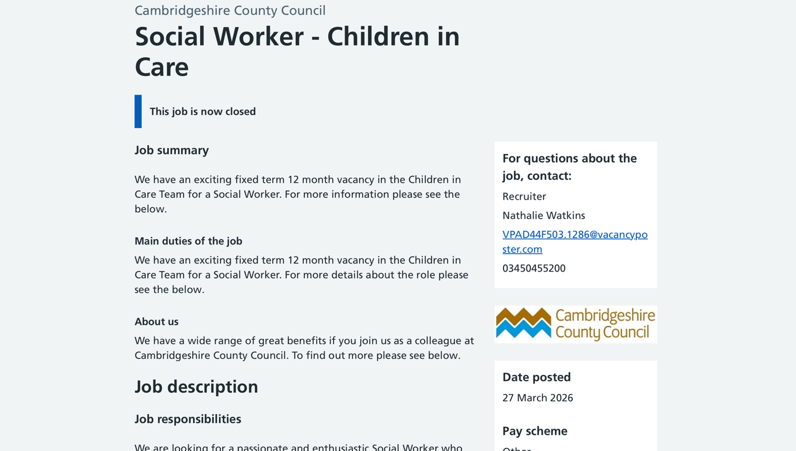
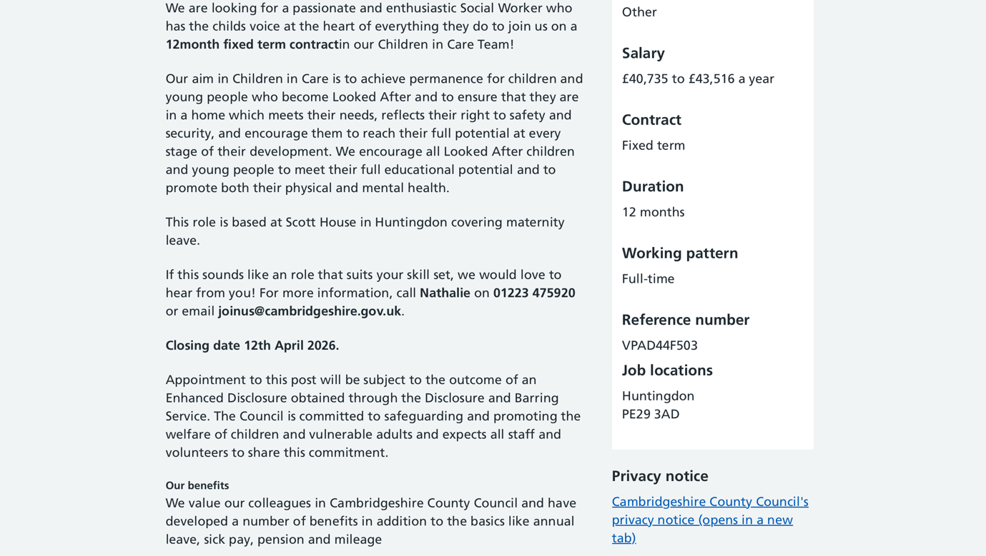
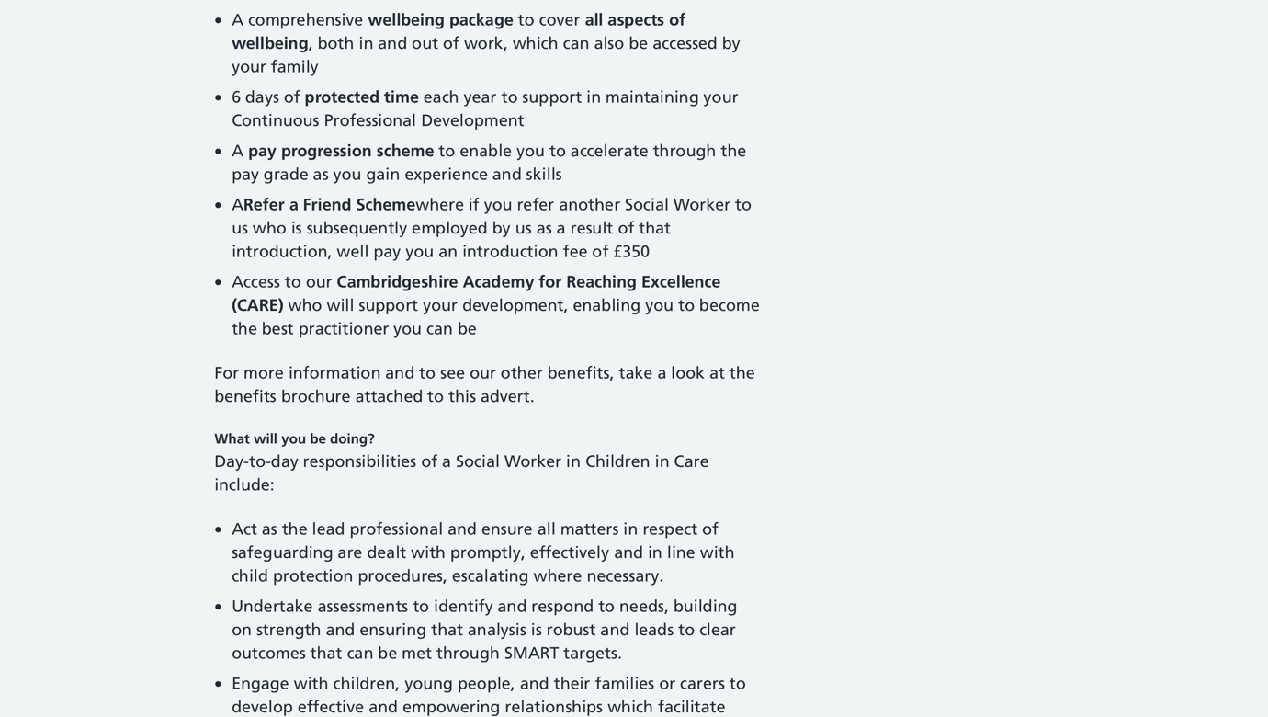
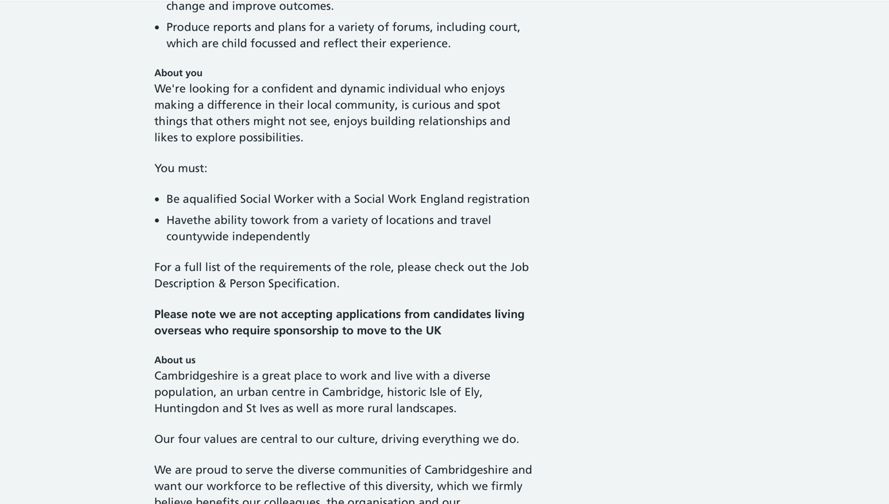
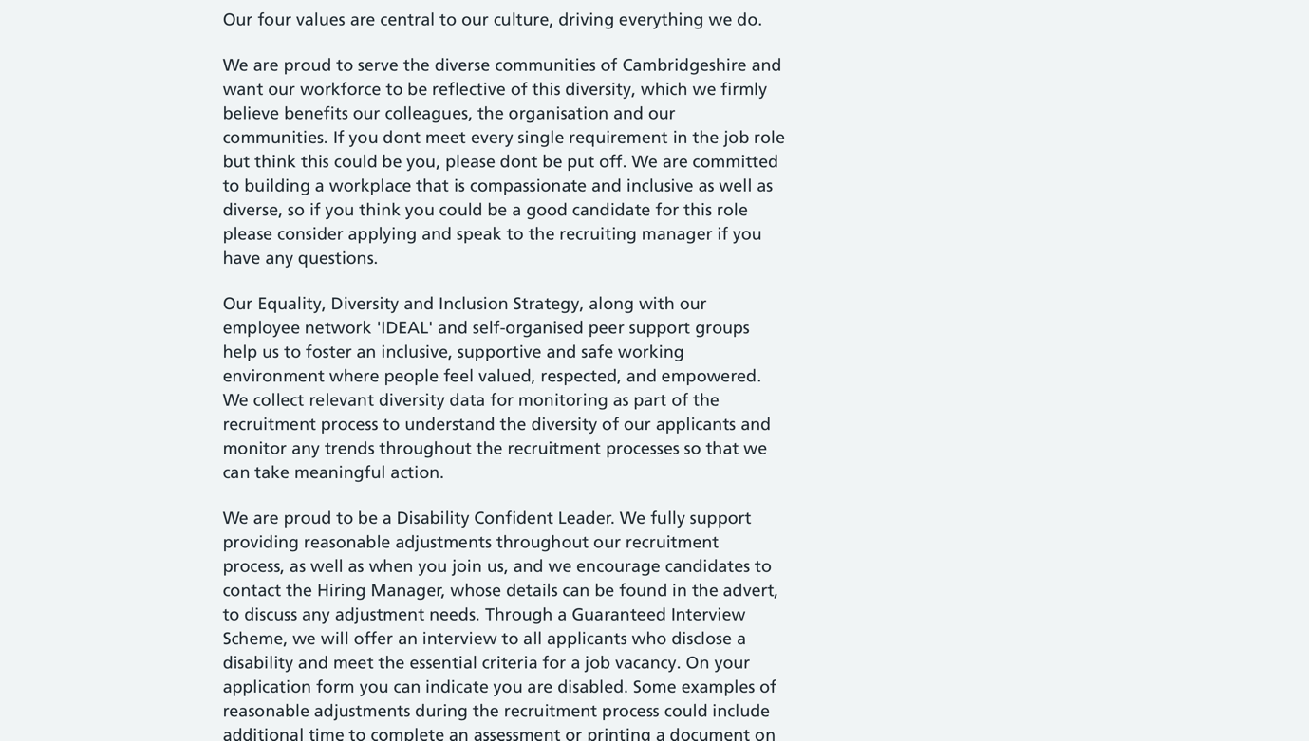

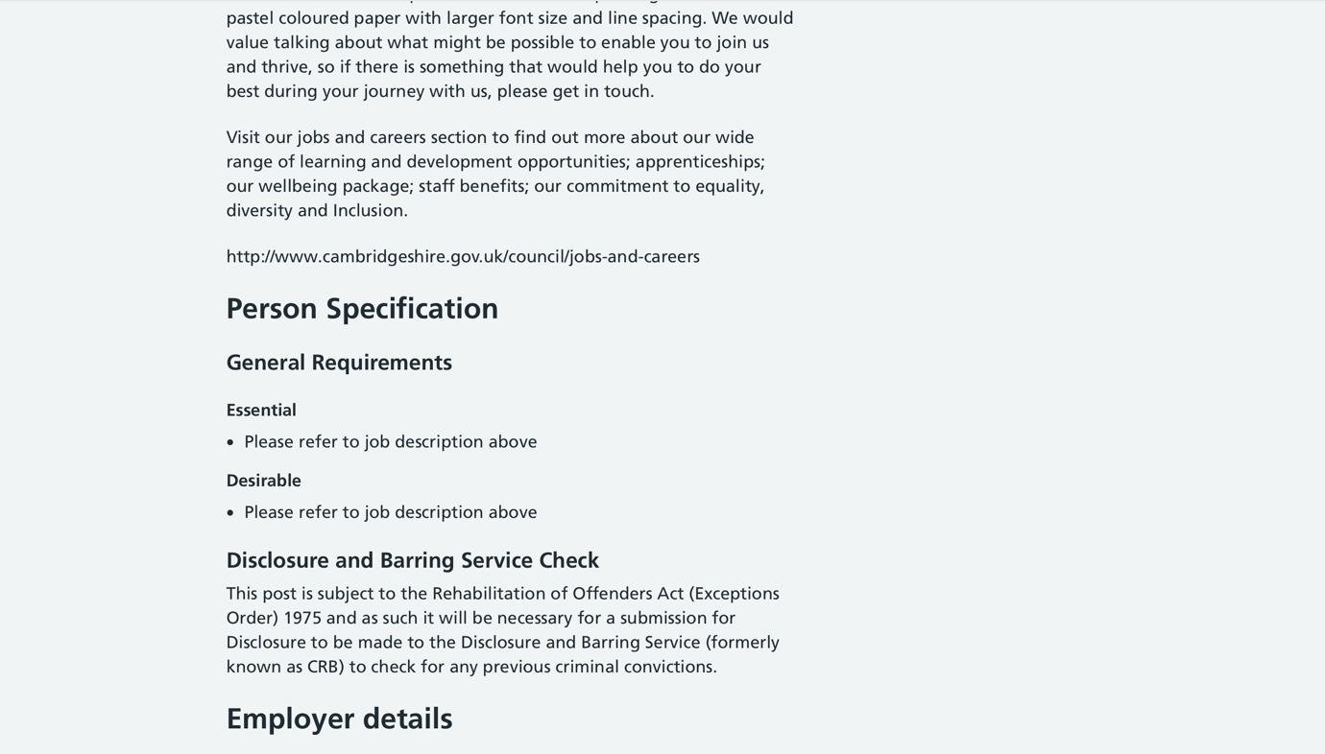



Analyse the Personal Employability Skills Required
The Children's Social Worker is a key worker for the protection of vulnerable children, supporting families and protecting children's well-being through assessment, intervention and liaison with other agencies. Current jobs in UK local authorities are all looking for Social Work England approved degree holders who are registered with Social Work England and understand safeguarding legislation, understanding of child development and understanding of effective risk assessment. Employers will also expect candidates to have professional qualifications but will also want to see evidence of good interpersonal skills, resilience, sound judgement and effective communication skills with children, families and professionals from other agencies (Skills for Care, n.d.; Social Work England, n.d.).
Communication is one of the most important employability skills for a Children's Social Worker. Practitioners need to communicate effectively with children of all ages, as well as with parents, teachers, health and legal professionals, and need to tailor their approach to communication to the individual needs of the child. Effective communication is recognised as active listening, empathy, verbal and written communication – and the ethical use of digital technologies – with people, says Social Work England. The importance of written communication to ensure accuracy is also significant, as social workers have important duties to produce assessments, safeguarding reports and court documentation which will inform key decisions regarding children's lives (Social Work England, n.d.; Social Work England, n.d.).
Resilient is another key employability trait. Children's Social Workers routinely deal with situations where children are at risk of abuse and neglect, domestic violence and family breakdown are issues, and the situation is emotionally challenging. They will be expected to make evidence-based judgements and decisions whilst maintaining professional judgement when supporting vulnerable children; being composed in challenging circumstances. In Skills for Care's list of social work skills, the primary skills are resilience, problem-solving and working effectively under pressure. These attributes help practitioners to manage the complexity of their caseloads, and to practice safely and with a focus on the people they support (Skills for care, n.d.; Social Work England, n.d.).
Team working is also crucial, as ensuring the safety of children depends on the cooperation of local authorities, schools, health and social care services, the police and voluntary services. Partnership working is seen by Social Work England as a fundamental professional behaviour and is essential for practitioners to establish trust and confidence, exchange information appropriately and collaborate with others to secure the best for children and families (Social Work England, n.d.). This is in line with the wider NHS England’s (2023) values of working together for patients, which encourage collaborative, respectful and caring care, at the heart of which is respect for others.
Digital literacy is more relevant and significant in the context of contemporary social services. They employ electronic case management systems, virtual conferences, secure information-sharing platforms, digital communication tools, and uphold confidentiality and professional conduct (Social Work England, n.d.). Social Work England (n.d.) emphasises that social workers are expected to use digital technologies in a suitable and appropriate way in their work – keeping accurate records and communicating securely with service users and partner agencies.
The Skills for Care (n.d.) Core Skills Framework underpins these employability skills through the focus on person-centred communication, safeguarding, professionalism, digital competence and problem-solving and continuous learning. These are transferable skills that allow practitioners to deliver safe, quality care and be flexible in adapting to legislation, technology and the needs of the service user (Social Work England, n.d.).
These employability skills are explained in terms of Kolb's Experiential Learning Cycle. According to Kolb (1984), professional competency can be broken down into four phases: concrete experience, reflective observation, abstract conceptualisation and active experimentation. For instance, a newly qualified Children's social worker may be present at a home visit when a parent becomes verbally aggressive with their social worker. The practitioner reviews the experience, considers other approaches to communicating and implements these considerations during subsequent safeguarding visits. This builds up confidence, EI, conflict management and professional judgement slowly over time.
For example, if a children's social worker (C.S.W.) has been sent on a safeguarding visit where a young person is exhibiting aggressive behaviour. The practitioner uses emotional intelligence, which involves a non-confrontational approach, actively listening to the child's concerns, acknowledging the child's emotions and using de-escalation techniques before the assessment. At the same time, the social worker records the incident properly, makes suitable arrangements for the safety of the child, and shares the information they have with their colleagues and/or other agencies involved. This can serve as an example of the integration of communication, resilience, teamwork, digital literacy and reflective practice in effective and ethical social work practice (Social Work England, n.d.; Social Work England, n.d.; Grant et al., 2025).

Evaluate Own Skills
When considering my suitability to apply for the position of Children's Social Worker I analysed my knowledge, skills and personal attributes against the criteria of the job description and Social Work England Professional Standards. A SWOT analysis and reflective practice was used to support this self-assessment and enabled me to identify the strengths and areas for further development.
I consider myself to be a strong communicator and inter-personal. During my Health and Social Care degree, I have delivered a lot of presentations, group discussion and written work, which has enhanced my communication skills with various groups. My teachers have always given me positive remarks on the organization of my written assignments, critical thinking and professionalism. These experiences have bolstered my confidence when I must present evidence-based arguments and work with peers. Recent studies further show that structured reflective learning and communication-based tasks have a significant impact on the confidence and interpersonal skills of social work students, thus the need to practise these skills throughout social work professional education (Kelly et al., 2024).
A key strength of mine is also being empathetic and supportive towards others, which is a key part of social work values. In my academic studies, I have studied safeguarding, person centred care, mental health and equality legislation, which has enabled me to gain an understanding of the issues faced by vulnerable children and families. My inspiration for social work is to represent the people who are facing hardships and make a difference in their lives. This is indicative of the higher tiers of Maslow's Hierarchy of Needs, including esteem and self-actualisation, which I want to pursue with my career as I want to be fulfilled professionally and see others benefit, too.
This self-evaluation has also revealed some areas needing further development. While I have gained experience through group work within university, I have not yet had much first-hand experience of working with children and families in a professional social work context. Therefore, I know that my ability to perform safeguarding assessments, deal with conflict and make informed professional decisions is still in the process of growth. Having a resilient approach to work is especially significant as Children's Social Workers are often confronted with emotionally challenging activities. The study with UK social work students further confirmed that reflective learning is a crucial aspect of resilience and that it is not something that is innate but is developed from supervision and exposure to professional practice, emphasizing the need for practical experience when developing resilience in the profession (Uisce, 2024).
I engaged in Gibbs' (1988) Reflective Cycle and used it to reflect on a recent group presentation in university where I presented the evidence and answered questions from my lecturer and classmates. At first, I was afraid to present in front of a large audience because I was afraid that I might forget something. I received positive feedback on my preparation and communication and felt that if I was well prepared, it would really help with my confidence. It was in hindsight that I realised the reason for confidence is repeated practice and not avoidance of challenging situations. Therefore, I now offer to offer some additional support at seminars and presentations to enhance my abilities in public speaking and communication.
My SWOT also identified some opportunities to improve my employability in the following ways: training in Safeguarding; volunteering with organisations who support children and families; LinkedIn and attending Social Work England events. Competition for graduate social work positions and the high emotional toll of the job are challenges that will need to be met in the future as well and will continue to demand resilience and a commitment to lifelong learning. Overall, I have many of the personal values and transferable skills that are expected of a Children's Social Worker, but it is now necessary to build further practical experience, build professional networks and build confidence to be fully ready to enter the profession.

Building a Personal Brand and Professional Identity
In the fiercely competitive UK health and social care industry, building a powerful personal brand and professional identity is crucial. Compassion, integrity, respect, equality and advocacy are my personal values and are like those expected of Children's Social Workers and those set out by Social Work England in their professional values. These values will shape the way that I pursue academic studies and how I will support vulnerable children and families in my future career.
To build my professional profile, I will create a high-quality LinkedIn profile demonstrating my skills, accomplishments and goals. My profile will feature a professional photograph, headline e.g. 'Health and Social Care Student | Passionate about Safeguarding and Child Wellbeing | Aspiring Children's Social Worker' and an 'About' section that outlines my interest in child protection and person-centred practice, along with my commitment to continuous professional development. I will be presenting appropriate university projects, safeguarding training, voluntary experience, transferable skills and appropriate professional certificates. By regularly sharing articles that are grounded in research on child safeguarding, children's mental health and social work practice, I will showcase my commitment to lifelong learning and raise my professional profile within the child safeguarding and child mental health and social work sectors.
My unique selling point (USP): Effective communication, empathy and reflective practice, strong academic research skills. I believe in using evidence for decision-making, and lifelong learning and self-development are highly valued in social work with children. The CareerEDGE Model supports developability of graduate employability in combination with career development learning, work experience, emotional intelligence, reflection and transferable skills, leading to professional confidence and employability (Pool et al., 2014).
Establishing professional networks will also be an integral part of career development. I would look to become a student member of the British Association of Social Workers (BASW), join the social workers and local authority professionals in the UK on LinkedIn and attend webinars, conferences and discussion groups online. This is in line with the Social Capital theory, which posits that job opportunities, mentoring, or knowledge exchanges may come with the process of having a professional relationship. The establishment of these networks will help to boost my professional identity and enhance my opportunities for progression in UK children's social work (Nghia et al., 2024; Krouwel et al., 2018).

Action Plan and Timeline
My long-term goal is to be able to become a Children's Social Worker within a Local Authority in the UK, and for this reason I have structured my action plan around a SMART goal framework of activities (Doran, 1981), ensuring each goal is Specific, Measurable, Achievable, Relevant and Time-bound. This plan is targeted at building my knowledge and skills as a professional in the workplace and skills for employment, alongside developing my practice and building the confidence to be registered with Social Work England.
According to Bandura's (1977) theory of self-efficacy, people gain knowledge of their own capabilities by experiencing success or failure in their own actions, watching successful actions in others, receiving verbal affirmations and feedback, and reflecting on their own experiences. Therefore, I believe that through experience, my level of confidence and competency as a future social worker will build up as I will get feedback from others, mentors, lecturers, and complete professional training. Continuous professional development (CPD) is also expected of the registered social worker and is an important aspect of ensuring competence throughout their career (Social Work England, n.d.; Social Work England, n.d.).
Timescale | SMART Goal/ Activity | Resources Required | Expected Outcome
0-6 months | Obtain my Health and Social Care degree with a high mark and update my CV and LinkedIn profile | University career service, lecturer feedback | Enhance both my professional and employability identity
0-6 months | Complete proper safeguarding and child protection training | Free or low-cost CPD courses; personal study time | Improve my safeguarding knowledge which is required to be able to work in children’s social care
6-12 months | Volunteer for a children’s charity or family support NGO for at least one day weekly | Local charities, travel expenses and personal time | Grasp practical experience while working with children and families, as well as improve communication and resilience
6-12 months | Become a student member of BASW and be part of webinars, professional workshops and networking events | Student membership fee and internet access | Develop professional network and current knowledge of social work practice
1-2 years | Apply for a graduate Children’s Social Worker job role in a UK-based local authority and start recording CPD according to the Social Work England requirements | Job applications, interview preparation and professional supervision | Secure employment and start long-term professional advancement

This action plan is realistic but ambitious, as it includes academic, practical, networking and lifelong learning. Upon achieving these objectives, I will be able to address gaps in my current skills and build my confidence, knowledge and professional identity in becoming an effective Children's Social Worker.

Conclusion
The report has shown that my values, learning and transferable skills are all well developed and are building a good platform for a career as a Children's Social Worker. While I will need to build up more knowledge and experience in practice as well as build my confidence and resilience in safeguarding practice, my action plan will be realistic and achievable in building my knowledge and experience in practice as well as building confidence and resilience in safeguarding practice through training, volunteering, networking and continuous professional development (Social Work England, n.d.). The experience of this written assignment has broadened my knowledge of the profession and the need for constant learning, reflection and professional identity in social work (Kolb, 1984). This essay has reaffirmed my love for helping vulnerable children and families and inspired me to take up an enriching career to enhance the wellbeing and life opportunities of children and families.

References
Bandura A. (1977) ‘Self-efficacy: toward a unifying theory of behavioral change’. Psychological Review. 84(2):191-215. doi: 10.1037//0033-295x.84.2.191. PMID: 847061.
Doran, G.T. (1981) ‘There’s a SMART Way to Write Management’s Goals and Objectives’. Journal of Management Review, 70, 35-36. Available at https://community.mis.temple.edu/mis0855002fall2015/files/2015/10/S.M.A.R.T-Way-Management-Review.pdf
Gibbs, G. (1988) Learning by doing: A guide to teaching and learning methods. Oxford: Further Educational Unit, Oxford Polytechnic
Grant, L., Bostock, L., Kinman, G., Shephard, L., Friel, S. and Tinarwo, M. (2025) ‘Child and family social worker knowledge and skills: Rapid evidence review’. Department for Education. Available at https://assets.publishing.service.gov.uk/media/6808da570324470d6a394efc/Child_and_family_social_worker_knowledge_and_skills.pdf
Kelly, A., Brown, S., Honess, A., McCaffrey, M., Parkinson, T., and Skoura-Kirk, E. (2024) ‘Action replay role-play: promoting social work students’ communication skills through video enhanced reflective practice’. Social Work Education. Volume 43, Issue 9. Available at https://doi.org/10.1080/02615479.2023.2275654
Kolb, D. A. (1984). Experiential Learning: Experience as the Source of Learning and Development. Englewood Cliffs, NJ: Prentice Hall
Krouwel, S. J. C., van Lujin, A., and Zweekhorst, M. B. M. (2018) ‘Developing a processual employability model to provide education for career self-management’. Education + Training. Volume 62, Issue 2, Pages 116-128. Available at https://www.sciencedirect.com/org/science/article/abs/pii/S0040091220000015
Nghia, T.L.H., Anh, N.P., Kien, L.T. (2024) ‘English Language Skills and Employability: A Theoretical Framework’. In: Nghia, T.L.H., Tran, L.T., Ngo, M.T. (eds) English Language Education for Graduate Employability in Vietnam. Global Vietnam: Across Time, Space and Community. Singapore: Springer.
NHS England (2023) Workforce development framework for care co-ordinators. 1 February. Available at https://www.england.nhs.uk/long-read/workforce-development-framework-for-care-co-ordinators
NHS Jobs (n.d.) Social Worker - Children in Care. Available at https://beta.jobs.nhs.uk/candidate/jobadvert/F0063-26-0047
Pool, L. D., Qualter, P., and Sewell, P. J. (2014) ‘Exploring the factor structure of the CareerEDGE employability development profile’. Education + Training, Volume 56, Issue 4, 303–313. Available at https://doi.org/10.1108/ET-01-2013-0009
Skills for Care (n.d.) Social worker. Available at https://www.skillsforcare.org.uk/Careers-in-care/Job-roles/Roles/Social-worker.aspx
Social Work England (n.d.) Communicating online: guidance for social workers. Available at https://www.socialworkengland.org.uk/standards/communicating-online-guidance-for-social-workers
Social Work England (n.d.) CPD guidance for social workers. Available at https://www.socialworkengland.org.uk/cpd/cpd-guidance/
Social Work England (n.d.) CPD: what you need to know. Available at https://www.socialworkengland.org.uk/cpd/what-you-need-to-know
Social Work England (n.d.) Knowledge, skills and behaviours. Available at https://www.socialworkengland.org.uk/education-training/knowledge-skills-and-behaviours
Social Work England (n.d.) Professional standards guidance. Available at https://www.socialworkengland.org.uk/standards/professional-standards-guidance
Social Work England (n.d.) ‘Standard 4: Maintain my CPD’. In: CPD guidance for social workers. Available at https://www.socialworkengland.org.uk/cpd/the-cpd-standard
Uisce, J. (2024) ‘A visual investigation of resilience from the perspective of social work students in the UK’. Social Work Education. 43(4), pp. 1024-1038. (doi: 10.1080/02615479.2022.2161506). Available at https://eprints.gla.ac.uk/378281/1/378281.pdf

