

Student name: Ronke Olomola
Student ID:1916047

Module name: ITP
Module code:BMHP5003_Lon
Lecturer name: Eleni Koutsogeorgou

Obesity
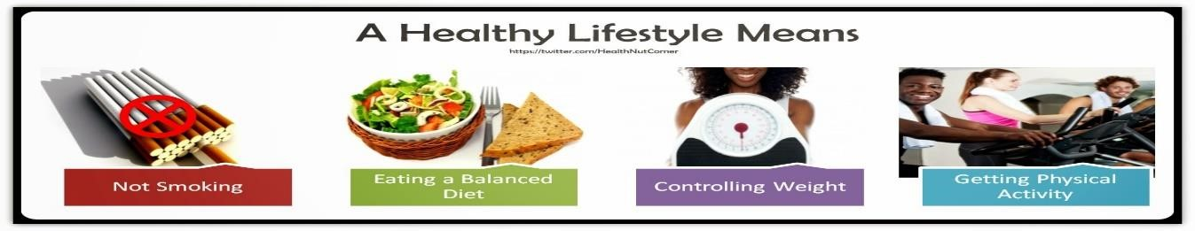
This Phot
o

b
y Unknown Author is licensed unde
r

CC B
Y
-
N
C
-
N
D

Definition: obesity could be defined as an individual that is overweight. National Health Service (2019) states that obesity describes a person with a lot of body fat. | Physiology: Obesity occurs as the result of an imbalance between energy expenditure and calorie intake. (Saber and Geibel ,2021). Obesity can take place when an individual is eating more than what the body needs.
Findings: From Patient A  Risk factors  Poor diet: Could lead to type 2 diabetes High bp: Could lead to a stroke if not checked  BMI 32.3 high risk could lead to cardio vascular disease and also cause heart failure. BMI is one of the indicators that Patient A has excess fat on her body family history: dad had heart attack 68  Sister high cholesterol | Interventions/Management Options:  Change of diet  Exercise  Reduce alcohol intake
References  Lockett, M, S., (2019) “Diabetes and obesity “ diabetes.co.uk  Louzada, M, L., Millett, C., Monteriro., A, C., Levy, R, B., (2020) Ultra – processed food consumption and indicators of obesity in the UK population  Manrique-Acevedo, C., Chinnakotla, B., Padilla,  J., Martinez-Lemis, L, A., Gozal D., (2020),  “Obesity and Cardiovascular disease in women”  International journal of obesity 44, 1210 – 1226 National Health Service (2019), ‘Overview  Obesity’ | Saber, A, A., Geibel, J., (2021) “What is the  pathophysiology of obesity?” Medical  Economics MedScape  Paixao, C., Jorge, R., Dias, M., Carraca, V.,  Yamakoullia, M., Zwaan, M., Sirpa, Z., Soini, J,  O., Hill, P, J., Santos, I, T., (2020)  Obesity/Weight loss management obesity reviews https://doi.org/10.1111/obr.13003  Marques, A., Peralta, M., Naia, A., Laoureiro, N., Gaspar de Matos, M., (2018), ‘Prevalence of adult overweight and obesity in 20 European countries’ European journal of public health vol 28, issue 2 april 2018 pg 295 – 300 https://doi.org/10.1093/europub/ckx143

Speaker Notes
Definition:
Obesity is when an individual’s food intake is more than the body needs. It is a very big issue in the United Kingdom, a research was undertaken that demonstrated that more than a quarter of adults are obese. (Louzada, et al 2020). In numerous countries obesity has been their main focus as regards a public health concern. Marques et al (2020) explain that overweight and obesity are the focus of many public health concerns regarding prevention, control and the decrease of prevalence.
Findings and Risk Factors:
Patient A showed that she is 86kg and her height was 1.65cm her BM was worked out and this was 32.2 which places her on the high risk. Obesity in women can lead to cardiovascular diseases. Manrique-Acevedo et al (2020) agree with this line of thought and state that women are at higher risk of CVD when obese. The fact that her bp was 180/90 shows that she suffers from high blood pressure. Loss of weight could also help lower her blood pressure. Poor diet of eating chips and fries also eat meat. Which could lead to diabetes, Diabetes.co.uk (2019) explain that been over- weight can lead to type 2 diabetes especially when the BMI is over 30.
Interventions/Managements:
Patient A needs to be educated on the following:
Change of diet: adding vegetables and cooked meals at home Paixao et al (2020) explain that healthy foods available at home, regular breakfast intake, increasing vegetable consumption also increase in physical activity is the most
Exercise: Due to Patient A’s busy schedule the gym may not be possible however brisk walking starting slowly once a week and then increasing it as it is possible. patient A needs to lose 4.3kg, 1 2 lb a week (NHS 2019, overview obesity). Patient A can start walking from work home if not too far or take up cycling.
Reducing Alcohol intake: Patient A drinks a lot especially at the weekend however for her to lose weight she must reduce her intake. Locket (2019) states that alcohol can contribute to excess belly fat.

