

Changemakers: Building Your Personal Brand for Sustainable Employment



Component 1: Online Portfolio
Student Name: Carla Cardoso
Student ID: 1818222
Programme: BSc (Hons) Health and Social Care
Module Code: BMHP5015
Lecturer: Caroline Salami
Date of submission: 5th December 2025 14:00

Introduction
This online portfolio is a record of how I've grown as a person and as a worker through the four units of the module Changemakers: Building my Personal Brand for Sustainable Employment. We had the chance to think about ourselves, learn about the world, plan for our future jobs, and get healthier in each unit: Brand Me, It's a Small World, Opportunity Knocks, and The Pursuit of Happiness.
As a student preparing for a career in social work, I have learnt how important it is to know yourself, have a professional identity, and have strong moral values in order to build a career that lasts and has meaning. Thinking about things has helped me link what I've learnt in theory to what I've done in real life. The portfolio uses relevant frameworks, such as Goleman's Emotional Intelligence (1998), the Johari Window (Luft and Ingham, 1955), Hofstede's Cultural Dimensions (2011), SMART Goals (Doran, 1981), and Seligman's PERMA Model (2011), to show how I have grown and how ready I am to work in a professional setting.

Unit 1: Brand me
This unit helped me learn more about myself and my professional identity. It taught me how my values, the way I talk to people, and my emotional intelligence affect my chances of getting a job in health and social care.
Motivation
The internal process that starts, guides, and keeps goal-oriented behaviour going (American Psychological Association, 2023) is very important for professional growth because it affects how hard people work and how long they keep learning and performing. In social work, it is essential to maintain engagement, empathy, and resilience when confronted with complex emotional difficulties.
I used the Johari Window model (Luft and Ingham, 1955) to think about my strengths and weaknesses and why I want to be a social worker in the future. This model demonstrates the significance of self-awareness and feedback for personal development. I am very good at listening, talking to people, and understanding how they feel. I also realised that I needed to work on my self-confidence and assertiveness to be able to handle tough conversations better.
Maslow's Needs Hierarchy
Maslow's (1943, 1970) Hierarchy of Needs theory delineates five tiers of human motivation: physiological, safety, love and belonging, esteem, and self-actualization. Satisfying lower-level needs fosters the pursuit of higher-level growth needs. Three levels of real-world action can help us understand motivation:
1. Deficiency needs (D-needs) – behaviour motivated by the absence of basic stability or security.
2. Growth needs (B-needs) – actions driven by learning, creativity and contribution.
3. Self-actualisation – striving for fulfilment and purpose beyond external reward..
There was a time in my own practice when I wasn't as motivated because I wasn't making as much progress with families as I wanted to. This changed how they felt about their effectiveness, which is what Maslow's esteem needs are all about. They used Gibbs' Reflective Cycle (1988) to think about how they felt and took positive steps, like asking a supervisor and peers for help to meet their need to belong. People felt like they had done something when they set SMART goals (Doran, 1981) for each case. Mindfulness practices helped them remember their purpose, which helped them reach their full potential. This experience demonstrates how motivation can fluctuate depending on the need to belong. It also shows how important it is for social workers to think about themselves and have people they can turn to for help to stay professional and caring.
Goleman (1998) talked about how developing emotional intelligence can change how people act at work. The module was about controlling your emotions, being aware of yourself, and finding motivation. These things can help you make better decisions and get along better with others at work. This led to the use of self-reflection tools like Gibbs' Reflective Cycle (1988) to keep track of how well people were doing.
Example:
I used emotional intelligence techniques (Goleman, 1998) to manage my feelings while I was working with a service user who was upset. I made the user feel safe and encouraged them to solve problems by recognising my own anxiety and focussing on empathy. Afterward, I thought about the experience using Gibbs' Reflective Cycle (1988). I wrote down how empathy and emotional control made communication and trust better, which are important skills in social work.
The Brand me unit helped me understand professional identity better by stressing honesty, privacy, and responsibility, as the Council (HCPC, 2023) says it should. It helped me be real when I talked about myself, which helped me build a professional brand that was in line with the values of social work. The unit emphasised that establishing a distinct personal brand necessitates recognising one's skills and embodying values such as empathy, equality, and respect, which are essential for cultivating trust with service users and colleagues.
Critical Reflection
Unit 1 emphasised that personal brand development entails acknowledging strengths and rectifying behaviours such as insufficient assertiveness. To build a confident, ethical professional identity that meets HCPC standards, you need to keep thinking about and getting feedback on your work.
Critical Conclusion:
I used Goleman's emotional intelligence framework to turn my first defensive response into a positive outcome during a difficult interaction with a service user who was upset. This experience showed how hard it is to keep your emotions in check when you're stressed and how important it is to keep thinking about and watching over them.
Example of Emotional Intelligence in Practice:
I recognise that Maslow's hierarchy elucidated variations in my motivation. People have said bad things about the model because it moves in a straight line and doesn't have any real-world evidence to back it up. My own experience demonstrated that emotional exhaustion may arise despite the fulfilment of lower-level needs.
Theoretical Models' Limitations:
Using the Johari Window showed that the backgrounds and perceptions of my coworkers can affect their feedback. This suggests that my view of myself and how others see me may not match up. This realisation pushed me to look for more structured and varied feedback.

Screenshot 1 – My Future Career Goal
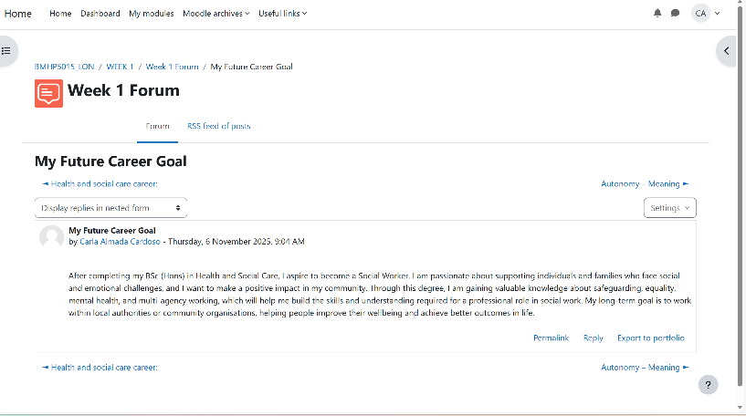

Screenshot 2 – Emotional Intelligence in Health and Social Care
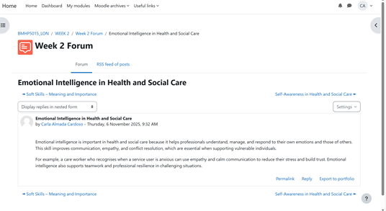
Unit 2: It’s a Small World
This unit emphasized the importance of global awareness, cultural competence, and diversity in social work. It highlighted the necessity of understanding how culture and communication influence service engagement. Through Hofstede’s Cultural Dimensions Theory (2011), it was illustrated how aspects like power distance and individualism can shape interactions between practitioners and clients, particularly demonstrating how collectivist cultures may value family decision-making over individual autonomy, thereby affecting care planning and promoting inclusive support.
Through online discussions, I reflected on cultural competence frameworks, as proposed by (Campinha-Bacote 2002), which foster awareness, knowledge, and cross-cultural skills in line with the Equality Act (2010) and the Working Together to Safeguard Children (HM Government, 2023). This activity prompted me to examine my cultural assumptions. As a bilingual person in the UK, my adaptation experiences have enhanced my empathy for users from diverse backgrounds, emphasizing the necessity of cultural humility—remaining open and curious rather than presuming competence.
Challenge:
At first, I found it challenging to communicate confidently with individuals from different cultural and linguistic backgrounds. I sometimes worried that I might unintentionally say something inappropriate or fail to understand cultural expectations, especially when discussing sensitive issues such as family or health.
How I Overcame It:
- Applied Hofstede’s Cultural Dimensions (2011) and Campinha-Bacote’s Cultural Competence Model (2002), to understand cultural values' impact on communication and decision-making.
- Practiced cultural humility by asking open-ended questions and allowing service users to share their perspectives.
- Utilized Gibbs’ Reflective Cycle (1988), to acknowledge that mistakes are part of learning and emphasized active listening as a sign of respect.
- Gained confidence and adaptability while becoming more empathetic through reflective practice.
- Plans to enhance cultural competence through workshops, reading about diverse communities, and obtaining feedback from peers.
- Recognized the necessity of combining cultural theory knowledge with emotional intelligence in effective social work practice.
- Acknowledged the importance of global awareness in social work, including issues like migration, poverty, and health inequality, fostering a commitment to lifelong learning and advocacy for inclusive policies.
Critical Reflection:
Unit 2 highlighted that cultural competence requires continuous reflection, openness and developing confidence to engage with diverse communities.
Critical Conclusion:
I noticed my anxiety when speaking with service users from unfamiliar backgrounds, and realised that my fear of being inappropriate sometimes limited communication. Through supervision, I learned to ask open questions and accept that mistakes are part of the learning process.
Example:
Campinha-Bacote’s framework assumes cultural competence is fully achievable, yet in practice, cultural humility is a continuous process rather than a completed skill.
Limitations:
While Hofstede’s dimensions supported my understanding of cultural differences, I also
recognised that these models can oversimplify complex cultural identities. Real-life
interactions showed me that individuals do not always follow national cultural patterns.
Screenshot 3 – Making Connections in Health and Social Care
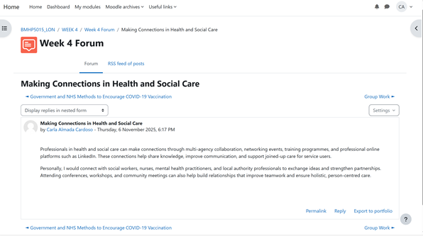
Screenshot 4 – Connections Outside My Industry
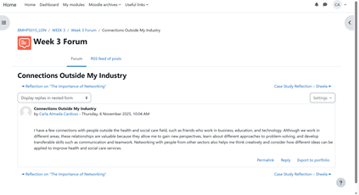
Unit 3: Opportunity Knocks
This unit focused on employability, goal setting, and career pathways, facilitating reflection on translating academic learning into professional development. Using SMART goal setting (Doran, 1981), an action plan was created to achieve strong academic performance, gain placement experience in children and family services, and apply for a master's in social work by 2027(Time-bound). The Opportunity Knocks activities highlighted transferable skills like communication, teamwork, leadership, and problem-solving, aligning with the Social Work England Professional Standards (2023), which emphasize critical reflection, accountability, and effective partnership working.
Example: Opportunity Knocks
To put this plan into action, I attended a university employability workshop that focused on NHS and local authority recruitment frameworks. This session helped me understand how to apply for roles in social care and how to align my professional portfolio with the Social Work England standards (2023). I also created a LinkedIn profile to build professional connections and showcase my learning achievements.
Through this new opportunity, I engaged in conversations with practitioners currently working in children’s and family services, which gave me insight into the realities of case management and multi-agency collaboration. These interactions not only improved my networking confidence but also encouraged me to explore potential placement opportunities within the NHS and local councils. This experience reinforced the importance of professional visibility, communication, and maintaining positive contact with employers to support ongoing career development.
Networking involves developing and sustaining professional relationships that offer mutual support, information, and growth opportunities (CIPD, 2023). In social work, it is crucial for sharing best practices, collaborating across agencies, and fostering learning and professional development.
I learned about the significance of networking and LinkedIn profile development in establishing a professional presence, emphasizing the impact of digital identity on employability and the need for responsible online management.
Reflecting through Gibbs' Reflective Cycle (1988), I realized that rejection or feedback in job applications signifies growth opportunities rather than failure. In social work, resilience is crucial for managing emotionally challenging situations, aligning with the growth mindset (Dweck, 2006) concept that promotes learning from challenges.
My Weakness and Challenge:
Initially, I struggled with networking due to shyness and a lack of confidence, which hindered my ability to introduce myself and engage with new professionals. This affected my opportunities for building connections and advancing my goals.
How I Overcame It:
To address challenges in networking, I attended university workshops and online sessions, learning key communication techniques like active listening and maintaining a LinkedIn profile. I focused on mutual learning rather than self-promotion.
By initiating small conversations and connecting with others, I improved my confidence and established contacts in the NHS and local authority sectors, gaining valuable insights for placement applications. This experience underscored the importance of authenticity, curiosity, and sustained communication in effective networking.
Reflection:
By transforming a weakness into a learning opportunity, the author discovered that networking enhances employability and fosters teamwork and collaboration in social work. They intend to further develop this skill through sector events, mentorship, and professional forums like BASW and NHS Future Learn.
This unit has bolstered their career planning confidence and aligned professional development with the ethical standards of social work.
Critical Reflection:
Unit 3 showed me that employability is not only about skills and qualifications but also overcoming internal barriers and practising ongoing self-development.
Critical Conclusion:
During an employability workshop, I hesitated to introduce myself to a social work team
leader. Reflecting on this, I understood it was fear of appearing inexperienced. This
reinforced the need to continue developing self-confidence and professional communication.
Example:
Networking activities revealed that my confidence still fluctuates, especially when
approaching senior professionals. This highlighted that personal barriers can affect
employability as much as technical skills.
Limitations:
SMART goals facilitated my planning; however, I found that rigid goal-setting can seem unrealistic during emotionally challenging times or when juggling study, family, and placement obligations.
Screenshot 5 – SMART Goals Planning Activity
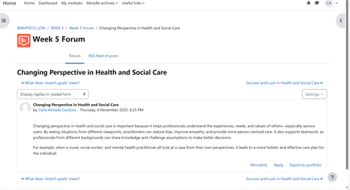

Screenshot 6 – Employability and Digital Presence
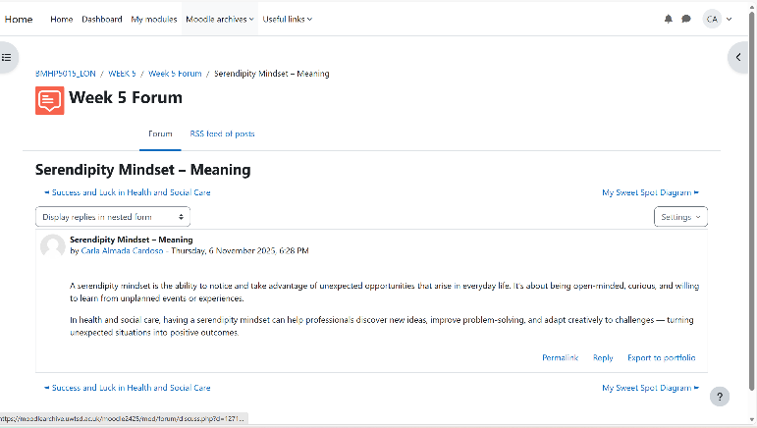

Unit 4: The Pursuit of Happiness
The final unit explored wellbeing, resilience, and work–life balance, which are fundamental to sustaining a career in health and social care. I learned that self-care is not a luxury but a professional responsibility.
Using Seligman’s PERMA Model (2011) — which includes Positive Emotion, Engagement, Relationships, Meaning, and Accomplishment — I evaluated how wellbeing influences performance and satisfaction. I realised that maintaining balance supports both personal and professional growth. For example, engaging in reflective practice, mindfulness, and supervision sessions enhances emotional regulation and reduces burnout risk.
Through the wellbeing activities, I identified strategies to build resilience, such as maintaining healthy boundaries, seeking peer support, and setting realistic expectations. This aligns with the British Association of Social Workers (BASW, 2021) guidance, which promotes reflective supervision and emotional wellbeing for practitioners.
I also explored the relationship between happiness and purpose. In social work, fulfilment often stems from making a positive difference in people’s lives rather than external rewards. The unit reminded me that personal satisfaction derives from contributing meaningfully to society, which reinforces the values of care, respect, and social justice.
By applying these wellbeing principles, I have developed a more sustainable approach to professional practice — recognising that caring for others begins with caring for oneself.
Critical Reflection:
Unit 4 emphasised that wellbeing requires deliberate strategies, boundary setting and
continuous reflection to prevent burnout and sustain long-term practice
Critical Conclusion:
Placement experiences highlighted that stress affected my sleep and concentration, underscoring the need for early intervention, effective supervision, and realistic workload management.
Example:
Wellbeing models often assume individuals have equal access to support systems, yet in professional environments, workload and organisational culture strongly influence
practitioner resilience.
Limitations:
Although PERMA helped me understand wellbeing, I recognised that in practice, maintaining
balance is challenging when facing emotional intensity or safeguarding pressures.
Screenshot 7 – Reflection on My Limiting Beliefs
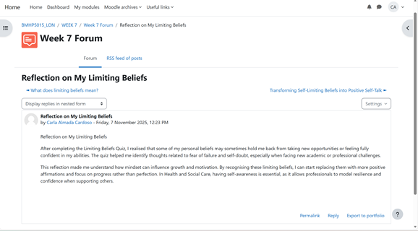
Screenshot 8 – Transforming Self-Limiting Beliefs into Positive Self-Talk
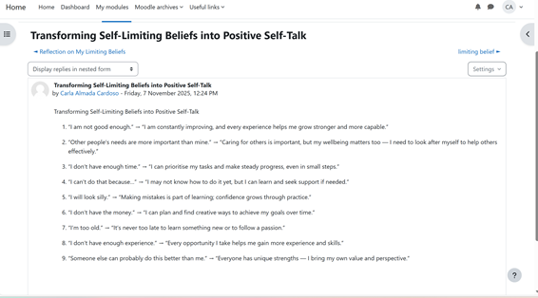

Conclusion
Engagement with the Changemakers: Building my Personal Brand for Sustainable Employment module has enriched my understanding of employability, professional identity, and wellbeing within the social work context. Each unit contributed distinct insights: Brand You fostered self-awareness and emotional intelligence; It’s a Small World enhanced intercultural understanding; Opportunity Knocks developed my strategic and goal-setting abilities; and The Pursuit of Happiness underscored the importance of wellbeing and resilience in sustainable practice.
Through reflective analysis, I have integrated theory and experience to strengthen my professional identity and confidence in articulating a coherent personal brand. My practical actions, including self-assessments, reflective exercises guided by Gibbs’ model, participation in employability workshops, and professional networking, demonstrate purposeful steps toward career development. The application of models such as Hofstede’s Cultural Dimensions and the PERMA framework has supported both professional competence and personal wellbeing.
Collectively, these experiences affirm my commitment to continuous professional learning, ethical practice, and reflective self-awareness—foundations essential to effective and compassionate social work practice.

References:
American Psychological Association (2023) APA Dictionary of Psychology. Washington,
DC: APA.
BASW (2021) Professional Capabilities Framework: Social Work in England.
Birmingham: BASW.
Campinha-Bacote, J. (2002) ‘The process of cultural competence in the delivery of
healthcare services: a model of care’, Journal of Transcultural Nursing, 13(3), pp.
181–184.
CIPD (2023) Networking and Building Professional Relationships. Available at:
https://www.cipd.co.uk (Accessed: 7 November 2025).
Doran, G. (1981) ‘There’s a S.M.A.R.T. way to write management goals and objectives’,
Management Review, 70(11), pp. 35–36.
Dweck, C. (2006) Mindset: The New Psychology of Success. New York: Random
House.
Gibbs, G. (1988) Learning by Doing: A Guide to Teaching and Learning Methods.
Oxford: Oxford Polytechnic.
Goleman, D. (1998) Working with Emotional Intelligence. London: Bloomsbury.
HCPC (2023) Standards of Conduct, Performance and Ethics. London: HCPC.
Hofstede, G. (2011) ‘Dimensionalizing cultures: The Hofstede model in context’, Online
Readings in Psychology and Culture, 2(1), pp. 1–26.
Luft, J. and Ingham, H. (1955) ‘The Johari Window: A graphic model for interpersonal
relations,’ University of California Western Training Laboratory in Group Development.
Maslow, A. H. (1943) ‘A theory of human motivation’, Psychological Review, 50(4), pp.
370–396.
Maslow, A. H. (1970) Motivation and Personality. 2nd edn. New York: Harper &amp; Row.
Seligman, M. (2011) Flourish: A Visionary New Understanding of Happiness and Well-
being. New York: Free Press.
Social Work England (2023) Professional Standards for Social Workers. London: SWE.
Working Together to Safeguard Children (2023) Statutory Guidance on Inter-agency
Working to Safeguard and Promote the Welfare of Children. HM Government.

