Advanced Statistical Programming——Data Analysis

Question 1
- Question 1 is designed to create a suitable graphic to illustrate the changes in average seasonal maximum temperatures from 1892 to 2022, with the data plotted for every tenth year instead of annually. Let's introduce each part of my code works:
The code begins by reading data from "WalesClimateData.xlsx" into a data frame called climate, using the read.xlsx function. And the data specifically resides on the first sheet of the excel file, as indicated by the parameter 1 in the function.
As data is imported, the code filters this data frame to include only the rows where the year column values are between 1892 and 2022, and more specifically, the values for every tenth year rather than for every year. This filtered data is stored in a new data frame named climate_year_filter.
The next step involves selecting specific columns from this filtered data frame. The columns chosen are those related to the seasons (win, spr, sum, aut) along with the year column. The result of this selection is stored in another data frame, climate_season_filter. This step is crucial for focusing the analysis on the seasonal data and the corresponding years.
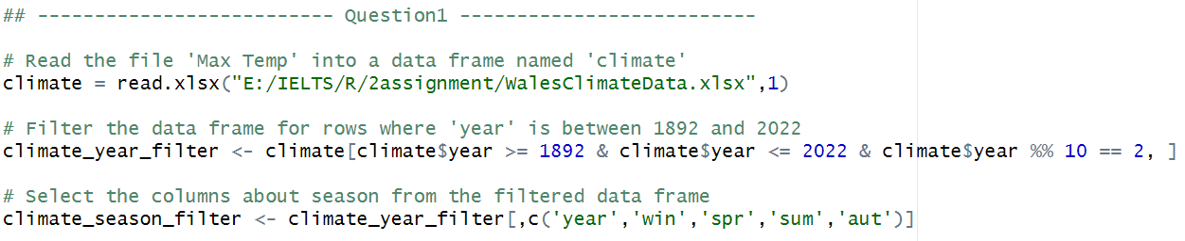
Following the selection of columns, the code transforms the data into a long format using the gather function. This function reshapes the data frame by collapsing the season columns into two new columns: one for the season names (season) and another for the corresponding temperature values (temperature). This transformation is a vital step in preparing the data for effective visualization and analysis.
Finally, the temperature column in the transformed data frame, climate_long, is converted from its current format to a numeric format. The plot visualizes data from the climate_long data frame, mapping year to the x-axis and temperature to the y-axis. It uses different colors to distinguish seasons.
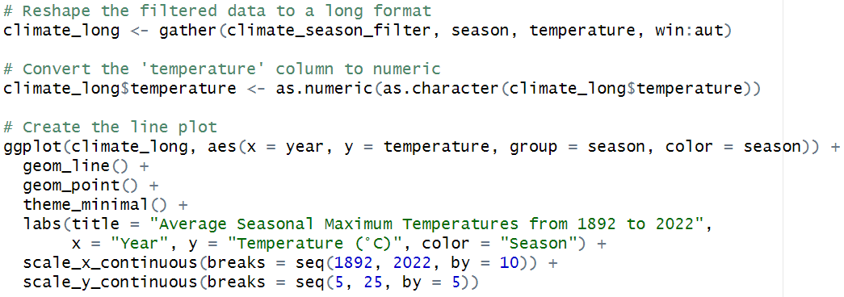
- Visualization
As shown in Fig.1, it is a line plot illustrating the average seasonal maximum temperatures from the years 1892 to 2022. The x-axis represents time, specifically the years in ten-year increments, and the y-axis shows temperature in degrees Celsius. Overall, although summer, spring, winter, autumn temperatures exhibit some fluctuations , they show an overall increase over time.
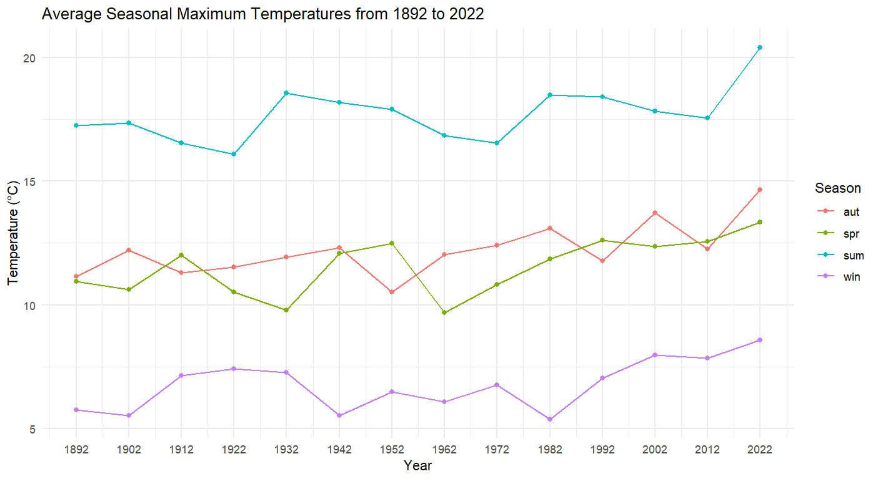
Fig.1 The average seasonal maximum temperatures from the years 1892 to 2022

- The flowchart is as follows:
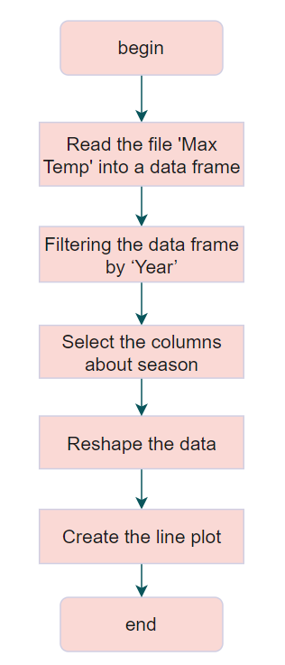

Question 2
- Question 2 is designed to calculate the correlation between the total annual rainfall and the annual maximum temperature. Let's introduce each part of my code works:
Initially, the script reads two separate datasets from "WalesClimateData.xlsx" into two data frames: climate_max for maximum temperature data and climate_rainfall for rainfall data. The data is sourced from the first and fourth sheets of the workbook, respectively.
After importing the datasets, the script merges them into a single data frame climate_combined based on the 'year' column, which is common to both datasets. This merging process allows for a combined analysis of the two climate variables. Once merged, the columns are renamed to "year," "AnnualMaxTemp," and "AnnualRainfall" for clarity.
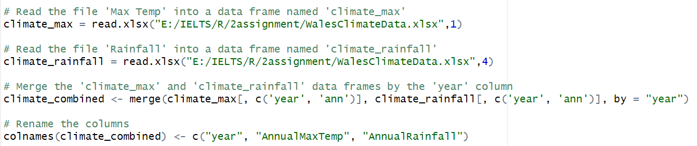
The script then calculates the Pearson correlation coefficient between the annual maximum temperature and annual rainfall to identify any linear relationship between the two variables. In addition to computing the correlation coefficient, a correlation test (cor.mtest) is performed.
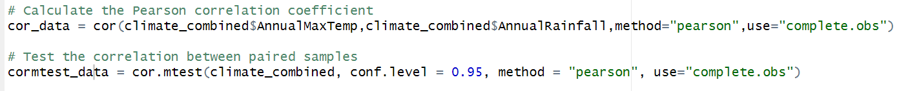
For visualization, the script employs three functions: ggpairs, chart.Correlation and scatterplot. The ggpairs function is likely used to create a matrix of scatterplots for all pairwise comparisons in the climate_combined data frame, along with the correlation tests. The chart.Correlation function, which comes from the 'PerformanceAnalytics' package, is intended to plot a correlation matrix that graphically represents the strength and direction of the relationships. The scatterplot depict the relationship between annual maximum temperature and annual rainfall. This plot includes points for the data values and a linear model fit line to indicate the trend.
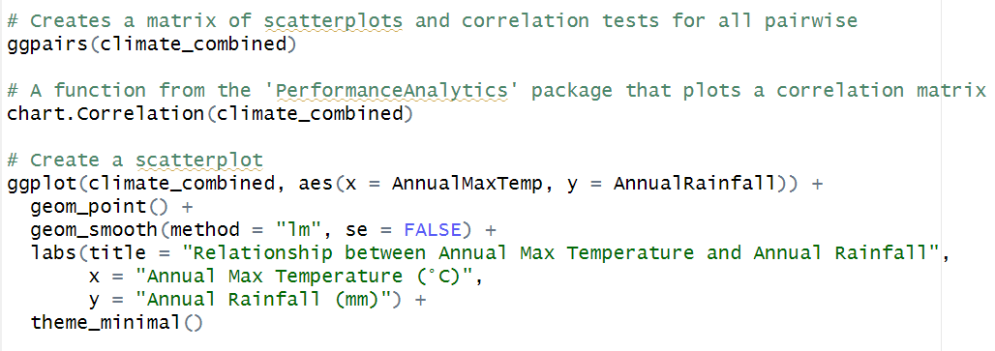
- Analysis and Visualization
As shown in Fig.2, in the context of the data, it suggests that there is no strong linear relationship between these two variables.
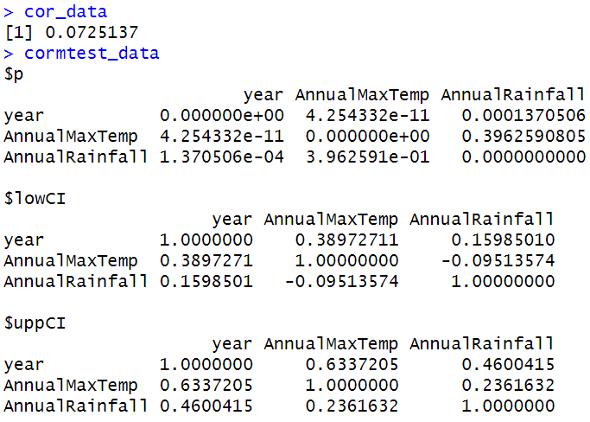
Fig.2 Correlation between the total annual rainfall and the annual maximum temperature

As shown in Fig.3, it shows histograms for each variable: 'year', 'AnnualMaxTemp', and 'AnnualRainfall'. The histograms provide a visual distribution of the data points across the time frame. The upper triangle of the matrix displays the Pearson correlation coefficients. Notably, there is a correlation coefficient of 0.522 between 'AnnualMaxTemp' and 'year', indicating a moderate positive relationship, suggesting that maximum temperatures may have risen over the years. The correlation between 'AnnualMaxTemp' and 'AnnualRainfall' is 0.073, which is very low, implying almost no linear relationship between the two.
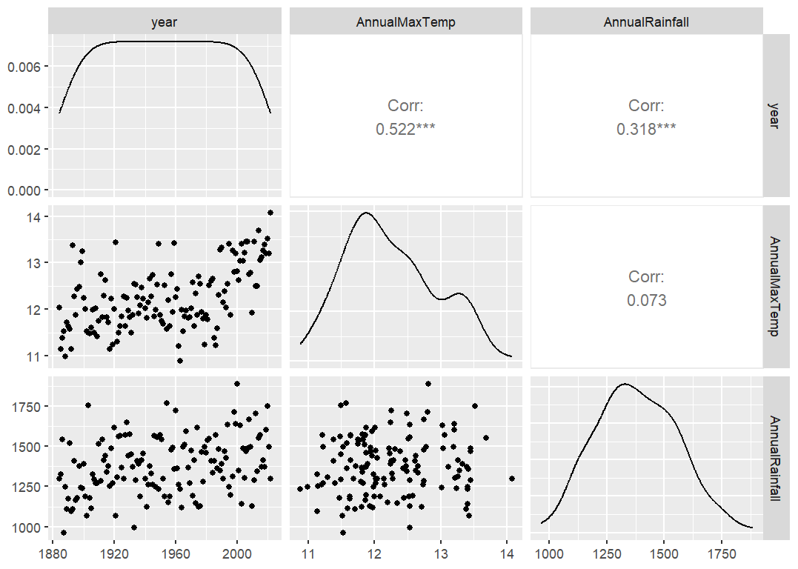
Fig.3 Ggpairs of the correlation between the total annual rainfall and the annual maximum temperature

Fig.4 includes scatterplots on the lower triangle, with the 'year' plotted against 'AnnualMaxTemp' and 'AnnualRainfall'. The overlay of a smooth line on these scatterplots suggests trends over time. The histograms on the diagonal now include a density plot, showing the distribution of each variable. The bar graphs on the upper triangle show correlation coefficients, with stars indicating the significance level. A value of 0.52 between 'AnnualMaxTemp' and 'year' confirms the moderate positive correlation seen in the first image. The correlation of 0.32 between 'year' and 'AnnualRainfall' suggests a weak positive relationship, indicating that rainfall might have slightly increased over the years.
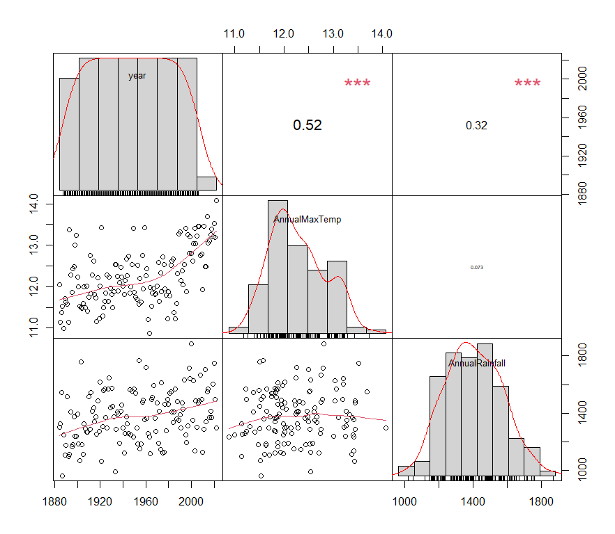
Fig.4 Chart of the correlation between the total annual rainfall and the annual maximum temperature

Fig.5 suggests that there is no significant linear relationship between annual maximum temperature and annual rainfall, as the line does not show an upward or downward trend. The density of the data points is fairly uniform across different temperatures, showing variability in rainfall that does not correspond to changes in temperature.
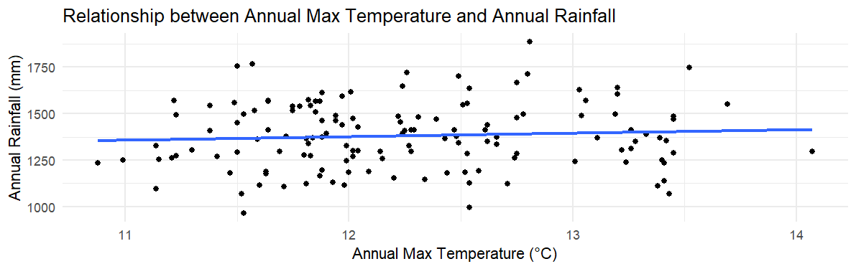
Fig.5 Scatterplot of the correlation between the total annual rainfall and the annual maximum temperature
Overall, both images suggest that annual maximum temperatures have a noticeable trend over time, while rainfall shows a weaker pattern. The temperatures and rainfall do not appear to have a strong linear relationship with each other based on the data presented.
- The flowchart is as follows:
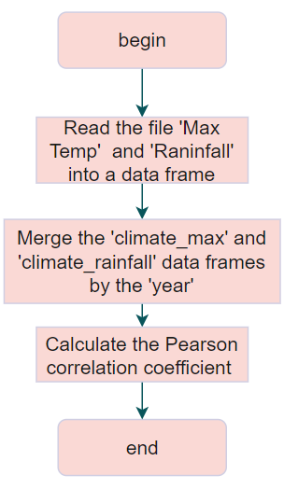

Question 3
- Question 3 is designed to perform a t-test to identify whether there is a significant difference in minimum temperatures between August 1890-1910 and August 2000-2020. Let's introduce each part of my code works:
Firstly, it reads the minimum temperature data from the second sheet of the excel file into a data frame called climate_min. Once the data is loaded, the script filters this data frame twice to create two separate subsets. One subset contains data from the years 1890 to 1910, and the other from 2000 to 2020.
After the data is filtered, the script proceeds to select the relevant columns for comparison. For both time periods, it narrows down the data to the 'year' and 'aug' columns.
The final step is the execution of a t-test, which is a statistical hypothesis test that compares the means of the August temperatures between the two time periods. The t-test will check whether there is a statistically significant difference between the average minimum temperatures of August in the early 20th century and the early 21st century.
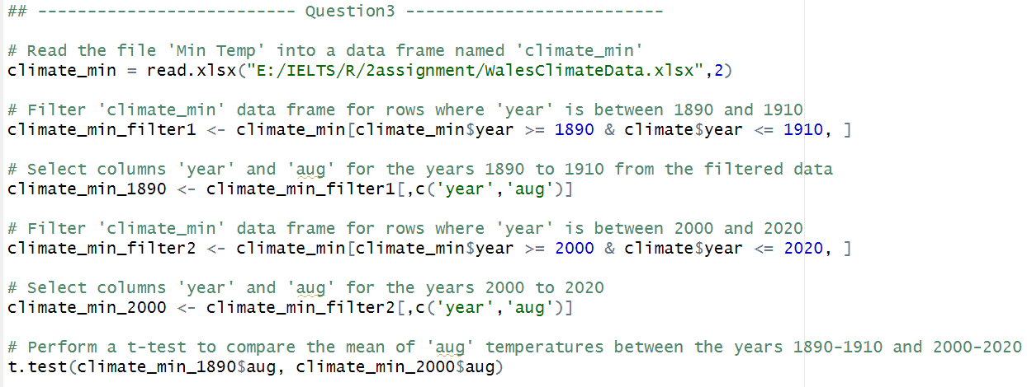

- Analysis the statistical result
As shown in Fig.6, the t-test results indicate a t-value of -4.6707 with degrees of freedom approximately equal to 39.819. The negative t-value suggests that the mean temperature of the first group (1890-1910) is lower than that of the second group (2000-2020).
The p-value is reported as 3.388e-05, which is much lower than the conventional alpha level of 0.05, indicating that the difference in means is statistically significant. This means we can reject the null hypothesis that there is no difference in mean temperatures between the two periods.
The 95 percent confidence interval for the difference in means ranges from approximately -1.555 to -0.618, not containing zero, further confirming that the difference is significant.
The sample estimates show the mean August minimum temperatures for the two periods, with the mean for the period 1890-1910 being 10.24286 °C and for 2000-2020 being 11.32857 °C. The increase in the mean temperature over time is consistent with global trends in rising temperatures. This analysis supports the conclusion that there has been a statistically significant increase in August minimum temperatures from the period 1890-1910 to 2000-2020.
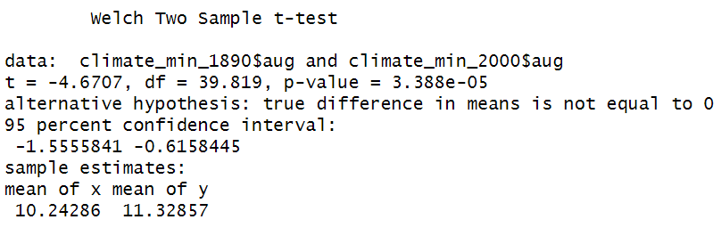
Fig.6 The t-test results

- The flowchart is as follows:
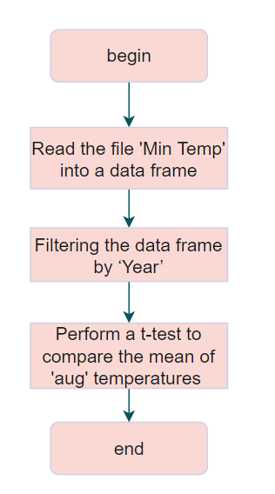

Question 4
- Question 4 is designed to perform perform an ANOVA test to identify if there are statistically significant differences in the annual numbers of wet days Let's introduce each part of my code works:
The data is first loaded from a specified Excel file "WalesClimateData.xlsx" into a data frame called climate_rainy, which contains climate data from the fifth sheet of the workbook. From this data frame, only the columns 'year' and 'ann' (presumably standing for annual number of wet days) are selected and stored in a new data frame, climate_rainy_ann.
A key step in the preprocessing involves categorizing the years into decades. The script proceeds with the statistical analysis, performing an ANOVA test on the annual numbers of wet days using the decade groups. The ANOVA test is a method to check for significant differences in means across multiple groups. If the ANOVA test indicates significant differences, a Tukey's Honest Significant Difference (HSD) post-hoc test is conducted. The purpose of Tukey's HSD is to determine precisely between which decades the significant differences lie. This test compares all possible pairs of means while controlling for the type I error rate.
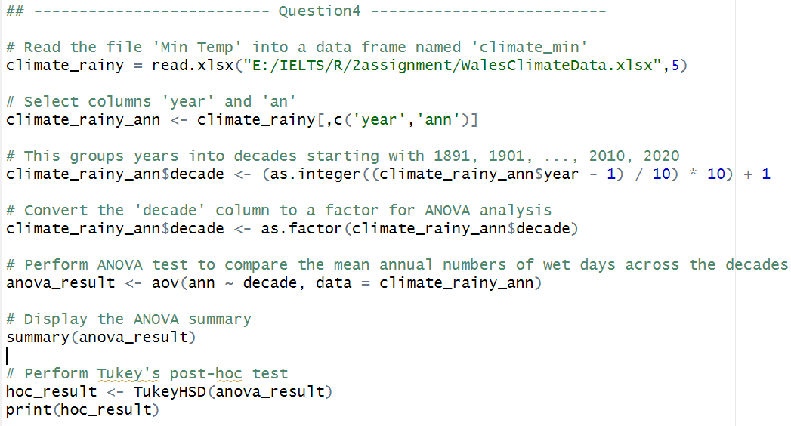
- Analysis the statistical result
As shown in Fig.7, we can see that the degrees of freedom for the 'decade' factor is 13, indicating that there are 14 categories (decades) considered in the analysis. The residuals, which represent the variation within the decades, have 118 degrees of freedom.
The F value is 1.568, which is a measure of the variance between the group means relative to the variance within the groups. The Pr(>F) value is 0.104, which is the p-value associated with the F statistic. This p-value is greater than the common alpha level of 0.05, suggesting that there is no statistically significant difference in the mean annual numbers of wet days across the different decades at the 95% confidence level.
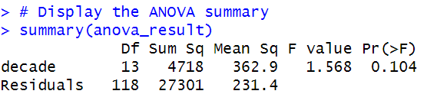
Fig.7 The ANOVA results

From the Fig.8, each row compares a pair of decades, with the 'diff' column indicating the mean difference in the number of wet days between those decades. The 'lwr' and 'upr' columns provide the lower and upper bounds of the 95% confidence interval for the mean difference.
Looking at the 'p adj' column, which gives the adjusted p-values for multiple comparisons, it appears that all the p-values are high, mostly very close to or equal to 1. This suggests that there are no statistically significant differences in the mean annual number of wet days between any pair of decades after adjusting for multiple comparisons.
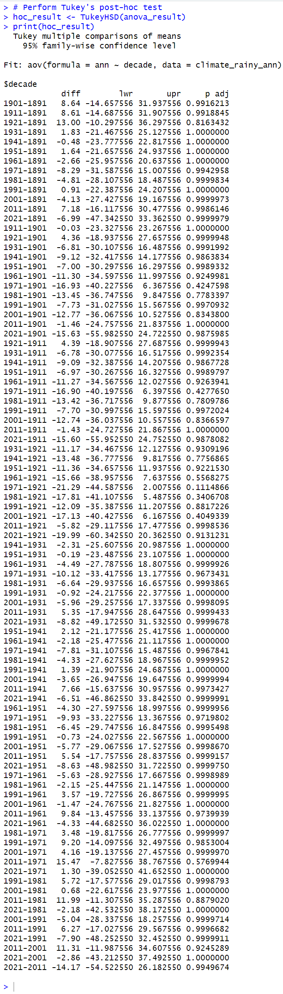
Fig.8 The Tukey HSD results

- The flowchart is as follows:
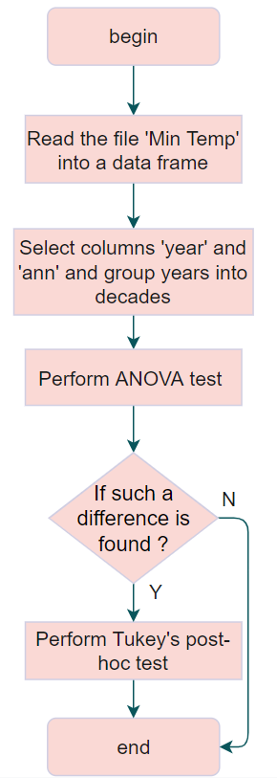

Reflection
- Challenges：
- Data Filtering Complexity: The script requires careful data filtering, especially for selecting specific years or decades. Ensuring the correct logical conditions are used to filter the data can be challenging and prone to errors, such as making sure the correct operators are used for comparisons.
- The challenge with the visualization of the line plot is that when I draw the line chart, the y-axis scale turn out to be densely packed, as shown in Fig.9.
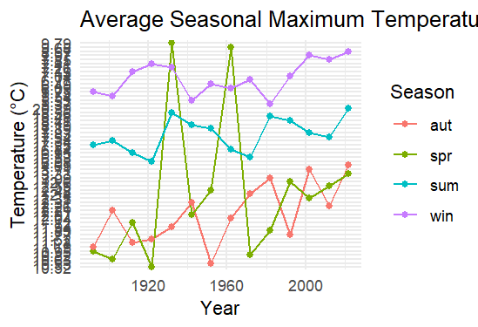
Fig.9 The densely y-axis

My solution is to configure scale_y_continuous(breaks = seq(5, 25, by = 5)); however, before this adjustment, the 'temperature' variable exists in the dataset as a character or factor rather than a numerical value. When using ggplot2, I make sure that my temperature data is in numeric form because continuous scales require numeric input.
- Learned：
- Data Manipulation: The process of reshaping data from wide to long format and categorizing years into decades improved my understanding of data manipulation in R.
- Visualizations: Creating effective visualizations using ggplot2 is essential for data analysis. The script has provided practical experience in plotting complex data, such as time series and correlation matrices.
- Statistical Analysis: Performing correlation analysis and hypothesis testing has reinforced the importance of statistical methods in data analysis. The use of cor.test, aov, and TukeyHSD functions are valuable techniques for examining relationships between variables.
- Future：
In the next time, I will explore enhancing the aesthetics of the visualization to make it more visually appealing. And I also Analyze and explore the relationships between other variables within the dataset.

