Section 1:

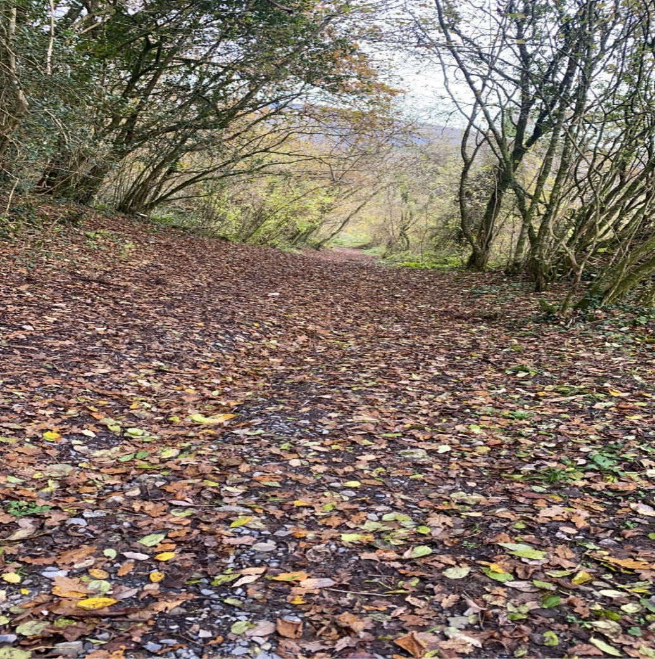

(Gough, 2022).

Section 2:

Feature 1-
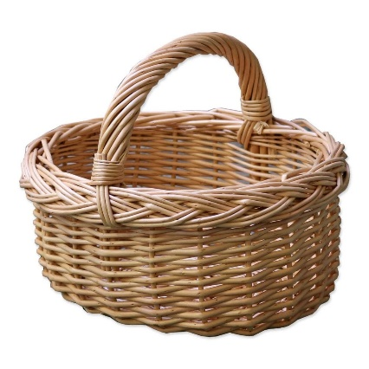
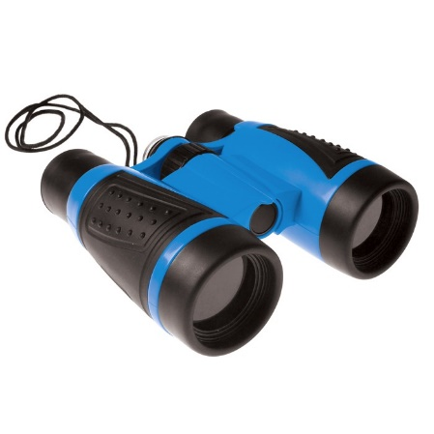
The first feature which is evident in this picture are the leaves on the ground. Children can begin by recognising the various shapes and sizes of the leaves. The colour of the leaves will give children the opportunity to explore concepts such as why leaves change from green to yellow based on what time of year it is and why leaves fall from trees during certain times of the year. It also starts to encourage the children’s understanding of life cycles. To help support their understanding of this, the location could be revisited throughout the four seasons and therefore see this scientific concept for themselves. As stated by the Welsh Government (2019), by exploring and recognising the living things that exist around them, children begin to understand that they require specific conditions and resources to grow and develop. Therefore, during summertime the children would see the different flowers that may grow in the area and begin to understand that plants need sun and water to grow.
(Fun Learning, 2022).

Children will be able to explore living insects and minibeasts that live underneath the fallen leaves on the ground. To help them achieve this, binoculars and magnifying glasses could be provided so they can focus closely on specific areas on the ground to find what lives on the ground. In the curriculum for Wales found by the Welsh Government (2019), one of the progression steps is for children to recognise that animals and plants are living things that grow. As children explore and learn in this outdoor space, their curiosity will enable them to move throughout the progression steps where eventually they will understand what it is that’s needed for the animals and plants to grow.
(The basket company, 2022).

Children could be given a basket to encourage them collect sticks, rocks, leaves, and other objects they find interesting. Practitioners can scaffold the child’s mathematical development by asking them to find a stick as long as their finger for example, giving them opportunities to estimate and compare which sticks are longer and shorter. This helps with achieving the progression step that suggests children can make estimates and comparisons with measures such as shorter and longer.

Practitioners could provide children with pots, pans, mixing spoons, and water so they can create mud pits with the soil from the ground. This will encourage the children to understand change because soil becomes mud once water is added to it due to the change in texture and consistency. The less water that is added the thicker the mud is so it explores those scientific concepts.
(Britten and James, 2022).

Feature 2-

As seen in the picture there is a natural slope which children could use to learn about forces as well as energy. This could be achieved by rolling a ball down the slope which could land into something and make a noise which shows the changes in energy. From the moving energy and the energy of sound. According to the Welsh Government (2019), by understanding concepts about forces and energy, children will be able to overcome future challenges and utilise the resources around them. A progression step suggested by the curriculum for Wales is for children to understand how the motion of objects can be affected by forces. For example, down a steep slope, a ball will roll harder and faster compared to a slight slope on the ground and children can compare this when trying to roll the ball back up the slope. Practitioners could also encourage children to wear appropriate clothing such as wetsuits so they could roll themselves down the slope so they can feel for themselves the different forces and energy.
(Early Years Resources, 2022).
Feature 3-
The final significant feature of this photograph are the trees. Between the trees, light shines through but if children were to stand under the trees, then they would see shadows. To encourage the scientific concept of light and shadows, paper and pencils could be provided so they could place the paper under the tree and trace around the shadows that appear on the paper to explore what shadows are. Mathematical concepts can also be explored through looking at the shapes and patterns on the bark situated on the trees. Children can also measure the girth of the tree trunk using a tape measure to identify the rough age of the tree.

The trees are also good for climbing as it give children an opportunity to discover nature on a different level. They can grasp the feeling of being up high compared to on the ground. The children may discover different insects and bugs that live on the trees compared to ones living on the ground. Sat under the trees or within the trees, children can hear the sounds the tree and leaves make. Trees can be used to create dens. Children can collect various branches and sticks which are different lengths and shapes that will help create their den. This gives children time to make decisions about what branches they think are best suitable for the activity and discover different lengths and sizes.

The practitioners can encourage the scientific concept of life cycles through using a story. The hungry caterpillar helps children to understand the life cycle of a caterpillar which turns into a butterfly. Children can use a magnifying glass to see if they can find a caterpillar that has cocooned on the bottom of the tree trunk. They can see this story come to life by seeing it for themselves helping them to make connections between caterpillars and butterflies.

Section 3:

RISK BENEFIT ASSESSMENT

Location / Activity: | Woodlands | Date: | 15th March 2022
Assessor: | Alissa Jane Gough | Review date: | 15th June 2022

ACTIVITY | How will young people BENEFIT from this activity? | Hazards and risks | Who is at risk? | PRECAUTIONS in place to reduce the risk of injury | Overall risk RATING: L/M/H
Walking on uneven ground | Supports and develops their gross motor skills and sense of balance.  Begin to understand how they need to walk differently depending on the surface they are walking on.  They can learn how slopes and gradients can have an impact due to forces and energy. | Children may fall over or trip causing cuts, bruises, or other injuries such as sprains. | Children and adults. | Discuss with the children beforehand how they may want to try walking slowly on the uneven surface first so they can get used to the feel of it as it could be a new experience for some.  Play a balance game with the children so they can gain understanding of how it may feel on the uneven surface.  Wear appropriate clothe and shoes such as long trousers and wellingtons. | L
Exploring things they are able to see such as rocks, sticks, flowers, trees, insects and other mini-bugs. | Children can learn about the living things around them and the relationship they have with their habitats.  Children have an opportunity to learn about life cycles by understanding how things grow, develop, and reproduce.  Through bending, stretching, picking flowers etc, children will develop their gross and fine motor skills.  Teaches children to be kind and respect other livings things as they begin to understand how these living things benefit our world and environments.  Children can learn about the different properties of different materials and analyse their uses.  Discover what materials are appropriate depending on what they want to achieve such as large sticks being useful to create a den.  Can learn about the weight and shape of different materials like rocks and sticks.  Begin to understand the concept of gravity and sound through rolling stones and rocks they have collected down slopes and other gradients.  Can support schemas.  Children can explore numbers, shapes, and sizes. | Low branches could cause eye injuries, scratches or injuries to the head which may lead to infections.  Could be bitten or stung and some children may be allergic to them.  There could be poisonous or plants that irritate the skin such as stinging nettles, blackthorns, etc.  Children could wonder of on their own and become lost.  Could be touching and picking up inappropriate materials such as rubbish.  Children could pick up sharp and inappropriate objects that are hidden within the woodland grounds.  May touch plants with thorns or stinging nettles that could potentially hurt the child. | Children and adults. | Discuss with the children what new experiences they may come across before attending the woodlands.  Consider boundaries that should be discussed with the children such as what materials are suitable to collect. Could play a game to enhance their understanding of this. Make the children aware of where is appropriate for them to go and not go without an adult present.  Make them aware of the number one rule which is to not put anything in their mouths and to wash hands at the end of the experience.  Understand the danger of strangers and the procedures if this was to occur.  The area being explored needs to be checked before the children have access to it to help prevent unsuitable objects from being picked up. | L
The outdoors in different weather conditions. | Become aware of different temperatures and the words associated with them such as wet, dry, hot, cold etc.  Children can identify things in the environment which may cause them harm and therefore discover ways to act that will reduce this risk and harm from themselves and those around them.  Understand that walking on wet surfaces could be different compared to dry surfaces. May need to walk slower and be more aware to reduce risk of slipping for example. | Different weather conditions can affect children.  Children being exposed to sun could cause sun burn or heat stroke.  Children who are too cold could in severe cases cause hyperthermia or hypothermia.  If it is raining and children become very wet, they could become uncomfortable and distressed.  Due to high winds, branches from trees could fall and harm the children causing head injury which may lead to life-changing injuries or death. | Children and adults. | Monitor weather met office to reduce being caught in unsafe weather conditions such as thirty wind speed or stormy weather.  Wear appropriate clothing depending on the weather conditions. Waterproofs with warm layers and wellington boots for wetter and colder conditions. Sun cream, hats, shelter, and water available for in hotter conditions.  Discuss with children that the grounds may be slippery if it has been raining so to be aware of this when they are out in the woodlands. | L
Climbing trees. | Become aware of different heights and the words associated with them such as being up high or down low.  Can help with their physical development like their gross motor skills.  Children can identify various insects and minibeasts that live in the trees. | Children could fall from the trees causing sprains, broken bones, scratches, bruises and other injuries. | Children and adults. | Discuss with children the risks associated with climbing trees and suggest practising on smaller trees and make their way up to the bigger ones. | L

Section 4:
According to Maynard and Waters and Clement (2013), the current foundation phase framework maintains the idea of their being a balance between child-led and practitioner-led activities within an outdoor area which is stimulating for the children. Therefore, this gives children the experiences they need through the help of the practitioner supporting and extending these. Similarly, Oakley (2004) draws upon Piaget’s theory on the children being ‘little scientists’ who learn best through activities created by the practitioner that will stimulate the children to ask questions, experiment, and discover whilst at play. Bose and Seetso (2016) found that if children are provided with the correct stimulating environments, then it allows children to be curious and explore mathematical and scientific concepts. Moreover, Bilton and Crook (2016) portray that the outdoor environment is the best place for these experiences to be achieved as there are natural areas such as woodlands, fields and nature trails that provide resources that have an open-ended purpose, allowing children with opportunities for creative thinking and their imagination, all linking to mathematic and scientific ways of thinking. Therefore, Ernst and Tornabene (2012) feel it is important for adults to facilitate the outdoors as part of children’s play as the natural settings offers a learning environment full of enriched opportunities for decision making and problem solving.
Additionally, Nicholson’s loose parts theory demonstrates why children having access to natural objects such as sticks, twigs, stones, and leaves has a profound effect on their learning because through having access to these, children can begin to form ideas such as weight, length, gravity, and friction. Nicholson also felt that children should not be rushed during this type of play and that children should be given time to play and revisit the activity to keep adding to their knowledge (Play Scotland, no date). Based on a study by Rahardjo (2019), she discovered that loose parts were a fundamental part of scaffolding a child’s mathematic and scientific knowledge. She suggests that loose parts provide open and endless learning opportunities whilst inviting the children to be creative. Play Scotland (no date) also suggests that loose parts have no instructions and therefore can be whatever the children envision them to be as the children use them freely to fulfil their curiosity. However, practitioners may not understand the full benefits related to loose parts and therefore not acknowledge their importance when creating learning environments so it is important for practitioners to be mindful of the usefulness related to loose parts (Robertson, 2017).
When discussing the role of the practitioner, there is an emphasis on the importance of sustained shared thinking. This involves helping a child to think more deeply about certain scenarios and topics to greater their understanding and knowledge on it. This can be achieved through asking the child open-ended questions and providing resources to help them problem solve (Grimmer, 2017). According to McLeod (2019), Vygotsky’s zone of proximal development theory has close links to sustained shared thinking because his idea shows the stages a child goes through when learning. The first base being what a child can achieve on their own, leading up to what a child cannot do on their own but is able to achieve through guidance and support from a more knowledgeable other being a practitioner. However, according to (Carr, 2022), this theory may not always be practical as it is often hard for practitioners to find time to give each individual child their time to help them with their learning as all children’s educational demands are different. Also, topics such a mathematics and science may be found more difficult to explain to children so practitioners may struggle to scaffold the child’s learning without specific training. Therefore, Montessori’s approach suggests that setting up stimulating environments within an environment is a good way of starting practical mathematic and scientific conversations between the adult and child (Berg, 2021).
White (2011) suggests that the outdoor environment gives children opportunities to have first-hand experiences based on what adults can achieve which includes taking care of the living things in the environment for example. This links with the curriculum for Wales as part of a child’s scientific learning is discovering all the living things around us and how they depend on each other (Welsh Government, 2022). Watts (202) also suggests that children will initially fear small living things such as worms, ants, and spiders and their initial reaction may be to squish them, however with the right approach from the adult, children can begin to see their role in looking after the living things in their nature and how this contributes to the planet. As the Welsh Government (2021) states ‘Children who are able to engage and connect with the natural world can build an empathy for the environment, showing an awareness of their potential impact on the living world.’
With the help of adults, children can start listening out for birds singing and leaves rustling in the wind so they can develop awareness about what is going on around them (Watts, 2020). The outdoor space also creates unlimited play affordances but through adding other resources to the activity such as rope, plastic, gutters, it creates more complex and diverse affordances for the children (White, 2011). However, mathematics and science can also be explored through risk taking. According to Little and Eager (2010), risk-taking is fundamental to developing new ideas, concepts, and behaviours which is achieved through children testing their limits. Risky play provides children with opportunities to challenge and test themselves as well as explore boundaries. Robertson (2017) explains how mathematical learning can be achieved through risk-taking such as climbing trees. She suggests that through climbing trees, children can consider concepts such as weight which involves discovering if a branch is strong enough to hold their body weight. Another being positioning and moving their bodies to be able to fit through branches to reach the top of the tree.
Moreover, Keith (2018) suggests that practitioners initially perceive mathematics in the early years as being separate concepts such as counting, shapes, and patterns however this is all learning to a child. Therefore, practitioners should plan a child’s needs through understanding the links and connections in early years mathematics which will result in children developing new ideas and have the confidence to apply their new skills in other scenarios. However, there are a few challenges that are linked with risky play. Little (2015) portrays the idea that risky play may not always be accessible to children in early years settings due to parental fears. Many mothers in the study expressed the understanding of importance related to risky play however still felt uncomfortable with allowing their children to participate in it. Although, the Welsh Curriculum does suggest that mathematics plays an important part in enabling children to develop into critical thinkers, so the mathematical experiences need to be as engagingly exciting as possible which many children will find through risky play (Welsh Government, 2020).
Similarly, Watts (2020) mathematics can be discovered through creating shapes with sticks in the mud so the practitioners should pick this up and discuss it with the children. Through practitioners doing this, they help to scaffold a child’s learning. This theory comes from Bruner who believes that scaffolding a child’s learning involves the practitioner reducing the child’s freedom slightly so that they concentrate on the skill they are trying to acquire without other distractions (McLeod, 2019). However, according to Berg (2021), the Reggio approach would contradict this as this approach emphasis the importance of children taking lead on their own learning and that they are in control of what they learn and discover. This theory sees children as confident and competent learners whose curiosity allows them to construct their own learning. This is achieved through making connections with others and the environments the children are in (Berg, 2021).
In Davies and Hamilton (2016) study, they discovered that many practitioners did not use the outdoor space due to various reasons. This included lack of appropriate training as many practitioners were seen to have one type of training or no training at all. Another factor identified was the change in weather as many children did not like to get wet if it was raining or did not have the appropriate clothing to go outside. Many early years setting did not have the outdoor space to facilitate children using it so may have to limit the number of children that went outside at one time to reduce risk (David and Hamilton, 2016).
However, Froebel believed that an enriched outdoor environment overshadowed the limitations associated with the outdoors. According to Tovey (no date), a garden gave children many learning opportunities just from simply nurturing nature. Tovey (no date) discussed that Froebel discovered children were able to understand life cycles and the four yearly seasons through planting flowers in a garden. From these children were able to gain first hand experience on growth, death, and decay and the rhythm of the seasons. Richardson (2013) discovered that freedom is offered through an outdoor environment as children can move around freely and gain a feeling of the space around them. It also gives them the freedom to manipulate and change things in their environment to fulfil their learning needs. Children are also able to explore various ways of behaving and interacting in the outdoor space. It allows children to be at different levels and gradients so they can experience another perspective. Children can experience the change in temperature, light, and movements through being in an outdoor environment (Richardson, 2013).
To conclude, according to Early Years Resources (2022), there are many benefits to the outdoors on a child’s development and learning. It gives children opportunities to express themselves freely and actively seek curiosity in the areas of development they are interested in. Children who experience the outdoors from a young age are more likely to keep up with an active lifestyle as they grow. The outdoors also helps individuals to gain social skills as they may feel more relaxed and settled in an outdoor area due to the classroom being overcrowded with children. Children may not feel intimidated and therefore have the confidence to join in with peers. Furthermore, the outdoors also encourages independence for children. Children will begin to discover what they can do by themselves due to the increase freedom of an outdoor area (Early Years Resources, 2022). Mullan (2019) agrees as children have the chance to connect with the world and gain experiences with the life and growth around them. The children are given endless opportunities for creativity and imagination through being in a stimulating outdoor environment.

Reference List:
Berg, V. (2021) The Reggio Emilia approach to early years education. Available at: What is the Reggio Emilia Approach to Early Years Education? - daynurseries.co.uk advice (Accessed: 25th March 2022).
Berg, V. (2021) The Montessori method of education: A child-led approach. Available at: The Montessori Method of Education: A Child-Led Approach - daynurseries.co.uk (Accessed: 25th March 2022).
Bilton, H. and Crook, A. (2016) Exploring outdoors ages 3-11: a guide for schools. London: Routledge.
Bose, K. and Seetso, G. (2016) ‘Science and mathematics teaching through local games in preschools of Botswana’, South African Journal of Childhood Education, 6(2). DOI:10.4102/sajce.v6i2.453
Britten and James. (2022) Britten & James ® Giant CHILD SAFE Magnifying Glass PURPLE. Available at: Britten & James ® Giant CHILD SAFE Magnifying Glass PURPLE - Britten & James (brittenandjames.com) (Accessed: 22nd March 2022).
Corr, S. (2022) The Disadvantages of the Zone of Proximal Development. Available at: The Disadvantages of the Zone of Proximal Development (ehow.co.uk) (Accessed: 27th March 2022).
Davies, R. and Hamilton, P. (2016) ‘Assessing learning in the early years’ outdoor classroom: examining challenges in practice’, International Journal of Primary, Elementary and Early Years Education, 46(1), pp. 117-129. https://doi-org.ezproxy.uwtsd.ac.uk/10.1080/03004279.2016.1194448
Early Years Resources. (2022). First-Play Standard Foam Balls. Available at: First-Play Standard Foam Balls - Physical Development from Early Years Resources UK (Accessed: 22nd March 2022).
Early Years Resources. (2022) 5 Benefits of Outdoor Learning in Early Years. Available at: 5 Benefits of Outdoor Learning in Early Years | EYR (earlyyearsresources.co.uk) Accessed: 26th March 2022).
Ernst,J. and Tornabene,L. (2012) ‘Preservice early childhood educators’ perceptions of outdoor settings as learning environments’, Environmental Education Research, DOI:10.1080/13504622.2011.640749
Fun learning. (2022) Binoculars With Compass. Available at: Binoculars With Compass (funlearning.co.uk) (Accessed: 22nd March 2022).
Gough, A. (2022) The woodlands.
Grimmer, T. (2017) Let’s think about it – sustained shared thinking. Available at: Let’s think about it – sustained shared thinking | Parenta.com (Accessed: 23rd March 2022).
Keith, L. (2018) Developing Young Children’s Mathematical Learning Outdoors. London: Routledge.
Little, H. (2015) ‘Mothers’ beliefs about risk and risk-taking in children’s outdoor play’, Journal of Adventure Education and Outdoor Learning, 15(1), pp. 24-39. DOI: 10.1080/14729679.2013.842178
Little, H. and Eager, D. (2010) ‘Risk, challenge and safety: implications for play quality and playground design', European Early Childhood Education Research Journal, 18(4), pp. 497-513. DOI: 10.1080/1350293X.2010.525949
Maynard, T. and Waters, J. and Clement, J. (2013) ‘Child-initiated learning, the outdoor environment and the ‘underachieving’ child’, Early Years, 33(3), pp. 212-225. DOI: 10.1080/09575146.2013.771152
McLeod, S. (2019) The Zone of Proximal Development and Scaffolding. Available at: Zone of Proximal Development and Scaffolding | Simply Psychology (Accessed: 23rd March 2022).
McLeod, S. (2019) Bruner - Learning Theory in Education. Available at: Bruner - Learning Theory in Education | Simply Psychology (Accessed: 25th March 2022).
Mullan, C. (2019) The importance of outdoor exploratory play in Early years. Available at: The importance of outdoor exploratory play in Early years (acornhouse.school) (Accessed: 26th March 2022).
Oakley, L. (2004) Cognitive Development. London: Routledge.
Play Scotland. (No Date) Loose Parts Play. Available at: Play-Scotland-Loose-Parts-Leaflet.pdf (playscotland.org) (Accessed: 23rd March 2022).
Rahardio, M. (2019) ‘How to use Loose Parts in STEAM?’, Early Childhood Educators
Focus Group discussion in Indonesia, 13(2), pp. 310-326. DOI: https://doi.org/10.21009/JPUD.132.08
Robertson, J. (2017) Simon Nicholson and The Theory of Loose Parts – 1 Million Thanks. Available at: Simon Nicholson and The Theory of Loose Parts – 1 Million Thanks | Creative STAR Learning | I'm a teacher, get me OUTSIDE here! (Accessed: 23rd March 2022).
White, J. (2011) Outdoor provision in the Early Years. London: SAGE.
Richardson, G. (2013) Creating a Space to Grow : Developing Your Enabling Environment Outdoors. Available at: Creating a Space to Grow : Developing Your Enabling Environment Outdoors (uwtsd.ac.uk) (Accessed: 26th March 2022).
Robertson, J. (2017) Messy Maths : A playful, outdoor approach for early years. Wales: Crown House Publishing.
The basket company. (2022) Small Child's Size Wicker Shopping Basket. Available at: Small Child's Size Wicker Shopping Basket - The Basket Company (Accessed: 22nd March 2022).
Tovey, H. (No Date) Outdoor play and exploration. Available at: Layout 1 (froebel.org.uk) (Accessed: 25th March 2022).
Watts, A. (2020) Outdoor learning through the seasons. London: Routledge.
Welsh Government. (2020) Mathematics and Numeracy. Available at: Mathematics and Numeracy: Introduction - Hwb (gov.wales) (Accessed: 24th March 2022).
Welsh Government (2021) A curriculum for funded non-maintained nursery settings. Available at: curriculum-funded-non-maintained-settings-consultation-doc.pdf (gov.wales) (Accessed: 25th March 2022).

