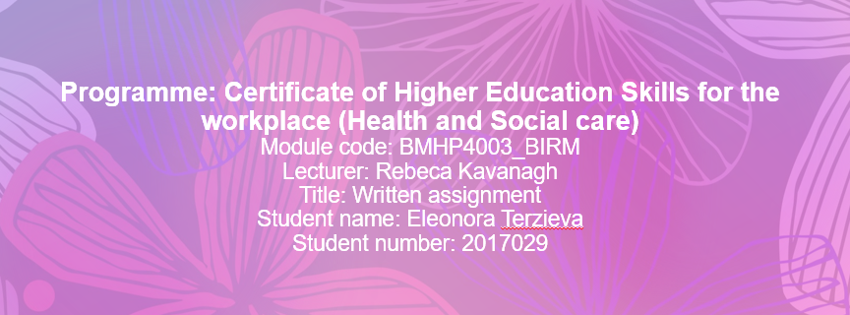

Contents
Introduction 3
Self-concept and self image 3
What is social identity theory 4
Social identity factors 4
How it applies to Mason 4
Theory of planned behaviour 5
How Does Planned Behaviour Theory Explain Drug involvement? 5
How it applies to Mason 5
Frustration-Aggression Hypothesis 6
How it applies to Mason 6
Conclusion 7
References 8

Introduction

The purpose of this report is to identify a link between aggressiveness and delinquency in young men like Mason Kabee, 17 years of age, as well as to look at the function of drug use as a moderator of aggression and delinquency. I will be using Social Identity theory, theory of planned behaviour and the frustration aggression hypothesis to assess the case.
Shabbir, Javaid, Aaqib and Ali Rizvi (2020) already tell us that ‘drug use acts as a moderator
among aggression and delinquency for male adults.’

Self-concept and self-image

I will also be talking about the idea of self-concept and self-image, these are the images we have of ourselves, that develop via interaction with the environment. I will be exploring this idea in every theory and how it links to Mason’s self-image and characteristics that he is working towards.

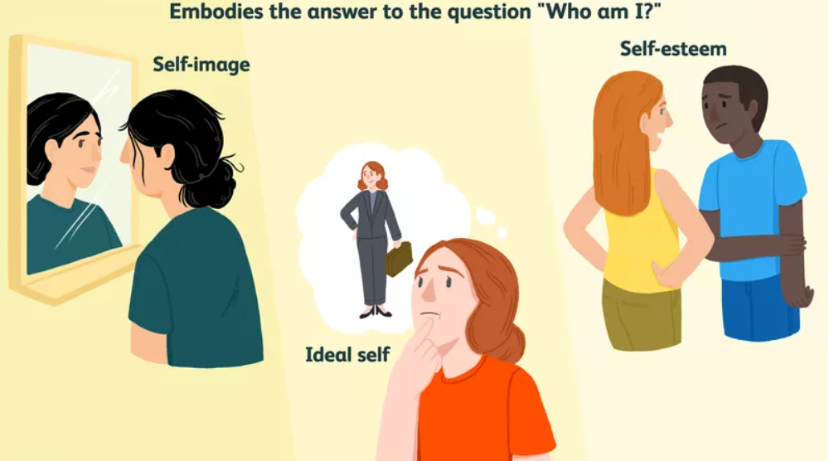

What is social identity theory

Have you ever wondered why we like to get together in a particular group with people similar to us? How does group membership affect behaviour between groups? Why do we support people like "us" and discriminate against people who are not us?
Social identity is part of a person's self-concept that comes from being perceived as belonging to the relevant social group. It is the ‘part of the self that is defined by one’s group memberships’ says Cynthia Vinney (2019).
A person does not have a specific identity of his own but has multiple identities that he adopts depending on the circumstances. These multiple identities act to improve self-esteem. Sarah Gaither (2019) gives us a few examples of different identities like ‘race, gender, age, sexual orientation, occupation’
Social identity theory was formulated by Henri Tajfel and John Turner in the 1970s and 1980s and explains behaviour between groups. The theory is based on Tajfel`s own experiences as a Polish Jew during World War II. In which the message is that individual perception of oneself and of others is formed based on the social groups to which we belong.
The theory states that individuals strive to improve their own self esteem by modifying their perception of identity and social identity. We define what is appropriate behaviour by referencing to the norms of the groups to which we belong.
Thus, a person who wants to sell drugs will associate with people who are doing the same (in a group) and will distance themselves from people who are studying in college (outside the group), inversely, if a person’s group starts delving into drug selling, they are more likely to try doing so themselves.

Social identity factors
Several social identity factors have been found to increase adolescent drug involvement:
- Poor parental supervision.
- Poor neighbourhood conditions.
- Low neighbourhood employment opportunities.
- Parental drug use or abuse.
The relationship between adolescent drug sales opportunities is partially predicted by alienation from adolescent traditional goals and attachment to schools. Adolescent autonomy also predicted adolescent non-marijuana trafficking in situations where drug sales opportunities were scarce.
Adolescent criminal motivations are closely linked to their interactions within the family, school networks, and neighbourhood peer groups, says Little and Steinberg (2006).

How it applies to Mason
Mason’s social circle consists mainly of other people involved in drug selling, as he was seen with former associates that are also known by the police. Part of mason’s social identity relies on being part of that group of peers and steering clear of the drug selling world proves difficult to him as he would have to dissociate from this group and change his perception of himself, which makes it easy for him to relapse. Mason needs to be involved with other peers of similar age, that are leading positive normal lives, so he can change his social circle and social identity.

Theory of planned behaviour
The theory of planned behaviour (TPB), developed by Icek Ajzen in 1985, is now possibly the most widely used social-psychological model for behaviour prediction.
It's a psychological theory that links one's beliefs to one's actions. According to the idea, an individual's behavioural intentions are shaped by three fundamental components: attitude, subjective norms, and perceived behavioural control. As a result, one of TPB's guiding principles is that behavioural intention is the most accurate predictor of human social behaviour.
According to the Social theory, if an individual evaluates a suggested behaviour as having positive effects(attitude), and if they believe that others want the person to perform the behaviour, the intention (motivation) to perform the behaviour will be higher and the individual will be more likely to perform the behaviour. This is also impacted by the behavioural control, which is the belief of different factors affecting the likelihood of success or failure of a given behaviour.
The theory of planned behaviour suggests that it is much more likely that people intend to perform a particular behaviour when they feel these three fundamentals are greatly favourable. According to Arafat and Ibrahim (2018) ‘the greater the favourable behaviour, subjective norm, and perceived control, the stronger the person’s intention to perform the behaviour in question.’

How Does Planned Behaviour Theory Explain Drug involvement?
Drug and alcohol use is a learned behaviour, such behaviour being encouraged by reinforcement, environment, thoughts and emotions, and drug use. It suggests persistence due to direct short term positive effects.
There are many reasons why teens take and sell drugs. The general reasons are:
Social status is very important for teens. Teens may use drugs to blend in with friends or impress a new group of young people, for example ‘recent evidence has suggested that large numbers of university students both consume excessive quantities of alcohol and use cannabis’ says Armitage et al. (1999).
Coping with changes in life, changing is not easy for everyone and drug use relieves pain and anxiety. Adolescents may also deal drugs for easy money in something they feel they can do, this can be common in teenagers with low self esteem that are unable to see themselves doing any skilled work, possibly due to bad grades causing low self-esteem, whereas the ‘success’ of being a drug dealer can affect their self-image positively and lead them to repeat the behaviour.

How it applies to Mason
In our case Mason Kabee does not believe that going to college will change his life positively. He considered the possibility of taking apprenticeship with a local college to improve his skills, as he was positive about the idea. However, it is very possible that the challenge that a life change implied, and the loss of easy income and escape that drugs provide, made him change his mind and go back to his old ways. He needs help to understand that going to an apprenticeship will be best for him, will make society accept him, and that it will be a straightforward process with lots of support.

Frustration-Aggression Hypothesis

The frustration-aggression hypothesis states that aggression is a result of frustration. ‘Frustration is any event or stimulus that prevents an individual from attaining a goal and its accompanying reinforcement quality’ as defined by Dollard et al. (1939).
The frustration-aggression hypothesis is based on a psychodynamic approach. When people become frustrated, they feel the urge to be aggressive towards the object of frustration, which is often impossible or inappropriate and shifts the cause of the frustration to something or someone else.
Frustration is the tension that arises when our efforts to reach our goals are hampered.
When our motivation to reach our goals is hampered by external factors, we experience frustration, which in turn creates an aggressive motivation that can lead to aggressive behaviour. When we express this aggression through physical, verbal or imaginary means, we experience catharsis and relieve emotional tension.
However, the attack is not always directed at a legitimate target. According to Charlotte Nickerson (2021) ‘this is often impossible or inappropriate, so the source of aggression is displaced on something or someone else’. Therefore, we postpone the aggressive response to low-risk targets or targets that happen to exist.
Aggression is not just a reaction to a stimulus, but an action towards a specific goal. The nature of the response is not the same for all types of stimuli, and the goal usually is removing hindrance from our goals.

How it applies to Mason

As we have seen, the imposed rules of society on Mason are creating frustration, as he is unable to continue the only lifestyle he knows and has been part of, which caused him to lash out on the team during probation. As it is inappropriate to react in a harsher manner, Mason stormed off the situation to avoid facing the problem and will probably release the aggression later in some other target.
Mason gets his income and sense of self by being part of a group selling drugs, if he is forced to exit this situation, he has to face a lot of change, and this creates a lot of frustration that he is not dealing with properly. At this point any follow up visits to mason are not seen as helpful in his view, but rather pressure and a source of frustration for him to give up on his previous goals and thoughts. More understanding and help to transition should be given to Mason, so he considers the process a good thing rather than a frustrating change.

Conclusion
Who we are with is a big part of how we see ourselves, and we try to avoid difficult things as much as we can, we like to be comfortable and feel successful in what we can and know how to do, even if this is not acceptable by societal standards, like in Mason’s case.
Mason seems positive to the life changes proposed in theory but goes back to his old ways once faced with the issues of his social identity, the challenges of a lifestyle change, and the frustration caused by the situation.
He needs help changing his environment and support in the process of becoming a better self.

References
Arafat, Y., Ibrahim, M.I.M. (2018). The use of Measurements and health behavioural models to improve medication adherence. Social and administrative aspects of Pharmacy in Low and Middle-Income countries. Available at https://www.sciencedirect.com/science/article/pii/B9780128112281000042. Accessed on 7th April 2022.

Armitage, C.J., Armitage, C.J., Conner, M., Loach, J. and Willetts, D. (1999) Different Perceptions of Control: Applying an Extended Theory of Planned Behavior to Legal and Illegal Drug Use, Basic and Applied Social Psychology, 21(4), 301-316. Available at https://www.tandfonline.com/doi/abs/10.1207/S15324834BASP2104_4 . Accessed on 7th April 2022.

Dollard, J., Miller, N. E., Doob, L. W., Mowrer, O. H., & Sears, R. R. (1939). Frustration and aggression.

Gaither, S. (2019). Considering your multiple identities. Psychological Science Agenda. Available at https://www.apa.org/science/about/psa/2019/07/multiple-identities. Accessed on 7th April 2022.

Little, M., and Steinberg, L. (2006). Psychosocial Correlates of Adolescent Drug Dealing in the Inner City: Potential Roles of Opportunity, Conventional Commitments, and Maturity. The Journal of research in crime and delinquency, 43(4), 357–386. Available at https://www.ncbi.nlm.nih.gov/pmc/articles/PMC2792760/. Accessed on 7th April 2022.

Nickerson, C. (2021), ‘Frustration-aggression hypothesis’, Psychodynamic theory. [blog]. 17 December. Available at: https://www.simplypsychology.org/frustration-aggression-hypothesis.html. Accessed on 7th April 2022.

Shabbir, F., Javaid, M.B., Aaqib, M. and Ali Rizvi, S.H., (2020). Exploring the impact of drug use on aggression and delinquency among adults. HSOA journal of addiction and addictive disorders, 7(4), pp.1-7. Available at https://www.heraldopenaccess.us/article_pdf/2/exploring-the-impact-of-drug-use-on-aggression-and-delinquency-among-adults.pdf. Accessed on 7th April 2022.

Vinney, C. (2019), ‘Understanding social identity theory and its impact on behaviour’, Thought Co. [blog]. 21 July. Available at https://www.thoughtco.com/social-identity-theory-4174315. Accessed on 7th April 2022.

