SCS SUSTAINABLE CIVIL SOLUTIONS

Feasibility Study
‘Prince Of Wales Dock’ Footbridge & Attached Moorings
Author: Ben Kneeshaw (1902457)
Date: 17.05.22
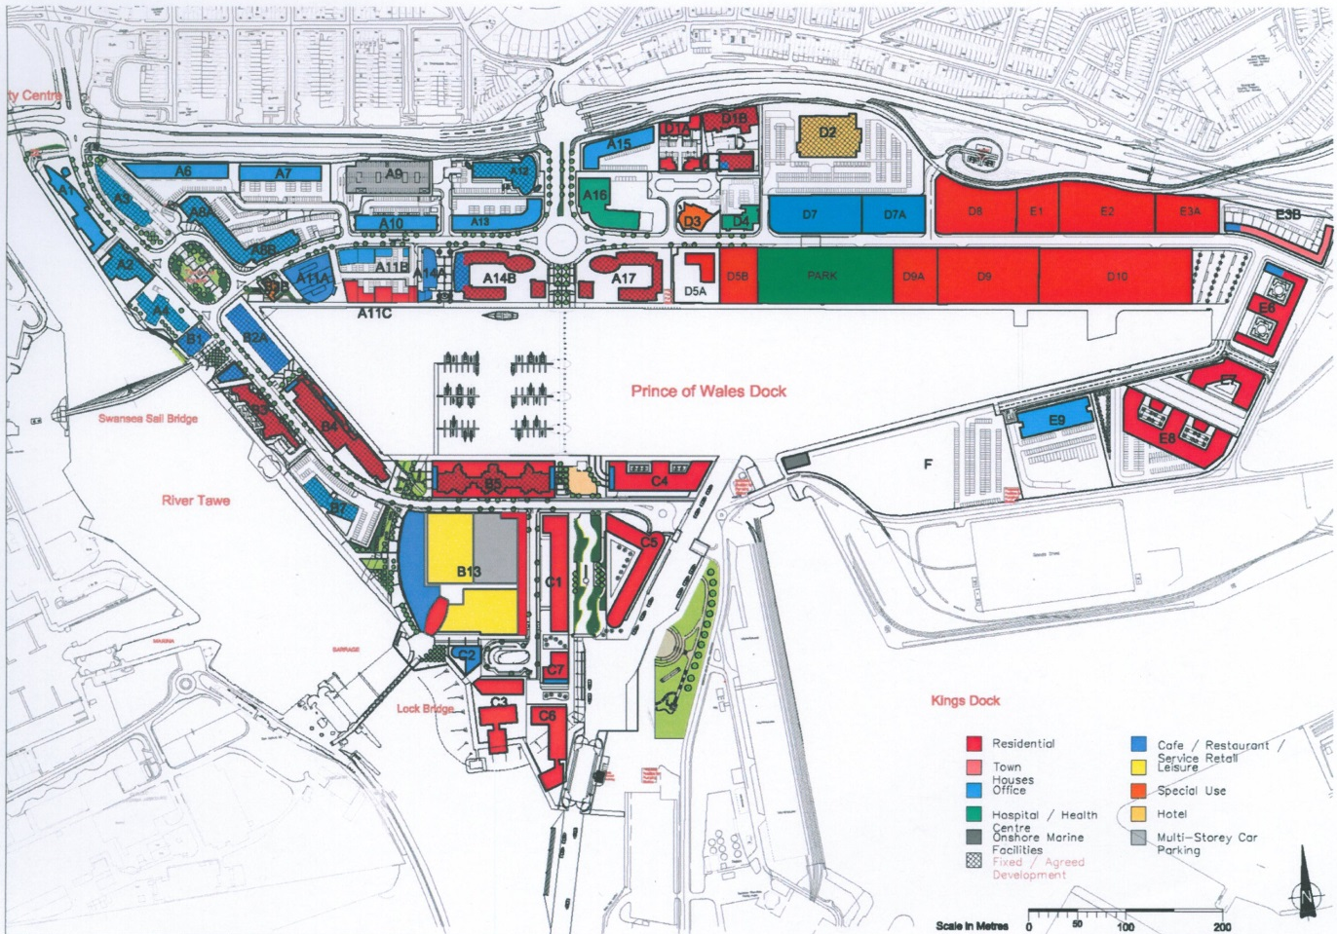

List of figures
Figure | Page | Description
1 | 7 | Plan showing proposed location of footbridge
2 | 10 | Rights of way
3 | 11 | Geology underwater at the dock
4 | 14 | Map of archaeological points of interest
5 | 15 | SSI/SSSI/AONB areas of interest
6 | 16 | Photo showing eastbound section of north dock footpath
7 | 16 | Photo showing access roads to Langdon road roundabout
8 | 17 | Photo showing the carpark at plot A14b
9 | 17 | Photo showing westbound section of north dock footpath
10 | 18 | Photo showing north to south span across dock
11 | 18 | Photo showing car-park on south side of dock
12 | 19 | Photo showing westbound path on south-side of dock
13 | 19 | Photo showing eastbound path on south-side of dock
14 | 20 | Photo showing span across the dock from south to north
15 | 20 | Aerial photo w/ proposed site and alternatives
16 | 21 | OS map w/ proposed site and alternatives
17 | 23 | Table showing flood risk measures required
18 | 24 | Map showing flood risk in the area of the proposed site

Contents

1. Introduction……………………………………..……………………………Page 6
2. Background information………………………………….……………..Page 7
2.1 Use of site – past & present……………...….…………….………………..Page 7
2.2 Proposed occupancy……………………...…………….….………………..Page 7
3. Outline brief……………………………………………………..……………Page 8
3.1 Client’s requirements………………………………………….……………..Page 8
3.2 Functional/operational needs…………………………………………...….Page 8
3.3 Funding provision………………………………………………………....….Page 8
3.4 Programme, phasing…………………………………………………………Page 9
4. Site/Location……...……………………………………….…………..…….Page 10
4.1 Site description……………………………………………………………….Page 10
4.2 Legal boundaries………………………………………….………………….Page 10
4.2.1 Ownership…………………………………………………………………...Page 10
4.2.2 Rights of way……………………………………….……………………….Page 10
4.2.3 Wayleaves……………………………………………………………………Page 11
4.3 Site underlay…………………………………….………………………….…Page 11
4.3.1 Geology & substrata……………………………………………………….Page 11
4.3.2 Boreholes………………………………….………………………………...Page 12
4.3.3 Mine survey……………………………….…………………………………Page 12
4.3.4 Hydrology……………………………………………………………………Page 12
4.3.5 Contaminated land………………………………….……………………...Page 12
4.4 Ground levels survey…………………………………………...……………Page 13
4.5 Existing services locations…………………………………………………Page 13
4.6 Access restrictions………………………………………………..……..…..Page 13
4.7 Archaeological status…………………………………………….………..Page 14
4.8 SSI/ SSSI/ SNCI/ AONB status………………………………….………...Page 15
4.9 Visual survey…………………………………….………………………..…Page 16
4.10 Alternative sites & location plans………………………………………Page 20
4.11 Surrounding development……………………………………………….Page 21
4.12 Ecological survey………………………………………………………….Page 21
4.13 Tree assessment………………………………………………………......Page 22
5. Development constraints……...…………………………………...…Page 23
5.1 Planning………………………………………………………………………Page 23
5.2 Flood consequence assessment………………………………………...Page 23
5.3 Environmental protection requirements………………………………..Page 24
5.4 Highways implications of development………………………………...Page 25
5.5 Services adequacy……………………………………………………….…Page 25
5.6 Uses of surrounding development………………………………………Page 25
5.7 Constraints on size, height and right of way…………………………..Page 26
5.8 Client imposed constraints……………………………………………….Page 26
5.9 Additional constraints…………………………………………………….. XXXXX
6. Accommodation requirements……………………………..............Page 27
6.1 Space requirements – Internal & external……………….…………….Page 27
6.2 Service requirements……………………………………………………...Page 27
6.3 External works………………………………………………………….......Page 27
6.4 Equipment…………………………………………………………………...Page 28
6.5 Alternative accommodation…………………………………………..….Page 28
6.6 Security………………………………………………………………..……..Page 28
6.8 Flexibility……………………………………………………………………..Page 28
7. Design/specification……………………………………………………Page 29
8. Estimate…………………………………………………………………….Page 29
9. Programme………………………………………………………………...Page 29
10. Conclusions/recommendations………………………………….Page 29
11. List of references……………………………………………………...Page 30
12. Appendix A – Client communications…………………………Page 25
13. Appendix B – Internal meetings record……………………….Page 27

1. Introduction

The client, ‘University of Wales Trinity St David’ (UWTSD), has proposed a pedestrian bridge crossing the ‘Prince of wales’ dock in Swansea. This aims to streamline pedestrian traffic to and from the university buildings, cutting the current walking time from the Langdon road roundabout to the campus. It also aims to provide access to new boat moorings built alongside said footbridge.
This feasibility study is intended to examine the feasibility of such a project, with recommendations for successful implementation and evaluation of alternative approaches. The study encompasses a wide range of topics as outlined in the contents.
A record of client meetings and feedback is included in appendix A, with a record of meetings between the ‘design & build’ team included in appendix B. The principle designer allocated for this project is Cai Gibbons.

Disclaimer: Due to a lack of availability of work from certain team members (as of 17.05.22) certain sections of this study are not as complete as others. Attempts have been made by the author to fill in any gaps (indicated by any section that does not directly reference other documents).

2. Background information
2.1 Use of site – past & present

Ground investigations carried out on the site have established that, since the dock was built in 1881, the land has been used extensively for industrial activity. Being the site of transit sheds, and railways used to transit freight arriving in the docklands. Current use consists of residential buildings and a small car-park on the south side, with a larger carpark connected to Langdon road roundabout on the north side. The dock itself is no longer used for freight, with planning permission granted to transform it into a marina (Swansea council, 2013).

2.2 Proposed occupancy

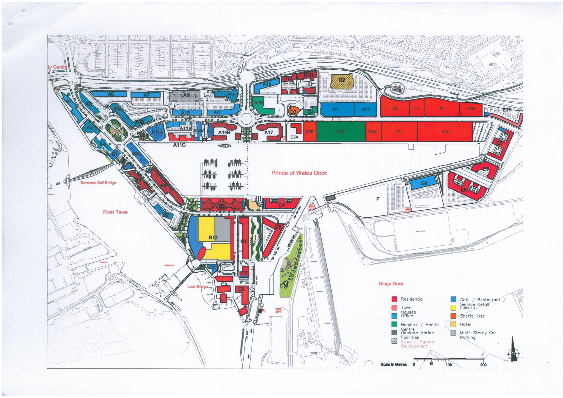
The client wishes to construct a pedestrian footbridge crossing the dock, stretching from Langdon road roundabout in the north to the university campus in the south. Docking for 60 motorboats will be included along the east side of the footbridge. A picture showing this is included in figure 1, with Langdon road carpark shown as plot A14B and the residential buildings adjacent to the bridge on the south side shown as plot B5.
Fig.1: Plan showing the proposed site for the pedestrian footbridge
3. Outline of brief
3.1 Client’s requirements

The client has outlined a number of requirements in the brief, these can be summarised as such:
- The pedestrian footbridge must meet anticipated traffic requirements.
- The pedestrian footbridge must be innovative and aesthetic, with a design complimenting the industrial heritage of the city.
- Sustainable solutions are required with specific attention to the environmental impact of any proposals.
- The pedestrian footbridge must be illuminated at nightfall.
- Walkway-linked berthing is to be included for 60 motorboats along the eastern side of the footbridge.

3.2 Functional/operational needs

Being a pedestrian footbridge the loads it must hold are significantly lighter than a vehicle or rail bridge. However, the large span it must straddle means stiff, strong materials will be required. Electrical connections and sustainable power sources must be included to ensure it is lit at nightfall and its connected moorings are powered. Drainage will also be necessary to ensure the footbridge does not become slippery and dangerous during downfalls, however, as it is over-water this can be directed straight into the dock.

3.3 Funding provision

Funding is to be provided by the client (UWTSD) as part of the ‘SA1 Waterfront’ development, taking place in the lands surrounding ‘Prince of Wales dock’ in Swansea.

3.4 Phasing

Phasing for the project will be divided into 7 steps:
- Initial surveys
- Site set-up
- Foundation & footing
- Suspension member installation
- Deck installation
- Mooring installation & final fixings
- Handover

4. Site/Location
4.1 Location description

The location of the proposed site is an old dock, no longer used for freight, with carparks at the north and south sides and a footpath encircling the dock. The dock itself is 7.6m deep (ABP, 2022) with a span of 150m.

4.2 Legal boundaries
4.2.1 Ownership

The client has legal ownership over most land surrounding the proposed site. On the north are plots A14B and A17, shown in section 4.11(figs 6 & 8). On the south is a car park and adjacent plot C5, shown in section 4.11(figs 11 & 13). Plot B5 is immediately south-west of the proposed site and is a private residential development as shown in section 4.11 (fig 10). All surrounding highways, and access thereto, are owned by the welsh government.

4.2.2 Rights of way

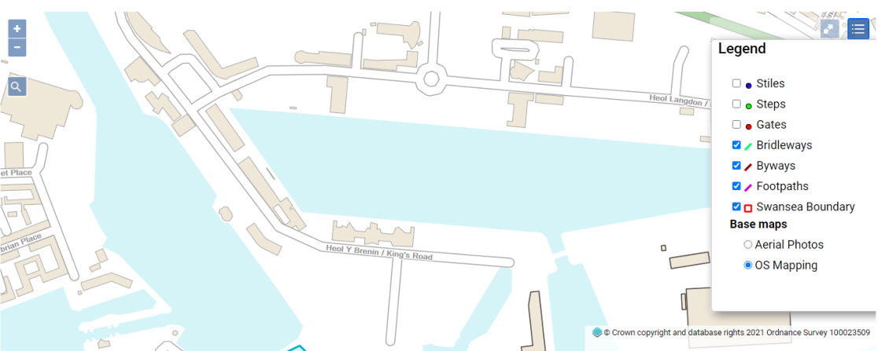
The site in question does not intercede with any official rights of way, as defined by the council, as shown in figure 2. It is however situated on public land and bound by footpaths either side of the dock, as such, diversions will be taken into account during planning for public pedestrian traffic.
Figure 2: Map showing legal rights of way in the vicinity of ‘Prince of Wales dock’ (Swansea Council, 2021)
4.2.3 Wayleaves

The client has expressed there are no active wayleaves present in the area of the proposed site.

4.3 Site underlay
4.3.1 Geology & substrata

The ground investigation conducted revealed that beneath either side of the dock is a superficial deposit of windblown sands, with bedrock of carboniferous rock consisting of: mudstone, siltstone and sandstone. This is shown via data procured from the ‘British Geological Society’ (BGS), included in the ground investigation. The water in the dock has sedimentary bedrock consistent with the south wales middle coal measure formation, consisting of: sandstone, siltstone and mudstone (in line with land either side). This is shown in figure 3.
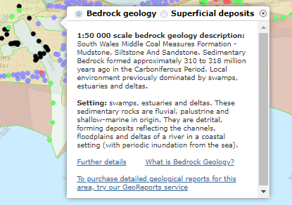
Figure 3: A map showing the geology present beneath the water at ‘Prince of Wales’ dock (BGS, 2021)

4.3.2 Boreholes

The ground investigation found boreholes in the area that confirmed the underlying geology stated above, these can be found in the ground investigation.

4.3.3 Mine survey

Due to the nature of the bedrock present on site and Swansea’s coal mining history, a survey was conducted to assess the risk of undiscovered mines in the area. This found the site to be outside the region of concern for such activities. The survey can be found in the ground investigation.

4.3.4 Hydrology

The site is a former dock and thus, waterlogged. The water extends to 7.6m at a maximum (ABP, 2022). Intrusive works will be avoided at the dockside and thus hydrology there can be disregarded.

4.3.5 Contaminated land

The conducted ground investigation found the site to be categorised as contaminated land by the local council, due to former use as dockland.

4.4 Ground levels survey

Topographical data collected as part of the ground investigation has determined that although the pedestrian walkways situated on either side of the dock are flat, there is a difference in height of 3 metres across the dock. With the south side being 6 metres above sea level and the north side 9 metres above sea level.
The site is bound by car parks and pedestrian footpaths on either side. The south car park contains a few young trees and a small hedge, a photo showing these is included in figure 11 (page 14) as part of the visual survey in section 4.11 of this document. The north car parks contain no vegetation, images showing these are also included as part of the visual survey in figures 6 & 8 (pages 12 & 13).

4.5 Existing services locations

The highways present either side of the site house the full range of services, namely: gas, electric, water, drainage and broadband. No evidence at present has been found to suggest the presence of any services directly below the proposed site

4.7 Access restrictions

There are two access points to the proposed site, north and south. On the north side access will be via Langdon road roundabout. This is a two lane roundabout, connected to the M4 via the A483 and a joining two-lane road. All mentioned roads are wide enough to bring in large deliveries and abnormal loads if required. Height is restricted, however, by a bridge crossing the A483. The south side of the site is accessed via King’s road, a narrow two-way highway.
The tidal lock also poses constraints to aquatic vessels entering the dock, being roughly 20m in width.
Further details on the constraints imposed by the restrictions are included in section 5.4.

4.8 Archaeological status

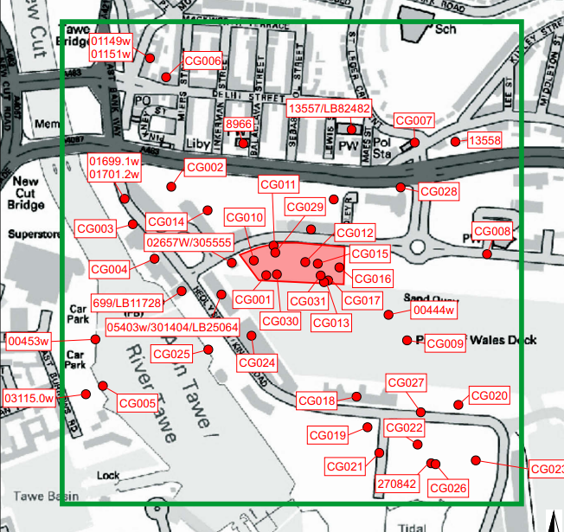
An archaeological survey conducted by Waterstone Estates Ltd (2011) found a number of archaeological sites of interest in the area; this was conducted as part of a proposal for development of a plot on the north side of the dock. A map illustrating the location of these sites is included in figure 4.
Figure 4: Map showing locations of archaeological sites of interest in the vicinity of the proposed site (Waterstone Estates Ltd, 2011)

Two sites are situated close to the proposed development; these are marked on the map as CG009 and 00444w. The marking CG009 refers to the dock itself and can be disregarded as any footbridge proposed shall be designed so as not to alter the dock itself. Site 00444w however is proposed as a possible location for a medieval chapel known as ‘St. Thomas’s chapel’. Waterstone Estates Ltd (2011) cite that 14th century evidence place it in the former mudflats present in Fabian bay, now underneath the ‘Prince of wales’ dock.

4.9 SSI/ SSSI/ SNCI/ AONB status

The site in question does not compromise any sites with SSI/SSSI/AONB status (gov.wales, 2021). This is shown below in the map, figure 5. The closest site with any of these statuses is Crymlyn bog situated roughly a mile away.
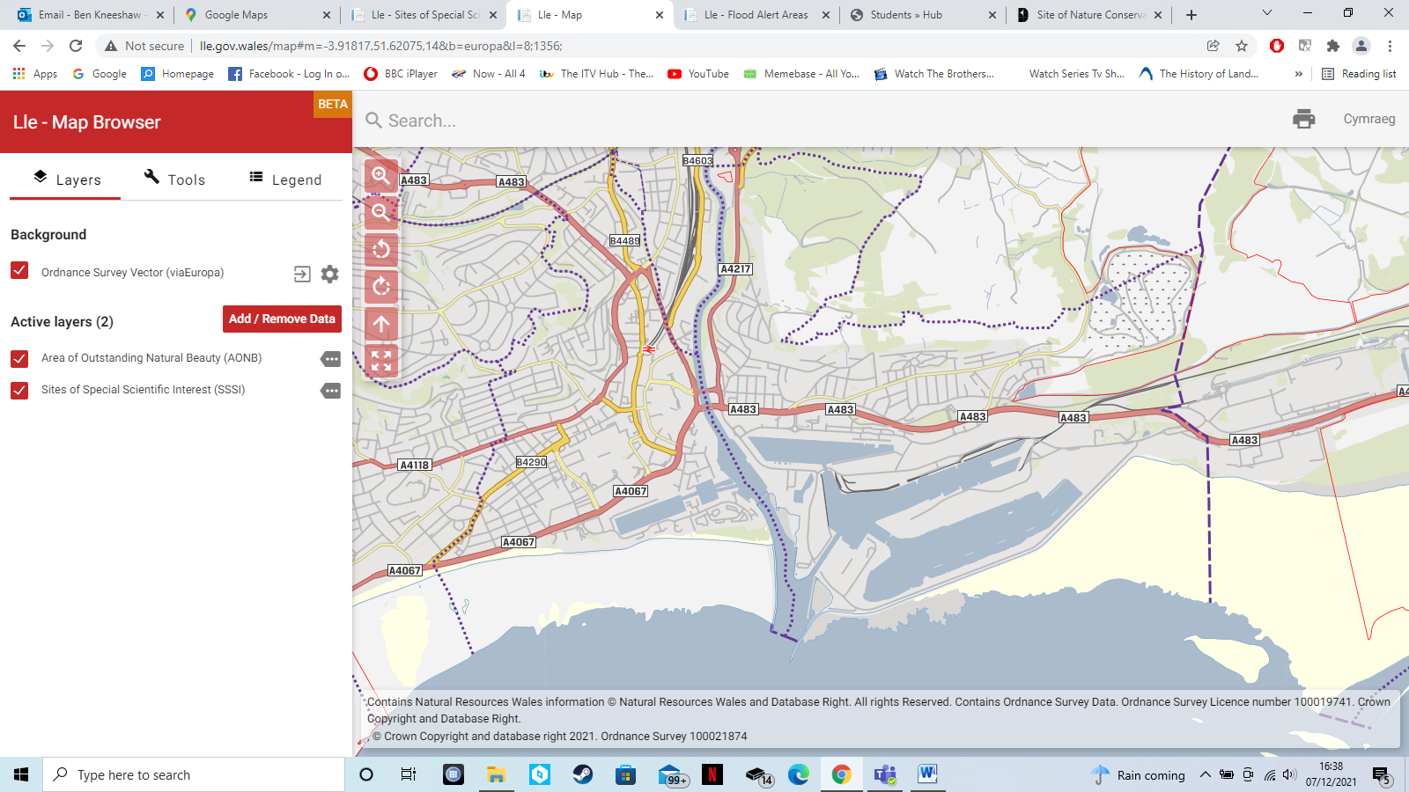
Figure 5: Map showing SSI/SSSI sites (outlined in red) and AONB sites (highlighted in pink but non-existent) in the vicinity of ‘Prince of Wales’ dock (gov.wales, 2021)

4.10 Visual survey

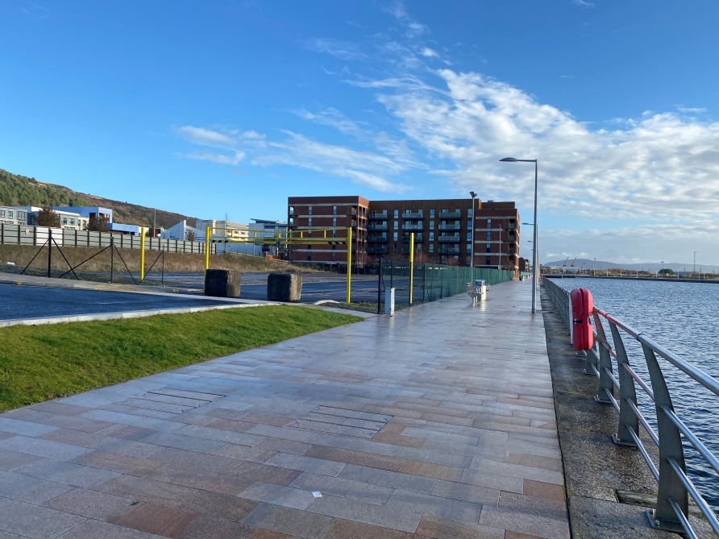
A visual survey was conducted of the site as part of the initial investigations. This included images of: access roads/footpaths, site boundaries, vegetation present, surrounding developments and the span to be cleared by the bridge. These images are included below in figures 6-14.
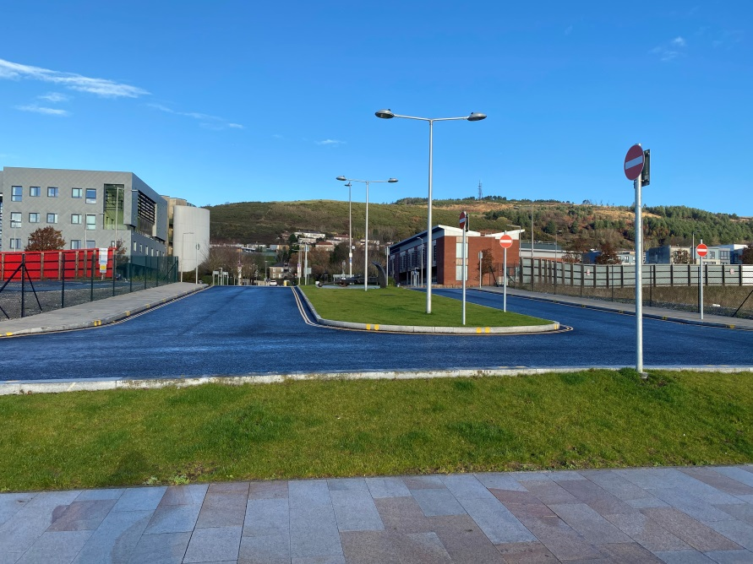
Figure 6: Photo showing eastbound section of north dock footpath, with plot A17 (carpark) to the left.
Figure 7: Photo showing access roads to plots A17 and A14B from Landon road roundabout.

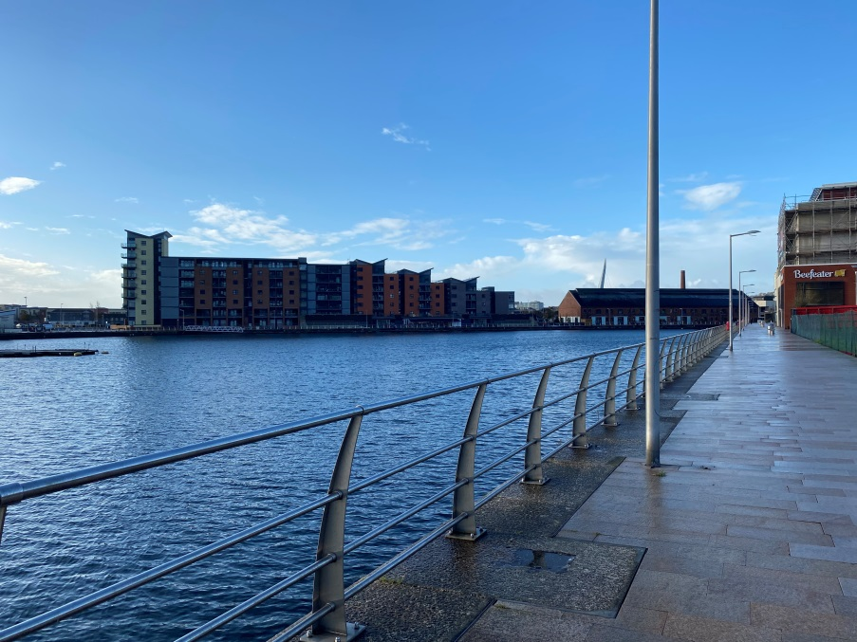
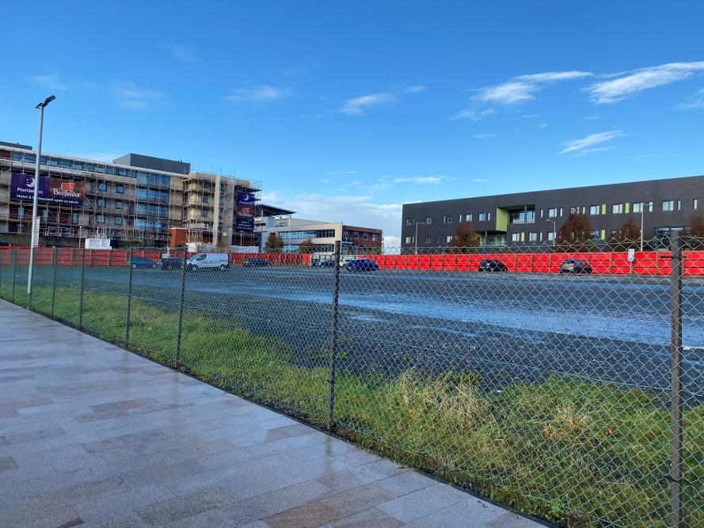
Figure 8: Photo showing the carpark located in plot A14B
Figure 9: Photo showing westbound section of the north dock footpath

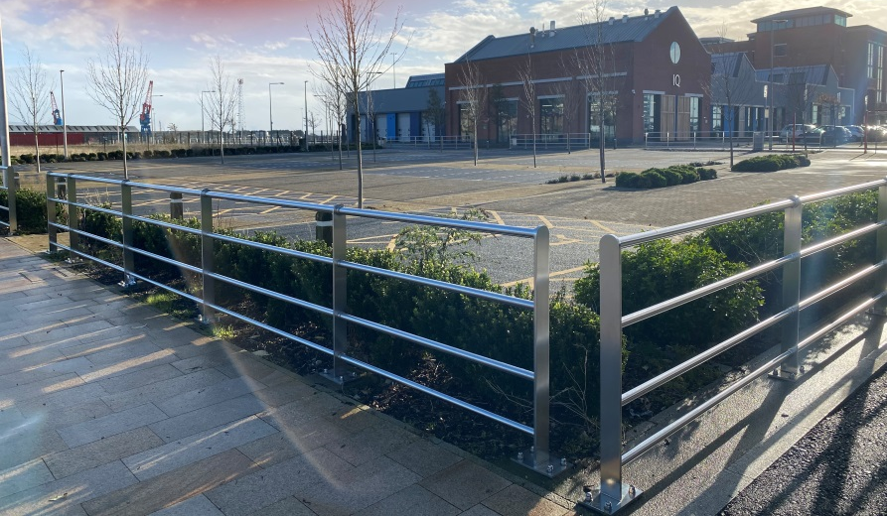
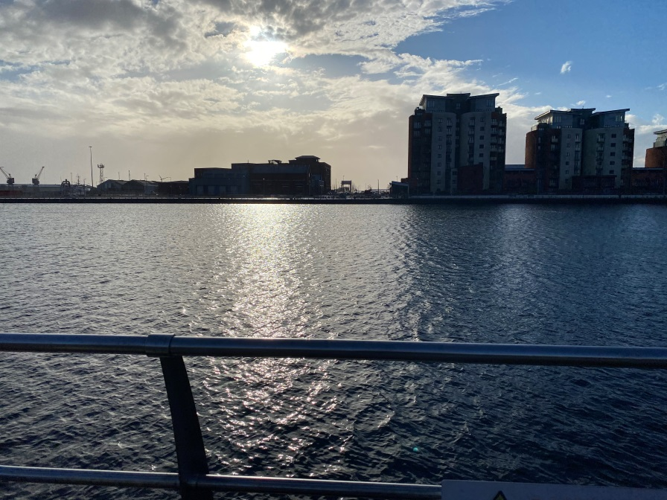
Figure 10: Photo showing the span across the dock from north to south.
Figure 11: Photo showing the carpark on the south side of the dock with associated vegetation

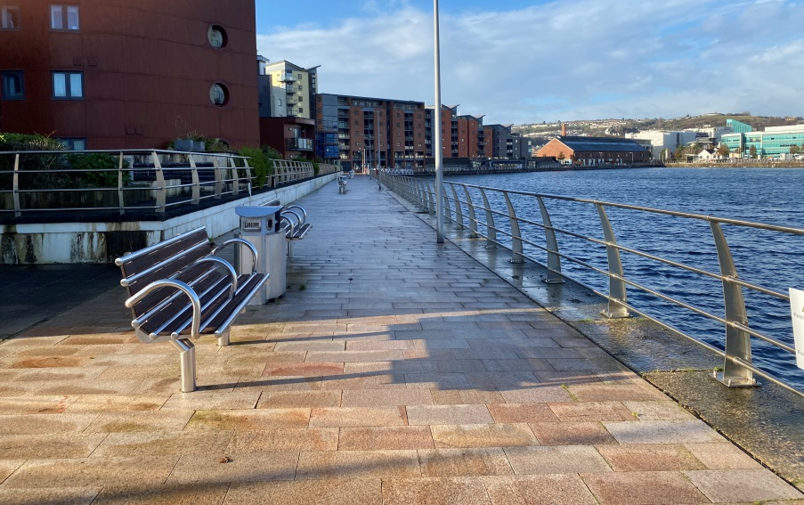

Figure 12: Photo showing westbound pathway on south side of dock.
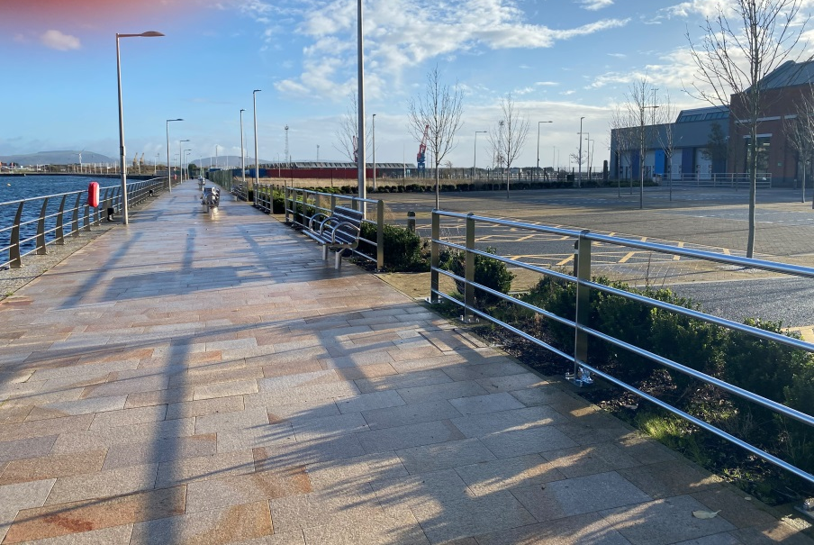
Figure 13: Photo showing eastbound pathway on south side of dock.

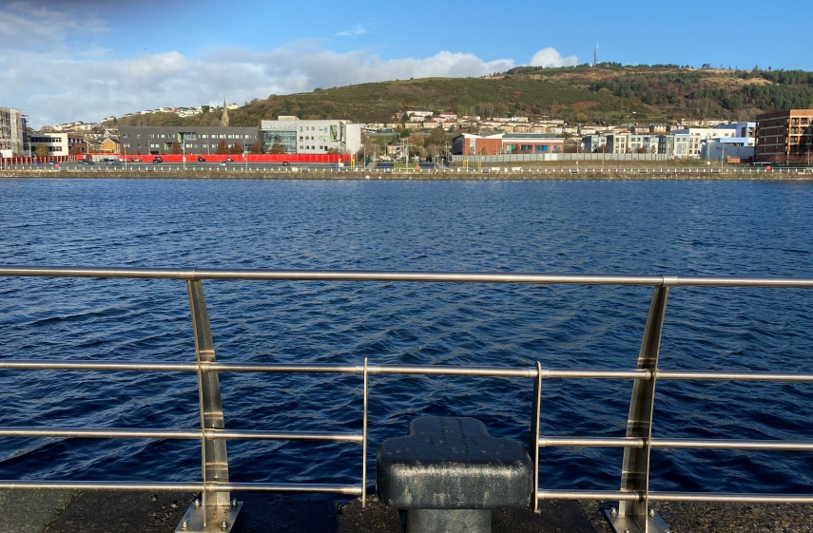

Figure 14: Photo showing span across dock from south side.

4.11 Alternative sites & location plans

In the event that investigations or unforeseen circumstances render the proposed site unsuitable, there are two alternative options. Option A involves building the bridge slightly eastwards between plot A17 and C5. Option B involves building the bridge in a slightly diagonal manner between plots A14B and C5. An aerial photo and OS map are included below to highlight the proposed site location along with alternative options should the need present itself.
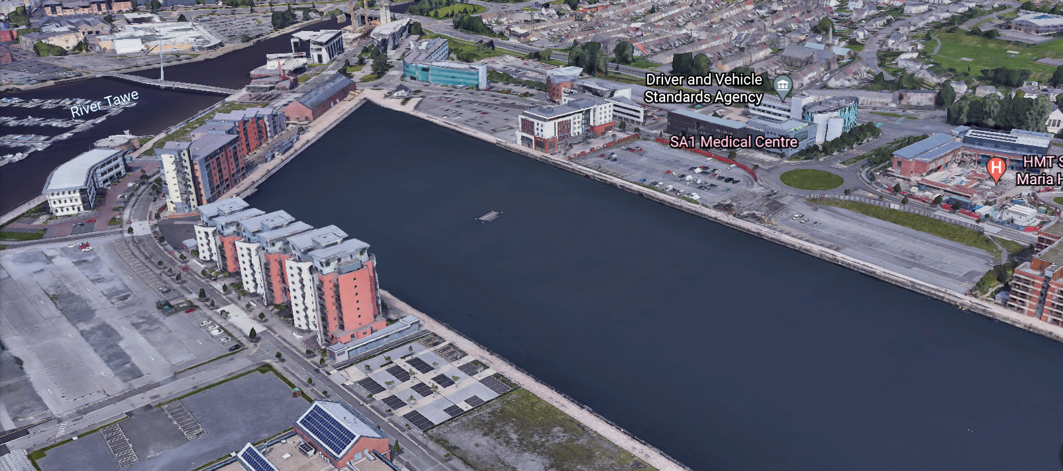
Figure 15: Aerial photo with the proposed site highlighted via the yellow line. Alternative site A is shown by the green line and alternative site B is shown by the red line.

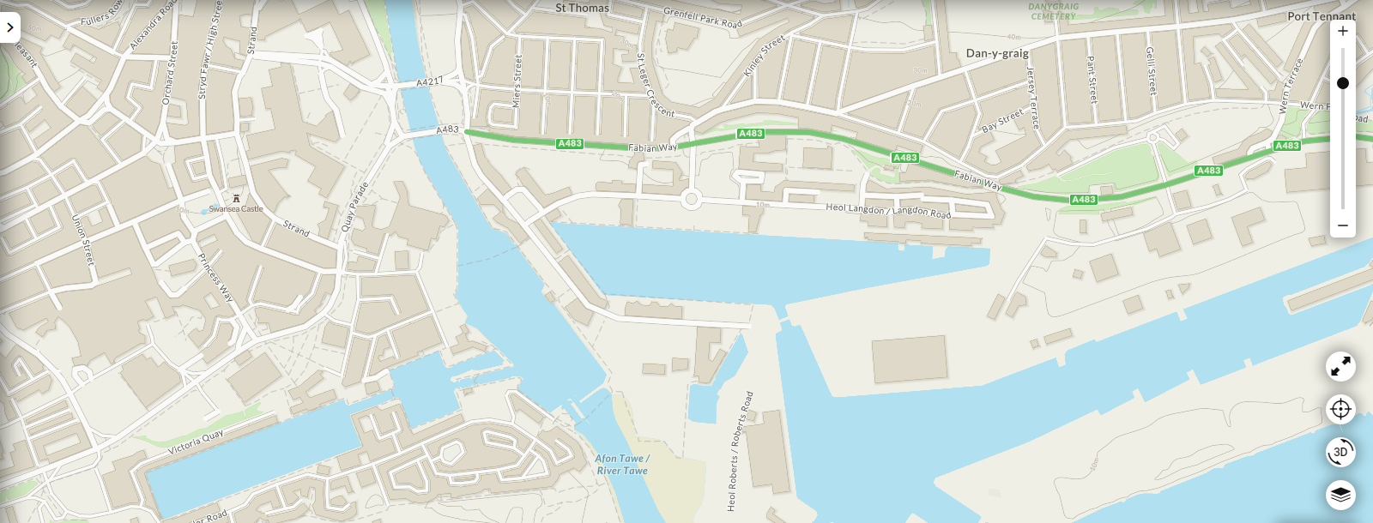
Figure 16: OS map showing the proposed site location and surrounding development, the site is shown as a yellow line. Alternative site A is shown by the green line, with alternative site B the red line.

4.12 Surrounding development

The proposed site is situated at the heart of Swansea’s SA1 waterfront development scheme, a mixed-use development of a sizable brownfield site. As part of the scheme the client acquired land in the area with aims of developing a ‘waterfront innovation quarter’ in 2015 (Paddick, 2015). Phase one of development works, including the core university buildings, is now complete. With the proposed works part of phase 2.
Land usage in the area directly surrounding the site is a mix of: commercial, residential and educational. Directly south of the proposed site, across Kings Road, sits the aforementioned university buildings. Residential units are also south of the site on the dockside. Various commercial units are present north of the site, both adjacent to plot A14B and across Langdon Road.

4.13 Ecological survey

The ecological survey has been conducted as part of the EIA compiled by Cai Gibbons and can be found in the relevant documentation submitted alongside this study.

4.14 Tree assessment

The site is relatively void of trees due to being mainly over-water. However, there are a few small trees in the car park between plots B5 and C5. Although there are no ‘Tree Protection Orders’ in place, careful planning will allow damage to be avoided to the foliage present.

5. Development constraints
5.1 Planning

The proposed project has had planning applications approved as part of phase-2 of the clients ‘SA1 waterfront’ development plan. As such, no extra measures are required to satisfy this.
5.2 Flood consequence assessment

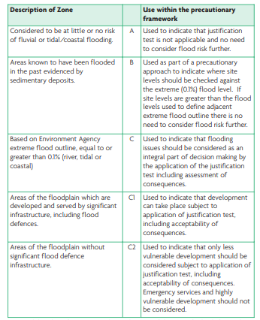
The Welsh government (2004) classify flood risk via a three tier system. In conjunction with planning policy guidelines, these designate what measures and tests must be undertaken regarding flood risk in order for planning permission to be granted. The table is shown below in figure 17.
Figure 17: Table showing classification of flood risk and measures required due to classification. (Welsh government, 2004, figure 1)

The proposed site sits on land classified as zone A, shown below in figure 18. As such, no flood consequence assessment is required.

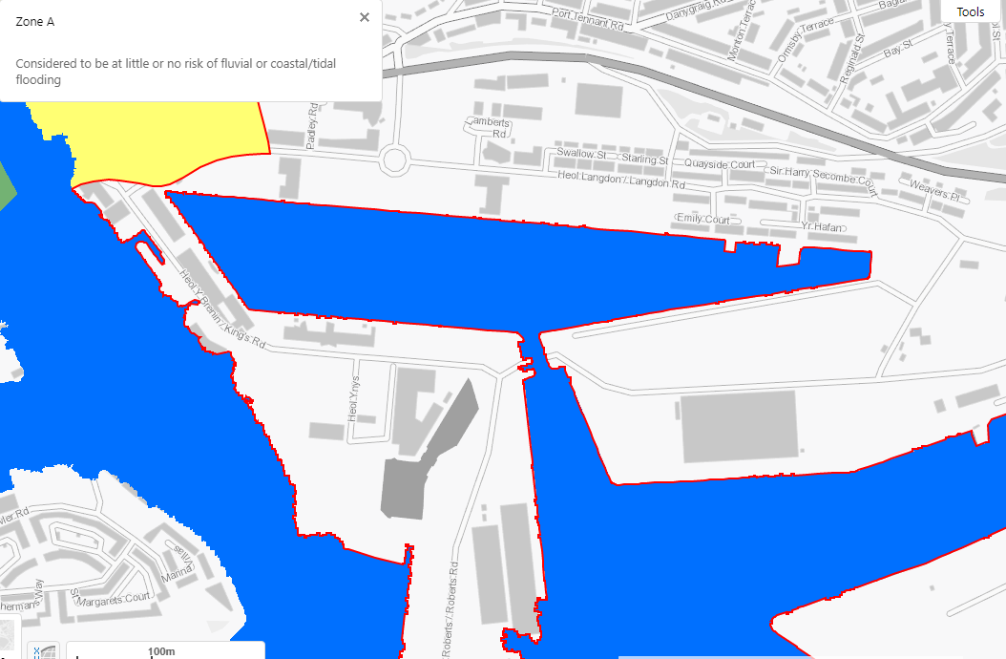
Figure 18: Map showing flood risk in the area of the proposed site, with zone A outlined in red (NRW, 2022).

5.3 Environmental protection requirements

Due to the possibility of radon and/or methane below the soil, measures will be taken to avoid worker presence in any excavations. The excavations will be carried out remotely via a crawler crane with a rotary excavator attachment.

5.4 Highways implications of development

The North side of the site is serviced by relatively wide access roads from the nearby motorway. However, the presence of a bridge along the A483 presents height restrictions that may affect delivery of the suspension tower. As such, the tower will be split into 3 components so as to ensure delivery can be completed, with the components laid horizontally on a large flatbed.
The actual access road to the proposed compound, in plot A17, is slightly narrower being single lane but should provide ample turning space for most deliveries. In the event an abnormal load is required (such as a premanufactured deck) it may be possible to create alternative access to the site via Langdon road itself to the north. As the carpark directly west of the plot is owned by the client, this can be used for parking, keeping traffic presence in the compound low.
Access to the south side of the site will be far more restricted with narrower access routes. Plot A17 will also have to be passed on the way to the south side. Due to these factors works here will be kept to a minimum where possible with the main works taking place at the north side.

5.5 Services adequacy

The services required by the proposed development are drainage and electricity.
Drainage will be built into the bridge deck and directed into the marina, avoiding any need for connection to existing drainage networks. Electricity will be provided via sustainable methods built into the bridge itself. However, additional connections may be required for the connected marina in order to power docked boats.

5.6 Uses of surrounding development

There is a residential development directly south of the proposed project. This poses constraints to noise and work hours. As such, considerations have been made to keep piling works to a minimum and keep works within daylight hours.

5.7 Constraints on size, height and right of way

Access to the dock and available plant pose constraints on both the size and height of various components of the proposed development.
In terms of height, this is limited by the AWPs (Aerial work platforms) available. This is because they are required to allow workers access to suspension elements of the bridge during construction. As the AWPs are limited to a height of 40.13m (as shown in the machinery justification report) this is the maximum height for the bridge.
The tidal lock allowing access for pontoons holding plant is roughly 20m wide. This limits the size of pontoon available, with the chosen pontoons being between 11.2m and 16.5m wide.

5.8 Client imposed constraints

Client imposed constraints are outlined in section 3.1. These include:
- The pedestrian footbridge must meet anticipated traffic requirements.
- The pedestrian footbridge must be innovative and aesthetic, with a design complimenting the industrial heritage of the city.
- Sustainable solutions are required with specific attention to the environmental impact of any proposals.
- The pedestrian footbridge must be illuminated at nightfall.
- Walkway-linked berthing is to be included for 60 motorboats along the eastern side of the footbridge.

5.9 Additional constraints

Additional constraints can be found in the constraints document provided by Rhyddian Preece alongside this study. These were not provided to the author of this study by the 16.05.22. As such, with limited time available, this section only provides the constraints identified by the author.

6. Accommodation requirements
6.1 Space requirements – Internal & external

In terms of internal space required, the space provided by plot A17 should be sufficient. As the bulk of materials required will be delivered pre-manufactured e.g. deck, ‘swan-style’ support etc.; it is possible to conduct deliveries as and when they are needed via a just-in-time delivery schedule. This will keep internal space requirements to a minimum. Space will, however, be required for both waste and delivery vehicles, it is believed that the proposed compound will be able to accommodate this.
Externally, space will be required for those working on the site to park their vehicles safely. This will be provided by the car-park present in adjacent plot A14b. This is also owned by the client; therefore alternative permission will not have to be sought.

6.2 Service requirements

As previously discussed, services present in the area are substantial enough to provide adequate provisions for the project in question. As such, alternative sources will not be required until the bridge and associated moorings are operational; these will be provided via the sustainable sources included in the designs.

6.3 External works

The only external works required as part of this project is alternative access to plot A17 via Langdon road north of the compound. This will allow for larger loads to be brought on site, as the narrow road entering the compound from its west side presents obvious constraints. It also allows the set-up of a one way system for smaller delivery vehicles, increasing safety for those working on the site.

6.4 Equipment

Flat-top pontoons located in the dock will hold the majority of plant required for the project, reducing space requirements in the compound itself. Space will, however, be required at dockside for dumper trucks (removing excavated soil) and mobile concrete mixers (pumping concrete for the foundations and footing).

6.5 Alternative accommodation

In the unlikely event of having to use an alternative location for the bridge and moorings, the uses of plots A14b and A17 could switch. Where A14b becomes the site compound and storage area, and A17 becomes a car-park. As these plots are both owned by the client, this is the most viable option. All efforts should be made to avoid using plots south of the dock due to limited road access for deliveries.

6.6 Security

Due to the aquatic nature of the proposed works security will be required on-site 24/7 to ensure public safety. This is to ensure no-one is injured via illegal access to above-water elements until the bridge itself is fully operational. There will be many hazards present overwater during most of the works proposed due to the need for a crane (to lift parts of the bridge into place). All efforts will be undertaken to ensure the public cannot access the site but additional security will ensure no one breaks in overnight whilst there is a much reduced presence.

6.7 Flexibility

Due to the constrained nature of the site there is not much room for flexibility in space usage. Therefore, a well though-out and developed site layout plan is paramount.

7. Design/specification

The design/specification for the project has been handled by the principal designer (Cai Gibbons) and can be found in the relevant documentation submitted alongside this study.

8. Estimates

Estimates and costings for the project have been handled by Morgan Davies and can be found in the relevant documentation submitted alongside this study.

9. Programme

Details of the programme and all associated works can be found in the Gantt chart submitted alongside this study. Phasing for the project will be carried out as outlined in section 3.4 of this study.

10. Conclusions/Recommendations

The optimum design and construction options, based on the information provided by others and constraints and limitations identified in this study, are outlined in the justification report for: methods, materials and machinery. It is believed that these present the most efficient and safe way to proceed with construction of the proposed project.

11. List of references
- ABP (2022) Prince of Wales dock, Swansea. [Online] Available at: https://www.southwalesports.co.uk/Port_Information/Hospitality_Berths/Swansea/#:~:text=Depth%20Alongside,The%20berth%20is%20surveyed%20annually. (Accessed: 05.01.22)
- BGS (2021) Geology of Britain viewer. [Online] Available at: https://mapapps.bgs.ac.uk/geologyofbritain/home.html?&_ga=2.19634491.283170393.1652868078-1615218976.1652868078 (Accessed: 10.12.21)
- Gov.Wales (2021) Lle (map viewer). [Online] Available at: http://lle.gov.wales/map#m=-3.159,51.47832,8&b=europa&l=1356; (Accessed: 08.12.21)
- NRW (2022) Flood risk map for planning. [Online] Available at: https://flood-map-for-planning.naturalresources.wales/ (Accessed: 03.01.22)
- Paddick, R (2015) UWTSD plans approved for Swansea innovation quarter. [Online] Available at: https://universitybusiness.co.uk/estates/uwtsd-plans-approved-for-swansea-innovation-quarter/ (Accessed: 17.12.21)
- Swansea Council (2013) Planning – Application Summary.[Online] Available at: https://property.swansea.gov.uk/online-applications/applicationDetails.do?keyVal=ZZZZRPEVXB795&activeTab=summary (Accessed: 20.10.21)
- Swansea Council (2021) Rights of way map. [Online] Available at: https://www.swansea.gov.uk/rightsofwaymap?languagepref=en (Accessed: 01.12.21)
- Waterstone Estates Ltd (2011) Canolfen Glandwr, Prince of Wales Dock, Swansea. [Online] Available at: https://coflein.gov.uk/media/314/712/665374.pdf (Accessed: 12.11.21)
- Welsh Government (2004) Technical Advice Note 15: DEVELOPMENT AND FLOOD RISK. [Online] Available at: https://gov.wales/sites/default/files/publications/2018-09/tan15-development-flood-risk.pdf (Accessed: 03.01.22)

14. Appendix A – Client communications
06.10.21

Client detailed the brief and asked for role allocations from the team to be finalised for the next meeting.

20.10.21

Role allocations were presented to the client. The client was happy with the allocations presented and asked for draft designs to be prepared for the next meeting, along with some initial investigations.

10.11.21

The client was presented with a draft design prepared by each of the team members. Also presented was an initial ground investigation prepared by Rhydian Preece and a report on location and need prepared by Adam Hassan. The client provided feedback for the 4 draft designs as follows:
Design 1 – Cai Gibbons: Liked the design and specifically the idea of modular design with etched pictures for highlighting industrial heritage. The client expressed they would like a more complex design for the final submission.
Design 2 – Rhydian Preece: The client liked the idea of etching pictures into the deck to highlight industrial heritage. They thought the design was too simple and should be more innovative. Concern was expressed at the combination of wooden decking with a steel undercarriage.
Design 3 – Ben Kneeshaw: The client raised concern at the idea of a floating walkway based on two factors: suitability for wheelchair access and possible issues for pedestrians suffering from vertigo.
Design 4 – Adam Hassan: The client liked the idea of a light-up walkway and suggested looking into kinetic walkways. They also liked the concept of integrating mosaics to highlight industrial heritage but asked for the final submission to be more innovative in its overall design.

08.12.21

Final designs were presented to the client. Designs included various suspension bridges and a swan-inspired bridge. The client expressed the desire for an amalgamation of the concepts be presented at the next meeting as a finalised design

02.02.22

A final design was decided upon, with a suspension bridge comprised of two swans being the preferred option for the aforementioned amalgamation.

23.03.22

Current progress was conveyed to the client. Reports on energy and social factors were presented to the client alongside finalised design choices.

15. Appendix B – Internal meetings record
13.10.21

Met to establish corporate identity and set out role allocations.

19.10.21

Met to establish who would present each section of the presentation for the client the following day. Topics of discussion were: corporate identity, preliminary ideas, incorporating industrial heritage based designs and illuminating the footbridge.

08.11.21

Met to establish completion level of work and decide what to present. Brought together and handed over work that aided other team member’s tasks. Discussed and shared draft design sketches for the client. The team agreed to meet again the following day.

09.11.21

Preparation for the client presentation the following day. Arranged the order in which to speak and what documents and designs to present. General advice was exchanged between team members.

01.12.21

Discussed each other’s progress, explaining what pieces of work need to be exchanged for document completion for the client. Discussed next steps and ordered the work for client submission. Discussed longevity and sustainability of the final designs and decided how to finalise them for the client.

25.01.22

Met to discuss outcomes of previous client meeting and arrange materials for the upcoming one. Debriefed the new team member and discussed how to re-arrange work allocations in an even manner. Arranged to meet again the following week.

31.01.22

Met to arrange documents for the upcoming client meeting and clarify the questions required for the client.

30.03.22

Met to discuss construction methods and planning for the project. Decided a single footing would be most efficient going forward.

