

MARKETING FUNDAMENTALS
LCBB4004
The Marketing Process - Assessment 1

Lecturer: Abdi Rahman
Student Name: Lucretia Diaconu
Student Number:2126928

Contents
Introduction 3
Main body 3
Background 3
Marketing Mix: 3
Market Surveys: 5
Sales Analysis: 5
Cost Analysis: 5
Review and Analysis 5
Challenges 6
Solutions: 6
Conclusion 7

Introduction
According to the Primark annual report, it is a prominent apparel retailer with a significant global presence. Throughout the past year, the company's revenue has steadily increased, with its grocery, sugar, and farm divisions contributing considerably to its total success. While its adjusted operating profit has decreased marginally, its return on average capital utilized has remained consistent, demonstrating excellent capital management. Primark is also devoted to sustainability, as indicated by waste reduction programs and expenditures in safety risk management. This report will look at Primark's marketing strategy in depth, using both financial and market data. It will also make suggestions for how the company can continue to grow its customer base while staying a top fashion store.
The following report is part of group research which evaluates the Marketing Mix and reviews the opportunities and challenges of Primark. The group is made up of four students who share their ideas. Each of us is going to concentrate on different parts of the Marketing Mix.

Main body

Background
Primark is a subsidiary of Associated British Foods (ABF) and is headquartered in Dublin, Ireland. The company operates more than 370 stores globally and has a significant presence in Europe, including the UK, Spain, and Germany including one at 38 High Street in Birmingham, England. Primark's success is attributed to its low-cost business model, which allows the company to offer affordable fashion to a mass market. Primark has made efforts to reduce its environmental impact by reducing the amount of plastic used in its packaging and allowing customers to recycle their worn clothing and footwear if they buy at one of its stores. Primark is demonstrating its commitment to a sustainable business strategy and the creation of a circular economy by reducing the amount of garbage it creates (Fashion, home & beauty 2022). .

Marketing Mix:
People: Primark employs more than 75,000 people globally. The company invests in training and development programs to ensure its employees are knowledgeable about its products and provide excellent customer service (Bryson Customers have reported feeling more secure and having a better time overall when shopping at Primark as a result of the retailer's dedication to maintaining a clean environment, providing thoughtful store layouts, and providing excellent service. Primark's success in Birmingham and the rest of the UK market may be due in large part to the fact that the company decided to invest in real-world attributes of customer convenience. Primark can appeal to a broader client base and win a greater portion of the market by maintaining its low-pricing strategy (Agnihotri and Bhattacharya, 2020).
Primark is known for placing a major focus on providing excellent customer service. Primark's plan for its staff is to recruit and train them so that they can give outstanding service to the company's customers. Almost one thousand employees work for Primark across its three locations in Birmingham. The team at the organization is trained to give a service that is both courteous and helpful to the company's clients. In addition, Primark has launched a variety of services, including click-and-collect and personal shopping services, with the goal of providing customers with an improved purchasing experience.

Process: Primark's business model is designed to streamline its supply chain, reducing costs and improving efficiency. The company's production processes are optimized to ensure products are produced quickly and efficiently.
The procedures of the organization are structured in such a way that can ensure smooth product transitions (from suppliers to store and then from store to customers). All items are supplied to the retailers in a prompt and effective manner from the supplier's end. Primark makes use of a central distribution centre that is also located in Birmingham in order to provide its stores in Birmingham with the items that they sell.
Primark's process strategy aims to simplify its processes in order to guarantee that its operations are efficient and to reduce waste as much as possible. Associated British Foods spent £4 billion on its supply chain and distribution network in 2020 (Smith, 2022). Reduced costs in waste management are rewarded with better profit margins. These margins get passed on to customers in the form of discounts on product prices.

Market Surveys:
Market surveys help Primark to identify new market opportunities. For example, in 2020, the company announced that it would be expanding into the US market (Ritch and McColl, 2021).

Sales Analysis:
Sales analysis also helps Primark to identify areas where it needs to improve. For example, if sales of a particular product are declining, the company might investigate whether the product design needs to be updated or whether there are issues with the supply chain (Turning it round, 2022).

Cost Analysis:
The financial and statistical data indicates that Primark's use of these tools is effective in maintaining its market position. Primark uses cost analysis to assess the costs of producing and selling its products. The company aims to keep costs low to maintain its low pricing strategy (Eisenberg, 2019).

Review and Analysis
Opportunities:
Primark's low-cost pricing strategy presents several opportunities for the company.It has helped the company to gain market share in Europe and the UK, where price sensitivity is a key factor for many customers (Agnihotri and Bhattacharya, 2020). It allows the company to expand into new markets where price is an important consideration for customers. Primark's low prices also provide opportunities for the company to attract a more diverse customer base and appeal to a broader range of customers.
People opportunity:
Primark's customer service and staff training present an opportunity for the company to further differentiate itself from competitors. The company emphasizes the importance of staff training and development, and seeks to create a positive and inclusive work environment. This focus on people is reflected in the company's customer service, which is consistently ranked as a strength by customers. Primark's commitment to people presents an opportunity for the company to build strong relationships with customers and improve customer loyalty.

Challenges
Some workers' rights organizations have spoken out against Primark, claiming that the retailer's low-cost business strategy causes awful working conditions for its employees. This has brought unwanted attention to the firm. Similarly, the corporation has the issue of continuing to invest in environmental initiatives while keeping product pricing reasonable. Primark is struggling to keep up with the retail industry's continual transformation, which includes increased competition from internet stores and changing consumer tastes. Finally, the firm is having difficulty competing with other low-cost apparel stores as well as adjusting to the changing retail scene, which includes more competition from online retailers and changed consumer tastes. Primark must strike a balance between its low-cost business model and the demands of customers who care more about environmental and ethical sourcing. Customers' growing worries about unethical and environmentally harmful sourcing practices exacerbate the situation.
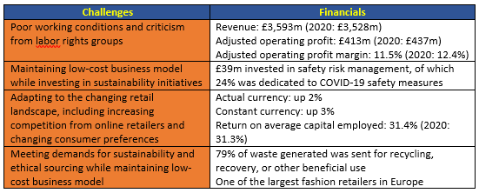
The challenges as identified
Self-Created from Annual report (2021)

Solutions:
Refer to Appendix 1 for more details.
Segmentation
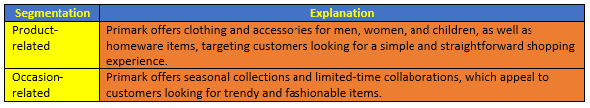
Image: The Solution based Segmentation
Source: Created by ME
Targeting
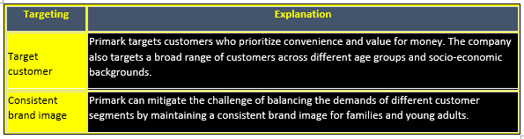
Image: The Solution based Targeting
Source: Created by ME
Positioning
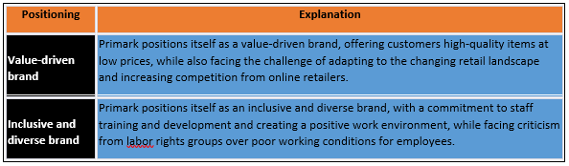
Image: The Solution based Positioning
Source: Created by ME
Overall, Primark's low-cost business model has helped it keep its position as a leading fashion retailer, but the company must continue to adapt to changing consumer preferences and the growing need for sustainability and ethical sourcing. The company's financial data reveals that it has been effective in producing revenue and improving its return on average capital employed, but it faces hurdles in preserving profitability while investing in sustainability programs and enhancing employee working conditions (Eisenberg, 2019). Primark can continue to expand and preserve its competitive edge in the fashion sector by concentrating on its core value proposition of supplying inexpensive apparel to a diverse variety of clients while also tackling these difficulties.

Conclusion
Primark's marketing mix strategy is based on offering affordable fashion to a mass market. The company's low-cost business model has enabled it to expand rapidly and maintain a strong presence in the fashion retail market. Primark faces challenges from competitors and changing consumer trends. Primark's approach to focus more on physical attributes in Birmingham include Shop Design. In addition, the layout contributes to the development of a calm and pleasant atmosphere for the clients while they are shopping.

Reference
Agnihotri, A. and Bhattacharya, S., 2020. Primark Stores Limited: Low-cost Strategy and Sustainability Initiatives. Ivey Publishing.
Annual report (2021) ABF Corporate. Available at: https://www.abf.co.uk/annual-report-2021 (Accessed: February 19, 2023).
Araujo, C.L., Picavet, M.E.B., Sartoretto, C.A.P.D.S., Dalla Riva, E. and Hollaender, P.S., 2022. Ecocentric management mindset: a framework for corporate sustainability. critical perspectives on international business, 18(4), pp.518-545.
Bryson, J.R., Sundbo, J., Fuglsang, L., Daniels, P., Bryson, J.R., Sundbo, J., Fuglsang, L. and Daniels, P., 2020. Reading and Managing Service Businesses: An Integrated Case Study Approach. Service Management: Theory and Practice, pp.261-278.
Caimotto, M.C., 2023. Food and neoliberal rationality. In Lifestyle Politics in Translation (pp. 170-188). Routledge.
Eisenberg, P., 2019. Financial Analysis of Primark Stores Ltd. with regard to a Stock Exchange Floatation (IPO). International Journal of Management, 7(1), pp.91-112.
Fashion, home & beauty (2022) Primark. Available at: https://www.primark.com/en-gb (Accessed: February 18, 2023).
Kasapi, E., 2022. Corporate social responsibility: is it still relevant? A critical look on its effectiveness in the fashion industry and contribution to corporate greenwashing.
Ritch, E.L. and McColl, J., 2021. Disruptive Innovation. In New perspectives on critical marketing and consumer society. Emerald Publishing Limited.
Turning it round (2022) Turning it Round | Primark Cares (USA). Available at: https://corporate.primark.com/en-us/product/turning-it-round (Accessed: February 19, 2023).
Xydia, N., 2019. Sustainably-conscious consumers’ perceptions, attitudes and behaviours towards the fast fashion industry: A Case of Primark.

