Problem Solving and Decision Making

Table of Contents
1. Introduction and Scenario Overview: 1
2. The problem, Alternative Solutions and Implementation: 3
2.1 Identification of the Problem and its Impact: 3
2.2 Analysis of the Information on the Identified Problem to Assist Decision Making: 5
2.3 Proposal for Alternative Solutions to the Identified Problem: 8
2.4 Use of a Decision-Making Technique to Evaluate the Proposed Solutions and Selection of the Most Appropriate Option: 9
2.5 Plan for the Implementation of the Solution: 13
2.6 Communication Plan to Stakeholders: 14
2.7 Assessment of Appropriate Monitoring and Review Techniques to Successfully Implement the Solution: 14
3. Conclusion: 16
References: 17

1. Introduction and Scenario Overview:
WINDLE & MOODIE (WM) is one of the award-winning beauty salon service providers in the UK. The WM was established in 1993 and it is situated in the Covent Garden. In the last 26 years, the WM has established itself as a reputed top-class beauty salon service provider in the Covent Garden (Windleandmoodie.com, 2019). The WM offers a range of beauty and salon services to its customers including haircutting and styling, technical services (including highlights, permanent tint, glossing and tint regrowth) and WM special treatment services. The WM also offer different beauty products to its customers which include shampoo, conditioner, sprays, creams, oils, and hairsprays. The WM claims that hundreds of people use its products and services to feel good, look good and make most out of their life (Windleandmoodie.com, 2019). The WM aims to grow its operation ensuring sustainable growth as it identified that the growth at the expense of the customers’ well-being is not going to assist the company in the long run. The WM has established a strong competitive position in the market by following a broad differentiation strategy. The company has differentiated its products and services by offering new & unique beauty salon services and high-quality products to its customers.
Over the past years, the WM has managed to ensure consistent growth in its sales and services by introducing its new styles and improved products to its portfolio. However, the company is facing difficulties in maintaining its growth in recent years. Furthermore, the increasing number of a beauty salon in the industry has added fuel to this problem. There are around 42000 hairdressers and beauty salon in the UK at present (nhf.info, 2019).
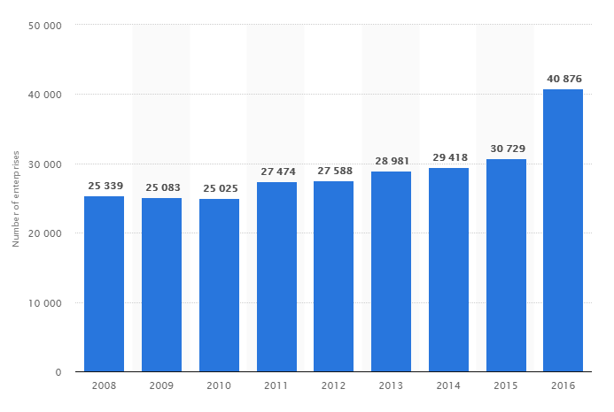
Figure 1 Growth of Beauty Salon in the UK
Source: (Statista, 2019)
As the above chart is showing that the beauty salon industry is experiencing consistent growth in the number of industry participants in recent years. The number of beauty salon services providers was 28981 in 2013 and the number is almost doubled in 2018 by reaching 42000 services providers. It is creating a major problem for a company that promised to maintain a continuous growth rate as the customers are getting acquired by the new entrants of the market. The management team of the WM has identified the pricing issues, limited service area and increasing competition of market and decreasing customer base as the major reasons for such declining growth of the company.
This report has represented the scope and impact of the problem as first. Then, an analysis of information to facilitate decision making has been presented based on which alternative solutions to this problem have been proposed. After that, decision-making techniques will be applied to evaluate the options and select a suitable one for the company. The implementation plan for the solution and communication plan for the stakeholders has presented later. Finally, appropriate monitoring and review techniques to ensure successful implementation of the solution has been presented which will be followed by a brief conclusion.

2. The problem, Alternative Solutions and Implementation:

2.1 Identification of the Problem and its Impact:
The WM offers one of the largest portfolios of services and products in the beauty and salon sector. The vision of the company is to achieve sustainable growth by making a sustainable living commonplace for its customers. The company has approximately €51.1 thousand turnovers in 2018 and 48% of which has come from the beauty products offered by the company (companycheck.co.uk, 2019). The company also has a diversified workforce consisting of full-time and part-time people with multicultural diversity. Despite its resources, the company is expiring difficulties in maintaining its growth rate.
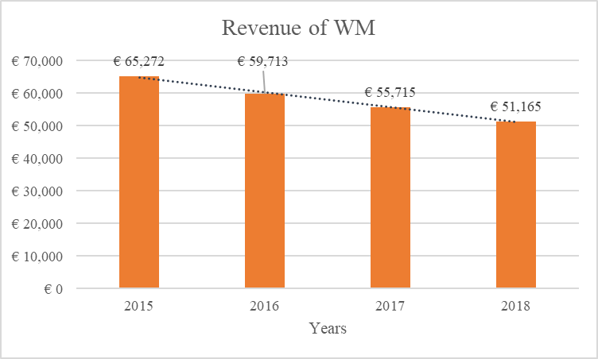
Figure 2 Revenue of WM
Source: (companycheck.co.uk, 2019)
As the above chart is showing, the WM has experienced a negative growth rate in its turnover in recent years. In 2016, the company has experienced a negative turnover growth of 9% compared to 2015. Though the company has also experienced negative growth in 2017. In fact, 2018 was one of the most challenging years for the company (Windleandmoodie.com, 2019). The revenue of the company has fallen to €51165 in 2018. This declining revenue of the company in recent years has attracted the attention of the management team of the company. As the sustainability principles of the company prioritise the achievement of sustainable growth, this negative growth has become one of the most important problems for the WM.
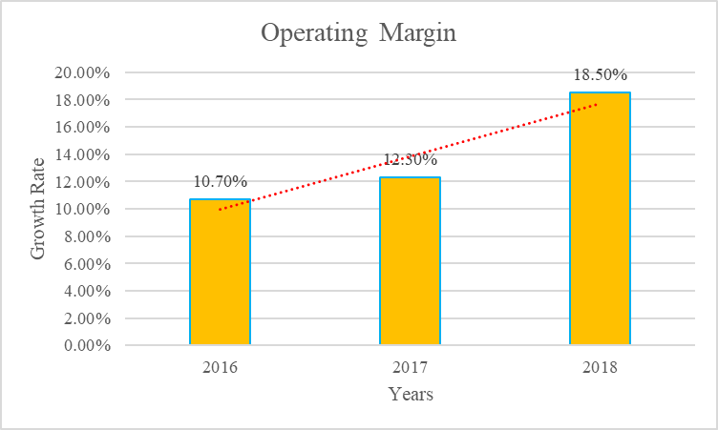
Figure 3 Operating Margin of the WM
Source: (companycheck.co.uk, 2019)
As the above chart is showing, the operating margin of the company has experienced a positive growth rate in the last three years. The operating margin of the company was 10.70% in 2016 and it has increased to 18.50% in 2018 (companycheck.co.uk, 2019). The company was able to achieve a higher operating margin because of its efficient operating system and the increased price of its products and services. The price of the products has increased in recent years which is allowing the company to secure a higher operating margin even though the sales volume is decreasing.
As the above chart is showing the operating margin of the company has made a jump in 2018. Especially, the operating margin of beauty products segment of the company has made a higher operating margin compared to the previous year’s operating margin in the same segment. Though the company’s revenue growth is slowing down and experiencing negative growth, the net margin of the company seems to have no impact. One of the main reasons for such unusual behaviour is the increased price for its products (Windleandmoodie.com, 2019). The company has increased the price for its products in 2018 which is contributing to the higher operating margin of the company. Though the company is maintaining a higher operating margin, the declining growth in the sales of the company will ultimately affect the bottom line of the company as well. Moreover, the higher price might add fuel to the decreasing sales growth of the company in future.

2.2 Analysis of the Information on the Identified Problem to Assist Decision Making:
As the company is experiencing a declining growth rate in its revenue, the analysis of revenue related information by segment might assist in the decision-making process. The revenue generating segments of the can be divided into two categories including the beauty salon services and beauty products. The following chart is showing that the beauty salon service segment has accounted for 52% of the revenue, and beauty products offered by the company are accounted for 48% of the revenue in 2018 (Windleandmoodie.com, 2019) which indicates that the beauty salon services care is the most important revenue generating source for the WM.
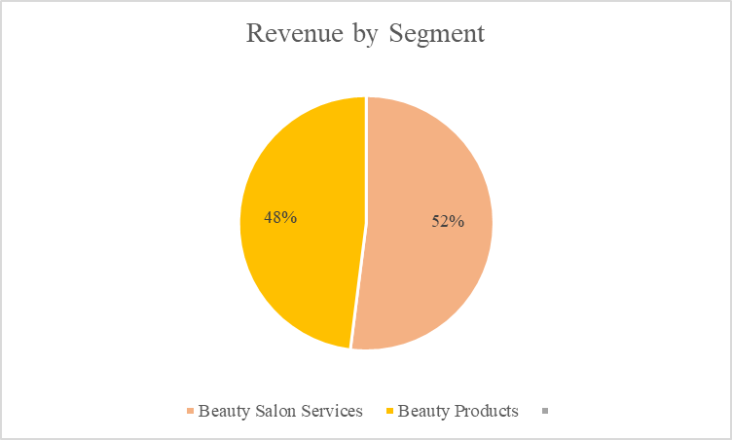
Figure 4 Revenue by Segment of WM
Source: (Windleandmoodie.com, 2019)
The following section will represent the price chart of the company for the above product and services offered by the WM which will help the company to understand the impact of its price changes on the declining growth of revenue of the company.
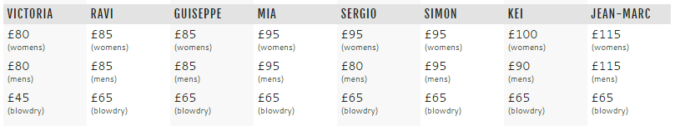
Figure 5 Price List of Haircutting Services Offered by the WM
Source: (Windleandmoodie.com, 2019)
As the above table is showing, the highest price charged by the company for the haircutting services is £115 for mems and women’s haircutting in Jean-Marc category whereas the lower price is £45 for the blow-dry Victoria and this price is representing 5% increase of the price over the previous year. As a result of the price increase, a portion of its customers are not returning for the hair cutting services which is influencing the declining sales of the company.
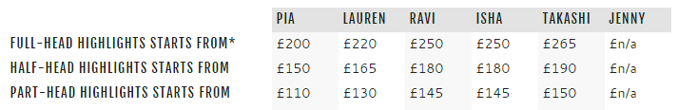
Figure 6 Price List for Technical Services of the WM
Source: (Windleandmoodie.com, 2019)
As the above table is showing the price list of the company for the technical service provided to its customers. As noticeable, the highest price for the technical services offered by the company is £265 whereas the lowest price is £110 and this price may increase further depending on the customised requirements by different customers (Windleandmoodie.com, 2019). The WM is reputed for its high-quality technical services which are enabling the company to charge a higher price to its customers but this high price is causing a potential customers group to move to the competing beauty salon which is reducing the turnover of the company.
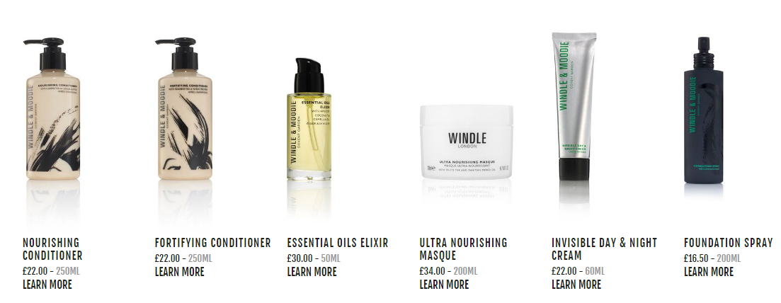
Figure 7 Price of the Beauty Products of the WM
Source: (Windleandmoodie.com, 2019)
The above image is showing the price list of some of the beauty products of the company. As noticeable, the price charged by the company for the beauty products is not very high but it makes the company compete with the dedicated beauty and homecare products suppliers in the market such as Nestle.
As the above analysis revealed, the primary source of the declining revenue growth of the WM is the hair cutting service category. The second source of the declining revenue is the technical service category and the third source is the beauty products category. The hair cutting category and technical service category has experienced an increase in price in the last year whereas the beauty products category has not experienced such price increase. Though the price increase has some impact on the decreasing turnover of the company, the reasons for such decline are identified as follows:
- Increasing Competition in the Market: One of the main reasons for declining sales is the increasing competition in the market. As mentioned earlier, the number of beauty salon service providers are increasing very rapidly in the last few years. In 2014, the number of the beauty salon in the UK was 29418 which has increased to 30729 in the following year (Statista, 2019). But in 2016, the number of beauty salon service providers in the UK has increased significantly. In 2016, the number of beauty salon service providers in the UK has increased to 40786 service providers (Statista, 2019). The number has further increased in 2018 to 42000 service providers approximately (nhf.info, 2019). This is indicating that the more competitors are entering the market, it is becoming harder for the WM to maintain its growth in the market.
- Pricing Issues: The WM and its competitors including the Best Beauty, Tip Top Hair and Paul Edmonds London have raised the price of their products from 2%-5% to maintain the operating margin (Franchisehelp.com, 2019). However, the increase in the price has not been a good strategy for the WM which is reflected in the declining sales of the company. Furthermore, Brexit uncertainties have caused the customers to be more careful about spending their money. As a result, the sales of the company has declined.
- Limited Area of Services: The services offered by the WM is limited by London city only. As a result, the company has depended on the customers of this city only to sell its services and products. Moreover, the competition in London city for the beauty salon services is very high. As a result, the customers are shifting to the service providers that offer high-quality services for a competitive price. This is causing the company to experience decreasing sales in recent years. The increased competition and recent price increase have caused the company to lose its customers to the competitors which are not a good sign for the sustainable growth of the company. Furthermore, the new coming players are offering a competitive price for their services which is making it harder to find new customers for the company within the limited area.

2.3 Proposal for Alternative Solutions to the Identified Problem:
As identified above, the primary problem of the WM is the declining sales growth in recent years and the declining growth in the beauty salon segment is one of the main reasons for such negative sales growth of the company. To solve this problem, the following alternatives are proposed to the WM:
- Alternative 1-Increase the Marketing and Brand Investment: One possible solution to this problem is the higher investment in the brand development and marketing of the products of the company. This strategy will help the company to attract more customers to purchase its products which will, in turn, increase the sales of the company.
- Alternative 2-Establish a Competitive Pricing Strategy: The increased price of the WM has initiated the declining sales growth in the first place. So, the company can pursue a more aggressive pricing strategy and lower the price of the products which will assist the company to increase its sales. As the company has higher brand value compared to small competitors, customers from those companies will shift to the WM which will ensure growing sales of the company.
- Alternative 3-Geographical Expansion of the Company: The WM is offering its services from a limited service area which is causing difficulties for the company to attract and retain new customers. So, the company has the opportunity to expand its business geographically which will help the company to attract new customers. The company will be able to retain those customers by providing high-quality services. As the company already has the reputation of being a high-quality services provider, it will be easier for the WM to attract new customers in the market area. This strategy will help the company to achieve sustainable growth as well because of the new customer base and new market presence will boost the sustainable growth of the company (Reed, Lajoux and Nesvold, 2016).

2.4 Use of a Decision-Making Technique to Evaluate the Proposed Solutions and Selection of the Most Appropriate Option:
While evaluating a possible solution it is important to evaluate whether the solution is financially and operationally feasible (Butterfield, 2016). The financial feasibility can be tested using the popular discounting method or net present value method. The operation feasibility can be tested by analyzing the human resource and infrastructural support to the solution (Habib and Jungthirapanich, 2016). Along with the financial and operational feasibility, other advantages and disadvantages of all the available options should be analysed to decide on a solution because the solution that passed the operational financial feasibility might have other negative consequences on the organisation. The following section will test the financial, operational feasibility and other consequences of the proposed solutions using appropriate techniques.
- Financial Feasibility: The financial feasibility of the proposed solution will be analysed using net present value technique and the solution with higher net present value will be preferred (Friedlob and Schleifer, 2015). As the following analysis is showing, the option 3 has higher NPV compared to other options and option 1 has lowest NPV among all the options which indicate that the managers of the company should choose to prioritise option 3 in terms of financial feasibility.
Year | Cash Flow |  |  | Present Value
Year | Option 1 | Option 2 | Option 3 | Option 1 | Option 2 | Option 3
0 | -500 | -800 | -1000 | -500 | -800 | -1000
1 | 250 | 200 | 220 | 229.36 | 183.49 | 201.83
2 | 220 | 270 | 250 | 185.17 | 227.25 | 210.42
3 | 180 | 350 | 480 | 138.99 | 270.26 | 370.65
4 | 150 | 480 | 515 | 106.26 | 340.04 | 364.84
5 | 100 | 500 | 650 | 64.99 | 324.97 | 422.46
NPV |  |  |  | 224.78 | 546.01 | 570.20
The above cash flow is an estimate of future cash flow available from each option. The amount is representing the incremental cash flow for each option. All the values are in thousand. The interest rate is assumed to be 9% and the life year for each option is assumed to be 5 years.

- Operational Feasibility: As option 1 has the lowest NPV, this option has been rejected in financial feasibility phase. As a result, option 2 and option 3 will be tested for operational feasibility.

Alternatives (Options) | Operational Compatibility
Option 2 | Option 2 involves lowering the price of services and products. This option is operationally feasible because the WM has a very efficient manufacturing process and expert human resources to support the lower price of the product by lowering the manufacturing cost.
Option 3 | The option suggested a geographical expansion of the company which will require expert human resource support to maintain its high-quality services to the customers in the new market. As the WM has a diverse workforce with high skills and expertise, the company will be able to support the implementation of this strategy as well.

- Analysis of Other Consequences: As both of the options are financially and operationally feasible, the other consequences of the available options will be analysed using the pros and cons method which is especially suitable to evaluate two alternative options for decision-making.
Options | Pros | Rating (10) | Cons | Rating (10)
Option 2
  A lower price will attract more customers as 32% of the business represent the price-sensitive markets.
  A lower price will help the company to compete with new competitors which will help to expand the market share of the company
  .
  The lower price will increase the sales volume by attracting more customers which will increase the turnover of the firm.
  7
  5
  7
  The lower price will decrease the return on investment which might upset the investors initially.
  A lower price might have a negative impact on the customers’ psychology as the beauty salon services require psychological satisfaction.
  Though lowering the price might boost the turnover immediately, the sustainable growth of the company can’t be achieved by lowering the price only.
  8
  7
  6
 | Total Score | 19 | Total Score | 21
Option 3
  The geographical expansion will offer an additional customer base which will increase the turnover of the company.
  This strategy will allow the company to offer its services to the new customers which existing price which will help to maintain higher gross and operating margin.
  The new customer base will ensure sustainable growth of the company as the satisfied customers will return to the company to make their purchase.
  8
  7
  8
  This option will require a huge initial investment and it might take two to three years to make a return to full capacity. The investors may not support this option.
  The company’s involvement with end customers will require additional human and infrastructural support which can be costly to maintain.
  This strategy will involve the company to compete with established competitors in the new market which might create a competitive disadvantage for the company.
  7
  6
  8
 | Total Score | 23 | Total Score | 21

As the above analysis suggests, option three has scored 23 in pros and 21 in cons whereas option 2 has scored 19 in pros and 21 in cons. As noticeable, option three has higher pros compared to option 2. The above analysis also suggested a higher NPV from option three. So, the WM should accept the option three to implement. That is the company should go for the geographical expansion to solve the identified problem and maintain its sustainable growth.

2.5 Plan for the Implementation of the Solution:
The successful implementation of the selected solution will require a well-structured plan following which the responsible manager will be able to achieve the desired outcome. The first step to implement the plan will include the identification of potential market with a large customer base which is suitable for carrying out the objective of the company. Once the target place is selected; the WM will require to establish a rent or land acquisition deal with the local landlords. The WM might employ its legal advisor to carry out this task. Then, the company will require to prepare the financial plan that is the funding of the acquisition. The company can use a combination of debt and equity to fund the acquisition. After that, the WM will require to assign a project manager to complete this land acquisition and office building project who will be responsible for the development of the office space for the company. Alternatively, office space can be rented for the long-term. In both cases, a quality control team should be deployed to monitor and control the implementation process to ensure the desired outcome from the project. The company should also plan decoration and interior designing of the building.

2.6 Communication Plan to Stakeholders:
The executive management team of the WM will require to maintain proper communication with different stakeholders of the company. The company should follow the stakeholder matrix to maintain communication with all the stakeholders depending on their power and interest in the selected solution (Middleton and Wedemeyer, 2015). At first, it should communicate with the stakeholders that the selected initiative is required to implement in order to solve the identified problem of the company within the first 2 weeks of the implementation process. The executive management team will communicate the need to implement the solution among their subordinates which will create an awareness among the employees. Then. the CEO of the company will be responsible for communicating with the investors of the company and convincing them to approve the selected solution to implement. Several meeting should be arranged during the first 5 weeks among the major stakeholders of the company and the landlord/owner of the building to reach a decision. Once the deal is established, the project manager will require to be formulated in the 10th week of the implementation process and assign the roles and responsibility of the project management team. After that, a weekly meeting will be arranged with the project management team and executive management team to regularly communicate the project progress. The CEO will also maintain a monthly meeting with the investors specifically for this project to communicate the progress.

2.7 Assessment of Appropriate Monitoring and Review Techniques to Successfully Implement the Solution:
The successful implementation of the selected solution will require appropriate monitoring and review techniques otherwise the solution might not be implemented successfully. For the monitoring of the implementation process, the project manager and executive management can use the Gantt chart, PERT and Critical Path Method (CPM). The CPM method will enable the project manager to identify the most efficient path to implement the solution (Rudman, 2015). These approaches will allow the responsible authority to actively monitor and implement progress. Appropriate performance indicators can use used to review the project progress such performance indicators can include the percentage completion, tasks completed and milestones achieved. The regular comparison of target work and actual will assist the company to identify inefficient areas and make improvements at the same time. As this solution will involve the development/renovation of the rented building, the participatory methods can be used for the monitoring and reviewing the implementation progress where the stakeholders will actively participate in the monitoring and review process. The following review template will be used by the monitoring team to measure the progress of the project:

Tasks | Responsible Individual | Target Performance | Actual Performance | Variance | Recommendations for Improvements
Week 1
Week 2
Week 3
Week 4
Week 5

3. Conclusion:
As the above report has illustrated, the WM is experiencing declining growth in its turnover in recent years. The declining sales growth has become one of the major problems for the company as it is disrupting the mission of the company. The above analysis has identified the increasing competition, higher pricing strategy and limited area of services as the major reasons for the declining sales of the company. After evaluating the financial, operational and other consequences of the proposed solutions, the geographical expansion has been selected to solve the identified problem of the WM. An implementation plan has also been prepared for the selected solution. The executive management team and project manager will require to maintain regular communication with different stakeholders of the company. The stakeholder’s matrix is suggested to apply to maintain communication with the stakeholders of the company. The company should also review and monitor the implementation process by applying appropriate tools and techniques to ensure successful implementation of the selected solution.

References:
Butterfield, J. (2016). Problem solving and decision making. 11th ed.
companycheck.co.uk. (2019). WINDLE & MOODIE LIMITED. A free business summary is taken from official companies house information. Free Alerts. Registered as 06552355. [online] Available at: https://companycheck.co.uk/company/06552355/WINDLE--MOODIE-LIMITED/companies-house-data [Accessed 18 Mar. 2019].
Franchisehelp.com. (2019). Beauty Industry Analysis 2018 - Cost & Trends. [online] Available at: https://www.franchisehelp.com/industry-reports/beauty-industry-analysis-2018-cost-trends/ [Accessed 18 Mar. 2019].
Friedlob, G. and Schleifer, L. (2015). Essentials of financial analysis. 9th ed. Hoboken (N.J.): John Wiley.
Habib, M. and Jungthirapanich, C. (2016). Feasibility study. 10th ed. Saarbrucken, Germany: Lambert Academic Publishing.
Middleton, J. and Wedemeyer, D. (2015). Methods of communication planning. 12th ed. Paris: Unesco.
nhf.info. (2019). Hair and Beauty Industry Statistics. [online] Available at: https://www.nhf.info/advice-and-resources/hair-and-beauty-industry-statistics/ [Accessed 18 Mar. 2019].
Reed, S., Lajoux, A. and Nesvold, H. (2016). The art of M & A. 8th ed. [New York]: McGraw Hill.
Rudman, R. (2015). Performance planning and review. 10th ed. Crows Nest, N.S.W.: Allen & Unwin.
Statista. (2019). Hairdressers and beauty salons in the UK 2008-2016 | Statistic. [online] Available at: https://www.statista.com/statistics/409073/number-of-hairdressers-beauty-salons-united-kingdom-uk/ [Accessed 18 Mar. 2019].

Windleandmoodie.com. (2019). Windle & Moodie | Covent Garden Hairdressers. [online] Available at: https://www.windleandmoodie.com/salon/#.XI_M-KAzbIU [Accessed 18 Mar. 2019].
Windleandmoodie.com. (2019). Windle & Moodie | Covent Garden hair salon services & pricelist. [online] Available at: https://www.windleandmoodie.com/salon/services-prices/ [Accessed 18 Mar. 2019].

