STUDENT FEEDBACK FORM
This section details the extent to which the assessment criteria are demonstrated by you, which in turn determines your mark. The marks available for each category of skill are shown. Lecturers will use the space provided to comment on the achievement of the task(s), including those areas in which you have performed well and areas that would benefit from development/improvement.
Generic Assessment Criteria | Marks available | Marks  awarded
1. Engagement with Literature Skills
 | 10
2. Knowledge and Understanding Skills
 | 20
3. Cognitive and Intellectual Skills
 | 20
4. Practical Application Skills
 | 40
5. Transferable Skills for Life and Professional Practice
 | 10

Assessment Mark (Assessment marks are subject to ratification at the Exam Board. These comments and marks are to give feedback on module work and are for guidance only until they are confirmed. ) | Late Submission Penalties (tick if appropriate) |  | %
 | Up to 1 week late (40% Max) |  | %
 | Over 1 week late (0%) |  | %
HNC Process Operations

Industrial Process Operation and Control

Process Automation

By Jack Peters

Contents

Task 1 – Pages 3, 4 & 5
Task 2 – Pages 5, 6 & 7
References – Page 8

Exercise 1. Steam generation plant operation.

Figure 1 represents a virtual simulation of a typical steam generation system. The system consists of a boiler, FD fan, water feed pump, valves, instrumentation and control panels. The boiler and associated equipment can be operated from BO101 control panel.
To support the safe operation of the boiler the system check panel should be used to confirm progression of the start-up process. The level alarm panel will indicate the boiler drum level and level alarms. The trend window can be used to monitor the boiler drum water level.

1) For this exercise you are required to start up the boiler to the point where steam is being generated and from your knowledge of the system develop the following in a report format:
- An explanation of the general operation of the process identifying specific equipment and a review of the instrumentation.
- A detailed standard operating procedure (SOP) to ensure safe and consistent start-up and operation of the boiler (ensure the SOP clearly states the operational steps)
- A timing diagram for the systems check process
- An alarm and interlock matrix table - table with what alarms come on when what valves etc. Are open
- A fault-finding guide should the system lock out operate.

This process involves boiling water to generate steam to turn a turbine. A tank is filled to between its high level alarm and its low level alarm, then a burner is started up to heat the water to boiling point. As the level drops a water feed pump is started to maintain the level of water above the low level alarm, the pump is then stopped when the level of the tank is getting close to the high level alarm. If either of these alarms are tripped then the burner will shut down at the start up procedure to be followed again. To measure the level of the tank an ultrasonic level sensor could be used. This is when ultrasonic waves are bounced down off the surface and then reflect back to the receiver. Using the time taken for the waves to come back, an ullage can be worked out. Using the ullage, the level in the tank can be worked out by subtracting the distance the wave travelled away from the distance from the sensor to the bottom of the tank. The sensor then sends this information to a receiver which feedbacks into the system, the alarms would then use the information and activate when a set level has been reached.

- The first step is to get water into the system by opening valves CV104 and CV105 and turning on pump PU101.
- The next step is to open CV101 which is the control valve for the gas supply, before moving onto the next step leave the pressure of the gas build until it hits 49.5 mBar on the Fuel gas pressure
- The next stage is to open CV103
- Then open Fuel damper DM101
- Turn on FD 101 and wait for the fan air to purge
- Press lockout reset before opening CV102
- Press burner ignition to start the flame
Checklist Item | Time Order
Water fill
Gas Valve Check
Gas Pressure Check
FD Fan Vane check
Flume Dampner Check
Fd Fan air Purge
Gas Flow Purge
Burner Ignition

Alarm/Fault | Cause/Solution
Low Low Level | Level is below 10%, turn on PU101 until alarm turns off
Low Level | Level is below 25%, turn on PU101 until alarm turns off
High Level | Level is above 80%, turn off PU101 and open CV108 to let water out the tank
High High Level | Level is above 80%, turn off PU101 and open CV108 to let water out the tank
Feed Pump off | When tank level is at 90%, PU101 will turn off and cannot be restarted, open CV108 to let water out
Burner Ignition won’t start | Press lock out reset and try again
Gas Pressure check hasn’t completed | Let pressure build up to 49.5mBar

Exercise 2. Container Filling Operation

This production process (see figure 2) places bottles onto the conveyor where they are moved to the filling and capping stations in turn. The operation of the bottle filling system is currently under manual control through the use of various buttons on the control panel. The process is to be fully automated and requires a sequential control strategy to be developed.
2a) You are required to construct a flow diagram for all the sequential control operations. Include in your flow diagram all consecutive and concurrent processes to ensure container are filled and capped in a continuous process.
2b) Briefly discuss the process and the application of the sequential control system.

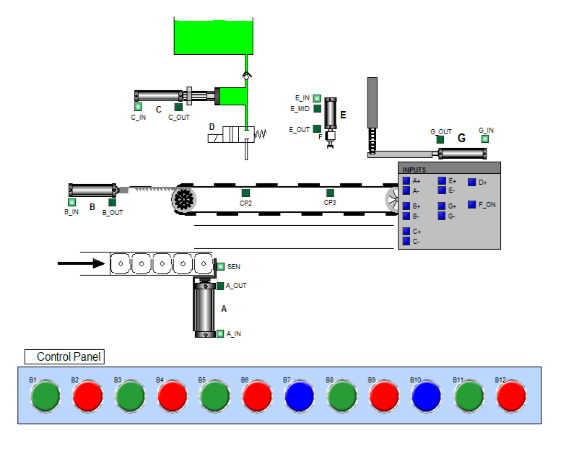

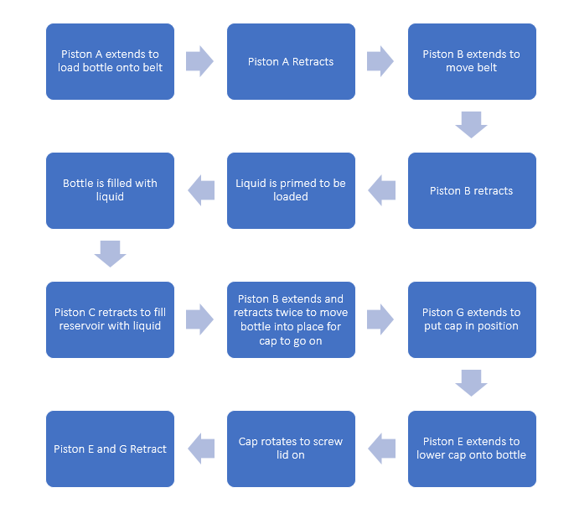

A sequential control system is a control system where the process can only move forward when the previous step has been completed. There are two types of sequential control systems, one is a closed loop system where the next step can only be carried out when the previous task has been completed. The other type is an open loop system, this is done by the next task in the sequence starting after a certain time period has passed, this means there is no direct feedback into the system. There can be sequential control systems which incorporate both of these. An industrial example of this would be the loading of a road tanker with diesel. This control system is ideal for this as it makes sure steps cannot be missed and that it can only be loaded safely. The system will only allow certain quantities to be loaded through certain loading arms into certain pots on a tanker. This is done to avoid human error which can lead to an escape of product. A disadvantage to sequential control systems is that they can be more time-consuming than other systems and if a mistake is made halfway through then the whole process must be done over again.

References

What is an ultrasonic sensor? | Sensor Basics: Principle-based Guide to Factory Sensors | KEYENCE

How Do Ultrasonic Distance Sensors Work? - The Learning Circuit - YouTube

What is Sequential Control System? (electricalandcontrol.com)

