Poster defence management ethics m5x00803

  - Aaron Roberts

- Whose corporation/ operation are you representing?

The operation I am representing are known as “Global March Against Child labour”. This network operates worldwide where teachers, trade unions along with civil society organisations unite, attempting to make people aware of child labour in attempt to prevent the act worldwide (Global March Against Child Labour, 2017).

- What are the views of the corporation/organisation you are not representing?

Apple uses a mineral known as cobalt for the production of Lithium Ion Batteries to power iPhones. Apple’s sources of cobalt include poor countries such as Congo. According to Frankel (2017) children are forced into labour, including agriculture and mining, with co-operations mainly responsible being rebel groups.
Apple’s global power can be illustrated in terms of their productivity. Karabell (2012, para. 8) illustrates that “Apple is a $600 billion company and growing” which indicates that they have more wealth than a large number of countries around the world. This raises concerns about what is happening in terms of contractual agreements made with the Republic of Congo’s government.

- What is the key message that you are trying to communicate?

They key message I am trying to convey is that Apple uses unethical practices to increase their production. Cultural relativism can play a major role in why it would be acceptable to use children from the Republic of Congo but not children from America. Another message includes fairness; all children should be treated the same way, with a loving caring environment no matter where they come from.
Demunijnck (2015) dictates people learn to accept differences in terms of how they are treated in comparison with other areas around the world as it is seen as a normal part of their culture. For example, child labour is considered ‘normal’ in terms of Congo’s culture; conversely, there are laws in America implemented to prevent child labour. This includes “Child Labour BulletIn 101” and is responsible for protecting American children against child labour. “United States Department of Labor” (2013).
Apple, as demonstrated in a recent article, moved their headquarters to Jersey gaining them $252 billion as there are loopholes regarding tax. This clearly illustrates Apple does not care about avoiding tax for their personal gain, although an Apple spokesperson states, “As the largest taxpayer in the world, Apple pays every dollar it owes in every country around the world” (Ashok, 2017).

- What is the main target audience that you hope will read and understand your message?

The main target audience would be customers of Apple products, to make them aware of the unethical practices Apple uses.
Friedman (1970) illustrates that the main responsibility of a business is to ensure that it operates ethically; although all businesses operate to earn as much profit as they can, they need to do so in a way that it complies with rules of society. In contrast, Freeman (2001) justifies in terms of the legal argument that society is responsible for limiting the “unrestricted pursuit of profit”, this is due to the implementation of a variety of laws passed via the government.

- What would someone who disagrees with you say in response to your argument?
Friedman (1970) outlines an organisation cannot be held completely responsible for their actions, then states “The individuals who are to be responsible are businessmen, which means individual proprietors or corporate executives.”

People may try to argue it should be the responsibility of the country’s own government to ensure child labour is eliminated. Running any organisation is extremely difficult and companies such as Apple may only see their desired success if they outsource to other countries. Where child labour is not culturally acceptable in the United States, it may be a part of the culture of third world countries such as the Republic of Congo.

This means that child labour may be seen as ‘normal in terms’ of their culture. Members of the public may also argue that other organisations in the same field do the same, so why should Apple do any different?

- What would someone who disagrees with you say in response to your argument?

The main background image used has a clear message: “Heartless Apple, Rotten Apple” this intentionally provides the audience with a strong message that this organisation use unethical practises to increase their production. In terms of text used “iVote freedom for the children, children need education not slavery, stop child labour now”. I believe this clearly illustrates exactly what message I am trying to communicate.
I have intentionally used red text to rapidly draw attention towards the message of the poster.
- What research have you done to underpin your argument

I have focused on CSR, “the individual must serve a more general social interest” (Friedman, 1970).
The Core Labour Standards (Ladbury & Gibbons, 2000), seek to create an increased public awareness revolving legislations put in place, attempting to eliminate forced labour of all formations in Britain and developing countries. I have also looked into the rights of a child; as an example of this I intend to illustrate the modern slavery act (2015) which clearly outlines that all organisations have been made aware of the issues regarding child labour, those organisations that do not comply with this act including Apple could face serious prosecution.

Websites I have used to underpin my research include the following:

https://www.savethechildren.org.uk/what-we-do/childrens-rights/united-nations-convention-of-the-rights-of-the-child

http://www.jsieurope.org/docs/core_labour_standards.pdf (Page 4)

http://onlinelibrary.wiley.com/doi/10.1002/sd.244/full

http://heinonline.org/HOL/LandingPage?handle=hein.journals/intlr136&div=23&id=&page=

http://fortune.com/2017/03/03/apple-cobalt-child-labor/

http://www.patentlyapple.com/patently-apple/2017/03/apple-caught-in-another-controversial-story-about-supporting-slave-and-child-labor-in-congo.html

http://www.sciencedirect.com/science/article/pii/S0165176503003616

http://www.bbc.co.uk/news/technology-35311456
https://www.savethechildren.org.uk/content/dam/global/reports/modern-slavery-statement-2016.pdf

http://www.zdnet.com/article/how-many-iphones-did-apple-sell-every-second-during-the-last-quarter/

https://www.dol.gov/ilab/reports/child-labor/findings/2011TDA/congodemocraticrepublic.pdf

http://uk.businessinsider.com/apple-cobalt-mine-child-labor-2017-5?r=US&IR=T

http://macdailynews.com/2012/04/30/apple-a-bigger-global-power-and-more-important-than-most-nations/

- How strong do you think the evidence is to back up your argument?

There is strong evidence that organisations such as Apple need to become more compliant with Corporate Social Responsibility and sustainability within the working environment.

Bansel & DesJardine (2015) state that “Business sustainability is the ability of firms to respond to their short term needs without compromising the ability to meet future needs”. Furthermore, Mihalache (2013) advises organisations to co-operate with a CSR strategy in order to take advantages of the opportunities they encounter to boost production.

Although organisations need to take advantages of opportunities that arise, Apple need to ensure that they perform in a way that it is ethical towards society, acting in a legal manner and counteracting with public expectations.

- What would you hope would happen after the audience has understood your message?

I hope to raise awareness that large organisations such as Apple unethically use child labour to increase their production. I am aware that changing buyer behaviour would be exceptionally difficult to achieve; however, I hope members of the public will at least begin to discuss amongst themselves the subject of “Corporate Social Responsibility” and have a more in-depth understanding of fairness in terms of what should be globally accepted.
- I intend to focus on the theory of Corporate Social Responsibility by Friedman (1970).

- CSR Pyramid. Carrol (1996)

References

Ashok, I (2017). Paradise Papers: Apple Secretly Moved to Tax Jersey After Ireland Crackdown, International Business Times, [Online] Available at: http://www.ibtimes.co.uk/paradise-papers-apple-secretly-moved-tax-haven-jersey-after-ireland-crackdown-1646161

Frankel, T,C (2017) Apple Cracks Down Further on Cobalt Supplier in Congo as Chid Labour Persists, The Washington Post, [Online] Available at: https://www.washingtonpost.com/news/the-switch/wp/2017/03/03/apple-cracks-down-further-on-cobalt-supplier-in-congo-as-child-labor-persists/?utm_term=.00df109b6693 Accessed 9th November 2017

Global March against Child Labour (2016), Against Child Labour (Online), Available at: http://www.globalmarch.org/aboutus Viewed 28th October 2017

Bansal, T, & DesJardine, M (2015), Don’t Confuse Sustainability with CSR, Ivey Business Journal, pp. 1- 3, Business Source Complete, EBSCOhost, Viewed 29th October 2017

Demuijnck, G (2015), Universal Values and Virtues in Management Versus Cross- Cultural Moral Relativism: An Educational Strategy to Clear the Ground for Business Ethics, Journal of Business Ethics, 128, 4, pp. 817- 835, Business Source Complete, EBSCOhost, Viewed 3rd November 2017

Freeman, R. Edward (2001). A stakeholder theory of the modern corporation. _Perspectives in Business Ethics Sie_ 3:144.

Friedman (1970). The Social Responsibility of Business is to Increase its Profits. New York Times, Accessed 17th October 2017

Karabell, Z (2012), Latest Records Show Apple a Bigger Global Power Than Most Nations, DailyBeast, (Online) Available at: https://www.thedailybeast.com/latest-record-results-show-apple-a-bigger-global-power-than-most-nations Viewed 3rd November 2017

Ladbury, S, Gibbons, S (2000), Key Issues and Proposal for a Strategy, Core Labour Standards, A Report Submitted to the UK Department for International Development, p. 4 (Online) Available at: http://www.jsieurope.org/docs/core_labour_standards.pdf, Viewed 3rd November 2017

Mihalache, SS, (2013), Aspects Regarding Corporate Social Responsibility Definition and Dimensions, Proceedings of the International Conference Marketing- From Information to Decision, 6, pp. 130- 144, Business Source Complete, EBSCOhost, Viewed 28th October 2017

United States Department of Labor (2013), Child Labour Provisions for Non-agricultural Occupations under the Fair Labor Standards, Child Labour Bulletin 101, (Online) Available at: https://www.dol.gov/whd/regs/compliance/childlabor101_text.htm Viewed 3rd November 2017

Bibliography

Ashok, I (2017). Paradise Papers: Apple Secretly Moved to Tax Jersey After Ireland Crackdown, International Business Times, (Online) Available at: http://www.ibtimes.co.uk/paradise-papers-apple-secretly-moved-tax-haven-jersey-after-ireland-crackdown-1646161

Global March against Child Labour (2016), Against Child Labour (Online), Available at: http://www.globalmarch.org/aboutus Viewed 28th October 2017

Greig, A (2013), Is America’s love affair with Apple and Google over? Tech Giants fall in poll of country’s most trusted brands, Mailonline (Online) Available at: http://www.dailymail.co.uk/news/article-2362588/Americas-love-affair-Apple-Google-tech-giants-fall-public-perception.html Accessed: 17th^{th} October 2017

Bansal, T, & DesJardine, M (2015), Don’t Confuse Sustainability with CSR, Ivey Business Journal, pp. 1- 3, Business Source Complete, EBSCOhost, Viewed 29th October 2017

Carnahan, S, Kryscynski, D, & Olson, D (2017), When Does Corporate Social Responsibility Reduce Employee Turnover? Evidence from Attomey’s Before and After 9/11, Academy of Management Journal, 60, 5, pp. 1932- 1962, Business Source Complete, EBSCOhost, Viewed 29th October 2017

Demuijnck, G (2015), Universal Values and Virtues in Management Versus Cross- Cultural Moral Relativism: An Educational Strategy to Clear the Ground for Business Ethics, Journal of Business Ethics, 128, 4, pp. 817- 835, Business Source Complete, EBSCOhost, Viewed 3rd November 2017

Friedman (1970). The Social Responsibility of Business is to Increase its Profits. New York Times, Accessed 17th October 2017

Karabell, Z (2012), Latest Records Show Apple a Bigger Global Power Than Most Nations, DailyBeast, (Online) Available at: https://www.thedailybeast.com/latest-record-results-show-apple-a-bigger-global-power-than-most-nations

Kess, S, Grimaldi, J, & Revels, J (2017) Legal Tax and Financial Issues for Working Minor Children, CPA Journal, pp. 65- 67, Business Source Complete, EBSCOhost, Viewed 26th October

Ladbury, S, Gibbons, S (2000), Key Issues and Proposal for a Strategy, Core Labour Standards, A Report Submitted to the UK Department for International Development, p. 4 (Online) Available at: http://www.jsieurope.org/docs/core_labour_standards.pdf, Viewed 3rd November 2017

Mihalache, SS, (2013), Aspects Regarding Corporate Social Responsibility Definition and Dimensions, Proceedings of the International Conference Marketing- From Information to Decision, 6, pp. 130- 144, Business Source Complete, EBSCOhost, Viewed 28th October 2017

Oresky, M (2009), The Contemporary Approach to Sustainable Development within the European Union: Challenges for Automotive Industry, Public Administration (16484541), 1, 21, pp. 12- 18, Business Source Complete, EBSCOhost, Viewed 26th October 2017

United States Department of Labor (2013), Child Labour Provisions for Non-agricultural Occupations under the Fair Labor Standards, Child Labour Bulletin 101, (Online) Available at: https://www.dol.gov/whd/regs/compliance/childlabor101_text.htm Viewed 3rd November 2017

Zakar, M, Zakar, R, Aqil, N, Qureshi, S, Saleem, N & Imran, S (2015), Nobody Likes a Person Whose Body is Covered in Mud, Health Hazards Faced by Child Laborers in the Brick Kiln Sector of the Okara District Pakistan, Canadian Journal of Behavioural Science, 41, 1, pp. 21- 28, Business Source Complete, EBSCOhost, Viewed 26th October 2017

Appendices

Appendix 1: Poster Main Image

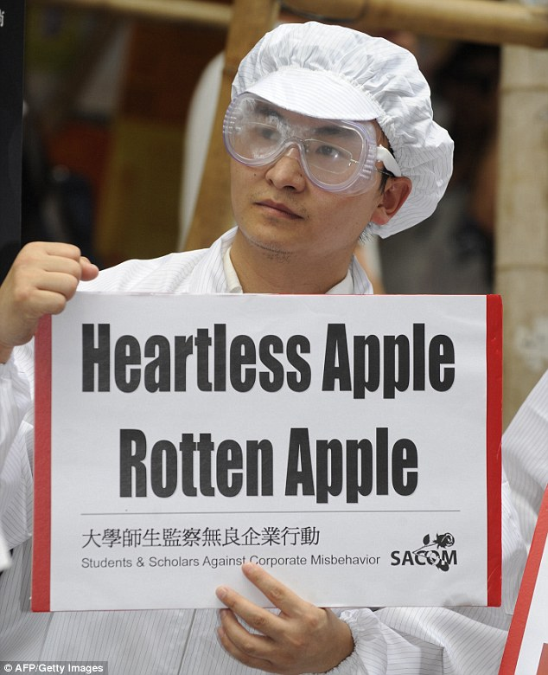

Source: Greig (2017)

