How have video game graphics and technology changed over the years?

Peredur Llyr Owen Williams
1702804
BA Games Design
Program Director Richard Morgan
Lecturer Julian Hainsworth
Lecturer Timi O`Neill
5602 words

Table of contents

Table of Contents
Table of contents 2
Acknowledgements 2
Abstract 2
Introduction 3
Methodology 3
Discussion 3
1. 3
2. 5
3. 6
4. 6
5. 7
6. 10
7. 13
8. 14
9. 15
Conclusion 17
Reference list 18
Books 19
Games 19

Acknowledgements
Thanks to Richard Morgan for the books I used to research for this document
Thanks to Julian Hainsworth for giving me advice on topics and what to discuss in the document.

Abstract
In this Document I will be looking at how graphics in games and the hardware used to create them have changed over the years. The main body of this document is set in 9 chapters, each chapter will correspond with each generation of consoles that have been released or are close to being released. In these chapters I will talk about a generation of consoles and what graphical advancements they brought to the gaming industry and how they have brought us where we are today. For the research on consoles before the 6th generation of consoles I used books mainly as there is not much on the internet about them and for consoles after the 5th generation I looked at articles and reviews on the hardware used in each console. With the introduction of polygons and bump map textures and better lighting games look a lot better and developer’s and designers can be more creative with less restrictions as time has passed so they can create even bigger and more imaginative games. By looking at an old game and the remade version of it side by side you can really see how better lighting, textures and more polygons have refreshed the old games but still kept the core game play which is amazing to see old games that u used to play brought back to life with some upgrades.

Introduction
In this document I will discuss what graphical advancements each generation of consoles made and how they have influenced graphics in the present. From the research I have conducted I hope to gain a better understanding on what drove graphics to where they are today and how they might shape the future. In each chapter I will be talking a generation of consoles and in the chapter, I will be looking at what the major graphic advancements where for the time. I will be looking at the very first console all the way to the present consoles and I will also discuss what we know about future console that are to be released in 2020.

Methodology
For my research I looked at different articles on websites and books and then from what I have learnt from what I have read I have put in the document and what I understand about the subject. For most of the older consoles I have looked at some books that discussed the major graphical advancements at the time, these books helped me understand the older consoles a bit better as my knowledge on consoles before the PlayStation 1 wasn’t great, also looking over my Game history notes taught by Richard Morgan helped recap on the history of game consoles. For a lot of the information on the specifications of each consoles I mainly looked at reviews and then did research on some of the hardware used in the consoles to get a better understanding of what it did.

Discussion

1.
The Magnavox Odyssey or Known to some as the Brown Box was the first home console ever built, it was released in 1972 and was designed by Ralph Baer who began developing it in 1966. The Magnavox Odyssey was able to display a vertical line and three squares on the screen, two of the squares could be controlled by two players using the controller or light gun that was sold separately, and the third square was controlled by the system.
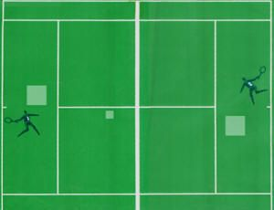
The console was Black and White, but you were able to get 23 coloured screen overlays that you would be able to place on your screen to make it feel like you were playing 23 different levels. With the 23 coloured screen overlays the console also came with dice and paper money and cards to coincide with the game that was playing on the screen.

Mark Langshaw, 13 December 2014, Photograph, Viewed November 2019, <https://hips.hearstapps.com/digitalspyuk.cdnds.net/14/50/gaming-magnavox-odyssey-tennis-game.jpg?resize=980:*>
The Magnavox Odyssey didn’t have the hard ware to create complicated visuals as it was the first home console ever made which set the path for all the other home console that have been released to date, the console may not have had complicated visuals but the console came with screen overlays that the player could attach to their television screen which made up for the lack of visuals which personally I think is a very clever visual trick.

2.
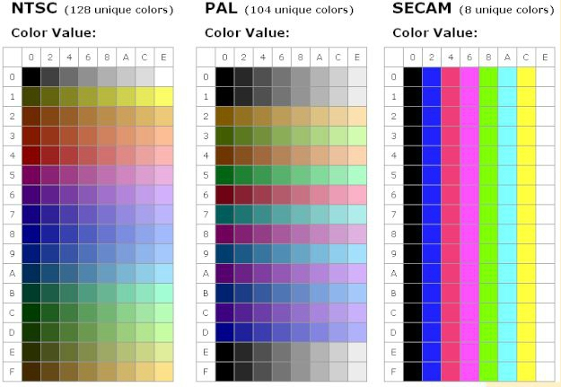
The Second-Generation console that was released was the Atari 2600. One of the main hardware features that the Atari 2600 came with was the TIA (Television interface adaptor) which is a custom computer chip that helped generate screen visuals, sound effects and read controller inputs. Due to the complexity of creating games using the TIA games where tended to be laid out quite simple, games would consist of a simple playfield with the player character on top. Sprites where limited to one colour per scan line and there are 192 lines on a display at a time these are usually loaded vertically down the screen and each colour line would be displayed horizontally. Some of the colours of the games would depend on the Television format that the players country supported, for example in the UK the television format would be PAL which supported a colour pallet of 104 colours which was pretty good comparing to the SECAM pallet which was used in places like Russia which only supported 8 colours but not as good as the NTSC colour pallet used in places like America which supported 128 colours. The PAL colour pallet consisted of a lot of dark cold colours compared to the NTSC which had a better variety of bright colours including primary colours which the PAL didn’t have.
Wilson, 17 October 2017, Photograph, Viewed November 2019, <https://retrocomputing.stackexchange.com/questions/4896/whats-with-the-atari-2600-colors-on-secam>

3.

The third generation of consoles brought the birth of Nintendo who released the NES (Nintendo Entertainment System) which was an 8-bit home console that helped revolutionise the gaming industry. Like the Atari 2600 the NES also had a limited colour pallet that consisted of a lot of cool colours which is why a lot of the games created for the console used cool greens and blues. The NES loads 8 colour pallets each consisting of 3 colours and a background colour like black or white, 4 of the colour pallets are used for the background and the other 4 are used for the sprites.
NES Colour Pallet
Dueling Analogs, 16 March 2012, Photograph, Viewed December 2019, < http://www.duelinganalogs.com/article/the-nes-that-never-was/>

The console was limited to 8 sprites per scan line, when there is a lot of data on the display the programmers would add a flickering effect to the sprites in order to cope with the restrictions that the NES had on sprites. With the NES only being able to display 8 sprites at a time a lot of the games would only use a muzzle flash to show a gun shooting which would just flicker the muzzle flash sprite for a frame due to the limitations of the hardware. The Background for scenes and sprites where loaded separately on the NES due to how they both work differently on screen; sprites are made of 8 by 8 tiles and each scan line can have a maximum of 8 sprites. The backgrounds for the games on the NES where created using a 16 by 16 grid that consisted of 8 by 8 tiles per grid to from the whole background for the display scene. As each sprite was limited to an 8 by 8 tile a lot of edges on the sprites would be quite jagged and can be quite noticeable but to tackle this designers would use basic anti-aliasing, if the background was dark on a scene and the sprites where light colours the designers would a transparent pixel wide border around the light colours to give the sprite a smoother edge.

4.
With the 4th generation of consoles there where two main competitors, one was Sega with their console the Sega Megadrive and Nintendo with their console the SNES (Super Nintendo entertainment system).
The Sega Megadrive was a 16-bit CPU which they displayed on the top of the console and was used as a marketing strategy against the popular 8-bit consoles at the time. Nintendo had the platformer Super Mario Bros (Nintendo Creative Department, 1985) which was very popular with their audience but Sega didn’t have any big platformer titles in till they released Sonic the hedgehog (Sonic Team, 1991) in 1991, the game and character sonic the hedgehog was supposed to showcase the speed and power of the 16 bit Megadrive, Sonic was created to compete with Nintendo’s Mario.

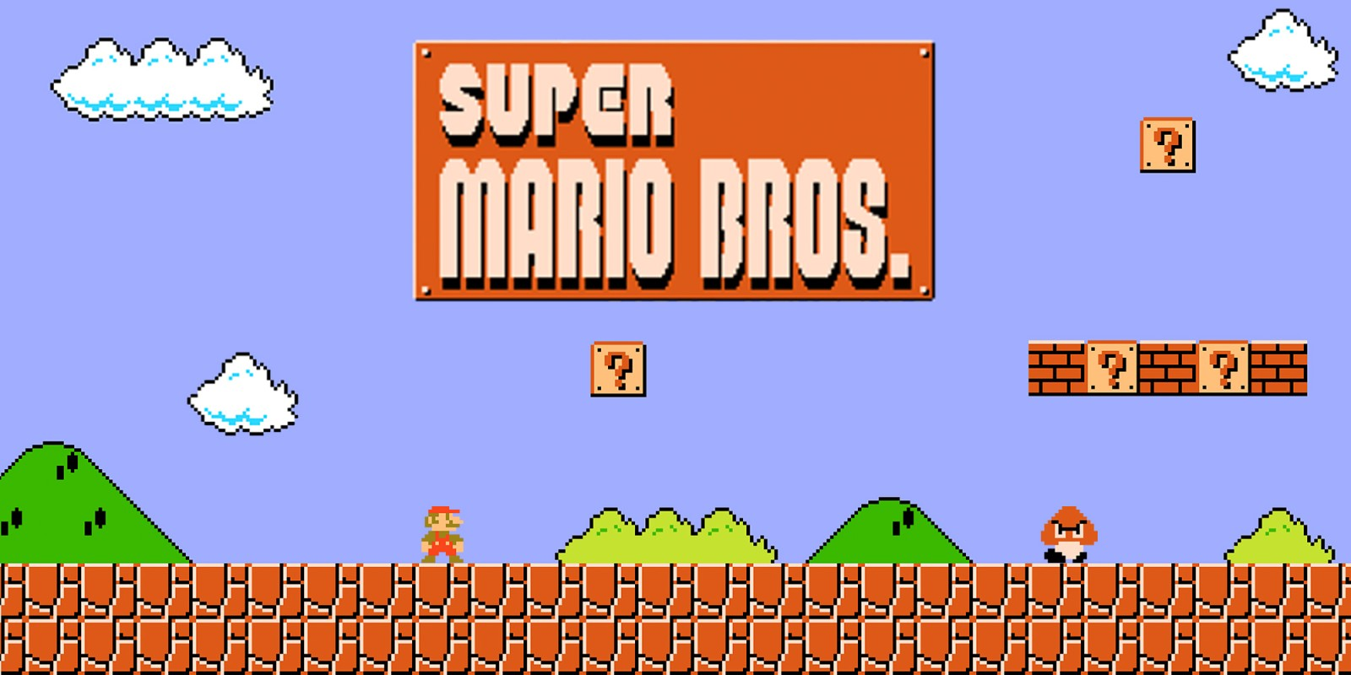
Image of Super Mario Bros
Nintendo, 2019, Photograph, Viewed December 2019, < https://www.nintendo.co.uk/Games/NES/Super-Mario-Bros--803853.html>

The SNES (Super Nintendo Entertainment System) was released as a direct competitor to the Sega Megadrive, like the Megadrive the SNES also featured a 16-bit CPU. Sega released the Megadrive before Nintendo released their SNES which meant that Sega gained most of the sales as it was the first console of the 4th generation of consoles, when Nintendo finally released their SNES Sega used aggressive marketing strategies by portraying the SNES as slow and childlike as well as the people who own a SNES whilst portraying their own console as speedy and cool and displayed this in their advertisement campaigns which showed how the Megadrive could render games quicker by using sonic the hedgehog to showcase this power. Sega took most of the gaming market in the start of the 4th generation but Nintendo slowly took most of the gaming market by the end of the 4th generation.
The SNES featured 7 different graphics modes, one of the most popular graphics modes was Mode 7 which allowed games display pseudo-3D graphics which gave the illusion of depth by warping the background layer of a level in a game changing the perspective which gave the illusion that the background of the game was moving. One of the limitations of the Mode 7 was that it only allowed the background of a level to be warped and manipulated and not the sprites in a level, some games have sprites that appear to have this effect on them but the sprites are actually part of the background which is why they are able to be stretched and manipulated.
There were quite a few different enhancement chips available for the SNES by first- and third-party companies which were included in the game cartridges, one of the most popular chips was the Super FX chip which was used in racing and simulation games like Star Fox. The Super FX chip allowed the SNES to handle more detail and 3D graphics.

5.
Winning run was the first arcade game to feature 3D graphics released in 1989, didn’t sell well because it was new technology compared to the 2D games at the time which looked a lot more sophisticated.
In 1992 ID Software released Wolfenstein 3D (id Software, 1992) which was a 2.5D FPS game, to achieve this look ID Software used 3D level that the player could navigate through and they used 2D sprites drawn from multiple angles, this gave the illusion of a 3D game but it was only halfway there. The game helped change the gaming industry due to its photorealism look for the time and the complicated 3D maze like maps, in order to have a 3D environment ID Software ray casting which is a rendering technique. The game was built on a 3D grid with consistent height wall on block colour floors and ceilings, each column of pixels displayed sent out a ray and a scaled texture is selected for the corresponding wall and the ray determines where in the wall is in the world by how long the ray takes to come back.


Example of Raycasting
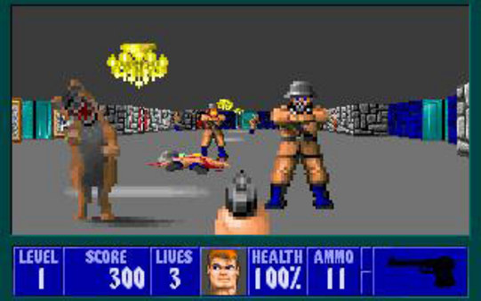
Aruvham, 2019, Photograph, Viewed December 2019, < https://github.com/aruvham/javascript-ray-casting>
Image from Wolfenstein 3D
Steam, 2019, Photograph, Viewed December 2019, < https://store.steampowered.com/app/2270/Wolfenstein_3D/g>
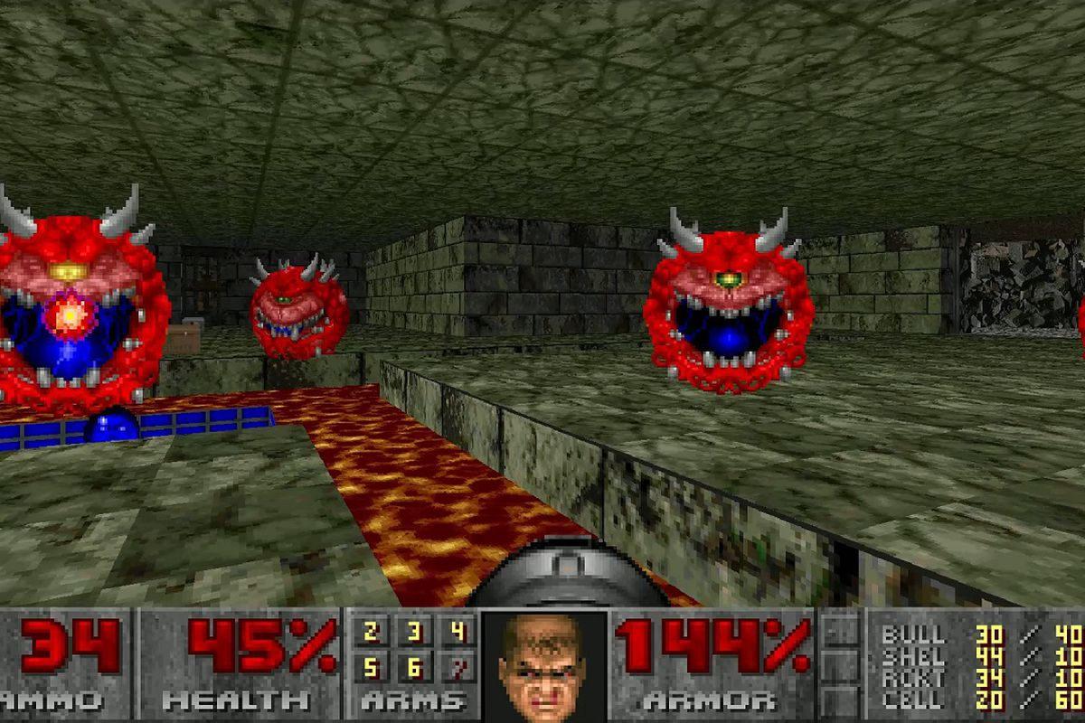
ID software later released Doom (id Software, 1993) in 1993 which had a large impact on the gaming industry and is considered the birthplace of all FPS games. Unlike Wolfenstein that had walls at a fixed angle and height, the Doom engine allowed floors and walls to be placed in any angle and height. The colour pallet of the 3D is changed during gameplay to depict what surface light is hitting and how dark or light the colours need to be. For the enemy sprites in Doom Adrian Carmack the lead artist for Doom and Gregor Punchatz created 3D sculptures of the Demons and then took pictures of them in slow motion from different angles and used them as the sprites so when in game they could be viewed at different angles giving the illusion of 3D and giving the game a more realistic look.
Image from Doom (1993)
Ana Diaz, 26 July 2019, Photograph, Viewed December 2019, < https://www.polygon.com/2019/7/26/8932238/doom-classic-2-3-bethesda-net-account-required-meme>
With a new generation of game consoles came a new generation of games and graphics, one of the first consoles for the 5th generation of consoles was Sony`s PlayStation 1 released in 1994. In the book revolutionaries at Sony it talks about Sony looking for developers to make games for the PlayStation 1 so Sony had a meeting with Company C who is well known for making combat games, in the book it quotes that Company C Said “Does Sony really want to commit suicide with the game business? Ours is a 2-D image culture; we have no interest in 3-D images. Worldwide hardware sales of---let`s say three million units --- would be a prerequisite for us to join with you.”
Namco was one of the first companies that PlayStation wanted to team up with, creating 3D graphics for game systems was what Namco was used to doing and they had many years of experience with computer graphics for arcade machines at the time. Namco also tried to persuade Sony not to enter the game console market in the first two meetings they had with each other but on their third meeting Sony demonstrated their demo software, the demo video presented that day featured pictures generated by Sony`s completed prototype board using polygons. The demo showed beautiful 3-D object moving smoothly in a 3D environment, Namco who were one of the leading companies in 3D Computer Graphics for games where impressed with the Demo and one of the game engineers at the time for Namco said “ This is remarkable. Very little surprises me; the only times I’ve been truly surprised where when the Famicom was released, when System 22[Namco`s 3-D game board for arcade games---the fastest in the world at the time] was completed--- and now, Let’s work together on this.” The first game Namco released in partnership with Sony in 1994 was Tekken which was and arcade combat game developed using the PlayStation technology, the game was the first fighting game to feature simulated 3D and it was the First game on the PlayStation 1 to sell over 1 million units. The PlayStation 1 was one of the first consoles to featured full 3D games.
In 1995 Sega released the Sega Saturn which featured twin CPUs and a couple of video processing chips. Unlike Sony Sega believed that 2D graphics where still the big thing in the video game industry and still aimed their consoles and games towards teenage boys unlike Sony who saw the potential of 3D graphics and aimed their console to gamers in their 20s. Despite that the Sega Saturn was generally a solid console which featured some beautiful games for the time and featured online play and digital downloads through its Net Link modem. Sega Saturn generally had more raw power compared to the PlayStation 1, but it’s complicated hardware made it difficult for developers to make games for it.
In 1996 Nintendo released the N64 console to compete against Sega’s Sega Saturn and Sony`s PlayStation 1, unlike the Saturn and PlayStation 1 the N64 still used 32 and 64MB cartridges rather than disks. The cartridges where the most advance and detailed for the generation, developers used to create their own microcode which allowed the N64 to process higher poly count, advanced lighting, physics, animations and AI routines compared to the 32bit consoles. One of the games that showcased the systems power was conkers bad fur day which featured multicolour real time lighting that illuminates areas in the game and Realtime shadowing and full in game facial animations. The N64s graphics chip allowed the system to execute complex rendering techniques compared to its competitors. The console featured trilinear filtering which allowed textures in games to look a lot smoother unlike the PlayStation and the Saturn which featured more pixelated textures.
In 1996 Quake (Id Software, 1996) was released which was the first video game title to feature full 3D enemies and maps, this was down to ID software’s Quake engine which featured real-time 3D rendering which was supported through OpenGL.

6.
In 1998 the 6th generation of consoles starred, the first console of the 6th generation was the Sega Dreamcast which was released in 1998. Despite the poor sales of the Sega Saturn the Sega Dreamcast sold well and was the most powerful console at the time of release, the Dreamcast had superior graphical capability’s over all the 5th generation consoles. The console allowed a lot more polygons on a screen at once compared to previous consoles which allowed game designers to realistic characters for the time rather than the blocky and sharp characters from the previous generations due to hardware capabilities. The Dreamcast also had a built-in modem which allowed for online play, many of the games on the Dreamcast are praised for being innovating and creative. Shenmue (Sega AM2, 1999) a game released on the Dream cast had detailed facial animations and was considered as some of the best facial animations in a game at the time, they achieved this by just showing head and shoulders of a character with a backdrop which meant the designers could have a lot more detail in a smaller area.

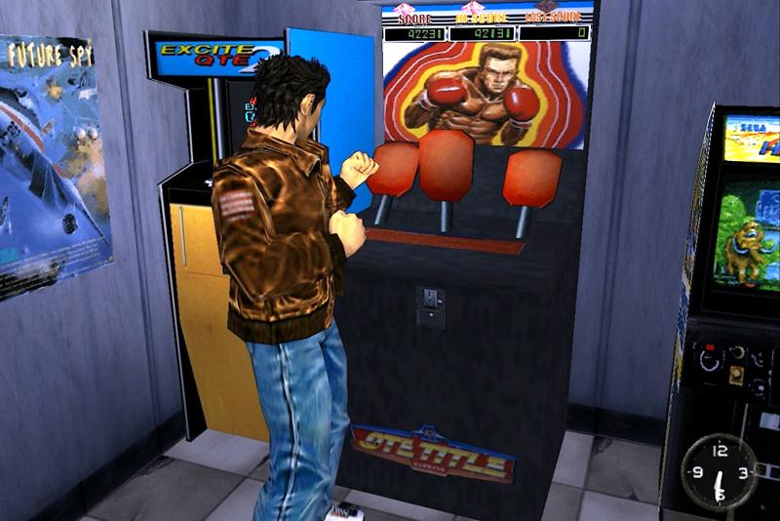
Image from Shenmue on the Dreamcast
Joseph Sammour, 05 July 2015, Photograph, Viewed December 2019, < http://www.retrocollect.com/Reviews/retro-review-shenmue-sega-dreamcast.html>
Although the Sega Dreamcast had a successful launch, Sony still had most of the market share in the console industry and in 2000 Sony released the PlayStation 2 which boasted to have 1000 times more bandwidth than a standard PC graphics processor. Sony designed the PlayStation 2 to render more than 7-16 million polygons per second with ease compared to the 3-6 million that the Sega Dreamcast could render per second. The PlayStation 2 also used DVD- ROM`s for games which could hold a lot more memory compared to the Dreamcasts GD-ROM, it also meant that you could watch films on the PlayStation and it was also backwards compatible which meant that players could play PlayStation 1 games as well as PlayStation 2 games. The PlayStation 2 had over 10000 game titles released on the system with many exclusives like Ratchet and Clank (Insomniac Games, 2002), Jak and Daxter (Naughty Dog, 2001) and God of war (SCE Santa Monica Studio, 2005) which some of them are still going to this day. Overtime the PlayStation 2 rendered the Sega Dreamcast obsolete by the time the PlayStation 2 was released in the US, in early 2000 the president of Sega resigned, and Sega abandoned the console industry and focused on software instead.
In 2001 Nintendo released their 6th generation console, which was the Nintendo GameCube, some of third-party games on the console weren’t as good as the first party games on the console due to developers not knowing the hardware and not getting the full potential from the console. The console released man highly praised games like Super Mario Sunshine (Nintendo EAD, 2002) and The Legend of Zelda: The Wind Waker (Nintendo EAD, 2002), the console also brought back some old game series like Metroid with Metroid Prime(Retro Studios, 2002) and Animal Crossing (Nintendo EAD, 2001). The best-selling game for the console was Super Smash Bros Melee (HAL Laboratory, 2001) which sold over 7 million copies. In article posted on the website Goliath, it said that Nintendo focused its time developing 3D technology by Developing stereoscopic 3D technology for the GameCube which meant it would have been compatible with 3D TVs. In the article Jack Sackman said “Nintendo likely would have gone further with its work in 3D had the development of 3D televisions not stagnated due to a high price point and lack of consumer interest. Nevertheless, many gamers and fans feel strongly that the GameCube, its graphics, and its 3D technology helped push the gaming industry into important new areas.” Some of the first party game for the console did look brilliant for the time especially the texturing in games like Metroid Prime but some did look bad like Sonic Heroes (Sonic Team USA, 2003).
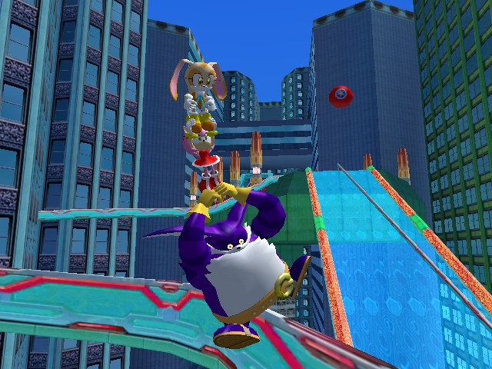
Screen shot from sonic Hero’s on the GameCube:
Daniel Bucy, 2004, Photograph, Viewed December, < https://www.the-nextlevel.com/reviews/gamecube/sonic-heroes/>
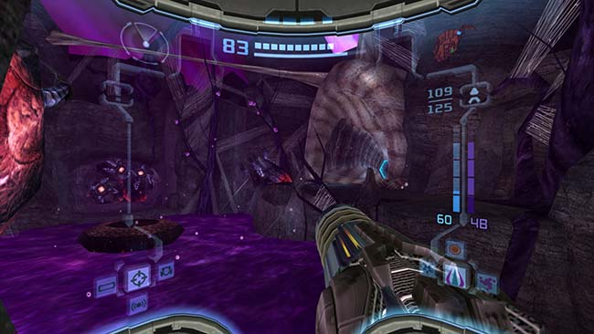
Screen shot from Metroid Prime 2 on the GameCube
Admin, 27 April 2019, Photograph, Viewed December, < https://www.modernwarfare7.com/metroid-prime-2-echoes-gamecube-iso-eur/>
In 2002 Microsoft entered the game console industry with their Xbox, The Xbox launched with Bungies Halo: Combat Evolved (Bungie,2001) which helped drive the Xbox sales on release as there hadn’t been a decent FPS on consoles since Golden eye (Rare, 1994) was released on the N64. The Xbox was one of the first consoles to feature a built in hard drive for storing game save and for downloaded content from Xbox Live instead of using a memory card like previous consoles, this was a feature that consoles have moved towards these days as hard drives could hold a lot more data compared to a memory card. The Xbox was known for being bulky the console is practically a PC which is why it was much heavier than the other consoles at the time. The Xbox outsold Nintendo’s GameCube and Sega’s Dream cast but the playststion2 outsold the Xbox and still is the highest selling console to this day.
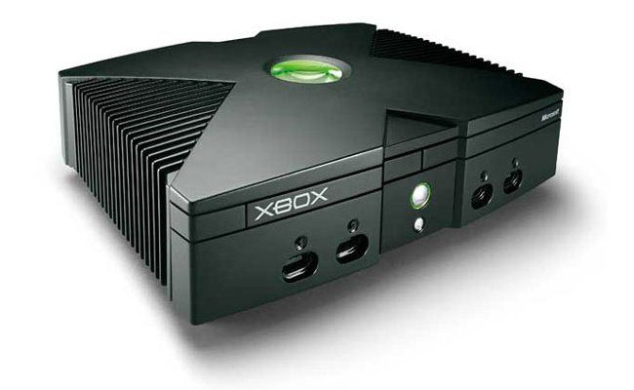
GameCentral, 14 March 2017, Photograph, Viewed December, < https://metro.co.uk/2017/03/14/the-original-xbox-is-15-years-old-today-in-the-uk-6508909/>

7.
In 2005 Microsoft released the Xbox 360 which was the first console of the 7th generation of consoles. The early versions of the Xbox 360 where known for failing and getting what they call the red ring of death which turns the power button light red which means there is something wrong with the system, due to the hardware issues of the Xbox 360 Microsoft released two redesigns; the Xbox 360 S in 2010 and the Xbox 360 Elite in 2013. The Xbox was highly praised for its influence in multiplayer games for its Xbox Live. The Xbox 360 featured a 500-MHz Graphics card with 10 MB of DRAM, the card was built Unified Shader architecture hardware which means that the rendering pipeline for vertexes, pixels and geometry in games have the same capabilities as the other. Shaders in games are used to determine the final look of what is displayed on the screen, there are two types of shaders which are pixel and vertex shaders both used to make 3D objects in game more realistic.

In 2006 Nintendo released the Nintendo Wii, Nintendo aimed the console towards a broad audience of people rather than towards a narrower target audience like Sony and Microsoft. The Nintendo Wii feature a controller that used motion control to navigate the Wii menus, it also came with a sensor to pick up movement from the Wii controller and the system also came with nunchuk controller which featured an analogue stick. Many of the games on the Nintendo Wii where activity-based games to get the user moving rather than just sitting on a chair. The Nintendo Wii sold over 600,000 consoles in the first 8 days of sale which is the best launch that Nintendo has ever had. Cartoony games for the Wii like Wii Sports (Nintendo EAD, 2006) and Mario kart Wii (Nintendo EAD, 2008) don’t look to bad as the work well in low resolution but more realistic games for the Nintendo have been criticized for looking like games from the original Xbox which was a generation before the Nintendo Wii. A lot of Major third part games released during the lifespan of the Nintendo Wii like The Elder Scrolls V Skyrim (Bethesda Games Studios, 2011) where released mainly on the Xbox 360 and the PlayStation 3 as the Nintendo Wii didn’t have the hardware to support these games. Most of the games on the Nintendo Wii are said to be like Minigames rather than full fleshed out games, this is because the console was aimed more towards a casual audience rather than a more hardcore gaming community. The Nintendo’s motion controller was quite inaccurate in game most of the time even though Nintendo did release Motion Plus technology to resolve the problem however this was only used on a handful of games for the Nintendo Wii.
In 2006 Sony released the released the PlayStation 3, the system was designed to be more than just a game console it was designed to more of a home entertainment computer. The PlayStation 3 featured a specially designed CPU called the Cell processor developed and designed by Sony, IBM and Toshiba, the Cell processor features multiple processors on one chip which means that processor can be scalable to meet different performance needs.
Many reviews when the PS3 was released said that the console was overpriced for what it was and was disappointed with the lack of games available for the console when it was first released. Many game developers considered the architecture for the system as difficult to develop games for but they also praised it for its graphical potential and also the fact that the PlayStation used Blu-ray disks rather than standard DVD, Blu-ray disks could hold a lot more memory than a standard DVD but cost more.
Just like the original Xbox 360 the original PlayStation 3 also suffered from hardware failure which was displayed as a yellow light on the power button and called the yellow ring of death, this problem only occurred with the original PS3 and not with the slim or super slim model as Sony like Microsoft had fixed the problem with the later models.

8.
The 8th generation of consoles started with the release of the Nintendo Wii U in 2012, just like its predecessor the Wii U also struggled to get third party support for the system however it did feature some good games like Super Mario 3D World (Nintendo EAD Tokyo, 2013) but not as much as the PlayStation 4 and the Xbox One. Nintendo went for a different approach with the Wii U compared other consoles, the Wii U featured quite a large screen which featured a touch screen in the centre of it so that the player could play games on the controller or on their tv screen.
In 2013 Sony released the PlayStation 4 and Microsoft released the Xbox One, when it comes to the PlayStation 4 Pro and the Xbox One X which are the higher spec versions of the consoles the Xbox One X is capable of better graphics than the PS4 Pro but a lot of developers don’t push the Xbox One X to its full potential so the differences aren’t are hugely different as a lot of the developers use the same quality textures for both consoles, however the Xbox One X does display sharper textures than the PlayStation pro. When it comes to the standard PlayStation 4 and the standard Xbox one the PlayStation 4 does run games at a higher resolution than the Xbox One, because of its GPU the PlayStation 4 is able to handle more foliage in environments compared to the Xbox One other than that they are pretty similar in quality overall.

Graphics comparison between Medievil on PlayStation 1 and PlayStation 4
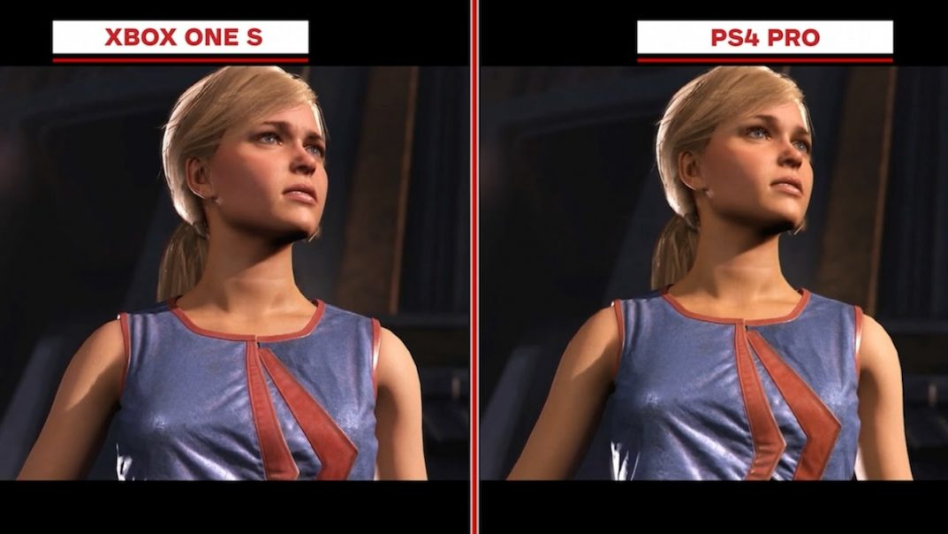
CodeJunkies, 1 November 2017, Photograph, Viewed December 2019, < https://www.codejunkies.co.uk/injustice-2-graphics-comparison-xbox-one-s-vs-ps4-pro>
In 2017 Nintendo Released the Nintendo Switch which is very similar to the Nintendo Wii U but more Streamlined. The Graphical Performance for the Nintendo Switch is pretty much the same as the Wii U, but the Shape of the console and controllers have been worked on to make it a lot more comfortable to use. Some users have experienced frame rate drops when they play the Switch on a TV but if they use the switches built in screen it maintains a steady frame rate. Even though the Switch might not have the same graphical capabilities as the PS4 and Xbox One but thanks to the Switches bright screen colours in games are a lot more vibrant which is good for Nintendo’s games as a lot of the games are cartoony so the screen helps the colours pop more which helps the games look better.

9.
In 2020 the 9th generation of consoles will be released, evidently the PlayStation 5 will feature better graphics and also raytracing thanks to its new GPU which is capable of hitting 9.2 teraflops which is not quite as fast as a RTX 2080 which is capable of hitting 10.1 teraflops but for a console the GPU is better than quite a few Graphics cards available for PCs these days. The PlayStation will also be upgrading to a SSD (Solid State Drive) from a Hard drive, this will allow for quicker boot up times for games and also load times which is good as its predecessor the PlayStation 4 load times can take some time for some games. The console will also allow for players to select what they want to install from a game for example if they only wanted to play the single player mode of a game then they could select to download only the single player, this will cut down installation times and also save room on the consoles memory. Sony has also upgraded the DualShock controller for the PlayStation 5, the controller will feature haptic feedback unlike its predecessors that used rumble motors. In a article by Shelby Brown on the website Cnet she quotes the president of Sony Jim Ryan Saying “With haptics, you truly feel a broader range of feedback, so crashing in a race feels much different than making a tackle on the football field. You can even get a sense for variety of textures when running through fields of grass or plodding through mud”, the controller will also feature adaptive triggers for the R2 and L2 triggers which means that developers can add resistant’s to the triggers to make the experience in game feel more real. With the new hardware for the DualShock controller and introduction of Raytracing the PlayStation 5 sounds like it will be offering a more immersive experience but it’s too early to say if the console will be good or bad as its not out yet, but some of the features do sound good and might change the way people play games.
In 2020 Microsoft will also be releasing the Xbox Two which will compete directly with the PlayStation 5, the Xbox 2 will be 4 times as powerful than its predecessor the Xbox One X which was a more powerful console than the PlayStation 4 Pro so it will be interesting to see which 9th generation console is the most powerful. Like the PlayStation 5 the Xbox 2 will also use an SSD rather than a Hard Drive but it will also feature 8K resolutions for games, the PlayStation 5 was also rumoured to support native 8K resolution. Both consoles have similar features so the main thing that separates the consoles are the actual games they will feature. The Xbox Two will launch with Halo Infinite (343 Industries, 2020) which is a highly anticipated game for the console, both companies have been working with studios to get exclusives for their consoles like on the PlayStation 4 Sony released Spiderman (Insomniac Games, 2018) and God of war (SIE Santa Monica Studio, 2018) which where amazing games that both won game of the year at the game awards and Microsoft had Forza Horizon 4 (Playground Games, 2018) which was also a good game.
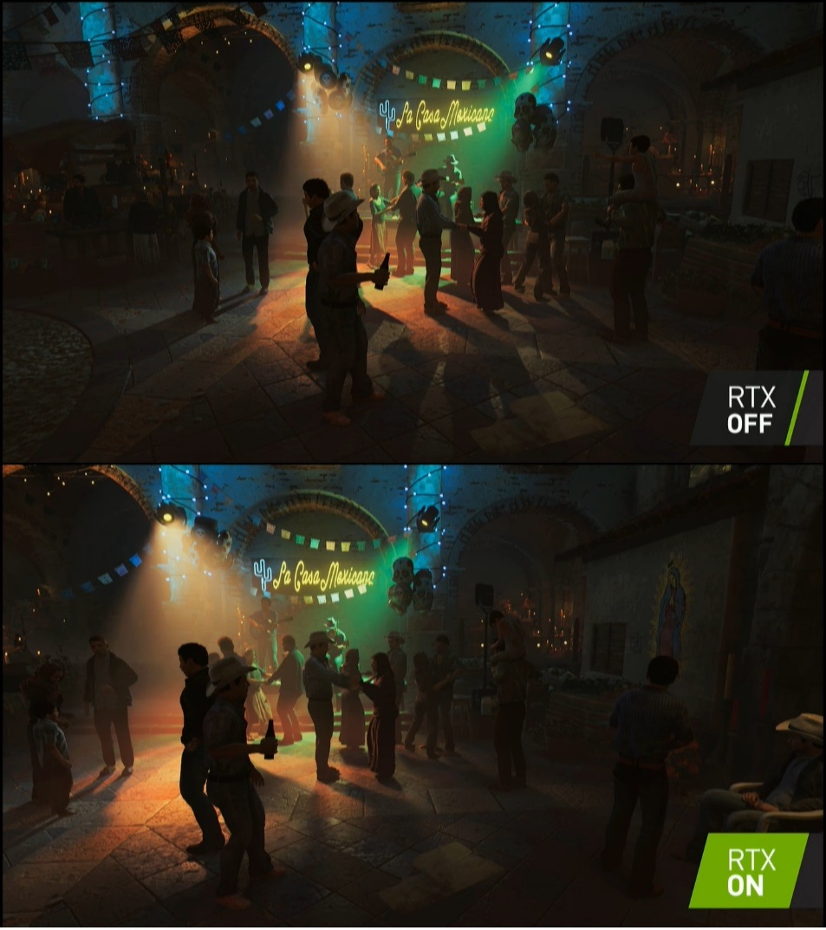
Ray tracing is a new piece of technology, GPU`s like the RTX series have dedicated hardware to support real-time raytracing but also some of the GTX series support DirectX Raytracing. Raytracing is mainly to do with light and how light interacts with objects in a 3D environment, Raytracing gives games a more realistic look and feel which is why it is a big advancement in computer graphics.
Ray trasing off and on comparison
João Carrasqueira, 20 August 2018, Photograph, Viewed November 2019, <https://www.neowin.net/news/nvidia-announced-new-rtx-gpus-with-real-time-ray-tracing/ >

Conclusion
Over the years Graphics in games have come along way since the first gen consoles back in the 1970s, some of the major advancement have been the introduction of 3D polygons and bump mapping textures which helped create more realistic looking games. With the introduction of real time Raytracing to the next generation of consoles this will be a big advancement as it will make games look a lot more realistic as ray tracing simulates how real light interacts with objects in a 3D space. From what I have learnt I can see that games are trying to look as real as possible but some consoles haven’t really changed and they make games that are fun rather than realistic like Nintendo who haven’t really been trying to advance the look of their games but how the player interacts with them which is a good direction to go in as games are supposed to be fun rather than realistic. To see how far graphics have come I have looked at games like Spyro Reignited trilogy (Toys for Bob, 2018) and Medievil (Other Ocean Emeryville, 2019) which are remastered games originally released on the PlayStation 1 and now remade for the PlayStation 4 with the new technology that has been introduced since they first released, the games are still as fun as they used to be but look a lot better with extra polygons, textures and better lighting.

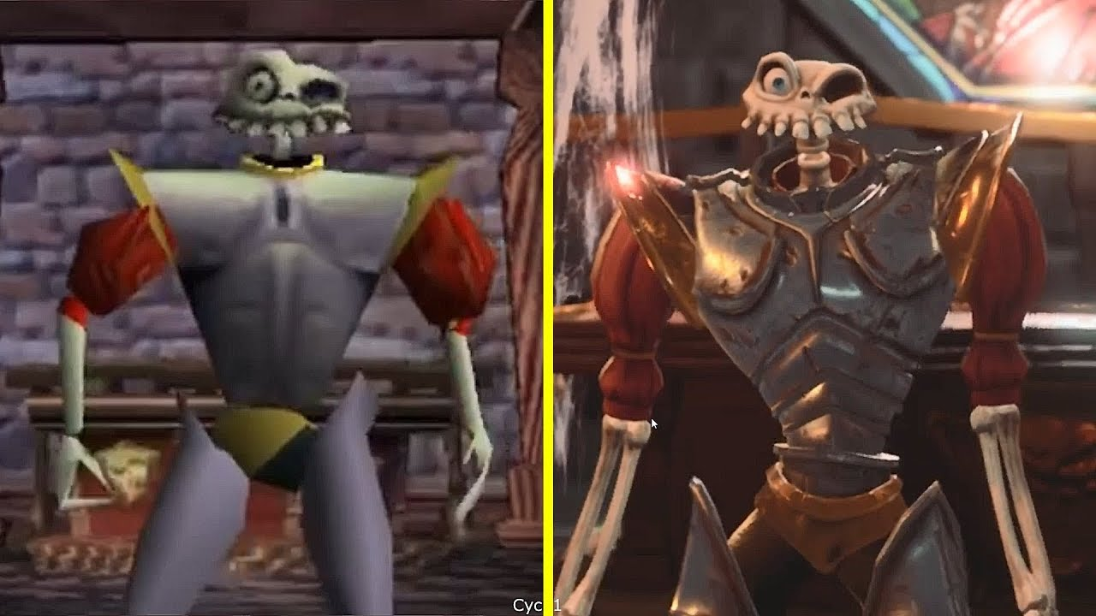
Graphics comparison between Medievil on PlayStation 1 and PlayStation 4
Cycu1, 1 November 2018, Photograph, Viewed November 2019, <https://i.ytimg.com/vi/REjRfnWk3Lk/maxresdefault.jpg>
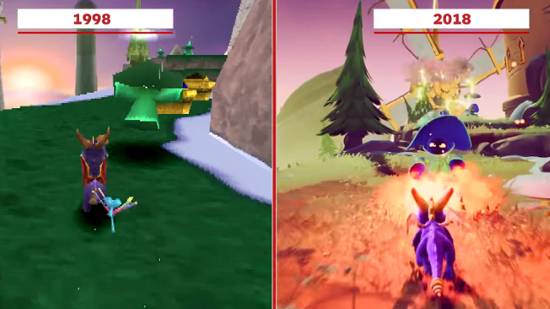
Graphics comparison between spyro on PlayStation 1 and PlayStation 4
BaltazarOS, 4 July 2018, Photograph, Viewed November 2019, < https://s20.postimg.cc/ohgdx6565/remaster.jpg>
From looking at both examples of games you can see that games have come a long way in just 20 years thanks to the hardware advancements that allow more polygons and better resolution textures to appear on screen as well as better lighting and effects and with the introduction of Raytracing games have the potential of looking better than before. As a whole I think that games have come along way since the Magnavox Odyssey back in the 1970s and I am excited to see how the games industry will evolve in the future.

Reference list

CHM, 2019, Timeline of Computer History, Computer History Museum, Viewed 20 November, <https://www.computerhistory.org/timeline/graphics-games/>

Riad Chikhani, 2015, The History Of Gaming: An Evolving Community, Tech crunch, Viewed 20 November, <https://techcrunch.com/2015/10/31/the-history-of-gaming-an-evolving-community/>

Rob Bunce, 2018, The Evolution of Video Game Graphics, Escape Technology, Viewed 20 November 2019, <https://www.escape-technology.com/news/the-evolution-of-video-game-graphics>

Jon Irwin, 2016, As SNES turns 25, devs discuss its 7 greatest graphics innovations, Gamasutra, Viewed 20 November 2019, <https://www.gamasutra.com/view/news/279467/As_SNES_turns_25_devs_discuss_its_7_greatest_graphics_innovations.php>

The Scout, 2019, A Brief History of 3D Texturing in Video Games, The Rookies, Viewed 21 November 2019, <https://discover.therookies.co/2019/05/09/a-brief-history-of-3d-texturing-in-video-games/>

The centre for computing history, 2019, Magnavox Odyssey, The centre for computing history, Viewed 24 November 2019, <http://www.computinghistory.org.uk/det/16909/Magnavox-Odyssey/>

Robert Valdes, 2005, How PlayStation 3 Works, HowStuffWorks, Viewed 25 November 2019, <https://electronics.howstuffworks.com/playstation-three.htm>
Richard Leadbetter, 2013, Wii U graphics power finally revealed, EuroGamer, Viewed 25 November 2019, <https://www.eurogamer.net/articles/df-hardware-wii-u-graphics-power-finally-revealed>

Shelby Brown, 2019, PlayStation 5: Better graphics, haptic controllers and everything we know so far, Cnet, viewed 08 December 2019, <https://www.cnet.com/news/playstation-5-better-graphics-haptic-controllers-and-everything-we-know-so-far-sony/>

Andrew Burnes, 2019, Ray Tracing, Your Questions Answered: Types of Ray Tracing performance on GPU`s, and more, NVidia, viewed 09 December 2019, <https://www.nvidia.com/en-gb/geforce/news/geforce-gtx-dxr-ray-tracing-available-now/>

Jade King, 2019, Xbox 2 (Project Scarlett): All you need to know about Microsoft`s next-generation console, Trusted Reviews, viewed 10 December 2019, <https://www.trustedreviews.com/news/xbox-two-release-date-news-3408041>

Books
Williams, A 2017, History of Digital Games Developments in Art, Design and interaction, Taylor & Francis Group, Boca Ranton
Asakura, R 2000, Revolutionaries at Sony, The McGraw-Hill Companies, New York
Mott, T 2010, 1001 Video Games you must play before you die, Cassell illustrated a division of octopus publishing group Ltd, London
Loguidice Barton, B M 2009, Vintage Games, Elsevier Inc, Oxford

Games
Super Mario Bros (1985). Nintendo Entertainment System [Game]. Nintendo: Kyoto, Japan.
(Nintendo Creative Department, 1985)
Sonic the Hedgehog (1991). Sega Genesis [Game]. Sega: Tokyo, Japan.
(Sonic Team, 1991)
Wolfenstein 3D (1992). MS-DOS [Game]. Apogee Software: Texas, U.S.
(id Software, 1992)
Doom (1993). MS-DOS [Game]. Id Software: Louisiana, U.S.
(id Software, 1993)
Quake (1996). MS-DOS [Game]. GT Interactive: New York, U.S.
(Id Software, 1996)
Shenmue (1999). Dreamcast [Game]. Sega: Tokyo, Japan.
(Sega AM2, 1999)
Ratchet and Clank (2002). PlayStation 2 [Game]. Sony Computer Entertainment: California, U.S.
(Insomniac Games, 2002)
Jak and Daxter: The Precursor Legacy (2001). PlayStation 2 [Game]. Sony Computer Entertainment: California, U.S.
(Naughty Dog, 2001)
God of War (2005). PlayStation 2[Game]. Sony Computer Entertainment: California, U.S.
(SCE Santa Monica Studio, 2005)
Super Mario Sunshine (2002). GameCube [Game]. Nintendo: Kyoto, Japan.
(Nintendo EAD, 2002)
The Legend of Zelda: The Wind Waker (2002). GameCube [Game]. Nintendo: Kyoto, Japan.
(Nintendo EAD, 2002)
Animal Crossing (2001). GameCube [Game]. Nintendo: Kyoto, Japan.
(Nintendo EAD, 2001)
Smash bros Melee (2001). GameCube [Game]. Nintendo: Kyoto, Japan.
(HAL Laboratory, 2001)
GoldenEye 007 (1994). Nintendo 64 [Game]. Nintendo: Kyoto, Japan.
(Rare, 1994)
Halo: Combat Evolved (2001). Xbox [Game]. Microsoft Game Studios: Washington, U.S.
(Bungie,2001)
Sonic heroes (2003). GameCube, PlayStation2, Xbox, Windows [Game]. Sega: Tokyo, Japan.
(Sonic Team USA, 2003)
Metroid Prime (2002). GameCube [Game]. Nintendo: Kyoto, Japan.
(Retro Studios, 2002)
Wii Sports (2006). Wii [Game]. Nintendo: Kyoto, Japan.
(Nintendo EAD, 2006)
Mario Kart Wii (2008). Wii [Game]. Nintendo: Kyoto, Japan.
(Nintendo EAD, 2008)
The Elder scrolls V: Skyrim (2011). PlayStation 3, Xbox 360, Windows [Game]. Bethesda Softworks: Maryland, U.S.
(Bethesda Games Studios, 2011)
Super Mario 3D World (2013) Wii U [Game]. Nintendo: Kyoto, Japan
(Nintendo EAD Tokyo, 2013)
Spiderman (2018). PlayStation 4 [Game]. Sony Interactive Entertainment: California, U.S.
(Insomniac Games, 2018)
God of war (2018). PlayStation 4 [Game]. Sony Interactive Entertainment: California, U.S.
(SIE Santa Monica Studio, 2018)
Halo Infinite (2020). Xbox One, Xbox 2, Microsoft Windows [Game]. Xbox Games Studios: Washington, U.S.
(343 Industries, 2020)
Forza Horizon 4 (2018). Xbox One, Microsoft Windows [Game]. Xbox Games Studios: Washington, U.S.
(Playground Games, 2018)
Spyro Reignited trilogy (2018). PlayStation 4, Xbox One [Game]. Activision: California, U.S.
(Toys for Bob, 2018)
Medievil (2019). PlayStation 4 [Game]. Sony Interactive Entertainment: California, U.S.
(Other Ocean Emeryville, 2019)

