

Name : Nofiza Sajid
Student no : 2407944
Module : Professional Development within Health and Social Care
Lecturer: Internal Verifier: Dr Raheela Shaikh, Dr Besty Jose
Module code : LCHS4009
Assignment Title : Personal Development Portfolio

Contents
Task 1: Job Application and Personal Action Plan 3
1.1. Job Role and Key Skills 3
1.2. Personal Development Plan (PDP) 3
1.3. Potential Interview Questions and Responses 6
Question 2: How do you handle stressful situations, such as a resident becoming agitated? 6
Question 3: How do you maintain patient confidentiality? 6
Task 2: Academic Report on a Key Skill in Health and Social Care 7
The Core Elements of Effective Communication 7
Importance for Person-Centred Care 7
Impact on Safety and Outcomes 8
Conclusion 8
Task 3: Critical Reflection on LCHS4009 Presentation Assessment 9
Experience 9
Reflection 9
Action 10
Reference List 11

Task 1: Job Application and Personal Action Plan

1.1. Job Role and Key Skills
My focus is to become a Care Assistant within a residential home providing care to the elderly population. This role is crucial in providing person-centred (direct) care to the residents of the home, assisting them with their daily living tasks and promoting their well-being. The analysis of the job description and person specification has indicated a number of required skills.
To carry out this role I will require good effective communication skills (both verbal and non-verbal). Communication helps to ensure that I can understand the needs of the resident, communicate with their families and report accurately to my senior staff members (NHS, 2023). I currently have the required effective communication skills through my part-time job as a retail assistant and I have developed the ability to communicate effectively and patiently with a large and varied group of people, including people who may be upset or hard of hearing. My course in health and social care has also enabled me to understand how important it is to use active listening skills and body language that is appropriate for building up trusting relationships.
Empathy and compassion are second essential skills in caring for residents at a care home by treating them with dignity while acknowledging how they feel both emotionally and physically vulnerable. I have demonstrated this skill through volunteer work at a local community centre for older adults who have mobility problems and have engaged them in meaningful conversation to reduce feelings of isolation from other people in the community. This has reinforced my ability to be an effective provider of person-centred care (Kitwood, 1997), which is one of the fundamental principles of health and social care.
Triple collaboration and teamwork also provide an essential skill for care assistants because they need to work as part of a multidisciplinary team to ensure that each person receives consistent care. I have demonstrated my ability to work in a team during group projects in my university course. I did this by working towards shared objectives, providing support for my peers and communicating what needed to be done for the team members to achieve a positive result.

1.2. Personal Development Plan (PDP)
Although I have some basic skills, I recognize that I still have two areas that require improvement: the first gap is in my knowledge of manual handling and moving & assisting; the other gap is my lack of hands on experience with the creation and use of digital records in relation to the writing of care plans.
Skill Gap | Action Steps | Resources | Timeline | Success Criteria
Manual Handling | 1. Take a reliable online programme on safe lifting and safe movement of people and objects. 2. Arrange to see a qualified carer on duty and observe their duties during my next volunteer shift. 3. If your institution provides a hands-on workshop, then you should take the opportunity.. | Online platforms (e.g., FutureLearn, High Speed Training), University careers service, Volunteer placement supervisor. | Within  2 months | Obtain certification by demonstrating hoisting methods and supporting a client when standing that have been supervised.

Record Keeping | 1. Read through the records that the NHS states should be maintained in relation to client records as it relates to caring for them. 2. Practice writing SOAP notes (Subjective, Objective, Assessment, Plan) for your assigned case studies from class work. 3. Request that a faculty member or a currently working CARER give you constructive feedback about your practice SOAP notes. | NHS England website, Course textbooks, Module tutor. | Within  1 month | Create three high-quality SOAP notes that provide positive outcomes from case studies.
Skill Gap | Action Steps | Resources | Timeline | Success Criteria

1.3. Potential Interview Questions and Responses

Question 1: Can you tell us about a time you provided excellent care to someone?

My response will be to focus on my experiences with my volunteer work, and one specific person who I helped. He was a gentleman who appeared to be withdrawn and needed assistance with his meals. To really make a difference, I decided to sit with him for a period of time, to get to know him and learn that he used to be a gardener. I then organised an opportunity for him and I to spend time in the garden together. This gave him a great lift; just by me listening to him, he opened up, and it had a positive impact on his level of engagement. This demonstrates that I have an understanding that when you provide care, you must look at the individual behind the task.

Question 2: How do you handle stressful situations, such as a resident becoming agitated?
I would explain to them that I keep calm and use a low tone of voice to use the de-escalation techniques I learned in my course; I also ask a number of simple questions to understand what has caused the resident to become distressed; my priority is to ensure the safety and well-being of the resident. I would then refer the situation to a senior team member as I am aware of the benefits of seeking assistance and teamwork in difficult situations.

Question 3: How do you maintain patient confidentiality?
The confidentiality of someone receiving care is very important, both legally (e.g., Care Act 2014) and as per the policies set out by my employer. Therefore, when I am working with a resident, I will ensure that all discussion of their care will be limited to the multi-disciplinary team who is responsible for providing support. I will never share information about a resident with family or friends, and of course, that includes social media. With regard to written documentation, I will ensure that it is kept securely in compliance with relevant data protection legislation.

Task 2: Academic Report on a Key Skill in Health and Social Care

Title: The Indispensable Role of Effective Communication in Health and Social Care

Introduction
The foundation of quality relating to both health and social care is said to be effective communication. This means that effective communication is a dynamic and complex skill, involving much more than just talking to somebody there are non-verbal methods of communicating; actively listening to another individual; and adapting your style of communication in accordance with the requirements of the service user.
This report will demonstrate that effective communication is not simply a desirable skill it is a fundamental clinical and ethical requirement; it is necessary for the provision of person-centred care; the development of therapeutic relationships; and promoting safe care for patients.

The Core Elements of Effective Communication
Effective communication in this sector is multifaceted; it reflects the ability to communicate effectively (and clearly) what we are trying to communicate to our service users (i.e., explaining their treatment plan, or offering support in assisting their daily living activities). However, this is only part of what constitutes effective communication. The more subtle aspects of effective communication (such as non-verbal communication) often convey more empathy and reassurance to service users than verbal (i.e., words) communication (Argyle, 2017). Active listening (the process of being fully engaged, being mindful, and responding to another individual) is also crucial to validating a service user's feelings and to appreciating their perspective.

Importance for Person-Centred Care
Effective Communication is at the heart of Person-Centred Care which can be tracked back to Carl Rogers who inspired the person-centred approach to care and modern day practice. A practitioner’s responsibility to provide care that takes into account the individual's values and preferences begins with their ability to know the individual. This can only be achieved through the use of open-ended questions, and being non-judgemental. According to the Health and Care Professions Council (HCPC) (2023) registrants must demonstrate effective communication skills with service users and their families as well as apply a person-centred communication strategy that meets the needs of the individual.

Impact on Safety and Outcomes
When communication is ineffective it can lead to an adverse event in care settings. In a chance remark that refers to previous cases of care failures, the Francis Report (2013) highlighted that a lack of open, compassionate communication by both staff and patients contributed to several catastrophically poor levels of care experienced by patients who were the victims of the Mid Staffordshire NHS Foundation Trust. On the other hand, effective communication leads to improved communication between shifts and accurate medication administration as well as enabling facilities to detect the early signs of deterioration in patient health. Furthermore, effective communication empowers service users to express their concerns, actively participate in the decision making process regarding their care, and therefore helps to support their independence and safety.

Conclusion
To sum up, communication is the key to safety, compassion and a person-centered approach in both health and social care. Effective communication is how clinical knowledge is turned into positive results and supports building trust as well as maintaining the service user's dignity. The continuous enhancement of this skill should be viewed by all practitioners as part of their core professional obligations – not just as an optional add on.
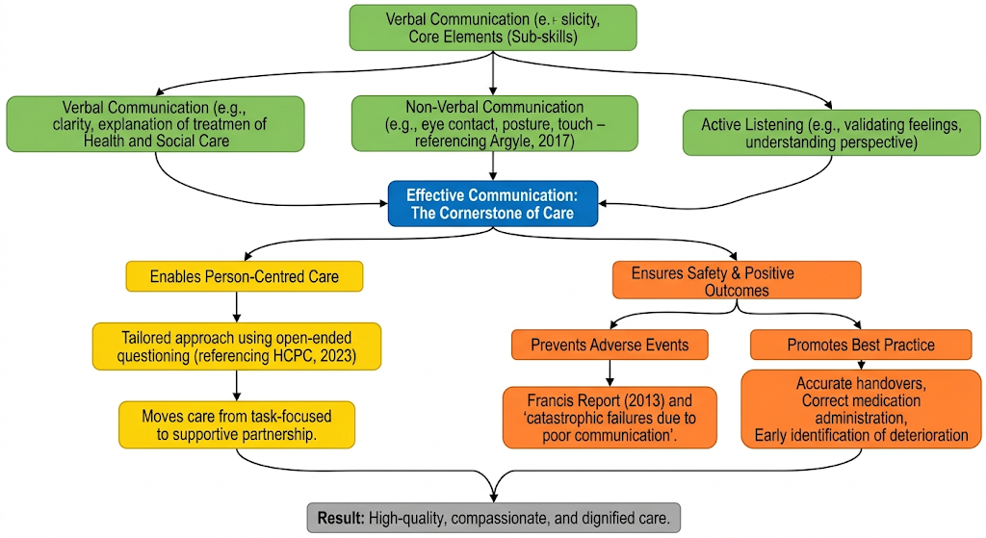

Figure 1: The role of effective communication in health and social care. This flowchart illustrates how effective communication serves as the cornerstone of practice, underpinning core communication skills, enabling person-centred care, and ensuring patient safety and positive outcomes.

Task 3: Critical Reflection on LCHS4009 Presentation Assessment
In this Critical Reflection I will be using the ERA (Experience, Reflective and Action) Model, which is a circular process enabling us to learn from our experiences. My reflective experience is based on the verbal feedback provided to me by my lecturer (after my presentation) on the topic of Vulnerable Adult Safeguarding.

Experience
I had my presentation during the second assessment week. I really prepared a lot for this presentation: I created detailed slides, rehearsed every single part of the presentation multiple times, etc. When I got to the introduction part of my presentation, I noticed that my hands were visibly shaking and my voice was shaky. I had practiced my presentation a lot and knew my content well, however, I was able to make only an average amount of eye-contact with the audience. I found that I was reading from my notes more than I wanted to do. I got through the presentation but did not feel as though I connected with the audience. The verbal feedback I received from my lecturer was that my content was “ accurate and well-researched” however, my delivery was described as “rigid” and “palpable”; therefore, my nerves contributed to my lack of authority on the subject.

Reflection
I felt disappointment and frustration after my assessment. I was viewing knowledge as the main marker of success, and thus didn’t believe I had performed to a level that reflected my understanding. But as I started to understand the anxieties I felt through this model it has noted it can mainly be attributed to a fear of judgement in front of others. I focused on trying to remember the content, but forgot how important it is to deliver that content well when communicating within the health and social care settings. I didn’t connect well with my “service users” (the audience) which is an important part of person-centred practice. The lecturer’s feedback about my inflexibility was a key insight; now I can see that delivering information flat, and without engagement in a real life care setting, could be detrimental, as would trying to communicate a care plan to a family member. I had focussed on completing a task rather than creating a relationship with my audience and ensuring they understood what had been presented to them.

Action
In order to show
what I do next to fill the gap, I will take a number of specific action steps. I will build confidence by practicing future presentations (in front of small groups of family members or peers) to simulate an audience while getting feedback on my delivery (not just content). I will focus on decreasing my dependence on notes by making cue cards that contain key words instead of complete sentences.
Once again, I want to have a more natural, engaging style of speaking. I will also attend a university workshop focused on presentation skills, where I’ll learn techniques related to controlling anxiety and using body language.
Through these actions, I hope to transform my presentation style from a rigid rehashing of facts into one that is confident, engaging, and ultimately a more effective form of communication than previously seen. This experience supports my belief that the manner in which a message is delivered can be just as important as the message itself.

Reference List
Argyle, M. (2017) The Psychology of Interpersonal Behaviour. 5th edn. London: Penguin.
Francis, R. (2013) Report of the Mid Staffordshire NHS Foundation Trust Public Inquiry. London: The Stationery Office.
Health and Care Professions Council (HCPC) (2023) Standards of conduct, performance and ethics. London: HCPC.
Kitwood, T. (1997) Dementia Reconsidered: The Person Comes First. Buckingham: Open University Press.
NHS (2023) The NHS Constitution for England. London: Department of Health and Social Care.

