HEALTH ASSESSMENT REPORT

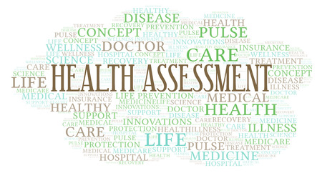
(HEALTH ASSESSMENT 2022)

Student name: Yasmin Azam
Student number: 2013925
Tutor name: Muhammad Hamza Saeed
Module code: bmhp5003_birm
Assignment title: health assessment report.

Table of content

Introduction ……………………………………. Page 3
Case study ……………………………………...Page 4-5
Symptoms ……………………………………… Page 5
Assessment report ……………………………. Page 6-7
Care Plan……………………………………….. Page 8-9
Recommendation ……………………………… Page 10
Conclusion ……………………………………… Page 10
Reflection ……………………………………….. Page 11
References ……………………………………… Page 12
Lifestyle Questionnaire ………………………… Page 13-15

Introduction

I am going to develop a health assessment report witch will be based on a health questionnaire that I have done on a man that I have named Mr Khan to keep his identity anonymous, before conducting the health questionnaire Mr Khans consent was given. The questionnaire is about his health, family history, lifestyle and medical conditions.
I am going to produce a case study within this report, I will do this by using the information that Mr Khan gives to me in the lifestyle questionnaire. Mr Khan has a diagnosis of COPD which is a lung condition that causes breathing difficulties so in this report we will be looking at the respiratory system. I will be looking at what the signs and symptoms, how it develops and why, are effects it has long term on a person, how they cope with it and difficulties they face due to having this condition.
The aim of the assessment will be after speaking with Mr Khan about his condition and looking at his records and gaining information from other health services I will be able to put together a care plan that will help Mr Khan in the future with his medical needs, treatments and care. I will also look at what lifestyle adjustments I can advise Mr Khan on so that will also help with improving health condition.

Case study

Mr Khan is aged 70 and lives with his wife and 2 sons and a daughter in law he also has 5 daughters that visit him every day, as Mr Khan has a big family they all help him with meeting his daily needs his main career is his oldest son and he sees to Mr Khans medication and attends regular appointments with his dad. Mr Khan has always worked and was self-employed he enjoyed his job very much but he took early retirement over 10 years ago due to his health issues that have affected his health and he has deteriorated a lot due to this. Mr Khan is now unable to do a lot of the things he was able to do before. He requires a lot of help. Mr Khan is partial sighted due to glaucoma, he has had a bypass surgery on his heart and suffers from angina his main problem at the moment is a respiratory disease called COPD.
Chronic obstructive pulmonary disease (COPD) refers to a range of lung disorders that cause difficulty breathing. It includes emphysema, which is caused by damage to the air sacs in the lungs. Chronic bronchitis is characterized by long-term inflammation of the airways. COPD is a common illness that primarily affects middle-aged or older smokers. Some people can be unaware that they have it. Breathing problems tend to worsen with time and might interfere with your daily activities, however treatment can help keep the disease under control. (NHS, 2019). With Mr Khan this has been the case as over time his COPD has worsened and he struggles with his breathing and chest pain if he over does it.
Mr Khan has had a good healthy lifestyle throughout his life at present he has variety of foods including fish, chicken, eggs, lentils and a mix of fruit, veg and dairy. Mr Khan eats twice a day not three times and he only occasionally snacks when he feels the need. No alcohol has ever been consumed by Mr Khan but he does smoke 10-20 cigarettes a day and he has been smoking for a long number of years, he drinks lots of tea and water. After doing the health questionnaire I also found that Mr Khans condition was not genetic as none of family members suffer with the same condition there was no evidence of high blood pressure, stroke or high cholesterol.
Mr Khan was diagnosed with COPD in 2011 over 10 years ago he then started suffering with Angina attacks then he had a heart attack so he had to have a stent fitted in 2013 that went well. In 2015 he suffered a heart attack and had to have bypass surgery after having this done Mr Khan was starting to feel really weak within himself he had already taken early retirement due to his health conditions Mr Khan felt helpless and started to feel depressed as he was not used to not doing anything and missed being at work.

Mr Khan stated that having COPD has made things really difficult for him as he gets out of breath very easily and finds it hard to even get to the toilet without getting out of breath when he is having a bad day. He enjoys sitting out in the garden on a nice day but has difficulty with the breathing when the weather is too hot or too cold. He finds it hard to get comfortable in the night when lying down he needs to use several pillows to be in a sitting position he finds this helps. Mr Khan uses inhalers and a nebulizer throughout the day and oxygen as and when needed. When Mr Khans COPD flairs up he gets infections and has to have a course of steroids and antibiotics to help get back to normal. Mr Khan says that due to his health conditions he struggles with
meeting his daily needs and is grateful for the care given to him by his family but does not want to continue to rely on others and feels he is a burden to them.

Symptoms of having copd
- Shortness of breath when being active
- Persistent Chesty Coughs
- Wheezing
- Regular Chest Infections
- Phlegm
- Tiredness
- Coughing Up Blood
- Chest Pain
- Weight Loss
- Swelling of Ankles due to buildup of fluid can be known as Oedema.
(NHS, 2019)

Assessment report
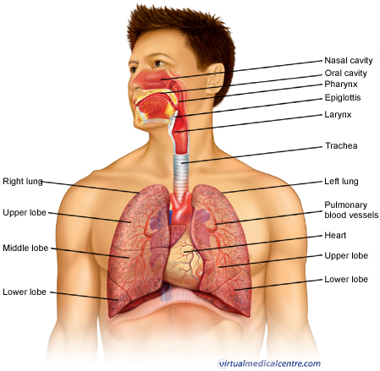
( Makmal, 2022)

As you can see above this is a diagram showing the respiratory system. All of the organs involved in breathing are part of the respiratory system. The nose, pharynx, larynx, trachea, bronchi, and lungs are among them. The respiratory system performs two critical functions: it transports oxygen into our bodies, which our cells require to survive and operate properly, and it aids in the removal of carbon dioxide, which is a waste product of cellular function. The nose, throat, larynx, trachea, and bronchi all function as a network of pipelines that funnel air into our lungs. There, in very small air sacs known as alveoli, oxygen is introduced into the bloodstream and carbon dioxide is expelled from the blood into the atmosphere. (Makmal 2011). This is all part of the normal function of the respiratory system and is how the system should function. To maintain oxygen and carbon monoxide in the body a proper respiratory rate is essential and for adults this should be between 12 and 20 per minute (Rowden, 2021).

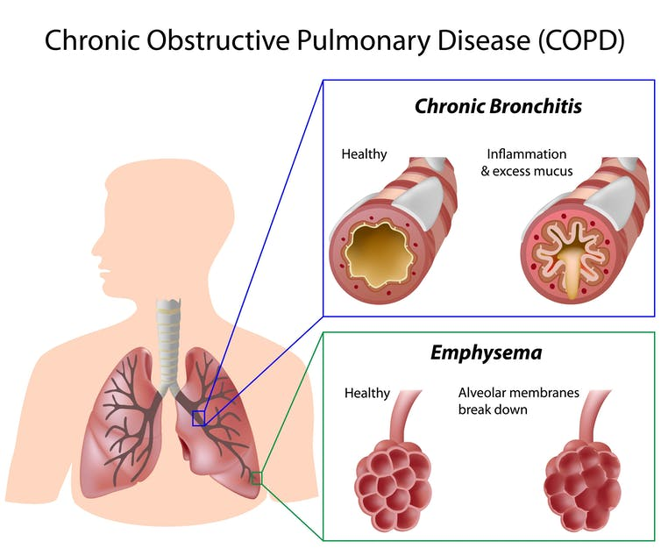
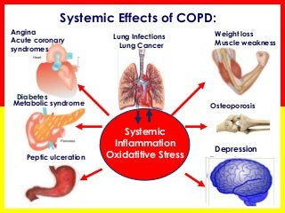

(The Eladawy, 2022) (Conversation, 2022)

COPD causes the airways in your lungs to become irritated and thickened, as well as the destruction of the tissue where oxygen is exchanged. The flow of air into and out of your lungs slows down. Whenever this happens, less oxygen enters your body tissues and it becomes more difficult to eliminate the waste gas carbon dioxide. COPD is not curable but can be treated to help the function.
In the United States, COPD is the third highest cause of death by disease. COPD has been diagnosed in over 16.4 million people, causes substantial long-term disability and premature death, and the number of individuals dying from COPD is increasing. (Lung.org 2021).
Other effects of having COPD are Angina acute coronary syndrome, Lung infections, Asthma, Diabetes, Weight loss, Depression, Osteoporosis, T.B, and ulcers. Symptoms and effect can very this can be minor or severe and can have a big impact if they are left untreated.

Care plan

Chest physicians and cardiologists state that it is essential for advanced care planning in patients with COPD and Chronic Heart Failure (CHF) it is necessary. (Janssen 2011).
Keeping all appointments and attending them on a regular basis is vital so that testing can be done when necessary, medicine can be evaluated, and doctors can determine if the medication given is beneficial or not. If it is ineffective, alternatives can be recommended. If appointments are not kept, treatment will be delayed, and some treatments may not be as successful as they should be.
Manage your COPD:
- Do not expose yourself to things that make your breathing worse i.e too much heat, too much cold and smoke.
- Physical Activity is important for staying healthy.
- Have the correct nutrients in your diet this can help you to breathe easier, some foods may worsen your breathing.
- Seek emotional support this will help with managing depression and cope with your feelings and anxiety.
- Discuss future care with your loved ones, caregivers and Drs.
- Access the quit smoking help service.
There is no need to rush everything, instead take regular rests when participating in activities. Exercise can be done sitting or standing and will help your body use the oxygen better, help to sleep better, strengthen your bones and heart there are lots of benefits from exercise, however, it is critical to be active and out of bed as often as possible. Tasks that are more important to you should be prioritized, so if there are specific things and activities you enjoy doing, do them, if you can't accomplish it alone, seek help this will benefit your mental health and depression. This will help you both physically and mentally. Speak to your G.P about aids to help with getting around whether this be indoors or out things such as wheelchairs and walking frames with seats are available on the NHS for patients.
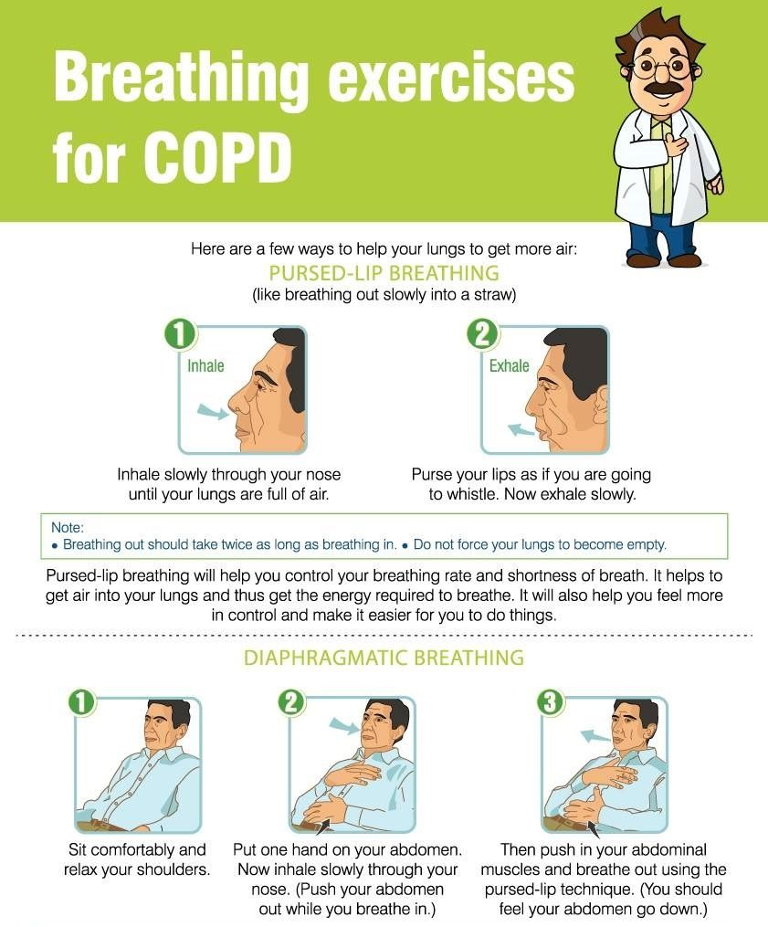
(Otosection 2022)
Above are some exercises that will help you with your breathing you can do them when you are finding it hard to breath or just to help strengthen the muscles in your diaphragm and lungs you will find them beneficial if followed correctly.

recommendation

Mr Khan must recognize the importance of health, and I advise him to make quitting smoking his first priority; smoking has a tremendous impact on his condition and is quite dangerous. He must prioritize what he wants to achieve and what he need in order of significance in order to improve his physical and mental health. Mr Khan should not feel he cannot ask for help, and if he believes he is a Borden for his family, there are health specialists available to assist him and give care for him as their priority, and they will be more than delighted to provide the support that he requires. I have provided Mr Khan with some leaflets with information on that I recommend he looks at and considers getting in touch with. My recommendation is a statement that intends to help Mr Khan make a decision which best suites him and will benefit him for a better future with less struggling.

Conclusion
After getting to know Mr. Khan and listening to his difficulties with his copd, I can conclude that the respiratory system is a major part of the body system and function in the body, and by looking into it in more detail, it has many effects that can become difficult to deal with as this is a lifelong illness that is not curable but only manageable with the correct treatment, and it will be more effective if it is used as early as possible. Healthy lungs help to circulate oxygen throughout the body, assisting the function of the body's primary organs; if this is not operating properly, it affects other organs and leads to many health problems.
Mr Khan's lungs have already suffered permanent damage as a result of COPD, making breathing difficult for him when inflammation occurs more frequently than usual. This has caused damage to his heart and he has had surgery several times as a result of this, so in this case, he needs to take advantage of stopping smoking and doing breathing exercises to help with this condition if he wants to live a better life.
To improve his quality of life, it is recommended that he engage in a light mix of physical and breathing exercises, avoids being in too cold or too hot settings, and keeps the rooms well aired. Consider changing his diet to include more fruits and vegetables and smaller portions on a regular basis rather than two fixed meals because he is not receiving enough exercise, which is causing muscle and bone seizing and gastrointestinal problems. Using excellent ventilation or humidifiers is an effective technique to eliminate poisonous vapors and consume clean air.

REFLECTION
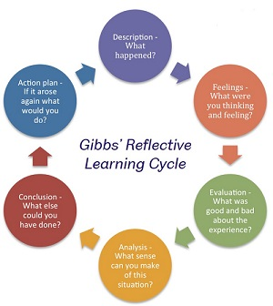(Sheffield 2018)

To reflect on what I have done I have used the Gibbs cycle to help me to do this. After meeting Mr Khan and completing the health questionnaire I found that he suffers from COPD ant that he also has Angina due to this he suffered several heart attacks and has had heart surgery. I found that due to the conditions that he suffers he is unable to do a lot of things which he would like to do or did enjoy doing in the past. Whilst speaking to Mr Khan I found that he is suffering from depression as well and was feeling down and depressed due to his health and not being able to do much I felt that he was unaware of this and that he could access help, this I found was a bad experience for me as he was very upset whilst talking to me about this, but the good was that he felt comfortable to talk to me regarding his issues. I feel that I done everything I could for Mr Khan at this point regarding advice, sorting appointments, referrals, giving contact numbers to him, and pointing him the right direction for the needs in the future. I have given Mr Khan a contact number for the future even if it is only to have a chat with someone when he feels the need. A plan for Mr Khan has been put into place this involves making the changes regarding his eating and light regular exercise and breathing exercises. Mr Khan is due to be reviewed in 6 weeks’ time.

REFRENCES
American lung Association (2021) [Online] Available at https://www.lung.org/lung-health-diseases/lung-disease-lookup/copd/learn-about-copd (Accessed on 26th July 2022)
Clinic,C., (2018) [Online] Available at https://my.clevelandclinic.org/health/articles/9450-copd-exercise--activity-guidelines (Accessed on24th July 2022).
Eladawy,.A., (2014) [Online] Available at https://www.slideshare.net/ashrafeladawy/what-is-copd-41848417 (Accessed on 30th July 2022)
Health Assessment Stock Photos and Images (2022) [Online] Available at https://www.123rf.com/stock-photo/health_assessment.html (Accessed on 29th July 2022)
Healthline (2020) [Online] Available at https://www.healthline.com/health/copd/breathing-exercises (Accessed on 23rd
Hirakawa, Y., Aita, K., Nishikawa, M., Arai, H. and Miura, H., (2021). Facilitating advance care planning for patients with severe COPD: a qualitative study of experiences and perceptions of community physicians, nurses, and allied health professionals. Home Healthcare Now, 39(2), p.81. (Accessed on 25th July 2022).
Janssen, D.J., Spruit, M.A., Schols, J.M. and Wouters, E.F., (2011). A call for high-quality advance care planning in outpatients with severe COPD or chronic heart failure. Chest, 139(5), pp.1081-1088. (Accessed on 25th July 2022)
Makmal, S.A., (2011) [Online] Available at https://anjungsainssmkss.wordpress.com (Accessed on 25th July 2022)
NHS, (2019) chronic obstructive pulmonary disease. [Online] Available at www.nhs.uk/conditions/chronic-obstructive-pulmonary-disease-copd/ (Accessed on 25th July 2022)
Oliver.B.,Milne.S., (2014) The Conversation [Online] Available at https://theconversation.com/explainer-what-is-chronic-obstructive-pulmonary-disease-25539 (Accessed on 25th July 2022)
Otosection (2022) [Online] Available at https://www.otosection.com/deep-breathing-exercises-for-copd-pulmonary-disease-sufferers/ (Accessed on 25th July 2022).
Rowden, A., (2021). Normal respiration rate: For adults and all ages, and how to measure. [Online] Medicalnewstoday.com. Available at https://www.medicalnewstoday.com/articles/324409 (Accessed On 25th July 2022)
Sheffield, (2018). [Online] Available at https://abiomalley.wordpress.com/2018/11/28/reflective-practice-as-evidence-for-decision-making/ (Accessed 4th August 2022).
WHO, (2022). WHO Guidelines. [Online] Who.int. Available at https.who.int/publications/who-guidelines (Accessed on 22nd July 2022)

Appendix

LIFESTYLE QUESTIONNAIRE

Introduction:

In order to help us focus our Health Promotion activities in the practice, we would be grateful if you could fill in this short questionnaire. If you have already completed one on a previous visit, please return this questionnaire to the receptionist.
Name MR KHAN Date of Birth 25/02/1952

Do you smoke? |  | Y | [ | * ] No [ ]
If Yes, do you –
smoke less than 1 | daily |  | [ | ]
1 – 9 | A day |  | [ | ]
10-19 | A day |  | [* | ]
20-39 | A day |  | [ | ]
more than 40 | A day |  | [ | ]
smoke a pipe |  |  | [ | ]
smoke cigars |  |  | [ | ]

If No, have you –

never ever smoked  given up smoking in the last year not smoked for more than 1 year |  | [  [  [ | ]  ]  ]
Do you have high blood pressure? | Y | [ | *] | No | [ | ]
Have you ever had a heart attack or suffered from angina? | Y | [* | ] | No | [ | ]
Have you ever had a stroke, “shock”
or any weakness down one side? Yes [ ] No [ *] Have any of the following – mother, father,
brothers or sisters had –
a heart attack below the age of 60 | Yes | [ | [ ] | No | [* | ]
a heart attack above the age of 60 | Yes | [ | [ ] | No | [* | ]
a stroke | Yes | [[ | [ ] | No | [* | ]
trouble with very high cholesterol (hyperlipidaemia) | Yes | [ | ] | No | [* | ]

………………………………………………………………………………………

Practice Use Only
Health Education Smoking YES

BP 130 / 60

Height 5FT 6INC

Weight 85KG

EXERCISE
Healthy exercise usually involves activity that lasts for at least 20 minutes, raises your pulse and produces hard breathing. In younger people this might be running, cycling or sport, or brisk walking for older people.

Do you take this type of exercise –

daily [ ]
3 times weekly [ ]
once weekly [ ]
once monthly [ ]
seldom [ ]

I cannot take exercise because of disability [*]
DIET
Please tick the one category which is closest to your usual eating pattern.

I eat no meat, fish, or dairy produce [ ]
I eat no meat [ ]
I eat a mixture including daily fruit and vegetables [* ]
I eat a mixture including regular chips and fries [ ]
I eat frozen meals (e.g. TV dinners) 3 or 4 times/week [ ]
I eat mainly snacks [ ]
I eat a special medical diet [ ]

Please specify ………………………………………………………………………

ALCOHOL
Please tick the statement which most closely describes your usual average alcohol intake. (1 unit is 1 glass wine, ½ pint beer or a single measure of spirit.)

I never drink alcohol [*]
I drink less than 1 unit per day [ ]
I drink between 1 and 2 units a day [ ]
I drink between 3 and 6 units a day [ ]
I drink between 7 and 9 units a day [ ] I drink more than 9 units a day on average [ ]
…………………………………………………………………………………….

Practice Use Only

Health Education Alcohol [n/a]
Alcohol Brief Intervention [n/a]

