Problem Solving and DecisionMaking Student Name: Maureen Ann Lyttle
Student ID: 2029466
Lecturer’s Name: Sujeewa Herath
Module Code: BMSW4004

Table of Contents
Introduction 3
Impact of Work-Related Stress 3
Cause and Effect Analysis 4
PESTLE Analysis 5
Solutions 6
Action Plan 6
Key Success Indicators 7
Conclusion 7
References 8

Introduction
This report discusses the complex problem of employee dissatisfaction and work-related stress within the UK. The area of discussion is focused on the nature and impact of the issue at hand, the cause and effects of the problem, an overview of the factors that influence the problem alongside an analysis of potential solutions. Finally, an action plan is discussed as to highlight the key success indicators that emphasise the solution selected for implementation renders positive change.

According to the case study at hand, over 5.5 million inpatients are admitted by the NHS on a yearly basis consequently to stress-related conditions. Moreover, the primary factor that contributes to stress within the UK are work-related problems, closely followed by financial stressors.

Impact of Work-Related Stress
This report presents four main impacts of work-related stress resulted due to the nature of the problem. These are as per Rowden et. Al. (2011) the following:
- Physical and psychological symptoms – including fatigue, muscular tension, headaches and heart palpitations alongside insomnia, gastrointestinal upset, and dermatological issues. Psychological symptoms on the other hand refer to irritability, anxiety, depression, pessimism, feeling overwhelmed and suffering from cognitive difficulties (e.g., a decreased ability to concentrate or make optimal decisions).
- Behavioural symptoms – these are symptoms that directly impact the relationship of the employee to the business as well as to those around them, including family. From aggression to an increase in absenteeism, work-related stress greatly contributes to behaviours that do not benefit the individual, the business or society at large.
- Loss of job – work-related stress can lead to poor performance due to apathy, isolation, and a decreased tolerance of frustration. Altogether, these are transformed into characteristics that do not imply quality talent output within an organisation. Consequently, the employee is liable to lose current employment as work related stress increases.
- Loss of income – because of the above impact related to a potential loss of job, this implies a critical loss of income that adds to stress based on financial worries.

The nature of work-related stress is complex and can vary from individual to individual. Nevertheless, Santos, Hayward, and Ramos (2012) identify that it can be a result of an organisational culture that is not conducive of employee wellbeing, poor managerial practices, the demand and content of the role, a working environment that implies physical work, the relationships within the workplace, a lack of support, conflicts, and trauma as well as change management within the business. Consequently, from heavy workload to inappropriate pay, the nature of work-related stress is difficult to pinpoint as it consists of numerous stressors. 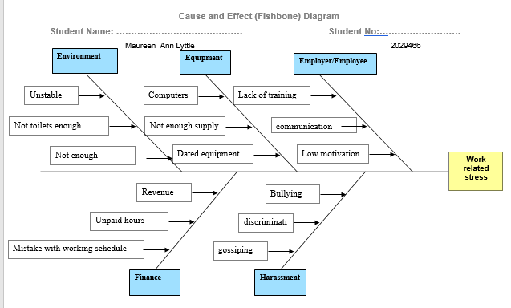

Cause and Effect Analysis
The overall effects of work-related stress, which is an effect, are its symptoms described above. In terms of direct causes, Ipsen and Jensen (2010) can present five key contributing factors:
- Working environment – organisational culture is often unique to a business. Regardless, certain industries can present environments that contribute to a greater extent to work-related stress compared to others. For example, high turnover industries such as hospitality provide an unstable, unsecured environment for staff. An additional example are organisations with a critical focus on metrics, for example warehouse facilities and call centres. These may cause employee performance to drop to unsatisfactory levels if additional, yet needed, breaks are taken.
- Equipment – this refers to general resource provision as well as resource management/maintenance. For example, a lack of technology equipment or faulty equipment can affect the quality of the output delivered as well as the overall employee experience due to frustration, time waste and non-value adding work.
- The relationship between the employer and the employee – this contributing factor encompasses the entirety of management related component. To illustrate, a lack of training, poor communication, or an inability to drive motivation within a team directly impacts on the degree of commitment of the talent within an organisation.
- Business finances which can impact on personal finances – this ranges from unpaid overtime, excessive overtime, low revenues that can lead to understaffing and hence to employees being overworked as well as poor talent placement within the business (i.e., maximising the resources available by benefiting from qualified talent in appropriate positions).
- Harassment within the workplace – working environments, similarly to other environments, are not except from acting as harassment platforms. Bullying, gossiping, nepotism, favouritism, and other workplace misconducts can lead to high levels of anxiety and stress for certain employees. Consequently, their performance is diminished alongside their job satisfaction levels.

PESTLE Analysis
The below PESTLE Analysis has been conducted as per Cousins et. Al. (2004) to discuss the factors that may impact upon work-related stress and consequently, on employee dissatisfaction:
- Political factors – the UK Government established laws and regulations that seek to control procedures within the business sector. To this extent, these laws and regulations can either encourage the development of stress within the workplace or, on the contrary, provide solutions. In addition, tax related policies alongside trading law policies and restriction trade laws can affect the ability of a company to operate effectively. Therefore, highly pressurised environments can lead to employees being required to work under pressure and suffer from stress symptoms.
- Economic factors – the overarching goal of a business within the for-profit sector is to drive profitability. This can often translate into a need for minimised costs as a primary focus is aimed at revenue generating operations. This strategy may imply that critical employee wellbeing functions are being overseen, such as CSR and HRM. Similarly, to political factors, tariff growth, exchange rates, dividend rates and surge-inflation can lead to additional pressure on businesses which, in turn, apply further pressure on maximising output from a limited volume of employees. 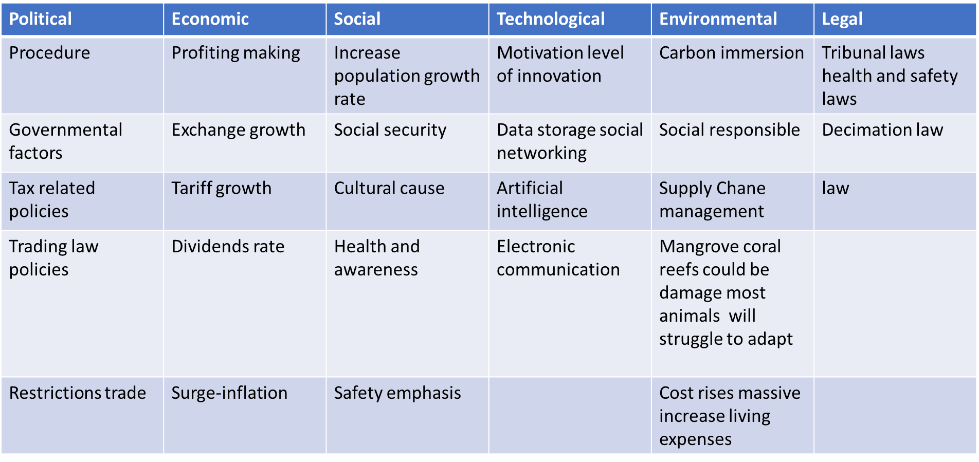
- Social factors – in terms of social factors, there is a two-fold perspective in terms of their impact upon work-related stress. On one hand, elements such as an emphasis on safety, health and awareness of symptoms can influence the approach that organisations adopt towards managing the potential implications and causes of stress in the workplace. On the other hand, an increase in the growth rate of the population and community or country cultures can determine the external expectations society holds upon business conduct.
- Technological factors – technological factors can either hinder or support the improvement of work-related stress. Electronic communication, for example, can enable employees to discuss their daily lives with those close and as such to find a degree of relief. Comparatively, excessive communication within a business can led to information overload, micromanagement and other further work inducing aspects.
- Legal factors – like political factors, laws determine business operations and can support employees in terms of implementing fines and penalties for businesses that do not ensure staff wellbeing.
- Environmental factors – at present, environmental changes can cause additional stressors for the contemporary workforce. These factors can moreover determine the degree of commitment an employee has to a business based on current Corporate Social Responsibility policies.

Solutions
To minimise work-related stress, Colling (2013) provides two solutions that seek to address the core causes of the complex problem. First, organisations must consider a continuous
improvement approach to seek the maximisation of efficiencies while. minimising costs. By implementing this throughout the entirety of business operations, the company can place greater investment on its most critical resources: its talent. In addition to addressing the core problem related to costs, this solution is similarly able to drive the quality of the output provided by the organisation to its clients. Secondly, managers must be held accountable for their actions and performance to the same degree lower-level employees do. This promotes a sense of accountability across the company, and it improves relations between different levels of the organisation.

An additional solution is provided by Manokha (2020) from the employee perspective who argues that a individuals must be aware of their rights within a certain country, sector, and business and as such to invest resources into being prepared to argue their case in a legal setting prior to the situation arising. This ensures a sense of confidence, greater control over their responsibilities and output as well as the fact promoting a two-sided conversation with the employer.

Action Plan 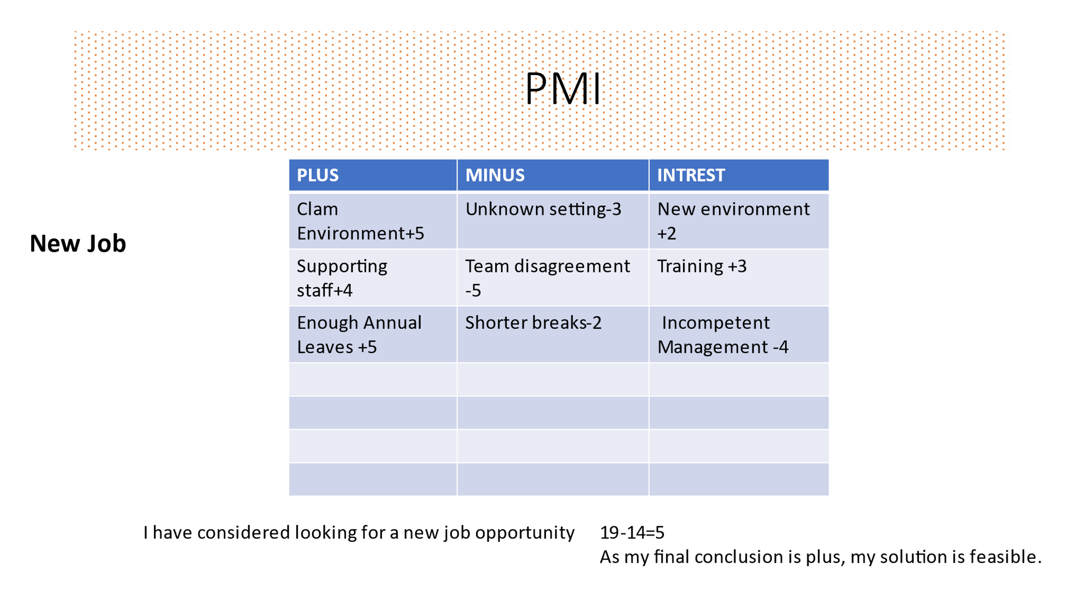
Considering the benefits of continuous improvement towards minimising the problem as well as its additional advantages to the employee and employer, an action plan is established to implement this philosophy across an organisation as per Bhuiyan and Baghel (2005):
- An expectation is implemented that feedback is valued within the company and that no negative outcomes will be reflected upon the employees feeding back to more senior layers
- Self-assessments are to be conducted by each team manager to identify areas for improvement (i.e., areas of waste or that cause employees difficulties)
- Collaboration is promoted through team-building and social activities that ensure each team can understand the importance and output of each function
- Cost-and-benefit analyses are to be conducted for each solution implemented for a current problem to understand the investment required to address it as well as to highlight its benefits to both the business and the team at large
- Adopt a plan-do-check-act approach to ensuring improvement is a continuous process. For example, if employee performance and wellbeing is affected by a current lack of equipment, an assessment must be carried out to understand the implications of the problem, the costs of resolving it and the benefits. Consequently, a plan must be formulated to address the issue, its implementation follows alongside measurements and the process is reinitiated.

Key Success Indicators
According to Olaru et. Al. (2013), there are five key success indicators that refer to measuring continuous improvement within an organisation. These include:
- Cost – this implies the cost of implementation of the solution as well as the cost saved upon implementing it. The cost saved can related to internal or customer cost.
- Time – this metric encompasses the time reduced in terms of conducting specific processes and operations. For example, half an hour daily may be saved in terms of waste for an employee that benefits from improved technology.
- Safety – a critical success indicator, this metric can significantly contribute to work related stress improvement. From a physical perspective (i.e., reduced number of workplace incidents) to a psychological perspective (i.e., less anxiety because there is more time to complete a task), the safety of employees can be measured by assessing their current position prior to implementing the solution against the position after implementation.
- ROI – this metric is like cost; however, it similarly considers labour cost savings in terms of time and the degree of quality improvement upon implementing the solution.
- Quality – this success indicator can refer to the final output as well as to the ability to meet each milestone within a process to the standard required by the company or a client.

Conclusion
Overall, work-related stress has critical consequences on the employee as well as the employer, economy, and society at large. As a result, addressing this complex issue must be a priority when considering market leadership. This is primary due to the need for resource use maximisation that is implied by managing employee wellbeing. While there are numerous solutions to addressing the issue currently within literature as well as practice, it is critical for companies to understand their own internal needs and resources in terms of managing stress in the working environment.

References

Bhuiyan, N. and Baghel, A., 2005. An overview of continuous improvement: from the past to the present. Management decision.

Colling, J., 2013. Positioning wellness solutions within employee benefit strategies. Strategic HR Review.

Cousins*, R., Mackay, C.J., Clarke, S.D., Kelly, C., Kelly, P.J. and McCaig, R.H., 2004.
‘Management standards’ work-related stress in the UK: Practical development. Work & Stress, 18(2), pp.113-136.

Ipsen, C. and Jensen, P.L., 2010. Causes of work-related stress and individual strategies in knowledge work. DTU Management Engineering. Department of Management Engineering-The Technical University of Denmark. Lyngby, Denmark, pp.1-32.

Manokha, I., 2020. The Implications of Digital Employee Monitoring and People Analytics for Power Relations in the Workplace. Surveillance & Society, 18(4), pp.540-554.

Olaru, M., Hohan, A., Maier, A. and Maier, D., 2013. Metrics for innovation of product–the basis for continuous improvement of an organization. organization, 8, p.9.

Rowden, P., Matthews, G., Watson, B. and Biggs, H., 2011. The relative impact of work-related stress, life stress and driving environment stress on driving outcomes. Accident Analysis & Prevention, 43(4), pp.1332-1340.

Santos, A., Hayward, T. and Ramos, H.M., 2012. Organizational culture, work and personal goals as predictors of employee well-being. Journal of Organizational Culture, Communication and Conflict, 16(1), pp.25-48.

