DS2 Log: Campus Print Hub Price Guide
Scenario 2 | Tool: Microsoft Word | Artefact: one-page student price guide
Student Name:
Student ID:

Table of Contents
1. The task 3
2. Why I chose Word 3
3. Information I used 3
4. Changes I made 4
Version 1: first draft 4
Version 2: improved draft 5
Final version 5
5. How these changes improved the work 5
6. Reflection 6
References 6

1. The task
M. Khan, Manager (Campus Print Hub) asked for a price guide that can be set out on the campus with one size of the page. The requirements of the brief were to clearly demonstrate the services, provide accurate pricing and be professional and easy to read. These are my criteria of success and success was measured with each version on the basis of these. The guide could only be read whilst standing, and was frequently read quickly from a considerable distance, so legibility was more important than decoration.

2. Why I chose Word
In the scenario, Word, PowerPoint or Adobe Express were allowed to be used. The reasons for choosing Word.
- Tables maintain prices in line. Table information is a price list. I can calculate my services and prices in fixed columns and align the prices to the right, with decimal points lining up with each other using word tables" (Microsoft, n.d.a). This will help make sure that the price is accurate, which is the biggest danger with this artefact.
- It may be changed by the manager. Prices change. A .docx file can be opened by any office computer and you don't need design skills to modify the value of a figure in a cell in a table. It would be easier for staff to edit a layout that they've created in Adobe Express.
- Prints legibly on A4. The important thing with this being a guide to be displayed is that it's better that it looks good when printed. Word emphasised page layout and thus it was easy to keep everything within one page and manipulate the page margins.
- Built-in structure. The heading styles and table header rows in Word provide structure, and not just for the looks. For documents that are accessible, Microsoft (n.d.b) recommends this type of organization.
I thought about the other possibilities. Adobe Express would provide more polish and more templates, but templates lead to decoration and the file can be more difficult for the shop to maintain. PowerPoint would be okay if a screen was in close proximity to the counter, but a slide in landscape would have fewer lines of price than a portrait A4 page.

3. Information I used
Only the info from M. Khan's email was used, which contained 9 prices in three groups (Printing, Binding and Other Services). I left the manager's three groups as is as they correspond to students' thoughts on the job, such as “I need it printed then bound”. Chunking, grouping similar elements together and the information will be absorbed more easily is what Lidwell, Holden and Butler (2010) refer to.
The most critical feature in the final version was each line of each price being correct, so I verified each price line by line in the email.
Service | Price in email | Price in final guide
Black and White A4 | £0.10 per page | £0.10 per page
Colour A4 | £0.50 per page | £0.50 per page
Colour A3 | £1.00 per page | £1.00 per page
Spiral Binding | £3.00 | £3.00
Comb Binding | £2.50 | £2.50
Laminating A4 | £1.50 | £1.50
Laminating A3 | £2.50 | £2.50
Poster Printing | £8.00 | £8.00

I also made "decisions" on what not to include. There is no indication of opening hours, contact information or VAT or poster size in the e-mail so these were not included, but I didn't guess either. Misleading consumers is possible if a price guide listing contains misleading information. Consumers should be provided with clear price information, this is not just for goods, but also services, says UK guidance (Business Companion, 2026). Before the guide goes on display, I would ask M. Khan, two questions:

- Are VATs charged in the prices? The actual price that consumers have to pay will usually be displayed as the total price (Business Companion, 2026).
- What size will a poster be if the cost is £8.00 and is binding cost per document?
The worked example in the final guide only costs £10.00 plus £3.00 for spiral binding, worked out as follows: 20 colour A4 pages at £0.50 is £10.00, plus £3.00 for spiral binding overall is £10.00 plus £3.00 = £13.00.

4. Changes I made
I developed the guide in three versions. Figures 1 to 3 show each version.
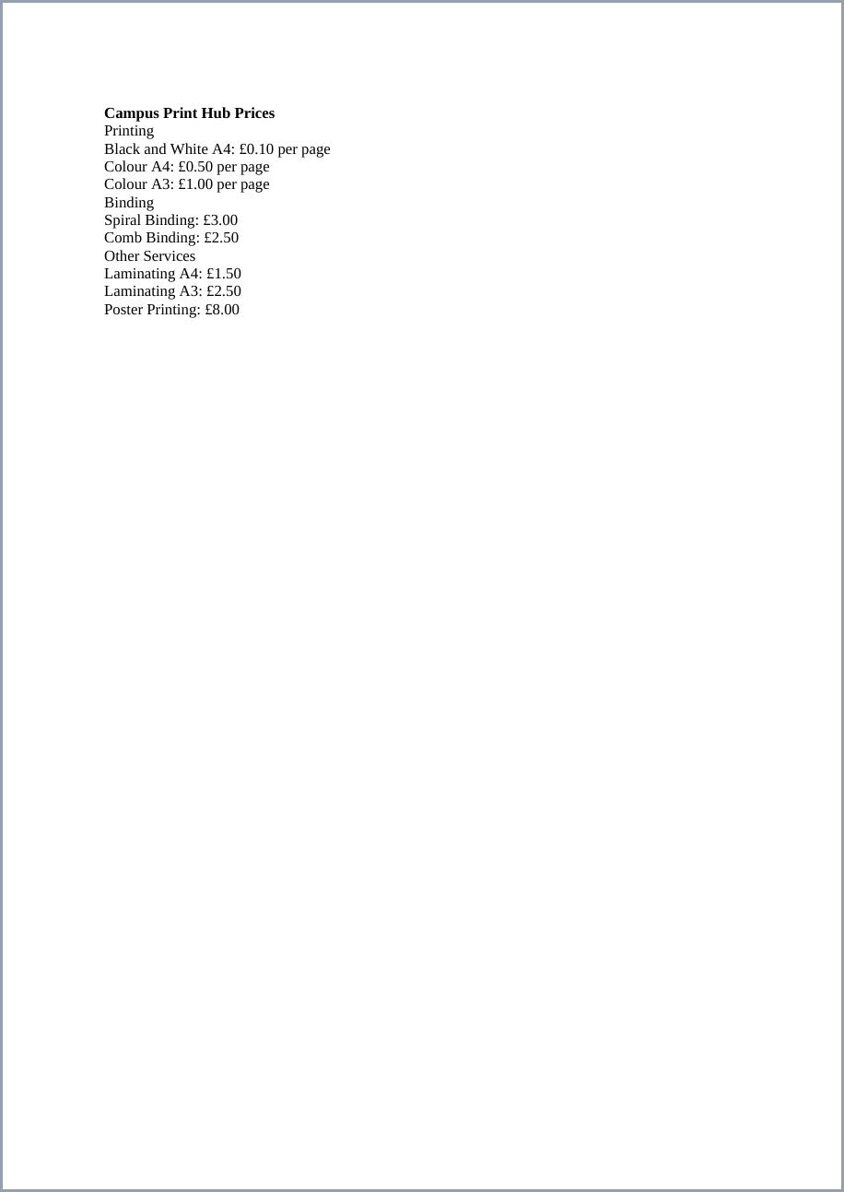
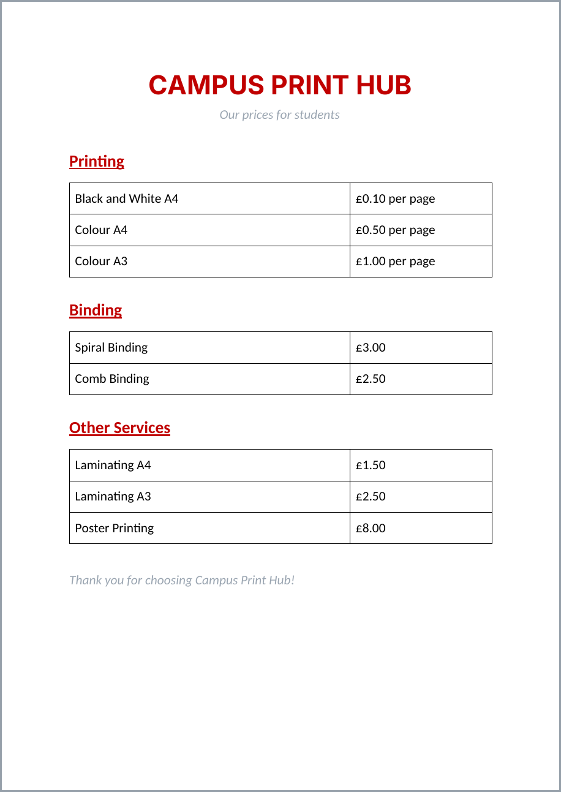
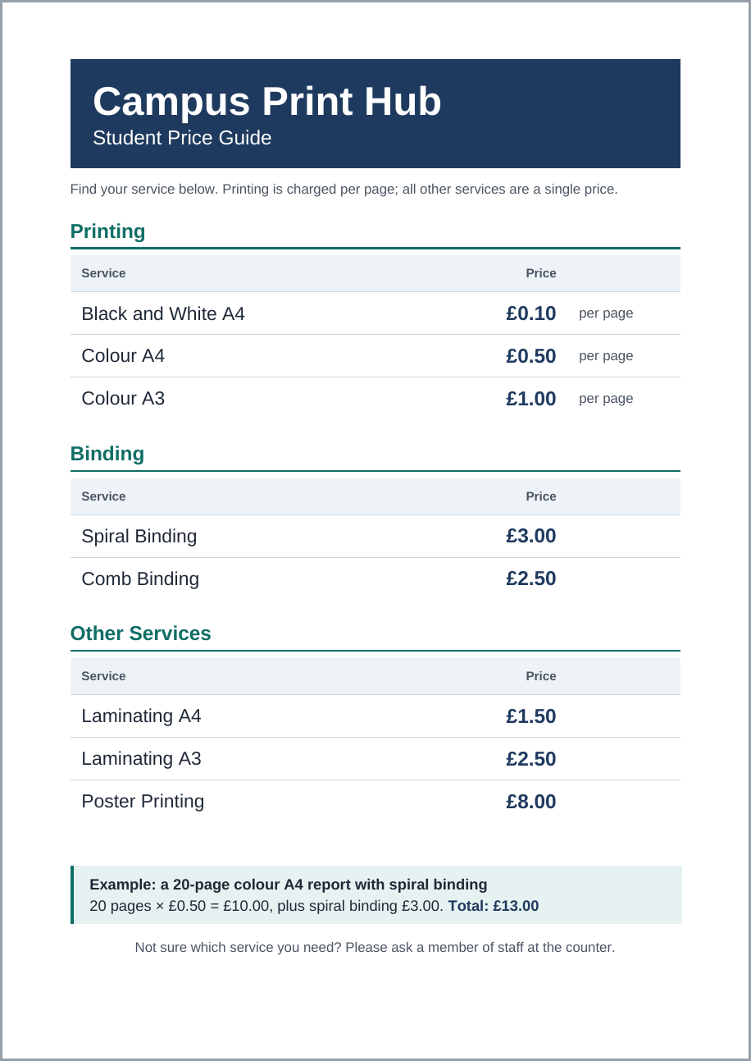

Version 1: first draft
I entered the information for the e-mail in Word using the standard Word style, one line per price. It was correct, but it seemed like a pasted e-mail instead of a sign. The text was too small to read from a distance, each line had the same weight and the prices were written at the end of each line, which means the student would have to read the entire line to determine the price.

Version 2: improved draft
- I had a big title at the top, section headings and a 2 column table for each group. This was definitely better as the prices now appeared in their own column. When critically examined, there are five issues I noted in it.
- The red headings were distracting. Bright warm colors like red should be used for warnings or errors, according to Gordon (2021).
- Grey subtitle and footer was difficult to read. I measured the grey (#9AA5B1) on white at about 2.5:1, below the 4.5:1 minimum for normal text in WCAG 2.2 (W3C, 2024).
- The page was quite cluttered - the headings were underlined and the page had a heavy black border.
- The price and unit were each in one cell (“£0.10 per page”) and the prices did not align.
- More than a third of the page was unfilled, and the text on the table was not much larger for a display sign.

Final version
I've made the following changes:
- The business name is on a navy header band.
- The headings are in a teal color and in Word's Heading 1 style.
- Prices are bold, Right aligned, and in their own column and Units are in a separate column, lighter text.
- Thin row borders are used for table borders, and the table's header row is shaded and repeated.
- There is more text and more space around it, making it bigger on the page and filling the space.
- Prices are shown in a short line under the title.
- A worked example box and friendly prompt to ask staff to sit at the bottom.
- I made sure that the final version still fits on one A4 page after all of the changes.

5. How these changes improved the work
Evaluated each change with reference to the brief and to accepted design principles. According to Williams (2015), there are four principles: contrast, repetition, alignment and proximity. The final version executes each of them:
- Contrast: The name of the business, the headings and prices stand out as the most salient items; a student could simply scan to a price. Colour, scale and grouping help in establishing a hierarchy of the picture and lead the eye in order of importance, as Gordon (2021) explains.
- Repetition: They have the same heading, header row and row style for all three sections, meaning that a reader who understands one section understands the other two.
- Alignment: right aligned prices align and make faster comparisons and are less likely to be misinterpreted. This directly meets the “accurate” criterion.
- Proximity: each heading is near its own table, and there is more space between sections, making the three groups into blocks.
I also enhanced the accessibility and legibility. I have calculated the contrast ratio for each colour combination. Navy on white is 11.5:1, dark body text on white is 14.7:1, the teal headings are 6.1:1 and the grey unit labels are 7.6:1. All of these pass the WCAG 2.2 minimum of 4.5:1 (W3C, 2024). WCAG is created for web content, but I applied it here as a measurable thing because it may be published in other formats such as a PDF or displayed on a screen. I have used Arial, a clear sans serif typeface, and have never used colour as a sole means of emphasis as the prices are bold and in their own column.
Last but not least, the worked example provides real business added value. It demonstrates that there is a combination of per-page and fixed prices, and should decrease questions at the counter.

6. Reflection
The single biggest lesson was to eliminate – red, underlines, heavy borders, low-contrast grey. This last guide fulfills all three aspects of the brief. It was limited in that I was not able to verify the VAT or poster size. If I had more time I would show the draft to a small number of pupils and see if they can quickly find a price – to see if it all works out as planned! Gordon (2021) suggests testing a design prototype with the end users.

References
Business Companion (2026) Providing price information. Chartered Trading Standards Institute. Available at: https://www.businesscompanion.info/en/quick-guides/pricing-and-payment/providing-price-information (Accessed: 19 October 2026).
Gordon, K. (2021) Visual hierarchy in UX: definition. Nielsen Norman Group, 17 January. Available at: https://www.nngroup.com/articles/visual-hierarchy-ux-definition/ (Accessed: 19 October 2026).
Lidwell, W., Holden, K. and Butler, J. (2010) Universal principles of design. Revised and updated edn. Beverly, MA: Rockport Publishers.
Microsoft (n.d.a) Insert a table. Microsoft Support. Available at: https://support.microsoft.com/en-us/office/insert-a-table-a138f745-73ef-4879-b99a-2f3d38be612a (Accessed: 19 October 2026).
Microsoft (n.d.b) Make your Word documents accessible to people with disabilities. Microsoft Support. Available at: https://support.microsoft.com/en-us/office/make-your-word-documents-accessible-to-people-with-disabilities-d9bf3683-87ac-47ea-b91a-78dcacb3c66d (Accessed: 19 October 2026).
W3C (2024) Web Content Accessibility Guidelines (WCAG) 2.2. W3C Recommendation, 12 December. Available at: https://www.w3.org/TR/WCAG22/ (Accessed: 19 October 2026).
Williams, R. (2015) The non-designer's design book. 4th edn. San Francisco, CA: Peachpit Press.

