Introduction To Web and Database Concepts
HTML & CSS Web Development
ACCA4023
Benjamin Bramwell – 2225602
12/05/2023

Table of Contents

- Assignment Title. Student Name & Number
- Introduction
- Requirements
- Implementation
  - Validation
- Evaluation
- Evaluation of My Website
- Accessibility
- References
- Appendices

Introduction
This report contains: The Module name and number, my name and my student number, the assignment title and also today’s date. It also includes a table of contents which outlines the sections which make up this report. In this document is also the requirements section, which is just a: Description of my website, Describing its purpose, What s the subject matter? And who is the intended target audience?
It also contains the Implementation section, which is just snippets of the pages of my website.
There is also the validation section which just validates my code to ensure there are no unseen errors or potential errors.
There is the evaluation section which is where I need to evaluate my websites usability and functionality etc.
There is also a reference section where I must include the references I have used for my research.
The Appendices is where I will copy and paste all of my code into this document.

Requirements
I have created a website for a fictional business. The purpose of this website is to show to their customers what items they currently have in stock and provide a little background about the business. It also gives descriptions of Motorbikes they have in stock for those who are interested but do knot have much knowledge about motorbikes. The subject matter is “Motorbikes”. The target audience is anyone is anyone who is currently interested in Motorbikes or anyone looking to delve into that world.

Implementation
Here I will provide snippets of each page of my website whilst it is up and running.
Here is the “Landing Page” or the index page:
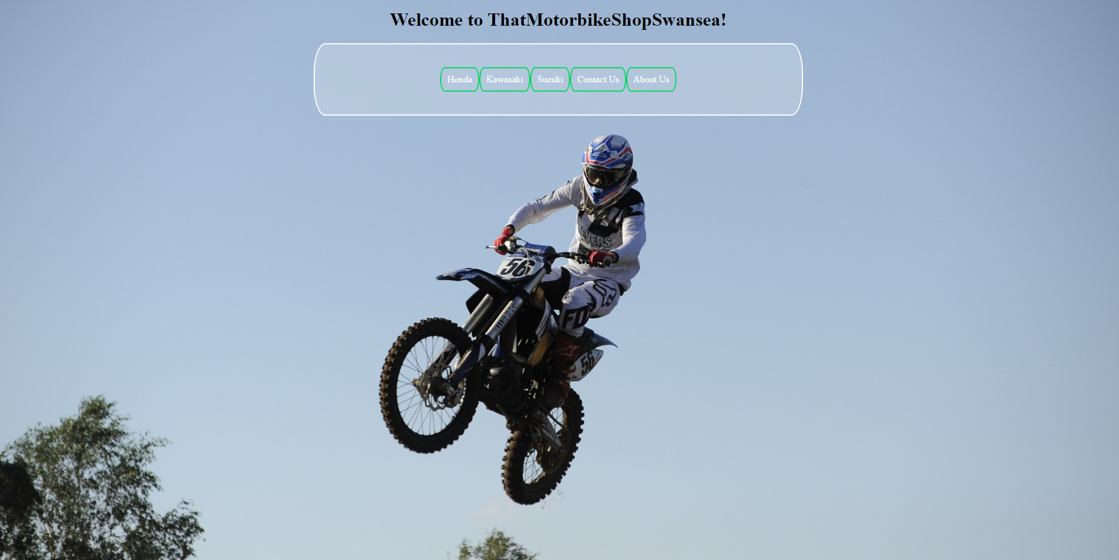 This page seems empty but that is to keep it to a minimalist feel. You access everything by the buttons within the NavBar.

This is the next page of my website, this is the “Honda Homepage”: 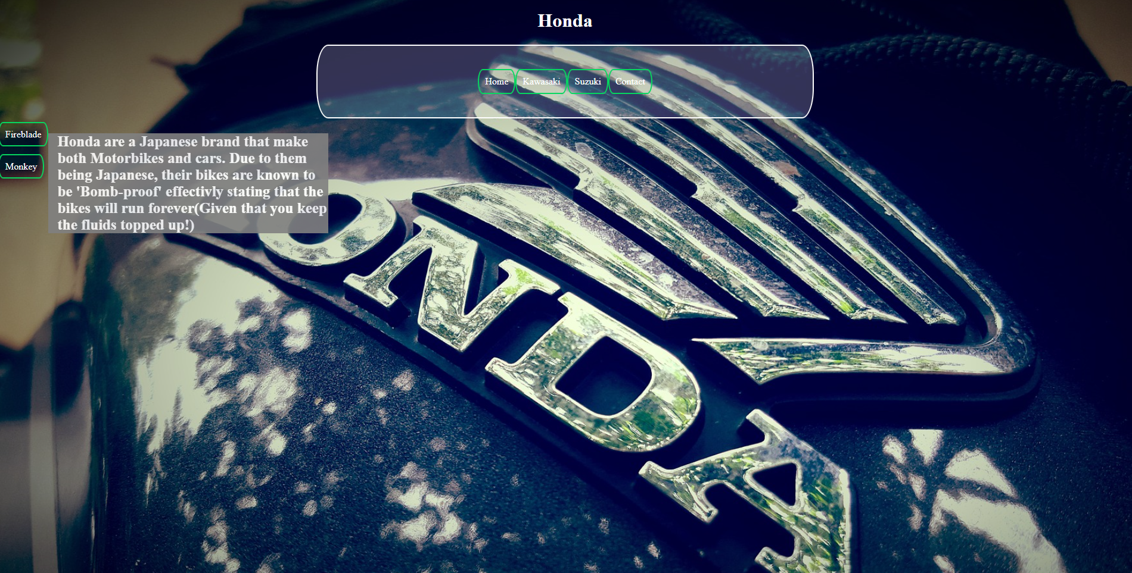 Here I have included the NavBar to other pages and also a vertical NavBar to redirect you to the Honda items. I have also provided a brief insight into Honda and their vehicles.
This is the first item of the Honda section, the “Fireblade” page:
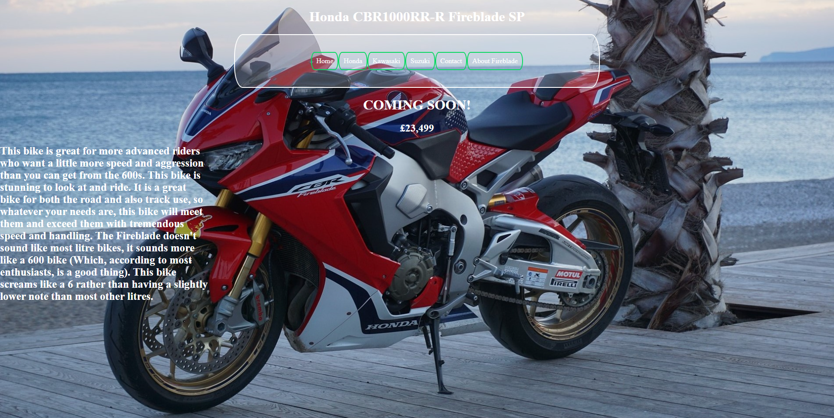Here I have stated that this item is not yet in stock but will be soon. I have also provided a description about this motorbike.
From this page you are able to access the “About the Fireblade” popup, which is a popup table which shows useful information about this motorbike: 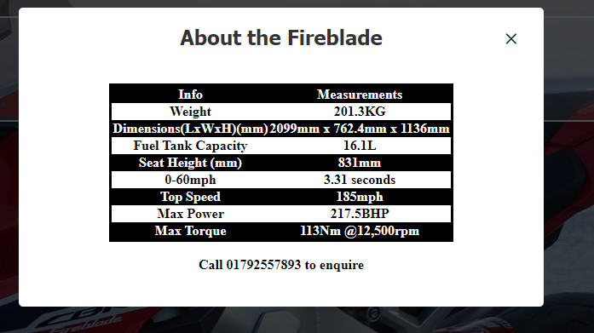It includes all the most commonly asked questions and their respective answers. It also includes the phone number of the business.

Here is the next page of my website, it is the other Honda item, the “Monkey Bike”: 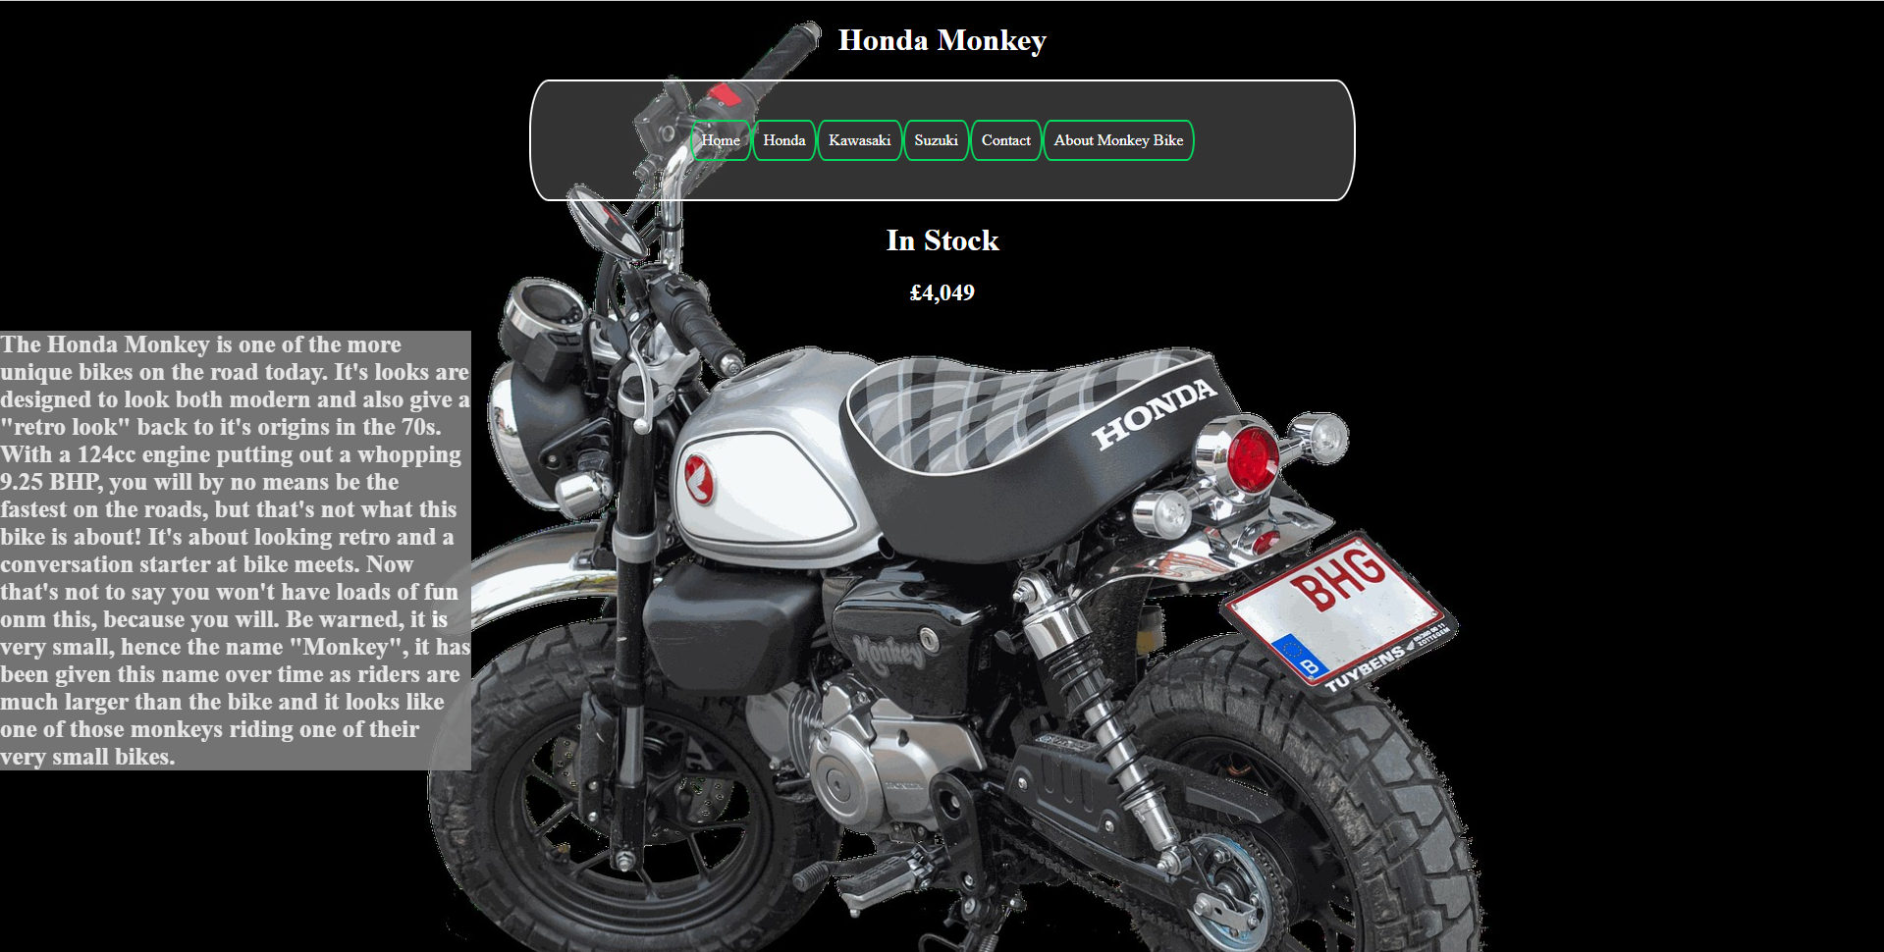On this webpage I have included an image of the Honda Monkey and also given some information about this particular motorbike including why Honda have given it the name “Monkey”
From this page you are able to access the “About the Monkey Bike” page: 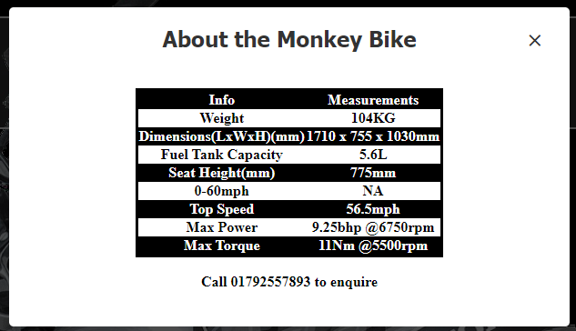This page provides all the necessary specifications of the motorbike for anyone who is interested in this bike.

The next page of my website is the “Kawasaki Homepage”: 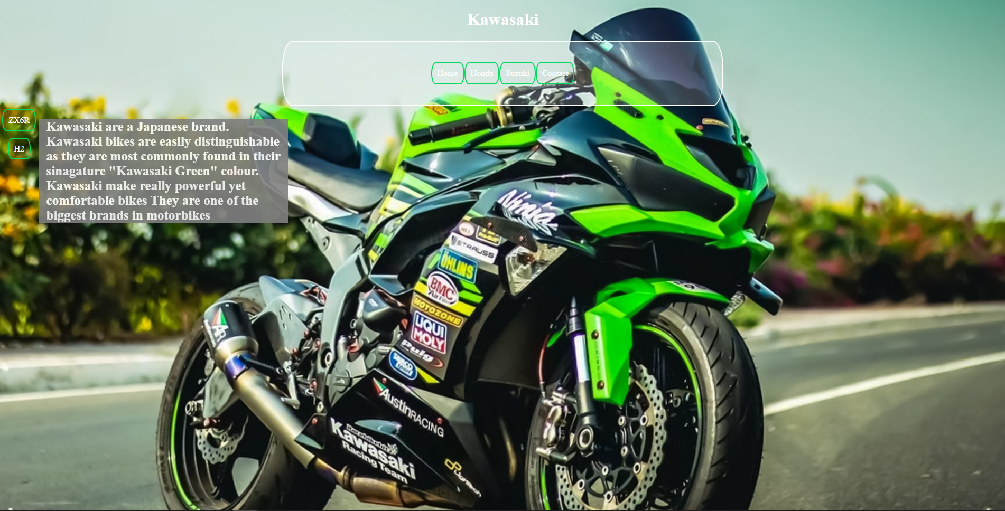On this webpage I have included an image of one of Kawasaki’s signature bikes. I have also included a brief insight into Kawasaki as a Motorbike Manufacturer. From this page you are able to navigate to the Kawasaki items they have in stock or arriving soon.
Here is the next page of the website, the “ZX6R 636” page: 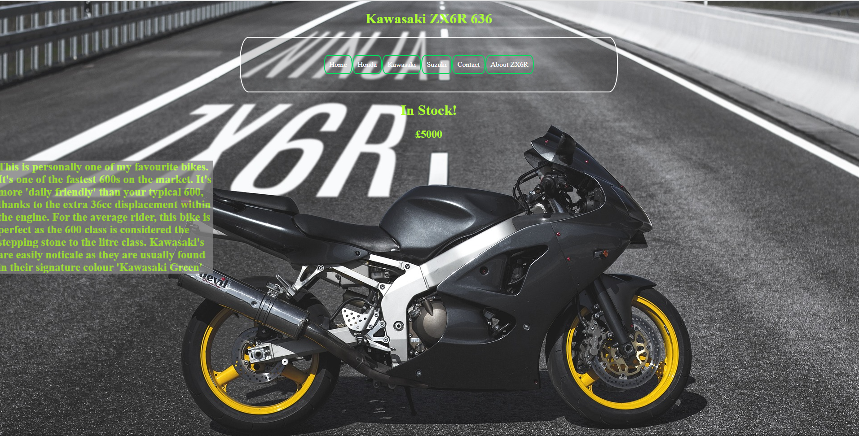On this page I have included a brief description of this motorbike, the name of it, whether it is in stock or not and also the price of the item. In these Kawasaki pages, I have set the text to a green as similar to the “Kawasaki Green” as I could get, this also helps the text stand out from the background. Similarly to the other pages, you are able to click on the button in the NavBar titled “About ZX6R” which will take you to the the following page: 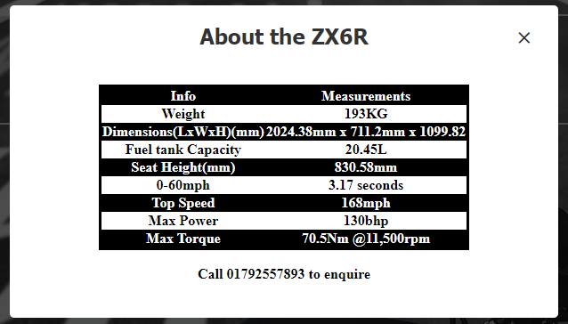This table follows the same structures as all the previous ones, highlighting the bikes performance, weight and dimensions of this bike

The next page within my website would be the other Kawasaki item or the “H2” page: 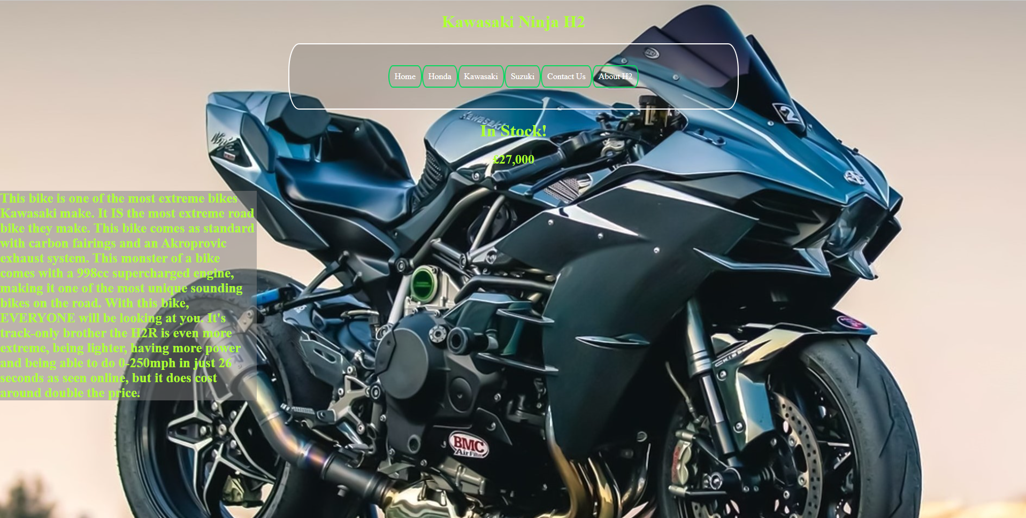This is the H2 page, on this page, the background image is of a Kawasaki H2. I have given some insight into this bike and also the track only version.I have included some basic information on this page such as whether it is in stock, and the price of it as well. From this page you are able to navigate to view the specs of this bike via the “About H2” button in the Navigation Menu. The specification page is as follows: 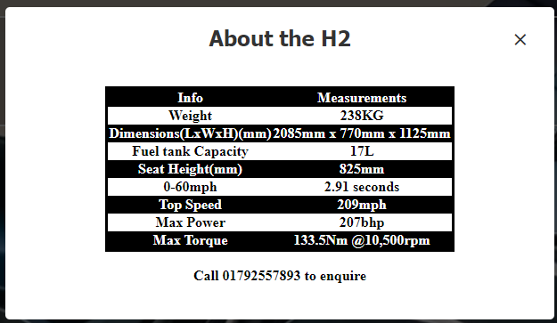 This page includes all the necessary and most commonly searched and/or asked specifications such as: weight, dimensions, performance, seeat height etc.
The next page within my website would be the “Suzuki Homepage”: 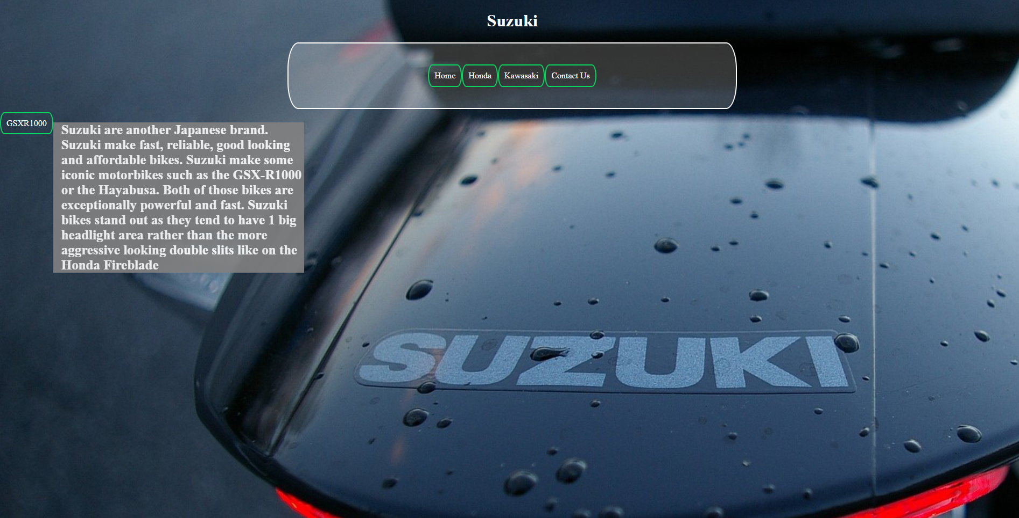On this page I have included an image clearly stating this is the Suzuki section of the website. I have also included a brief insight into Suzuki as a motorbike manufacturer and have also mentioned some of their more iconic motorbikes. From this page you can navigate to the “GSXR1000” page: 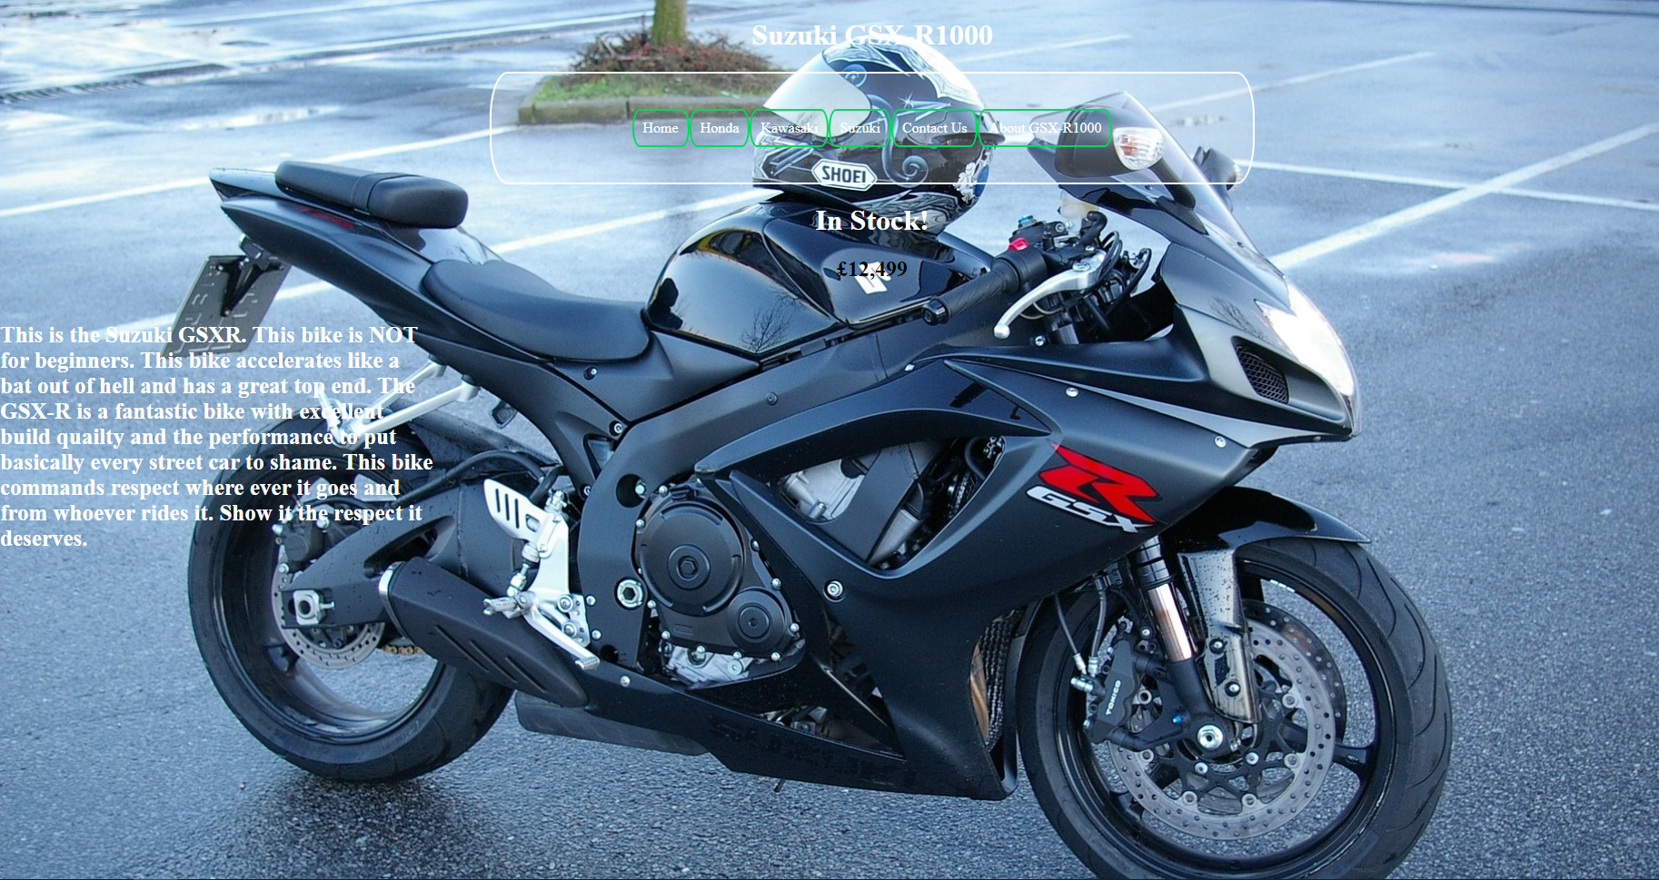On this page I have added a picture of a Suzuki GSXR1000. I have also included a brief description of this bike to inform people who are unfamiliar with this motorbike. From this page, similar to the other pages, you can navigate to the popup which then shows the user all the specifiactions of the bike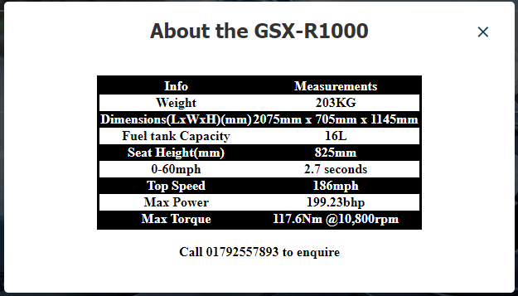Here I have created a table that holds lots of relevant data for anyone interesed in this bike.
Another page I have not previously mentioned is the “Contact Us” popup page. In every iteration of the Navigation Menu, I have included a button called “Contact Us” which, when clicked bring a popup screen containing all the different ways people can get into contact with the business: 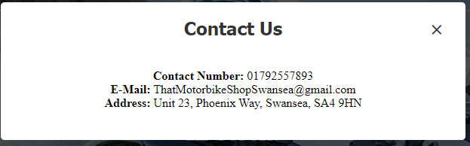Here I have included all the different ways people are able to contact the shop, whether that be via calling, E-Mail or visiting the shop. All this information is easy to read and straight to the point.
Another page not previously mentioned is the “About Us” page on the Index page or “Landing Page / Homepage”: 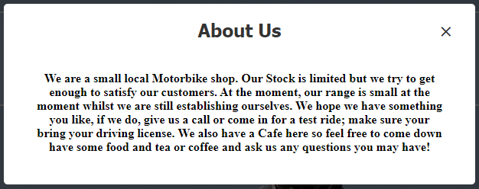 If you click the “About Us” button in the Navigation menu on the Index page, that will redirect you to a popup which just provides the reader with a bit of information about the business as whole and what their goals are as a business.

For the validation of my code, when I validated the index page, this is what came back: 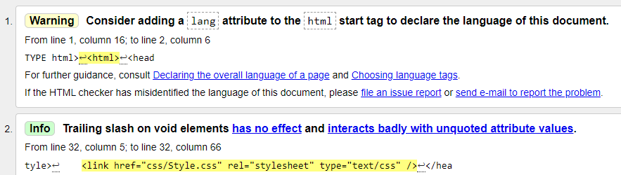It has given me one warning and 1 suggestion. The warning just tells me to specify the language of the webpages, however, it is not necessary, useful, but not necessary. The suggestion is to remove the \ at the end of my link tag. I have elected to ignore this as this is what HTML does by itslef and has presented no issues thus far. For my Validation, I have used (Validator.w3.org, n.d.) I uploaded my index file and it alidated the code
For the next part of the validation section, I have validated the main CSS file within my program: 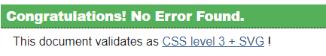 For my CSS validation, I used (http://jigsaw.w3.org/css-validator/, n.d.). I uploaded my CSS stylesheet file to their submission link and it checked and validated it and determined there is nothing wrong with my code.

Evaluation:
Usability:
The usability of a website is defined by ease of access for the user and how easy the user interface is to use. Usability also refers to making the finished product “easy-to-use” during the development state. Usability is defined by 5 points: Learnability – How easy is it for first time users to accomplish basic tasks. Efficiency – Once the users have learned the design, how quickly can they perform tasks? Memorability – When user’s return to the product after a period of absence, how quickly can they re-establish their efficiency? Errors – How many errors do users make? How severs are these errors and how easy is it for the user to recover from these errors? Satisfaction – How satisfying is your product to use?
Evaluation of My Website:
Usefulness and Usability: Utility - I feel like the functionality of my website is quite good as it is quite straight forward and quite user friendly.
Usability - I feel like the look of my website looks professional and suits the type of industry it was designed for quite well. Each page is designed to look different and showcase each product respectively. I feel the ease of use of my website is done quite well as it is straight forward and resembles modern websites and some of their key features.
Content – I feel like the content of my website is quite substantial as with each brand, there is a brief description of the brand as a whole, and each product has a description and the specifications of the corresponding item.
For future improvements I would suggest to perhaps add some more diversity to my website so each page feels unique.
SEO Techniques – Some of the on-page SEO techniques I have used are: Page titles, Headers, relevant URLs, Hyperlinking,
Page Titles: I have used relevant Page Titles for each of my pages.
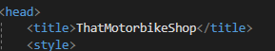This is for the homepage / Index page.
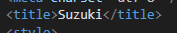This is for the Suzuki page of my application.
As you can see I have used relevant titles for each page.
Headers: Throughout my application, I have added relevant headers to each page to inform the user of what type of content they can expect to see there.
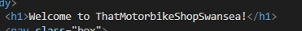 This is the header on the Homepage / Index page and it informs the user of the website and business they are interacting with currently.
URLs: I have used relevant URLs throughout my website, this makes it easier to navigate between the webpages for the user and also helps with accurately tracking the webpages
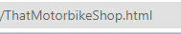 This is the URL for my homepage, it represents the website well.
Hyperlinking – I have used hyperlinking in my application to allow the users to navigate between the different pages within my website
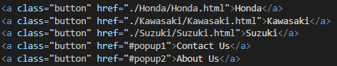 Here are some of my hyperlinks within my website.

Accessibility
According to (Hawkins, 2020) the first point of the WAGC 2.1 is: Perceivable, for content to be classed as perceivable, it cannot be hidden from users who are unable to use all their senses. My website doesn’t make use of sound so for people who are visually impaired may have issue using my website.
Operable: A user should be able to navigate through your website without being required to use a mouse. With my website, the user is able to navigate through all of the pages without using a mouse and through my testing, I found that you can navigate without the use of a mouse.
Understandable: A user must be able to understand the content on the page and understand how to operate the page. The content of my website is easily understandable as all the information and content is stored neatly and is all labelled clearly and correctly. I also think it is easy to navigate.
Robust: A user should be able to access the website from a variety of devices, screen sizes and web-browsers. My webpage adjusts the items positions depending on the size of the screen, and works well on multiple devices and web-browsers, so I think it is robust.

References:
- (Hawkins, 2020)

Appendices:
Homepage / Index page:
<!DOCTYPE html>
<html>
<head>
<title>ThatMotorbikeShop</title>
<style>
nav {
background-color: #333;
height: 50px;
width: 100%;
display: flex;
justify-content: center;
align-items: center;
}

nav a {
color: white;
text-decoration: none;
padding: 0 20px;
font-size: 20px;
}

nav a:hover {
background-color: #555;
}

body {
background-image: url("Images/Index-background.jpg");
background-repeat: no-repeat;
background-size: cover;
}
</style>
<link href="./css/Style.css" rel="stylesheet" type="text/css">
</head>
<body>
<h1>Welcome to ThatMotorbikeShopSwansea!</h1>
<nav class="box">
<a class="button" href="./Honda/Honda.html">Honda</a>
<a class="button" href="./Kawasaki/Kawasaki.html">Kawasaki</a>
<a class="button" href="./Suzuki/Suzuki.html">Suzuki</a>
<a class="button" href="#popup1">Contact Us</a>
<a class="button" href="#popup2">About Us</a>
</nav>

<div id="popup1" class="overlay">
<div class="popup">
<h2>Contact Us</h2>
<a class="close" href="#">&times;</a>
<div class="content">
<b>Contact Number:</b> 01792557893 <br>
<b>E-Mail:</b> ThatMotorbikeShopSwansea@gmail.com <br>
<b>Address:</b> Unit 23, Phoenix Way, Swansea, SA4 9HN
</div>
</div>
</div>

<div id="popup2" class="overlay">
<div class="popup">
<h2>About Us</h2>
<a class="close" href="#">&times;</a>
<div class="content">
<b>We are a small local Motorbike shop. Our Stock is limited but we try to get enough to satisfy our customers.
At the moment, our range is small at the moment whilst we are still establishing ourselves.
We hope we have something you like, if we do, give us a call or come in for a test ride; make sure your bring your driving license.
We also have a Cafe here so feel free to come down have some food and tea or coffee and ask us any questions you may have!</b>
</div>
</div>
</div>
</body>
</html>

Suzuki:
<!DOCTYPE html>
<html>
<head>
<meta charset="utf-8" />
<title>Suzuki</title>
<style>
h1 {
text-align: center;
color: white;
}

nav {
background-color: #333;
height: 50px;
width: 100%;
display: flex;
justify-content: center;
align-items: center;
}

nav a {
color: white;
text-decoration: none;
padding: 0 20px;
font-size: 20px;
}

nav a:hover {
background-color: #555;
}

.container {
display: flex;
margin: 0 auto;
}

.VertNavBar {
height: 100vh;
width: 115px;
color: #fff;
}

a {
color: white;
text-decoration: none;
font-size: 20px;
padding-left: 10px;
}

a:hover {
background-color: #555;
}

body {
margin: 0;
background-image: url("../Images/Suzuki.jpg");
background-repeat: no-repeat;
background-size: cover;
}

p {
color: white;
font-weight: bold;
font-size: 25px;
}
</style>
<link rel="stylesheet" href="../css/Style.css" type="text/css" />
</head>
<body>
<h1>Suzuki</h1>
<nav class="box">
<a class="button" href="../ThatMotorbikeShop.html">Home</a>
<a class="button" href="../Honda/Honda.html">Honda</a>
<a class="button" href="../Kawasaki/Kawasaki.html">Kawasaki</a>
<a class="button" href="#popup1">Contact Us</a>
</nav>

<div id="popup1" class="overlay">
<div class="popup">
<h2>Contact Us</h2>
<a class="close" href="#">&times;</a>
<div class="content">
<b>Contact Number:</b> 01792557893 <br />
<b>E-Mail:</b> ThatMotorbikeShopSwansea@gmail.com <br />
<b>Address:</b> Unit 23, Phoenix Way, Swansea, SA4 9HN
</div>
</div>
</div>

<div class="container">
<div class="VertNavBar">
<br />
<a class="button" href="GSXR1000.html">GSXR1000</a>
</div>
<div>
<p class="textwrap">
Suzuki are another Japanese brand.
Suzuki make fast, reliable, good looking and affordable bikes.
Suzuki make some iconic motorbikes such as the GSXR1000 or the Hayabusa.
Both of those bikes are exceptionally powerful and fast.
Suzuki bikes stand out as they tend to have 1 big headlight area rather than the more aggressive looking
double slits like on the Honda Fireblade
</p>
</div>
</div>
</body>
</html>
GSXR1000:
<!DOCTYPE html>
<html>
<head>
<meta charset="utf-8" />
<title>GSXR1000</title>
<style>
body {
margin: 0;
background-image: url("../Images/GSXR1000.jpg");
background-repeat: no-repeat;
background-size: cover;
}

h1 {
text-align: center;
font-weight: bold;
color: white;
}

h2 {
text-align: center;
color: black
}

nav {
background-color: #333;
height: 50px;
width: 100%;
display: flex;
justify-content: center;
align-items: center;
}

nav a {
color: white;
text-decoration: none;
padding: 0 20px;
font-size: 20px;
}

nav a:hover {
background-color: #555;
}

.container {
display: flex;
margin: 0 auto;
}

.container {
width: 25%;
word-wrap: break-word;
margin: 0;
padding: 0;
}

p {
font-weight: bold;
color: white;
font-size: 25px;
}
</style>
<link rel="stylesheet" href="../css/Style.css" type="text/css" />
</head>
<body>
<h1>Suzuki GSXR1000</h1>
<nav class="box">
<a class="button" href="../ThatMotorbikeShop.html">Home</a>
<a class="button" href="../Honda/Honda.html">Honda</a>
<a class="button" href="../Kawasaki/Kawasaki.html">Kawasaki</a>
<a class="button" href="Suzuki.html">Suzuki</a>
<a class="button" href="#popup1">Contact Us</a>
<a class="button" href="#popup2">About GSX-R1000</a>
</nav>

<div id="popup1" class="overlay">
<div class="popup">
<h2>Contact Us</h2>
<a class="close" href="#">&times;</a>
<div class="content">
<b>Contact Number:</b> 01792557893 <br />
<b>E-Mail:</b> ThatMotorbikeShopSwansea@gmail.com <br />
<b>Address:</b> Unit 23, Phoenix Way, Swansea, SA4 9HN
</div>
</div>
</div>

<div id="popup2" class="overlay">
<div class="popup">
<h2>About the GSXR1000</h2>
<a class="close" href="#">&times;</a>
<div class="content">
<table class="table striped">
<thead>
<tr>
<th>Info</th>
<th>Measurements</th>
</tr>
</thead>
<tbody>
<tr>
<td>Weight</td>
<td>203KG</td>
</tr>
<tr>
<td>Dimensions(LxWxH)(mm)</td>
<td>2075mm x 705mm x 1145mm</td>
</tr>
<tr>
<td>Fuel tank Capacity</td>
<td>16L</td>
</tr>
<tr>
<td>Seat Height(mm)</td>
<td>825mm</td>
</tr>
<tr>
<td>0-60mph</td>
<td>2.7 seconds</td>
</tr>
<tr>
<td>Top Speed</td>
<td>186mph</td>
</tr>
<tr>
<td>Max Power</td>
<td>199.23bhp</td>
</tr>
<tr>
<td>Max Torque</td>
<td>117.6Nm @10,800rpm</td>
</tr>
</tbody>
</table>
<br />
<b>Call 01792557893 to enquire</b>
</div>
</div>
</div>

<h1>In Stock!</h1>
<h2>£12,499</h2>

<div class="container">
<p>
This is the Suzuki GSXR1000. This bike is NOT for beginners. This bike accelerates like a bat out of hell and has a great top end.
The GSXR is a fantastic bike with excellent build quailty and the performance to put basically every street car to shame.
This bike commands respect where ever it goes and from whoever rides it. Show it the respect it deserves.
</p>
</div>
<link href="css/Style.css" rel="stylesheet" />
</body>
</html>

ZX6R:
<!DOCTYPE html>
<html>
<head>
<meta charset="utf-8" />
<title>ZX6R</title>
<style>
body {
margin: 0;
background-image: url("../Images/zx6r.jpg");
background-repeat: no-repeat;
background-size: cover;
}

h1 {
text-align: center;
font-weight: bold;
color: greenyellow;
}

h2 {
text-align: center;
font-weight: bold;
color: greenyellow
}

nav {
background-color: #333;
height: 50px;
width: 100%;
display: flex;
justify-content: center;
align-items: center;
}

nav a {
color: greenyellow;
text-decoration: none;
padding: 0 20px;
font-size: 20px;
}

nav a:hover {
background-color: #555;
}

.container {
display: flex;
margin: 0 auto;
}

.container {
width: 25%;
word-wrap: break-word;
margin: 0;
padding: 0;
}

p {
font-weight: bold;
color: greenyellow;
background-color: gray;
opacity: 0.8;
font-size: 25px;
}

.boxBG {
width: 40%;
margin: 0 auto;
background: rgba(51,51,51,0.2);
padding: 35px;
border: 2px solid #fff;
border-radius: 20px/50px;
background-clip: padding-box;
text-align: center;
}
</style>
<link rel="stylesheet" href="../css/Style.css" type="text/css" />
</head>
<body>
<h1>Kawasaki ZX6R 636</h1>
<nav class="boxBG">
<a class="button" href="../ThatMotorbikeShop.html">Home</a>
<a class="button" href="../Honda/Honda.html">Honda</a>
<a class="button" href="Kawasaki.html">Kawasaki</a>
<a class="button" href="../Suzuki/Suzuki.html">Suzuki</a>
<a class="button" href="#popup1">Contact</a>
<a class="button" href="#popup2">About ZX6R</a>
</nav>

<div id="popup1" class="overlay">
<div class="popup">
<h2>Contact Us</h2>
<a class="close" href="#">&times;</a>
<div class="content">
<b>Contact Number:</b> 01792557893 <br />
<b>E-Mail:</b> ThatMotorbikeShopSwansea@gmail.com <br />
<b>Address:</b> Unit 23, Phoenix Way, Swansea, SA4 9HN
</div>
</div>
</div>

<div id="popup2" class="overlay">
<div class="popup">
<h2>About the ZX6R</h2>
<a class="close" href="#">&times;</a>
<div class="content">
<table class="table striped">
<thead>
<tr>
<th>Info</th>
<th>Measurements</th>
</tr>
</thead>
<tbody>
<tr>
<td>Weight</td>
<td>193KG</td>
</tr>
<tr>
<td>Dimensions(LxWxH)(mm)</td>
<td>2024.38mm x 711.2mm x 1099.82</td>
</tr>
<tr>
<td>Fuel tank Capacity</td>
<td>20.45L</td>
</tr>
<tr>
<td>Seat Height(mm)</td>
<td>830.58mm</td>
</tr>
<tr>
<td>0-60mph</td>
<td>3.17 seconds</td>
</tr>
<tr>
<td>Top Speed</td>
<td>168mph</td>
</tr>
<tr>
<td>Max Power</td>
<td>130bhp</td>
</tr>
<tr>
<td>Max Torque</td>
<td>70.5Nm @11,500rpm</td>
</tr>
</tbody>
</table>
<br />
<b>Call 01792557893 to enquire</b>
</div>
</div>
</div>

<h1>In Stock!</h1>
<h2>£5000</h2>

<div class="container">

<p>
This is personally one of my favourite bikes. It's one of the fastest 600s on the market.
It's more 'daily friendly' than your typical 600, thanks to the extra 36cc displacement within the engine.
For the average rider, this bike is perfect as the 600 class is considered the stepping stone to the litre class.
Kawasaki's are easily noticale as they are usually found in their signature colour 'Kawasaki Green'
</p>
</div>
<link href="css/Style.css" rel="stylesheet" />
</body>
</html>

Kawasaki:
<!DOCTYPE html>
<html>
<head>
<meta charset="utf-8" />
<title>Kawasaki</title>
<style>
body {
margin: 0;
background-image: url("../Images/zx10r.jpg");
background-repeat: no-repeat;
background-size: cover;
}

h1 {
text-align: center;
color: white;
}

nav {
background-color: #333;
height: 50px;
width: 100%;
display: flex;
justify-content: center;
align-items: center;
}

nav a {
color: white;
text-decoration: none;
padding: 0 20px;
font-size: 20px;
}

nav a:hover {
background-color: #555;
}

.container {
display: flex;
margin: 0 auto;
}

.VertNavBar {
height: 100vh;
width: 110px;
text-align: center;
color: #fff;
}

a {
color: white;
text-decoration: none;
font-size: 20px;
padding-left: 10px;
}

a:hover {
background-color: #555;
}

p {
font-weight: bold;
color: white;
background-color: gray;
opacity: 0.9;
font-size: 25px;
}
</style>
<link rel="stylesheet" href="../css/Style.css" type="text/css" />
</head>
<body>
<h1>Kawasaki</h1>
<nav class="box">
<a class="button" href="../ThatMotorbikeShop.html">Home</a>
<a class="button" href="../Honda/Honda.html">Honda</a>
<a class="button" href="../Suzuki/Suzuki.html">Suzuki</a>
<a class="button" href="#popup1">Contact</a>
</nav>

<div id="popup1" class="overlay">
<div class="popup">
<h2>Contact Us</h2>
<a class="close" href="#">&times;</a>
<div class="content">
<b>Contact Number:</b> 01792557893 <br />
<b>E-Mail:</b> ThatMotorbikeShopSwansea@gmail.com <br />
<b>Address:</b> Unit 23, Phoenix Way, Swansea, SA4 9HN
</div>
</div>
</div>

<div class="container">
<div class="VertNavBar">
<br />
<a class="button" href="ZX6R.html">ZX6R</a>
<br />
<br />
<br />
<a class="button" href="H2.html">H2</a>
</div>
<div>
<p class="textwrap">
Kawasaki are a Japanese brand. Kawasaki bikes are easily distinguishable as they are most commonly found in their
sinagature "Kawasaki Green" colour. Kawasaki make really powerful yet comfortable bikes.
They are one of the biggest brands in motorbikes
</p>
</div>
</div>
</body>
</html>

H2:
<!DOCTYPE html>
<html>
<head>
<meta charset="utf-8" />
<title>H2</title>
<style>
body {
margin: 0;
background-image: url("../Images/H2-2.jpg");
background-repeat: no-repeat;
background-size: cover;
}

h1 {
text-align: center;
font-weight: bold;
color: greenyellow;
}

h2 {
text-align: center;
font-weight: bold;
color: greenyellow
}

nav {
background-color: #333;
height: 50px;
width: 100%;
display: flex;
justify-content: center;
align-items: center;
}

nav a {
color: greenyellow;
text-decoration: none;
padding: 0 20px;
font-size: 20px;
}

nav a:hover {
background-color: #555;
}

.container {
display: flex;
margin: 0 auto;
}

.container {
width: 25%;
word-wrap: break-word;
padding: 0;
padding-bottom: 15px;
margin: 0;
}

p {
background-color: rgba(128, 128, 128, 0.5);
font-weight: bold;
color: greenyellow;
font-size: 25px;
}

.boxBG {
width: 40%;
margin: 0 auto;
background: rgba(51,51,51,0.2);
padding: 35px;
border: 2px solid #fff;
border-radius: 20px/50px;
background-clip: padding-box;
text-align: center;
}

</style>
<link rel="stylesheet" href="../css/Style.css" type="text/css" />
</head>
<body>
<h1>Kawasaki Ninja H2</h1>
<nav class="boxBG">
<a class="button" href="../ThatMotorbikeShop.html">Home</a>
<a class="button" href="../Honda/Honda.html">Honda</a>
<a class="button" href="Kawasaki.html">Kawasaki</a>
<a class="button" href="../Suzuki/Suzuki.html">Suzuki</a>
<a class="button" href="#popup1">Contact Us</a>
<a class="button" href="#popup2">About H2</a>
</nav>

<div id="popup1" class="overlay">
<div class="popup">
<h2>Contact Us</h2>
<a class="close" href="#">&times;</a>
<div class="content">
<b>Contact Number:</b> 01792557893 <br />
<b>E-Mail:</b> ThatMotorbikeShopSwansea@gmail.com <br />
<b>Address:</b> Unit 23, Phoenix Way, Swansea, SA4 9HN
</div>
</div>
</div>

<div id="popup2" class="overlay">
<div class="popup">
<h2>About the H2</h2>
<a class="close" href="#">&times;</a>
<div class="content">
<table class="table striped">
<thead>
<tr>
<th>Info</th>
<th>Measurements</th>
</tr>
</thead>
<tbody>
<tr>
<td>Weight</td>
<td>238KG</td>
</tr>
<tr>
<td>Dimensions(LxWxH)(mm)</td>
<td>2085mm x 770mm x 1125mm</td>
</tr>
<tr>
<td>Fuel tank Capacity</td>
<td>17L</td>
</tr>
<tr>
<td>Seat Height(mm)</td>
<td>825mm</td>
</tr>
<tr>
<td>0-60mph</td>
<td>2.91 seconds</td>
</tr>
<tr>
<td>Top Speed</td>
<td>209mph</td>
</tr>
<tr>
<td>Max Power</td>
<td>207bhp</td>
</tr>
<tr>
<td>Max Torque</td>
<td>133.5Nm @10,500rpm</td>
</tr>
</tbody>
</table>
<br />
<b>Call 01792557893 to enquire</b>
</div>
</div>
</div>

<div>

<h1>In Stock!</h1>
<h2>£27,000</h2>
</div>
<div class="container">
<p>
This bike is the most extreme bikes Kawasaki make. It IS the most extreme road bike they make.
This bike comes as standard with carbon fairings and an Akroprovic exhaust system.
This monster of a bike comes with a 998cc supercharged engine, making it one of the most unique sounding bikes on the road.
With this bike, EVERYONE will be looking at you.
Its track-only brother the H2R is even more extreme, being lighter, having more power and being able to do 0-250mph in just 26 seconds
as seen online, but it does cost around double the price.
</p>
</div>
<link href="css/Style.css" rel="stylesheet" />
</body>
</html>

Monkey:
<!DOCTYPE html>
<html>
<head>
<meta charset="utf-8" />
<title>Monkey</title>
<style>
body {
background-image: url(../Images/Monkey-Bike3.jpg);
margin: 0;
background-repeat: no-repeat;
background-size: cover;
}

h1 {
color: white;
font-weight: bold;
text-align: center;
}

h2 {
color: white;
font-weight: bold;
text-align: center;
}

nav {
background-color: #333;
height: 50px;
width: 100%;
display: flex;
justify-content: center;
align-items: center;
}

nav a {
color: white;
text-decoration: none;
padding: 0 20px;
font-size: 20px;
}

nav a:hover {
background-color: #555;
}

.container {
width: 25%;
word-wrap: break-word;
background-color: gray;
opacity: 0.9;
margin: 0;
padding: 0;
}

p {
font-weight: bold;
color: white;
font-size: 25px;
}

</style>
<link rel="stylesheet" href="../css/Style.css" type="text/css" />
</head>
<body>
<h1>Honda Monkey</h1>
<nav class="box">
<a class="button" href="../ThatMotorbikeShop.html">Home</a>
<a class="button" href="Honda.html">Honda</a>
<a class="button" href="../Kawasaki/Kawasaki.html">Kawasaki</a>
<a class="button" href="../Suzuki/Suzuki.html">Suzuki</a>
<a class="button" href="#popup1">Contact</a>
<a class="button" href="#popup2">About Monkey Bike</a>
</nav>

<div id="popup1" class="overlay">
<div class="popup">
<h2>Contact Us</h2>
<a class="close" href="#">&times;</a>
<div class="content">
<b>Contact Number:</b> 01792557893 <br />
<b>E-Mail:</b> ThatMotorbikeShopSwansea@gmail.com <br />
<b>Address:</b> Unit 23, Phoenix Way, Swansea, SA4 9HN
</div>
</div>
</div>

<div id="popup2" class="overlay">
<div class="popup">
<h2>About the Monkey Bike</h2>
<a class="close" href="#">&times;</a>
<div class="content">
<table class="table striped">
<thead>
<tr>
<th>Info</th>
<th>Measurements</th>
</tr>
</thead>
<tbody>
<tr>
<td>Weight</td>
<td>104KG</td>
</tr>
<tr>
<td>Dimensions(LxWxH)(mm)</td>
<td>1710 x 755 x 1030mm</td>
</tr>
<tr>
<td>Fuel Tank Capacity</td>
<td>5.6L</td>
</tr>
<tr>
<td>Seat Height(mm)</td>
<td>775mm</td>
</tr>
<tr>
<td>0-60mph</td>
<td>NA</td>
</tr>
<tr>
<td>Top Speed</td>
<td>56.5mph</td>
</tr>
<tr>
<td>Max Power</td>
<td>9.25bhp @6750rpm</td>
</tr>
<tr>
<td>Max Torque</td>
<td>11Nm @5500rpm</td>
</tr>
</tbody>
</table>
<br />
<b>Call 01792557893 to enquire</b>
</div>
</div>
</div>

<h1>In Stock</h1>
<h2>£4,049</h2>

<div class="container">
<p>
The Honda Monkey is one of the more unique bikes on the road today. It's looks are designed to look both modern and also give a "retro look"
back to it's origins in the 70s. With a 124cc engine putting out a whopping 9.25 BHP! You will by no means be the fastest on the roads,
but that's not what this bike is about! It's about looking retro and a conversation starter at bike meets. Now that's not to say you won't
have loads of fun on this, because you will. Be warned, it is very small, hence the name "Monkey", it has been given this name over
time as riders are much larger than the bike and it looks like one of those monkeys riding one of their very small bikes.
</p>
</div>
</body>
</html>

Honda:
<!DOCTYPE html>
<html>
<head>
<meta charset="utf-8" />
<title>Honda</title>
<style>
h1 {
text-align: center;
color: white;
}

nav {
background-color: #333;
height: 50px;
width: 100%;
display: flex;
justify-content: center;
align-items: center;
}

nav a {
color: white;
text-decoration: none;
padding: 0 20px;
font-size: 20px;
}

nav a:hover {
background-color: #555;
}

.container {
display: flex;
margin: 0 auto;
}

.VertNavBar {
height: 100vh;
width: 110px;
color: #fff;
}

.sep {
padding-top: 10px;
}

a {
color: white;
text-decoration: none;
font-size: 20px;
padding-left: 10px;
}

a:hover {
background-color: #555;
}

body {
margin: 0;
background-image: url("../Images/honda-logo.jpg.jpg");
background-repeat: no-repeat;
background-size: cover;
}

p {
color: white;
font-weight: bold;
font-size: 25px;
}
</style>
<link rel="stylesheet" href="../css/Style.css" type="text/css" />
</head>
<body>
<h1>Honda</h1>
<nav class="box">
<a class="button" href="../ThatMotorbikeShop.html">Home</a>
<a class="button" href="../Kawasaki/Kawasaki.html">Kawasaki</a>
<a class="button" href="../Suzuki/Suzuki.html">Suzuki</a>
<a class="button" href="#popup1">Contact</a>
</nav>

<div id="popup1" class="overlay">
<div class="popup">
<h2>Contact Us</h2>
<a class="close" href="#">&times;</a>
<div class="content">
<b>Contact Number:</b> 01792557893 <br />
<b>E-Mail:</b> ThatMotorbikeShopSwansea@gmail.com <br />
<b>Address:</b> Unit 23, Phoenix Way, Swansea, SA4 9HN
</div>
</div>
</div>

<div class="container">
<div class="VertNavBar">
<br />
<a class="button" href="Fireblade.html">Fireblade</a>
<br />
<br />
<br />
<a class="button" href="Monkey.html">Monkey</a>
</div>
<div>
<p class="textwrap">
Honda are a Japanese brand that make both Motorbikes and cars. Due to them being Japanese, their bikes are known to be 'Bomb-proof'
effectivly stating that the bikes will run forever(Given that you keep the fluids topped up!)
</p>
</div>
</div>
</body>
</html>

Fireblade:
<!DOCTYPE html>
<html>
<head>
<meta charset="utf-8" />
<title>Honda CBR1000RR-R Fireblade SP</title>
<style>
h1 {
color: white;
font-weight: bold;
text-align: center;
}

h2 {
color: white;
font-weight: bold;
text-align: center;
}

nav {
height: 50px;
width: 100%;
display: flex;
justify-content: center;
align-items: center;
}

nav a {
color: white;
text-decoration: none;
padding: 0 20px;
font-size: 20px;
}

nav a:hover {
background-color: #555;
}

.VertNavBar {
height: 100vh;
width: 100px;
background-color: #333;
color: #fff;
}

a {
color: white;
text-decoration: none;
font-size: 20px;
padding-left: 10px;
}

a:hover {
background-color: #555;
}

body {
margin: 0;
background-image: url("../Images/Fireblade.jpg");
background-repeat: no-repeat;
background-size: cover;
}

.table th {
text-decoration: double;
background: #808080;
color: #ffffff;
}

.table td {
font-weight: bold;
}

.container {
width: 25%;
word-wrap: break-word;
}

p {
font-weight: bold;
color: white;
font-size: 25px;
}
</style>
<link rel="stylesheet" href="../css/Style.css" type="text/css" />
</head>
<body>
<h1>Honda CBR1000RR-R Fireblade SP</h1>
<nav class="box">
<a class="button" href="../ThatMotorbikeShop.html">Home</a>
<a class="button" href="Honda.html">Honda</a>
<a class="button" href="../Kawasaki/Kawasaki.html">Kawasaki</a>
<a class="button" href="../Suzuki/Suzuki.html">Suzuki</a>
<a class="button" href="#popup1">Contact</a>
<a class="button" href="#popup2">About Fireblade</a>
</nav>

<div id="popup1" class="overlay">
<div class="popup">
<h2>Contact Us</h2>
<a class="close" href="#">&times;</a>
<div class="content">
<b>Contact Number:</b> 01792557893 <br />
<b>E-Mail:</b> ThatMotorbikeShopSwansea@gmail.com <br />
<b>Address:</b> Unit 23, Phoenix Way, Swansea, SA4 9HN
</div>
</div>
</div>

<div id="popup2" class="overlay">
<div class="popup">
<h2>About the Fireblade</h2>
<a class="close" href="#">&times;</a>
<div class="content">
<table class="table striped">
<thead>
<tr>
<th>Info</th>
<th>Measurements</th>
</tr>
</thead>
<tbody>
<tr>
<td>Weight</td>
<td>201.3KG</td>
</tr>
<tr>
<td>Dimensions(LxWxH)(mm)</td>
<td>2099mm x 762.4mm x 1136mm</td>
</tr>
<tr>
<td>Fuel Tank Capacity</td>
<td>16.1L</td>
</tr>
<tr>
<td>Seat Height (mm)</td>
<td>831mm</td>
</tr>
<tr>
<td>0-60mph</td>
<td>3.31 seconds</td>
</tr>
<tr>
<td>Top Speed</td>
<td>185mph</td>
</tr>
<tr>
<td>Max Power</td>
<td>217.5BHP</td>
</tr>
<tr>
<td>Max Torque</td>
<td>113Nm @12,500rpm</td>
</tr>
</tbody>
</table>
<br />
<b>Call 01792557893 to enquire</b>
</div>
</div>
</div>

<h1>COMING SOON!</h1>
<h2>£23,499</h2>

<div class="container">
<p>
This bike is great for more advanced riders who want a little more speed and aggression than you can get from the 600s.
This bike is stunning to look at and ride. It is a great bike for both the road and also track use, so whatever
your needs are, this bike will meet them and exceed them with tremendous speed and handling.
The Fireblade doesn't sound like most litre bikes, it sounds more like a 600 bike (Which, according to most
enthusiasts, is a good thing). This bike screams like a 6 rather than having a slightly lower note than most other
litres.
</p>
</div>
<link href="css/Style.css" rel="stylesheet" />
</body>
</html>

CSS – Stylesheet:
h1 {
text-align: center;
}

.button {
font-size: 1em;
padding: 10px;
color: #fff;
border: 2px solid #06D85F;
border-radius: 20px/50px;
text-decoration: none;
cursor: pointer;
transition: all 0.3s ease-out;
}

.box {
width: 40%;
margin: 0 auto;
background: rgba(255,255,255,0.2);
padding: 35px;
border: 2px solid #fff;
border-radius: 20px/50px;
background-clip: padding-box;
text-align: center;
}

.button:hover {
background: #06D85F;
}

.overlay {
position: fixed;
top: 0;
bottom: 0;
left: 0;
right: 0;
background: rgba(0,0,0,0.7);
transition: opacity 500ms;
visibility: hidden;
opacity: 0;
}

.overlay:target {
visibility: visible;
opacity: 1;
}

.popup {
margin: 70px auto;
padding: 20px;
background: #fff;
border-radius: 5px;
width: 30%;
position: relative;
transition: all 5s ease-in-out;
}

.popup h2 {
margin-top: 0;
color: #333;
text-align: center;
font-family: Tahoma, Arial, sans-serif;
}

.popup .close {
position: absolute;
top: 20px;
right: 30px;
transition: all 200ms;
font-size: 30px;
font-weight: bold;
text-decoration: none;
color: #333;
}

.popup .close:hover {
color: #06D85F;
}

.popup .content {
max-height: 30%;
overflow: auto;
}

/*Tables*/

.table th {
text-decoration: double;
background-color: black;
color: #ffffff;
}

.striped {
border-collapse: collapse;
border: solid;
border-block-color: black;
margin-left: auto;
margin-right: auto;
}

.striped tr:nth-child(even) {
background-color: black;
color: white;
}

.striped tr:nth-child(odd) {
background-color: white;
color: black;
}

.table td {
font-weight: bold;
text-align: center;
}

.content {
flex-grow: 1;
padding: 20px;
text-align: center;
box-sizing: border-box;
}

.textwrap {
background-color: gray;
opacity: 0.9;
width: 25%;
padding-left: 15px;
word-wrap: break-word;
}

