University of Wales Trinity saint David

Module Name: Digital Skills and Research Methods
Module Code: BMSK4003

Student’s Name: Shamsul Hoque
Student’s Number: 1706272

Contents
Introduction: 3
Task 1: Evaluating the effectiveness of the use of modern technologies within the workplace. 3
Task 2: Exploring social media for marketing, information gathering, and communication within the workplace. 6
Task 3: Creation of own professional accounts in several social media. 9
Conclusion: 11
References: 12

Introduction:
The report is about the blessings of the modern technologies. The present age is blessed with the modern technologies, so are the business and non business organizations. The modern technologies have developed the effectiveness of the workplaces of the organizations. The evaluation of the effectiveness is described in this report. The improved communication, reduced cost and so many things are responsible for the development of the workplace environment. The social media has a great influence on the development of the organizations. This report will briefly discuss some of the influences of social media on different organizations such as business and non business organizations.

Task 1: Evaluating the effectiveness of the use of modern technologies within the workplace.
The modern technology is providing effective facilities to all the sectors in the world. Different types of organizations are getting various benefits of modern inventions and making the workplace more efficient. In all the sectors such as businesses, military forces, governmental organizations, services organizations are now surrounded with the blessings of modern technologies (Poynter, 2010). To get the effectiveness of the modern technologies, digital skills must be developed. This is the competency of using the digital technologies like smartphone, laptop, Wi-Fi, cloud computing, networking etc. These technologies help the development of organizations and make those effective.

Figure: Modern Technologies.
Source:
There are so many usefulness of using the modern technologies. The effectiveness and uses of the modern technologies are described below.
Security in the workplace: The modern technologies like close circuit camera, security brokers, micro segmentation etc. enhance the workplace security. The effective and proper use of these new technologies can secure the workplaces strictly. The security of the people, production, and communication system of the organization is necessary for the development of the organization (Cottrell, 2011). For example, Apple is using e-CRM for the security of the system of the organization. It gradually helps to increase the value of the organization to the employees. This security system has established a belief among the employers of the company and increases the effectiveness of the workplace.
Effective communication: The new technologies are making the communication easier in the workplace. The use of social media and communication technologies are developing the communication process. People are now more likely to use this technological advancement for their logistics in the businesses. In most organizations, people use emails, telephones, cell phones, internet and other technologies for communicating with the others. The people of any organization may need internal or external communications. For the internal communication in an organization, the people may use intercom, intranet or other communication technologies that can enhance the effectiveness of that organization. Both written and verbal communication technologies are used for effective communication. For external communication, the people of a particular organization may use emails, social media, telephone, cell phone etc. For example, the use of intranet system inside the organization enriches the internal communication of Amazon.com. Better communication always enhances the effectiveness of the workplace of any types of organizations.
Cost reduction: The automation in the workplace can reduce the cost of an organization. The automation technologies reduced the cost of labor in an organization which can reduce the cost. Besides, the communication technologies of today reduce the cost of organization. Now a day, the employees and employers of the organizations use internet mostly for communication which is less costly. So, the use of communication technology, the cost can be reduced. For example, people of NHS use internet for their communication now. This has reduced the cost of their communication for £200,780 in the last year (Maund, Schriek, and Tinkler, 2017). Besides, the improved technology has also increases the effectiveness of the company.
Information collection: The technologies are now used for the information collection about the customers’ choices, demands, opinions, and feedbacks. The social networking sites are available in the present age. The businesses use the social networking sites for assessing the information about the customers and demand of them (Morgan, 2016). They also capture feedback from the social media. Some company’s customer relationship management departments work using the technologies. Electronic CRM (Customer Relationship Management) is one popular example of this. For example, Google gets feedback from its customers by the apps feedback section. From that section the company can know the reasons for what people like it or for what people do not like it or in which section people are facing problems.
Increase productivity: The advanced technology has increased the productivity of the workplaces. By the grace of technology, the productivity of people as well as the products and services is increasing day by day. The newer psychological models for the development of people are improving their productivity. The new technologies are improving the manufacture of the products in the factories. Both of these improvements are increasing the effectiveness of the workplace as well as the company.
Improvement of the employability skills: The employability skills can be developed by the developed technologies. Employability skills are the skills that an individual needs for his or her job and to increase the competitive advantage. Modern technology is helpful for improving the employability skills. For example, people of Google use online training sessions, group chats, video conferencing and other technologies for sharing their employability skills with others and improving themselves. People of different companies also use technologies like internet, video games and such other things to improve their employability skills.

Task 2: Exploring social media for marketing, information gathering, and communication within the workplace.
Different organizations use different social media sites for different purposes in this digital age. Facebook, tweeter, Instagram, linked-in YouTube etc. are the example of social media. The social media marketing means understanding the customers’ need by using these social media, promoting and selling the products through social media, and capturing value from the customers by the social media. Through the social media, marketing organization tries to gain traffic in the online customers (Morgan, 2016).
The social media work more effectively than any other media to influence the buying pattern of the customers. Various types of advertisements in the social media affect the customers in their buying behavior. Customers’ products and service acquisition habit can be changed or modified by the social media promotional campaigns. For example, many business use Facebook and posts different movement in the market in different time. These trends may change the customers’ mood. They can buy those products following the trends.
The social sites are used for understanding the needs and demand of customers. At the present age, the social media is used to gather the information about the customers’ choice. The customers’ Facebook uploads, comments, and such other things are analysed to know their choices and demands. Social media marketing attach with their needs with the supply of the organization. The social media marketing plan follow some steps. At first, the business considers the social media presence in the customers’ life. What social media is used by the customer should be known by the marketer. If the customers use mainly some of the social media sites like Facebook and Twitter, then the company should start the promotional activities over there. The company should start working with Facebook pages or twitter account to follow the customers as well as gather information about their choices. The target customer can be identified through the social media. By the social networking sites, the customers’ choices can be detected. It makes the company realize the actual customers of the company are. For example, Google creates poll in the Facebook in order to learn the choice of the customers and their trend toward specific issues so that it can find out its target customers.
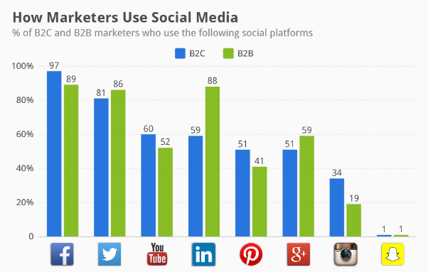
Figure 3: Usages of Social media as marketing.
Source:
The business people do their marketing activities to sell their product to another business people or to the direct consumer. That means the marketing promotions may be done for B2B or B2C operation. From the given figure, it can be said that the b2b operations use less social media marketing than the b2c operations.
The social media statement demonstrates the future actions of the business. For example, Facebook page of Apple writes statement that works as the marketing of its product and brand to the Facebook users. It sets a goal for the company or for the new products and then shows those goals as statements in the social media. By this, people come to know about the future products of the company and can show their reaction toward that product (Loon, 2014).
The social networking sites may be used for the measurement of the success of using the social media. Whether social media marketing successful or not can be measured by using some metrics.
The marketers must decide what they will post on social media as promotion. They cannot post anything wrong or mistake in the social media. It may cause a lot in the future. There are some popular contents such as videos, picture, blog post, company news, infographics, eBook, interviews etc. that are used in the social media marketing. The marketers must focus on the mission statement to create target customer oriented content (Nickoson and Sheridan, 2012). For example, different companies post on Facebook and share videos in the Instagram and YouTube to inform the customers about the products and brand.
And last of all, the marketers track the data and analyse those for the proper use of social media for the marketing activities of their company. They follow their regular customers and capture the feedback of those customers using the social sites. In the social sites, the customers feel free to share their opinions and most of them do not think it formal or difficult matter. So, they easily share their opinions on the social Medias. The marketers have the opportunities to get proper idea about their customers’ choice and opinions. After getting the information about the customers’ feedback, the marketers can analyse those and then take necessary steps for the future plans.
Though the social media has so many advantages for the marketers, the social media has some drawbacks. People do not take social media as a formal place of communication. So, they may share their informal or personal information in the social sites. When the marketers of the businesses work for gathering the information about the customers’ choice about their products or services, the customers’ personal information may uncover. This is a major drawback of social site. Besides, the people do not take social media as a formal platform. So, most of them do not take it seriously for sharing opinions (Ramsey, 2010). So, the actual number of customers cannot be identified properly by using the social media. For example, the people aged more than sixty five do not share their choices, opinions, or feedbacks to the social sites. So, their choices, opinions, or feedbacks cannot be understood b using social networking sites.

Task 3: Creation of own professional accounts in several social media.
To get the advantages of the modern technology and to have the competitive advantages, an individual must follow the trend of using social media. I have my own professional social media accounts in several sites. I have accounts in Facebook, Twitter, and Yahoo for attaching with my family and friends as well as for the working purpose.
My Facebook Account Link is https://web.facebook.com/shamsulhoque. I am attached with my family members, friends, neighbors, and my colleagues through my Facebook account.
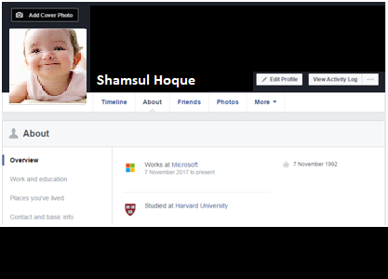
Figure: My Facebook Account.
I have an account in Twitter. My Tweeter Account Link is https://twitter.com/ShamsulHoque. I am attached with my friends and other professionals as me by this account.

Figure: My Twitter Account.
I have an account on Yahoo. My Yahoo mail ID is shamsulhoque@yahoo.com and the Yahoo account link is www.yahoo.com/shamsulhoque. I use this account for the formal emails and sometimes for the professional conversations.
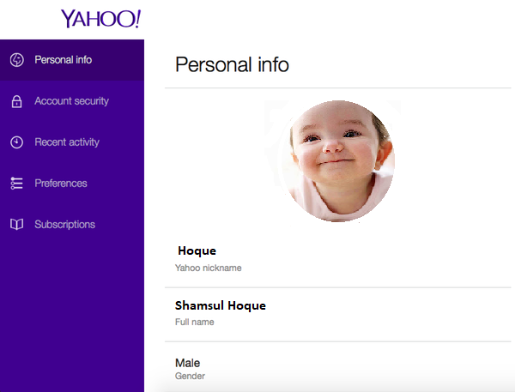
Figure: My Yahoo Account.
These are my social media accounts that I use to communicate with the people around me for the professional purpose as well as the personal one.

Conclusion:
In the present age, the technological advancement is improving day by day. The newer technologies are enhancing the peoples’ life, organizations, public facilities etc. The workplaces are becoming more effective by the blessings of the modern technology (Chan, 2012). The advancement in the communication, reduction in cost of the organization, improved quality of products and services, and improved employees are the outcomes of the modern technologies. These outcomes have improved the effectiveness of the organizations. The social media has put a great value to the organizational improvement. To be use to with the present trend, every individual needs to be familiar with the new technologies. These technologies can improve the skills of the people.

References:
Chan, L. (2012). Social media marketing for digital photographers. Indianapolis, IN: John Wiley & Sons.
Cottrell, S. (2011). Critical thinking skills: Developing effective analysis and argument (Palgrave study skills). 2nd edn. Basingstoke: Palgrave Macmillan.
Loon, J. (2014). Media technology. Maidenhead: McGraw-Hill/Open University Press.
Maund, A. Schriek, M. and Tinkler, P. (2017). Certificate in Higher Education: Skills for the Workplace Student Yearbook. Sage Publications.
Morgan, P. (2016). The Business Student’s Guide to Study and Employability. Sage Publications.
Nickoson, L. and Sheridan, M. (2012). Writing Studies Research in Practice. Southern Illinois University Press.
Poynter, R. (2010). The handbook of online and social media research: Tools and techniques for market researchers. United Kingdom: Wiley.
Ramsey, A. (2010). Working in the archives. Carbondale: Southern Illinois University Press.

