DS 1 Template

My Screenshots/Photos
- Please add 4–6 screenshots or photos of your digital life.
- You can use your phone or laptop.
- For each screenshot, write one or two sentences explaining what it shows.

Screenshot/Photo 1
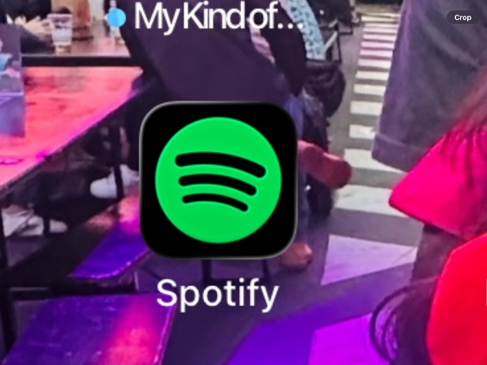
This is my Spotify i using for listen my favourite music

Screenshot/Photo 2
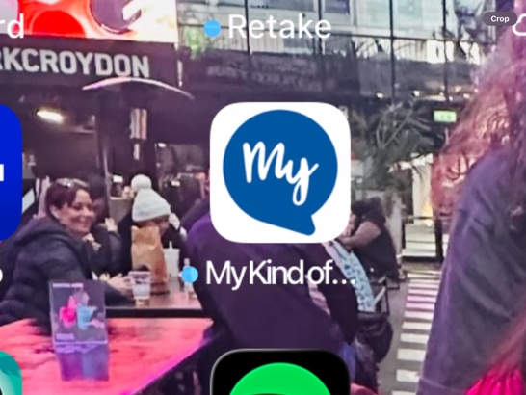
This is my kind app a like for find offers cruises end monthly pay

Screenshot/PhotoScreenshot/Photo 4
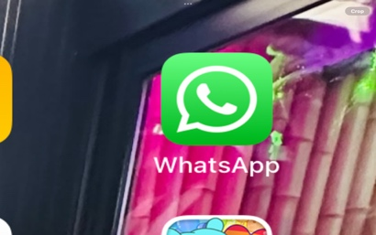
My WhatsApp app in using for tanking friends end family

Screenshot/Photo 5

Screenshot/Photo 6
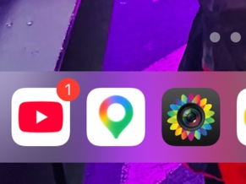
YouTube I’m using for listen music watch funny video when in free

My Short Reflection
- Write 5–8 simple sentences about your digital life.
- You can use the sentence starters below if helpful.
My reflection about digital life
I using digital tools for talking my family for find offers descants, in using for email for asses my noodles . Digital live is very important
I using every day for access my kids school app
I using googles maps when i need find any address
I using for access ring camera in my house
I using for my bank account
Now I learned more

Submission Checklist
Before you submit, please check:
​​​ ☒ I added 4–6 screenshots
☒ I wrote short sentences for each screenshot
☒ I wrote my short reflection
☒ My work is my own
☒ My file opens correctly
​​☒ My file opens correctly

