University of Wales
Trinity Saint David

Certificate of Higher Education in
Skills for the Workplace (Level 4)

ACADEMIC AND EMPLOYABILLITY SKILLS
(BMSW4001_LON)

Student: Georgi Todorov (1922057)
Lecturer: Peter Allen

August 2020

Table of content:

- Introduction | 2
- Main Body | 2
- Overview of security company | 2
Summarization of articles over employability skills for the security company | 2
Article 1 – Unraveling Concept of employability, bringing together research on employability in higher education and the workplace | 2
Article 2 - The role of Work-Integrated Learning (WIL) in enhancing employability skills: graduate perspectives | 4
Article 3 - Employability Skills: A Review | 5
Article 4 - Employability skills are the heart of the future | 6
Reflection on my personal skills – SWOT Analysis | 7
- Conclusion | 7
- References | 9
- Appendix | 10

- INTRODUCTION

Employability skills can be defined as the set of skills and behaviours, which are highly essential for every job. However, employability skills are also known as soft skills that allow individuals to communicate with other people effectively. These skills are problem-solving skills, organisation skills, communication skills and others which supports individuals to be proactive and productive at the job place. (Simplelearn, 2020) In this report will discuss employability skills and its significance. Then further will analyze the requirement of employability skills for opening security company effectively in this report.

- MAIN BODY

  - Overview on security company
To run a security company effectively in the business market requires to have great security officers who will always be alert and aware by training. An effective security officer always focuses on the situation that could impact on people safety and place and protects them precisely. So, it is important having such employees who can effectively run a security company in the business market in order to lead better functioning of the business.

Summarization of articles over employability skills for the security company

Article 1 – Unraveling Concept of employability, bringing together research on employability in higher education and the workplace
Employability skills are considered one of the major platforms for commerce and industry as well as for professional education. This article has provided a high understanding of employability and its importance in academic time as well. According to author employability has been one of the major discussed topics for all companies because these skills are not taught by teachers in the academic period, but students have to develop these skills own by own (Unraveling the concept of employability, bringing together research on employability in higher education and the workplace. (Römgens, et al., 2019). Mohamad et al., (2018) stated that most of the time students do not seem aware about employability skills in higher education so, it is the responsibility of teachers to influence awareness in students about employability skills that are also known as soft skills. However, employability skills involved in the personal image, good habits, attributes and interpersonal skills. Effective employability skills have the ability to enable the graduate to achieve a satisfying job. Then in this article has described over American Society for Training and Development (ASTD) which supports to develop basic employability skills which make graduates able to give an interview for the job as per their choice or successfully open own business in the business market. Skills are competency skill, communication skills, development skills, adaptability skills and influencing skills that are projected by ASTD. When individuals develop these all skills in them that makes them liable to establish a successful business in the business market. This article has emphasized on other skills as well such as analytical skills, computer skills, creativity, risk-taker, flexibility and others. These skills support individuals to become competent in the business market when there is cut-throat competition. In that state, these skills will support employers to take effective action to make it’s business sustainable prolong time.
As per the view of Remi Scoupe & Simon Beausaert, employability skills influence potential in individuals and make them highly competent. So, the authors stated that these skills must develop in graduate and postgraduate students by involving extra curriculum activities like challenging task, assignments, competition and others. Remi Scoupe & Simon Beausaert have quoted in their published article that academics must convince the institutions to incorporate employability skills into their teaching, which will impact on student learning positively. Authors said in the article that academics must organize debate competition in the institutions and encourages their students to participate in such activities. Such competitions will develop effective communication skills in students and makes them effective communicators. Remi Scoupe and Simon Beausaert mainly focus on communication skills because it considered one of the most important employability skills, among others. Debate and GD competitions are one of the best platforms for individuals such as debate competition brings two people together who argue over one topic to keep their logical issues. On the other hand, group discussion leads five to six people together who also keeps their views in front of other candidates by following all rules and regulation effectively. This type of activities remove hesitation in individuals and make them interactive to convince others with their logical statements. It is an essential role of higher education to enable its students by offering training in order to improve their existing skills, knowledge, attitudes as well as abilities. Such training empowers students to be critical and reflective learners for a lifelong period.
Remi Scoupe & Simon Beausaert also have mentioned in their published article that the development of employability skills is the joint based platform of the industry. Also, education institute, for example, teachers trains their student how to develop employability skills in higher education while industry helps to improve existing employability skills in those students who have become part of the company as employees. Basically, this article has emphasized on all employability skills that are required in individuals to become successful in their life in business purpose. However, this article has highlighted the communication skills that students should develop in higher education. The reason behind is that when employer or employee have effective communication skills, then they might be eligible to establish and runs their business in future precisely. To open and run a security company in future effective communication skills would be required. It is a simple concept when an employer has good communication skills they can understand customers needs and the actions of competing security companies. Such knowledge will support to establish and operates a business in the business market effectively.

Article 2 - The role of Work-Integrated Learning (WIL) in enhancing employability skills: graduate perspectives
This article is proposed by Nombeko Felicity Dwesini (2017) to provide a brief understanding of employability skills and involvement of integrated learning in work. Work-integrated learning is the equipment that empowers graduates to develop employability skills in order to work effectively at the workplace in future. Such a work-integrated learning program would also bring a high understanding of the students how to work at the workplace. This program is organised for skill development in graduates during the academic period. Abas & Imam, (2016) have mentioned in their published article that work-integrated learning program must be practised in the classroom and placement activities which would develop employability skills and determine factors that can improve skill performance in individuals. The work-integrated learning program focuses on problem-solving skills that are considered one of the major effective employability skills. According to Nombeko Felicity Dwesini, when graduates have such skill that always keeps them alert and proactive to deal with any situation, whether favourable or non-favourable. To open a new business or job perspective requires that individuals must have this skill so that they can make their own decision at personal level effectively. (Dwesini, 2017) There are various situation taking place when starting a new business, like employee’s requirements for the salary, customer’s demand, emerging changes, competitors’ pressure and others. These are quite common issues that always takes place, but it is important that employer should possess problem-solving skills, so then they can run longer in the business market and gain all framed objective within a timeframe. Overall problem-solving skills are highly required for the opening security company in future.
From the article for work-integrated learning can be analyzed that problem-solving skill is one of the major skills that keeps individuals alert and creative problem-solver.

Article 3 - Employability Skills: A Review
They were illustrated by Nisha, et al., (2016) that the job market has become one of the dynamic and challenging places for the young generation who are graduating from different education institutions. There are extensive job opportunities for graduates who have employability skills which are highly expected by the workplace. But the major issue is that there are only 30% of candidates who posses’ employability skills which they show during the interview session and recruited by companies. Currently, English and employable skills make individuals professional and require by all workplaces. So, academics must give high concentrations on graduate’s employability skills. This article has highlighted interpersonal skills that are needed to have in employer or graduates. (Nisha, et al., 2016) Interpersonal skill is also categorised in employability skills that must-have in the employer. This skill includes such characteristics, i.e. be friendly and polite, respect supervisor and co-workers, quick response on customer request, and resolve conflicts calmly which supports individuals to become more competent. Practical interpersonal skills support graduates to become a successful employee in their field. Security company requires such skills so the customer would prefer to buy security services of the company. To open a security company, a person must have interpersonal skills in individuals then they can become a capable employer.
It has analysed that interpersonal skills supported individuals to be competent and make them a good employer.

Article 4 - Employability skills are the heart of the future
This article is published by Katy Jordan, who has highlighted the role of employability skills for the career perspective in future. According to Katy Jordan, individuals should be aware of their skills so that they can determine their strengths and weakness. Most of the people or students are out updated for their strengths and weaknesses due to this, they unable to develop their weak areas or unawareness causes loss opportunities. Katy Jordan has emphasised on creativity and cross-cultural skills in her published article. These skills are highly essential for the individuals because it keeps them proactive and supports in future to incorporate diversity in the workplace. (Jordan, 2019) There are two types of people such as one who wants to do the job in a highly reputable multinational company while the second type of people who wants to open a business in future. These skills will support both types of people to gain their goals. With creativity and cross-cultural skills, the first type of people is enabled to communicate and work with the diverse workforce at a common platform effectively. At the same time, the second type of people is enabled to manage the wellbeing of a diverse workforce in the workplace with cross-cultural skills. Thus, these skills will support a start-up in the security business in future, and also would help to maintain diversity in the workplace.
From the above-discussed articles can be analyzed that employability skills are crucial for the career. There are four employability skills, i.e. communication skills, interpersonal skills, creativity and cross-culture skills, and problem-solving skills that are highly required to open security company and run business lifelong in future.

Reflection on my personal skills – SWOT Analysis
By my personal SWOT ANALYSIS, given as homework for this module, I can make a reflection on my strengths, weaknesses, opportunities and threats.
Working as a security officer has given me a chance to develop some employability skills such as trustworthiness, dedication, discipline, flexibility, hard-working and a good team-worker. Starting from the positive side, in my personal opinion, hard-working, disciplined and good team-worker are the first employability skills that can help me to develop a security business. Also, when it comes to employing people who would work for me, thrust worthiness, honesty and flexibility would give me help. If I connect my strengths together, I think that I can be a good leader to a company which looks for dedication for future development.
As for weaknesses, that I should work on improving and developing, I have pointed on public speaking and sometimes lack of confidence as first. It is quite important for a person who would own a business, to develop good skills for public speaking and have stable confidence in what they do. It helps into meetings with the team but as well for making good deals for the development of the business. As well I have mentioned taking a risk, impatient and details orientated. As one of my weak sides, I had the time management as well. But through the case study given by our lecturer Peter Allen, 'Weekly Calendar', I managed to realise how I can organise my days. I improved into combining working and studying together. This helped me overcome the threats that I had on the starting of this course.
The opportunities that I see for the future are gaining various skills from this course. This would mean that I will improve in the strengths and learn how to develop my weaknesses into positive sides with all the lecturers' help. Writing the assessments helped me to improve into writing and research skills.

- CONCLUSION
In this report, I have summarized four articles, reflecting on the importance of the development of employability skills. Also, I have done a reflection on my personal SWOT analysis. In my opinion, it was a good startup for me in realizing what do I have as strength, and in which part I should improve. In my understanding, it is beneficial for all the people to start having perspective for the employability skills since a young age, like that they can begin developing the skills that they find as a significant role in their future employment. In case of someone that wants to open a business, as soon as they start improving in their employability skills, they can start developing the business plan as well. With well-done research and knowing which capabilities are essential for the particular business, one would know what kind of employees they will need for future help.

REFERENCES

Abas, M. & Imam, O., 2016. Graduates’ Competence on Employability Skills and Job Performance. International Journal of Evaluation and Research in Education (IJERE), 5(2), pp. 119-125.
Dwesini, N. F., 2017. The role of Work-Integrated Learning ( WIL ) in enhancing employability skills : graduate perspectives. [Online]
Available at: http://www.ajhtl.com/uploads/7/1/6/3/7163688/article_40_vol_6__2__2017.pdf
[Accessed 21 August 2020].
Jordan, K., 2019. Employability skills are the heart of the future. [Online]
Available at: https://www.careers.govt.nz/articles/employability-skills-are-the-heart-of-the-future
[Accessed 20 August 2020].
Nisha, M., S. & Rajasekaran, V., 2016. Employability Skills: A Review. IUP Journal of Soft Skills, 12(1).
Römgens, I., Scoupe, R. & Beausaert, S., 2019. Unraveling the concept of employability, bringing together research on employability in higher education and the workplace, Studies in Higher Education. [Online]
Available at: https://www.tandfonline.com/doi/full/10.1080/03075079.2019.1623770?scroll=top&needAccess=true
[Accessed 13 August 2020].
Simplelearn, 2020. Why are Employability Skills Important. [Online]
Available at: https://www.simplilearn.com/why-are-employability-skills-important-article
[Accessed 10 August 2020].

- APPENDIX

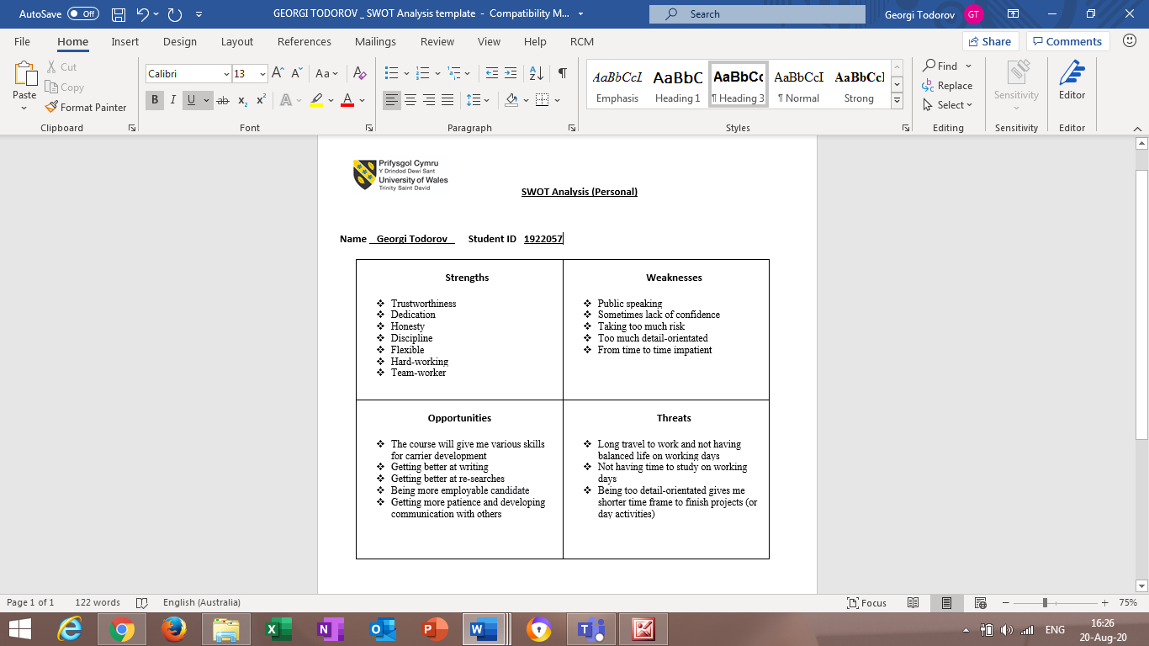
SWOT Analysis

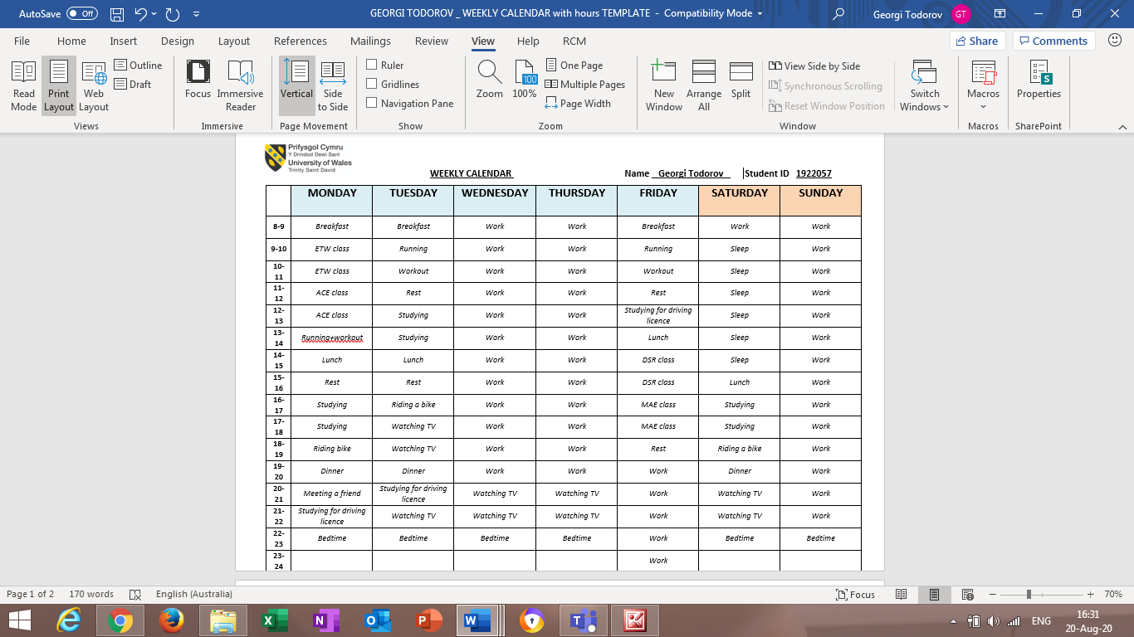
Weekly Calendar
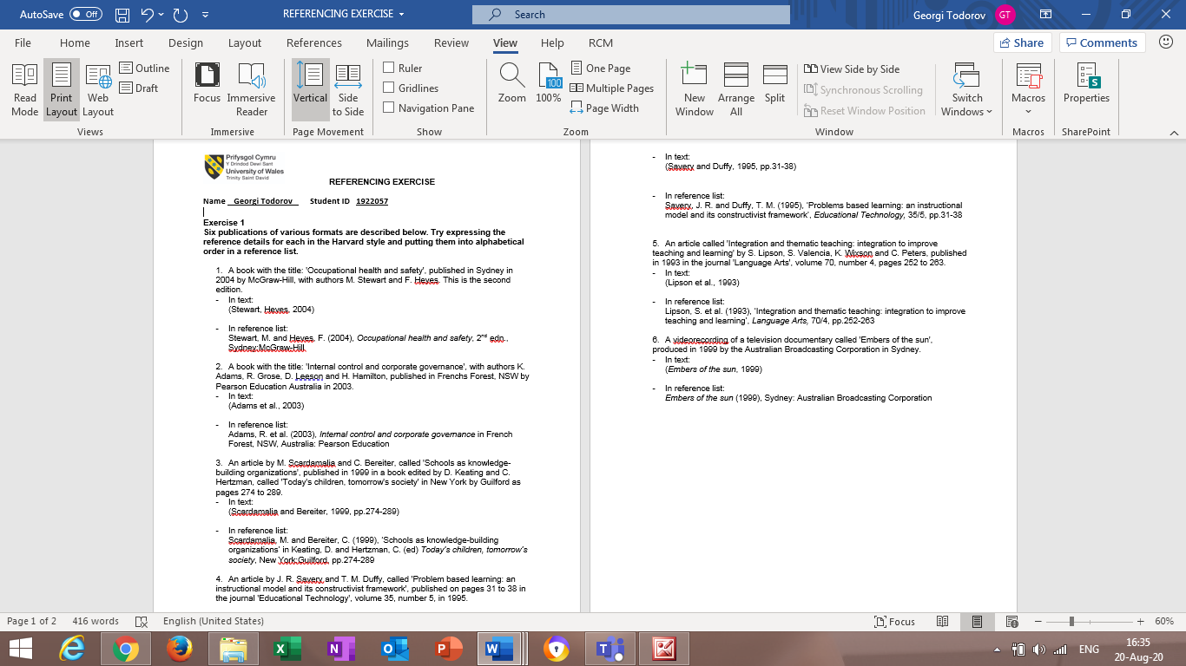
Referencing Exercise

