Education in Action: Portfolio and Reflective Account
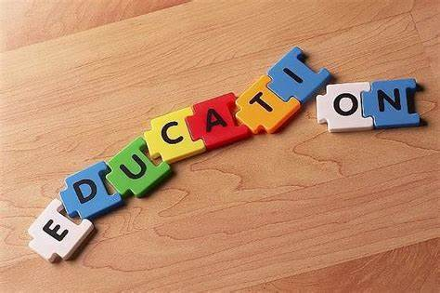
Georgia Louise Davies

Contents

Overview ………………………………………………………………………………………..…2
Placement Information Form ……………………………………………………...……..……3
Email Correspondence …………………………………………………………………………4
Initial Correspondence with the School ………………………………………………4
Confirming the Placement is Acceptable ……………………………………………6
Correspondence between the University and the Placement …………………..7
Continued Correspondence with the Placement ………………………………….9
Correspondence Following the Completion of the Placement ………………..15
DBS Certificate ………………………………………………………………………………….17
Completed Attendance Forms ……………………………………………………………..18
Evidence …………………………………………………………………………………………19
Topic Work and Reflection ……………………………………………………………..19
Learning Letters …………………………………………………………………………..20
Spellings ……………………………………………………………………………………21
Read Write Inc. …………………………………………………………………………..22
Welsh Work …………………………………………………………………………….….23
Reflective Account ……………………………………………………………………………24
References ………………………………………………………………………………………26

This portfolio is based on my experience of a ten-day placement at a primary school in Pembrokeshire. I was placed in a class of Year 1 students, learning predominately in English for 9 days of the placement. The remaining 1 day of the placement was spent in a class of Year 1 students learning predominately through the Welsh Language. My role for this placement was to support and guide the students with the work that was already set by their teachers.
OVERVIEW


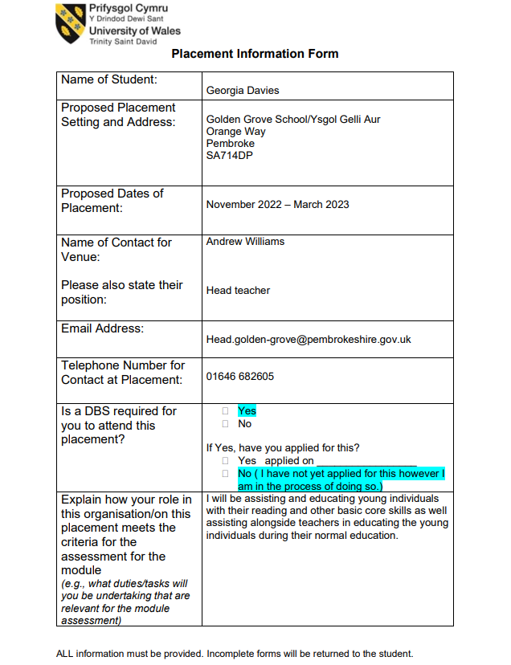
Placement Information Form
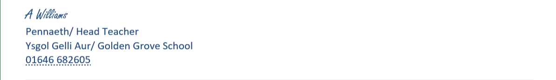
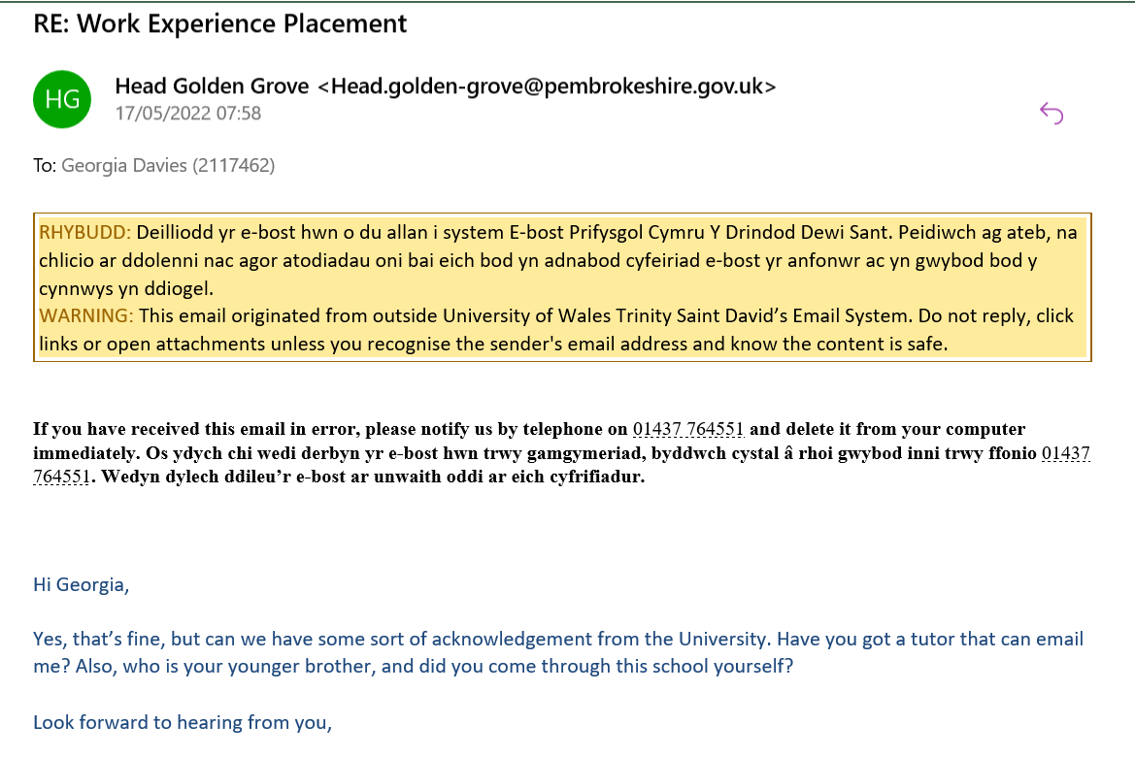
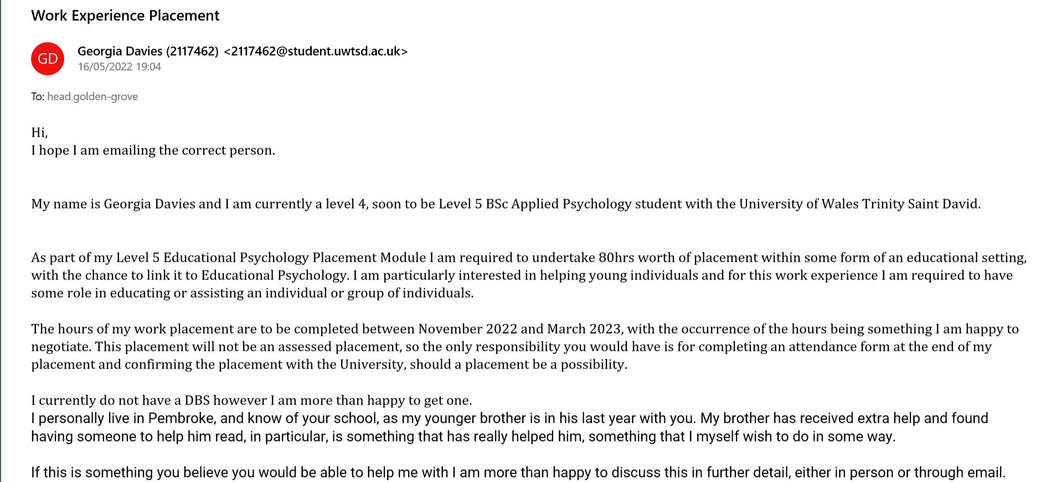
Initial Correspondence with the School
Email Correspondence
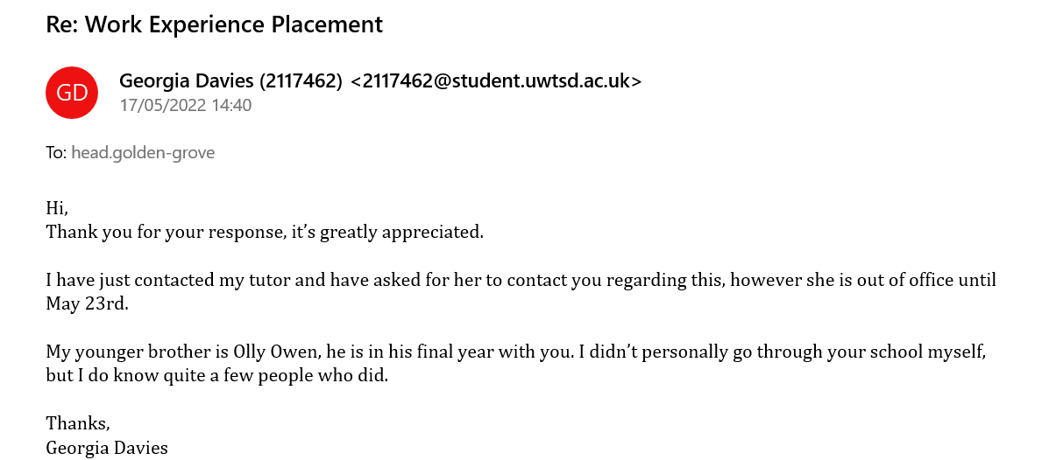
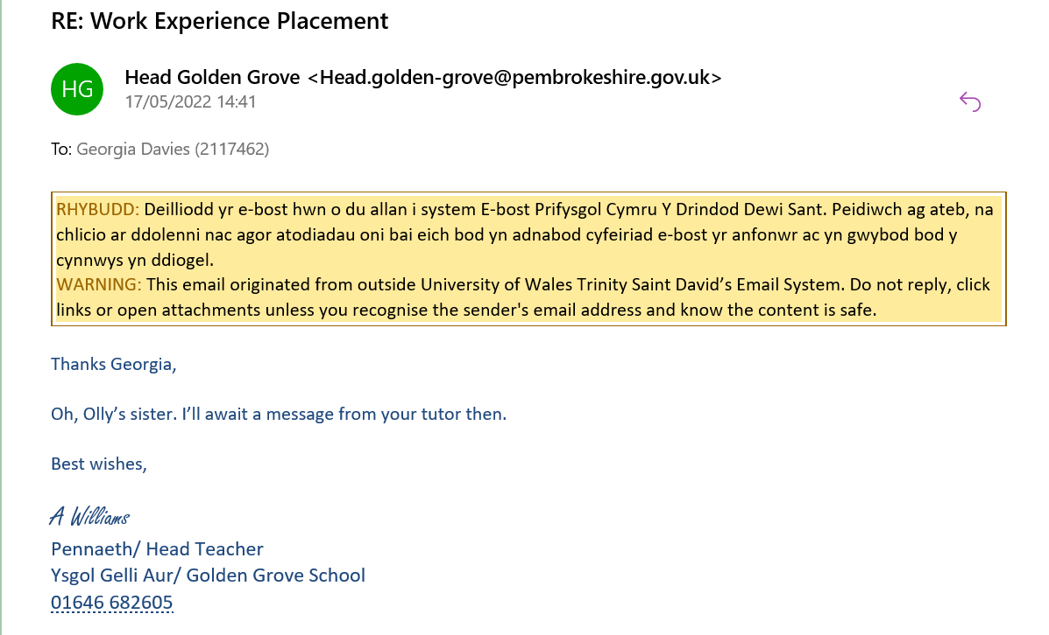
Confirming the Placement is Acceptable
Email Correspondence
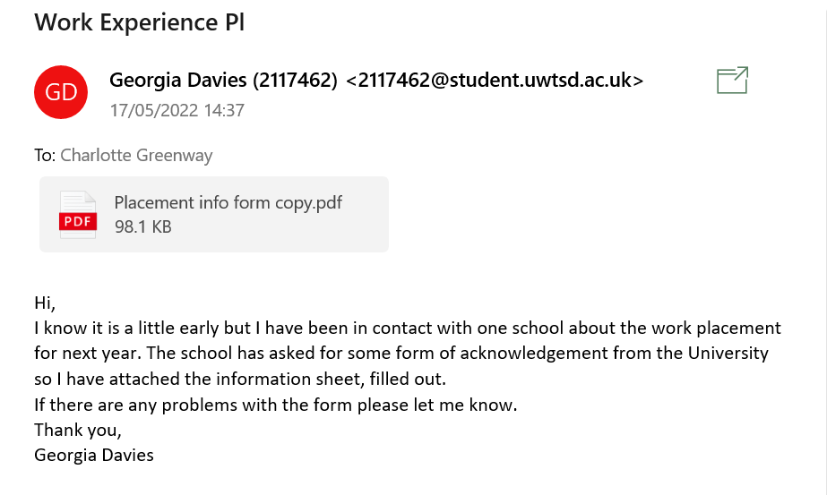
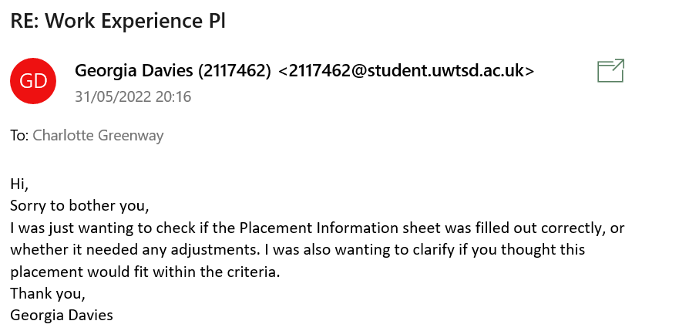
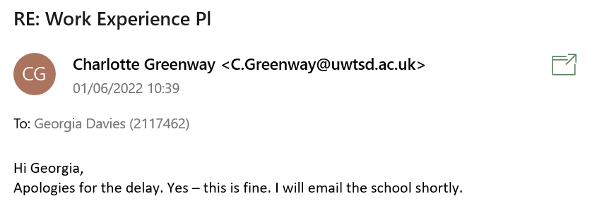
Correspondence between the University and the Placement
Email Correspondence
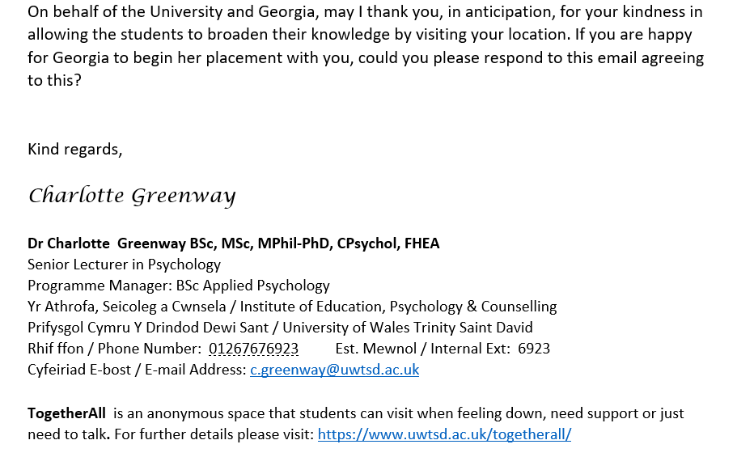
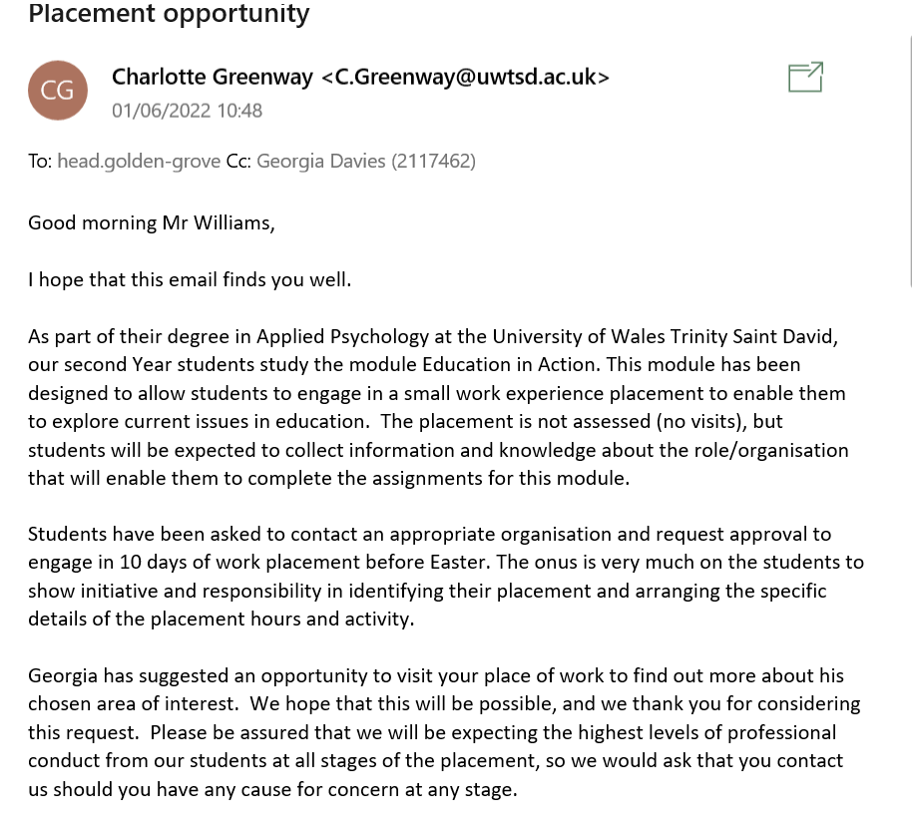

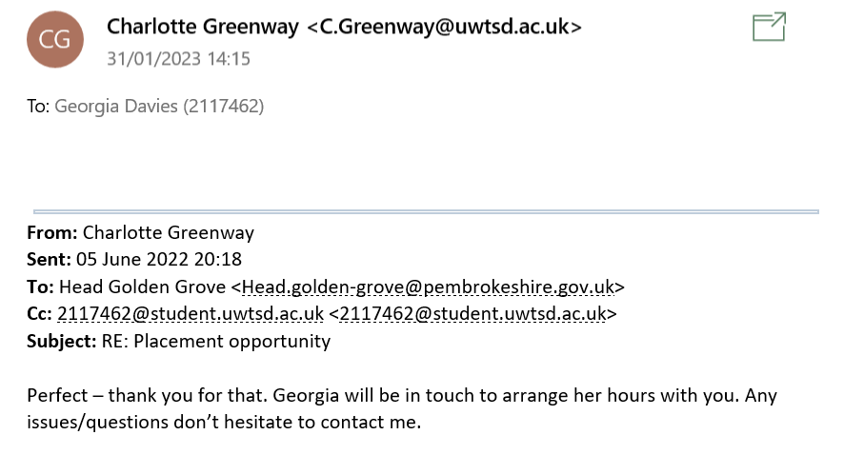
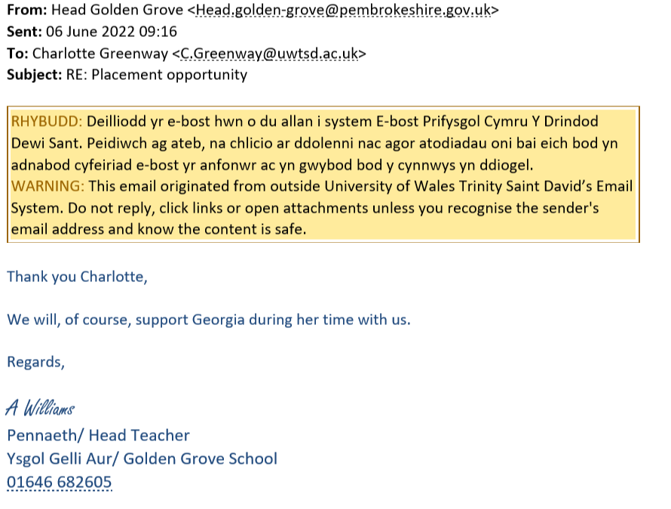

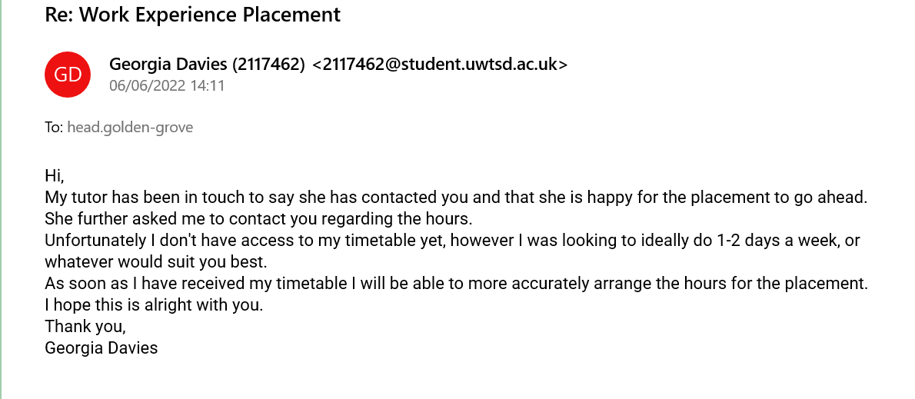
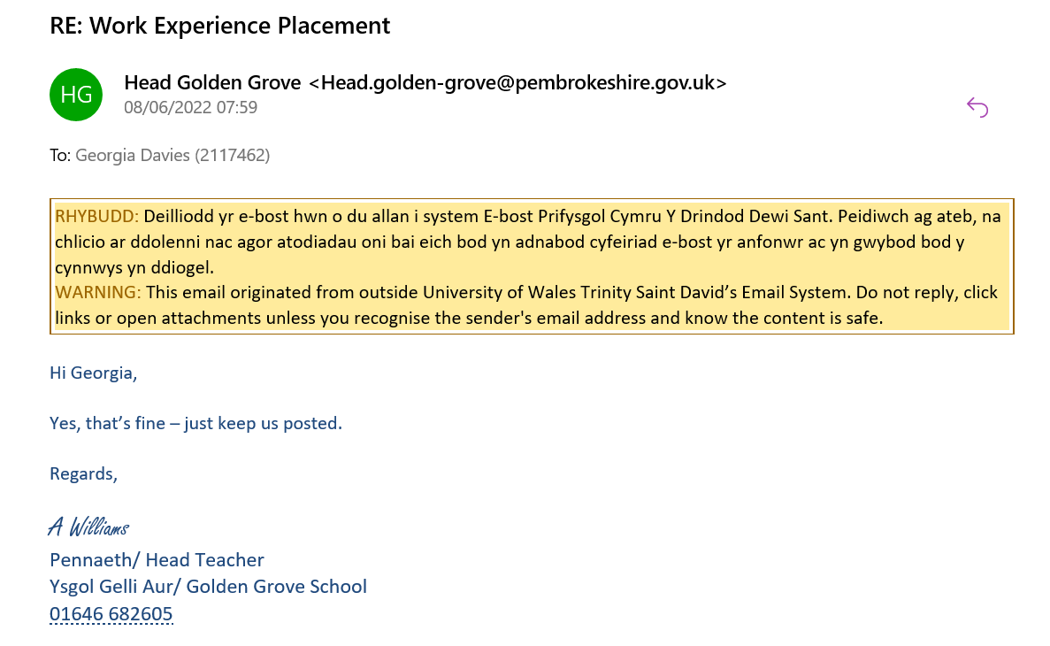
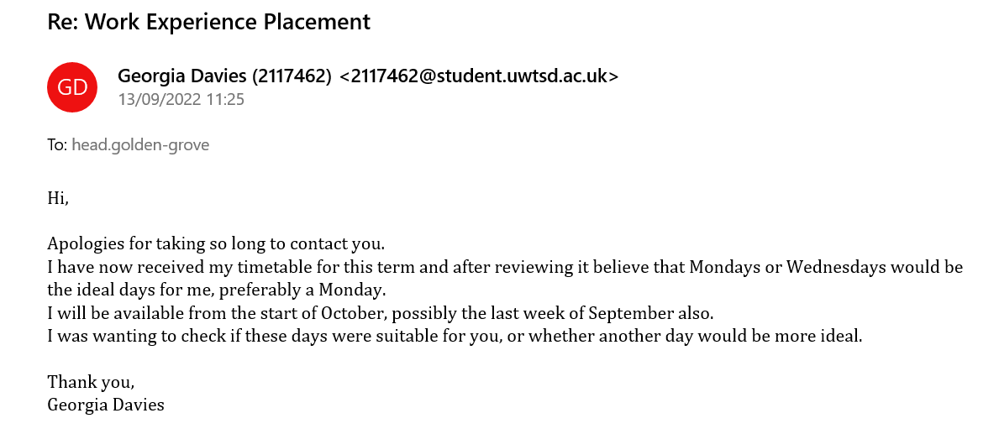
Continued Correspondence with the Placement
Email Correspondence

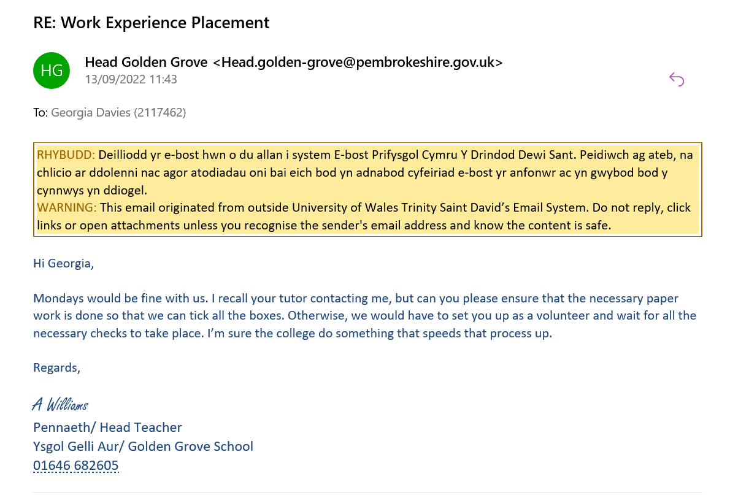

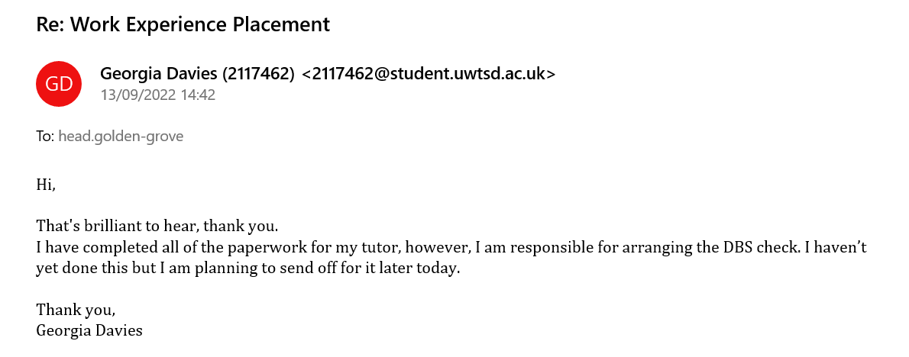

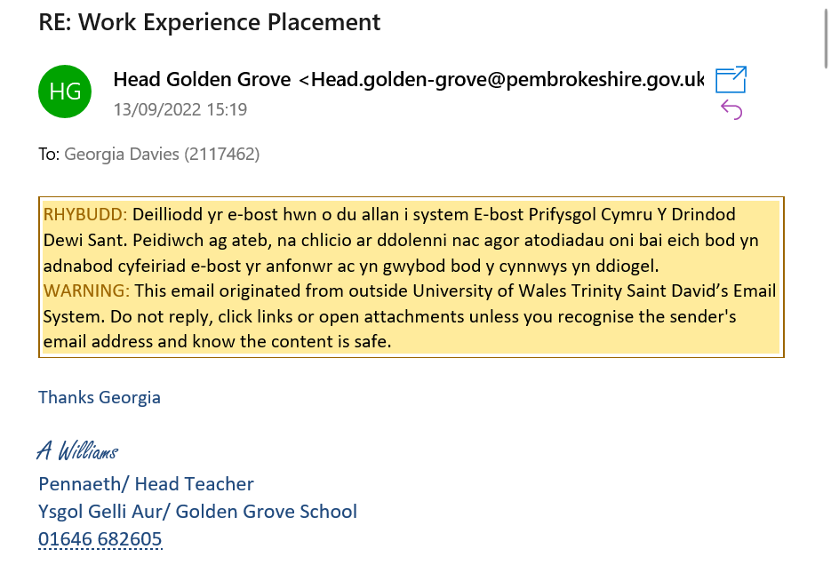

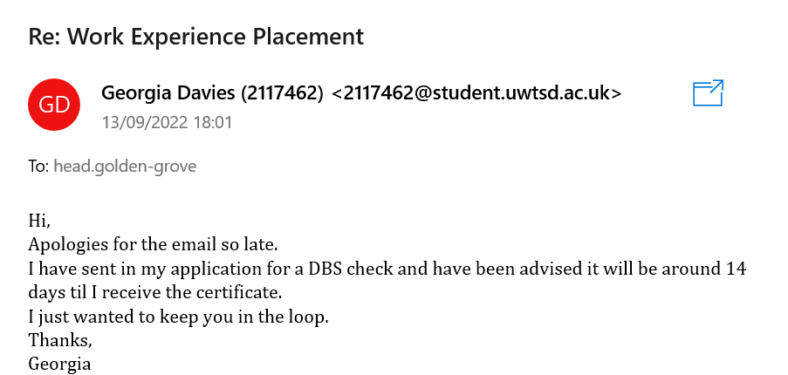

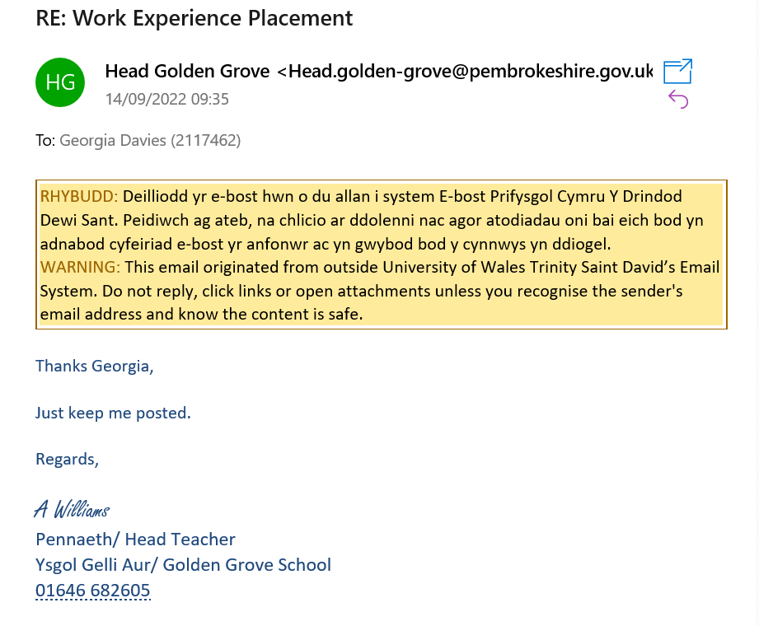

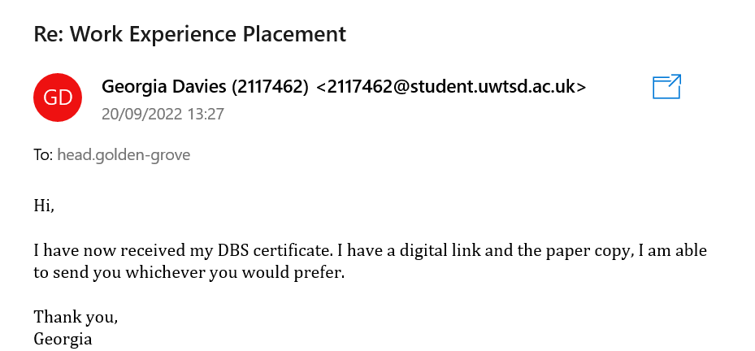

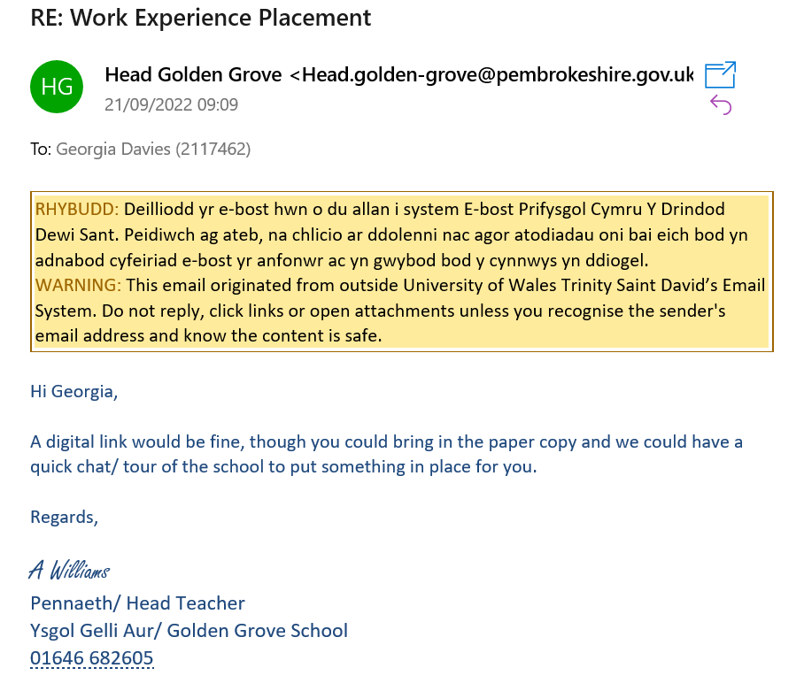

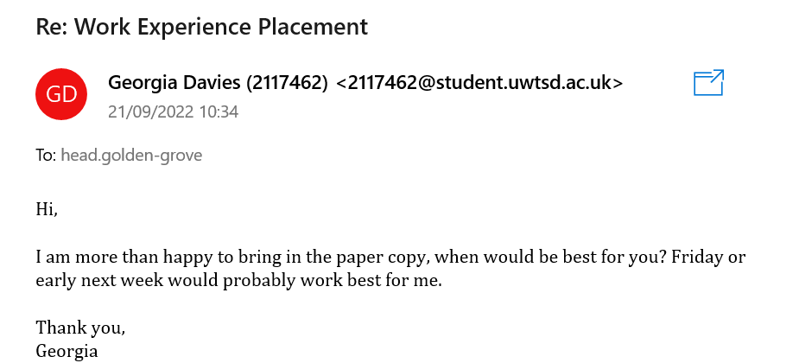

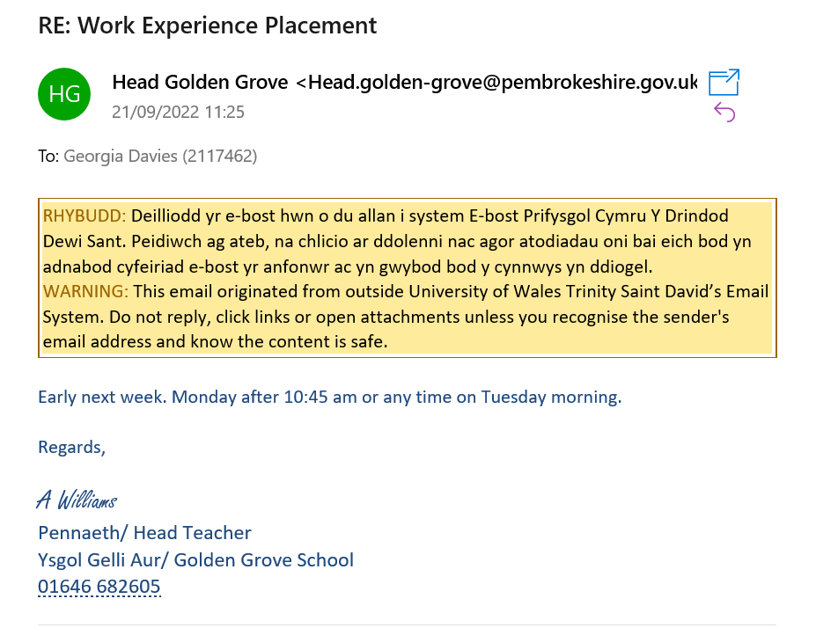

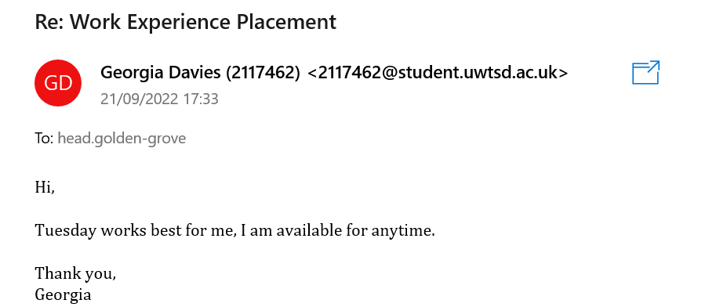

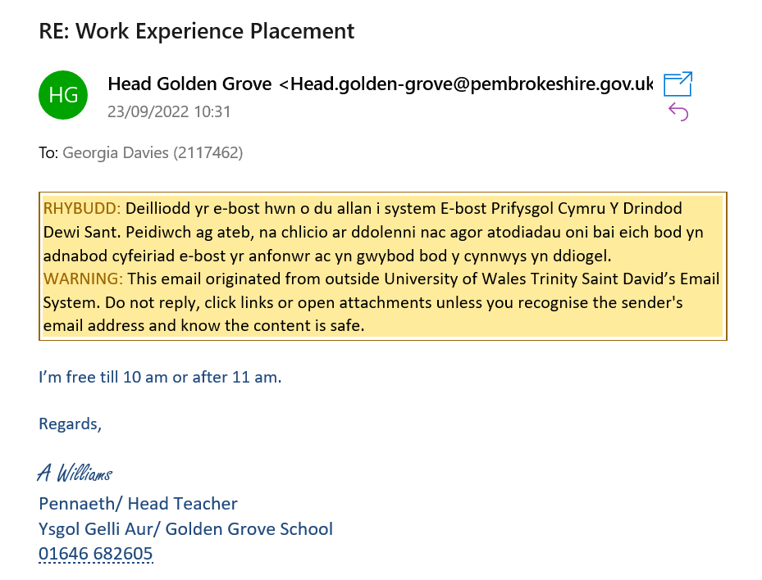

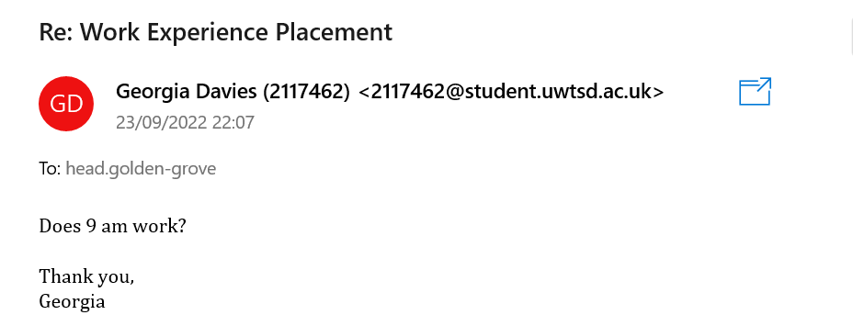

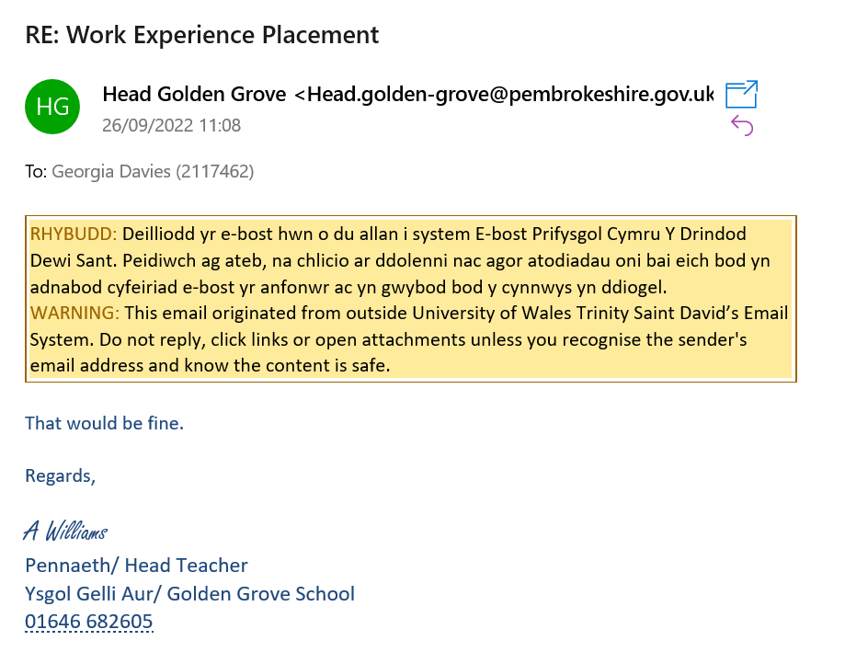

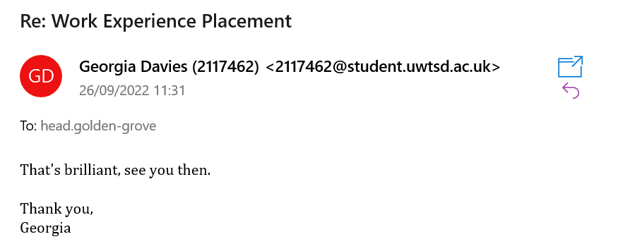

Correspondence Following the Completion of the Placement
Email Correspondence

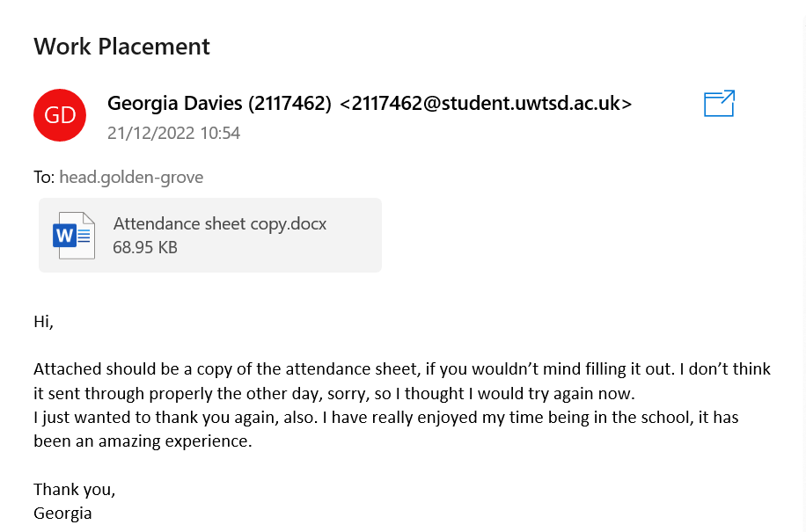

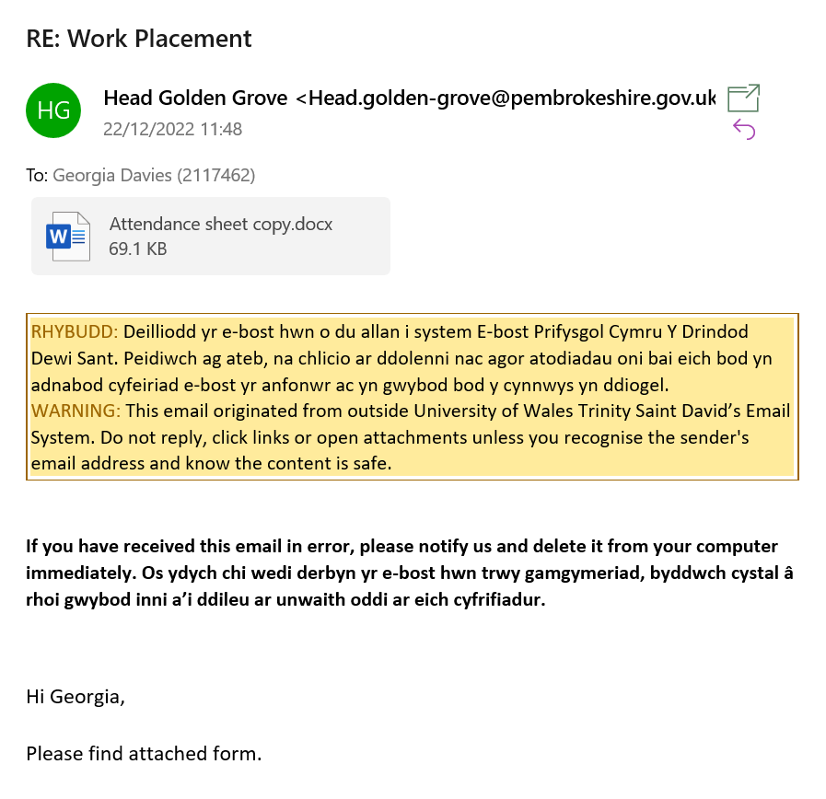

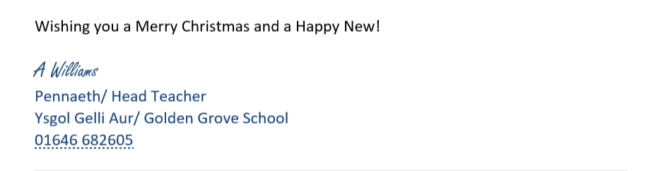

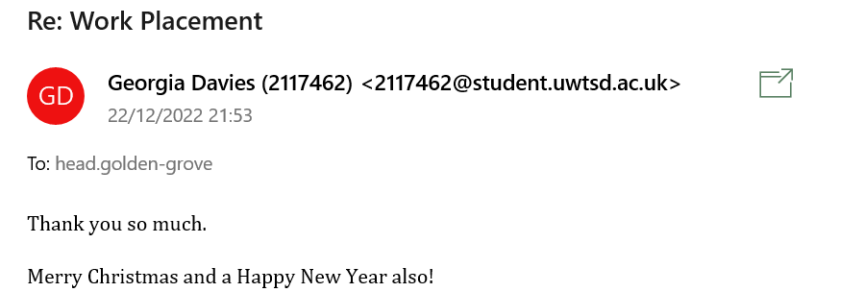

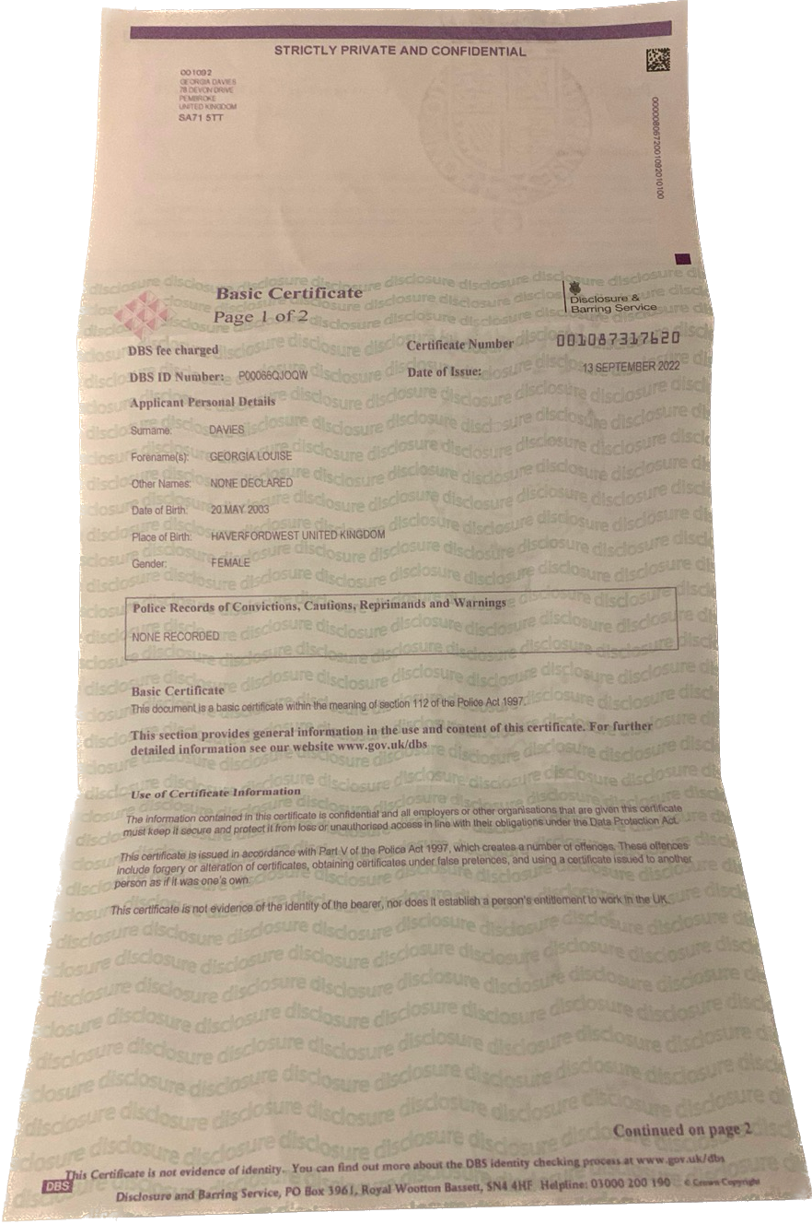
DBS Certificate

Completed Attendance Forms
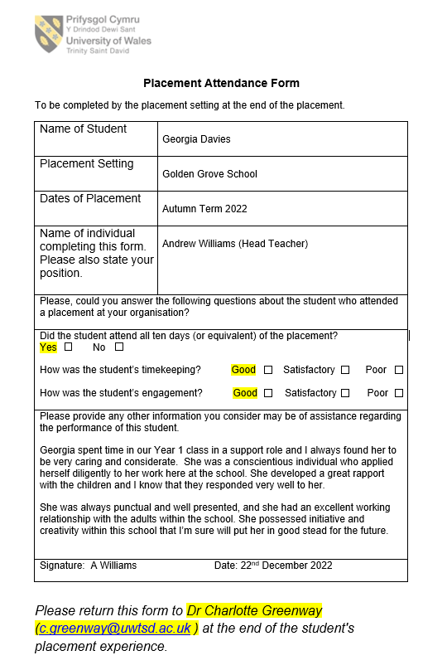


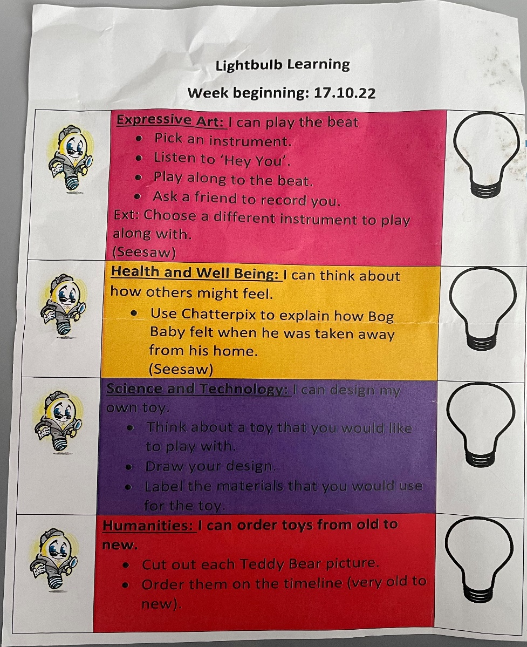
- Topic Work and Reflection
EVIDENCE

As part of the class’s topic work, they were learning about different toys. I supervised and guided two tasks as part of their learning, in which each child used the Lightbulb Learning sheets, as shown in the image, to reflect on their level of understanding, with the lightbulb being coloured pink next to any sessions they didn’t quite understand, and green for those they did.
In the first task, Science and Technology, I supervised them selecting between three toys: a wooden-spoon doll, marbles and a cup-and-ball. I encouraged discussion among them regarding the materials needed to make the toys, which the children then used to create instructions that they would later use to make the toy. My role for this lesson meant I helped the children with any issues they had with spelling, also, using the whiteboards to write the correct spelling that the children would be able to copy from.

For the Humanities task, the children were responsible for cutting out a selection of teddy bear pictures, that I had prepared, and placing them on a timeline from very old to very new, guiding them to use their fine motor skills and decision-making. I aimed to guide the children to complete both tasks as independently as they could, however, I did provide little prompts if they were struggling and did assist in providing correct spellings of words, by writing on a whiteboard that the children could copy from.

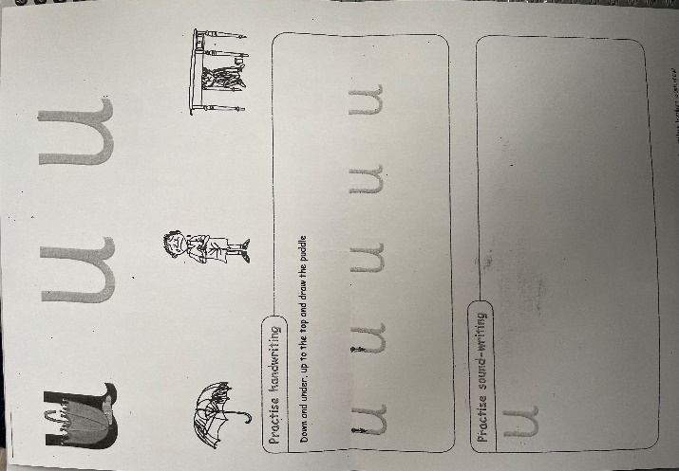
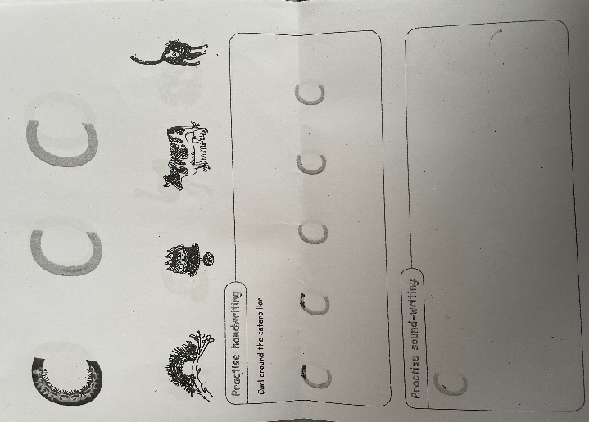
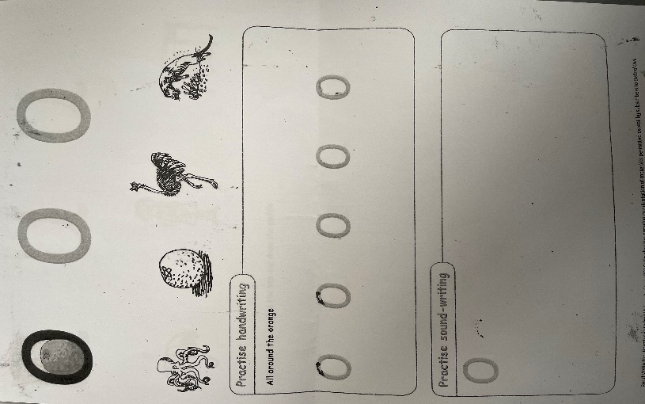
These worksheets, as shown in the images, were provided to target and improve individual letters that the child I was to independently work with had been struggling to remember and correctly write. The aim of this task saw the child initially identify the letter, where I provided some prompting if needed, before they identified a small range of items beginning with that letter, to create a higher level of familiarity and engagement. In the last section, I encouraged the child to trace the letters with a pencil before trying to write the letters on their own. For each letter, they struggled to remember or correctly write we revisited these sheets until they were able to successfully identify and write each letter. I held verbal conversations with the child about each letter and different words containing the letters, to allow them to find ways to relate the work to their own lives, therefore making it more engaging for them, from which I saw an increase in concentration.
2. Learning Letters
3. Spellings

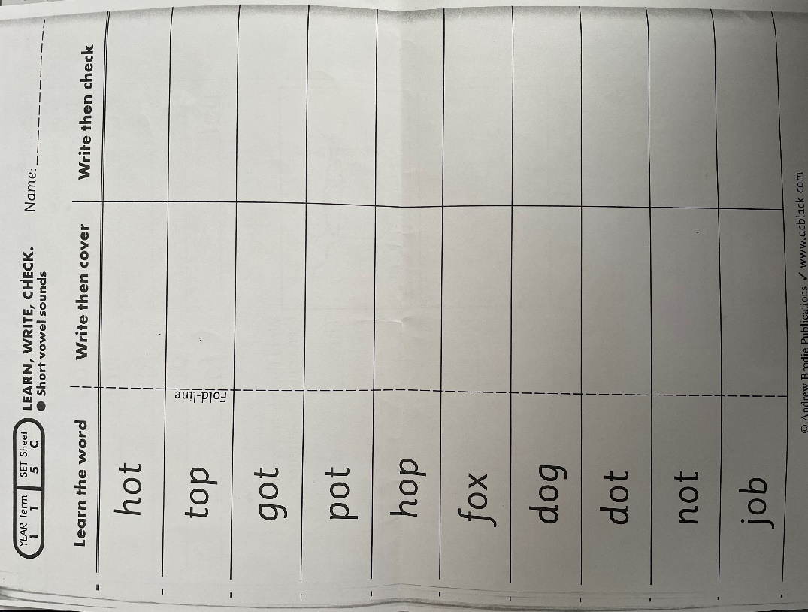
The image depicts the list of spellings that the class I was situated with took home and completed. My role with this piece of work was to orchestrate a check of the pupil’s knowledge, working in small groups and conducting small spelling tests, that they would complete before the final spelling test that they would have at the end of each week. If there were any words that the children struggled with, I would take the time to work through each word with each child within the groups until they were able to correctly spell the words. I ensured to do this at an individual level as all the children were at different levels with their ability and hence had different words to learn.

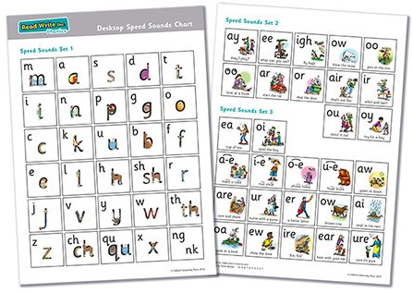
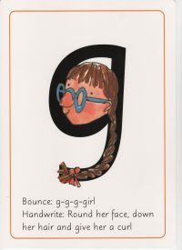
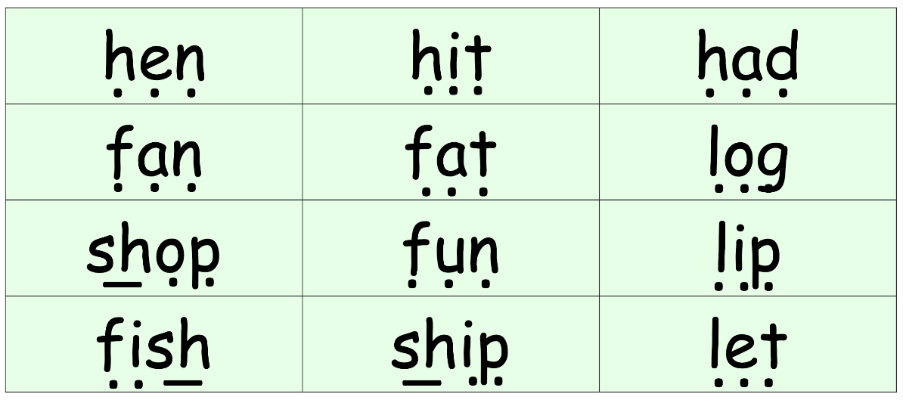

4. Read Write Inc.

Every morning that I was with the class the children completed Read Write Inc., a literacy programme that focuses on using phonics to help children read fluently and at speed. They would sound out a selection of short words before putting the sounds together and reading the word, a process they called ‘Fred Talk’ shown in the first image. They would also have a ‘quick fire’ session where I would hold up a set of letter cards asking them to identify the letter and the sound it makes as quickly as they could. My role was to further take note of any sounds or letters they had difficulty with, even after a small amount of prompting, reporting this back to their usual teacher so that they could respond accordingly.

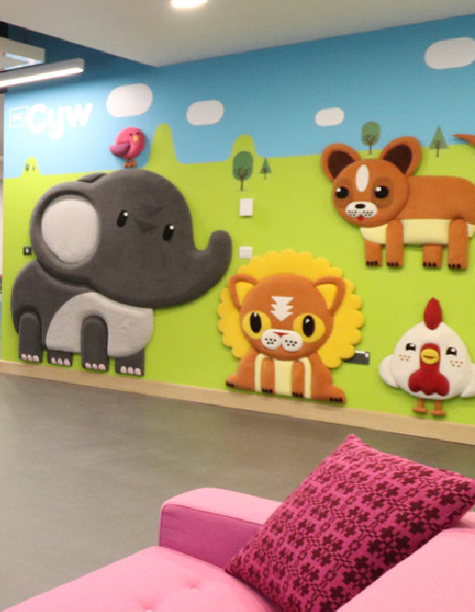
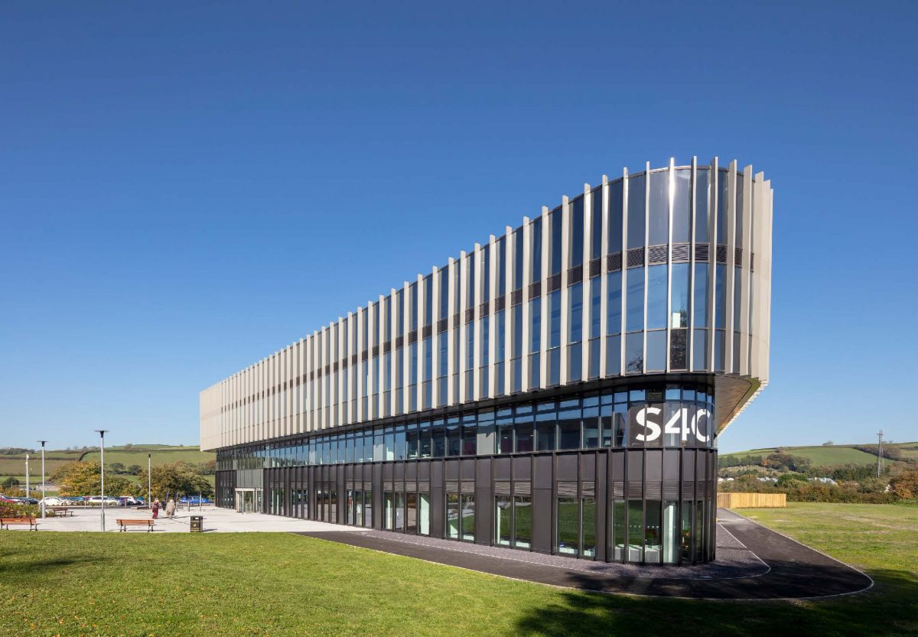
5. Welsh Work

To cover for a teacher that was unwell, for one of my final days in the placement, I assisted the class of year 1 students, learning through the medium of Welsh, on their end-of-term trip to the S4C building, where they experienced a tour of the studios, particularly that of cŷw, a children’s tv show in Welsh, that they all know well. My role was to supervise them on this visit and answer any questions that the children may have had, using Welsh as the means of communication, as the children were required to use their Welsh communication skills to communicate with all of the individuals within the S4C building.

Reflective Account

Using Gibbs’ Reflective Cycle (Gibbs., 1988), I can reflect on my time during the placement, recalling a variety of emotions and feelings that I felt about the placement as a whole and the individual aspects of it.
Firstly, at the beginning of the placement, I recall feeling overwhelmed, I had never worked inside a classroom setting before and felt as if, because of this, I may have struggled to gain the respect and attention of the children. This was something that I consistently worked on throughout the placement, and after a few sessions within the classroom, believe I had started to overcome. Going into the placement, I did believe I would have a lack of confidence, as that has been the case in many situations in which I have no previous experience, like the placement. Despite this, I wanted to push myself to succeed even without initial confidence, which I did by supervising activities that I had some experience in or could relate to, such as listening to the children read, something I found easy and enjoyable due to my own love of reading. In the future, I would also want to continue working on my confidence as this would benefit me in many different situations.
One of the difficulties I faced was struggling to maintain conversations on the topics of the lessons. As I was a new teacher in their class many of the children tried to test how far they could stray from the topic of the work. This was something I had never dealt with before and hence initially struggled with. I observed their usual teacher for the methods that they used in controlling the children’s behaviour and was surprised at how frequently the teacher dismissed the children’s attempts at changing the conversation’s topic. I understood how this was necessary though and tried implementing similar practices by suggesting that once their work had been completed there would be plenty of opportunities to discuss different things outside of their work topics. This was something I found very effective, with it becoming an effective method that I will use again in the future, this brought feelings of satisfaction as I had succeeded in ensuring the children completed their work.
For most of my placement I was asked to work with one child individually, something which was unexpected, catching me off-guard. I was not previously warned of any behavioural issues that the child may have had, something which I also did not ask. After working with the child, I was able to identify that they struggled with maintaining concentration, something which If I was previously aware of, I would have been able to better prepare for. Despite this, I found ways to make the lessons easier on the child, implementing little breaks whenever it was clear that the child was becoming easily distracted, breaking the lesson into little chunks. This proved to also be successful and felt like a great accomplishment due to how I quickly adapted and changed the lesson plan to adequately suit the child’s needs individually, something which I feel I would have more confidence in doing, should I need to in the future, making lessons more accessible for more children.
To make the lessons more accessible for the children I also had to address the ways I would describe and explain different things as some of the children did not understand. This was something I was not used to and therefore had to adjust my way of thinking and describing things, which I found challenging; however, I knew it was necessary to make these changes and after doing so I felt happy and that I had accomplished something. The process of doing this was also enlightening and made me readjust my way of thinking to be more understanding and inclusive of other people who may have different ways of thinking.
I was often pushed outside of my comfort zone, however, I found it incredibly rewarding. I recall feeling apprehensive when asked to supervise the students learning through the medium of Welsh on their school trip, as I had a limited understanding and knowledge of Welsh. Despite this, I wanted to push myself and did find it easier than anticipated and enjoyed being able to use what little knowledge of Welsh I had, presenting new opportunities where I can develop my language skills more.
Overall, I found the placement to be a positive experience, that I thoroughly enjoyed. By completing the placement, I have gained a new and different perspective on teachers and what it takes to be an educator. I believe I faced many challenges all at varying levels of difficulty, however, I overcame each one, finding different methods of doing this, and working on skills that will benefit me in many future situations, including employment opportunities.

References:
Gibbs, G. (1988). Learning by doing: a guide to teaching and learning methods. Further Education Unit.

