University of Wales
Trinity Saint David

Skills for the workplace (Level 4)

EFFECTIVE TEAM WORKING AND COMMUNICATION
(BMSW4002_LON)

Student: Georgi Todorov (1922057)
Lecturer: Dr. Alfred Mensah

August 2020

TABLE OF CONTENT

- Introduction | 2
- Models of communication | 2
- Shannon-Weaver Model of Communication 1969 | 3
- Berlo’s Model of Communication | 3
- Schramm’s Model of Communication | 4
- Communication skills | 5
- Verbal communication | 5
- Non-verbal communication | 6
- Listening | 6
- Conclusion | 7
- References | 8
- Appendix | 11

- INTRODUCTION
In this report, I will highlight my research and the way of understanding what communication is, its importance and how to communicate successfully. Also, I will reflect on the three models of communication - The Shannon-Weaver Mathematical Model 1969, Berlo's Model of Communication, Schramm's Model of Communication 1954, communication skills, and giving an example of misunderstanding in everyday life and how it would be improved.
Can we say that there is one definition that will explain what communication is? In my opinion, that isn't easy. Starting from cave drawings to the invention of the papyrus and then the paper and spoken language, people have been communicating since the stone age. Communication is evolving even in these modern days, we have Internet, we use Social media, and every development in modern technology is developed in communicating as well. According to the Merriam-Webster dictionary (2020), communication was defined as a method of exchanging information between persons with symbols, signs, or behaviour. This world cannot function without communication. It is a very important part of our lives, and it is not an easy one. If communicating was easy, people would not have conflicts, misunderstandings, or saying something that maybe they did not think at the moment. Communication is an ongoing process because we do it either willingly or spontaneously. (UKEsseys, 2018) Communication is not just talking. Communication can be achieved on a verbal or non-verbal way; it can be done by expressing emotions or even giving body or facial signs. Without effective communication, we would have a lot of problems. We must see/listen, understand, process, and give reflection by communicating with other parties.

- MAIN BODY

2.1. Models of Communication
Communication models define as an organised representation of the process that gives the idea of ways of communication. It helps in breaking communication from complicated to understand form and hence helps increasing communication skills. (Ruler, 2018) There is a number of methods and channels which can be used for communication within the workplace, for example by representation graph and pie chart to explain the growth of a company which is Non-verbal form. Communication models can be categorised in three types, namely linear model, transaction model and interactional model. The linear model of communication can be described as one-way communication (messenger to sender) for example, transfers of information from hierarchy to employees in the organisation. Transactional model refers to the transfer of information between two people, for example, meeting discussion in the organisation, in this both are communicators. Interactive model is similar to the transaction, but here media plays the role of mediator, for example, mail chats. In the below explains three models by Shannon and Weaver (1948), Schramm (1954), Berlo (1960).

  - The Shannon-Weaver Mathematical Model 1969
Shannon and weaver in the year 1948 explain Mathematical Theory of Communication by publishing it as an article later it becomes the mother of all communication models. It is more of technological rather than other forms of linear.
The Shannon-Weaver Model of Communication is composed of: Information source > Transmitter (Encoder) > Channel > Reciever (Decoder) > Destination. This model of communication is considered as a linear model. In my understanding, the Sender sends encoded information (signal, sign, message, etc.), which is transferred through the channel to the Reciever which should decode it, recognize and explain the meaning of the information received. The problem which is found in this model is that any noise from the channel can lead to misinterpretation of the information received. (Businesstopia, 2018)
In the case study “The Professor and the Village people”, we can see a good example of a disadvantage for the Berlos’ model of communication. The professor who is sender – sends a message to the villagers, but with vocabulary that is not familiar to them. The villagers are the receivers, they cannot understand (decode) the message sent there for they did not help him, so there was no feedback.

  - Berlos’ model of communication
Berlos’ Model of Communication was developed in 1960 based on the Shannon-Weaver Model of Communication. Berlo made a pattern that contains from S - Source, M – Message, C – Channel, and R – Reciever (SMCR). In his model, Berlo made even the sender and the receiver and counted the different points of the message.
The message starts from the source who is the sender. The sender passes the message to the receiver putting down his ideas into words. When both, the sender and receiver have similar communication skills and common background, the communication process would be complete. With all the “common ground” that the sender and receiver are sharing, the encoding and decoding of the message would be easier. This model has a lot of critics because there is now feedback in the communication process. Berlo put up a point that the meanings are in message users, and communicators should be researched from their environment, knowledge, culture, etc. (Peterson & Khalimzoda, 2016)

  - Schramm's model of communication 1954
Wilbur Schramm Model focuses on two ways of communication, and it was developed in the year 1954 from the theory of Osgood. The model focuses on the circular way communication between sender and receiver. The model can be used for Intrapersonal and Interpersonal communication. Information of sender and feedback by the receiver never closed in Schramm Model.
This model has the same five elements as Shannon-Weaver’s: Information source > Transmitter (Encoder) > Channel > Reciever (Decoder) > Destination, but Schramm added the 6th element – feedback later on while developing his model of communication. In his first model, Schramm initiated “common ground” between the sender and receiver. The source or the sender will pass the encoded information to the receiver who should decode it. It will be easy for understanding from both sides as they can clarify the information because it is familiar to them. In the second one, he initiated “field experience” between the source and the receiver which will decide if the information will reach the receiver in the source’s mode. In the final one, Schramm thought about the noise that can misinterpret the information. He added the 6th element - feedback, which made the circular communication process. With the feedback, both the sender and the receiver will know if they understood each other. (Ulah, 2015)

- COMMUNICATION SKILLS
Effective and good communication means that the information (symbol, sign, message, body language, etc.) sent should be passed clearly from the sender to the receiver and understood in its manner. To avoid misunderstanding, conflicts, wrong judgments, a person has to have good communication skills. Those communication skills can be separated into two groups: non-verbal and verbal communication skills. Verbal and non-verbal communication skills are highly connected in lots of aspects of our life. Of course, this is the simple way of dividing, and both groups have their subgroups for which I will be giving my understanding in the text below.

3.1. Verbal communication
Passing information to one person or group of people with the utilization of words is verbal communication. It contains oral and written types of communication. This part of the communication it reflects on the words chosen and the way that the audience is hearing and understanding them. In verbal communication, especially the written types, it is very important to use the right words to pass the message if there is no assistance from non-verbal communication. (SkillsYouNeed, 2020)
- Effective speaking
If the right words are chosen, interpreted in the right way, and supported by good non-verbal communication skills, then we covered the three aspects of effective speaking. These elements can help us to achieve sharing the message in the right way and acknowledgement from the audience. Utilization of the right words, even when speaking for the same subject in different circumstances it is the most important factor. (SkillsYouNeed, 2020) As an example from everyday life, it is different when a person wants to ask someone for help with something if they say: “DO (something) FOR ME” and “CAN YOU PLEASE DO (something) FOR ME?”.
- Written types – informal and formal
Daniel Potter (2019) made a complete guide for the difference between formal and informal writing. Informal language is used for talking or writing to one person or group of people which a person knows well and communicates on a regular basis. With those people, communication can be accomplished with a short form of words. Also, the usage of jargon and even can express emotions. However, a person can always choose to communicate formally with his close friends for some occasion. Formal language is significant, it looks for well set up words/sentences, and it does not allow usage of jargon. It is used for writing formal emails to employers or when applying for a job, reference letters, briefs, etc. In formal writing, there is no expression of emotions. When using informal writing, a person uses an active voice, and when using formal writing, passive voice.

  - Nonverbal communication skills – body language (gestures, facial expressions, posture, tone, and pitch of voice, signals, and signs)
Nonverbal communication is the reaction that one is giving with its body or part of the body while communicating with others. All of the nonverbal reactions that are given by body language, the way of speaking, contact with eyes, gives a lot of information for the person that one communicates with. These signs can be useful in life when it comes to trust, respect, or attracting others (e.g. manager at work), or on the other hand, can be negative and useless (e.g. failing a job interview). Nonverbal messages are sent even when one is not speaking. Body language is a natural process, and a person can easily be distrusted because his way of verbal and nonverbal communication is not supported by one another. When it comes to these types of situations, it is given more value to the nonverbal message. (Jeanne Segal, et al., 2019) In the set of nonverbal communication there are mimics with the face, is there contact with eyes, the way of standing in front of a person or audience, tone of the voice that is used, the movements with the body, etc.

  - Listening – active listening, empathetic listening
Listening plays an important role in human communication. Proper understanding of information or message can only be possible by effective listening. It helps to increase communication level and individual’s growth. Below discuss two types of listening, namely empathetic and active listening.
- Active listening
Active listening means putting our focus on the person speaking with, so we can understand, interpret and give a good response to the information given. Active listening is supported by verbal and non-verbal communication skills. With this, we show to the speakers that we are focused on the conversation. An active listener has the ability to memorize the conversation and does not have to take a lot of time for response. It can help us improve connection, building a trust, helps into problem-solving and decision making; it increases the knowledge and does not allow missing on essential pieces of information. (Indeed.com, 2020)
- Empathetic listening
One line above the active listening is empathic listening. If a person has good empathic listening skills, that person can improve its relationships in life, and it can understand with intellectuality and emotions as well. For an individual to be a good empathetic listener, it should have patience. Also, it should show acceptance and put good attention to the speakers' emotions. Attention should be put on the body language as well because there are signs to be read if the speaker is not feeling comfortable or if they try to keep something for themself. When listening to empathetically, we should gain speakers confidence so they can feel free to open up. (MindTools.com, 2016)

- Example of poor communication on the workplace
I work in a Dior shop in Central London. I was at work, and there was a special event in the store. I was supervising the busiest part of the store. I realized in one moment that in the department there are a lot of people. On immediate, I called the security leader on the radio and said to him that I need one more person there to keep the department as safe as it can be. He misunderstood my words, thinking that I’m not able to stay there at all and replaced me with my colleague.
In my opinion, if he came and saw how many people were in one place, he would know that just one person cannot supervise the whole department. But probably, the miscommunication resulted from the pressure of the event, and the security leader jumped into conclusion without checking first.

- CONCLUSION
Above report describe various communication models. It helps individual to understand the form of communication, for example, two-way communication process explained by Schramm Model. There is a number of communications skills used by an individual in personal and professional life elaborate in the report; for example, verbal communication such as face to face conversation. However, the tone of speech and attitude also effect on communication skills of the individual and sometimes leads to a different meaning of information created by the receiver. Listening plays an important role in the growth of the individual as without proper listening message cannot be understood.

REFERENCES
Businesstopia, 2018. Shannon and Weaver Model Of Communication. [Online]
Available at: https://www.businesstopia.net/communication/shannon-and-weaver-model-communication
[Accessed 03 August 2020].
Indeed.com, 2020. Active Listening Skills: Definition and Examples. [Online]
Available at: https://www.indeed.com/career-advice/career-development/active-listening-skills
[Accessed 20 August 2020].
Jeanne Segal, P., Melinda Smith, M., Robinson, L. & Boose, G., 2019. Nonverbal Communication. [Online]
Available at: https://www.helpguide.org/articles/relationships-communication/nonverbal-communication.htm
[Accessed 18 August 2020].
Merriam-Webster, 2020. “Communication.” Merriam-Webster.com Dictionary. [Online]
Available at: https://www.merriam-webster.com/dictionary/communication
[Accessed 01 August 2020].
MindTools.com, 2016. Empathic Listening, Going Beyond Active Listening. [Online]
Available at: https://www.mindtools.com/CommSkll/EmpathicListening.htm
[Accessed 23 August 2020].
Peterson, A. & Khalimzoda, I., 2016. Communication models and common basis for multicultural communication in Latvia. SOCIETY. INTEGRATION. EDUCATION, Proceedings of the International Scientific Conference, 4(10), pp. 426-427.
Potter, D., 2019. Formal vs. Informal writting. [Online]
Available at: https://www.grammarly.com/blog/formal-vs-informal-writing/
[Accessed 13 August 2020].
Ruler, B. v., 2018. Communication Theory: An Underrated Pillar on Which Strategic Communication Rests. International Journal of Strategic Communication, 12(4), pp. 367-381.
SkillsYouNeed, 2020. Effective speaking. [Online]
Available at: https://www.skillsyouneed.com/ips/effective-speaking.html
[Accessed 10 August 2020].
SkillsYouNeed, 2020. Verbal communication skills. [Online]
Available at: https://www.skillsyouneed.com/ips/verbal-communication.html
[Accessed 10 August 2020].
UKEsseys, 2018. Importance of Communication in Daily Life. [Online]
Available at: https://www.ukessays.com/essays/english-language/communication-is-integral-to-human-life-english-language-essay.php?vref=1
[Accessed 01 August 2020].
Ulah, R., 2015. OSGOOD- SCHRAMM MODEL OF COMMUNICATION. [Online]
Available at: https://rahmanjmc.wordpress.com/2015/02/09/osgood-schramm-model-of-communication/
[Accessed 03 August 2020].

- APPENDIX

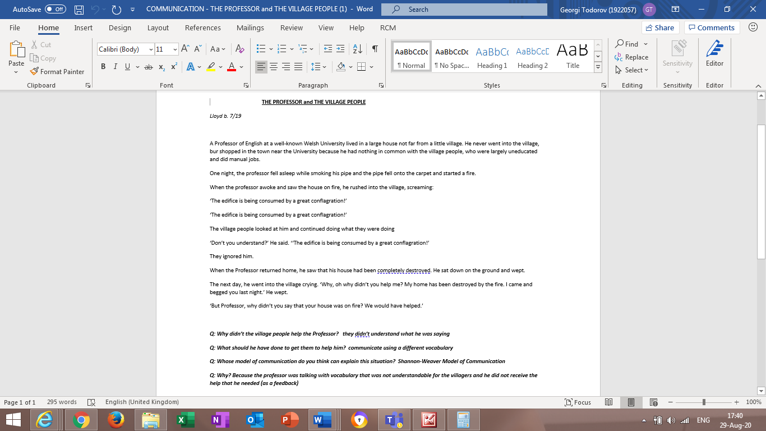
THE PROFFESOR and THE VILLAGE PEOPLE (a case study)

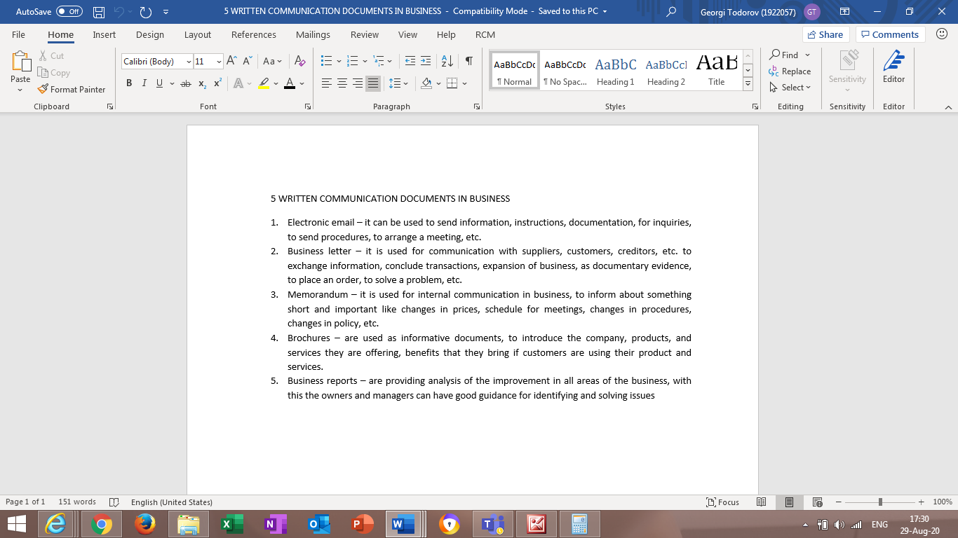
5 Written communication documents in business

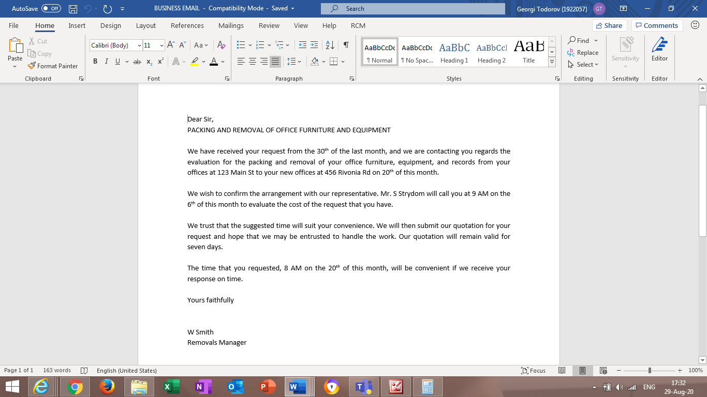
Corrected e-mail

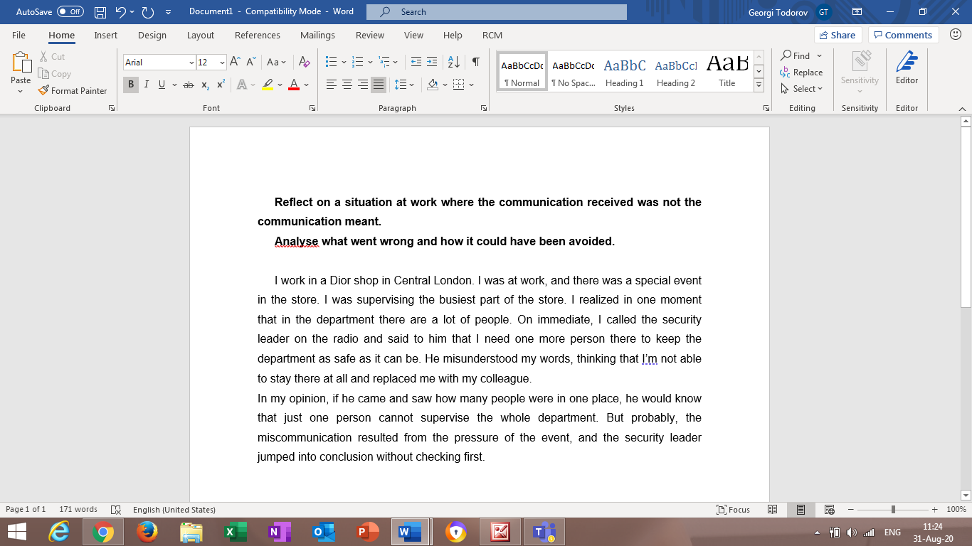
Example of poor communication on the workplace

