OBESITY AND ITS HEALTH CONSEQUENCES: EPIDEMIOLOGY, BIOPSYCHOSOCIAL IMPACT AND EVIDENCE-BASED MANAGEMENT WITHIN THE UK NHS
Student Name: Bhumikaben Rajubhai Patel
Student ID: 2520143
Programme:
MSc Public Health and Social Care in Practice
Module Code:
LCHS7003
Module Title:
Community Care and Management of Longer-term Conditions
Assessment Title:
Component 1 – Information Booklet of Long-Term Condition Management
Lecturer:
Dr Aishat Bakre
Submission Date:
27 February 2026

Table of Contents
Introduction 3
Definition of Obesity 3
Global and UK Burden and Prevalence 4
Aetiology 5
Types of Obesity 6
Risk Factors 6
Signs and Symptoms 7
Physical, Psychological and Social Impact 7
Physical impact: 7
Psychological impact: 8
Social impact: 9
Evidence-Based NHS Management 9
Clinical management: 9
House of Care Model (UK): 10
Chronic Care Model (International): 10
Summary 11
References 12

Introduction
Obesity is now seen as a long-term and recurring as well as multifactorial illness with intricate metabolic, behavioral and environmental causes and not just a personal choice of lifestyle (Ahmed and Mohammed, 2025; Luli et al., 2023).
It is a high public health problem that is increasing in high-income and middle-income nations, causing international concern about the long-term effects of the disease on health systems in the population (WHO, 2025; Myerson, 2026).
Most importantly, excess mortality and intensified risk of cardiometabolic disease, such as cardiovascular disease and metabolic complications, is strongly linked with elevated body weight, which reinforces its position as a systemic health hazard (Ward et al., 2022).
In England, national survey statistics show that the prevalence rates of adults in terms of overweight and obesity remain remarkably high, making the NHS services and long-term condition management pathways persistently demand (NHS Digital, 2026).
The impact of the economic consequences is significant, including the direct healthcare expenses and productivity loss that imposes an economic burden on employers and national economies (Okunogbe et al., 2021; Dall et al., 2024).
This booklet is a critical analysis of the epidemiology, Etiology, biopsychosocial implications and the NHS management of obesity with a long-term care approach.

Definition of Obesity
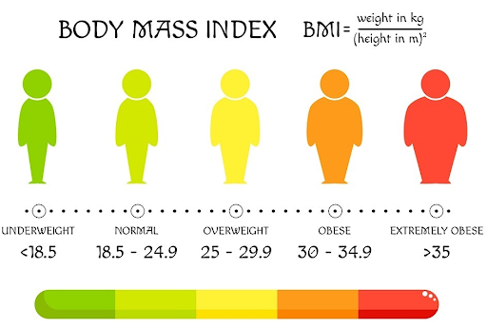
Figure 1: Body Mass Index
- Obesity refers to disordered or excessive fat that poses a threat to health with the body mass index (BMI) of 2529.9 kg/m 2 considered as overweight and a BMI of 30kg/m2 as obese in adulthood (WHO, 2025; NICE, 2025). BMI offers a screening that is feasible and extensively applied in clinical and population health and supports monitoring the population as well as qualification to take part in organized management apparatus.
- But greater focus has been given to central or abdominal obesity, which is usually measured as waist circumference or waist-to-hip ratio and this is more closely related to cardiometabolic complications than that of BMI. Both national epidemiological data show progressive age groups of central adiposity in England, indicating the high cardiovascular risk among the population (Gray and Opazo Breton, 2025).
- Current discussion acknowledges obesity as a chronic, relapsing illness that is defined by complex biological, behavioural and environmental factors instead of being a mere outcome of personal choice or failure of lifestyle (Luli et al., 2023). This reframing leads to the focus on long-term, structured approaches to management.
- Pathophysiologically, the mechanisms that lead to obesity include chronic inflammation of low grade that is systemic, insulin resistance, adipokine disequilibrium and impaired expense homeostasis processes, which shape its correlation with cardiovascular disease, type 2 diabetes and other metabolic conditions (Ahmed and Mohammed, 2025; Sun et al., 2022).
- Basic theoretical models emphasize the interplay between genetic factors, neuroendocrine regulation of energy intake and expenditure, and exposure to obesogenic environments in the perpetuation of the gain in weight (Bray & Bouchard, 2019).
- More importantly, BMI is not sufficient due to its inability to distinguish between fat and lean mass as well as detailing metabolic heterogeneity where individuals with comparable BMI can have vastly different health risks.

Global and UK Burden and Prevalence
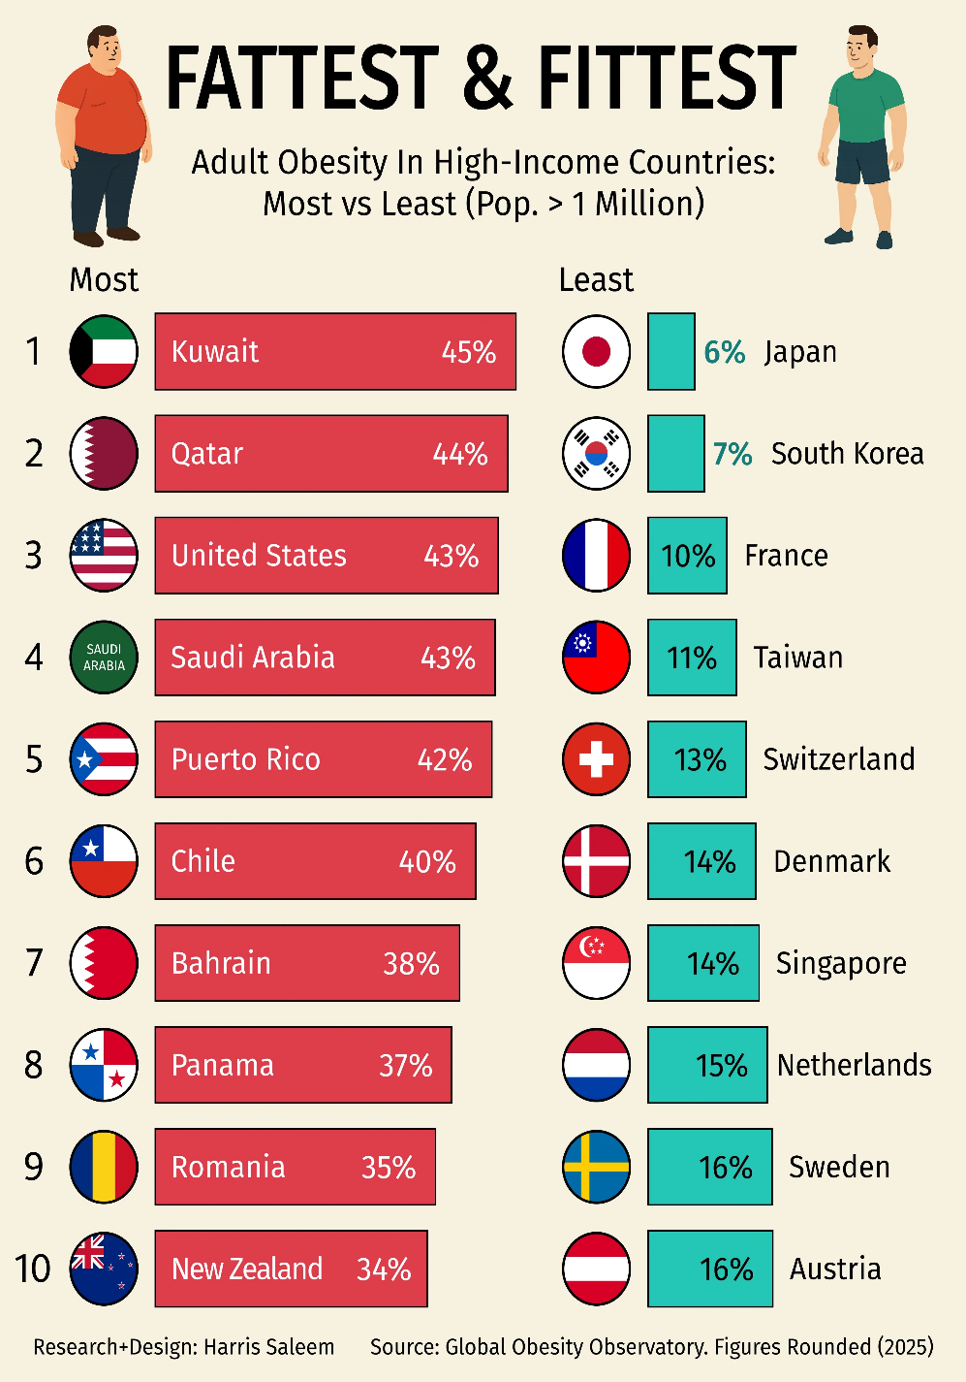
Figure 2: Global prevalence of obesity
- Obesity is a significant and growing health challenge on Earth, and the World Health Organization reveals that the prevalence of both overweight and obese individuals in all regions of the world has steadily increased both in adults and children (WHO, 2025).
- It is estimated that the morbidity associated with obesity is going to rise further, becoming part of the healthcare demand and extent of non-communicable diseases in the future (Sun et al., 2022).
- Models of studies show that there is a strong correlation between overweight status and excess mortality within subgroups of the population, highlighting obesity as one of the causes of death at the start of interventions (Ward et al., 2022).
- Regarding the viewpoint of the public health, today obesity can be discussed as a systemic crisis that must be tackled by both policy and healthcare means, especially in high-income countries (Myerson, 2026).
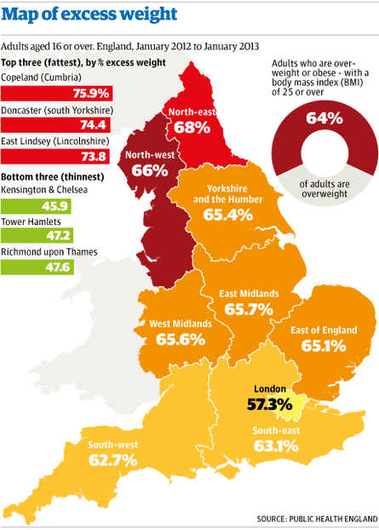
Figure 3: Prevalence of obesity in UK
- The national survey data of the prevalence of adult overweight and obesity in England indicate that the diseases are at the high levels with no clear signs of improvement, which proves that it is one of the primary long-term health issues (NHS Digital, 2026).
- The longitudinal studies additionally indicate the rising trends in central obesity among age groups in England, which supports the emerging cardiometabolic risk profile among the population (Gray and Opazo Breton, 2025).
- An analysis of mortality reveals that there are increasing disparities in atherosclerotic cardiovascular disease outcomes owing to obesity which are unevenly allocated among various groups of people (Parvez et al., 2025).
- These have serious economic impacts, and multinational modelling has estimated high direct healthcare costs and productivity loss because of overweight and obesity (Okunogbe et al., 2021).
- The employer-centered studies also define absenteeism and low productivity of workforce as other significant effects of obesity and increase the economic burden (Dall et al., 2024).
- Notably, life-course data suggests that untreated childhood obesity relates to future lifelong poor health results and supports the explanation that risk is intergenerational (Putri et al., 2025).
- Importantly, this increase in prevalence, socioeconomic clustering and growing health inequalities has posed a threat to the long-term financial sustainability of the NHS and as a consequence primary prevention and structurally sensitive public health actions are required.

Aetiology
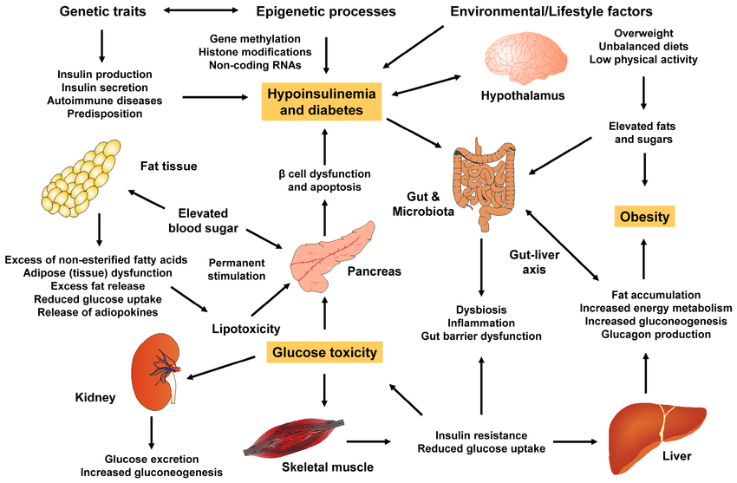

Figure 4: Aetiology of Obesity

- Obesity is a multifactorial aetiology, which develops due to the combined effect of multiple factors causing genetic predisposition, metabolic regulation and environmental exposure to the factors as opposed to a single causal pathway (Bray & Bouchard, 2019).
- There are genetic and neuroendocrine controls on the regulation of appetite, energy expenditure, and distribution of adipose tissue, which predisposes some individuals to the obesity caused by exposure to obesogenic environments (Bray and Bouchard, 2019).
- Modern research emphasizes the importance of environmental and structural causes, such as urbanisation, sedentary living situations, availability of ultra-processed food and marketing strategies, which all contribute to the maintenance of positive energy balance (Kushwah, 2026).
- Operations aimed at prevention are often limited due to such systemic factors like inaccessibility to healthy food, socioeconomic disadvantage and difficulties of policy implementations, as evidenced by international prevention studies (Proaño et al., 2024).
- Emotional distress and psychological stress is another factor contributing to dysregulated eating patterns and metabolic imbalance, and this confirms two-way relationships between mental health and the risk of obesity (Steptoe and Frank, 2023).
- Such wider social determinants as income inequality, education, employment status and neighbourhood settings play a major role in determining the distribution of obesity among populations (WHO, 2025).
- More importantly, an overlapping of biological, environmental, and social factors indicates that obesity is structurally and socially intermediate and more difficult to present the disease as practiced by single behaviour or personal choice.

Types of Obesity
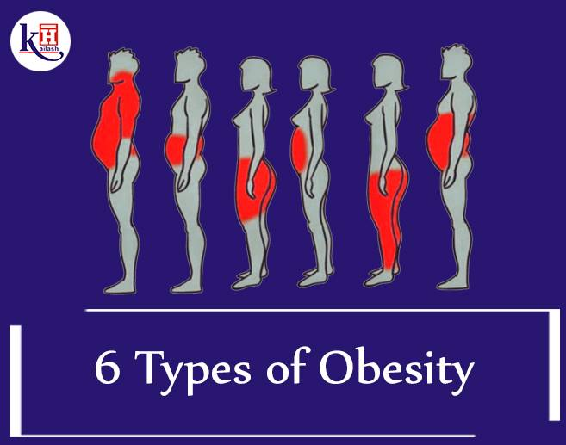
Figure 5: Types of Obesity
- Obesity typically has severity levels according to body mass index (BMI) with a Class I of 3034.9 kg/m 2, Class II 3539.9 kg/m 2 and Class III (severe obesity) 40kg/m 2 with increasing the health risk levels in the severity levels (WHO, 2025).
- Besides classification based on BMI, there is a differentiation made among general obesity and central (abdominal) obesity, which the latter is measured with the help of waist circumference and shows a higher likelihood of cardiometabolic problems; the tendencies in England show that central adiposity is getting more prevalent with age (Gray & Opazo Breton, 2025).
- Metabolically healthy obese as concept has become controversial as individuals may not necessarily appear with metabolic issues, yet, with time, the risk level is still high, which argues against the classification (Luli et al., 2023).
- The greatest rates of cardiovascular disease, metabolic dysfunction and healthcare utilisation are linked to severe obesity (Class III), which subsequently prompts to cause disproportional clinical and economic strain on health systems (WHO, 2025).

Risk Factors
- The aetiology of obesity is multifactorial as it depends on non-modifiable and modifiable risk factors and is integrated with the biological and environmental determinants.
- Genetic predisposition is considered as the non-modifiable factors through which hereditary variations influence the regulation of appetite, energy balance and fat distribution in adipose tissues, exposing individuals to the vulnerability of gaining weight in conducive obesogenic conditions (Bray and Bouchard, 2019).
- The role of age and life-course exposure also cannot be overlooked since early-onset obesity may be linked with long-term metabolic vulnerability and a poor outcome in long-term health well-being during adulthood (Putri et al., 2025).
- Changeable factors involve eating habits that are characterised by high intakes of energy containing, ultra-processed foods and minimal incorporation of exercises that add to continual positive energy equilibrium (Ahmed and Mohammed, 2025).
- The barriers to prevention strategies through structural food systems also hinder capabilities of individuals to sustain healthy behaviours (Proaño et al., 2024).
- Emotional eating and metabolic deregulation are some of the things that may be facilitated through psychological distress and chronic stress, which support weight gain trajectories (Steptoe and Frank, 2023).
- Importantly, socioeconomic deprivation increases the exposure to these risk factors, and the unequal distribution of obesity among the populations.

Signs and Symptoms
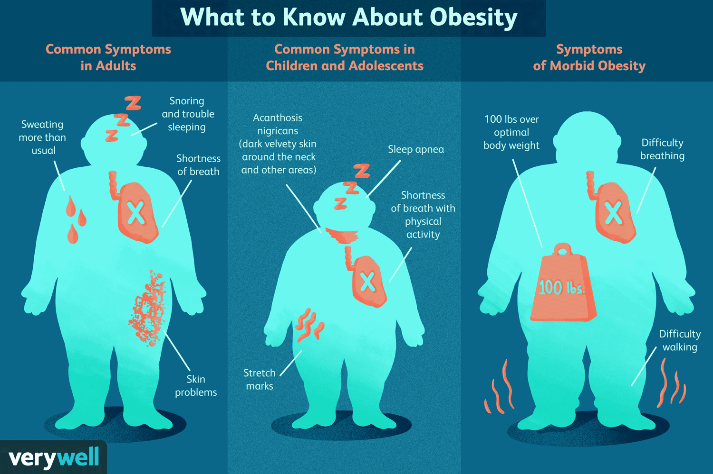

Figure 6: Signs and Symptoms of Obesity
- The clinical factors associated with obesity include the presence of excessive body fat that leads to easily visible issues with the mass of the body that in most cases can be revealed by high body mass index and re-measurement of the waist during routine examination (NICE, 2025; Ahmed and Mohammed, 2025).
- Breathlessness may emerge in the individuals especially when they are exerting themselves as there is increased mechanical pressure on the respiratory system and a lesser lung expansion in relation to the excess adiposity (Ahmed and Mohammed, 2025).
- Chronic fatigue is also frequently reported and can be due to the joint impact of decreased physical fitness, metabolic dysregulation and comorbid sleep or cardiometabolic abnormalities (Sun et al., 2022).
- Musculoskeletal symptoms such as joint pain and lack of mobility are common as extra weight causes overweight to put extra pressure on weight-bearing joints, leading to osteoarthritis and functional restriction (Ahmed and Mohammed, 2025).
- Metabolic complications tend to progress over time, such as insulin resistance, dyslipidaemia, hypertension and impaired glucose tolerance, which might be asymptomatic at the initial stages but greatly contribute to the number of diseasers in the long term (Sun et al., 2022).
- Clinical assessment thus involves extensive examination beyond visible body mass because obesity has systematic metabolic effects that need to be managed in a systematic and guideline-based approach (NICE, 2025).

Physical, Psychological and Social Impact

Physical impact:
- Obesity has been closely linked to high cardiovascular morbidity and mortality, and modelling indicates that there are large excess deaths due to high body weight regardless of demographic groups (Ward et al., 2022).
- These are the findings that put significant emphasis on obesity as a cause of preventable mortality and reduced life expectancy. Longitudinal reviews also show that atherosclerotic cardiovascular diseases mortality related to obesity are disparaging and worsening, which implies that an unequal effect is experienced by people at venerability socioeconomically and demographically (Parvez et al., 2025). This implies that obesity does not just predispose a disease but also worsens the existing health disparities.
- The core of the obesity pathophysiology is metabolic complications, which encompass insulin resistance, type 2 diabetes, dyslipidaemia and hypertension, all of which increase the cardiometabolic risk in due course considerably (Sun et al., 2022).
- Their persistent low-grade inflammation, and dysfunction of adipose tissues add to the accelerated process of vascular and endocrine dysfunction that strengthens the systemic character of the condition.
- Being a longstanding and relapsing illness, obesity elevates the chances of life-long exposure to various non-communicable diseases, such as cardiovascular diseases, some types of cancer, musculoskeletal disorders, and this leads to sustained healthcare usage and morbidity in health systems (Ahmed and Mohammed, 2025).

Psychological impact:
- In addition to physical implications, in most instances, obesity comes with weight stigma, discrimination and prejudice in healthcare, employment and social settings, which impact adversely on the psychological wellbeing as well as the health behaviours (Westbury et al., 2023; Brown et al., 2022). Stigma levels might prevent people to consult health professionals, exercise or interact in social environments thus continuing health degradation.
- The necessity to manage the stigma as a serious obstacle to effective prevention and management of obesity has been stressed in an international consensus statement proposing the respectful, evidence-based methods of care (Rubino et al., 2020).
- Meta-analytic research proves the existence of strong correlations between the weight stigma and depression, the anxiety, body dissatisfaction and decreased self-esteem and reflects mental health burden related to the discriminatory experiences (Emmer et al., 2020).
- Limited social support, social isolation and internalised stigma may further contribute to the development of psychosocial distress and increase vulnerability among people with overweight and obesity (Timkova et al., 2025).
- Also, psychological suffering can play a two-way role in gaining weight due to stressful hormonal mechanisms and the use of compulsive coping strategies, including emotional eating, which shows that the relationship between mental health and obesity is complicated (Steptoe and Frank, 2023).

Social impact:
- The cost of obesity has a significant economic impact, both in direct healthcare expenditures on chronic disease treatment and contributes indirectly to obesity, in the form of productivity losses, absenteeism and low participation in the workforce (Okunogbe et al., 2021). The analyses that focus on employers also show the costs of obesity to organisations, but in the bigger picture, the impact of obesity on society is in larger scale than in clinical contexts (Dall et al., 2024).
- Bias and disadvantages in healthcare systems organization can also limit equitable service accessibility, which can impair service quality and incur and fuel disparities (Bannuru, 2025). Also, the social cultural discourses situating obesity as individual failure strengthen stigma and marginalisation promoting perpetuated social inequality and exclusion (Gordon, 2023).
- Most importantly, stigma and structural inequality compound the total burden of obesity in all its forms which means that any serious approach to its management must ensure that socially-determined determinants of health are equally treated as biomedically-related determinants to ensure a sustainable improvement of health status.

Evidence-Based NHS Management

Clinical management:
- England recommends using NICE NG246 as a structure of set measures to address overweight and obesity, which involves lifestyle change, behaviour modification, medications and referral to professional care (where necessary) (NICE, 2025).
- The NHS Enhanced Service Specification on Weight Management additionally promotes the use of structured primary care intervention, which will promote early detection, referral and continuity of care across the pathways of the community (NHS England, 2025).
- Lifestyle medicine is still primitive, focusing on nutrition change, exercise, sleep optimisation and behavioural norm change methods to lessen risk of cardiometabolism (Rippe, 2024; Stout et al., 2025).
- It is suggested that a multidisciplinary strategy involving primary care providers, dieticians, psychologists and specialist services is necessary because obesity has a complex biological and psychosocial aetiology (Heidelbaugh, 2025).
- It has been shown that digital and group-based interventions are effective and can be used among people with severe obesity, and provide the means of scalability to allow increasing access and promoting long-term interaction (Milne-Ives et al., 2025).
- Nonetheless, inequality of access, waiting times and capacities per region in Integrated Care Systems is a problem that tends to create issues as to whether the systems can sustain over the long term and deliver services with fairness and equality (NICE, 2025; NHS England, 2025).

House of Care Model (UK):
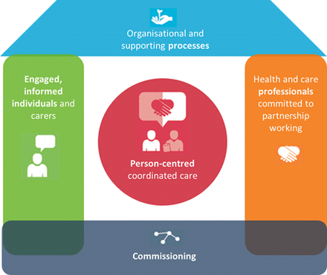

Figure 7: House of Care Model (UK)
- The use of the House of Care framework in obesity management is known to encourage management related to shared care planning, personalised goal-setting and collaborative behavioural support in the primary care environment (NICE, 2025).
- The collaborative work of multidisciplinary teams and patient-centred decision-making are in line with the NHS strategic objectives; however, their implementation across Integrated Care Systems is ineffective because of commissioning and workforce differences (NHS England, 2025).

Chronic Care Model (International):
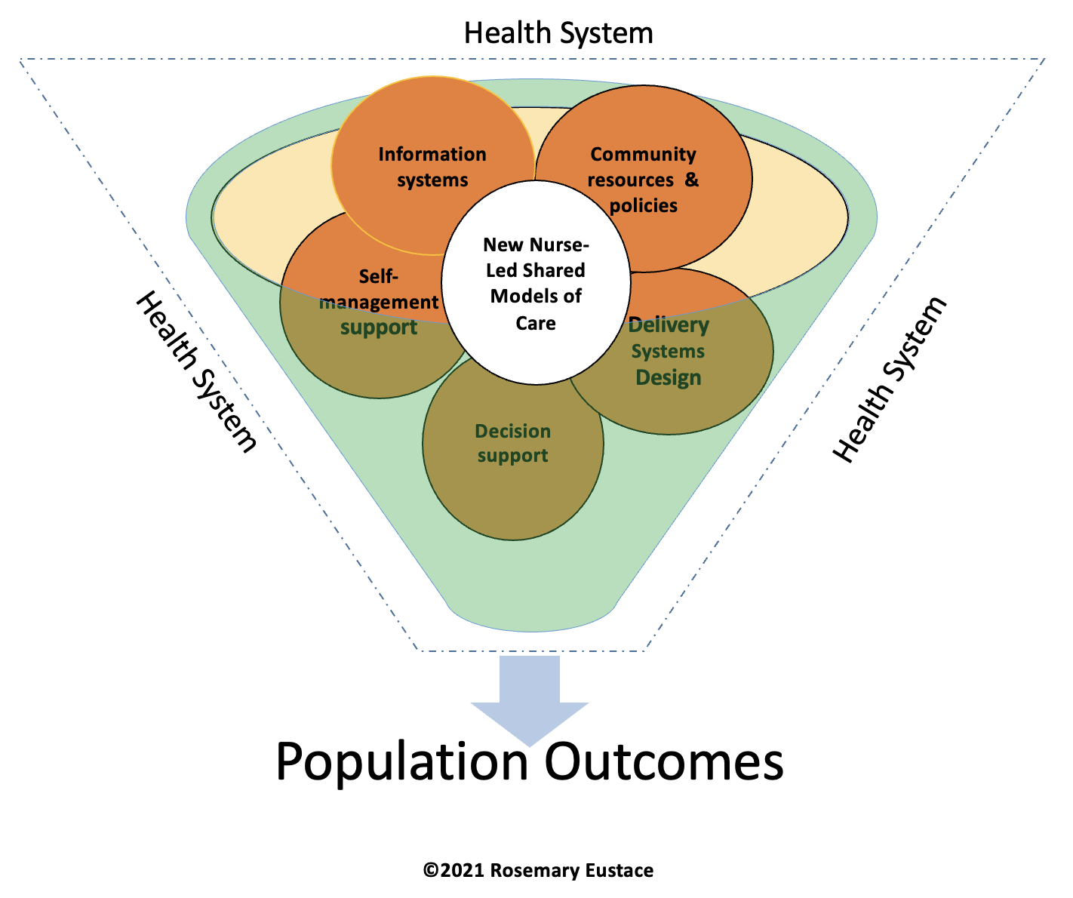

Figure 8: Chronic Care Model (International)
- Chronic Care Model focuses on the proactive and long-term management with the community involvement, organized self-management assistance, and the regular follow-up (Ahmed and Mohammed, 2025).
- Combination of digital surveillance and group-based behavioural components assist in maintaining weight and eliminating risk in the long run (Milne-Ives et al., 2025).
- Although the two models focus on coordinated, patient-centred care, the viability within the NHS budgetary limit is a crucial issue whereby prevention and chronic disease management should receive equal attention.

Summary
Obesity is among the most urgent problems of the public health in the United Kingdom, and national survey statistics prove the high and steadily increasing rates of overweight and obesity in adults, which confirms its established status in the systems of long-term managing the conditions (NHS Digital, 2026). Impact on clinical work is significant since a high level of body weight is closely linked with greater amounts of cardiovascular morbidity and excess deaths, and obesity, in effect, leads to preventable deaths and lower life expectancy (Ward et al., 2022).
In addition to personal health effects, there are also substantial economic costs with modelling studies citing huge direct healthcare expenses in addition to productivity costs that affect employers and national economies (Okunogbe et al., 2021). Notably, there is no obesity outside of social circumstances; weight stigmatization and discrimination can be considered systematic harms that deteriorate mental well-being, diminish healthcare access and propagate inequality (Rubino et al., 2020).
These overlapping physical, psychological and socioeconomic effects explain why obesity is a multi-layered and long-term condition, which cannot be dealt with in a short-term or person-centered manner. It places a special focus on evidence-based pathways involving lifestyle intervention, behavioural support and multidisciplinary management in both primary and specialist care environment (NICE, 2025).
Nevertheless, the results of the long-term implementation will be effective only in case of a regular implementation, equality of access and integration between health and community services. The measures to combat obesity thus require integrated, person-centred, long-term care measures, which entails clinical treatment, preventive public health and stigma reduction efforts as a means of improving population health and sustaining the NHS.

References
Ahmed, S.K. and Mohammed, R.A., 2025. Obesity: Prevalence, causes, consequences, management, preventive strategies and future research directions. Metabolism Open, 27, p.100375. https://www.sciencedirect.com/science/article/pii/S2589936825000313
Bannuru, R.R., 2025. Weight stigma and bias: standards of care in overweight and obesity—2025. BMJ open diabetes research & care, 13(Suppl 1). https://drc.bmj.com/content/bmjdrc/13/Suppl_1/e004962.full.pdf
Bray, G.A. and Bouchard, C. eds., 2019. Handbook of obesity, two-volume set. CRC Press.
Brown, A., Flint, S.W. and Batterham, R.L., 2022. Pervasiveness, impact and implications of weight stigma. EClinicalMedicine, 47. https://www.thelancet.com/pdfs/journals/eclinm/PIIS2589-5370(22)00138-9.pdf
Dall, T.M., Sapra, T., Natale, Z., Livingston, T. and Chen, F., 2024. Assessing the economic impact of obesity and overweight on employers: identifying opportunities to improve work force health and well-being. Nutrition & diabetes, 14(1), p.96. https://www.nature.com/articles/s41387-024-00352-9.pdf
Department of Health and Social Care, 2025. 10 Year Health Plan for England: fit for the future. Available at: https://www.gov.uk/government/publications/10-year-health-plan-for-england-fit-for-the-future (Accessed: 25 February 2026).
Emmer, C., Bosnjak, M. and Mata, J., 2020. The association between weight stigma and mental health: A meta‐analysis. Obesity reviews, 21(1), p.e12935. https://onlinelibrary.wiley.com/doi/pdfdirect/10.1111/obr.12935
Gordon, A., 2023. " You Just Need to Lose Weight": And 19 Other Myths About Fat People (Vol. 13). Beacon Press.
Gray, L.A. and Opazo Breton, M., 2025. Long-term trends in central obesity in England: an age-period-cohort approach: Epidemiology and Population Health. International Journal of Obesity, pp.1-8. https://www.nature.com/articles/s41366-025-01949-5.pdf
Heidelbaugh, J.J. ed., 2025. Obesity Management: A Multidisciplinary Approach: Obesity Management, E-Book (Vol. 15, No. 1). Elsevier Health Sciences.
Kushwah, P., Kumar, R., Srivastava, I., Ranganathan, G., Tiwari, P., Patel, K., Mishra, S. and Maurya, A.K., Obesity in 2026: Analyzing the Rapid Rise and Pathways to Prevention. https://www.sochob.cl/web1/wp-content/uploads/2026/02/Obesity-in-2026-Analyzing-the-Rapid-Rise-and-Pathways-to-Prevention.pdf
Luli, M., Yeo, G., Farrell, E., Ogden, J., Parretti, H., Frew, E., Bevan, S., Brown, A., Logue, J., Menon, V. and Isack, N., 2023. The implications of defining obesity as a disease: a report from the Association for the Study of Obesity 2021 annual conference. EClinicalMedicine, 58. https://www.thelancet.com/pdfs/journals/eclinm/PIIS2589-5370(23)00139-6.pdf
Milne-Ives, M., Burns, L., Swancutt, D., Calitri, R., Ananthakrishnan, A., Davis, H., Pinkney, J., Tarrant, M. and Meinert, E., 2025. The effectiveness and usability of online, group-based interventions for people with severe obesity: a systematic review and meta-analysis. International Journal of Obesity, 49(4), pp.564-577. https://www.nature.com/articles/s41366-024-01669-2.pdf
Myerson, M., 2026. Obesity in the United States: A public health perspective. Journal of Clinical Lipidology, 20(1), pp.3-8. https://www.sciencedirect.com/science/article/pii/S1933287425003034
National Institute for Health and Care Excellence, 2025. Overweight and obesity management. NG246. Available at: https://www.nice.org.uk/guidance/ng246 (Accessed: 25 February 2026).
NHS England Digital, 2026. Adults’ overweight and obesity. Health Survey for England, 2024. Available at: https://digital.nhs.uk/data-and-information/publications/statistical/health-survey-for-england/2024/adults-overweight-and-obesity (Accessed: 25 February 2026).
NHS England, 2025. Enhanced Service Specification – Weight Management 2025/26. Available at: https://www.england.nhs.uk/wp-content/uploads/2025/03/enhanced-service-specification-weight-management-2025-26.pdf (Accessed: 25 February 2026).
Okunogbe, A., Nugent, R., Spencer, G., Ralston, J. and Wilding, J., 2021. Economic impacts of overweight and obesity: current and future estimates for eight countries. BMJ global health, 6(10). https://gh.bmj.com/content/bmjgh/6/10/e006351.full.pdf
Parvez, A., Zeeshan, N., Sultan, L., Mukhlis, M., Bhagwan, R., Munir, T., Ali, M.F., Siddiqui, S.A., Jain, J., Yadav, R. and Singh, D., 2025. Trends and disparities in obesity and atherosclerotic cardiovascular disease mortality in a 25-year retrospective analysis. Scientific Reports. https://www.nature.com/articles/s41598-025-30451-1_reference.pdf
Proaño, G.V., Moreno, L.M.R., Arciniegas, M.J., Sifre-Acosta, N., Espinal, C., Chowdhury, R., Flórez, L.J.H. and Palacios, C., 2024. Effectiveness, barriers, and facilitators of overweight and obesity prevention strategies in Latin America; a scoping review and qualitative study in Colombia. The Lancet Regional Health–Americas, 29. https://www.thelancet.com/pdfs/journals/lanam/PIIS2667-193X(23)00230-2.pdf
Putri, R.R., Danielsson, P., Ekström, N., Ericsson, Å., Lindberg, L., Marcus, C. and Hagman, E., 2025. Effect of pediatric obesity treatment on long-term health. JAMA pediatrics, 179(3), pp.302-309. https://jamanetwork.com/journals/jamapediatrics/articlepdf/2829443/jamapediatrics_putri_2025_oi_240098_1739908539.05014.pdf
Rippe, J.M., 2024. Lifestyle nutrition: eating for good health by lowering the risk of chronic diseases. CRC Press.
Rubino, F., Puhl, R.M., Cummings, D.E., Eckel, R.H., Ryan, D.H., Mechanick, J.I., Nadglowski, J., Ramos Salas, X., Schauer, P.R., Twenefour, D. and Apovian, C.M., 2020. Joint international consensus statement for ending stigma of obesity. Nature medicine, 26(4), pp.485-497. https://www.nature.com/articles/s41591-020-0803-x.pdf
Sánchez-Carracedo, D., 2022. Obesity stigma and its impact on health: A narrative review. Endocrinología, Diabetes y Nutrición (English ed.), 69(10), pp.868-877. https://www.sciencedirect.com/science/article/pii/S2530018022001767
Steptoe, A. and Frank, P., 2023. Obesity and psychological distress. Philosophical Transactions of the Royal Society B, 378(1888), p.20220225. https://royalsocietypublishing.org/rstb/article-pdf/doi/10.1098/rstb.2022.0225/1280272/rstb.2022.0225.pdf
Stout, R., Reichert, D. and Kelly, R. eds., 2025. Lifestyle Medicine and the Primary Care Provider: A Practical Guide to Enabling Whole Person Care. CRC Press.
Sun, X., Yan, A.F., Shi, Z., Zhao, B., Yan, N., Li, K., Gao, L., Xue, H., Peng, W., Cheskin, L.J. and Wang, Y., 2022. Health consequences of obesity and projected future obesity health burden in China. Obesity, 30(9), pp.1724-1751. https://onlinelibrary.wiley.com/doi/abs/10.1002/oby.23472
Timkova, V., Mikula, P. and Nagyova, I., 2025. Psychosocial distress in people with overweight and obesity: the role of weight stigma and social support. Frontiers in Psychology, 15, p.1474844. https://www.frontiersin.org/journals/psychology/articles/10.3389/fpsyg.2024.1474844/pdf
Ward, Z.J., Willett, W.C., Hu, F.B., Pacheco, L.S., Long, M.W. and Gortmaker, S.L., 2022. Excess mortality associated with elevated body weight in the USA by state and demographic subgroup: a modelling study. EClinicalMedicine, 48. https://www.thelancet.com/pdfs/journals/eclinm/PIIS2589-5370(22)00159-6.pdf
Westbury, S., Oyebode, O., Van Rens, T. and Barber, T.M., 2023. Obesity stigma: causes, consequences, and potential solutions. Current obesity reports, 12(1), pp.10-23. https://link.springer.com/content/pdf/10.1007/s13679-023-00495-3.pdf
World Health Organization, 2025. Obesity and overweight. Available at: https://www.who.int/news-room/fact-sheets/detail/obesity-and-overweight (Accessed: 25 February 2026).

